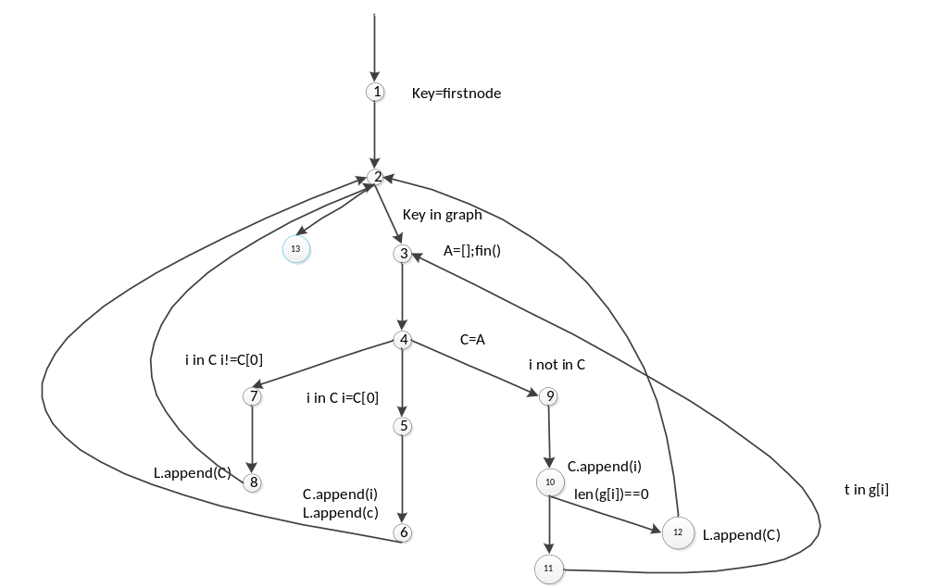
节点覆盖：[1,2,3,4,7,8]
[1,2,3,4,5,6]
[1,2,3,4,9,10,11]
[1,2,3,4,9,10,12]
[1,2,13]
测试用例:graph：{1:[2,3],2:[3,4,5],3[2],4[1],5[]} 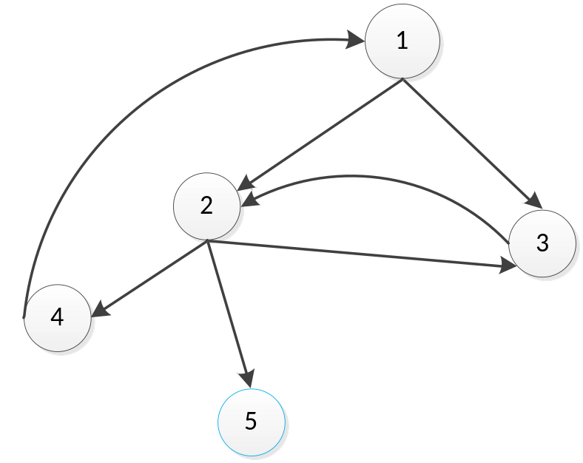
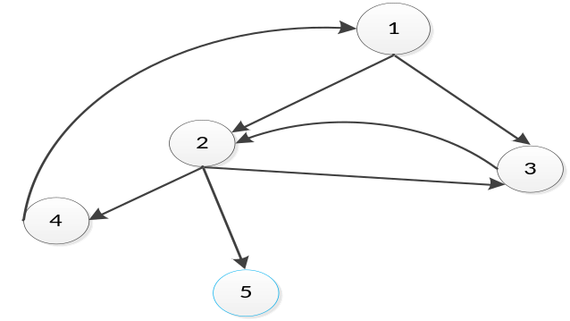[1,2,3,4,7,8]:
输入:key=3 a=[1,2,3] l=[] data=graph
输出：[1,2,3]
[1,2,3,4,5,6]:
输入:key=4 a=[1,2,4] l=[] data=graph
输出：[1,2,4,1]
[1,2,3,4,9,10,11]:
输入:key=2 a=[1,2] l=[] data=graph
输出：[1,2,3][1,2,4,1][1,2,5]
[1,2,3,4,9,10,12]:
输入:key=5 a=[1,2,5] l=[] data=graph
输出：[1,2,5]
[1,2,13]:
输入:key=6 a=[] l=[] data=graph
输出:[]

