**Task 1**

**1) Simulating Geometric Brownian Motions**

Firstly, to simulate the Geometric Brownian Motion, we use the import command to import the pylab and numpy to provide the multidimensional array. After that, we need to define all the values of the parameters and create the Brownian paths with 1000 runs. Lastly, a graph of 5 realizations of Geometric Brownian Motion is plotted as shown in the Graph 1.

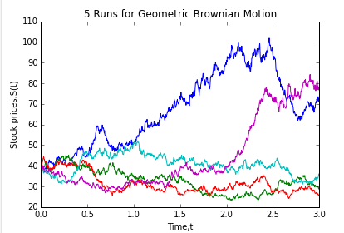

**Graph 1**

Based on the simulation, we use p.array (S[:,-1]) to find the values of stock price at time three while numpy module is used to find the (i) expectation value and (ii) variance of the stock price at time three.

Furthermore, to find the (iii) probability of the stock price at time three which is greater than 39, we need to use mask module. We considered mask as a parameter that represent the frequency of the stock price at time three which is greater than 39. For example, true represent the stock price at time three greater than 39 while false represent the stock price at time three smaller or equal to 39. Finally, we can calculate the probability of the stock price at time three which is greater than 39 by using the summation of the mask divide by the length (number of items) of mask.

Lastly, to compute the (iv) conditional expectation of stock prime at time three given that the stock price at time three is greater than 39, we need to multiple the stock prices at time three with the mask. After that, we can get the value of the conditional expectation by the ratio of the summation of the multiplication to the summation of the mask. All of the results are presented as below by using the print function.

(i) E(S(3))= 52.0010828832

(ii) Var(S(3))= 574.041135655

(iii) P(S(3)>39)= 0.672

(iv) E(S(3)|S(3)>39)= 62.8563021166

**2) Simulating Mean Reversal Process**

Firstly, to simulate the Mean Reversal Process, we use the import command to import the pylab and numpy to provide the multidimensional array. After that, we need to define all the values of the parameters and create the Brownian paths with 1000 runs. Lastly, a graph of 5 realizations of Mean Reversal Process is plotted as shown in the Graph 2.

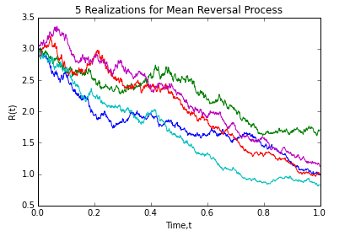

**Graph 2**

Firstly, we use p.array (R[:,-1]) to find the value of stock price at time one while numpy module is used to find the (i) expectation value of the stock price at time one.

Next, to find the (ii) probability of the stock price at time one which is greater than 2, we need to use mask module. We considered mask as a parameter that represent the frequency of the stock price at time one which is greater than 2. For example, true represent the stock price at time one is greater than 2 while false means that the stock price at time one is smaller than or equal to 2. Finally, we can calculate the probability of the stock price at time one which is greater than 2 by using the ratio pf the summation of the mask divide by the length (number of items) of mask. All of the results are presented as below by using the print function.

(i) E(R(1))= 1.13875106599

(ii) P(R(1)>2)= 0.015

**Task 2- Downloading and Manipulating Data**

**1) FTSE Bursa Malaysia KLCI Index**

There are 30 components stocks in the FTSE Bursa Malaysia KLCI Index

|  |  |  |  |  |  |  |  |
| --- | --- | --- | --- | --- | --- | --- | --- |
| **No** | **Stock Name** | **Stock Sector** | | **Stock Code** | **Weighted in FTSEKLCI**  **(%)** | **P/E Ratio** | **Net Market Capital** |
| 1 | CIMB Group Holdings | Banks | | 1023 | 5.76 | 17.42 | 47.29 |
| 2 | AMMB Holdings | Banks | | 1015 | 2.38 | 8.88 | 17.42 |
| 3 | Hong Leong Bank | Banks | | 5819 | 1.67 | 11.74 | 14.74 |
| 4 | Hong Leong Financial | Banks | | 1082 | 0.64 | 9.97 | 16.63 |
| 5 | Public Bank Bhd | Banks | | 1295 | 11.60 | 15.34 | 73.99 |
| 6 | RHB Capital | Banks | | 1066 | 1.06 | 9.37 | 19.52 |
| 7 | Malayan Banking | Banks | | 1155 | 9.32 | 12.41 | 87.85 |
| 8 | Axiata Group Bhd | Telecommunications | | 6888 | 5.62 | 24.31 | 55.52 |
| 9 | Digi.com | Telecommunications | | 6947 | 4.16 | 20.75 | 42.14 |
| 10 | Maxis Bhd | Telecommunications | | 6012 | 3.45 | 30.09 | 49.41 |
| 11 | Telekom Malaysia | Telecommunications | | 4863 | 2.96 | 32.63 | 25.14 |
| 12 | Tenaga Nasional | Alternative Electricity | | 5347 | 9.28 | 9.16 | 69.53 |
| 13 | Sime Darby Bhd | Diversified Industrials | | 4197 | 5.51 | 21.66 | 53.91 |
| 14 | Genting | Hotels | | 3182 | 3.68 | 19.49 | 31.52 |
| 15 | Genting Malaysia Bhd | Hotels | | 4715 | 2.50 | 20.45 | 25.71 |
| 16 | PETRONAS Chemicals Group Bhd | Commodity Chemicals | | 5183 | 3.55 | 22.21 | 52.8 |
| 17 | Petronas Gas | Exploration & Production | | 6033 | 3.40 | 22.83 | 42.5 |
| 18 | IHH Healthcare | Health Care Providers | | 5225 | 3.28 | 63.42 | 48.59 |
| 19 | IOI | Farming & Fishing | | 1961 | 2.99 | 74.43 | 27.84 |
| 20 | Kuala Lumpur Kepong | Farming & Fishing | | 2445 | 2.28 | 29.18 | 24.55 |
| 21 | SapuraKencana Petroleum | Oil Equipment & Services | | 5218 | 1.98 | 12.03 | 14.44 |
| 22 | Petronas Dagangan Bhd | Integrated Oil & Gas | | 5681 | 1.21 | 37.02 | 20.52 |
| 23 | PPB Group | Food Products | | 4065 | 1.80 | 17.73 | 18.14 |
| 24 | British American Tobacco (Malaysia) | Tobacco | | 4162 | 1.70 | 20.11 | 18.76 |
| 25 | YTL Corp | Multiutilities | | 4677 | 1.63 | 15.05 | 17.38 |
| 26 | UMW Holdings | Automobiles | | 4588 | 1.37 | 20.37 | 11.94 |
| 27 | Astro Malaysia Holdings | Broadcasting & Entertainment | | 6399 | 1.22 | 28.69 | 15.76 |
| 28 | MISC | Transportation | | 3816 | 2.45 | 16.07 | 36.07 |
| 29 | Westports Holdings | Transportation | | 5246 | 0.93 | 26.86 | 14.39 |
| 30 | KLCC Prop&Reits-Stapled Sec | Real Estate Holding & Development | | 5235SS | 0.63 | 28.16 | 12.66 |
|  |  |  |

**2) Downloading Data**

Firstly, we have use the import command to import pandas and DataReader to download the daily data from the yahoo. The starting date and ending date is set and the data is presented using the print function. After that, we use the built in function in pandas (moving average=pd.rolling_mean (RHB,5)) to calculate the 5 days moving average. A graph of 5 Days Moving Average for RHB Capital is plotted as shown in the Graph 3.

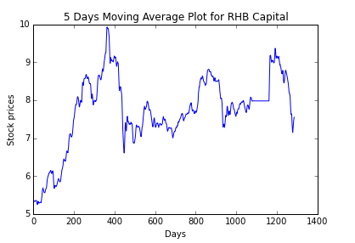

**Graph 3**

Previous steps are repeated to download the FTSEKLCI daily data. Finally, we use the corr() command to compute the (i) correlation between the RHB Capital and FTSEKLCI. The answer is presented using the print function.

(i) Correlation between RHB Capital and FTSEKLCI = 0.634884