Gesture Sentry Turret — Full Wiring, As Bought
Every connection needed to bring up the turret, matched strictly to the parts on the three purchase receipts (28-09-2026) — not the spec’s ideal shopping list.
Project: Gesture-Controlled Sentry Turret (BACSE324, friend’s group) Source: Gesture_Sentry_Turret_Full_Spec.md + 3 purchase receipts

Parts confirmed on the receipts
- Breadboard 400-point, Breadboard 840-point
- 0.96" OLED display, 4-pin I2C
- Female Berg strip 40x1 × 2
- 18650 battery holder (4-cell)
- Buzzer 5V
- Two-cell charger (for 18650 / 16340 / 14500)
- MPU6050 (GY-521) 3-axis accelerometer + gyroscope
- HC-SR04 ultrasonic sensor
- HC-SR501 PIR motion sensor
- Laser module
- SG90 micro servo
- Tower Pro MG995 servo
- 6x4" general-purpose PCB (perfboard)
- 18650 rechargeable battery × 4
- ESP32 development board (USB Type-C) × 2
- RGB LED module × 2
- Jumpers × 16
- 4-Wheel Drive acrylic chassis kit with motors (separate from this build — see note at the end)
Not on any receipt, but required before the build runs untethered: a buck/boost converter for the turret’s 18650 pack, a LiPo cell + TP4056 + boost converter for the glove, two resistors for the HC-SR04 voltage divider, and (optional but recommended) a physical mode-switch button. Each is explained in context below.

Full Wiring Diagram
Blue lines are GPIO signal connections, green is the I2C bus to the glove’s IMU, and the dashed purple line is the BLE wireless link between the two boards — there is no physical wire between the turret and the glove.
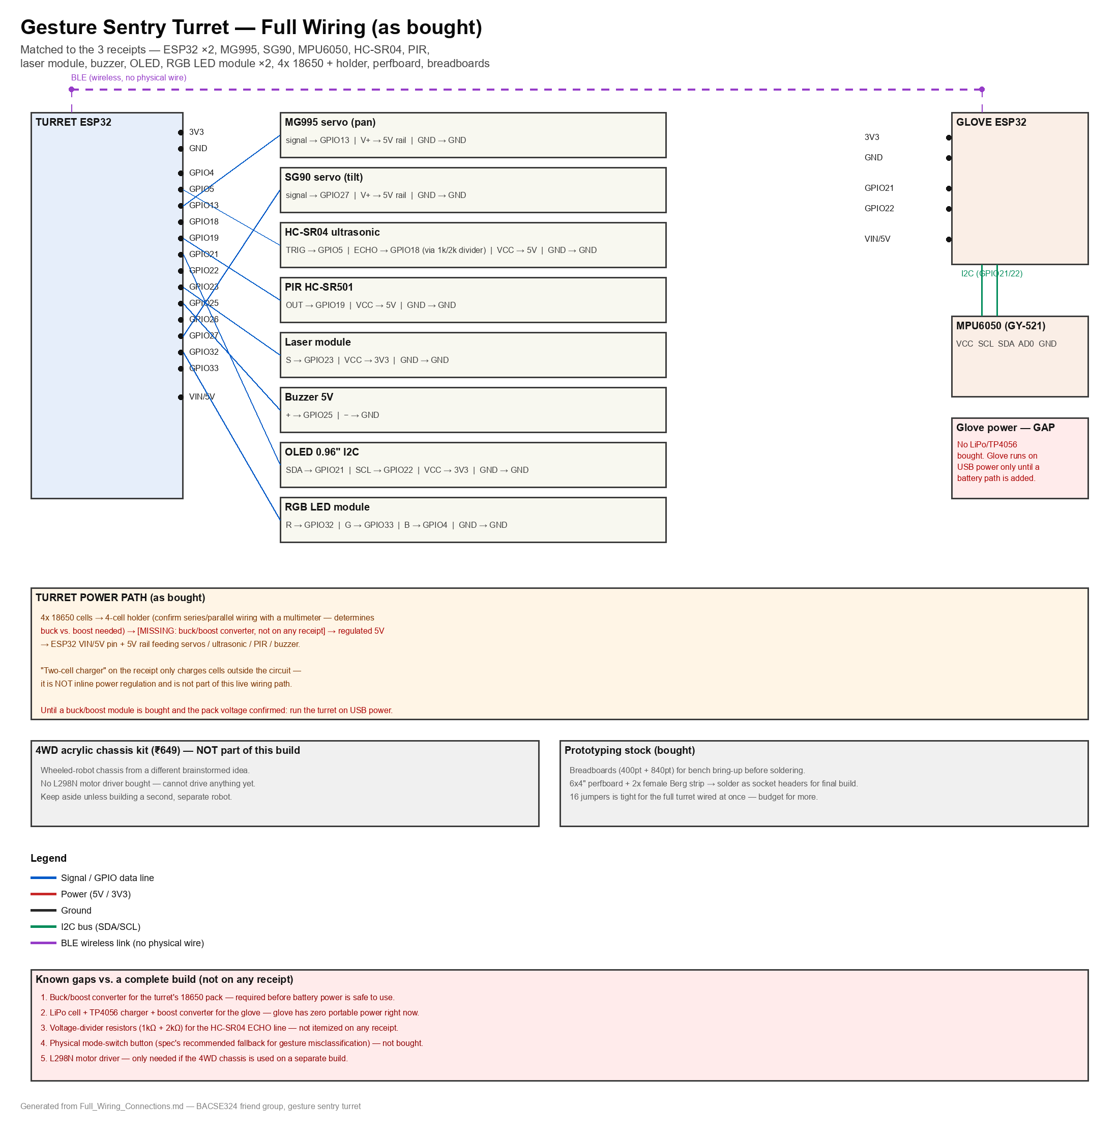

Turret ESP32 — Full Connections

Servos — MG995 (pan) + SG90 (tilt)
The receipt has an MG995, not the spec’s MG996R — both share the same 3-wire pinout, so the wiring is identical either way.
Servo wire | Connects to
MG995 (pan) signal — orange | GPIO13
MG995 (pan) V+ — red | External 5V rail (NOT the ESP32’s own 5V/USB — MG995 stall current is too high for that)
MG995 (pan) GND — brown | Common GND rail
SG90 (tilt) signal — orange | GPIO27 (GPIO12 avoided — boot-strapping pin on some boards)
SG90 (tilt) V+ — red | Same external 5V rail as the pan servo
SG90 (tilt) GND — brown | Common GND rail

HC-SR04 ultrasonic
Pin | Connects to
VCC | 5V rail
TRIG | GPIO5
ECHO | GPIO18 — through a voltage divider (1kΩ + 2kΩ); ECHO outputs 5V and the GPIO is 3.3V-only
GND | Common GND rail

PIR motion sensor (HC-SR501)
Pin | Connects to
VCC | 5V rail
OUT | GPIO19 (3.3V logic output, no divider needed)
GND | Common GND rail

Laser module
The receipt just says "Laser Module," not confirmed as a KY-008. If it is a 3-pin module (S / + / −) with an onboard resistor, wire as below. If it turns out to be a bare 2-pin diode with no resistor, do not wire it directly to a GPIO or 3V3 — add a series resistor (roughly 100–150Ω for 3.3V) first, or it risks damaging the diode or the pin.
Pin | Connects to
S (signal, if 3-pin) | GPIO23
+ / VCC | 3V3
− / GND | Common GND rail

Buzzer (5V)
Pin | Connects to
+ | GPIO25
− | Common GND rail

0.96" OLED (I2C, 4-pin)
Pin | Connects to
VCC | 3V3
GND | Common GND rail
SCL | GPIO22
SDA | GPIO21

RGB LED module × 2
The receipt lists two individual "RGB LED Module" units, not the spec’s 12-LED WS2812 ring. Treat each as a 4-pin common-cathode (or common-anode) RGB LED breakout with separate R/G/B signal pins — the simpler and more likely part at this price. One module covers the status indicator the spec calls for (green = idle, amber = tracking, red = locked); the second is a spare, the same role the spec’s extra SG90 played.
Pin (common-cathode module) | Connects to
R | GPIO32 (through the module’s onboard series resistor, or add one if it has none)
G | GPIO33
B | GPIO4
GND (common pin) | Common GND rail
If the module is common-anode instead, wire the common pin to 3V3 instead of GND, and drive R/G/B LOW to turn each color on (inverted logic) in firmware.

Mode-switch button
Not on the receipt. If a spare push-button exists, wire one leg to GPIO26 and the other to GND (use INPUT_PULLUP in firmware, no external resistor needed). Without one, the mode-switch gesture (double-tap) is the only way to flip AUTO/MANUAL — fine for bench testing, but the spec recommends a physical fallback before the live demo in case that gesture misclassifies.

Turret power path
4× 18650 cells go into the 4-cell holder, but the pack’s wiring (series or parallel) is not yet confirmed — check it with a multimeter before connecting anything. This matters because it determines whether a boost converter (parallel pack, ~3.7V) or a buck converter (series pack, 7.4–14.8V+) is needed to get a clean regulated 5V. Neither is on any receipt.
The receipt’s "two-cell charger" only charges cells outside the circuit — it is not inline power regulation and does not belong in the live wiring path.
Until a matched buck/boost module is bought and the pack voltage is confirmed: run the turret on USB power for all bring-up and testing.

Turret ESP32 pin summary
GPIO | Function
4 | RGB LED module — Blue
5 | HC-SR04 TRIG
13 | MG995 pan signal
18 | HC-SR04 ECHO (via divider)
19 | PIR OUT
21 | OLED SDA
22 | OLED SCL
23 | Laser signal
25 | Buzzer
26 | Mode-switch button (if present)
27 | SG90 tilt signal
32 | RGB LED module — Red
33 | RGB LED module — Green
BLE (internal radio) | Receives gesture labels from the Glove ESP32

Glove ESP32 — Full Connections

MPU6050 IMU (I2C)
Pin | Connects to
VCC | 3V3
GND | Common GND rail
SCL | GPIO22
SDA | GPIO21
AD0 | GND (sets I2C address 0x68, the default)
INT | Not used — polling mode is fine for this model

Glove power path — gap vs. the spec
No LiPo cell or TP4056 is on any receipt. The glove currently has no portable power source. Until one is bought, it runs tethered via USB cable to a laptop or power bank — this defeats the "untethered glove" part of the demo but does not block firmware or gesture-training work, all of which can be done over USB. To go wireless: buy a small LiPo pouch cell, a TP4056 charge module, and a boost converter (three items, none currently owned) — the same power chain the spec describes for the glove.

Glove ESP32 pin summary
GPIO | Function
21 | MPU6050 SDA
22 | MPU6050 SCL
BLE (internal radio) | Transmits classified gesture label to the Turret ESP32

Cross-board link
There is no wired connection between the two ESP32s — they communicate only over BLE (Glove = peripheral broadcasting gesture labels, Turret = central receiving them). This is the one link in the whole system that is wireless by design, per the spec’s control architecture.

Prototyping-Stage Parts (bought, used before final assembly)
- Breadboard 400-point + 840-point — bench-test every module above before soldering to the perfboard. Put the turret’s modules on the 840-point (more room for servos, sensors, OLED, and LEDs together); the MPU6050 alone fits the 400-point for the glove side.
- Female Berg strip × 2 — solder onto the perfboard as socket headers so the ESP32s and modules can be plugged/unplugged from the final board rather than soldered directly — standard practice, do this before final assembly.
- Jumpers × 16 — enough for bringing up one subsystem at a time on a breadboard, but tight for the full turret wired simultaneously (servos + ultrasonic + PIR + laser + buzzer + OLED + RGB LED is 20+ individual wires). Budget for more jumpers, or move to perfboard sooner.

4WD Acrylic Chassis Kit (₹649) — Not Part of This Build
This is a wheeled-robot chassis (motors + wheels + acrylic deck) matching a different brainstormed idea — a line-follower/obstacle-avoider or the sumo robot — not the sentry turret spec. No motor driver (L298N or similar) was bought to go with it, so it cannot drive anything yet. Keep it aside unless the team is also building a second, separate robot.

Summary — What to Buy Before the Build Is Fully Untethered
- Buck or boost converter for the turret’s 18650 pack (confirm series vs. parallel wiring first with a multimeter — this decides which type is needed).
- LiPo pouch cell + TP4056 charge module + boost converter for the glove.
- Two resistors (1kΩ + 2kΩ) for the HC-SR04 ECHO voltage divider.
- A small push-button for the physical mode-switch fallback (optional but recommended).
- An L298N motor driver — only if the 4WD chassis is used on a separate build.

