Input matched multisignal colocalization clarifies regulatory assignments at primary biliary cholangitis loci
Article type: Article
Authors: Zhi Chen¹ (ORCID: 0009-0001-0072-5576); Teng Qi¹* (ORCID: 0009-0007-7648-4776)
Affiliations: ¹ School of Medicine, The Chinese University of Hong Kong, Shenzhen, 2001 Longxiang Boulevard, Longgang District, Shenzhen, Guangdong 518172, China
Corresponding author: Teng Qi, School of Medicine, The Chinese University of Hong Kong, Shenzhen, 2001 Longxiang Boulevard, Longgang District, Shenzhen, Guangdong 518172, China; tengqi@link.cuhk.edu.cn

Abstract
Regulatory assignments can change when colocalization analyses use different inputs or causal assumptions. We screened 5,460 of 6,923 primary biliary cholangitis locus-gene-cell comparisons and applied source-matched multi-signal analysis to a prespecified 642-comparison subset. Matching variant support and disease statistics changed 15 and 19 classifications, respectively. Eight shared-signal (H4) comparisons became distinct-signal (H3), and ten H3 comparisons became H4. Across 486,000 simulations, multi-signal inference reduced false sharing from 12.41% to 8.56% but reduced shared-signal recovery from 32.99% to 26.66%. IL12RB2 sharing in natural killer (NK) cells received external disease-study and linked chromatin support, without establishing participant independence or mediation. Liver expression was detectable without corrected disease enrichment. These findings identify input matching, signal-pair identity, covariate sensitivity and discovery adequacy as complementary requirements for interpreting regulatory assignments. Statistical sharing supports regulatory association while direct mechanism remains untested.
Keywords: primary biliary cholangitis; colocalization; single-cell eQTL; fine-mapping; linkage disequilibrium; signal pair; regulatory genomics; statistical genetics

Introduction
Primary biliary cholangitis (PBC) is an autoimmune cholestatic liver disease characterized by progressive injury to small intrahepatic bile ducts [1]. Genome-wide association studies have identified a substantial inherited component and many non-HLA susceptibility loci, creating a strong foundation for mechanistic prioritization [2]. The central interpretive problem is no longer whether associated regions exist. It is whether a regional disease association and a molecular quantitative-trait locus (QTL) implicate the same local signal, in which gene and cellular context, and with what degree of uncertainty.
Single-cell QTL resources make this problem biologically more specific. OneK1K mapped cell-type-specific genetic effects on gene expression in peripheral blood immune populations [3], and TenK10K extends immune-cell molecular-QTL mapping to a larger donor cohort and a broader cellular taxonomy [4]. These resources allow the same disease locus to be compared across genes and cell contexts. That resolution also increases statistical dependence: a locus can contain several disease and expression signals, the same gene can appear in related immune populations, and a comparison-level label can conceal different signal pairs.
Approximate Bayes factor (ABF) colocalization provides an efficient first-pass test of whether two association patterns are more compatible with one shared causal variant (H4) or with two distinct causal variants (H3) [5]. Its standard formulation assumes at most one causal variant per trait in the tested region. That assumption can be restrictive in autoimmune loci with allelic heterogeneity. Multi-signal fine-mapping and signal-pair colocalization can instead represent several local components [6,7], but a direct comparison is difficult when the procedures use different variant sets, disease summaries or linkage disequilibrium (LD) inputs. An apparent H4-to-H3 or H3-to-H4 change can then reflect input mismatch as well as inferential structure.
This distinction matters for biological attribution. A stable shared signal pair supports a locus-gene-cell regulatory association, but it does not prove expression mediation or a molecular mechanism. A stable distinct pair does not imply that the entire locus contains no shared signal. Indeed, shared and distinct signal pairs can coexist within one locus-gene-cell comparison. Model sensitivity can also be informative: it identifies assignments that depend on the covariate adjustment used to construct QTL summaries and model-matched LD, rather than providing a reason to select the configuration that yields the most favorable posterior.
We used PBC to assess the reliability of immune-cell regulatory assignment through four linked tasks. First, we screened PBC-wide comparisons and performed multi-signal analysis in a prespecified high-information subset. Second, we reconstructed matched-input ABF arms to distinguish the effects of variant support and disease statistics from residual differences between single-causal and multi-signal procedures. Third, truth-known simulations separated credible-set discovery from inference conditional on an available signal pair. Finally, representative IL12RB2-NK and FCRL3 B-cell assignments were examined across molecular-QTL resources, a different disease study system and bounded chromatin and liver-expression evidence. Together, these analyses asked which assignments remained stable, which depended on inputs or model specification, and what additional evidence would be needed to infer mechanism.

Results

PBC-wide screening defined a bounded high-information multi-signal analysis
The frozen registry contained 6,923 locus-gene-cell comparisons. Of these, 5,460 met the overlap threshold for ABF screening and 1,463 were coverage-insufficient (Figure 1a). The latter were not interpreted as negative colocalization results. The multi-signal workload contained 642 comparisons: 184 primary trigger-verification comparisons, 455 H3 rescue/falsification comparisons and three borderline calibration cases (Figure 1b). It covered 47 PBC regions, 200 genes, 14 cell types and 286 cell-locus blocks. Complete records are provided in Source Data 1, S2/.
The final PF10 multi-signal classification contained 92 H4-supported comparisons, 428 H3-supported comparisons, 59 model-sensitive comparisons and 63 uninformative comparisons (Figure 1c). These are comparison counts, not independent genes or loci. The 92 H4-supported comparisons involved 27 genes and 19 loci. Repeated support for a gene across related cells therefore increased cell-context resolution but did not create additional independent disease associations.
The source-identity audit verified 14 comparison-model records from seven targeted comparisons under PF10 and PF50. This counting unit differs from the 14 cell types in the expanded registry. Kriging diagnostics were reviewed for all 2,568 comparison-model-trait units. One unique variant satisfied the stated diagnostic flag rule; it lay outside all recorded credible sets and was retained without a diagnostic-triggered refit (Figure 1d).

Matching support and disease statistics explained some, but not all, reclassification
The actual multi-signal support S_M was smaller than the historical ABF support S_A in all 642 comparisons, with 19-114 variants removed per comparison (median 65; median 7.67%; Figure 2a). A0 replay reproduced the historical ABF posteriors to within 3.55x10^-13, establishing numerical identity before attribution.
Restricting the ABF calculation from S_A to S_M changed 15 categorical states (A0-to-A1) while retaining all 112 historical H4 states. Replacing the harmonized GCST disease definition with the matched GJOKA z-statistic definition changed 19 states (A1-to-A2; Figure 2b). Fixed-versus-native sdY and matched-z-versus-rounded GJOKA sensitivity definitions produced no categorical changes within the frozen 642. The two change counts can involve the same comparisons and are not additive.
After exact support and disease-statistic matching, comparison with the frozen multi-signal result still showed bidirectional H4/H3 reclassification (Figure 2c). Among 113 A2 H4 comparisons, 79 retained H4, eight changed to H3, four were model-sensitive and 22 were uninformative. Among 452 A2 H3 comparisons, 413 retained H3, ten changed to H4, six were model-sensitive and 23 were uninformative (Figure 2d). Thus, strict matched-input transitions comprised eight H4-to-H3 and ten H3-to-H4 comparisons. The 139 total A2-to-M state changes also included ambiguity and information changes and cannot be interpreted as 139 corrections. Complete records are provided in Source Data 1, S3/.
Ten of 12 historical directional transitions remained strict H4/H3 changes under matched inputs. FCRL3-CD8_ET remained H4 in A0, A1 and A2 but was H3 under the primary PF10 multi-signal analysis. Two historical cases entered the multi-signal analysis from matched-input ambiguous states and were no longer counted as strict A2-to-M reversals. Strict reversal counts therefore follow the matched-input starting state.
Among the 520 comparisons with a definite PF10 H4 or H3 state, PF50 produced the same state in 491 (94.42%), changed four to the alternative supported state and was uninformative in 25 (Figure 2e). The remaining 122 PF10 model-sensitive or uninformative comparisons were not included in this denominator. The 94.42% agreement is conditional on a definite PF10 state.
Signal-pair semantics further limited comparison-level interpretation. All 92 stable-H4 comparisons and all 428 stable-H3 comparisons retained the same qualifying signal-pair identity between PF10 L=10 and at least one other PF10 L setting. However, 32 of the 92 H4-supported comparisons also contained an H3-qualifying pair (Figure 2f). H4 support therefore meant that at least one shared pair was stable, not that every signal in the region was shared. Conversely, H3 support identified a stable distinct pair and did not prove the global absence of another shared pair.

Simulation exposed a trade-off between false sharing, shared-signal recovery and discovery adequacy
The primary simulation branch completed all 486,000 iterations with no recorded technical errors. Multi-signal inference failed to produce an evaluable signal pair in many iterations because one or both traits lacked a credible set: 130,994 iterations had no credible set for either trait, 16,819 lacked a disease credible set and 177,405 lacked a QTL credible set. No iteration had credible sets for both traits but no eligible pair. A total of 160,782 iterations (33.08%) were pair-evaluable (Figure 3a,D).
This discovery layer materially changed interpretation of unconditional performance. Pair-evaluable rates ranged from 13.29% in S5 to 59.79% in S2. In S1, one true shared signal, the unconditional matched H4 rate was 54.12%, whereas H4 was selected in 94.06% of pair-evaluable iterations. In S4, two signals per trait with one shared pair, the corresponding rates were 9.57% and 66.72%. Conditional performance showed that the estimator often recognized sharing once a signal pair existed, but the unconditional rates captured the combined burden of discovery and pair classification (Figure 3b).
Across the two frozen distinct-signal scenarios, the average false-H4 rate decreased from 12.41% with ABF to 8.56% with matched multi-signal inference, a relative reduction of 31.02%. The gain was not uniform. In S2, which used correlated but distinct variants, the matched false-H4 rate remained 16.00% overall and 26.76% among pair-evaluable iterations. In S5, which contained two high-LD signals per trait without a shared pair, the false-H4 rate fell from 4.32% with ABF to 1.12% with matched multi-signal inference (Figure 3c).
The decrease in false H4 was accompanied by lower recovery in the shared-signal scenarios: average H4 recovery decreased from 32.99% with ABF to 26.66% with matched multi-signal inference, a relative loss of 19.20%. This result precluded a claim of general superiority. The S6 mismatch sensitivity produced few decision flips in the implemented, closely related LD contrast, but the zero-pair branch lacked per-trait credible-set counts. We therefore did not generalize S6 to ancestry mismatch or severe reference-panel mismatch. Complete records are provided in Source Data 1, S7/.

IL12RB2-NK gained external disease-study and chromatin signal support
IL12RB2-NK was a representative stable-H4 comparison in OneK1K. Best PF10 signal-pair PP.H4 values were 0.9980 across L=5, 10 and 20; PF50 L=10 yielded PP.H4=0.9965. The comparison also contained a distinct signal pair, illustrating why stable H4 did not impose a single global mechanism label on the region.
TenK10K NK-cell eQTL data reproduced the PBC-IL12RB2 sharing pattern under the bounded single-causal replication model (396 overlapping variants; default PP.H4=0.9975; low-prior H4/[H3+H4]=0.9760). FinnGen immune multiome outputs returned three PBC-IL12RB2 molecular-QTL records, for l1.NK, l1.PBMC and l2.NK strata. PP.H4 ranged from 0.9698 to 0.9706, with credible-set overlap of five to nine variants. These strata came from one resource and were not counted as three independent cohorts.
The FinnGen disease signal was stable between public releases. The R12 disease credible set contained 19 variants and the R13 set contained 17; all 17 R13 members occurred in R12 (Jaccard=0.895), the same variant led both sets, and member probabilities correlated at r=0.833 (Figure 4a). FinnGen R13 contained 795 PBC cases and 368,758 controls. At the exact bridged disease variant rs6679356, the aligned C-allele effect was positive in both the discovery PBC GWAS and FinnGen R13.
FinnGen R13 × OneK1K NK/IL12RB2 colocalization used 1,175 harmonized variants. PP.H4 was 0.9772 at p12=10^-6, 0.9977 at p12=10^-5 and 0.9998 at p12=10^-4; H4/(H3+H4) was 0.9776, 0.9977 and 0.9998, respectively (Figure 4b). The shared top variant was rs6702599, with concordant effect direction, and both members of the OneK QTL credible set occurred in the FinnGen R13 disease credible set. This supported the regulatory association in a different disease study system. Public metadata did not establish person-level zero overlap, and the external analysis remained single-causal rather than source-LD multi-signal. Complete records are provided in Source Data 2, data/.
The prespecified CASCADE audit further constrained the chromatin interpretation. Of 27 fixed genes, 22 had relevant broad-cell eQTL coverage, but only IL12RB2 returned a PBC-eQTL colocalization record (Figure 4c). At the linked l1.NK peak, PBC-IL12RB2 eQTL sharing gave PP.H4=0.9703 and PBC-caQTL sharing gave PP.H4=0.9695. All nine eQTL credible-set members and all 11 caQTL credible-set members occurred within the 19-member disease credible set. The peak was 239 bp from the IL12RB2 transcription start site and linked to the gene with coefficient 0.141 (Figure 4d). These three observed edges supported triangular signal coherence. They did not supply the unavailable direct eQTL-caQTL posterior or establish chromatin-to-expression mediation.
The aligned PBC risk allele was associated with higher IL12RB2 expression across compatible OneK1K, TenK10K and FinnGen records. Effect magnitudes were not compared because the expression transformations and models differed. In the OMIX001122 processed archive, IL12RB2 and FCRL3 were detectable in both the single PBC and single control spatial matrices. The absence of donor replication, tissue-image coordinates and spot annotations restricted this observation to descriptive detectability rather than disease enrichment or spatial validation.

FCRL3 combined reproducible B-cell sharing with a model-sensitive T-cell counterexample
FCRL3 showed stable OneK1K B-cell sharing in intermediate and memory B cells. Under PF10 L=10, best signal-pair PP.H4 values were 0.9937 and 0.9910, respectively (Figure 5a). TenK10K intermediate B cells reproduced the sharing pattern (343 overlapping variants; default PP.H4=0.9916; low-prior H4/[H3+H4]=0.9217; Figure 5b). Because the same PBC GWAS was reused, this was cross-QTL-resource support rather than independent disease replication.
The PBC risk allele was associated with lower FCRL3 expression in the compatible OneK1K and TenK10K B-cell contexts. Current FinnGen public output returned no direct PBC-FCRL3 pair. That non-return was a coverage boundary, not evidence against sharing.
FCRL3-CD8_ET provided the clearest input-matched counterexample to a simple comparison-level interpretation. Its single-causal ABF state remained H4 across A0, A1 and A2 (PP.H4=0.9413347, 0.9413350 and 0.9492605, respectively), whereas the PF10 multi-signal result supported H3, with best PP.H4=0.0036 and PP.H3 approximately 0.992. The same comparison was H4-supported under PF50 (best PP.H4=0.9919; Figure 5c). The result therefore showed that exact input matching did not remove the procedure-dependent classification, while PF-number sensitivity prevented it from being described as a universal CD8-cell falsification. It was evidence about the tested cell-QTL model and adjustment strategy, not evidence that FCRL3 has no role in CD8 T cells.

Liver expression supported lineage detectability but not corrected PBC-specific enrichment
Both target-lineage pairs passed technical and detectability gates in all five PBC and all five control liver donors. For FCRL3 in B-lineage cells, median target-lineage CPM was 5.48 in PBC and 12.45 in controls; the mean PBC-minus-control difference in log1p CPM was -0.786. The exact two-sided permutation P value was 0.111 and the two-target BH q value was 0.111 (Figure 6a).
For IL12RB2 in NK-lineage cells, median target-lineage CPM was 6.66 in PBC and 4.24 in controls; the mean log1p CPM difference was 0.330. The exact P value was 0.0635 and the BH q value was 0.111 (Figure 6b). The positive direction was descriptive and did not cross the prespecified corrected threshold. Complete records are provided in Supplementary Data 1, worksheet S9; Source Data 1, S9/.
These results established that both genes could be detected in the relevant liver immune-lineage compartments in this dataset. They did not show corrected PBC-specific enrichment, tissue mediation or a disease-state mechanism (Figure 6c). The small donor sample and surgical non-lesion controls further limited generalization. The tissue layer therefore constrained, rather than completed, the regulatory narrative.

Discussion
This study used a fixed PBC comparison universe to ask why regulatory assignments change when single-causal screening is followed by source-matched multi-signal inference. The central finding was that input coordination explained a measurable portion of the changes but did not eliminate bidirectional H4/H3 reclassification. Restricting the support set changed 15 of 642 states, and matching the disease statistic changed 19. After those steps, eight ABF H4 comparisons supported distinct pairs under the multi-signal procedure and ten ABF H3 comparisons supported shared pairs. The direction was therefore not limited to falsifying favorable ABF results.
The matched-input design changes the interpretation of earlier single-causal-to-multi-signal contrasts. An unmatched comparison could not distinguish the effect of a smaller variant intersection from the effect of a different disease-statistic source or the effect of representing several causal components [5,6,7,8]. A0/A1/A2 did not convert the final comparison into a controlled experiment in which only the number of causal variants changed; ABF and SuSiE-based colocalization still differ in priors, parameterization, signal discovery and decision rules. It did, however, remove two concrete alternative explanations and define the residual reclassification more precisely.
Signal-pair reporting was as important as the comparison-level count. The stability audit showed that all 92 H4-supported and 428 H3-supported comparisons retained the relevant pair identity across PF10 L settings. At the same time, 32 H4-supported comparisons contained a qualifying distinct pair. This coexistence is biologically plausible in loci with several regulatory variants and statistically incompatible with a forced one-label mechanism. The appropriate interpretation of H4 is that at least one disease-QTL signal pair is supported as shared under the tested model. The appropriate interpretation of H3 is that a distinct pair is supported, not that the locus lacks every possible shared component.
PF10/PF50 results provide a second boundary. Among comparisons with a definite PF10 H4/H3 state, 491 of 520 retained the same state under PF50. This high conditional agreement supports the overall stability of many assignments. Yet FCRL3-CD8_ET showed a near-complete change from H3 under PF10 to H4 under PF50. Expression-factor adjustment changes the phenotype model and the residualized LD used for fine-mapping. A more favorable posterior under one specification is not evidence that the specification is biologically true. The counterexample is therefore useful precisely because it remains unresolved: it identifies a cell context in which regulatory attribution depends on a defensible modeling choice.
The simulations clarified both the benefit and the cost of the multi-signal workflow. In the frozen distinct-signal scenarios, matched multi-signal inference reduced false-H4 decisions on average. The improvement was largest in the high-LD two-by-two no-sharing scenario and incomplete in the correlated-distinct scenario. Shared-signal recovery also decreased. This trade-off argues against presenting a lower H4 count as self-validating evidence of better inference.
The channel audit revealed why unconditional and conditional performance differed. Two thirds of the primary iterations never produced an evaluable signal pair, most often because at least one trait lacked a credible set. Conditional H4 rates can be high after a pair is found while overall recovery remains modest. These are different estimands: discovery adequacy asks whether the model generates the components needed for evaluation; pair-conditional inference asks how the estimator classifies an available pair. Reporting only the latter would overstate end-to-end performance, whereas labeling the former as technical failure would misdescribe normal weak-signal behavior.
The external axes demonstrate how a reliability framework can strengthen biological interpretation without inflating mechanism. IL12RB2-NK was stable across OneK1K configurations, reproduced in TenK10K and supported by FinnGen molecular-QTL strata. FinnGen R13 then supported the same OneK NK/IL12RB2 association in a different disease study system across the complete prior series and at the source-CS level. Prior PBC studies have also prioritized IL12RB2 through integrative genetic analyses [9,10], so the contribution is not first nomination of the gene. It is a source-aware, cell-context-specific chain that joins multi-signal discovery evidence to bounded external disease-study validation. The added chromatin layer strengthens biological coherence because the disease signal shared with both the eQTL and a linked caQTL. The missing direct eQTL-caQTL posterior prevents this triangle from becoming evidence of causal mediation.
FCRL3 B-cell sharing was supported in OneK1K and TenK10K, with a consistent lower-expression direction for the risk allele. Independent 2026 work has reported PBC-related FCRL3 evidence in liver B cells and plasma-protein colocalization [11,12]. Those findings increase biological plausibility but do not turn the present same-GWAS molecular-QTL analyses into independent disease replication. The FCRL3-CD8_ET result further shows that support for one gene can be cell-context specific: strong B-cell sharing can coexist with a T-cell assignment that changes under covariate specification.
The liver analysis prevented an equally common inferential jump. Both targets were detectable in the expected lineages in every donor, supporting tissue relevance at the level of presence. Neither target showed corrected PBC-specific enrichment in this bounded 5-versus-5 analysis. A genotype-expression association within a cell context and an average expression contrast between case and control donors estimate different relationships. The latter also combines cell-state, disease-stage and surgical-control differences. The null corrected result is therefore not a contradiction of the genetic association, but it also cannot be used as affirmative tissue mediation.
The study has several strengths. It used study-derived disease LD, cell-specific active donors and covariate-matched QTL LD rather than one generic reference matrix. It preserved a prespecified 642-comparison workload, including a large H3 layer that allowed rescue as well as falsification. The matched-input audit retained the same comparison identities and did not select examples after the A2-to-M results. Complete signal-pair, model-sensitivity and uninformative states were retained. Finally, external QTL resources, allele direction and donor-level tissue data were assigned separate evidentiary roles.
Several limitations define the claim ceiling. First, only the high-information subset received multi-signal analysis; the study is PBC-wide screening followed by bounded reclassification, not a multi-signal analysis of all 6,923 comparisons. Second, real data contain no causal truth, so H4-to-H3 and H3-to-H4 changes are reclassifications rather than measured error corrections. Third, the simulation used two empirical 128-variant LD templates and a finite parameter grid. It describes operating characteristics over that grid rather than end-to-end calibration at every disease architecture, sample size or LD mismatch. Fourth, credible-set discovery limited pair-evaluable iterations. Fifth, OneK1K and TenK10K analyses reused the same discovery PBC GWAS. FinnGen R13 supplied a different disease study system, but had 795 cases, public metadata could not establish person-level non-overlap and the external analysis was single-causal rather than a second source-LD multi-signal fit. Sixth, the chromatin triangle lacked a direct eQTL-caQTL posterior, and the OMIX archive contained only one matrix per condition without spatial coordinates. Seventh, the liver study contained five donors per group, used non-lesion surgical controls and applied a bounded target panel rather than full-transcriptome state modeling. Finally, no perturbational experiment tested whether changing IL12RB2 or FCRL3 expression alters PBC-relevant immune or biliary phenotypes.
Three tests would resolve distinct remaining uncertainties. First, source-matched multi-signal analysis in a larger external PBC GWAS with documented participant separation would test whether the same disease-QTL signal pairs persist under matched ancestry and variant support. Second, a direct eQTL-caQTL analysis with common variants and source-matched LD would test whether the chromatin and expression associations share a signal beyond their separate disease-sharing edges. Third, perturbing IL12RB2 in NK cells and FCRL3 in B-cell subsets, with non-targeting controls, would test whether altered expression changes immune activation and cholangiocyte injury in a defined coculture model. Reproduced signal identity would strengthen cross-study regulatory association; a perturbation response would address mechanism, and neither would alone establish clinical efficacy.
At PBC risk loci, matching variant support and disease-statistic definitions explained part of the difference between single-causal and multi-signal colocalization, but strict bidirectional reclassification remained. Reliable regulatory attribution required signal-pair identity, coexistence of shared and distinct pairs, covariate-model sensitivity and credible-set discovery to be reported separately. IL12RB2-NK additionally received bounded support in a different disease study system and a disease-linked chromatin triangle, whereas FCRL3 B-cell evidence remained cross-QTL-resource and liver data supported lineage detectability without corrected disease enrichment. The resulting framework improves interpretability without treating statistical signal sharing as causal mechanism.

Methods

Study design and governance
This was a secondary analysis of openly available genetic, molecular-QTL and single-cell transcriptomic data. The disease, resource and analysis scope was fixed before the matched-input comparison was run. Disease analysis used the European PBC meta-analysis and 56 non-HLA regional definitions. The molecular layer used 14 OneK1K immune-cell types. The initial registry contained 6,923 locus-gene-cell comparisons. Multi-signal analysis was restricted to a frozen 642-comparison high-information subset rather than extended to all screened comparisons.
The 642 comparisons retained their prespecified roles: 184 formed the primary ABF trigger-verification cohort, 455 formed a symmetric H3 rescue/falsification layer, and three were borderline high-information calibration cases. These identities were not changed after observing multi-signal or matched-input results. The matched-input A0/A1/A2 analysis was a result-informed methodological audit developed to resolve a documented input-asymmetry problem; it was not described as an external preregistration. No locus, gene or cell type was added in response to its outputs.
The analysis comprised source validation, harmonization, ABF screening, high-information follow-up, cell-specific LD construction, multi-signal inference, diagnostic review, matched-input comparison, simulations and bounded external and tissue evaluation. The liver analysis preceded the PBC-wide design; signal-semantics and matched-input comparisons were post-result audits. Negative, model-sensitive, coverage-limited and uninformative results were retained.

PBC association data and study-derived disease LD
PBC summary statistics were obtained from GWAS Catalog study GCST90061440, representing the GRCh37 European five-panel meta-analysis reported by Cordell and colleagues [2] (https://www.ebi.ac.uk/gwas/studies/GCST90061440). The dataset comprised 8,021 cases and 16,489 controls (total N=24,510). After byte-level and schema validation, 5,054,572 rows contained valid numeric association data. Study-derived regional association summaries and LD matrices were obtained from the public GJOKA archive accompanying the PBC fine-mapping analysis [13] (https://www.staff.ncl.ac.uk/heather.cordell/GjokaPaper.html).
The GJOKA resource defined 56 non-HLA regions. Disease-side multi-signal analysis used each region's aligned summary z statistics and study-derived LD after intersection with the comparison-specific QTL input. The regional files, row order, alleles and matrices were tied to stored checksums. We did not substitute a generic external LD reference for the primary disease analysis.

OneK1K expression-QTL data and PBC-wide comparison registry
The cohort origin was the OneK1K single-cell peripheral-blood study [3]. The present reanalysis used the updated 980-donor genotype, covariate and expression resource associated with Xue et al. and Zenodo record 18910121 [14,15]. The cohort publication and the exact analysis release therefore have distinct provenance roles. We retained the 14 source cell labels used by the frozen workflow. Gene eligibility and locus assignment were inherited from the pre-result manifest: genes were assigned to a disease region when the gene transcription start site fell within the region extended by 1 Mb and the gene met the source-level eGene rule (q<0.05) in at least one cell type. Once a gene entered the registry, available source top-summary records across the retained cells were preserved rather than restricted to cells with the smallest q value.
This procedure yielded 6,923 locus-gene-cell comparisons. Of these, 5,460 had at least 200 aligned variants and were eligible for the ABF screen; 1,463 had insufficient overlap and were retained as technical indeterminates rather than biological negatives. The eligible universe contained repeated cells and genes within loci, so comparisons were not treated as independent discoveries.

Variant identity, allele alignment and exact support sets
Variants were represented by chromosome, GRCh37 position and alleles. For ABF calculations and cross-resource effect-direction comparisons, disease and QTL effects were aligned to the OneK1K PLINK BIM A1 allele. In the GJOKA multi-signal input, disease z statistics remained in the GJOKA effect-allele orientation paired with the corresponding disease LD; QTL z statistics remained paired with BIM-A1 QTL LD. Variant identities and ordering were matched across traits, whereas each trait retained internally consistent effect and LD signs. Strand complements were allowed only when allele identity remained unambiguous. Palindromic variants were excluded when source metadata and allele frequency did not resolve orientation. Duplicated or conflicting identities, nonnumeric effects or standard errors, and variants absent from the relevant LD matrix were removed before posterior calculation.
Two comparison-specific support sets were distinguished. S_A was the variant support used by the historical ABF screen. S_M was the actual intersection used by the multi-signal analysis after disease, QTL and LD alignment. Across the frozen 642 comparisons, S_M contained 19-114 fewer variants than S_A (median 65; median reduction 7.67%). Exact member identities and row order, rather than variant counts alone, defined equality.

Historical single-causal ABF screen
Single-causal colocalization followed the approximate Bayes factor framework of Giambartolomei et al. [5]. Case-control disease effects used a prior standard deviation of 0.20. Quantitative-trait QTL effects used 0.15 multiplied by the estimated phenotype standard deviation (sdY). Priors were p1=1x10^-4, p2=1x10^-4 and p12=1x10^-5, with p12=1x10^-6 and 1x10^-4 retained for sensitivity analysis. The primary posterior quantities were PP.H3, representing distinct associated variants, PP.H4, representing one shared associated variant, and H4/(H3+H4), conditioning on the distinct-versus-shared alternatives.
A default-prior H4 screening trigger required PP.H4>=0.80 and H4/(H3+H4)>=0.80. The lower and higher p12 results were retained as sensitivity outputs, not as additional admission conditions. Among comparisons that did not meet the H4 rule, H3/H4 ambiguity required H3+H4>=0.80 and 0.20<=H4/(H3+H4)<=0.80; high-information H3 required H3+H4>=0.80 and H4/(H3+H4)<0.20. The expanded 642-comparison workload retained the high-information H3/H4 subset, including the three borderline cases. These screening rules did not establish final multi-signal support.

Source-matched QTL LD and current-release model identity
For each OneK1K cell-locus block, genotype dosage was extracted only for donors active in that cell type. A global genotype cohort was not substituted for cell types with smaller active-donor sets. Genotypes were aligned to the expression-QTL effect allele. Raw genotype correlations were retained for diagnostics. Model-matched QTL LD was calculated after projecting the genotype dosage matrix G off the same covariate design C used in the corresponding QTL analysis:
G* = [I - C(C^T C)^-1 C^T]G,
and R_QTL = cor(G*).
The covariate design included sex, age, six genotype principal components and expression factors. PF10, using ten expression factors, was the primary specification; PF50, using 50 factors, was a prespecified sensitivity model. Current-release PF10 and PF50 QTL summaries and LD were generated from matched phenotype, genotype, active-donor and covariate sources. The earlier targeted dual-model gate evaluated 14 comparison-model identity rows from seven frozen comparisons; this count must not be read as 14 independently validated cell types. The expanded study retained 14 cell labels and comparison-specific source manifests. Matrix dimension, variant order, symmetry, diagonal, finite values, rank behavior and positive-semidefinite tolerance were checked before fine-mapping.

Multi-signal fine-mapping and signal-pair colocalization
Disease and QTL association summaries were fine-mapped with SuSiE-RSS [8], the summary-data extension of the SuSiE model [6]. The primary PF10 model was evaluated at L=5, 10 and 20; PF50 was evaluated at L=10. Fits used estimate_residual_variance=FALSE, estimate_prior_variance=TRUE, max_iter=2000, tol=1x10^-4, 95% credible sets and minimum absolute within-set correlation of 0.5. Disease sample size was 24,510; QTL sample sizes followed the cell-specific donor counts.
Signal-pair colocalization used coloc.susie [7]. All eligible disease-QTL credible-set pairs were evaluated using the same p12 sensitivity series as the ABF screen. For a given configuration, an H4-qualifying pair required default PP.H4>=0.80, default H4/(H3+H4)>=0.80 and H4/(H3+H4)>=0.50 at p12=1x10^-6 for that same pair. An H3-qualifying pair required default PP.H3>=0.80 and H4/(H3+H4)<=0.20. A stable PF10 comparison required the relevant L=10 support and support in at least one of L=5 or L=20. H4 was assigned before H3 when both were available. Comparisons without stable H4/H3 support but with a high-information pair in any required PF10 configuration were model-sensitive; the remainder were uninformative. The subsequent signal-identity audit added cross-L correspondence without overwriting these historical labels.
In the post-result signal-semantics audit, signal identity was matched across L settings using exact lead-pair identity or a credible-set Jaccard overlap of at least 0.50 for both traits. H4 and H3 pairs were recorded separately. A comparison could therefore support at least one shared pair and still contain a different H3-qualifying pair. Bayesian posterior thresholds were not interpreted as family-wise error or false-discovery-rate control across the correlated comparison universe.

Multi-signal diagnostic adjudication
Corrected kriging diagnostics were evaluated for every comparison-model-trait unit: 642 comparisons x two QTL covariate models x two traits, for 2,568 units. Returned key structure, expected and observed row counts and finite values were checked. Both the historical logLR>2 count and the source-code plotting flag (logLR>2 and abs(z)>2) were retained. All 2,568 diagnostic units were evaluated and passed the recorded review gate; a reviewed flag was not recoded as no anomaly. One unique official-rule event, rs1800378, was reviewed; it did not enter a disease or QTL credible set and did not trigger a refit. This diagnostic repair occurred after the original multi-signal run and was disclosed as a post-result audit.

Matched-input A0/A1/A2/M attribution design
We constructed four analysis arms for the frozen 642 comparisons. A0 replayed the historical ABF calculation using the original harmonized GCST disease statistics and S_A. A1 retained those disease statistics but restricted both traits to S_M, isolating the effect of support-set restriction at the categorical level. A2 retained S_M and used the GJOKA matched-z disease definition aligned to the disease LD source. M was the already frozen PF10 multi-signal outcome and was not refitted for this comparison.
A0 replay reproduced the historical posteriors to a maximum absolute difference of 3.55x10^-13. Fixed sdY was used for the primary A1 and A2 contrasts so support-set differences did not also alter the QTL effect scale. Native-sdY sensitivity analyses were reported separately. GJOKA matched-z statistics were primary for A2; an analysis based on the rounded public beta and standard error was retained as a statistic-definition sensitivity analysis.
We counted all adjacent categorical changes for A0-to-A1, A1-to-A2 and A2-to-M, but did not add those counts because the affected comparisons could overlap. Strict bidirectional reclassification was reserved for H4-to-H3 and H3-to-H4 changes between A2 and M. Other transitions to or from ambiguous, model-sensitive or uninformative states were retained as uncertainty changes. Because A2 and M are complete inferential procedures with different assumptions and parameterizations, A2-to-M was not described as a single-factor experiment or as a truth-known correction rate.

Simulation design and outcome channels
The frozen simulation contained 486 parameter combinations with 1,000 iterations each, for 486,000 primary matched-LD iterations. Summary z statistics were generated with two empirical 128-variant LD templates. Six scenarios were evaluated: one shared signal (S1); correlated but distinct signals (S2); two disease signals and one QTL signal with partial sharing (S3); two signals per trait with one shared pair (S4); two signals per trait with no shared pair under high LD (S5); and a matched-versus-mismatched LD sensitivity scenario (S6). Disease N=24,510 and QTL N=750 were fixed, not varied. The 486 grid rows were six scenarios crossed with three MAF values (0.05, 0.20, 0.40), three target causal-pair r-squared values (0.20, 0.50, 0.80), three L values (5, 10, 20) and three p12 values (1x10^-6, 1x10^-5, 1x10^-4). Each row allocated 500 iterations to each empirical template.
The two templates used disease/QTL LD from locus 2/NK and locus 4/B_IN. Simulated summaries followed z ~ Normal(sqrt(N) R b_std, R), with per-allele effects scaled by sqrt(2 MAF(1-MAF)); the first disease effect was log(1.12), the first QTL effect was 0.30, and second effects were -0.8 times the first. These were summary-z experiments rather than individual-level binary PBC simulations. S6 changed only the analysis QTL LD from the same-locus PF10 to PF50 matrix, preserving trait identities and variant order.
Each simulated comparison was evaluated at one L and one p12. Thus, this component-level experiment did not directly calibrate the real-data composite gate that also required cross-L stability and same-pair low-prior support. Scenario-level rates averaged the frozen MAF, LD, L and prior grid; they were not error rates at a single default-prior operating point.
ABF and matched multi-signal decisions were recorded for every iteration. The multi-signal branch additionally classified each iteration into both traits lacking a credible set, disease-only absence, QTL-only absence, both traits having credible sets but no evaluable pair, an H3 pair, an H4 pair, or a pair-evaluable uninformative result. Technical errors were counted separately. Unconditional decision rates used all iterations; pair-conditional rates used only iterations with an evaluable signal pair. The latter describe estimator behavior after the discovery stage and were not directly compared with the ABF unconditional denominator as if they were the same estimand.

External molecular-QTL evaluation
External evaluation was bounded to the representative IL12RB2-NK and FCRL3 B-cell axes; it was not used to select new genes. TenK10K common-variant cis-eQTL statistics within +/-100 kb were intersected with the same PBC disease summaries [4,16]. ABF colocalization used the frozen prior series, and source TenK10K credible-set membership was reviewed where available. The PBC GWAS was shared across the OneK1K and TenK10K analyses, and donor-level TenK10K LD was not reconstructed. These results were therefore termed cross-resource molecular-QTL replication, not independent disease replication or a second source-matched multi-signal proof.
FinnGen R12 PBC and molecular-QTL colocalization records were queried through the public outputs of the population-scale immune multiome resource [17] for the two representative genes. Returned IL12RB2 records were summarized by source cell stratum. Multiple strata from the same resource were not counted as independent cohorts. Absence of a returned PBC-FCRL3 pair was treated as a public-output coverage boundary rather than a powered negative result.
For allele-direction analysis, the PBC risk allele was mapped to the QTL effect allele in each compatible resource. Directional agreement was reported without comparing effect magnitudes across different expression scales. A consistent expression direction was not interpreted as mediation or as a therapeutic direction.

Different-disease-study validation and source credible-set audit
FinnGen R12 and R13 CHIRBIL_PRIM metadata, regional R13 summary statistics and official disease fine-mapping records were obtained from the public release interfaces (https://r13.finngen.fi/pheno/CHIRBIL_PRIM). The release-stability audit compared R12 and R13 disease credible-set membership and probabilities in the IL12RB2 region. The R13 disease signal was bridged to the frozen OneK1K NK/IL12RB2 QTL by rsID and allele identity across GRCh38 and GRCh37 representations. After harmonization, 1,175 shared variants entered single-causal ABF colocalization with p1=p2=10^-4 and p12=10^-6, 10^-5 or 10^-4. OneK1K QTL credible-set members were then checked directly against the source FinnGen R13 disease credible set.
FinnGen R13 and the discovery PBC GWAS constitute different study systems, but person-level non-overlap could not be demonstrated from public metadata. This module was therefore treated as external disease-study validation with a source-CS audit, not as proof of an entirely independent cohort and not as a second source-LD multi-signal fit.

Source-integrated chromatin evidence
Before querying the full CASCADE outputs, we fixed the 92 stable-H4 comparisons, comprising 27 genes and their corresponding broad cell strata. For those genes, we recorded relevant-cell eQTL availability and returned PBC-eQTL colocalization. The IL12RB2-linked peak chr1-67307618-67308670 was prespecified from the earlier source record. We extracted the PBC-eQTL and PBC-caQTL colocalization records in l1.NK, source credible-set membership and the peak-IL12RB2 link [17]. The disease-eQTL and disease-caQTL edges were evaluated separately. A direct eQTL-caQTL posterior was unavailable and was not inferred from overlapping credible sets. The integrated result was classified as triangular signal coherence rather than chromatin mediation.

Descriptive spatial-transcriptomic boundary
The public OMIX001122 processed spatial archive was checked at byte level and related to its original PBC study [18] (https://ngdc.cncb.ac.cn/omix/release/OMIX001122). The released archive contained one control matrix and one PBC matrix without tissue images, spot coordinates or donor-replicated case-control structure. Matrix dimensions, total counts, positive spots and IL12RB2/FCRL3 detectability were recorded. No differential-expression or spatial-localization inference was attempted, and this layer was not counted as independent tissue replication.

Donor-level liver target-panel analysis
HRA008003 is an open-access single-cell study of liver and blood in PBC [19] (https://ngdc.cncb.ac.cn/gsa-human/browse/HRA008003). We analyzed liver BAM files from five treatment-naive PBC donors (HRR1849459-HRR1849463) and five non-lesion liver controls obtained during hepatic hemangioma surgery (HRR1849454-HRR1849458). Source sizes and checksums were verified, and each BAM passed samtools quickcheck and tag-schema preflight.
Molecule representatives were counted from records carrying the 10x xf bit 8 flag, a corrected cell barcode and a unique gene assignment; unmapped, secondary and supplementary alignments were excluded. Cell calling used the library-specific order-of-magnitude rule with an expected recovered-cell count of 6,000: the UMI threshold was the ceiling of one tenth of the 99th-percentile count among the 6,000 highest-count barcodes. Called-cell counts had to fall between 2,500 and 7,500, with median total UMI count at least 500. B markers were CD79A, CD79B, MS4A1, CD37, CD74, HLA-DRA, CD19 and CD22; NK markers were NKG7, GNLY, KLRD1, PRF1, GZMB, XCL1 and XCL2. T markers were CD3D, CD3E, TRBC1, TRBC2 and IL7R, and myeloid markers were LST1, TYROBP, FCER1G, CTSS, AIF1 and LYZ. Both lineage rules required at least two detected panel genes and three panel UMIs. B-panel UMIs had to exceed NK, T and myeloid panel counts; NK-panel UMIs had to exceed B and myeloid counts and be at least the T-panel count. Each donor-lineage unit required at least ten cells. Target detectability required at least three target UMIs and two target-positive lineage cells. Target CPM was target UMIs divided by total lineage UMIs multiplied by 10^6.
The biological unit was the donor. The primary endpoint was log1p target CPM within the prespecified lineage. Group differences were compared with the exact distribution of all 252 assignments of five of ten donors to the PBC label. Two-sided exact P values were adjusted across the two target-lineage pairs using the Benjamini-Hochberg procedure. Cell-level observations were not used as independent case-control replicates. The controls were non-lesion surgical liver samples, not healthy volunteer livers.

Reproducibility and reporting
External inputs were recorded with accession, URL, byte count and available MD5 or locally calculated SHA-256 values. Large third-party files and donor-level genotype data were not mirrored publicly. Code, aggregate results and source manifests are available in the project repository (https://github.com/1209433622cz-maker/igan-open-regulatory-evidence/tree/r7c2-q1-journal-audit-dual-track-2026-10-11). Source tables provide the reported estimates and analysis identities, including uncertain and reviewed diagnostic outcomes.
OpenAI Codex, using the locally installed QiTeng Academic Writing Skill under author supervision, assisted with argument structure, language editing, file generation and consistency checks. It was not treated as an author or as a source of scientific evidence. The authors remain responsible for data interpretation, declarations and the final submitted text.

Ethics statement
Ethics approval was not required because this study exclusively reanalysed publicly available, de-identified data and involved no new participant recruitment or identifiable data collection. The original studies reported their applicable ethics approvals and participant consent.

Data availability
PBC summary statistics are available through GWAS Catalog study GCST90061440. Study-derived PBC regional statistics and LD are available from the GJOKA archive. OneK1K and TenK10K resources are identified in their cited publications and Zenodo records. FinnGen R13 CHIRBIL_PRIM summary statistics and fine-mapping records are publicly distributed by FinnGen (https://r13.finngen.fi/pheno/CHIRBIL_PRIM), and CASCADE records are accessible through the FinnGen immune multiome portal [17]. HRA008003 is available through GSA-Human and OMIX001122 through the National Genomics Data Center (https://ngdc.cncb.ac.cn/omix/release/OMIX001122). Supplementary tables and compact derived outputs accompany this submission. Individual-level genotype, BAM, pseudobulk matrices and third-party source archives are not redistributed.

Code availability
Analysis code, frozen protocols, aggregate outputs, manifests and source-bound figures are versioned in the public project repository at https://github.com/1209433622cz-maker/igan-open-regulatory-evidence/tree/r7c2-q1-journal-audit-dual-track-2026-10-11. The release records software environments, checksums and the mapping from manuscript claims to machine-readable evidence.

Acknowledgements
This research received no specific grant from any funding agency in the public, commercial or not-for-profit sectors.

Author contributions
Z.C.: Conceptualization, Methodology, Software, Formal analysis, Investigation, Data curation, Visualization and Writing - original draft. T.Q.: Conceptualization, Methodology, Validation, Supervision, Project administration and Writing - review and editing. Both authors interpreted the results.

Competing interests
The authors declare no competing interests.

References
1. Gulamhusein, A. F. & Hirschfield, G. M. Primary biliary cholangitis: pathogenesis and therapeutic opportunities. Nat. Rev. Gastroenterol. Hepatol. 17, 93-110 (2020). https://doi.org/10.1038/s41575-019-0226-7.
2. Cordell, H. J. et al. An international genome-wide meta-analysis of primary biliary cholangitis: Novel risk loci and candidate drugs. J. Hepatol. 75, 572-581 (2021). https://doi.org/10.1016/j.jhep.2021.04.055.
3. Yazar, S. et al. Single-cell eQTL mapping identifies cell type-specific genetic control of autoimmune disease. Science 376, eabf3041 (2022). https://doi.org/10.1126/science.abf3041.
4. Cuomo, A. S. E. et al. Impact of rare and common genetic variation on cell type-specific gene expression in human blood. Preprint at https://doi.org/10.1101/2025.03.20.25324352 (2025).
5. Giambartolomei, C. et al. Bayesian Test for Colocalisation between Pairs of Genetic Association Studies Using Summary Statistics. PLoS Genet. 10, e1004383 (2014). https://doi.org/10.1371/journal.pgen.1004383.
6. Wang, G., Sarkar, A., Carbonetto, P. & Stephens, M. A Simple New Approach to Variable Selection in Regression, with Application to Genetic Fine Mapping. J. R. Stat. Soc. B 82, 1273-1300 (2020). https://doi.org/10.1111/rssb.12388.
7. Wallace, C. A more accurate method for colocalisation analysis allowing for multiple causal variants. PLoS Genet. 17, e1009440 (2021). https://doi.org/10.1371/journal.pgen.1009440.
8. Zou, Y., Carbonetto, P., Wang, G. & Stephens, M. Fine-mapping from summary data with the “Sum of Single Effects” model. PLoS Genet. 18, e1010299 (2022). https://doi.org/10.1371/journal.pgen.1010299.
9. Wang, Q., Yan, H., Wang, N. & Yuan, J. Causal genetics prioritizes therapeutic targets and blood signatures in primary biliary cholangitis. npj Syst. Biol. Appl. (2026). https://doi.org/10.1038/s41540-026-00817-w.
10. Lin, Y. et al. Genetic mechanisms of primary biliary cholangitis and its association with immune cells using mendelian randomization and biological annotation. Medicine 105, e49146 (2026). https://doi.org/10.1097/MD.0000000000049146.
11. Han, Z. et al. FCRL3 as a potential link between Benzo[a]pyrene exposure and primary biliary cholangitis: insights from comparative toxicogenomics and multi-omics analysis. BMC Gastroenterol. 26, 101 (2026). https://doi.org/10.1186/s12876-026-04614-x.
12. Xi, J. et al. Exploration and discovery of treatment targets for primary biliary cholangitis based on plasma and cerebrospinal fluid proteomics: A multicenter mendelian randomization study. PLoS One 21, e0340166 (2026). https://doi.org/10.1371/journal.pone.0340166.
13. Gjoka, A. & Cordell, H. J. Fine‐Mapping the Results From Genome‐Wide Association Studies of Primary Biliary Cholangitis Using SuSiE and h2‐D2. Genet. Epidemiol. 49, e22592 (2025). https://doi.org/10.1002/gepi.22592.
14. Xue, A. et al. Genetic variants associated with cell-type-specific intra-individual gene expression variability reveal mechanisms of genome regulation. Nat. Commun. (2026). https://doi.org/10.1038/s41467-026-77453-9.
15. Xue, A. et al. OneK1K cell-specific cis-eQTL summary statistics, genotypes and covariates. Zenodo https://doi.org/10.5281/zenodo.18910121 (2026).
16. Cuomo, A. S. E. et al. TenK10K phase 1 molecular-QTL and fine-mapping resources. Zenodo https://doi.org/10.5281/zenodo.18221260 (2026).
17. Kanai, M. et al. Population-scale immune multiome atlas reveals regulatory disease mechanisms. Nature (2026). https://doi.org/10.1038/s41586-026-11078-2.
18. Li, X. et al. Unique DUOX2+ACE2+ small cholangiocytes are pathogenic targets for primary biliary cholangitis. Nat. Commun. 14, 29 (2023). https://doi.org/10.1038/s41467-022-34606-w.
19. Jin, C. et al. Single-cell RNA sequencing reveals the pro-inflammatory roles of liver-resident Th1-like cells in primary biliary cholangitis. Nat. Commun. 15, 8690 (2024). https://doi.org/10.1038/s41467-024-53104-9.

Figure legends
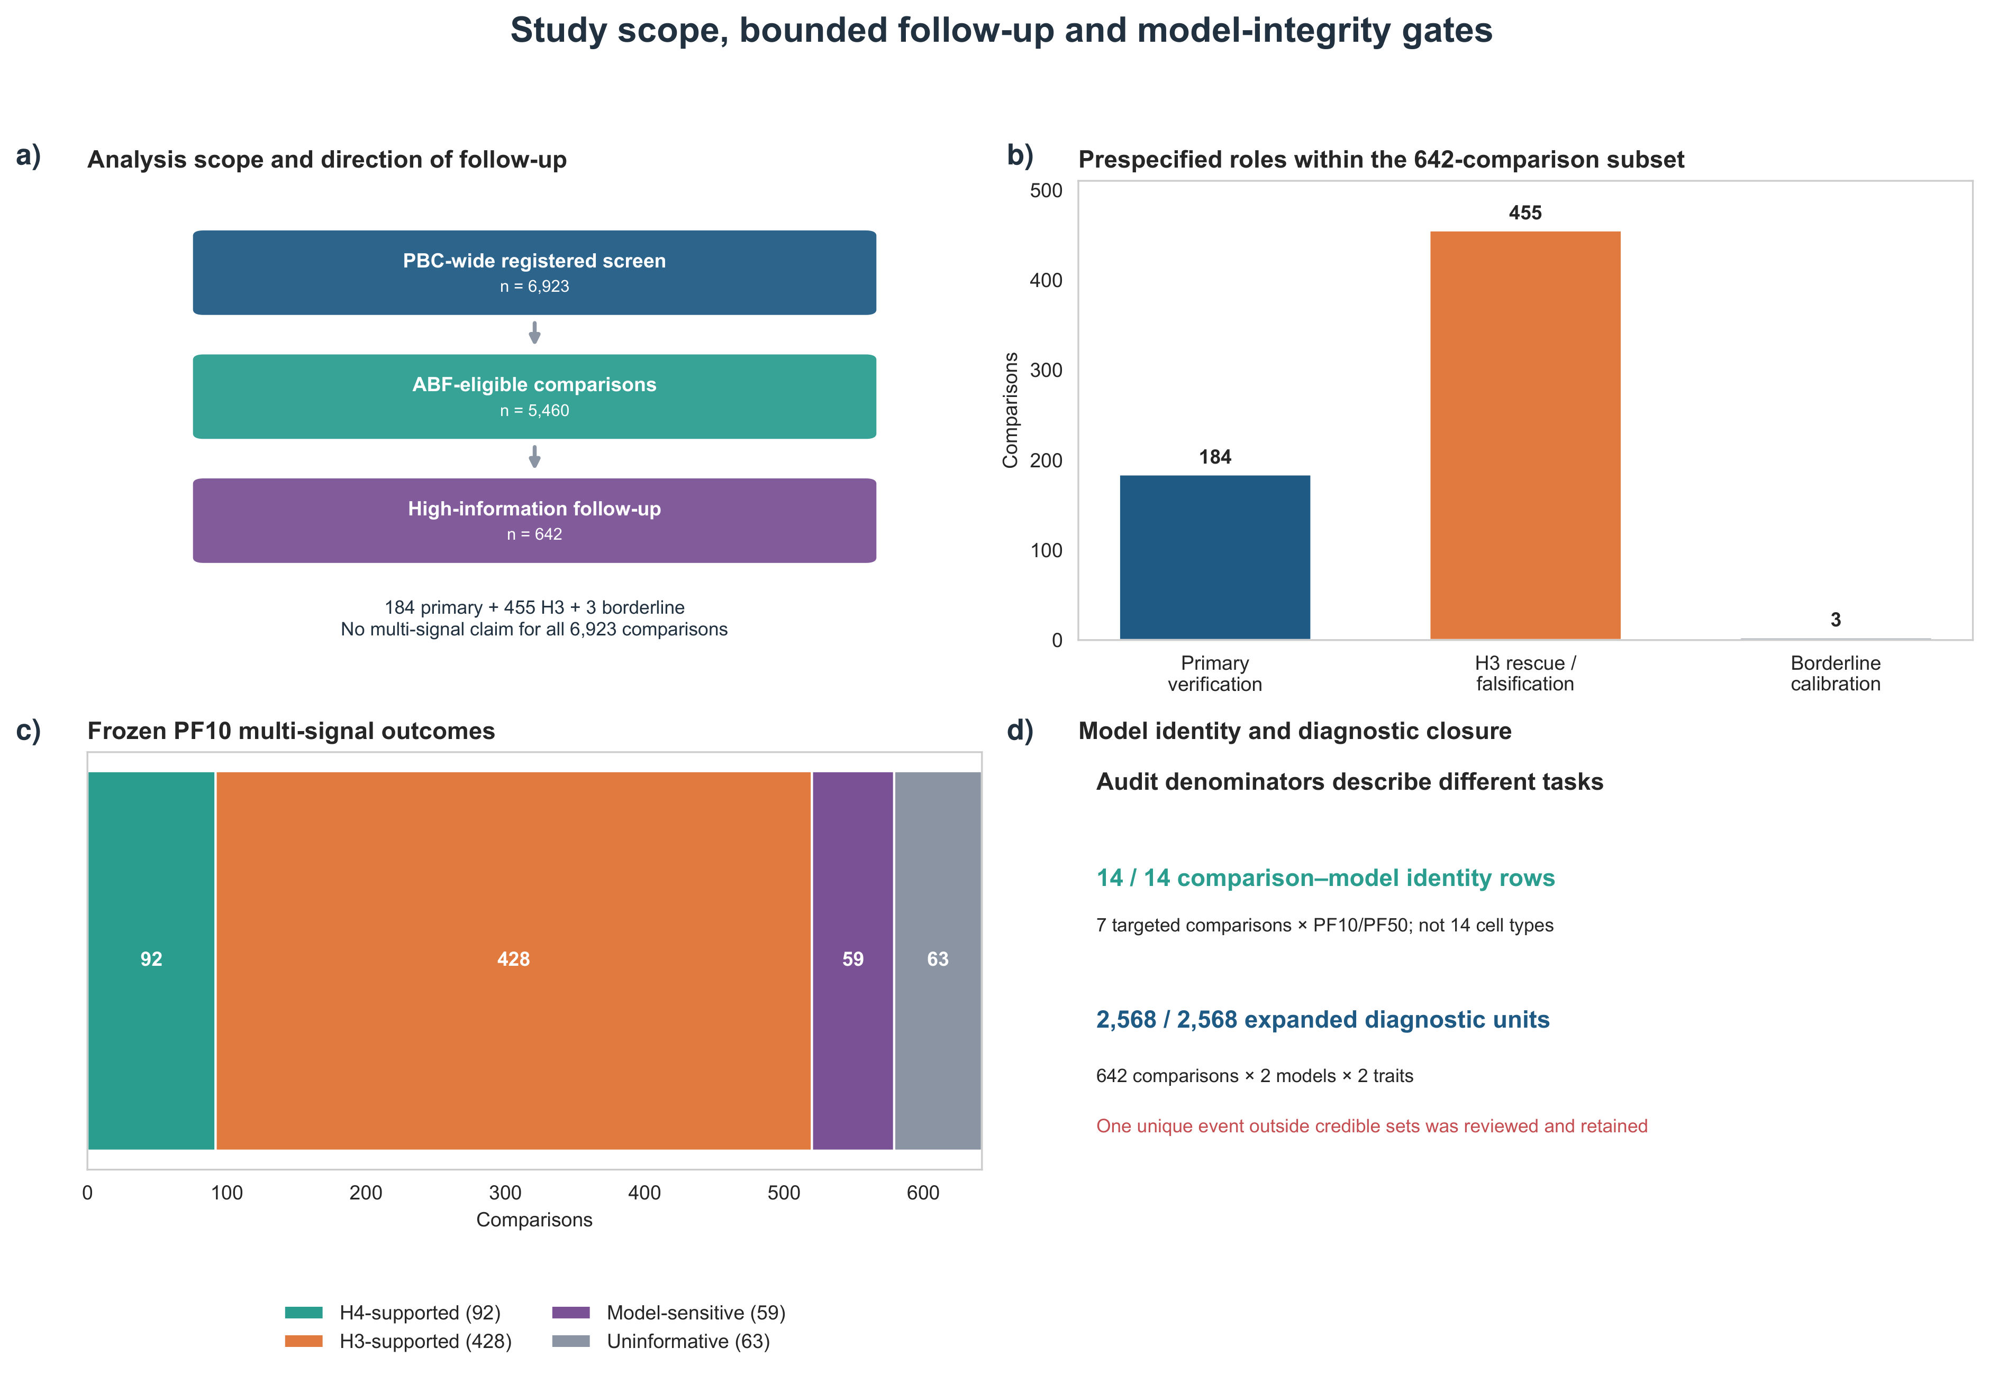
Figure 1. Study scope, bounded follow-up and model-integrity gates. (a) The frozen registry contained 6,923 locus–gene–cell comparisons; 5,460 were ABF-eligible, and 642 entered the high-information multi-signal analysis. (b) The 642 comparisons consisted of 184 primary H4/ambiguity triggers, 455 H3-focused falsification comparisons and three borderline cases. (c) Primary PF10 multi-signal outcomes were H4 support (92), H3 support (428), model-sensitive (59) or uninformative (63). (d) The initial identity gate evaluated 14 comparison–model rows from seven targeted comparisons, whereas the expanded kriging audit evaluated 2,568 comparison–model–trait units. These are different counting units, not numbers of cell types. One qualifying kriging event was reviewed and retained without a diagnostic-triggered refit.
Abbreviations: ABF, approximate Bayes factor; CS, credible set; H3, different-signal hypothesis; H4, shared-signal hypothesis; PF10, model with ten expression factors; PBC, primary biliary cholangitis; PF50, model with 50 expression factors.

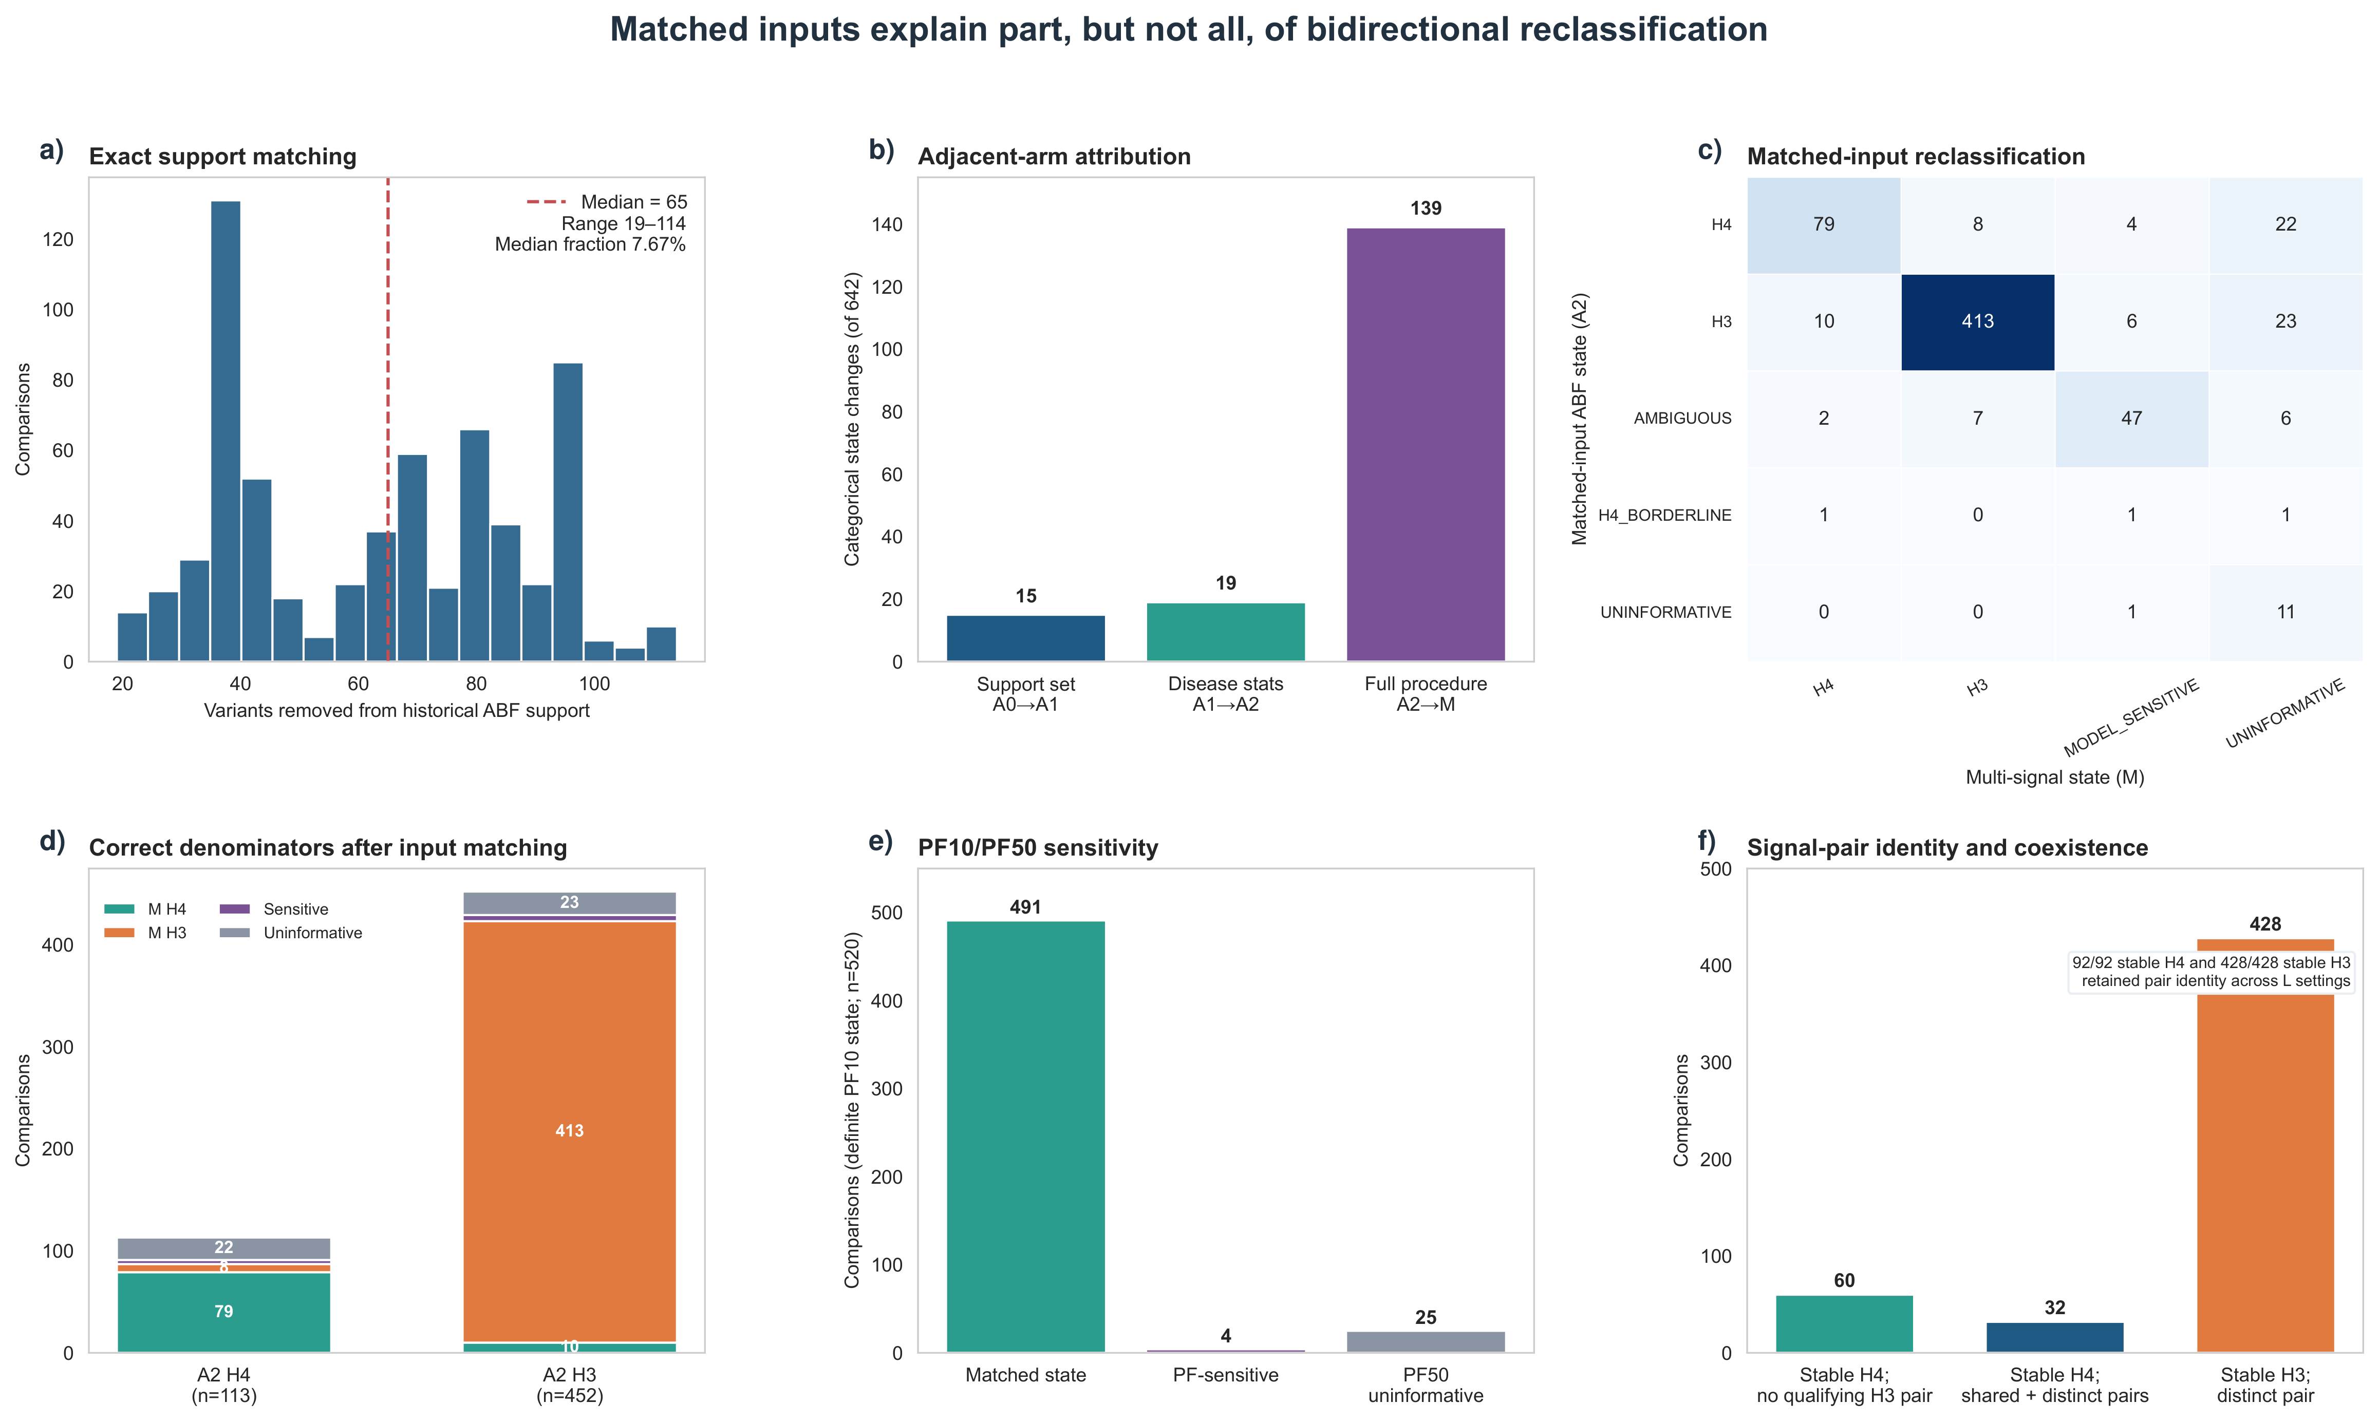
Figure 2. Matched inputs explain part, but not all, of bidirectional reclassification. (a) Across all 642 comparisons, restricting the historical single-causal ABF variant set (S_A) to the actual multi-signal intersection (S_M) removed 19–114 variants (median 65). (b) A0→A1 and A1→A2 changed 15 and 19 categorical states, respectively; affected comparisons may overlap, so the totals are not additive. (c) Full A2→M transition counts on the same disease-statistic definition and variant intersection; M retains the frozen PF10 multi-signal model. (d) Of 113 A2 H4 comparisons, 79 retained H4 and eight had stable H3 support; of 452 A2 H3 comparisons, ten gained H4 support. These are model-state transitions, not known-truth error rates. (e) PF10/PF50 agreement was assessed only among 520 comparisons with definite PF10 H4/H3 status: 491 matched, four differed and 25 were PF50-uninformative. (f) Of 92 H4-supported comparisons, 60 had no qualifying H3 pair and 32 also had a qualifying distinct-signal pair under the frozen thresholds.
Abbreviations: A0, historical ABF; A1, support-set-matched ABF; A2, support- and disease-statistic-matched ABF; M, frozen multi-signal analysis; H3/H4, alternative colocalization hypotheses; L, maximum number of SuSiE effects; PF10/PF50, models with ten/50 expression factors.

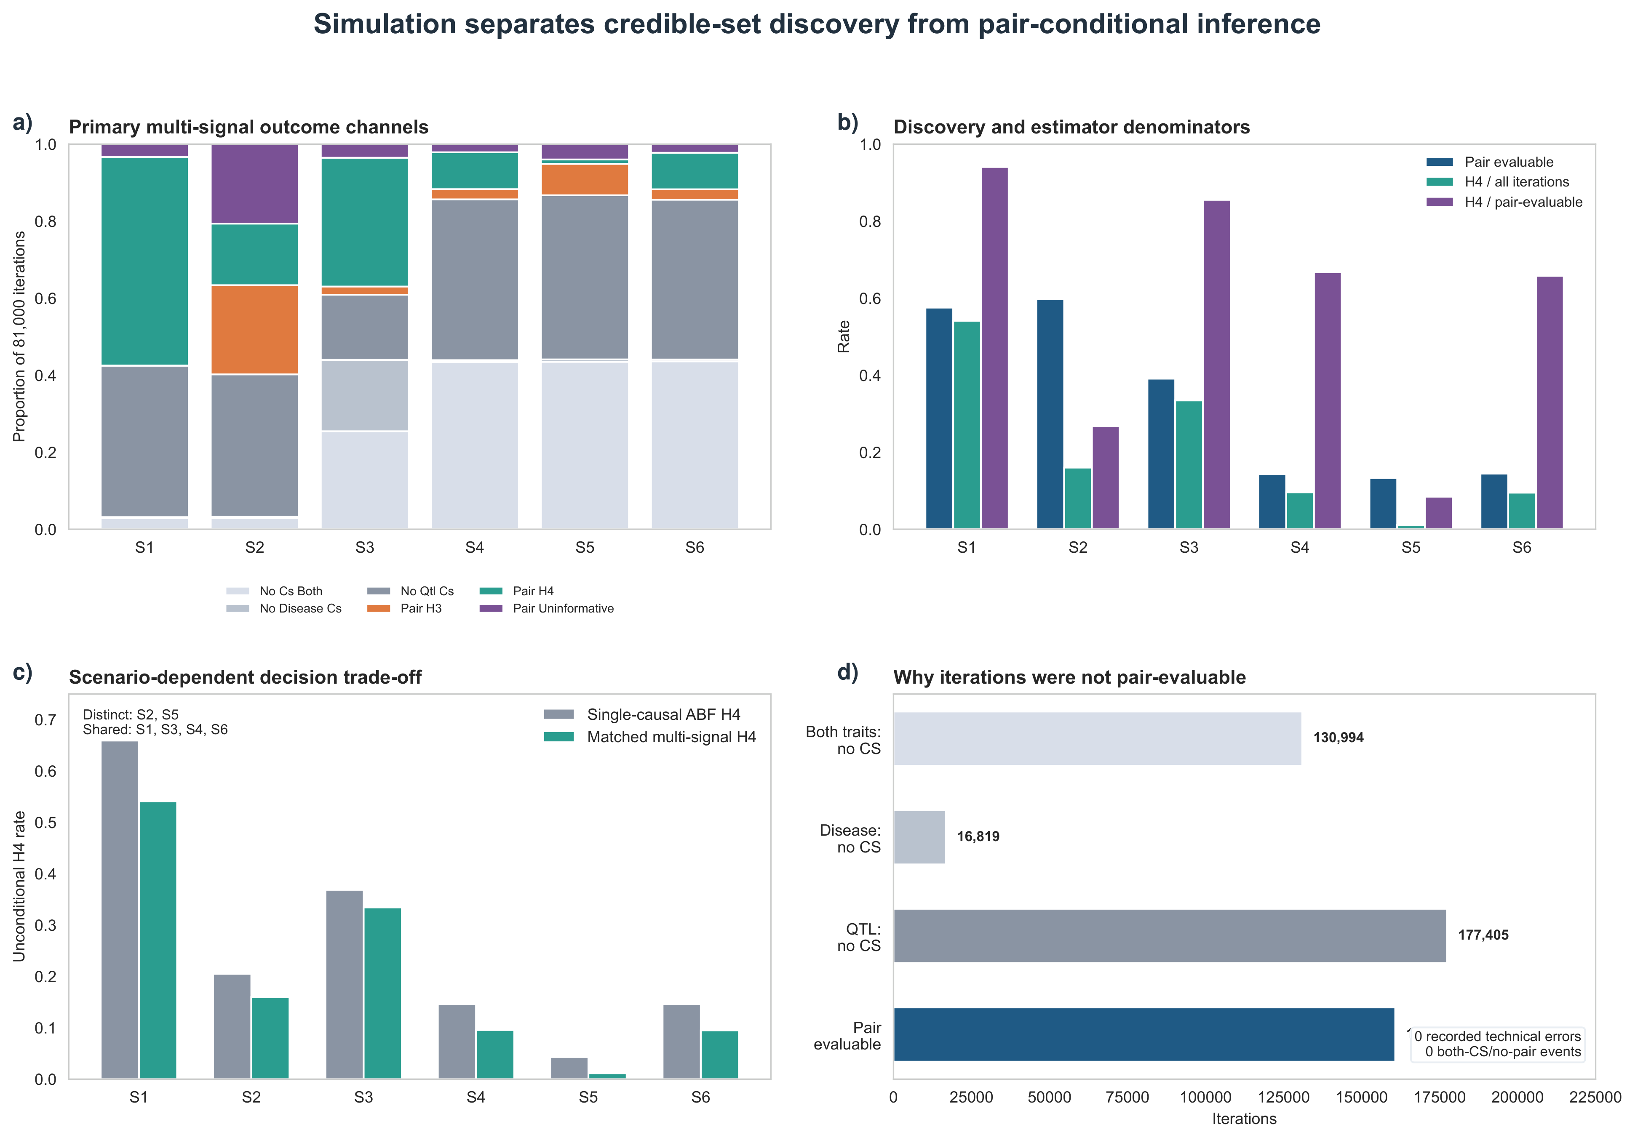
Figure 3. Simulation separates credible-set discovery from pair-conditional inference. The primary simulation comprised 486,000 iterations across six frozen scenarios using two empirical 128-variant LD templates. (a) Scenario-specific outcome channels, separating lack of a disease/QTL credible set from an evaluable signal pair. (b) Pair-evaluable rate and unconditional versus pair-conditional H4 decision rates. Across all iterations, 160,782 (33.08%) produced an evaluable signal pair. (c) Unconditional H4 decisions from single-causal ABF and matched multi-signal analysis; S2 and S5 have distinct causal signals, whereas the other four scenarios include a shared signal. A lower false-H4 rate coincided with lower shared-signal recovery. (d) Aggregate reasons for non-evaluable iterations. The primary matched branch recorded no technical errors or instances where both traits had credible sets but no evaluable pair. These results evaluate single-configuration components, not the complete cross-L/low-prior decision gate.
Abbreviations: CS, credible set; H4, shared-signal hypothesis; LD, linkage disequilibrium; S1–S6, six prespecified simulation architectures defined in Methods; QTL, quantitative-trait locus.

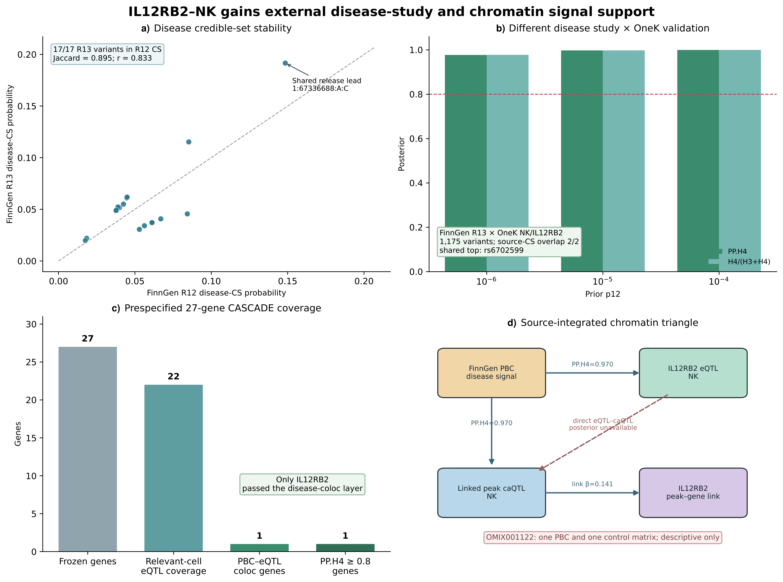
Figure 4. IL12RB2–NK gains external disease-study and chromatin support within bounded claims. (a) Comparison of source disease credible-set members and inclusion probabilities in the FinnGen R12 and R13 IL12RB2 region. (b) FinnGen R13 PBC summary statistics evaluated against the frozen OneK1K NK-cell IL12RB2 QTL using single-causal colocalization over the prespecified p12 sensitivity series. The disease study systems differ, but participant-level non-overlap was not established, and this is not a second multi-signal QTL-side analysis. (c) Prespecified 27-gene CASCADE resource-coverage assessment, with disease–eQTL colocalization reported only where returned. (d) PBC–eQTL, PBC–caQTL and peak–gene evidence shown as separate inferential edges. A direct eQTL–caQTL posterior and mediation estimate were unavailable. OMIX001122, containing one processed PBC and one control matrix, was used only for descriptive detectability, not independent spatial replication. Arrows denote reported association or peak-gene links, not the direction of a causal effect.
Abbreviations: caQTL, chromatin-accessibility quantitative-trait locus; CS, credible set; eQTL, expression quantitative-trait locus; PBC, primary biliary cholangitis; p12, prior probability of shared association; NK, natural killer cells; PP.H4, posterior probability of the shared-signal hypothesis.

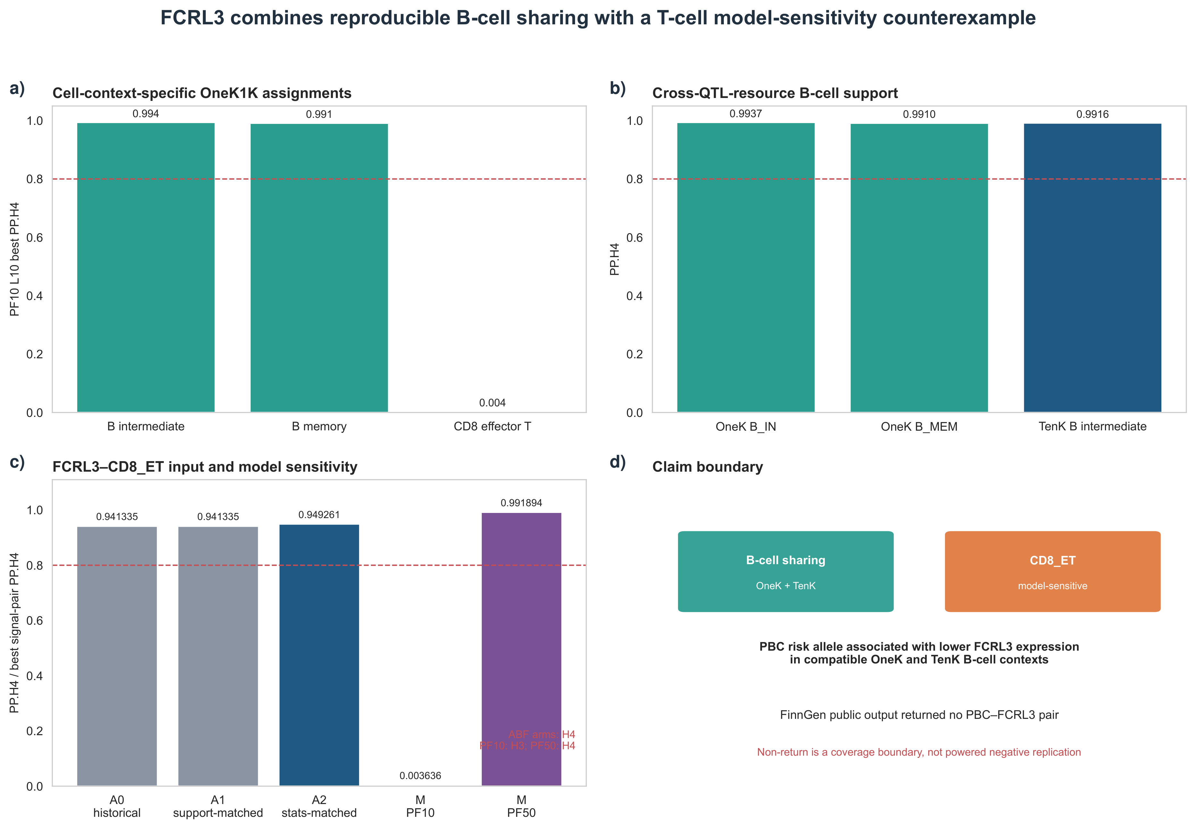
Figure 5. FCRL3 combines reproducible B-cell sharing with a T-cell model-sensitivity counterexample. (a) Representative cell-context-specific best signal-pair PP.H4 values in current-release OneK1K PF10 analysis, including intermediate B, memory B and CD8 effector T cells. (b) Molecular-QTL resource support in OneK B-cell contexts and TenK intermediate B cells; disease GWAS was reused in the TenK comparison, so this is not independent disease-cohort replication. (c) FCRL3–CD8_ET ABF posteriors from A0, A1 and A2 were 0.9413346827, 0.9413349988 and 0.9492605462, respectively. The primary PF10 multi-signal model supported H3, while the PF50 sensitivity analysis supported H4. The example therefore demonstrates a model-dependent comparison, not an unambiguous biological negative. (d) Claim boundary distinguishing B-cell sharing, CD8 context sensitivity and external data coverage.
Abbreviations: ABF, approximate Bayes factor; B_IN, intermediate B cells; B_MEM, memory B cells; CD8_ET, effector CD8 T cells; PP.H4, posterior probability of hypothesis H4; A0, historical ABF; A1, support-set-matched ABF; A2, support- and disease-statistic-matched ABF; M, multi-signal analysis; PF10/PF50, models with ten/50 expression factors.

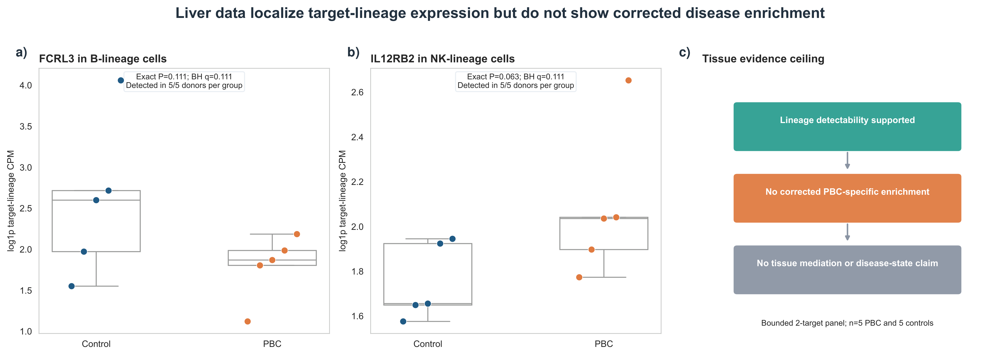
Figure 6. Liver target-lineage expression is detectable without corrected PBC-specific enrichment. (a) FCRL3 B-lineage and (b) IL12RB2 NK-lineage donor-level log1p counts per million (CPM) in five PBC and five non-lesion liver control donors; each point represents one donor, not one cell. Target–lineage pairs were detectable in all ten donors. FCRL3 was directionally lower in PBC (exact P=0.1111), and IL12RB2 was directionally higher (exact P=0.06349), but neither passed two-target Benjamini–Hochberg correction (both q=0.1111). (c) Evidence boundary: lineage observability does not demonstrate case-specific expression enrichment, genetic mediation or a therapeutic mechanism. Controls were non-lesion liver samples from hepatic hemangioma surgery rather than disease-free population controls. Boxes show the interquartile range, centre lines the median, and whiskers extend to the most extreme observations within 1.5 times the interquartile range. All donor observations are overlaid.
Abbreviations: BH, Benjamini–Hochberg procedure; CPM, counts per million; PBC, primary biliary cholangitis. Exact two-sided tests use all 252 possible assignments of five donors to the PBC group.

Supplementary information
Supplementary Information provides the data dictionary and file map. Supplementary Data 1 contains ten worksheet views (S1-S10). Source Data 1 supplies the complete primary machine-readable tables, including the full screening, signal-pair and simulation records; Source Data 2 supplies the external disease-study and chromatin evidence family (S11). These files contain aggregate, shareable outputs and do not redistribute donor genotypes or source BAMs.

