Supplementary Information
Article: Input matched multisignal colocalization clarifies regulatory assignments at primary biliary cholangitis loci
Authors: Zhi Chen; Teng Qi
This document defines the units, provenance and interpretation limits for the S1-S12 evidence families. Supplementary Data 1 contains ten worksheet views (S1-S10); complete row-level tables are supplied in Source Data 1. The S11 external-evidence family is supplied in Source Data 2, rather than an eleventh worksheet. Worksheet and archive labels are cross-referenced below. The S12 disease-N robustness family is supplied in Source Data 3.

Supplementary upload files
- Supplementary Data 1 — Supplementary_Data_1_Tables_S1-S10.xlsx. Editable workbook view of Supplementary Tables S1–S10; the complete large row-level tables remain in Source Data 1.
- Source Data 1 — Source_Data_1_Primary_Machine_Readable_Data.zip. Full primary source-derived TSV/TSV.GZ/JSON tables and a release-level checksum manifest.
- Source Data 2 — Source_Data_2_External_Regulatory_Evidence.zip. Bounded S11 external disease-study, CASCADE, chromatin and OMIX evidence tables; no complete mediation claim.
- Source Data 3 — Source_Data_3_Disease_N_Robustness.zip. Frozen 33-comparison effective-N stress test, disease credible-set identity audit and machine-readable decision state.

Supplementary table legends and interpretation notes

Evidence family S1. Source and accession manifest.
Data-source manifest: accession, provider, version, availability, licence and source/derived-data hashes. It is a provenance catalogue, not an additional cohort. File map: Supplementary Data 1, worksheet S1; Source Data 1, S1/.

Evidence family S2. PBC-wide screening registry.
PBC-wide screening registry: all 6,923 locus–gene–cell comparisons, including 5,460 ABF-eligible and 1,463 coverage-insufficient rows. Rows are comparisons rather than independent genetic discoveries. File map: Supplementary Data 1, worksheet S2; Source Data 1, S2/.

Evidence family S3. Matched-input analysis of the fixed 642 comparisons.
Frozen 642-comparison A0/A1/A2/M trajectories: 184 primary triggers, 455 H3-focused tests and three borderline comparisons. Original screening labels and matched-input classifications are recorded separately. File map: Supplementary Data 1, worksheet S3; Source Data 1, S3/.

Evidence family S4. Support-set membership and alignment audit.
Source-variant membership and identity: S_{A} and S_{M} sizes, removed variants, allele alignment, ordered-variant SHA-256 and model/source identities. Equal counts do not establish equal variant identity. File map: Supplementary Data 1, worksheet S4; Source Data 1, S4/.

Evidence family S5. Source-matched LD and SuSiE diagnostics.
Source-matched QTL LD, fine-mapping and model diagnostics: PF10 primary versus PF50 sensitivity, SuSiE convergence, credible-set metrics and kriging adjudication, including retained reviewed flags. File map: Supplementary Data 1, worksheet S5; Source Data 1, S5/.

Evidence family S6. Signal-pair posterior and cross-configuration semantics.
All eligible signal-pair posteriors, prior sensitivity, cross-L identity matching and mixed H4/H3 structures. An H3-supporting pair does not establish absence of a different H4-supporting pair. File map: Supplementary Data 1, worksheet S6; Source Data 1, S6/.

Evidence family S7. Simulation and estimation channels.
Simulation parameters and outcomes: six truth-known scenarios, 486,000 matched-branch iterations, no-CS/no-pair/error channels, unconditional and pair-evaluable denominators. Single-configuration results do not directly calibrate the composite decision gate. File map: Supplementary Data 1, worksheet S7; Source Data 1, S7/.

Evidence family S8. Cross-resource molecular-QTL evidence.
Cross-resource molecular-QTL evidence, risk-allele direction and FinnGen public results. Correlated FinnGen cell strata from one resource are not independent cohort replications. File map: Supplementary Data 1, worksheet S8; Source Data 1, S8/.

Evidence family S9. Liver donor-level expression.
Donor-level HRA008003 expression and exact five-versus-five liver comparison: target–lineage CPM, permutation P values, two-target BH q values and sensitivity summaries. Biological replication unit is the donor. File map: Supplementary Data 1, worksheet S9; Source Data 1, S9/.

Evidence family S10. Claim-evidence ledger and Methods–Results mirror.
Claim–evidence ledger and the Methods–Results mirror: distinguish background, association, robust association, unavailable evidence and causal/mechanistic claim ceilings. File map: Supplementary Data 1, worksheet S10; Source Data 1, S10/.

Evidence family S11. External disease-study and chromatin evidence.
External disease and chromatin-validation module in Source Data 2: FinnGen R12/R13 disease-CS, FinnGen R13 × OneK NK/IL12RB2 sharing, fixed CASCADE coverage, partial chromatin edges and OMIX descriptive limits. Not a new gene-screen or complete mediation chain. File map: Source Data 2, data/; the constituent files retain source-stage names for provenance.

Evidence family S12. Disease sample-size source identity and robustness.
The primary disease N=24,510 reproduces the source GJOKA SuSiE-RSS convention. A prespecified secondary stress test used Neff=21,584.38 in 33 high-risk comparisons across 14 loci. All 33 final classifications, all four manuscript key axes and all 164 disease credible-set membership records were unchanged; the largest absolute PF10 L=10 best-PP.H4 change was 1.63×10⁻⁴. This bounded analysis is neither a correction to the primary model nor a new validation cohort. File map: Source Data 3.

Data sharing and claim ceiling
The workbook and the three Source Data archives reproduce only derived, aggregate and source-licensed shareable material. Donor genotypes, source BAMs, pseudobulk matrices and third-party licensed archives are not redistributed. Neither high posterior support nor detectable tissue expression establishes expression mediation, biological mechanism or clinical utility. All reported hypothesis and model numbers retain their frozen definitions, and the corresponding manifests identify source releases.
The figure and panel columns in the preserved S10 workbook and source ledgers refer to the historical manuscript layout. The companion Supplementary_Editorial_Panel_Crosswalk.tsv maps all 27 historical C-series claims and ten MR-series Methods–Results records to the current figures or text. Current editorial claim IDs use an E-series namespace. Historical C17 retains its earlier positional chromatin ceiling; the S11 regional disease-caQTL evidence updates that ceiling without establishing mediation. Scientific source values and the original workbook/ZIP bytes remain unchanged.

Source-version interpretation
The S8 tables preserve the earlier molecular-resource and position-based chromatin audit. The later fixed-scope S11 query returned disease-caQTL colocalization at the linked IL12RB2 peak and supersedes that earlier positional ceiling. Both versions remain archived; current chromatin interpretation uses the S11 regional edges and retains the unavailable direct eQTL-caQTL posterior. A top variant missing from one peak credible set is not equivalent to absence of regional disease-caQTL sharing.
S5 contains 2,568 comparison-configuration fit rows (642 comparisons × four fine-mapping configurations). The separate corrected kriging audit contains 2,568 comparison-model-trait units (642 × two models × two traits). The targeted source-identity gate contains 14 comparison-model rows from seven comparisons. Equal counts describe different objects and must not be merged.

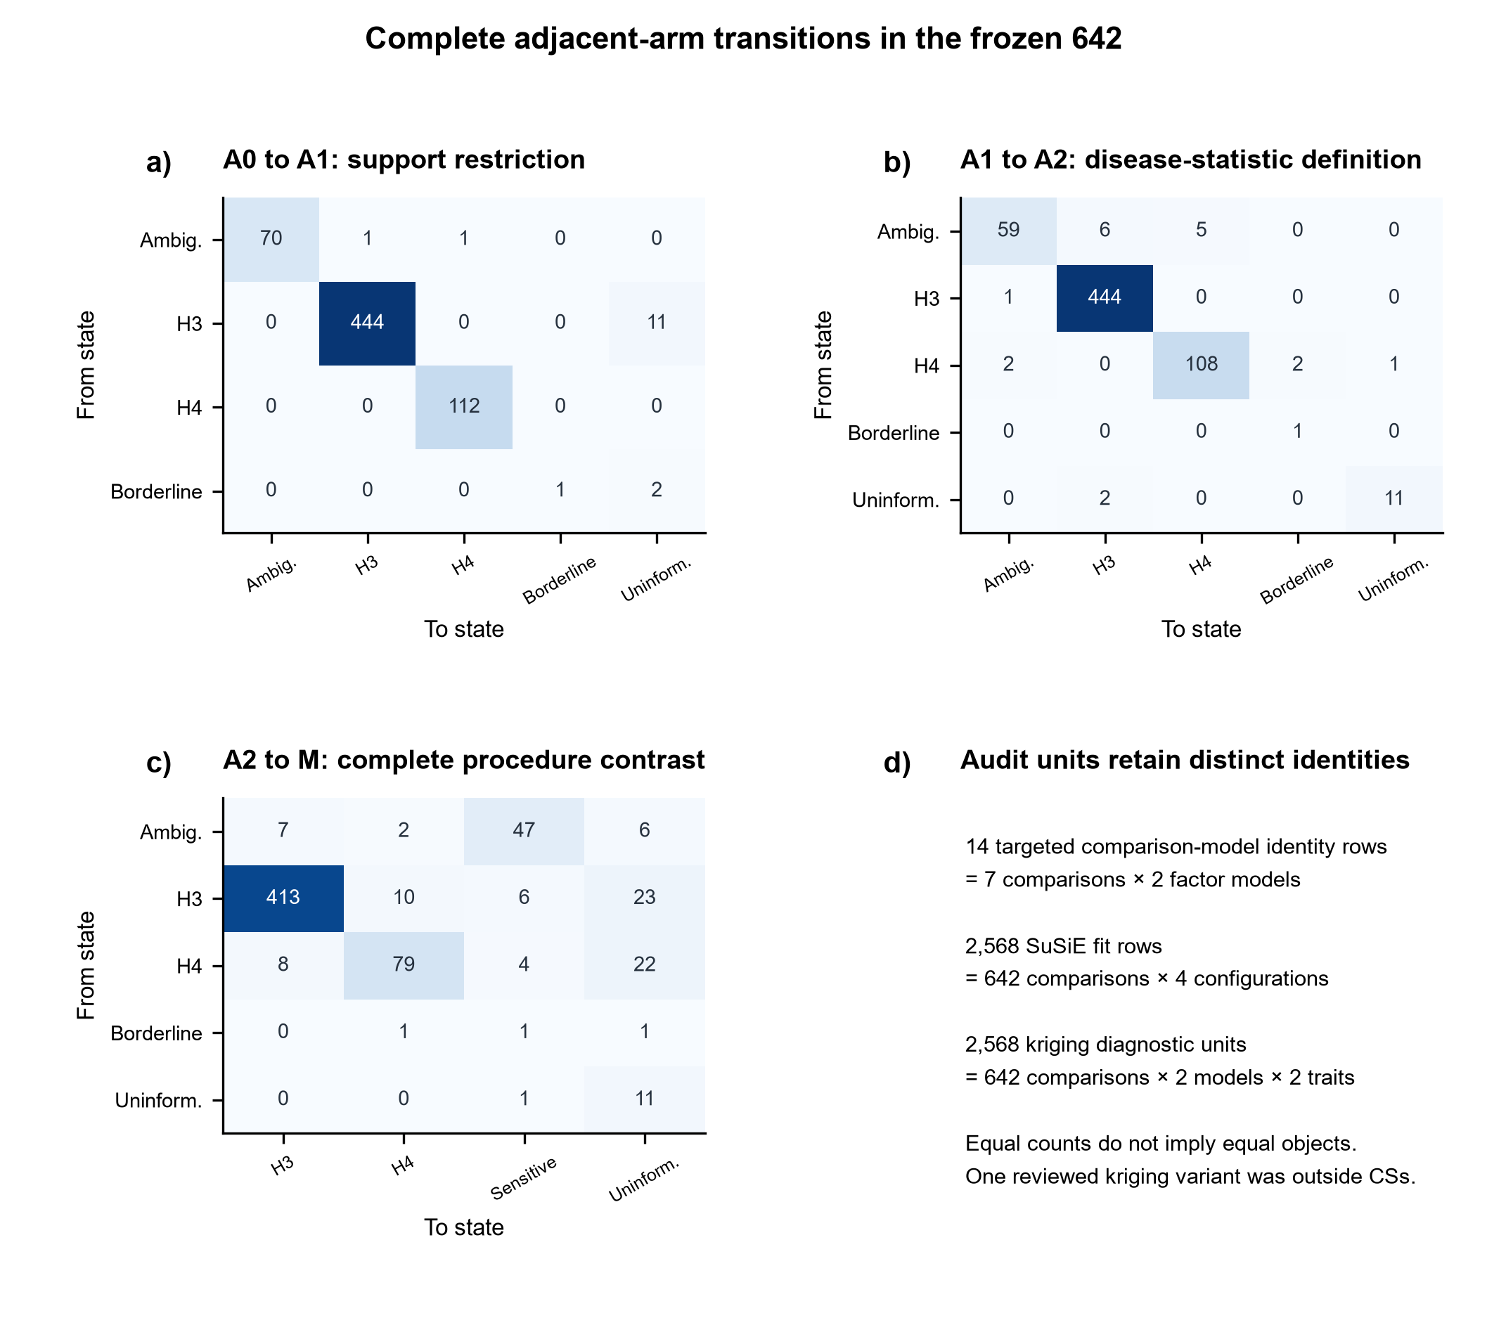
Supplementary Figure S1. Complete adjacent-arm transitions in the frozen 642 comparisons. Panels a-c show A0-to-A1 support restriction, A1-to-A2 disease-statistic replacement and A2-to-M complete-procedure contrast. Counts include all states, not only H4/H3 reversals. Panel d distinguishes targeted model identity, four-configuration SuSiE fit rows and two-model/two-trait kriging units. One reviewed kriging variant was outside the credible sets and did not trigger refitting.

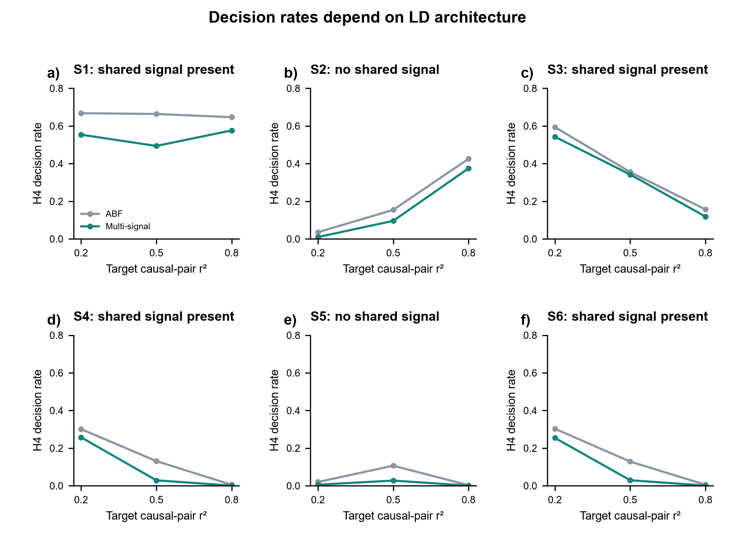
Supplementary Figure S2. Decision rates depend on LD architecture. Panels a-f correspond to S1-S6 defined in Methods. Unconditional ABF and matched multi-signal H4 rates are weighted by replicate counts within each target causal-pair r-squared level, averaging the frozen MAF, L, prior and template grid. In S2/S5 the H4 decision is false sharing; in the other scenarios it is shared-signal recovery. These are finite-grid component rates, not prevalence estimates or calibration of the full composite gate.

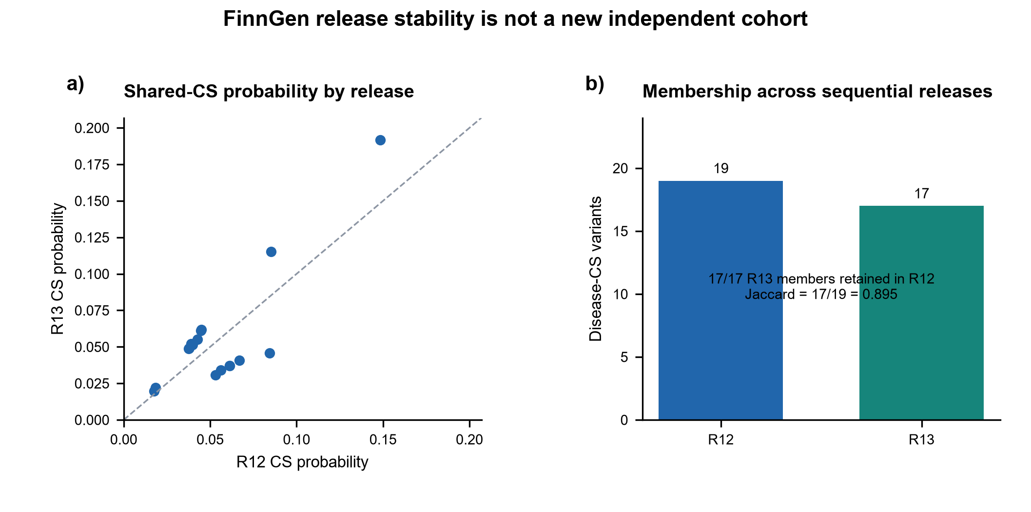
Supplementary Figure S3. FinnGen release stability is not a new independent cohort. Panel a compares source credible-set probabilities for the 17 members shared by R12 and R13; the two R12-only members are outside this scatter. Panel b uses the full source-set sizes: 19 R12 versus 17 R13 disease credible-set members; all 17 R13 members occur in R12 (Jaccard 17/19). Sequential releases are correlated and are not two independent disease replications.

