Supplementary information

Interferon remodeling remains reproducible despite less stable B cell state assignments in systemic lupus erythematosus
Authors: Zhi Chen and Teng Qi

Supplementary overview
This single Supplementary Information file contains Tables S1-S9 and Figures S1-S10 supporting the main Article. All analytical methods required to interpret the work are reported in the main manuscript. Machine-readable figure source data, regulator sensitivity results and complete statistical outputs are supplied separately as Supplementary Data 1-3. Original external-mapping sensitivity outcomes are superseded, and no corrected disease effect was estimated after calibration failed.

Supplementary Table S1 | Dataset roles and inferential units
Resource | Role | Biological unit | Active scope
GSE174188 | Discovery and internal replication | Sample-cohort stratum; donor sensitivities | Disease-blind B_CONV/B_ASC analysis scaffold, composition and B_CONV transcription
GSE135779 | Independent SLE replication | Donor | Broad conventional-B analogue; childhood primary
CollecTRI/OmniPath | Curated regulator prior | Ranked genes within contrast | Prespecified eight-regulator, three-contrast family
MSigDB M5911 | Orthogonal response prior | Ranked genes within contrast | Hallmark interferon-alpha response enrichment
GSE23307 | Orthogonal perturbation support | Paired profile within donor | Descriptive IFN-beta response, n=2 donors

Supplementary Table S2 | Claim boundaries
Supported | Not supported
Disease-blind B_CONV/B_ASC analysis scaffold with quantified boundary sensitivity | Universally reproducible B_CONV/B_ASC taxonomy or stable hard naive, memory or atypical subtypes
Primary B_ASC contrast lacks statistical support | General B_ASC expansion in SLE
Replicated IFN/ISG remodeling within B_CONV | Genome-wide shared disease transcriptome
ULM STAT1/STAT2 activity concordant across three contrasts | Causal TF activation or direct binding
IFN-centred response evidence | A unique initiating IFN ligand in SLE

Supplementary Table S3 | Quantitative anchors and prespecified boundaries
Analysis | Result
Frozen-representation identity policy | minimum mapped ARI 0.990; minimum agreement 0.9998; minimum state-median Jaccard 0.991
End-to-end identity sensitivity | prespecified criterion not met; minimum mapped ARI 0.930; minimum agreement 0.9988; B_ASC median Jaccard 0.930 below 0.95 criterion
Boundary propagation | primary B_ASC odds-ratio range 0.896-0.967, all intervals include one; primary B_CONV IFN/ISG range 0.836-0.845, all intervals above zero
Primary B_ASC composition | 43 controls and 47 source-defined managed SLE; odds ratio 0.947; 95% CI 0.636-1.410; P=0.787
GSE174188 primary IFN/ISG | effect 0.837; 95% CI 0.525-1.148; q=2.98 x 10^-6
GSE174188 donor-nonoverlap IFN/ISG | effect 1.086; q=3.61 x 10^-4
GSE135779 childhood IFN/ISG | effect 1.042; 95% CI 0.681-1.402; q=2.98 x 10^-6
Cross-dataset genome-wide agreement | 4,410 genes; Spearman rho=0.026
M5911 enrichment | NES 3.187, 3.050 and 3.527
GSE23307 perturbation | donor effects 3.294 and 3.666; 12/12 genes positive in each

Supplementary Table S4 | Regulator-sensitivity summaries
a, Correlation-aware core-regulator sensitivity
Contrast | Regulator | Matched targets | Inter-gene correlation | CAMERA BH q | FRY BH q
GSE174188 primary | STAT1 | 98 | 0.0362 | 0.0263 | 6.043e-06
GSE174188 primary | STAT2 | 14 | 0.1225 | 0.1355 | 4.909e-05
GSE174188 donor-nonoverlap | STAT1 | 129 | 0.0209 | 0.0263 | 8.49e-06
GSE174188 donor-nonoverlap | STAT2 | 19 | 0.1191 | 0.0263 | 4.277e-07
GSE135779 childhood | STAT1 | 161 | 0.0301 | 0.0263 | 2.685e-05
GSE135779 childhood | STAT2 | 20 | 0.1223 | 0.03026 | 1.231e-05

CAMERA and FRY directions were positive in all six tests. CAMERA passed BH correction in five of six; the explicit exception was GSE174188 primary STAT2 (q=0.1355). FRY passed BH correction in all six.
b, IFN-overlap-depletion summary
Depletion | Method | Positive direction | Dedicated q<0.05 | Main qualification
Prespecified 12-gene IFN/ISG arm | ULM | 6/6 | 6/6 | Minimum slope retention 53.5%; all 95% confidence intervals above zero
Prespecified 12-gene IFN/ISG arm | CAMERA | 6/6 | 5/6 | Discovery STAT2 q=0.326
Prespecified 12-gene IFN/ISG arm | FRY | 6/6 | 6/6 | Direction and corrected support retained
M5911 | ULM | 6/6 | 5/6 | Discovery STAT2 retained 8/14 targets; slope 0.391, 95% CI -0.745 to 1.526; q=0.500
M5911 | CAMERA | 6/6 | 2/6 | Broad attenuation across contrasts; discovery STAT2 q=0.623
M5911 | FRY | 6/6 | 5/6 | Discovery STAT2 q=0.099

All 11 depleted ULM models retaining at least ten targets preserved direction in every leave-one-target analysis. These sensitivities support robustness beyond the narrow 12-gene arm but not independence from the broader interferon-response transcriptome.

Supplementary Table S5 | Selected figure source-data map
Figure | Evidence basis | Machine-readable source
Figure 1 | Disease-blind identity stability, two-compartment adjudication and end-to-end B_ASC boundary | Figure1_source_data.csv
Figure 2 | Sample-level composition in the 43-control/47-managed-SLE primary comparison | Figure2_source_data.csv
Figure 3 | Raw-count pseudobulk transcription with explicit tested-gene symbols | Figure3_source_data.csv
Figure 4 | Source-label-defined GSE135779 replication, gene-level coherence and required calibration boundary | Figure4_source_data.csv
Figure 5 | Regulatory convergence, IFN-overlap-depletion ceiling and orthogonal response evidence | Figure5_source_data.csv
Supplementary Figure S4 | End-to-end identity boundary and downstream propagation | Supplementary_Figure_S4_source_data.csv
Supplementary Figure S8 | Corrected reference calibration and unresolved external transfer | Supplementary_Figure_S8_source_data.csv
Supplementary Figure S10 | STAT1/STAT2 IFN-overlap-depletion sensitivity | Supplementary_Figure_S10_source_data.csv

Supplementary Table S6 | Reproducibility record
Component | Reader-accessible record
Main and supplementary figure data | Supplementary Data 1 with SHA-256 manifest
Complete statistical results | Supplementary Data 3 with 12 gene-level branches and 12 sanitized design matrices
Correlation-aware sensitivity | Supplementary Data 2
End-to-end identity and boundary propagation | Supplementary Data 3, identity_robustness/
Analysis code and decisions | https://github.com/1209433622cz-maker/sle-bcell-remodeling
Environment reconstruction | Pinned scientific and release environments documented in REPRODUCIBILITY.md
Version-specific archive | Zenodo https://doi.org/10.5281/zenodo.22151739; version-specific archive of the released analysis code, Source Data and statistical outputs

Supplementary Table S7 | Statistical tests and multiplicity families
Result family | Biological unit | Test or estimator | Sidedness | Multiplicity | Role
B_ASC composition | Sample-cohort stratum | Beta-binomial Wald | Two-sided | BH across three prespecified base contrasts | Primary composition inference
Gene-level expression | Sample-cohort pseudobulk (GSE174188); donor pseudobulk (GSE135779) | edgeR robust quasi-likelihood F | Two-sided | BH within tested genes per contrast | Gene-level inference
Four prespecified programs | Sample-cohort pseudobulk (GSE174188); donor pseudobulk (GSE135779) | OLS with HC3 | Two-sided | BH across four programs per analysis | Program inference
TF-target activity | Ranked gene statistics | Signed-target slope t test | Two-sided | Global BH across 24 tests | Confirmatory regulatory evidence
STAT1/STAT2 sensitivity | Ranked gene statistics | CAMERA and FRY | Positive-direction | Separate BH families of six per method | Correlation-aware sensitivity
STAT1/STAT2 overlap depletion | Ranked gene statistics and pseudobulk counts | ULM, CAMERA and FRY | Two-sided ULM; positive-direction CAMERA/FRY | Separate BH family of six per branch and method | Additional sensitivity
End-to-end identity reproducibility | Cell resample within technical library | ARI, AMI, mapping agreement, state Jaccard and recall | Not tested | Five unchanged threshold criteria | Disease-blind robustness boundary
Broad-state boundary propagation | Sample-cohort stratum | Frozen beta-binomial and TMM logCPM/HC3 models | Two-sided intervals | No new multiplicity family; same-data sensitivity | Assignment-uncertainty sensitivity
M5911 | Ranked gene statistics | 10,000-permutation preranked test | Positive-direction | Descriptive BH across three contrasts | Orthogonal support
GSE23307 | Paired donor | Mean paired log2(x+1) effect | Not tested | None; n=2 | Descriptive perturbation

Supplementary Table S8 | Full statistical-results archive map
Directory | Contents | Files
gene_level_results | Complete filterByExpr gene results for GSE174188 and GSE135779 branches | 12
sanitized_design_matrices | Direct-identifier-free analysis designs | 12
composition | Frozen coefficients, contrasts, predictions, sensitivities, leave-one-out and diagnostics | 8
transcription | Program, ranked-list, influence and concordance results | 18
regulatory_and_orthogonal | ULM, target influence, CAMERA/FRY, M5911 and GSE23307 summaries | 9
statistical_framework | Machine-readable test and multiplicity map | 1
identity_robustness | Aggregate and replicate-level end-to-end identity metrics, boundary propagation results and integrity records | 101
external_mapping_calibration | Corrected feature and parameter tables, full confidence-calibration family, aggregate selection diagnostics, provenance, arithmetic recount and publication boundary | 20

Supplementary Table S9 | Reference-calibrated external mapping boundary
Component | Corrected diagnostic | Interpretation
External input | 56 matrices; 363,083 cells | Complete source matrix coverage
External QC and selection | 353,527 QC-passing cells; 36,630 B-lineage candidates | No source labels or disease fields parsed
Reference training | 13,000 B_CONV and 1,300 B_ASC; 258 donors; 601 features | Both algorithms share reference and features
Normalization | Full-library log1p(CP10K) before feature subsetting in both datasets | Corrects reference feature-only denominator
Elastic-net calibration | Diagnostic threshold 0.95; coverage 0.941958; B_CONV precision 0.996450; B_ASC precision 0.885210 | No eligible candidate: state precision must be at least 0.90 and coverage at least 0.80
Centroid calibration | Margin 0.117767; coverage 0.95; B_CONV precision 0.992374; B_ASC precision 1.0 | Eligible, but cannot replace required primary mapper
Mean reference-fold balanced accuracy | Elastic net 0.960569; centroid 0.950293 | Calibration diagnostics; not independent performance estimates
Outcome policy | Corrected disease outcomes not estimated | No corrected effect, confidence interval, P or q value exists
Prior outcome exposure | Original sensitivity outcomes were known before correction | Post-outcome correction; not prospective validation
Evidence boundary | Primary GSE135779 replication remains source-label-defined | Superseded uncorrected outcomes excluded from supporting evidence

Full candidate calibration, donor-grouped cross-validation, reference normalization audit and corrected input/prediction hashes are retained with the analysis code. The original source-label-defined pseudobulk effect is a standardized HC3 model estimate; the unexecuted sensitivity would instead compare donor mean cell-level log1p(CP10K) scores. They are different estimands and must not be compared as effect attenuation. No new multiplicity family was evaluated after corrected calibration failed.

Supplementary Table S10 | Uncertainty-method sensitivity for one frozen B_CONV IFN contrast
Additional measurement-rule sensitivity: methods. In the frozen 68-donor common-support subset (31 controls and 37 source-defined managed-SLE donors), the original pooled-count score was calculated from summed raw IFN counts divided by each donor's full captured-UMI library total (CPM). For the paired fixed-profile score, five within-bin linear full-library CPM profiles were combined using the frozen normal-control pi_ref weights before the same 12-gene log2(CPM + 0.5) T0 transformation and standardization using the fixed 43-control reference means and population SDs. Their within-donor score difference was regressed on the same four original columns: intercept, managed-SLE indicator, age-centred covariate and frozen ethnicity indicator. HC3 variance and the two-sided t(64) critical value were used for the already observed coefficient difference. The G2C interval method was developed after the positive WP1 contrast was known, then evaluated in an independent synthetic validation (40 frozen scenarios: 30 applicable and 10 boundary reports) before the write-once real-data interval. The simulation result qualifies this one interval only within the tested generating regimes and does not qualify other WP2 targets.
Additional measurement-rule sensitivity: results. On these same 68 donors the adjusted managed-SLE coefficient differed by 0.034925002 T0 units between fixed-profile and pooled-count scoring, equal within numerical precision to the previously observed RP v3 WP1 A1-A0 contrast. The earlier paired-percentile 95% bootstrap interval was 0.013789-0.057130 (2,000 paired donor resamples). The subsequent HC3-t(64) analysis of the identical contrast had a standard error of 0.011559, a 95% interval of 0.011834-0.058016, and a nominal two-sided P value of 0.003612. The procedures share the same donor outcomes, definition, reference and four-column design and must not be counted as independent confirmations.
Interval procedure (same contrast) | Estimate (T0 units) | 95% confidence interval | Interpretive status
WP1 paired percentile bootstrap; 2,000 donor resamples | 0.034925 | 0.013789 to 0.057130 | Earlier observed result; no independent replication
Stage I donor OLS + HC3, t(64) | 0.034925 | 0.011834 to 0.058016 | Uncertainty re-estimation for the same contrast; nominal P = 0.003612
Table S10 note. Both rows describe one observed contrast and one 68-donor analysis set, not two independent studies. The original percentile interval was not qualified under the later, full ten-target G2/G2B performance contract; G2C independently qualified only the single delta_profile HC3–t(64) procedure in its prespecified simulation domains. The Stage I analysis and nominal P value are outcome-exposed relative to WP1's earlier positive result; the P value does not undo multiple-analysis selection or establish independent confirmatory status. Fixed-profile weights are based on reference cell fractions but mix within-bin observed CPM profiles, whereas pooled-count CPM is captured-UMI-weighted. This difference can reflect UMI/capture and nonlinear measurement effects; it is not a causal composition mediation effect, a cell-intrinsic response, or a clinically calibrated change. It must not be compared numerically with the original 89-pseudobulk TMM-score disease effect.

Supplementary Figure S1 | Source integrity and hard-quality-control diagnostics
a, Hard-QC failure fractions by processing cohort and disease group. b, Residual-risk call fraction versus cells per library, coloured by the library median score. c, Percent and exact number of retained risk-negative cells and sensitivity-only residual-risk calls among 150,402 hard-QC B-lineage cells. d, Median, 95th-percentile and threshold residual-risk scores for all 88 libraries.
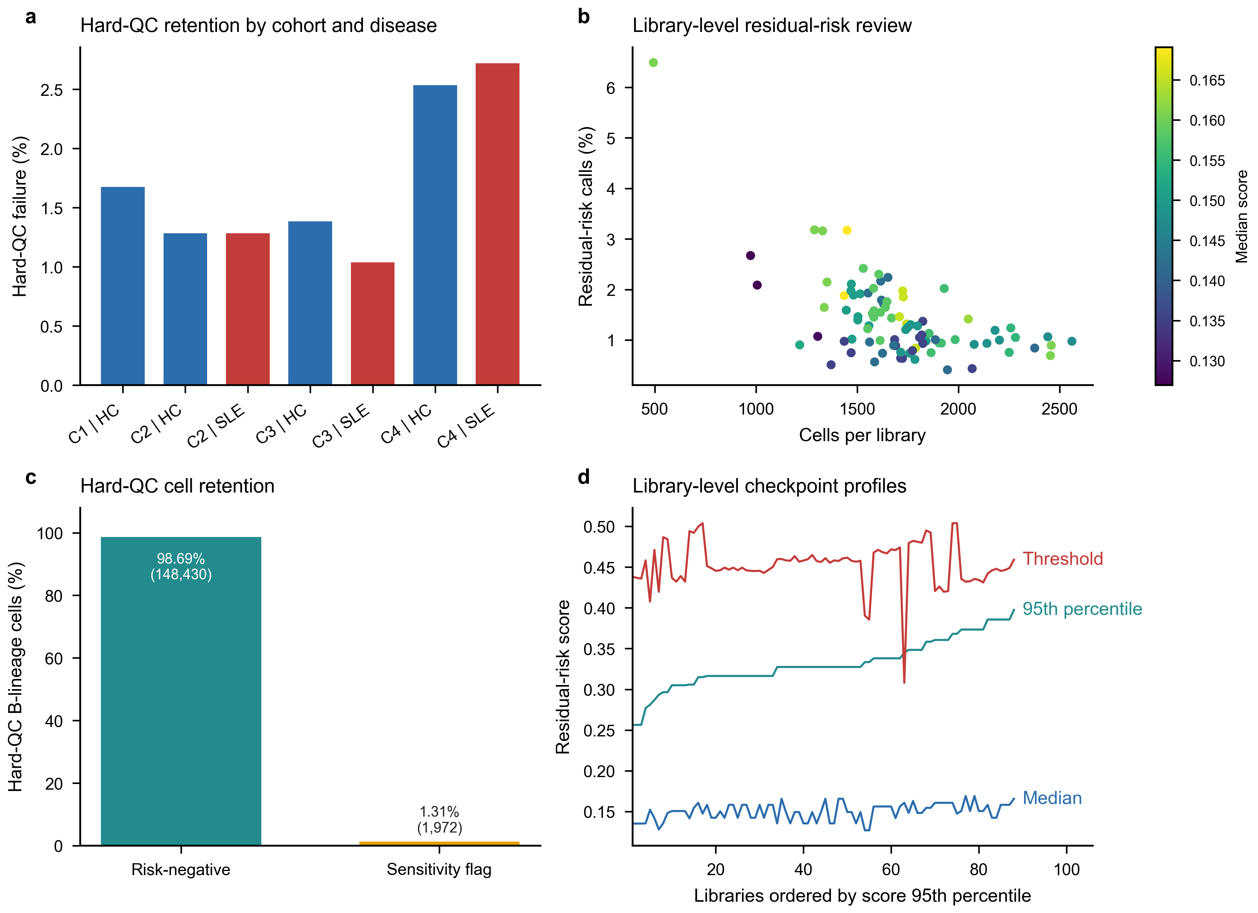

Supplementary Figure S2 | Representation and bridge diagnostics
a, Same-group neighbourhood concentration before and after Harmony adjustment. b, Cross-cohort bridge-pair cosine-distance distributions. c, Disease-blind branch concordance across Leiden resolutions for residual-risk-negative and strong-ISG-excluded branches; the vertical guide marks the primary resolution. d, Biological marker-module localization across the five fine clusters considered before stability adjudication.
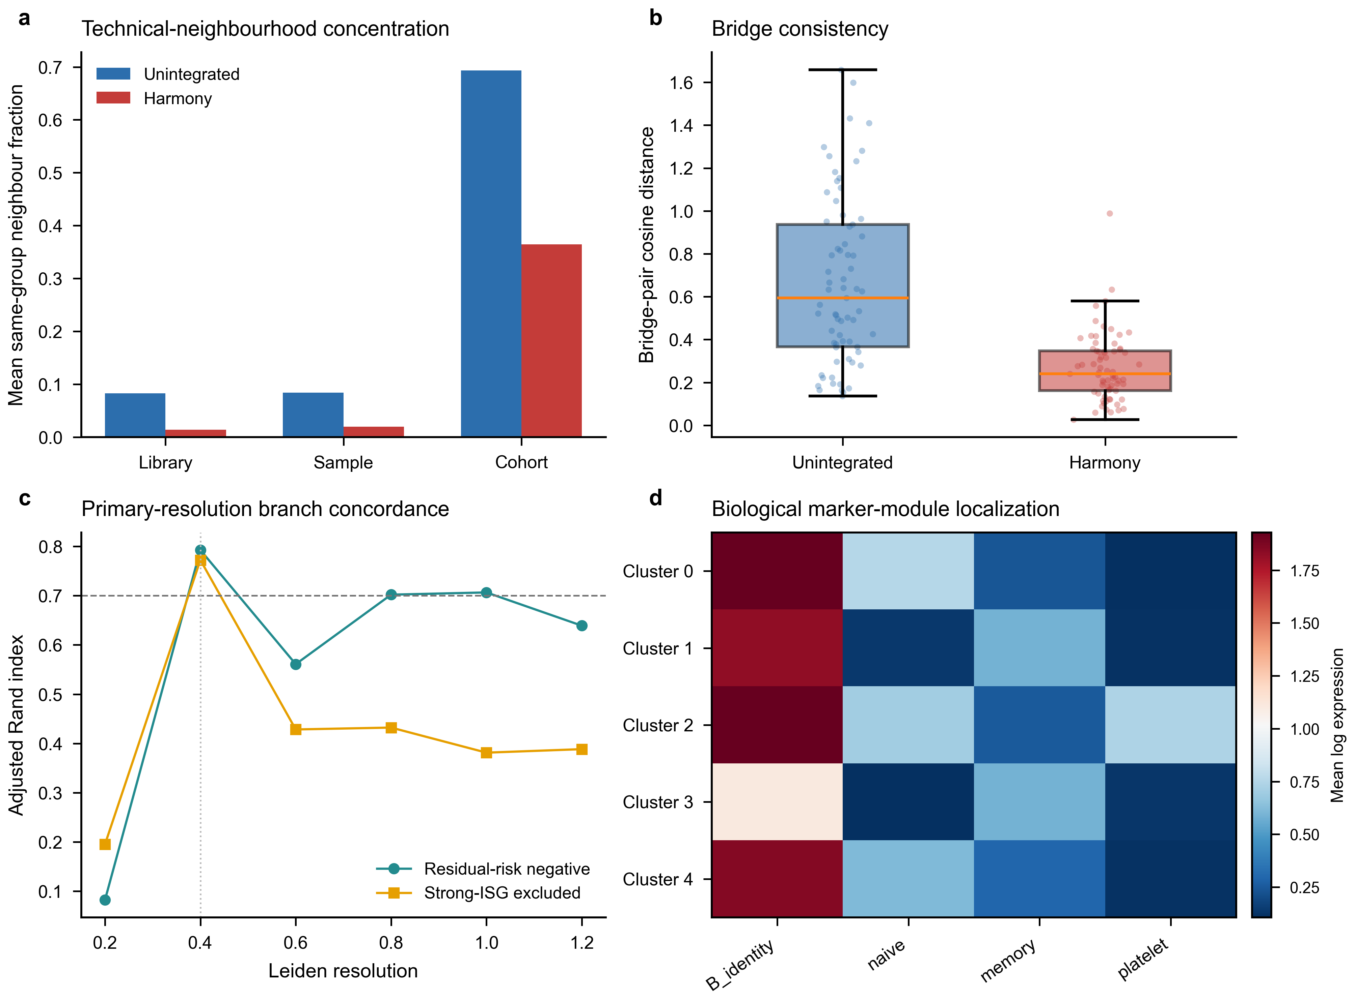

Supplementary Figure S3 | Fine-state failure and transition structure
a, Median and minimum cluster Jaccard values localize instability to fine-state membership across the five-, four- and three-state policies considered before broad adjudication. b, Mean transition matrix from original resolution-0.4 clusters to mapped reference clusters across frozen-representation resamples. These diagnostics explain the transition to the broad B_CONV/B_ASC analysis scaffold; broad-state pass criteria are shown in Fig. 1 and end-to-end reconstruction is shown in Supplementary Fig. S4. Highly variable genes, principal components and Harmony coordinates were not recomputed in this figure.
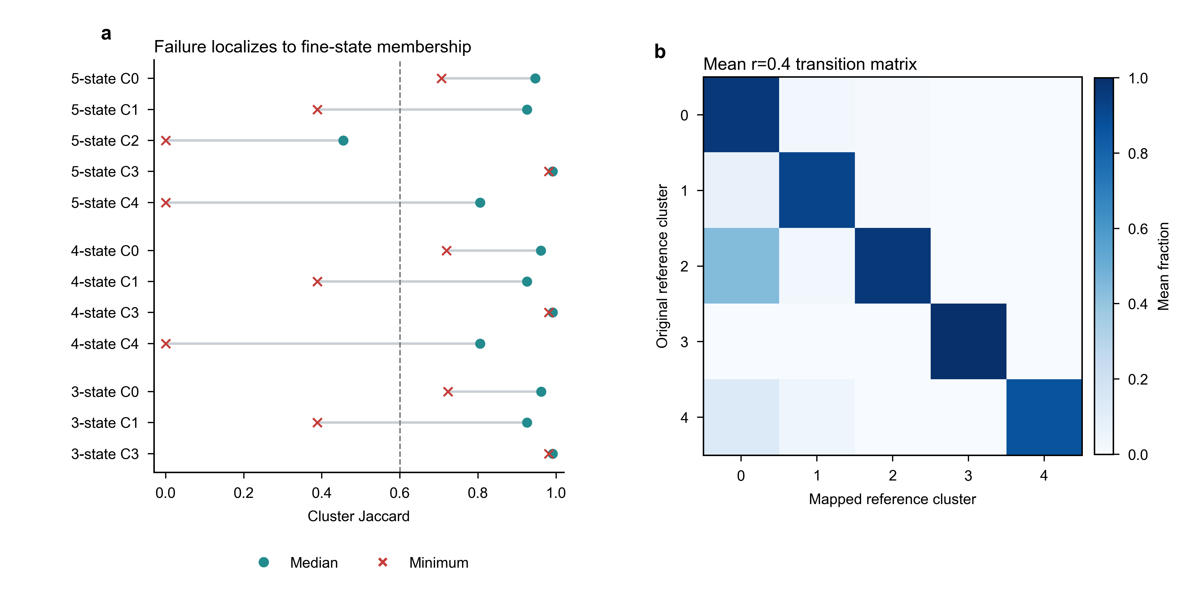

Supplementary Figure S4 | End-to-end reconstruction exposes a B_ASC-specific boundary without changing the disease conclusions
a, Observed values and prespecified criteria for five end-to-end two-compartment checks; four met their criteria and minimum state-median Jaccard did not. b, State Jaccard across 20 complete reconstruction replicates localizes the unmet overlap criterion to B_ASC, while B_CONV remains above 0.95. c, Counts of sampled cells exchanged across the B_CONV/B_ASC boundary. d, Primary B_ASC composition odds ratios and 95% confidence intervals after each observed boundary exchange; the dashed guide marks one and the orange line marks the frozen estimate. e, Primary and donor-nonoverlap B_CONV IFN/ISG effects after boundary-cell raw counts were propagated through frozen TMM logCPM and HC3 models; dotted lines mark the frozen effects. All propagation analyses reuse GSE174188 and quantify assignment sensitivity rather than independent replication.
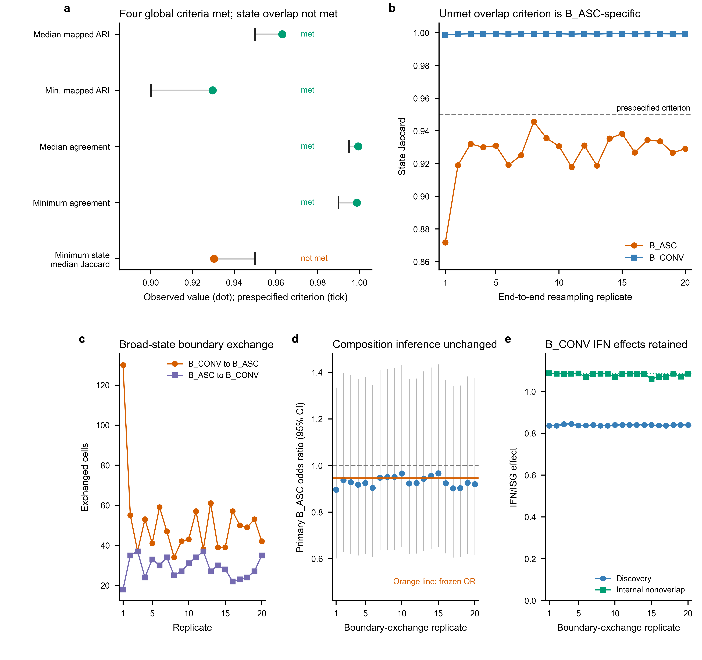

Supplementary Figure S5 | Composition-model diagnostics
a, Total and zero-ASC sample-cohort strata in the three base contrasts. b, Primary B_ASC odds ratios under support, explicit non-B and residual-risk policies using observed-information and HC1 covariance. c, Firth-logistic ASC-presence sensitivity. d, Positive-only abundance sensitivity using HC3 uncertainty. Panels c-d use logarithmic ratio axes with the null fixed at one; the two-part models are sensitivity analyses and do not replace the frozen beta-binomial primary model.
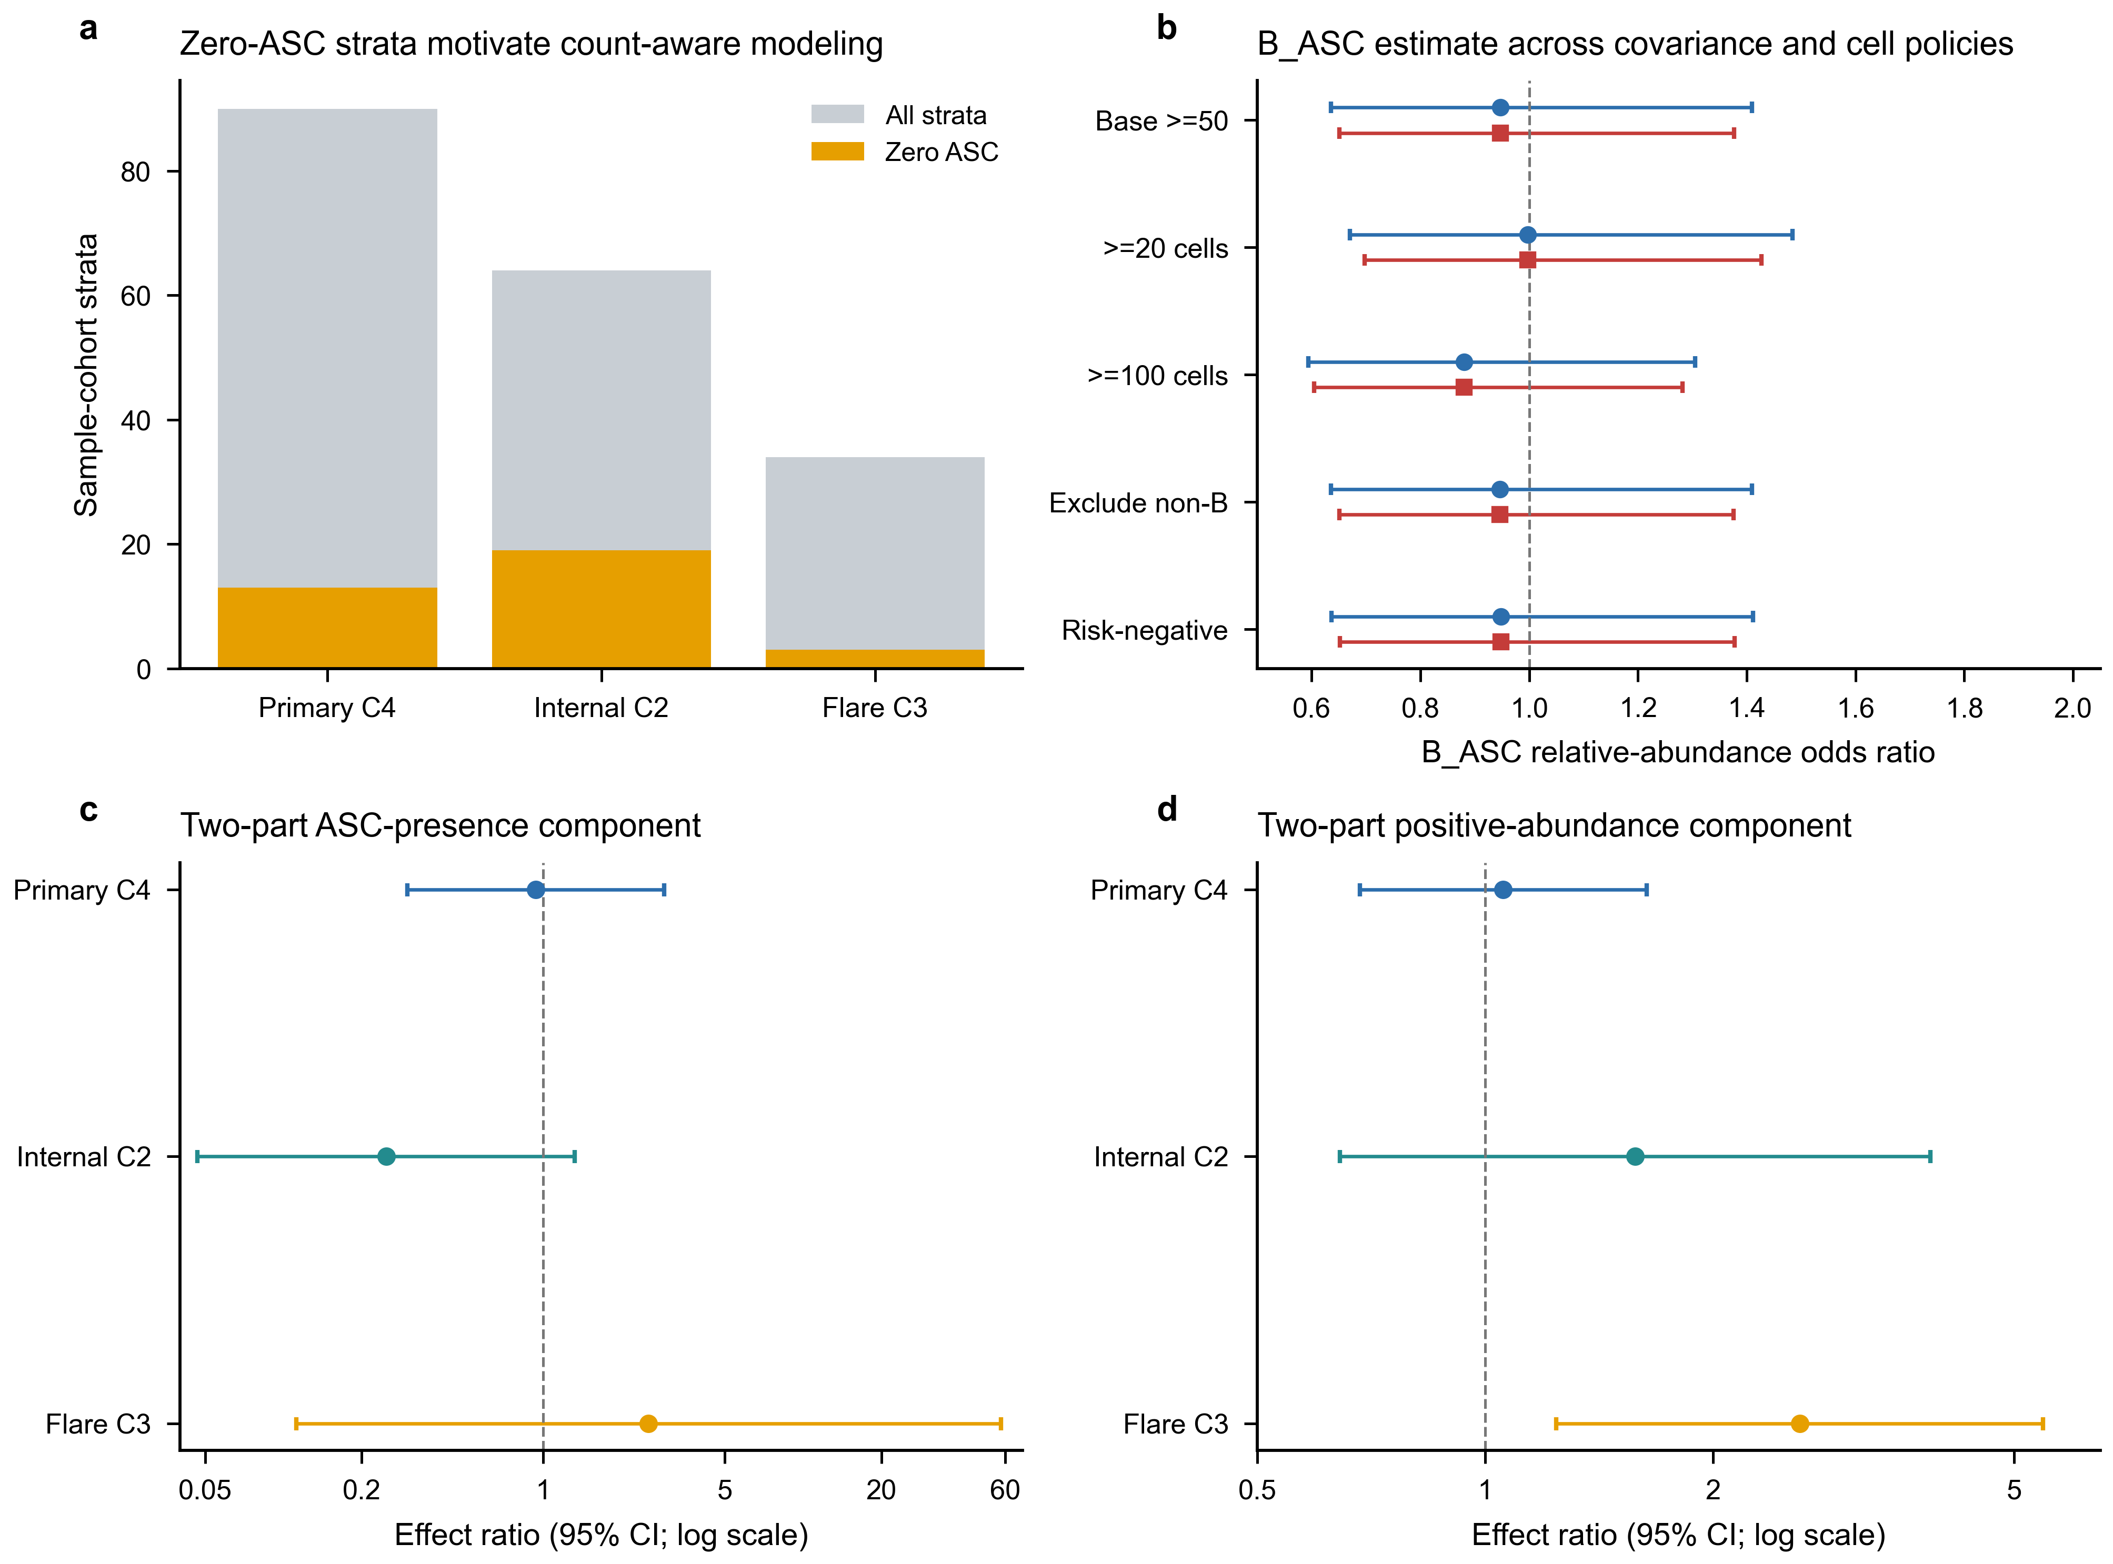

Supplementary Figure S6 | Pseudobulk and ranked-list diagnostics
a, Numbers of filterByExpr-tested and BH-significant genes across seven GSE174188 branches. b, Common and median tagwise edgeR dispersions. c, Mitochondrial, ribosomal, haemoglobin and immunoglobulin fractions among increasingly long primary ranked lists. IFN/ISG estimates across the frozen GSE174188 branches are owned by Fig. 3b and are not repeated here.
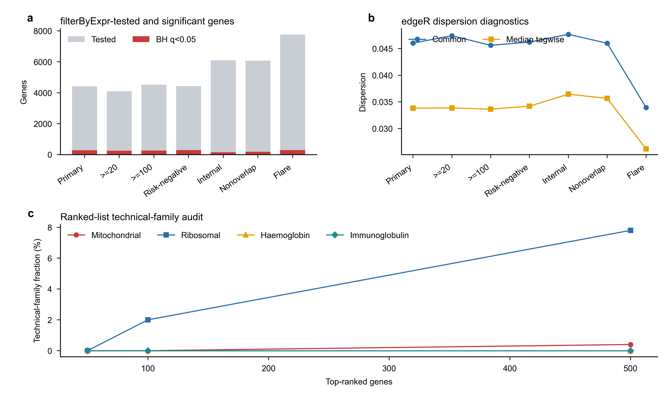

Supplementary Figure S7 | GSE135779 replication and robustness diagnostics
a, Control and SLE donor counts across the five GSE135779 models. b, Four-program childhood estimates. c, Childhood IFN/ISG estimates after omission of each source B-cell label. d, Full childhood program effects and ranges across donor-deletion analyses.
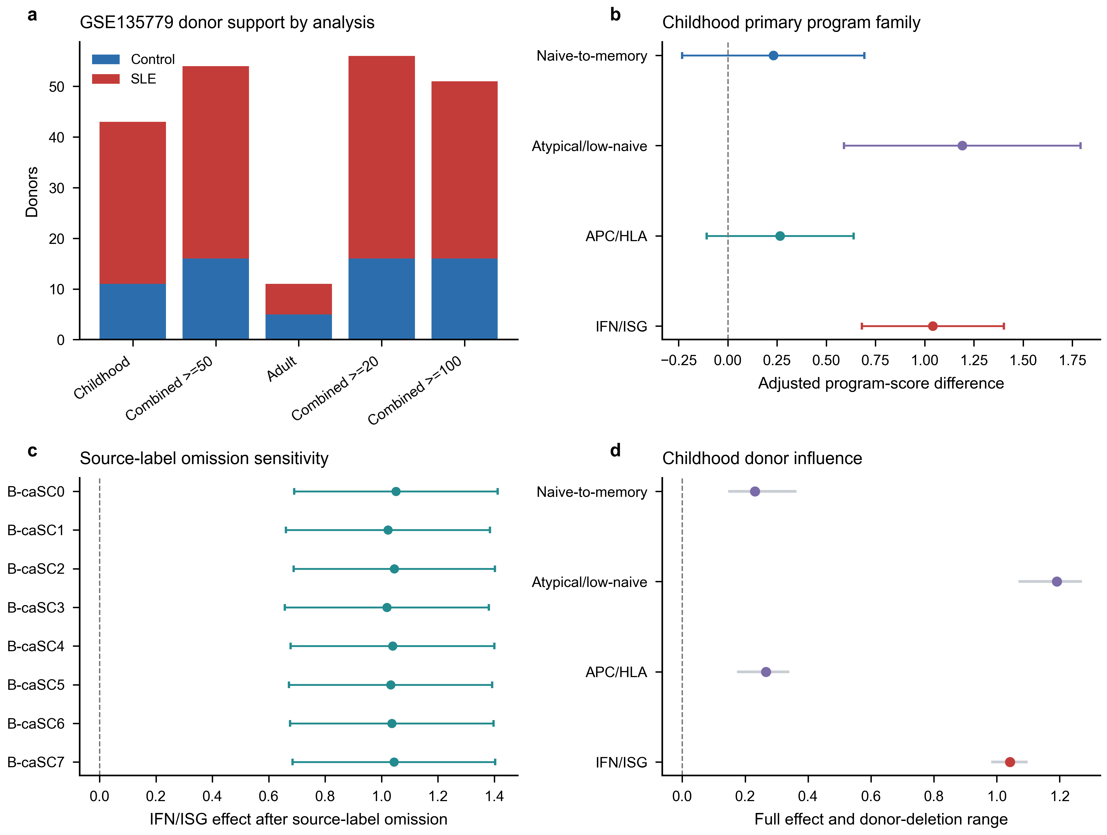

Supplementary Figure S8 | Reference calibration limits source-label-independent external transfer
a, Median and interquartile range of full-library divided by selected-feature counts among 13,000 B_CONV and 1,300 B_ASC reference training cells. This ratio quantifies the legacy pre-log scaling discrepancy; corrected mapping uses full-library denominators in both datasets. b, Per-state precision at the diagnostic elastic-net and eligible centroid thresholds. Mapper colour is held constant across panels b-d, marker shape distinguishes B_CONV from B_ASC, and the dashed line is the unchanged 0.90 state-precision criterion. c, Reference-cell coverage at those thresholds; the dashed line is the unchanged 0.80 criterion. d, Balanced accuracy in each of five donor-grouped reference calibration folds; black horizontal bars show fold means. No eligibility guide is drawn because balanced accuracy is diagnostic only. These folds select model and threshold parameters, not independent performance estimates. The elastic-net B_ASC precision failure prevents outcome access; centroid success is not a replacement analysis. No corrected external disease result is shown.
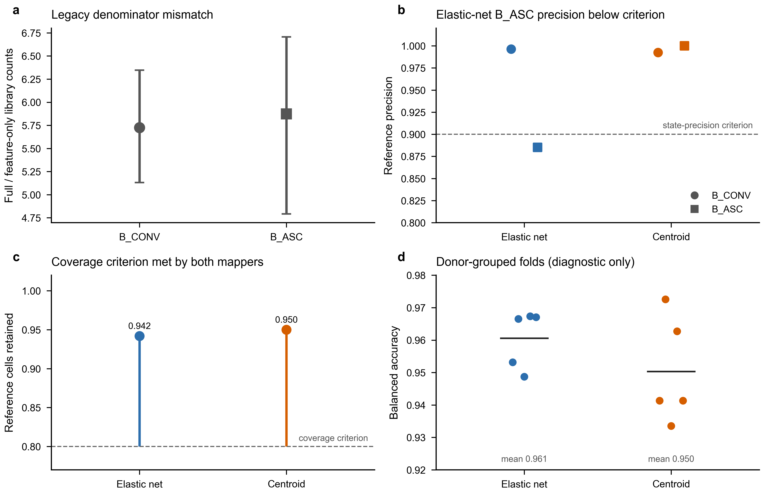

Supplementary Figure S9 | Correlation-aware regulator sensitivity
a, CAMERA and FRY six-test BH concordance for STAT1 and STAT2. Dashed guides indicate q=0.05. b, CAMERA residual-estimated inter-gene correlations. c, Exact CAMERA and FRY BH q values. d, Matched signed-target counts, which equal the frozen ULM family (STAT1: 98, 129 and 161; STAT2: 14, 19 and 20).
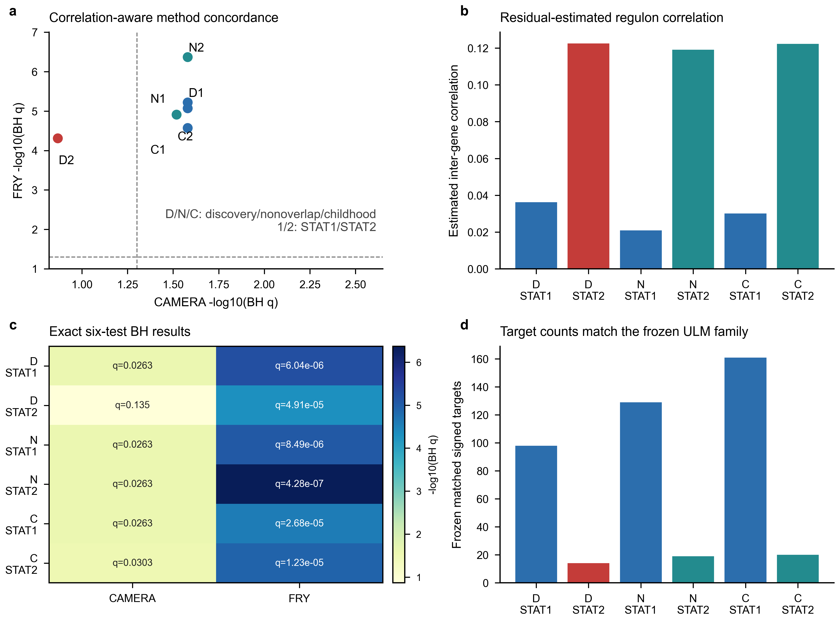

Supplementary Figure S10 | STAT1/STAT2 IFN-overlap-depletion sensitivity
a, ULM slopes and 95% confidence intervals after removal of the prespecified 12-gene IFN/ISG positive arm. b, Corresponding estimates after removal of all 97 M5911 genes; discovery STAT2 retains eight targets and its interval crosses zero. Labels report remaining matched targets. c, Exact branch- and method-specific Benjamini-Hochberg q values across the six regulator-by-contrast tests. d, Percentage of matched targets retained after each depletion. All method-level directions remain positive, but M5911 depletion produces substantial attenuation and does not support an overlap-independent interpretation.
