Supplementary information

Disease-blind single-cell reconstruction separates unstable B-cell state assignments from reproducible interferon remodeling in systemic lupus erythematosus
Authors: Zhi Chen and Teng Qi

Supplementary overview
This supplementary information reports the prespecified workflow, diagnostic analyses, statistical families and source-data structure supporting the main manuscript. Nine supplementary figures were reconstructed from frozen primary analyses and declared post-freeze sensitivity outputs. Every displayed panel is linked to machine-readable source data and exact numerical assertions; no exploratory result was promoted during preparation of this document.

Supplementary Methods 1 | Prespecification and outcome protection
The workflow used prespecified stages for source integrity, hard quality control, disease-blind identity reconstruction, sample-level composition, within-compartment pseudobulk analysis, independent validation and external regulatory evidence. Protected disease fields were separated during identity reconstruction. Disease effects were estimated only after the relevant inputs, mappings, contrasts and statistical methods had been recorded. Each stage retained a machine-readable decision and SHA-256 integrity manifest.

Supplementary Methods 2 | Identity stability boundary
Identity stability was evaluated without disease, activity, treatment or outcome fields. The initial policy-selection analysis used all 150,402 cells and the complete frozen 50-dimensional Harmony-adjusted principal-component representation. Twenty replicates were generated by selecting 80% of cells without replacement separately within each library_uuid; the target within each library was the rounded 80% count with a minimum of two cells. The recurrent highly variable genes, principal components and Harmony coordinates were not recomputed. Each replicate instead reconstructed a 15-nearest-neighbour graph from the selected frozen coordinates and reran Leiden clustering at resolutions 0.4, 0.6 and 0.8 using the leidenalg implementation.
The base seed was 20260806. For zero-based replicate r=0,...,19, within-library sampling used seed 20260806 + 1000 + r, whereas neighbour-graph and Leiden random states used 20260806 + r. Each resampled cluster was mapped to the full-data reference cluster with the largest cell overlap, using the row-wise maximum of the observed-by-reference contingency table. Stability summaries included adjusted Rand index (ARI), adjusted mutual information, majority-mapping agreement, state-level Jaccard index and recall.
At resolution 0.4, candidate policies were evaluated in a fixed order: the original five clusters; a four-state policy merging source cluster 2 into cluster 0; a three-state policy merging clusters 2 and 4 into cluster 0; and a two-compartment policy merging clusters 1, 2 and 4 into cluster 0 while retaining cluster 3 as the antibody-secreting compartment. The five-, four- and three-state candidates were required to achieve median ARI at least 0.75, minimum ARI at least 0.65, median mapping agreement at least 0.80 and minimum state median Jaccard at least 0.60; each failed at least the minimum-ARI criterion. The two-compartment policy was reconstructed from the saved disease-blind transition tables, with agreement reproduced to a maximum absolute difference of 1.11 x 10^-16, and was evaluated against stricter thresholds: median mapped ARI at least 0.95, minimum mapped ARI at least 0.90, median mapping agreement at least 0.995, minimum mapping agreement at least 0.990 and minimum state median Jaccard at least 0.95. Within the frozen representation it passed with values of 0.996, 0.990, 0.9999, 0.9998 and 0.991, respectively. The antibody-secreting compartment additionally required sample support of at least 0.90 for DERL3, JCHAIN, MZB1, TNFRSF17 and XBP1; observed support was 1.00 for every required marker. Fine naive/memory structure was therefore retained only as continuous transcriptional context rather than as hard disease-inference subtypes.

Supplementary Methods 2B | End-to-end identity reproducibility and uncertainty propagation
The post-freeze R1 sensitivity repeated the disease-blind reconstruction from the raw matrix rather than reusing frozen coordinates. Twenty 80% within-library resamples independently applied the frozen minimum-20-cell gene filter, normalization and log transformation; selected 3,000 recurrent highly variable genes from a 7,000-gene candidate pool; scaled expression; calculated 50 principal components; reran Harmony with library_uuid as the batch field; built 15-nearest-neighbour graphs; and reran Leiden at resolutions 0.4, 0.6 and 0.8. All 150,402 cells were eligible, no cap was applied, and the primary analysis used all 50 Harmony dimensions at resolution 0.4. Seeds, software versions, source hashes and the unchanged five broad-state criteria were frozen in the run contract. All 20 replicates and Harmony runs completed.
Four criteria passed: median mapped ARI 0.962972, minimum mapped ARI 0.929697, median mapping agreement 0.999368 and minimum mapping agreement 0.998770. Minimum state-median Jaccard was 0.930323, below the unchanged 0.95 criterion, producing the formal decision HOLD_FULL_PIPELINE_TWO_COMPARTMENT_REPRODUCIBILITY. The failure was B_ASC-specific: B_ASC median and minimum Jaccard values were 0.930323 and 0.871750, whereas B_CONV values were 0.999363 and 0.998760. A median of 76 of 120,320 sampled cells changed broad-state assignment per replicate.
For downstream propagation, each replicate-specific B_CONV/B_ASC exchange was applied only to sampled boundary cells in the complete frozen partition; unsampled cells retained their original assignment. The fixed sample eligibility, composition designs, pseudobulk contrasts, tested genes and frozen 12-gene IFN/ISG program were not reselected. Beta-binomial composition models were refitted, and B_CONV raw-count pseudobulks were corrected by adding or subtracting the observed boundary-cell counts before TMM log-counts-per-million transformation and HC3 program inference. The primary composition odds ratios ranged from 0.896040 to 0.966758, with all 20 confidence intervals including one. Primary and donor-nonoverlap IFN/ISG effects ranged from 0.836100 to 0.844613 and from 1.059318 to 1.086656, respectively; all 40 confidence intervals remained above zero. This analysis quantifies same-data assignment sensitivity and is not independent replication.

Supplementary Methods 3 | Biological units and contrast hierarchy
GSE174188 composition and expression analyses used sample-by-processing-cohort strata; donor-aware sensitivities addressed repeated samples. GSE135779 used donors as biological units. Primary, internal, donor-nonoverlap, secondary flare, childhood, combined and adult contrasts remained separate. No bridge stratum was used to manufacture a pooled disease coefficient, and internal GSE174188 estimates were not described as independent validation.

Supplementary Methods 4 | Robustness and specificity
Prespecified sensitivity analyses varied minimum cell support, excluded residual-doublet-risk cells, deleted samples or donors one at a time, omitted source labels and compared platelet/ambient, ASC/UPR and pan-B control programs. The TF-target family used one global correction across 24 tests. STAT1 and STAT2 core results underwent leave-one-target and deterministic 80% target-resampling analyses. The GSE23307 two-donor perturbation remained descriptive.

Supplementary Methods 5 | Correlation-aware regulator sensitivity
The sensitivity reused frozen STAT1/STAT2 signed targets, model matrices, contrasts and tested-gene backgrounds. Voom precision weights fed CAMERA with residual-estimated inter-gene correlation and FRY directional rotation tests. BH adjustment was applied across six core tests within each method. Exact agreement with frozen ULM matched-target counts was mandatory. This was a robustness analysis and not independent replication.

Supplementary Methods 6 | STAT1/STAT2 IFN-overlap depletion
Two post-freeze branches removed either the 12 frozen positive-arm IFN/ISG genes or all 97 M5911 genes from the signed STAT1/STAT2 target sets. The three contrasts, tested-gene backgrounds, ranked statistic, CollecTRI signs, model matrices and ULM/CAMERA/FRY methods were unchanged, and targets were not reselected after depletion. BH correction was applied separately within each branch and method across six core tests. Leave-one-target ULM analysis was limited to depleted models retaining at least ten targets. Interpretation considered direction, attenuation, target retention, confidence intervals, corrected q values and method consistency.

Supplementary Table S1 | Dataset roles and inferential units
Resource | Role | Biological unit | Active scope
GSE174188 | Discovery and internal validation | Sample-cohort stratum; donor sensitivities | Disease-blind B_CONV/B_ASC analysis scaffold, composition and B_CONV transcription
GSE135779 | Independent SLE validation | Donor | Broad conventional-B analog; childhood primary
CollecTRI/OmniPath | Curated regulator prior | Ranked genes within contrast | Prespecified eight-regulator, three-contrast family
MSigDB M5911 | Orthogonal response prior | Ranked genes within contrast | Hallmark interferon-alpha response enrichment
GSE23307 | Orthogonal perturbation support | Paired profile within donor | Descriptive IFN-beta response, n=2 donors

Supplementary Table S2 | Claim boundaries
Supported | Not supported
Disease-blind B_CONV/B_ASC analysis scaffold with quantified boundary sensitivity | Universally reproducible B_CONV/B_ASC taxonomy or stable hard naive, memory or atypical subtypes
Null primary B_ASC relative-abundance result | General B_ASC expansion in SLE
Replicated IFN/ISG remodeling within B_CONV | Genome-wide shared disease transcriptome
Convergent STAT1/STAT2 target activity | Causal TF activation or direct binding
IFN-centred response evidence | A unique initiating IFN ligand in SLE

Supplementary Table S3 | Frozen quantitative anchors
Analysis | Frozen result
Frozen-representation identity policy | minimum mapped ARI 0.990; minimum agreement 0.9998; minimum state-median Jaccard 0.991
End-to-end identity sensitivity | formal HOLD; minimum mapped ARI 0.930; minimum agreement 0.9988; B_ASC median Jaccard 0.930 below 0.95 criterion
Boundary propagation | primary B_ASC odds-ratio range 0.896-0.967, all intervals include one; primary B_CONV IFN/ISG range 0.836-0.845, all intervals above zero
Primary B_ASC composition | 43 controls and 47 source-defined managed SLE; odds ratio 0.947; 95% CI 0.636-1.410; P=0.787
GSE174188 primary IFN/ISG | effect 0.837; 95% CI 0.525-1.148; q=2.98 x 10^-6
GSE174188 donor-nonoverlap IFN/ISG | effect 1.086; q=3.61 x 10^-4
GSE135779 childhood IFN/ISG | effect 1.042; 95% CI 0.681-1.402; q=2.98 x 10^-6
Cross-dataset genome-wide agreement | 4,410 genes; Spearman rho=0.026
M5911 enrichment | NES 3.187, 3.050 and 3.527
GSE23307 perturbation | donor effects 3.294 and 3.666; 12/12 genes positive in each

Supplementary Table S4 | Correlation-aware core-regulator sensitivity
Contrast | Regulator | Matched targets | Inter-gene correlation | CAMERA BH q | FRY BH q
GSE174188 primary | STAT1 | 98 | 0.0362 | 0.0263 | 6.043e-06
GSE174188 primary | STAT2 | 14 | 0.1225 | 0.1355 | 4.909e-05
GSE174188 donor-nonoverlap | STAT1 | 129 | 0.0209 | 0.0263 | 8.49e-06
GSE174188 donor-nonoverlap | STAT2 | 19 | 0.1191 | 0.0263 | 4.277e-07
GSE135779 childhood | STAT1 | 161 | 0.0301 | 0.0263 | 2.685e-05
GSE135779 childhood | STAT2 | 20 | 0.1223 | 0.03026 | 1.231e-05

CAMERA and FRY directions were positive in all six tests. CAMERA passed BH correction in five of six; the explicit exception was GSE174188 primary STAT2 (q=0.1355). FRY passed BH correction in all six.

Supplementary Table S4B | IFN-overlap-depletion summary
Depletion | Method | Positive direction | Dedicated q<0.05 | Main qualification
Frozen 12-gene IFN/ISG arm | ULM | 6/6 | 6/6 | Minimum slope retention 53.5%; all 95% confidence intervals above zero
Frozen 12-gene IFN/ISG arm | CAMERA | 6/6 | 5/6 | Discovery STAT2 q=0.326
Frozen 12-gene IFN/ISG arm | FRY | 6/6 | 6/6 | Direction and corrected support retained
M5911 | ULM | 6/6 | 5/6 | Discovery STAT2 retained 8/14 targets; slope 0.391, 95% CI -0.745 to 1.526; q=0.500
M5911 | CAMERA | 6/6 | 2/6 | Broad attenuation across contrasts; discovery STAT2 q=0.623
M5911 | FRY | 6/6 | 5/6 | Discovery STAT2 q=0.099

All 11 depleted ULM models retaining at least ten targets preserved direction in every leave-one-target analysis. These sensitivities support robustness beyond the narrow 12-gene arm but not independence from the broader interferon-response transcriptome.

Supplementary Table S5 | Main-figure source-data map
Figure | Evidence basis | Machine-readable source
Figure 1 | Disease-blind identity stability and two-compartment adjudication | Figure1_source_data.csv
Figure 2 | Sample-level composition and asserted 43/47 primary groups | Figure2_source_data.csv
Figure 3 | Raw-count pseudobulk transcription with explicit tested-gene symbols | Figure3_source_data.csv
Figure 4 | Independent GSE135779 validation and influence analyses | Figure4_source_data.csv
Figure 5 | Regulatory and orthogonal response evidence | Figure5_source_data.csv
Supplementary Figure S8 | STAT1/STAT2 IFN-overlap-depletion sensitivity | Supplementary_Figure_S8_source_data.csv
Supplementary Figure S9 | End-to-end identity boundary and downstream propagation | Supplementary_Figure_S9_source_data.csv

Supplementary Table S6 | Reproducibility record
Component | Reader-accessible record
Main and supplementary figure data | Figure Source Data additional file with SHA-256 manifest
Complete statistical results | Full Statistical Results additional file with 12 gene-level branches and 12 sanitized design matrices
Correlation-aware sensitivity | Regulator Sensitivity additional file
End-to-end identity and boundary propagation | Full Statistical Results additional file, identity_robustness/
Analysis code and decisions | https://github.com/1209433622cz-maker/sle-bcell-remodeling
Environment reconstruction | Pinned scientific and release environments documented in REPRODUCIBILITY.md
Immutable archive | Zenodo doi:10.5281/zenodo.22086892

Supplementary Table S7 | Statistical tests and multiplicity families
Result family | Biological unit | Test or estimator | Sidedness | Multiplicity | Role
B_ASC composition | Sample-cohort stratum | Beta-binomial Wald | Two-sided | BH across three frozen base contrasts | Primary composition inference
Gene-level expression | Donor/sample pseudobulk | edgeR robust quasi-likelihood F | Two-sided | BH within tested genes per contrast | Gene-level inference
Four frozen programs | Donor/sample pseudobulk | OLS with HC3 | Two-sided | BH across four programs per analysis | Program inference
TF-target activity | Ranked gene statistics | Signed-target slope t test | Two-sided | Global BH across 24 tests | Confirmatory regulatory evidence
STAT1/STAT2 sensitivity | Ranked gene statistics | CAMERA and FRY | Positive-direction | Separate BH families of six per method | Correlation-aware sensitivity
STAT1/STAT2 overlap depletion | Ranked gene statistics and pseudobulk counts | ULM, CAMERA and FRY | Two-sided ULM; positive-direction CAMERA/FRY | Separate BH family of six per branch and method | Post-freeze sensitivity
End-to-end identity reproducibility | Cell resample within technical library | ARI, AMI, mapping agreement, state Jaccard and recall | Not tested | Five unchanged threshold criteria | Disease-blind robustness boundary
Broad-state boundary propagation | Sample-cohort stratum | Frozen beta-binomial and TMM logCPM/HC3 models | Two-sided intervals | No new multiplicity family; same-data sensitivity | Assignment-uncertainty sensitivity
M5911 | Ranked gene statistics | 10,000-permutation preranked test | Positive-direction | Descriptive BH across three contrasts | Orthogonal support
GSE23307 | Paired donor | Mean paired log2(x+1) effect | Not tested | None; n=2 | Descriptive perturbation

Supplementary Table S8 | Full statistical-results archive map
Directory | Contents | Files
gene_level_results | Complete filterByExpr gene results for GSE174188 and GSE135779 branches | 12
sanitized_design_matrices | Direct-identifier-free analysis designs | 12
composition | Frozen coefficients, contrasts, predictions, sensitivities, leave-one-out and diagnostics | 8
transcription | Program, ranked-list, influence and concordance results | 18
regulatory_and_orthogonal | ULM, target influence, CAMERA/FRY, M5911 and GSE23307 summaries | 9
statistical_framework | Machine-readable test and multiplicity map | 1
identity_robustness | Aggregate and replicate-level end-to-end identity metrics, boundary propagation results and integrity records | 101

Supplementary Figure S1 | Source integrity and hard-quality-control diagnostics
a, Hard-QC failure fractions by processing cohort and disease group. b, Residual-risk call fraction versus cells per library, coloured by the library median score. c, Percent and exact number of retained risk-negative cells and sensitivity-only residual-risk calls among 150,402 hard-QC B-lineage cells. d, Median, 95th-percentile and threshold residual-risk scores for all 88 libraries.
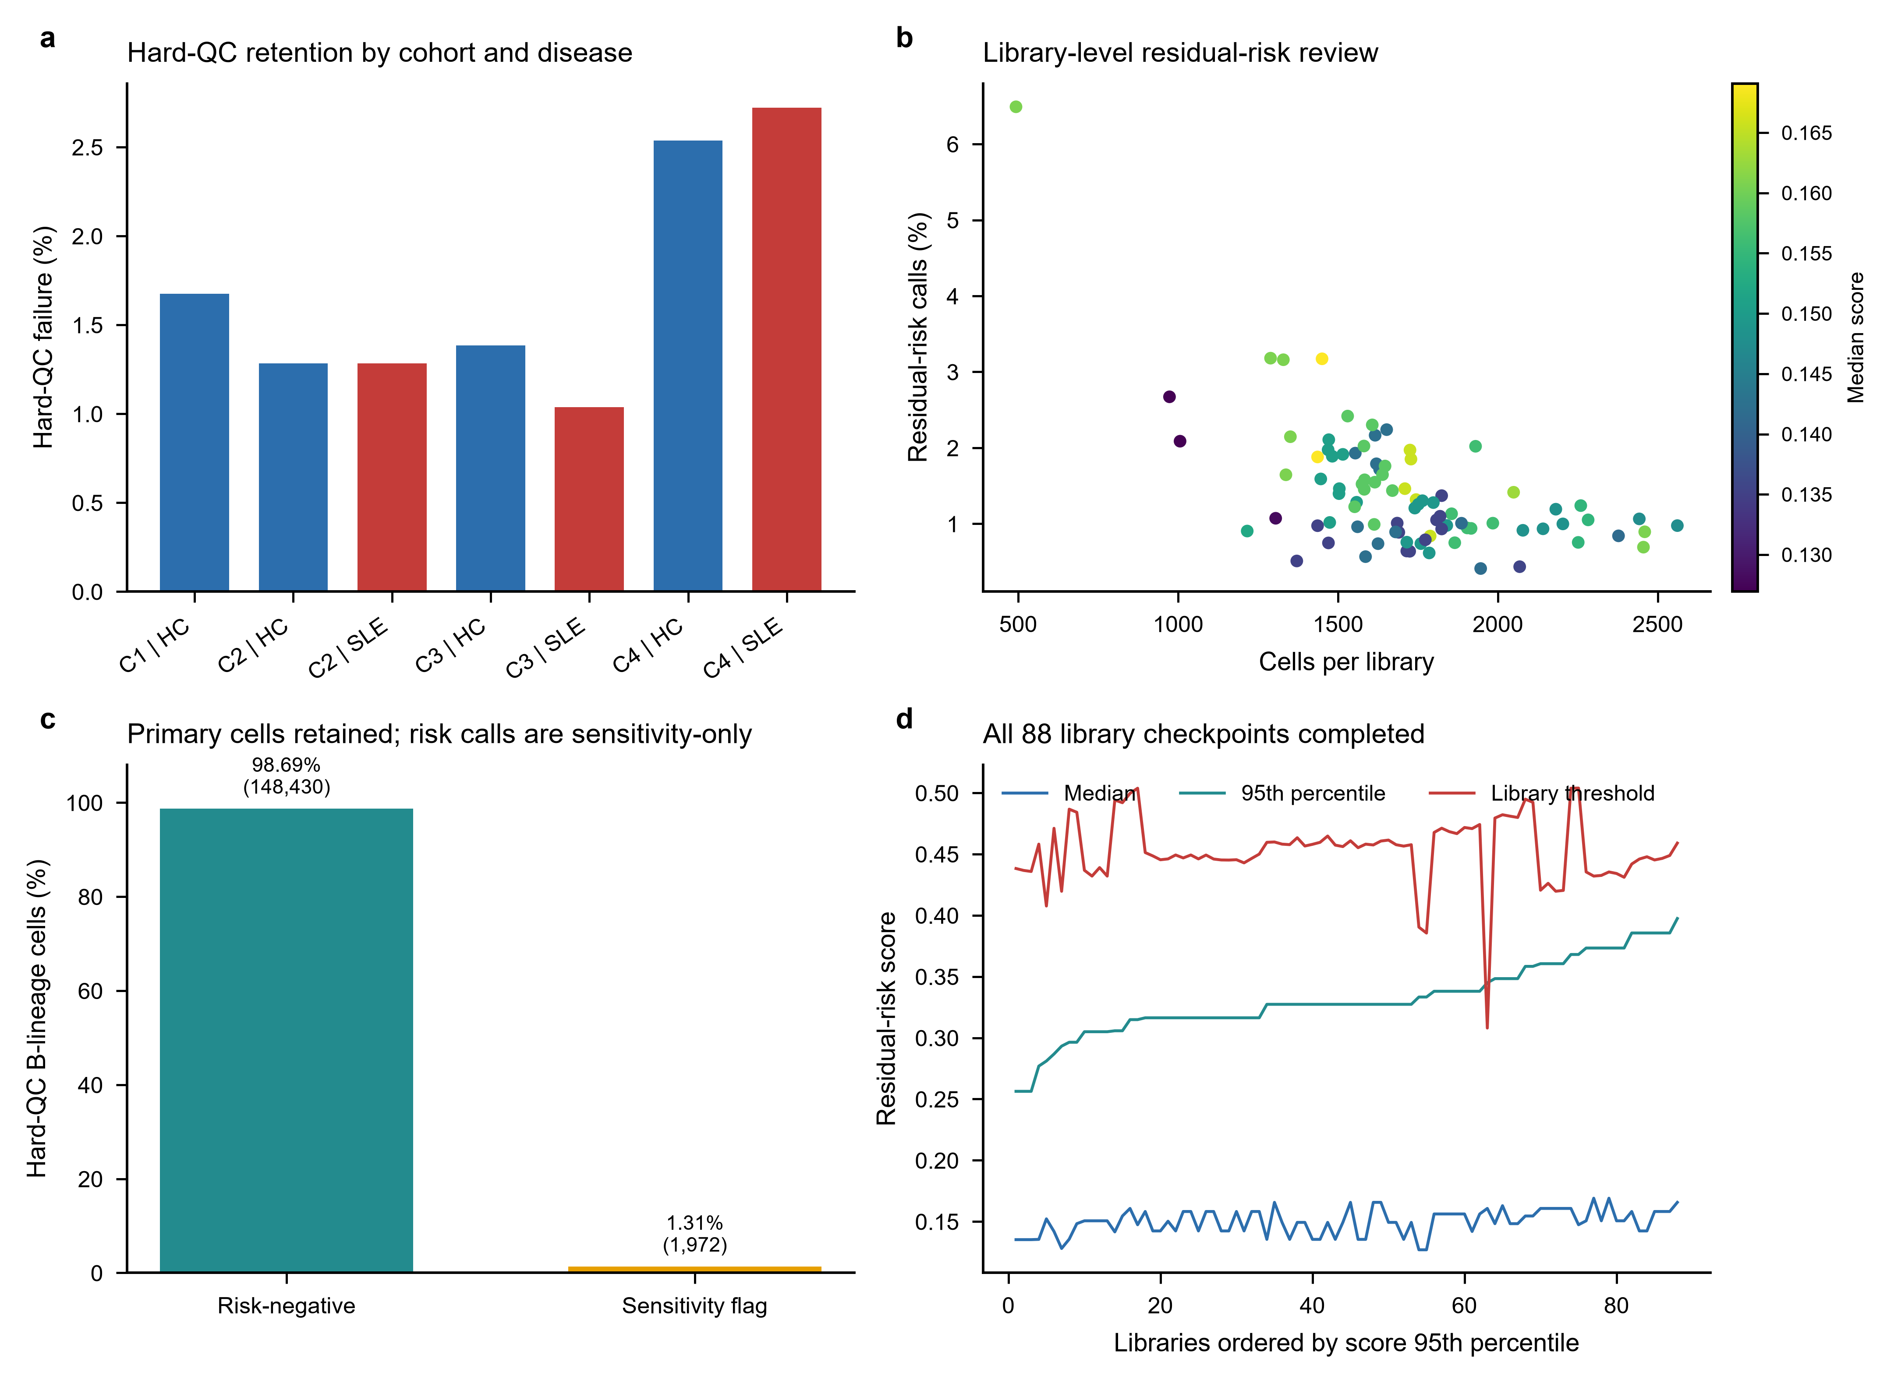

Supplementary Figure S2 | Representation and bridge diagnostics
a, Same-group neighbourhood concentration before and after Harmony adjustment. b, Cross-cohort bridge-pair cosine-distance distributions. c, Disease-blind branch concordance across Leiden resolutions for residual-risk-negative and strong-ISG-excluded branches; the vertical guide marks the primary resolution. d, Biological marker-module localization across the five fine clusters considered before stability adjudication.
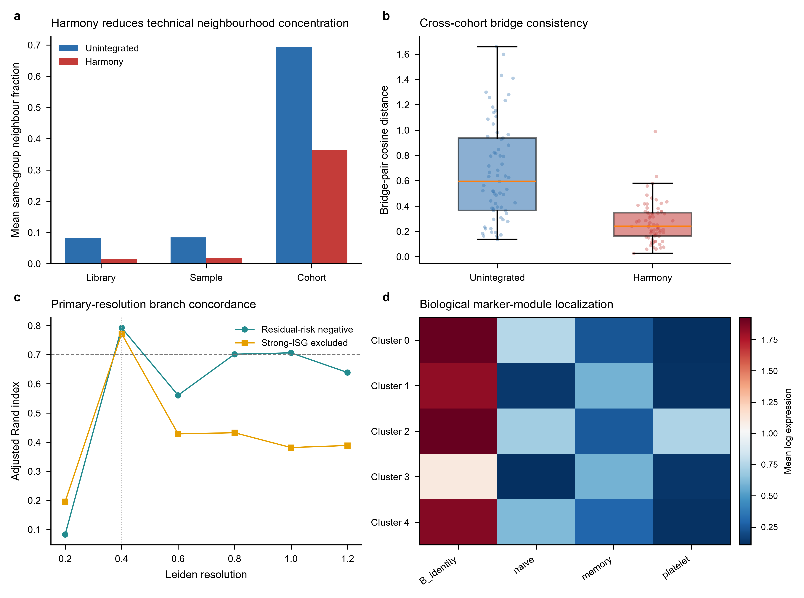

Supplementary Figure S3 | Disease-blind identity adjudication
a, Median and worst-case mapped ARI for five-, four-, three- and two-level policies across frozen-representation resamples. b, Median and minimum cluster Jaccard values show localization of failure to fine-state membership. c, Mean transition matrix from original resolution-0.4 clusters to mapped reference clusters. d, Minimum-to-median Jaccard intervals for the B_CONV and B_ASC analysis states across 20 frozen-representation resamples. Highly variable genes, principal components and Harmony coordinates were not recomputed in this figure.
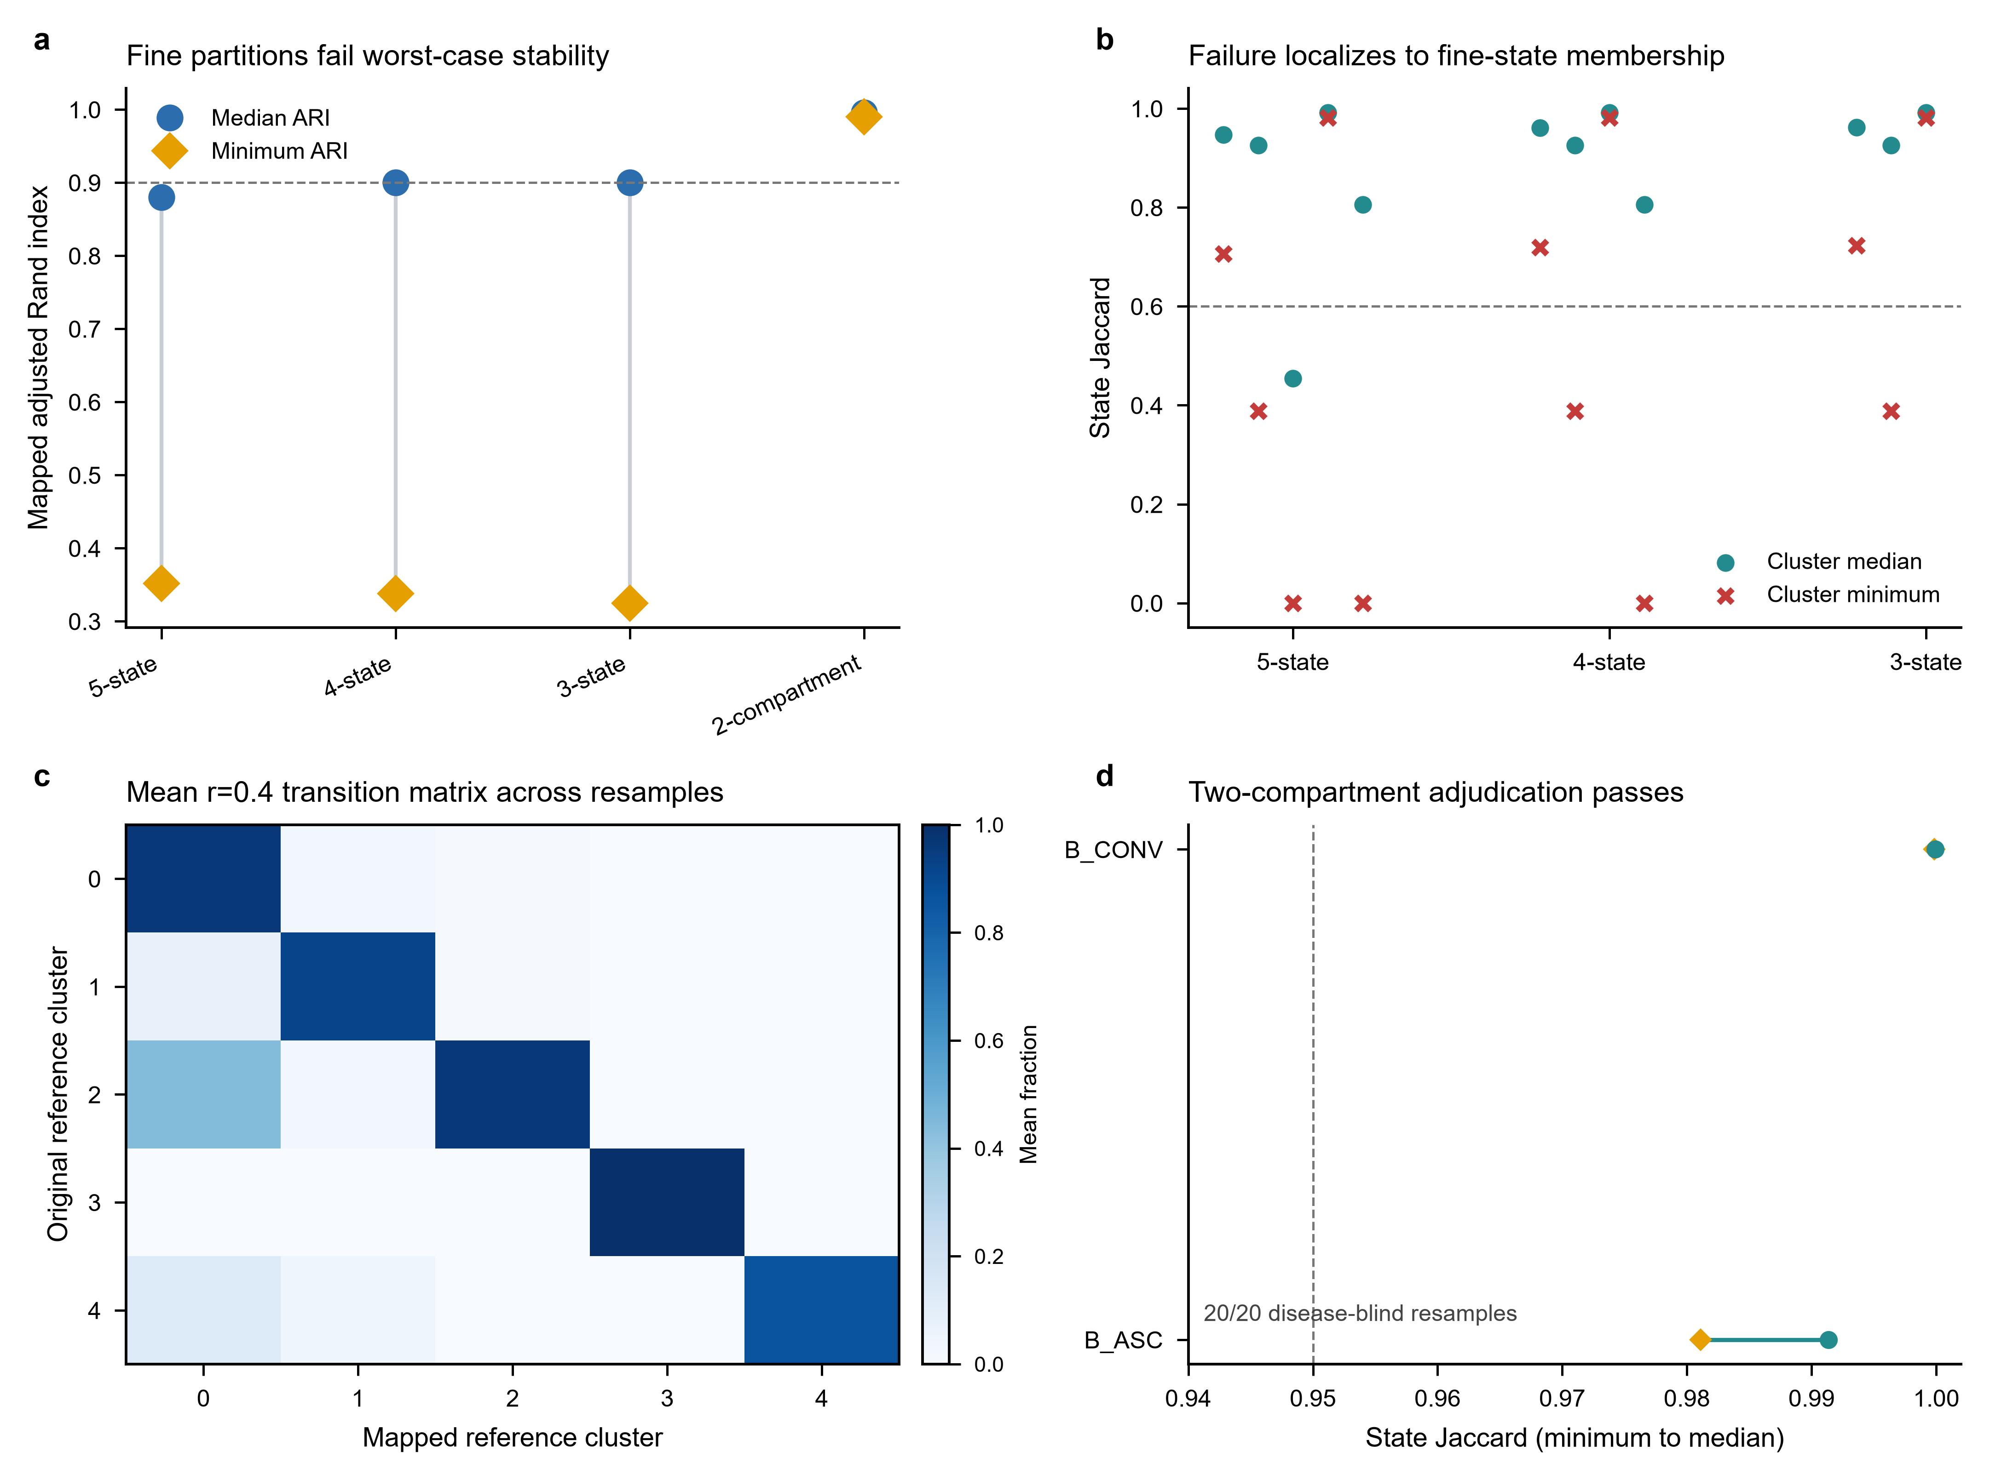

Supplementary Figure S4 | Composition-model diagnostics
a, Total and zero-ASC sample-cohort strata in the three base contrasts. b, Primary B_ASC odds ratios under support, explicit non-B and residual-risk policies using observed-information and HC1 covariance. c, Firth-logistic ASC-presence sensitivity. d, Positive-only abundance sensitivity using HC3 uncertainty. The two-part models are sensitivity analyses and do not replace the frozen beta-binomial primary model.
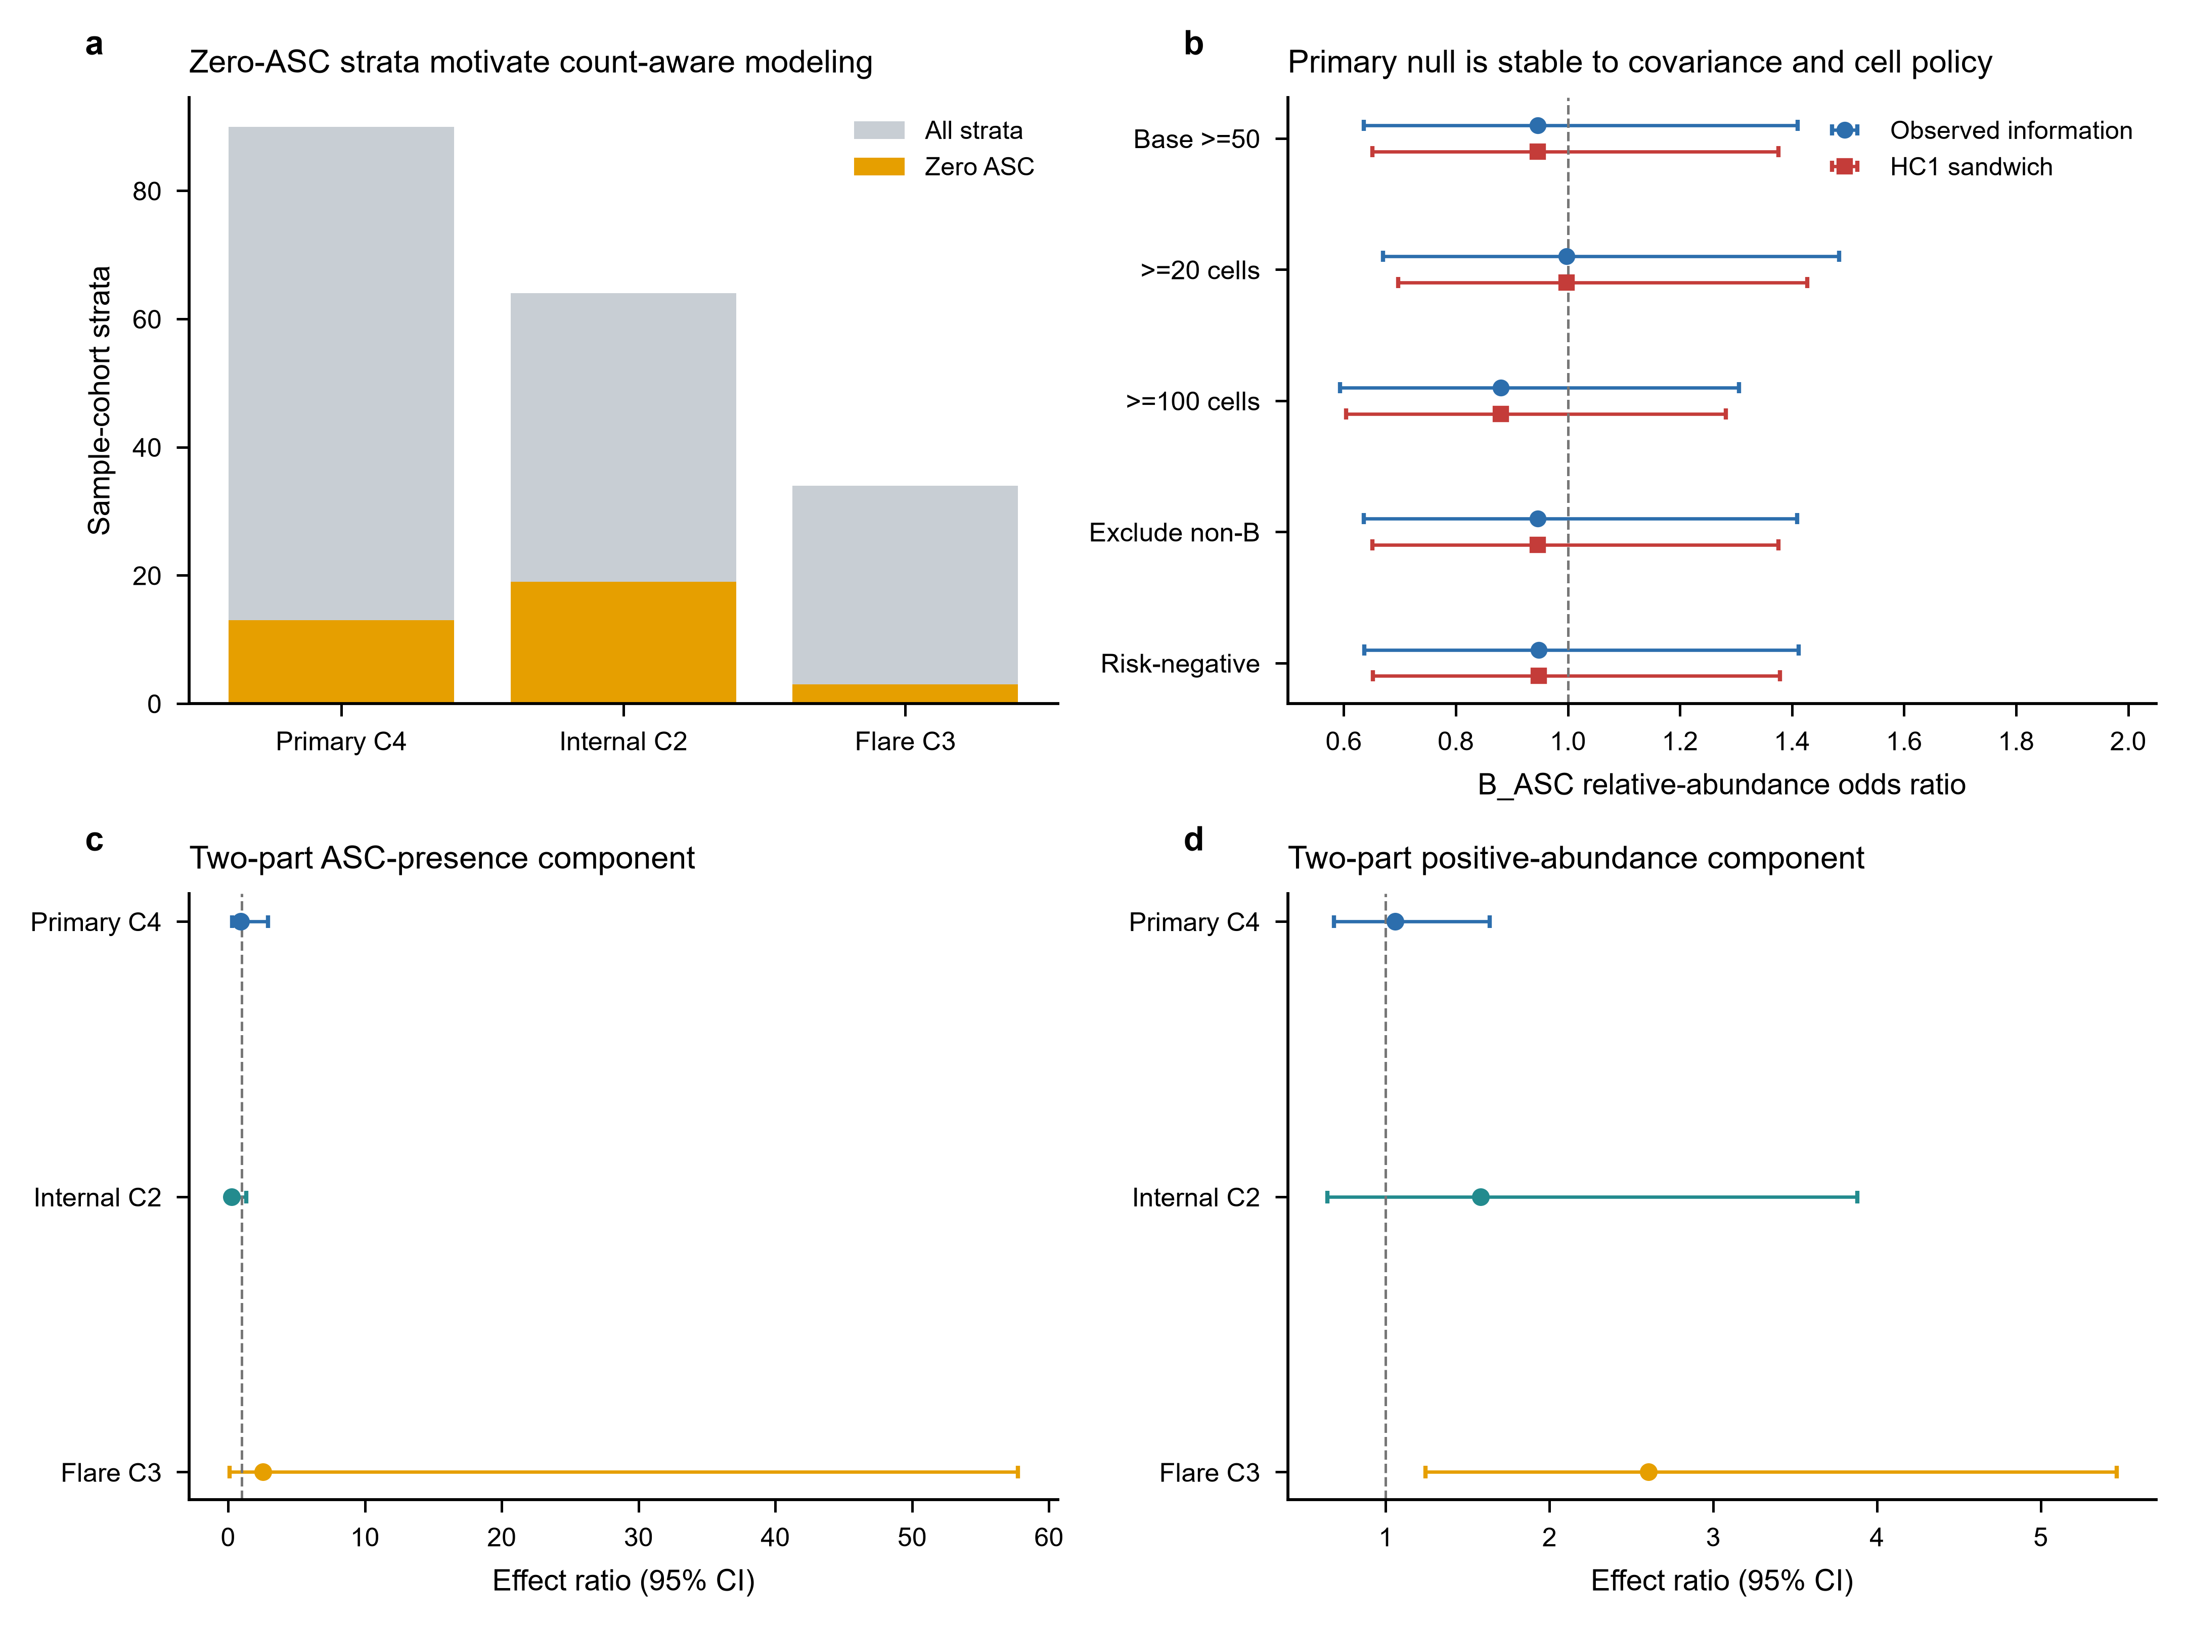

Supplementary Figure S5 | Pseudobulk and ranked-list diagnostics
a, Numbers of filterByExpr-tested and BH-significant genes across seven GSE174188 branches. b, Common and median tagwise edgeR dispersions. c, Mitochondrial, ribosomal, haemoglobin and immunoglobulin fractions among increasingly long primary ranked lists. d, IFN/ISG effects and 95% confidence intervals across frozen branches.
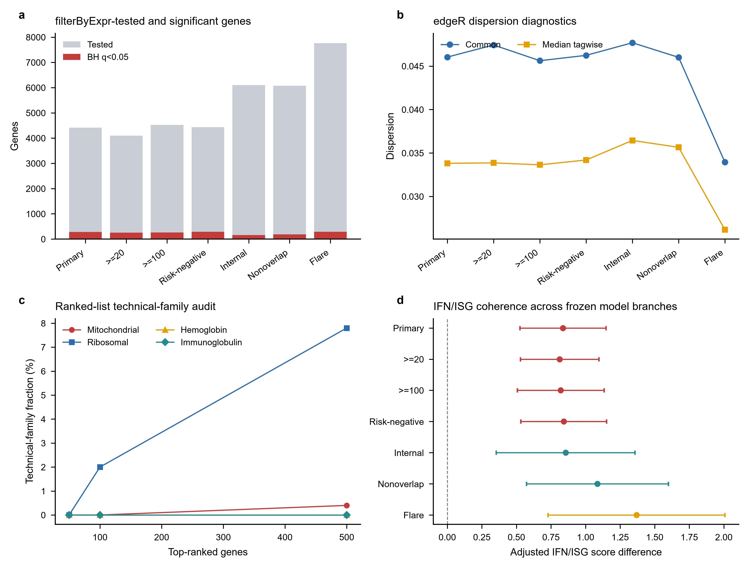

Supplementary Figure S6 | Independent-validation diagnostics
a, Control and SLE donor counts across the five GSE135779 models. b, Four-program childhood estimates. c, Childhood IFN/ISG estimates after omission of each source B-cell label. d, Full childhood program effects and ranges across donor-deletion analyses.
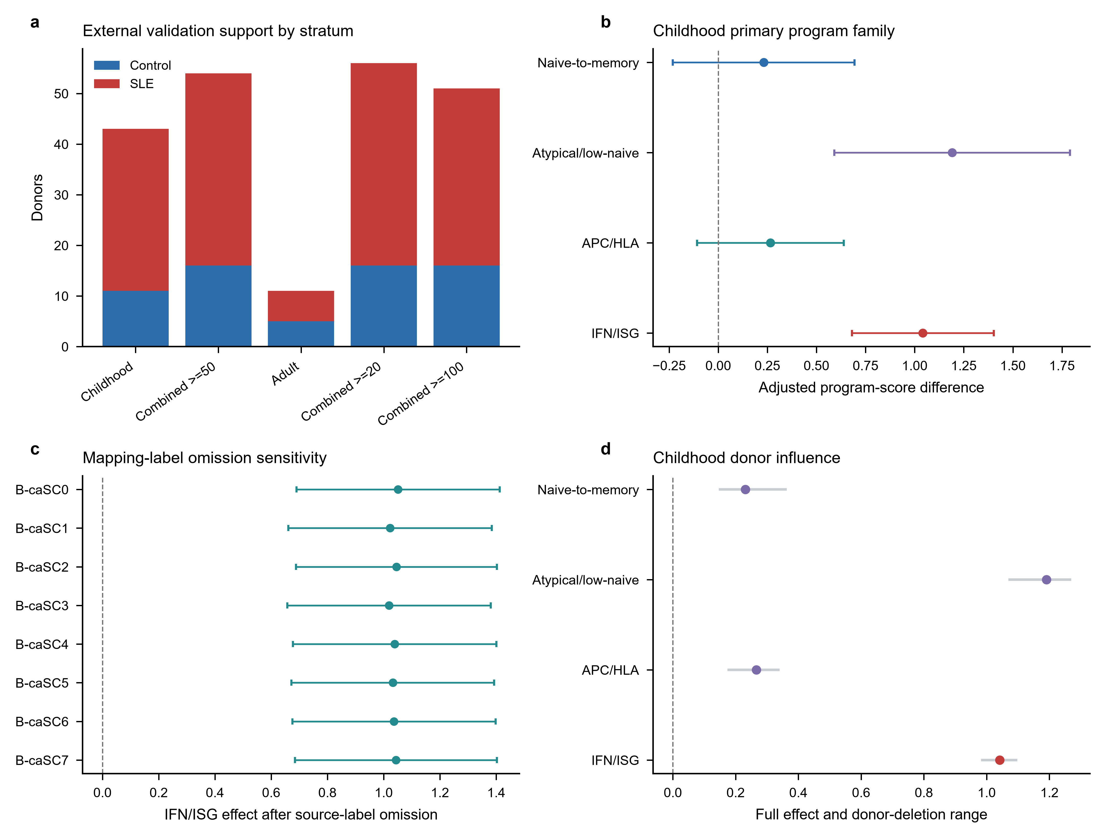

Supplementary Figure S7 | Correlation-aware regulator sensitivity
a, CAMERA and FRY six-test BH concordance for STAT1 and STAT2. Dashed guides indicate q=0.05. b, CAMERA residual-estimated inter-gene correlations. c, Exact CAMERA and FRY BH q values. d, Matched signed-target counts, which equal the frozen ULM family (STAT1: 98, 129 and 161; STAT2: 14, 19 and 20).
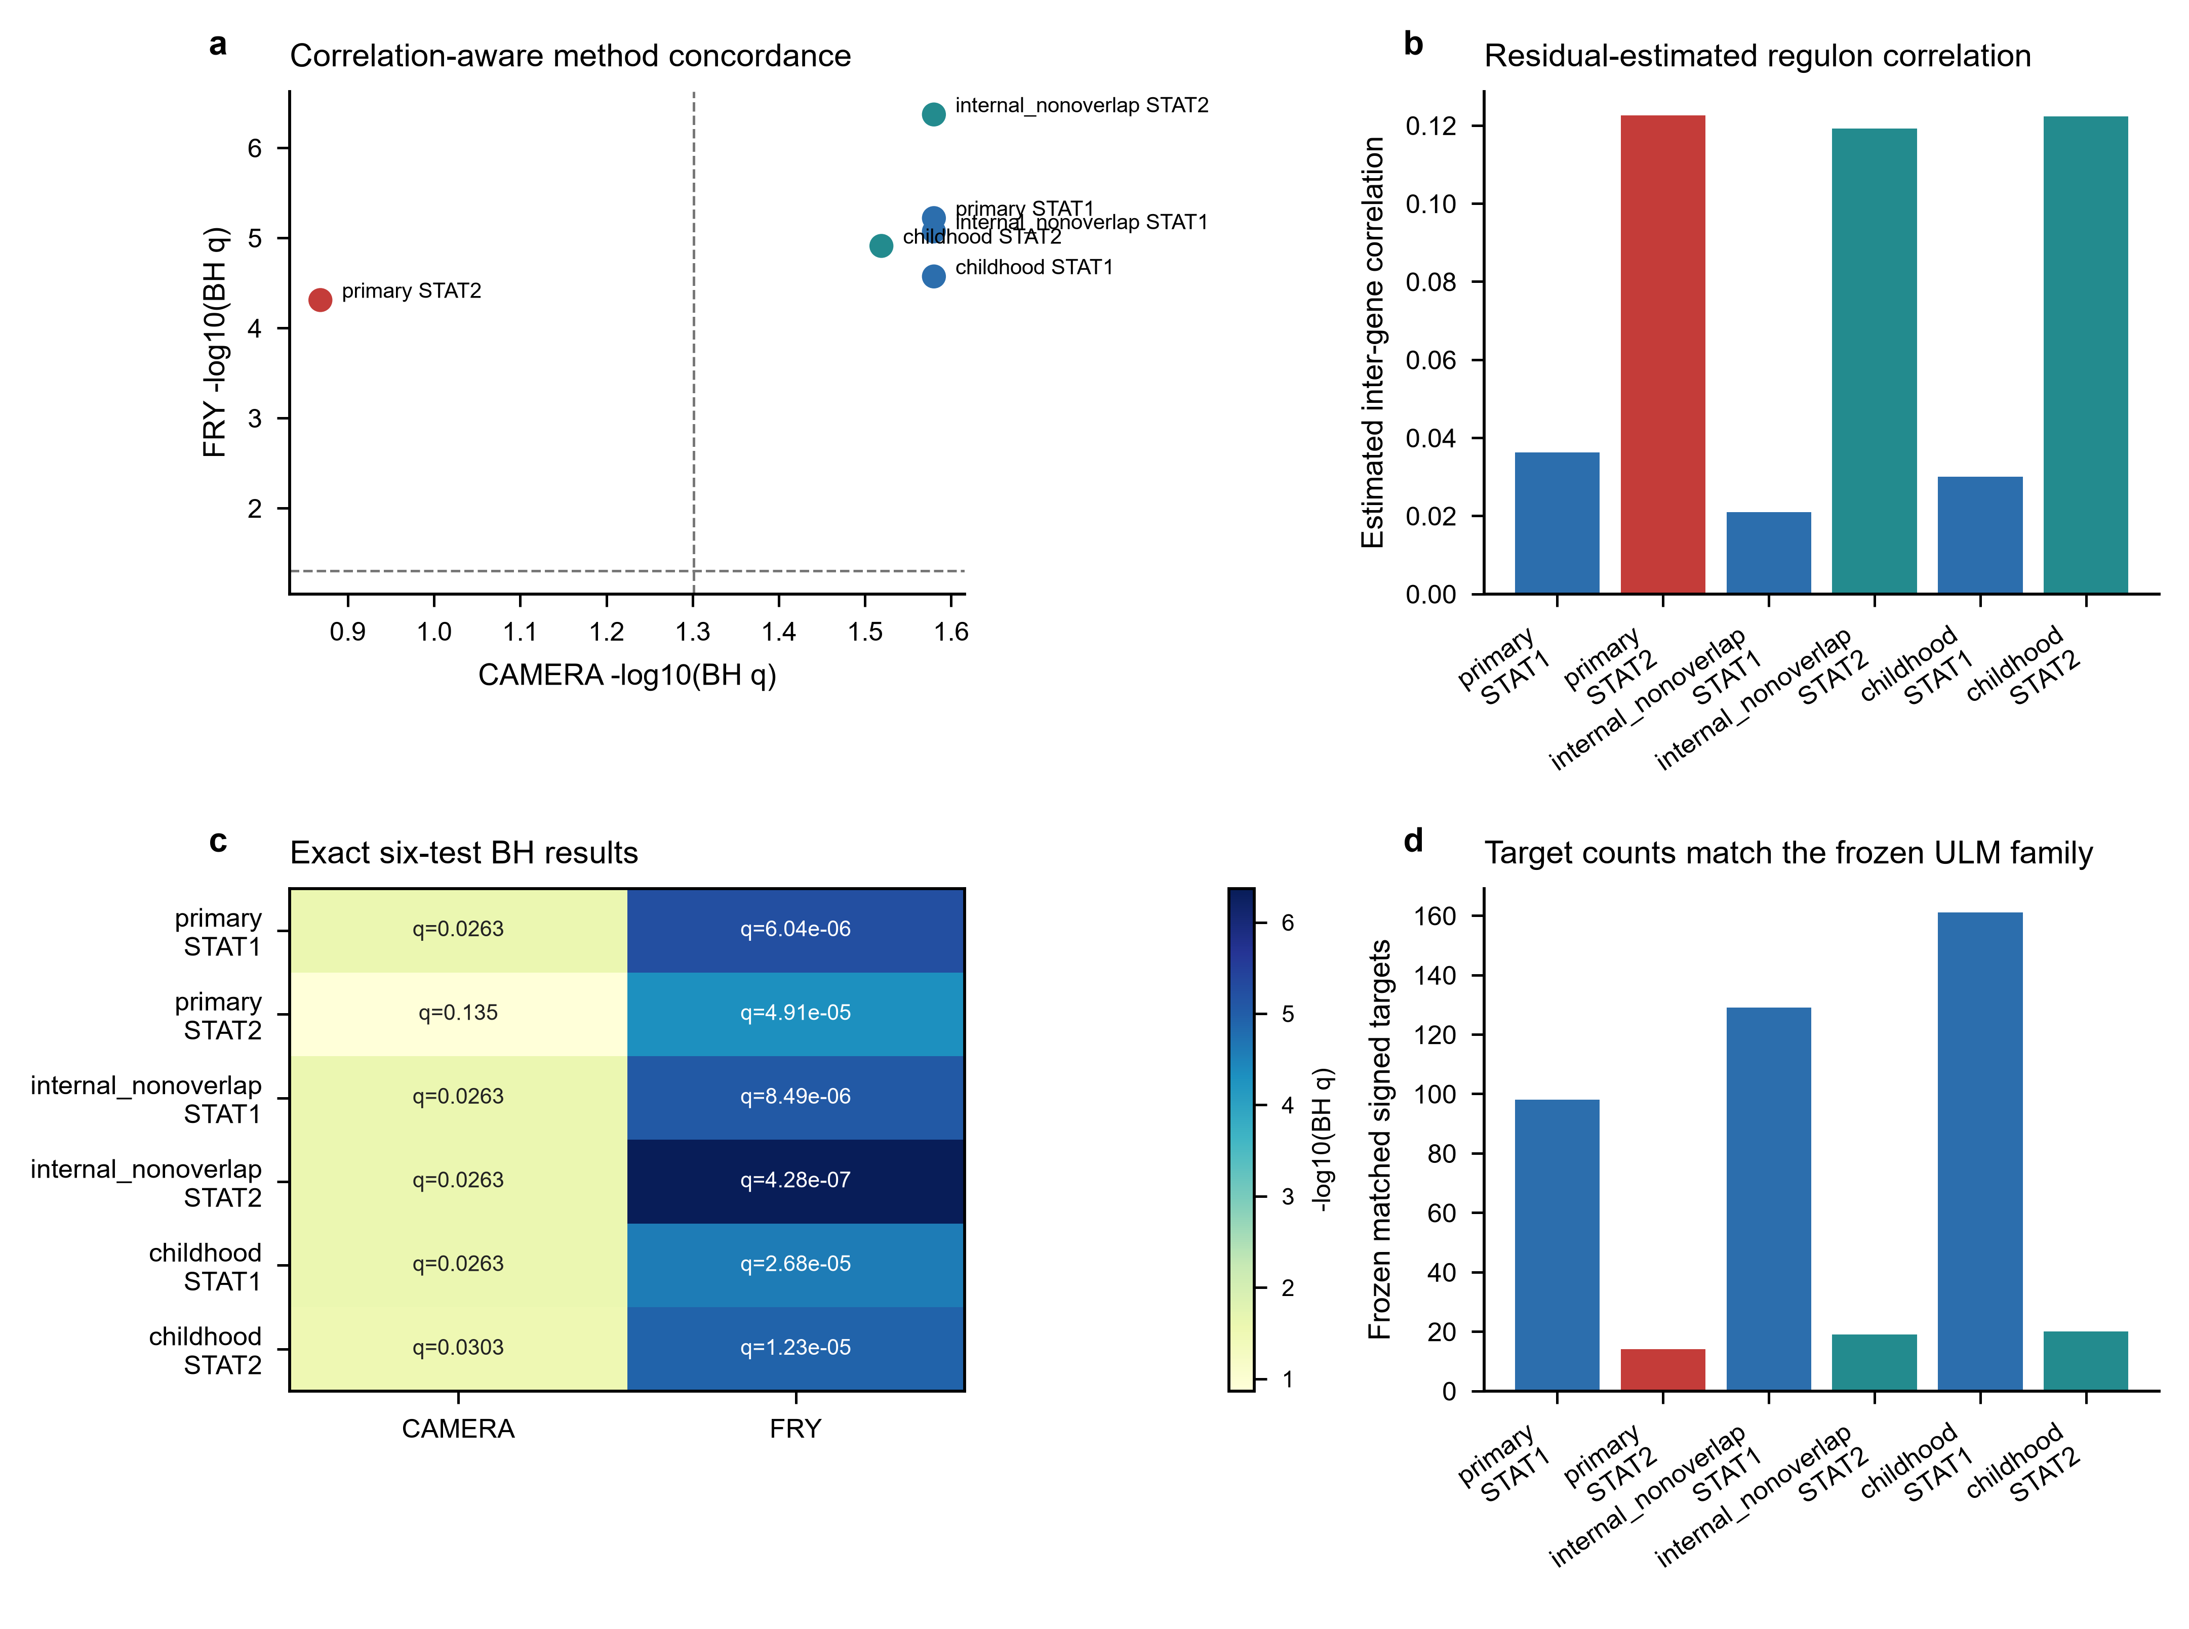

Supplementary Figure S8 | STAT1/STAT2 IFN-overlap-depletion sensitivity
a, ULM slopes and 95% confidence intervals after removal of the frozen 12-gene IFN/ISG positive arm. b, Corresponding estimates after removal of all 97 M5911 genes; discovery STAT2 retains eight targets and its interval crosses zero. Labels report remaining matched targets. c, Exact branch- and method-specific Benjamini-Hochberg q values across the six regulator-by-contrast tests. d, Percentage of frozen matched targets retained after each depletion. All method-level directions remain positive, but M5911 depletion produces substantial attenuation and does not support an overlap-independent interpretation.
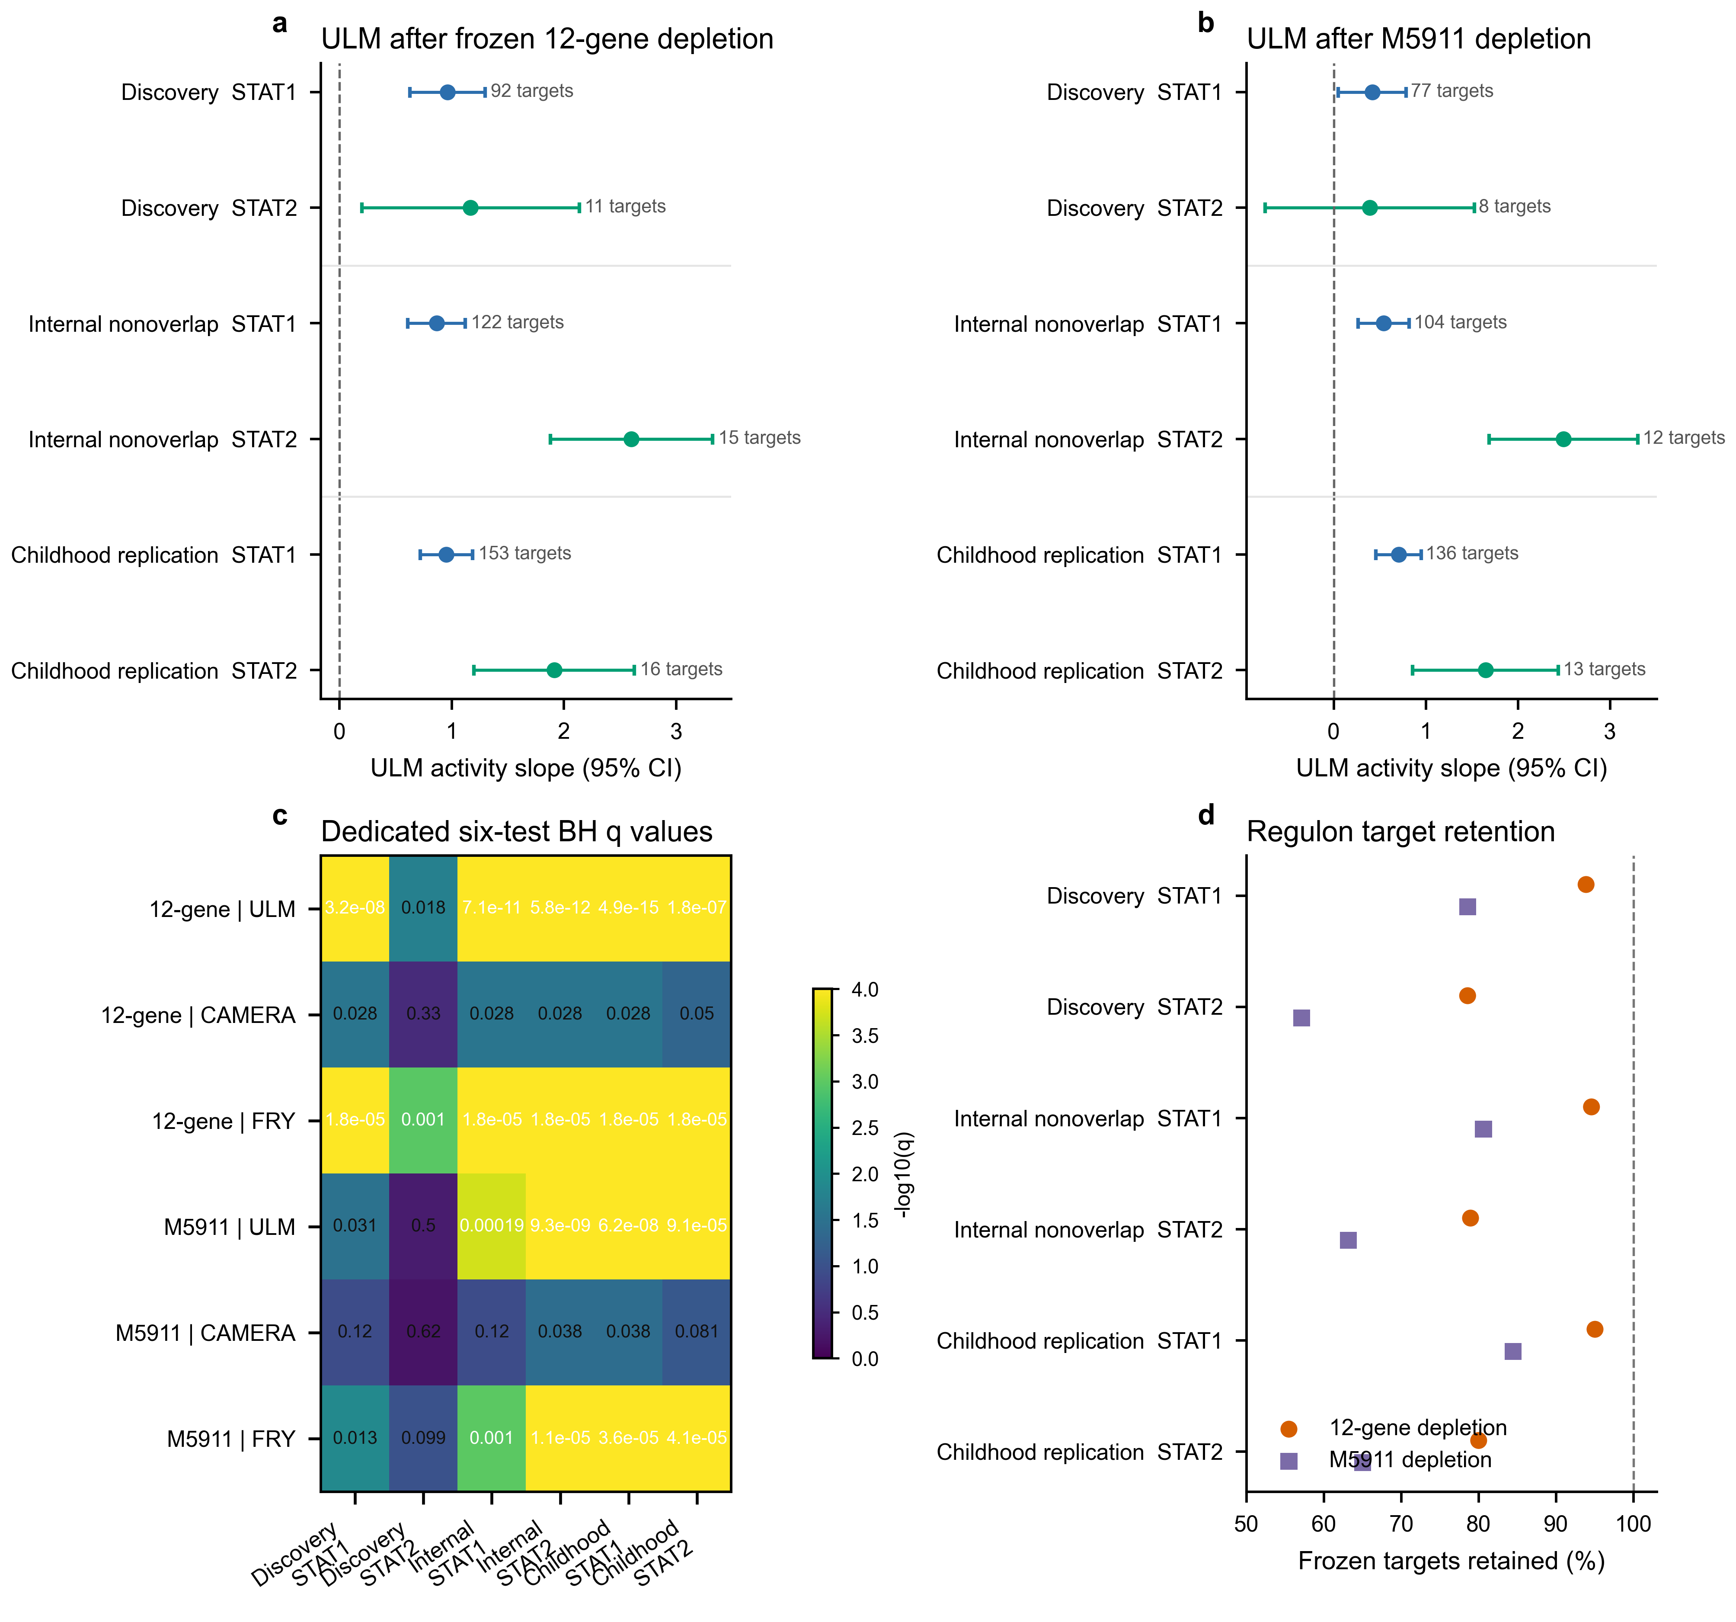

Supplementary Figure S9 | End-to-end reconstruction exposes a B_ASC-specific boundary without changing the disease conclusions
a, Observed values and unchanged criteria for the five formal end-to-end two-compartment checks; four passed and minimum state-median Jaccard produced HOLD. b, State Jaccard across 20 complete reconstruction replicates shows that the formal failure is localized to B_ASC, while B_CONV remains above the 0.95 criterion. c, Counts of sampled cells exchanged across the B_CONV/B_ASC boundary. d, Primary B_ASC composition odds ratios and 95% confidence intervals after each observed boundary exchange; the dashed guide marks one and the orange line marks the frozen estimate. e, Primary and donor-nonoverlap B_CONV IFN/ISG effects after boundary-cell raw counts were propagated through frozen TMM logCPM and HC3 models; dotted lines mark the frozen effects. All propagation analyses reuse GSE174188 and quantify assignment sensitivity rather than independent replication.
