**Description:**

User analysis is the process by which we track how users engage and interact with our digital product( s/w or mobile app) in an attempt to drive business insights for marketing, product & development teams.

These insights are then used by teams across the business to launch a new marketing campaign, decide on features to build for an app, track the success of the app by measuring user engagement and improve the experience altogether while helping the business grow.

Suppose we are working with the product team of Instagram and the product manager has asked us to provide insights on the questions asked by the management team.

**Advantages:** **Structured Data Analysis, Aggregation and Summarization:**

**Filtering and Sorting:**

**Joining Data:**

**Historical Analysis**

**Disadvantages: Data Complexity, data privacy and security**

**Concepts Covered:** Basic SQL Queries – Group by, Joins

**Motto:** By the end of day three we'll understand the basics of Structured query Language and how we can apply them to build basic insights that can be helpful in making data- driven decisions on success of Instagram.

-- **A) Marketing:** The marketing team wants to launch some campaigns, and they need your help with the following

-- i) Rewarding most loyal users: People who have been using the platform for the longest time.

-- i.e, Finding the 5 oldest users on the site

**-- ii)Remind Inactive users to start posting:** By sending them promotional emails to post their 1st photo.

-- i.e, finding the users who have never posted a single photo on Instagram

-- i.e, Find users who never posted a single photo on ig

**-- iii) 3.Declaring Contest Winner:** The team started a contest and the user who gets the most likes on a single photo will win the contest now they wish to declare the winner.

i.e, Identifying the winner of contest and provide their details to the team

**-- iv) Hashtag Researching**: A partner brand wants to know, which hashtags to use in the post to reach the most people on the platform.

-- i.e, Identifying and suggest the top 5 most commonly used hastags on ig

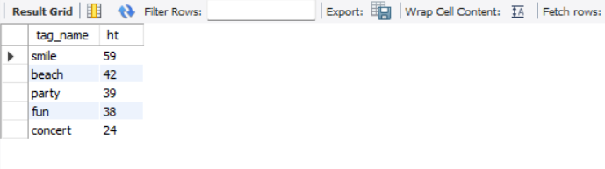

-- **v) Launch AD Campaign:** The team wants to know, which day would be the best day to launch ADs. Your Task: What day of the week do most users register on? Provide insights on when to schedule an ad campaign

-- i.e, Find what day of week do most users register on? provide insights on when to schedule an ad campaign

-- **B) Investor Metrics:** Our investors want to know if Instagram is performing well and is not becoming redundant like Facebook, they want to assess the app on the following grounds

-- **i) User Engagement:** Are users still as active and post on Instagram or they are making fewer posts

i.e, providing how many times does avg user posts on ig. also, find total no.of photos on ig/ no.of users

-- to get no.of users

-- to get no.of pics

-- ii) Bots & Fake Accounts: The investors want to know if the platform is crowded with fake and dummy accounts

-- i.e, Providing data on users(bots) who have liked every single pic on site( bots? : since any normal user would not be able to do this)