Buddy Allocator
Seminar
Shreeya Vachhani (121052)
Buddy Allocator

The buddy memory allocation technique is a memory allocation algorithm that divides memory into partitions to try to satisfy a memory request as suitably as possible. This system makes use of splitting memory into halves to try to give a best-fit.
Compared to the more complex memory allocation techniques that some modern operating systems use, buddy memory allocation is relatively easy to implement. It supports limited but efficient splitting and coalescing of memory blocks.
Memory management, especially memory allocation to processes, is a fundamental issue in operating systems. A fixed partitioning scheme limits the number of active processes and may use space inefficiently if there is a poor match between available partition sizes and process sizes. A dynamic partitioning scheme is more complex to maintain and includes the overhead of compaction. An interesting compromise is the buddy system.
In the buddy system, the memory is broken down into power-of-two sized blocks. The basic concept behind it is quite simple.
Memory is broken up into large blocks of pages where each block is a power of two numbers of pages. If a block of the desired size is not available, a large block is broken up in half and the two blocks are buddies to each other.



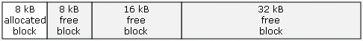

In a buddy system, the entire memory space available for allocation is initially treated as a single block whose size is a power of 2. When the first request is made, if its size is greater than half of the initial block then the entire block is allocated. Otherwise, the block is split in two equal companion buddies.

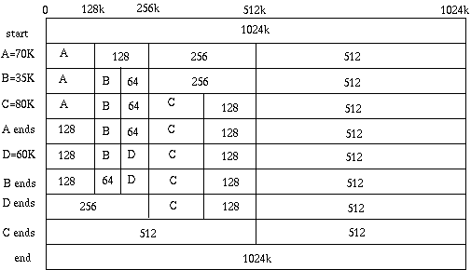

If the size of the request is greater than half of one of the buddies, then allocate one to it. Otherwise, one of the buddies is split in half again.
This method continues until the smallest block greater than or equal to the size of the request is found and allocated to it.
Whenever possible, an unallocated buddy is merged with a companion buddy in order to form a larger free block. Two blocks are said to be companion buddies if they resulted from the split of the same direct parent block.

Implementation and efficiency:
In comparison to other simpler techniques such as dynamic allocation, the buddy memory system has little external fragmentation, and allows for compaction of memory with little overhead. The buddy method of freeing memory is fast, with the maximal number of compactions required equal to log₂(highest order). Typically the buddy memory allocation system is implemented with the use of a binary tree to represent used or unused split memory blocks. The "buddy" of each block can be found with an exclusive OR of the block's address and the block's size.
However, there still exists the problem of internal fragmentation — memory wasted because the memory requested is a little larger than a small block, but a lot smaller than a large block. Because of the way the buddy memory allocation technique works, a program that requests 66K of memory would be allocated 128K, which results in a waste of 62K of memory. This problem can be solved by slab allocation, which may be layered on top of the coarser buddy allocator to provide more fine-grained allocation.

Advantages:
- Less external fragmentation.
- Search for a block of the right size is cheaper than, best fit because we need only find the first available block on the block list for blocks of size 2^k.
- Merging adjacent free blocks is easy.
- In the buddy system, the cost to allocate and free a block of memory is low compared to that of best-fit or first-fit algorithms.

Disadvantages:
- It allows internal fragmentation.
- For example, a request for 515k will require a block of size 1024k. In consequence, such an approach gives a waste of 509k.
- Splitting and merging adjacent areas is a recurrent operation and thus very unpredictable and inefficient.
- Another drawback of the buddy system is the time required to fragment and coalesce blocks.

