**EBU5504 Networks and Protocols**

Name:

QM ID:

BUPT ID:

**Class Test (Week 1 & 2)**

Total Marks : 25 Time Allowed: 35 Minutes  
**----------------------------------------------------------------------------------------------------------------------------**

**Question 1 [12 marks]**

1. Maintaining the correct sequence, list all layers of the OSI reference model. State two functions of Session layer. **(5 marks)**

– Application

– Presentation

– Session

– Transport

– Networks

– Data Link

– Physical

[3 marks for all correct names with sequence, deduct 0.5 for every incorrect name/sequence]

Session Layer:

* Responsible for dialog control and synchronization.
* Dialogue discipline
* Establishes, manages and terminates connections between applications
* Recovery

[1 mark each for any of these points, maximum 2]

1. What are the main challenges of IoT Networks? **(2 marks)**

* Power consumption
* Security of sensors
* Interoperability
* Data explosion

[2 marks for three points, 1.5 for 2 points and 1mark for one correct]

1. In CSMA/CD protocol, a truncated exponential back-off mechanism is employed after collisions. Explain how this mechanism works. **(5 marks)**

* Nodes wait a random time before attempting to retransmit data. [1 mark]
* After a collision, a node waits X slot-times* where X is a Random number taken from the following distribution: [1 mark]

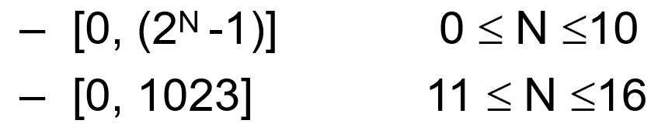 [2 marks]

N = number of retransmission attempts

* After 16 attempts, frame is lost. LLC problem! [1 mark]

**Question 2 [13 marks]**

1. Explain the passive scanning method in 802.11 based networks. **(3 marks)**

* Beacon frames sent from APs
* Association Request frame sent: Host to selected AP
* Association Response frame sent from selected AP to Host

[1 mark for each step] 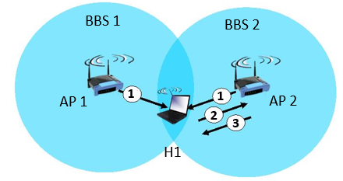

1. Explain the principle operation method of S-MAC protocol. How do devices synchronise to each other in S-MAC? **(5 marks)**

* The Sensor-MAC protocol solves the energy consumption related problems of Idle listening, collision and overhearing. [1 mark]
* S-MAC considers that nodes do not need to be awake at all times and reduces the idle listening problem by turning off and on periodically by dividing time in two parts.   
  [2 marks]
* Only in the ‘listen periods data will be exchanged [1 mark]
* Nodes Periodically sleep [1 mark]
* Trades energy efficiency for lower throughput and higher latency [1 mark]
* Sleep during other node’s transmission [1 mark]

[Maximum 4 marks for above points]

In order to synchronize, nodes broadcast their schedule to all neighbours with the help of SYNCH frame. [1 mark]

1. a) In 802.15.4 based networks, devices can be categorized into two different classes with respect to their functional capability. Name the classes. **(2 marks)**

* Full function device (FFD)
* Reduced function device (RFD)

[1 mark for each name]

b) Draw the Superframe structure of IEEE802.15.4, illustrating the different periods in the frame. **(3 marks)**

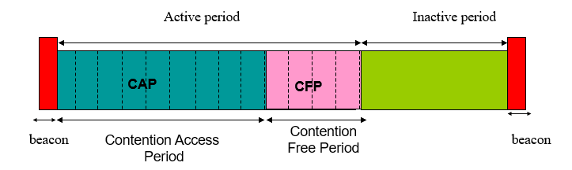

**1 mark**

**1 mark**

**1 mark**