Solutions

1. Let y(t) be a band-limited signal to W = 1 kHz, signal y(t) is sampled at a rate 30% higher than the Nyquist rate to provide a guard band.
   1. What is the sample rate for y(t)?

*The Nyquist sampling rate for y(t) is RN = 2* 1000 = 2 kHz (samples per second). The actual sampling rate is Rs = 2000*1.3=2.6 kHz.*

* 1. Please use diagrams to explain what aliasing is and why in general sampling has to meet the Nyquist sampling theorem.

*Nyquist rate is defined as twice the signal bandwidth W for low-pass band signal.*

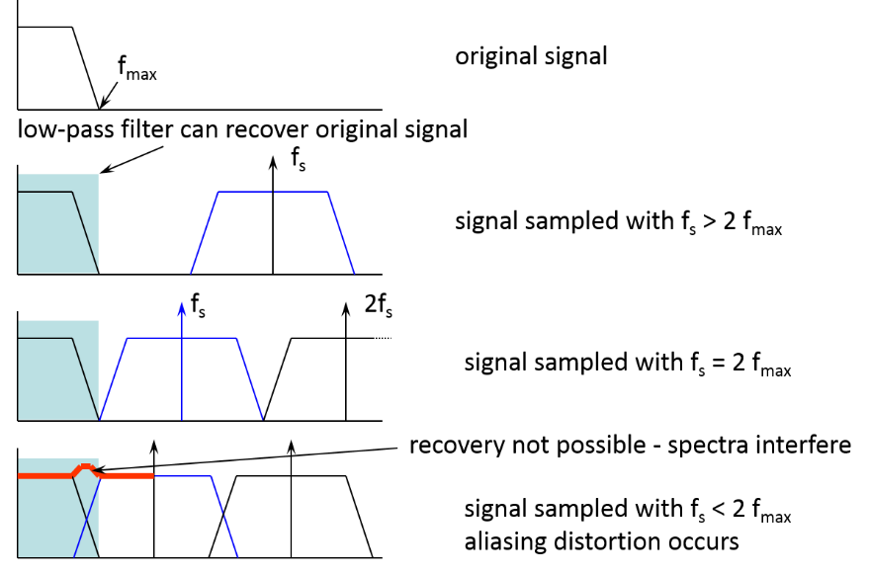

* 1. Please use diagrams to explain why the oversampling is easier to design a simple filter.

1. The maximum acceptable error for signal x(t) in the sample amplitude (the maximum quantization error) is 1% of the peak-to-peak voltage, where x(t) is with amplitude 0 ≤ x(t) ≤ 2.
   1. How many quantization levels are required? How many bits per sample are required?

*The quantization step is q, and the maximum quantization error is ±q/2, the peak-to-peak voltage (amplitude) is Vpp=2.*

*Therefore q/2 =1%*2. q = 0.04.*

*So quantization level M = Vpp/q = 50，*

*For binary coding, L must be a power of 2. Hence, the next higher value of L that is a power of 2 is L=64.*

*So we need n=log2 64 = 6 bits/sample.*

* 1. Assuming the sampling rate of this system is 8kHz, what is the maximum bit rate (digital bandwidth) of this system?

*As we required to transmit a total of*

*C=n*8kHz= 6bit /sample * 8k sample/s = 48kbit/s*

* 1. Calculated the bit rate required to transmit x(t) as a linearly quantised PCM signal maintaining an SQNR of 55 dB. (Assume that the signal’s peak to mean ratio is 20dB).

*As for linearly quantised PCM signals, the Signal to Quantisation Noise Ratio in dB is*

*SQNR = 4.8+6n-αdB where α is the signal’s peak to mean ratio and n is bit number for each symbol.*

*55=4.8+6n-20 🡪 n= 11.7*

*So 12 bit/symbol is needed for each PCM symbol.*

Bit rate is then:

12bit/symbol * 8k symbol/s = 96kbit/s

1. If x(t) is quantised by a non-uniform quantiser Q and power P = 100 w. The quantiser Q is defined by the following four quantisation regions: R0 = [0,1], R1 = [1,3], R2 = [3, 7] and R3 = [7,15]. ) Symbols I, i = 1, 2, 3 and 4, correspond to the amplitudes produced by each quantisation region Ri and the probabilities pi that the amplitude of x(t) is in each region Ri are as follows

|  |  |  |  |
| --- | --- | --- | --- |
| *p0* | *p1* | *p2* | *p3* |
| 0.17 | 0.49 | 0.25 | 0.09 |

1. What are the quantisation noise power in each region assuming that the noise is distributed uniformly, the average quantisation noise power, and the SQNR in dB.

Since the amplitude of the quantisation noise is distributed uniformly in each region, the quantisation noise power will be calculated as *PQi* = (*qi*)2/12, where *qi* is the size of each region.

The following table shows the quantisation noise power in each region:

|  |  |  |  |  |
| --- | --- | --- | --- | --- |
|  | *R0* | *R1* | *R2* | *R3* |
| *qi* | 1 | 2 | 4 | 8 |
| *PQi* | 1/12 | 1/3 | 4/3 | 16/3 |

The average quantisation noise power will be obtained as



By using the probabilities *pi* and the quantisation noise power in each region *PQi*, we obtain *PQ* = 0.987.

The SQNR as a fraction will be SQNR = P/ PQ = 101.3.

The SQNR expressed in decibels will be SQNR = 10 log10 101.3 = 20 dB.

1. Obtain the information content of each symbol and entropy of the information source under the probabilities in 1).

The entropy of an information source is defined as



where *Ii* = - log *pi* is the information content of symbol *ai*.

The information content of each symbol is then:

|  |  |  |  |
| --- | --- | --- | --- |
| *I0* | *I1* | *I2* | *I3* |
| 2.55 | 1.03 | 2 | 3.47 |

The resulting entropy will then be H = 1.75 bits/symbol.

1. Consider a source having an *M*=4 symbol alphabet where $P\left(x_{1}\right)=1/2$; $P\left(x_{2}\right)=1/4$  $P\left(x_{3}\right)=P\left(x_{4}\right)=1/8$ and symbols are statistically independent.
2. Calculate the information conveyed by the receipt of the symbol $x_{1}$, $x_{2}$, $x_{3}$. and $x_{4}$.



1. What is the source entropy and the redundancy?

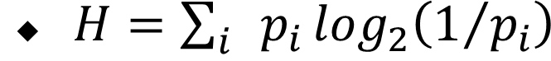

Redundancy= H_max - H