# Class Test Week 3&4

1. Assume a signal x(t) has a bandwidth of 50kHz.
2. What is the minimum sampling frequency according to Nyquist sampling theorem?

The minimum Nyquist sampling rate for *x*(*t*) is RN = 2* 50kHz= 100 kHz *[3 marks]*

1. Calculated the bit rate required to transmit x(t) as a linearly quantised PCM signal maintaining an SQNR of 58 dB. (Assume that the signal’s peak to mean ratio is 20dB). Furthermore, what is the minimum bandwidth required for this transmission?

*As for linearly quantised PCM signals, the Signal to Quantisation Noise Ratio in dB is*

***SQNR = 4.8+6n-αdB*** *[3 marks]*

*where α is the signal’s peak to mean ratio and n is bit number for each symbol.*

***58=4.8+6n-20*** 🡪 ***n= 12.2*** *[3 marks]*

*So 13 bit/symbol is needed for each PCM symbol.*

*Bit rate is then:*

*13bit/symbol * 100k symbol/s = 1300kbit/s [3 marks]*

*As transmission is 2bits/Hz,*

*The minimum required bandwidth is*

*1300kbps/2bits/Hz = 650kHz. [3 marks]*

1. A discrete memoryless source has seven symbols whose probabilities of occurrence and the produced Huffman code are described here:

|  |  |  |  |  |  |  |
| --- | --- | --- | --- | --- | --- | --- |
| Symbol  (S) | S0 | S1 | S2 | S3 | S4 | S5 |
| Probability  (Pk) | 0.25 | 0.25 | 0.125 | 0.3 | 0.05 | 0.025 |

1. Determine the Huffman code for each Symbol

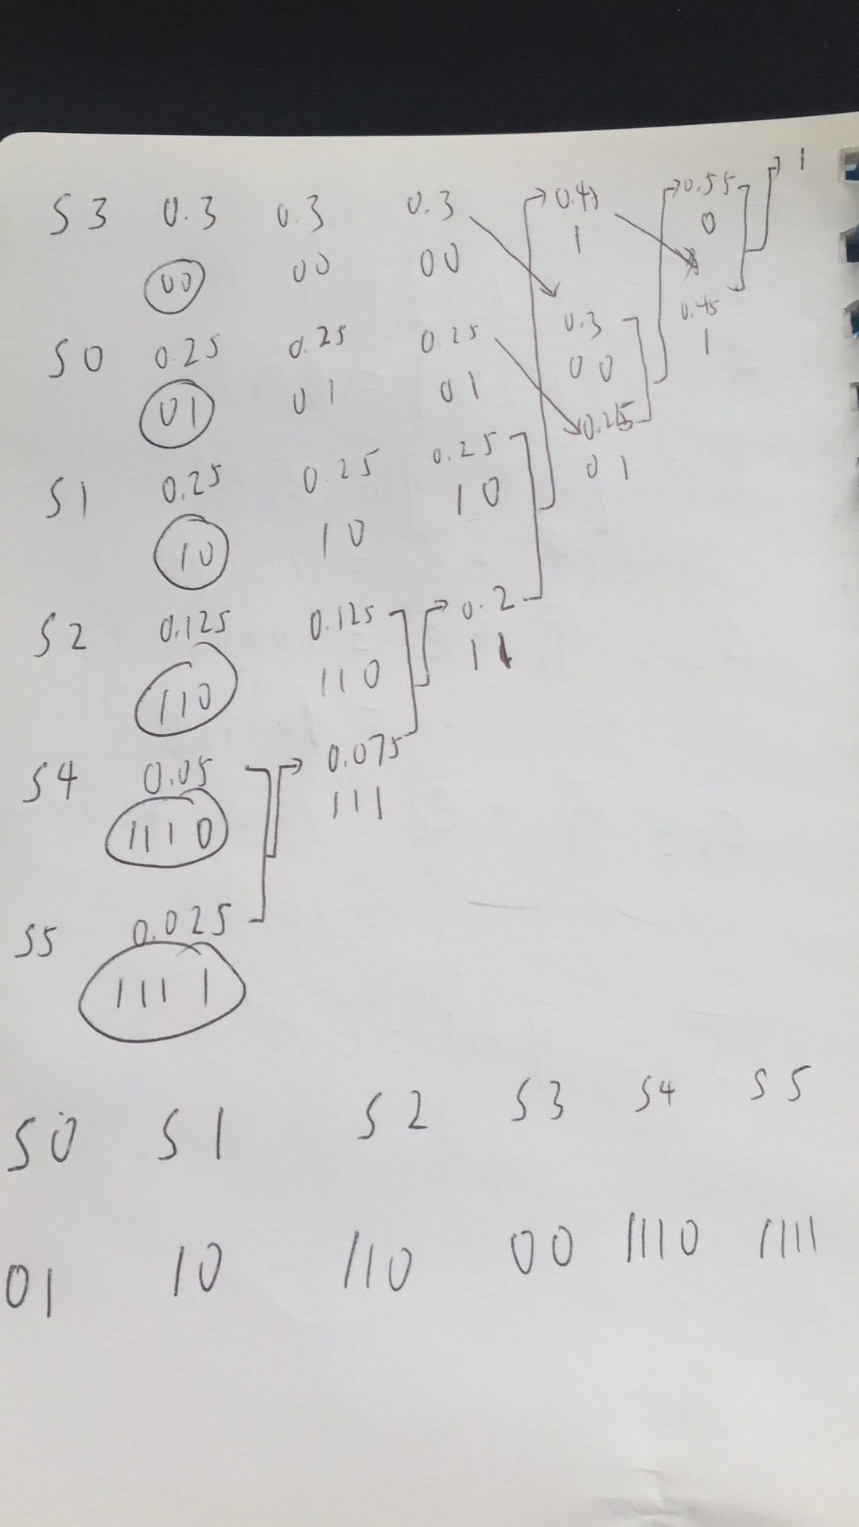

Show the diagram *[5 marks]*

Correct results *[5 marks]*

1. Determine the average Huffman code length.

L= 0.25*2+0.25*2+0.125*3+0.3*2+0.05*4+0.025*4 *[3marks]*

=2.275 bits/symbol*[2 marks]*

1. Determine the entropy of the source.

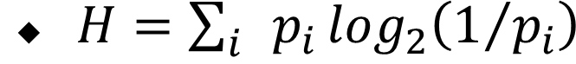 *[3 marks]*

H=0.25*2+0.25*2+0.125*3+0.3*1.73+0.05*4.34+0.025*4.85

=2.245 bits/symbol

*[2 marks]*

1. Assume “Alpha” is an M=8 symbol source. Symbol *A to H* represent each of the symbol amplitude values generated by the quantiser. The probability *pm* of each symbol is shown in the following table:

|  |  |  |  |  |  |  |  |  |
| --- | --- | --- | --- | --- | --- | --- | --- | --- |
| *m* | *A* | *B* | *C* | *D* | *E* | *F* | *G* | *H* |
| P(m) | 0.3 | 0.1 | 0.06 | 0.20 | 0.04 | 0.10 | 0.18 | 0.02 |

1. What is the information content for each symbol of Alpha?

The information content I of symbol is defined as

 [2 marks]

so

|  |  |  |  |  |  |  |  |  |
| --- | --- | --- | --- | --- | --- | --- | --- | --- |
| *m* | *A* | *B* | *C* | *D* | *E* | *F* | *G* | *H* |
| *I*m | 1.74 | 3.32 | 4.06 | 2.32 | 4.64 | 3.3 | 2.47 | 5.64 |

[3 marks]

1. The entropy is defined as

 [2 marks]

The resulting entropy will then be H = 0.3*1.74+0.1*3.32+0.06*4.06+0.20*2.32+0.04*4.64+0.1*3.3+0.18*2.47+0.02*5.64

=2.63 bits/symbol. [2 marks]

1. What are the source entropy and source efficiency for Alpha?

For an information source that produces 8 symbols with the same probability (uniform information source), the entropy is *Hmax* = log 8 = 3bits/symbol. [2 mark]

So the source efficiency is 2.63 /3= 87.7%. [2 marks]

1. Find the capacity of a telephone channel with bandwidth B = 3000 Hz and SNR of 39 dB. [6 marks]

The SNR of 39 dB is about 7943 (2 marks). So C=3000log(1+7943) is about 38,867bps (4 marks)

1. Let X and Y be binary random variables with *P (X=0,Y=0)* = 1/3, *P (X=1,Y=0)* = 1/3, *P (X=0,Y=1)* = 1/3. Find *I (X;Y)* in this case. [10 marks]

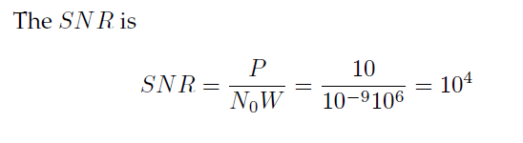(5 marks).

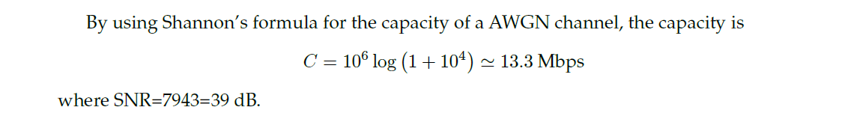(5 marks)

1. What is the bandwidth of the speech signal and sampling rate used in telephone system?*[6 marks]*

3.4 khz, 8khz (3 marks for each)

1. For a (6,3) systematic linear block code, the three parity check digits are: [30 marks]
$$P\text{1}=1×\text{I}\text{1}⊕1×\text{I}\text{2}⊕1×\text{I}\text{3}$$

$$P\text{2}=1×\text{I}\text{1}⊕1×\text{I}\text{2}⊕0×\text{I}\text{3}$$

$$P\text{3}=0×\text{I}\text{1}⊕1×\text{I}\text{2}⊕1×\text{I}\text{3}$$

2. Construct the generator matrix G for this code.

G = $\left[\begin{matrix}1 & 0 & 0 & 1 & 1 & 0 \\ 0 & 1 & 0 & 1 & 1 & 1 \\ 0 & 0 & 1 & 1 & 0 & 1\end{matrix}\right]$

1. Construct all the possible codewords generated by this matrix

|  |  |
| --- | --- |
| information | **codewords** |
| 000 | 000000 |
| 001 | 001101 |
| 010 | 010111 |
| 011 | 011010 |
| 100 | 100110 |
| 101 | 101011 |
| 110 | 110001 |
| 111 | 111100 |

1. Determine the error –correcting capabilities for this code

*d*min =3, Nc=1, Nd=2

1. Write down the syndrome table for this code.

|  |  |  |
| --- | --- | --- |
| E1=100000 | S1 | 110 |
| E2=010000 | S2 | 111 |
| E3=001000 | S3 | 101 |
| E4=000100 | S4 | 100 |
| E5=000010 | S5 | 010 |
| E6=000001 | S6 | 001 |
| E7=000000 | S7 | 000 |

1. Decode the received words 101100,000110 and 101011.

If only one error occurs to the codewords, we have

r=101100, s=111, c= 111100

r=000110, s= 110, c=100110

r=101010, s= 000, c=101011