DEPARTMENT OF ELECTRICAL ENGINEERING
(6th Semester Internship Report)

B.Tech.Project Report on
“ Ecommerce Web App”

Submitted By: -
Sumit Meena(12114048)

Under the supervision of:
Dr.JYOTI ORHI Professor



NATIONAL INSTITUTE OF TECHNOLOGY KURUKSHETRA KURUKSHETRA, 136119, HARYANA (INDIA)

DECLARATION

I hereby declare that the work which is being presented in the Project “Ecommerce Web App”, in partial fulfilment of the requirements for Internship project is an authentic record of my own work carried for the evaluation of the Sixth semester of B.Tech.
Electrical Engineering, National Institute of Technology, under the guidance of Dr.Jyoti, Professor, Dept. of Electrical Engineering. The matter presented in this internship report has not been submitted for the award of any other degree elsewhere.

Sumit Meena
(12114048)
It is certified that the above statement made by the student is correct to the best of our knowledge and belief.
Signature with date
Faculty Mentor
Dr.Jyoti Orhi
Professor

(ii)

ACKNOWLEDGEMENT

With the successful completion of the project under the stipulated time, I would like to take this opportunity to present my wholehearted compliments, with higher regards and warm thanks to all, which played an integral role and acted as sinews of this project. I would like to grab this opportunity to express my gratitude to all the individuals for their keen devotion without whom this endeavour wouldn’t have been a success.
I would like to pay my boundless thanks to my colleagues for extending help and guidance during the period. They have played an integral role in the successful completion of the project. We also do not like to miss the opportunity to acknowledge the contribution of all instructors who are available on YouTube, Google and Stack overflow.
I extend my deep sense of gratitude to Dr.Jyoti, Professor, Dept of EE, NIT Kurukshetra, mentor of the project. I sincerely thank him for imparting practical as well as theoretical knowledge. He played a keen role in making this effort a success through necessary steering whenever it was essential.
Last but not the least, I would like to express our deep sense of gratitude and earnest thanks giving to our dear parents for their moral support and heartfelt cooperation during the project.

SUMIT MEENA
12114048

ABSTRACT

This Ecommerce Web application is designed to help Watch Selling Store And Provide Online Business To Them. The application allows users to register as Buyer and Seller and provides a platform to buy watches Online with easy. The application is built using the MERN stack and uses React.js for the front-end, Express.js for the back-end, and MongoDB for the database. The application is user-friendly and easy to use. It is designed to be scalable and can be used by small or large organizations. The application is secure and uses encryption to protect user data.
The application is built using the MERN stack which makes it easy to develop and maintain. React.js is used for the front-end which provides a fast and responsive user interface.
Express.js is used for the back-end which provides a scalable server-side framework. MongoDB is used for the database which provides a flexible and scalable NoSQL database.
Overall, this Ecommerce application is a useful to provide the small store worldwide Buyer’s And help them in the Grow there Business.

Table of Contents

Declaration
Acknowledgment
Abstract
1. Introduction
1.1.Motivation and Overview
1.2.Basic Features
- Software and Requirement Analysis
  - Software Requirements
    - Web Browser
  - Language and Frameworks requirement
    - HTML
    - CSS
    - BOOTSRAP
    - JAVASCRIPT
2.2.5
2.2.6

3. Hardware and software requirements
4. Implementation and User Interface

5. Testing
6. Conclusion
7. Reference

INTRODUCTION

1.1 Overview and Motivation
Overview:
The Ecommerce Web. application to help Watch Selling Store And Provide Online Business To Them . The application also allows administrators to manage the Products data and keep track of the Order’s. The application is built using the MERN stack and uses React.js for the front-end, Express.js for the back-end, and MongoDB for the database. The application is user-friendly and easy to use.
Motivation:
The motivation behind this Ecommerce application is to help manage Selling Business and Shipment on Time. Now, a day’s after the covid-19 hit every Business owner know the importance of online app for there business growth is a critical process that can help them in reaching worldwide.. This application is designed to simplify the process of managing product’s that are made by admin and make it easier for Buyer’s.

1.2 Basic Features

Buyer’s: those who want my product and they can access from worldwide and there we
have login and register page for the buyer’s.
Admin : the admin that own the whole business and have login and register page separately the admin have access to add or delete the products.
User Authentication: Implement user authentication mechanisms to ensure secure access and protect sensitive data.
User-friendly interface: The application is user-friendly and easy to use, which makes it accessible to a wide range of users.
Secure data storage: The application uses encryption to protect user data and ensure secure data storage.
Responsive Design: Create a mobile-friendly and responsive user interface to offer a seamless experience across various devices.
Safe Payment: Gives the customer to pay online by Paypal International secured transection mode.
Fast Delivery: Open Box delivery option was provided by our site and there are fixed Return policy’s.

2. Software and Requirement Analysis

2.1 Software Requirement

VS Code’s tools can be used to enhance the functionality of any written code. Some of the advantages of using VS Code are:
Cross-platform editor: VS Code is available on Windows, Linux, and macOS operating systems.
Open-source: VS Code is an open-source code editor that is free to use.
Customizable: VS Code is highly customizable and can be tailored to suit individual needs.
Large community: VS Code has a large community of developers who contribute to its development and provide support.

Integrated terminal: VS Code has an integrated terminal that allows developers to run commands directly from the editor
Debugging tools: VS Code has built-in debugging tools that allow developers to debug their code directly from the editor.
Extensions: VS Code has a large number of extensions that can be used to enhance its functionality.
Git integration: VS Code has built-in Git integration that allows developers to manage their code repositories directly from the editor.
IntelliSense: VS Code has IntelliSense which provides smart completions based on variable types, function definitions, and imported modules

2.1.1 WEB BROWSER:

A Web Browser (typically called a browser) is a software utility for gaining access to facts on the arena huge net. Every individual internet web page, photo, and video is diagnosed by using a wonderful Uniform useful resource Locator (URL), permitting browsers to retrieve those sources from an internet server and display them at the consumer's device. A browser is not the identical thing as a search engine, though the 2 are regularly burdened. For a user, a search engine is only a website, consisting of google.com, that stores searchable facts approximately different websites. However, to connect with a website's server and show its internet pages, a user desires to have an internet browser set up on their tool. The most popular browsers are Chrome, Firefox, Safari, Explorer, and edge

2.2 Language and Framework Requirements
2.2.1 HTML:

Hypertext Markup Language (HTML) [2] is the standard markup language for documents designed to be displayed in a web browser.
With Cascading style Sheets (CSS) and JavaScript, it forms a triad of cornerstone technologies for the arena wide net. Web Browsers obtain HTML documents from an internet server or from local storage and render the documents into multimedia internet pages. HTML describes the structure of a web 14 page semantically and originally included cues for the arrival of the document. HTML elements are the constructing blocks of HTML pages. With HTML constructs, photos and other gadgets such as interactive forms can be embedded into the rendered web page. HTML offers a method to create structured files via denoting structural semantics for text which includes

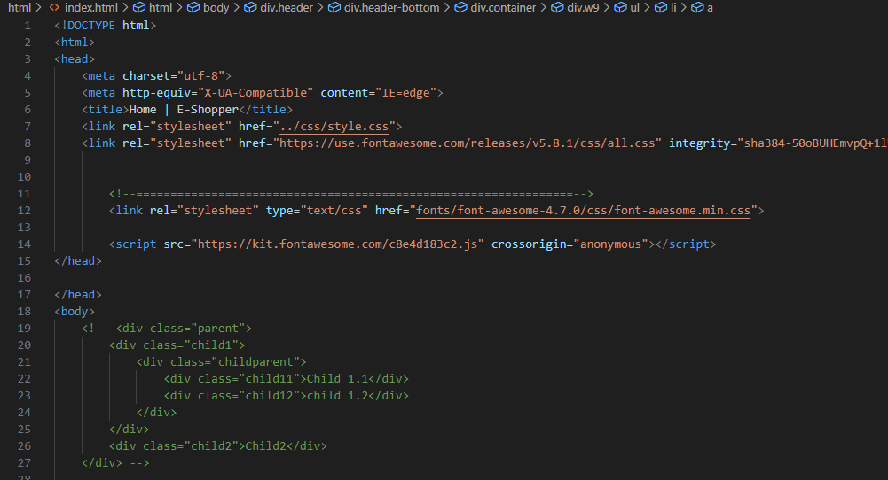

introduce content into the web page. Different tags inclusive of surround and offer statistics about report text and can include other tags as sub-elements. Browsers do no
longer show the HTML tags, however use them to interpret the content material of the page.
HTML can embed packages written in a scripting language including

JavaScript, which affects the behaviour and content material of net pages. Inclusion of CSS defines the look and format of content. The sector wide web Consortium (W3C), maintainer of both the HTML and the CSS requirements, has advocated using CSS over specific presentational HTML considering that 1997. HTML code guarantees the proper formatting of text and photographs in order that your net browser may also display them as they may be supposed to look. Without HTML, a browser might no longer recognize a way to show text as factors or load photographs or other factors. HTML also gives a simple structure of the page, upon which Cascading style Sheets are overlaid to trade its look. One ought to think about HTML because the bones (structure) of an internet web page, and CSS as its skin (look) and JavaScript as its brain.

2.2.2 CSS (Cascading Style Sheets):

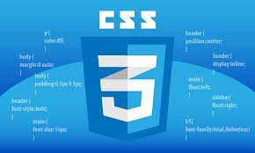

Cascading style Sheets [2], fondly called CSS, is a easy design language meant to simplify the manner of creating internet pages presentable. CSS handles the appearance and sense part of an internet web page. the use of CSS, you can manage the colour of the text, the fashion of fonts, the spacing between paragraphs, how columns are sized and laid out, what background pictures or colourings are used, format designs, versions in show for distinctive gadgets and display sizes in addition to a spread of other consequences.
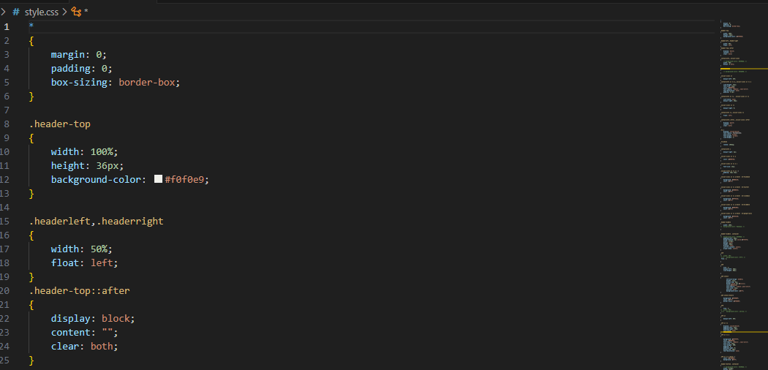

CSS is easy to study and apprehend but it affords powerful manipulate over the presentation of an HTML document. most generally, CSS is blended with the markup languages HTML or XHTML.

2.2.3 BOOTSTRAP:
Bootstrap is a popular open-source front-end framework for building responsive and mobile-first websites. It provides a number of features such as pre-built CSS and JavaScript components, responsive design, and more. Bootstrap is designed to make the development process smoother and easier. It provides a simple and flexible API for building web applications and websites. Bootstrap is built on top of HTML, CSS, and JavaScript which makes it fast and scalable. It provides a number of tools that make it easy to build responsive and mobile-first websites.
Bootstrap is highly customizable and can be tailored to suit individual needs. It provides a number of themes and templates that can be used to quickly build websites. Bootstrap is widely used by developers around the world to build websites and web applications.

2.2.4 JAVA SCRIPT (JS):

JavaScript, frequently abbreviated as JS [2], is a high-level, interpreted programming language that conforms to the ECMAScript specification. it is a programming 16 language that is characterized as dynamic, weakly typed, prototype-based and multi-paradigm. alongside HTML and CSS, JavaScript is one of the core technologies of the sector wide web. JavaScript enables interactive internet pages and is a critical a part of net programs. The extensive majority of websites use it, and most important web browsers have a devoted JavaScript engine to execute it.
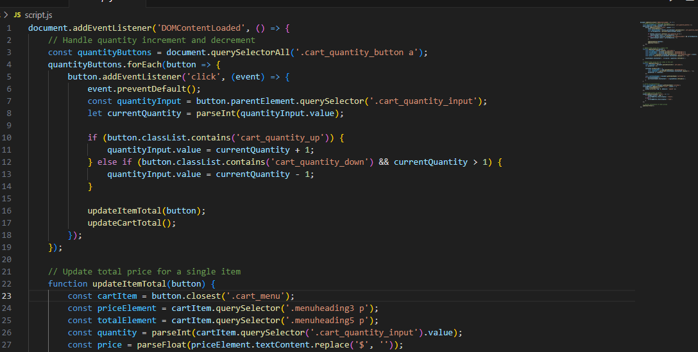

As a multi-paradigm language, JavaScript helps occasion-driven, purposeful, and vital (inclusive of object-orientated and prototype-based) programming styles. It has APIs for operating with text, arrays, dates, ordinary expressions, and the DOM, however the language itself does not encompass any I/O, such as networking, storage, or portraits facilities. It relies upon the host surroundings in which it's far embedded to offer those features. initially only implemented client-side in web browsers, JavaScript engines are now embedded in lots of different kinds of host software program, consisting of server-aspect in internet servers and databases, and in non-internet programs which include word processors and PDF software.

2.2.5 REACT JS:

ReactJS [4] is JavaScript library used for building and constructing reusable UI components. In line with React official documentation, following is the definition - It encourages the introduction of reusable UI additives, which present facts that changes over time. Plenty of people use React as the V in MVC. React abstracts away the DOM from you, imparting a simpler programming version and better performance.
React can also render at the server the usage of Node, and it may power local apps the usage of React local. React implements one-way reactive information flow, which reduces the boilerplate and is simpler to motive about than conventional data binding.
Other frameworks like Next.js, Angular and Vue can also be used in place of React.

React Features:

- JSX − JSX is JavaScript syntax extension. It isn't always essential to use JSX in React development, but it is endorsed
- Components − React is all approximately components. You need to think of everything as an element. This could assist you preserve the code when running on larger scale projects
- Unidirectional records go with the flow and Flux −− React implements one- manner information flow which makes it easy to reason about your app. Flux is a pattern that enables maintaining your data unidirectional.
- License − React is licensed beneath the Facebook Inc. Documentation is licensed below CC by 4.0.

React Advantages:
- 1. Uses virtual DOM that's a JavaScript object. This will enhance apps performance, because JavaScript virtual DOM is faster than the ordinary DOM.
- Can be used on consumer and server facet in addition to with other frameworks.
3.Component and data styles improve clarity, which enables or helps to preserve larger apps

React Limitations:
- Covers only the view layer of the app, hence you still need to choose other technologies to get a complete tooling set for development.
- Uses inline templating and JSX, which might seem awkward to some developers.

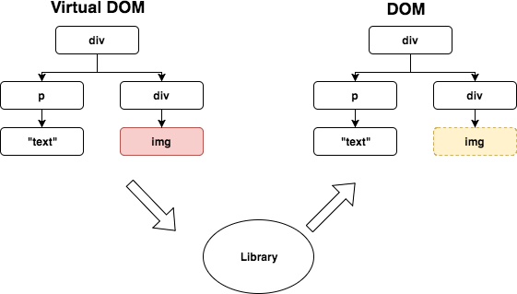

Fig 1: Virtual Document Object Model of React

2.2.6 MATERIAL UI:

Material-UI [5] is a simple and customizable element library to make faster, beautiful, and a lot of accessible React applications. Follow your own style system, or begin with Material style. Material style was created by Google in 2014, primarily based partially on the card- based layout used in Google Now. The nod to paper-based design designs differentiated it from the flat design vogue that was wide used at the time.
Like most design systems, Material Design was created to bring a unified user expertise across numerous devices, platforms, and input methods. like the method that Apple enforced flat style principles as their standard, Google used Material style to confirm that, notwithstanding however users were accessing their products, they'd have an identical user expertise.

2.2.7 Express.js:

Express.js is a popular open-source web application framework for Node.js. It provides a robust set of features for web and mobile applications. Express.js is designed to make the development process smoother and easier. It provides a simple and flexible API for building web applications and APIs. Express.js is built on top of Node.js which makes it fast and scalable. It provides a number of features such as routing, middleware, templating engines, and more. Express.js is highly customizable and can be tailored to suit individual needs. It is widely used by developers around the world to build web applications and APIs.
Express.js is a minimalist framework that provides a simple and flexible API for building web applications and APIs. It provides a number of features such as routing, middleware, templating engines, and more. Express.js is built on top of Node.js which makes it fast and scalable. It provides a number of tools that make it easy to build web applications and APIs. Express.js is highly customizable and can be tailored to suit individual needs.
Overall, Express.js is a powerful tool for building web applications and APIs. It provides a number of features that make it easy to build fast, scalable, and reliable applications. Whether you are building a small website or a large-scale application,
Express.js can help you get the job done quickly and efficiently.

2.2.8 REACT CONTEXT :

Context provides a way to pass data through the component tree without having to pass props down manually at every level.

Context is designed to share data that can be considered “global” for a tree of React components, such as the current authenticated user, theme, or preferred language. Whenever you want a store to keep your states or variables in and use them elsewhere in your program, use Context. Generally, when we have two or more levels(height) in our component tree, it is viable to use a store instead of passing props and then lifting the state as this will create confusion and unnecessary lengthy code.
Redux is also used in place of React Context but context is relatively easier for small scale state management and Redux is mostly in used in case of complicated global state management system for bigger projects.



Fig 2: React Context for handl

ing components
’
state

3. HARDWARE AND SOFTWARE REQUIREMENT

Following are the hardware and the software requirements for our project:
Hardware:
- Laptop/Desktop

- 4 GB of RAM

- Hard disk space: Minimum of 800MB up to 210GB of available space

- Video card that supports a minimum display resolution of 720p (1280 by 720)

- Good Internet connection.

Software:
- Windows 8.1 and above

- Visual Studio

- Web Browser

- Material UI and Materialize CSS

4. IMPLEMENTATION AND USER INTERFACE

Fig 4.1 Login page for User

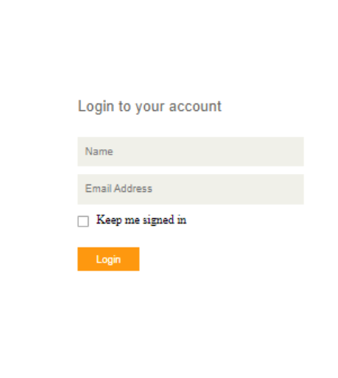

Fig.4.2 Register Page

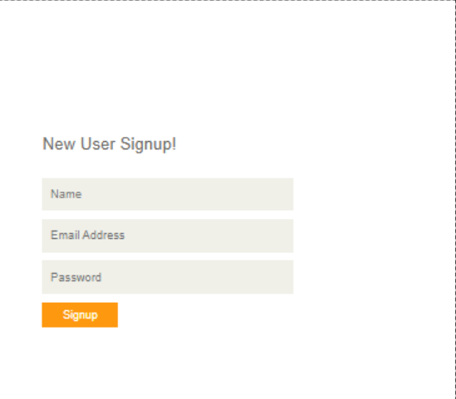

Fig 4.3 User Logged In Interface

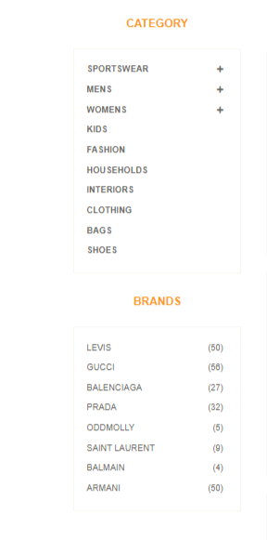



categories

fig4.4..Add to some prodect in card

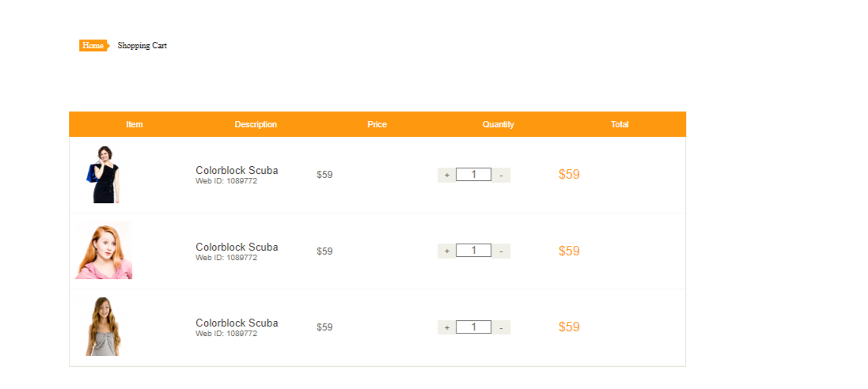

Fig 4.5 Website Icons


5. TESTING
The software developed in the project is integrated with the hardware testing environment and the system was tested. Integration tests were carried out in two phases, Client test scenarios written in the first phase were executed and Mongo DB test scenarios. The success rate in the first phase was determined as 92%.
Test Environment:
The errors that appeared in the first phase were corrected and the second phase was passed. In the second phase, a re-test was performed to check whether the errors in the first phase were removed. Website is tested in GTMatrixGrade platform and the success rate of the tests was determined as 92% and performance 99%.

Fig 5.1 Home Page

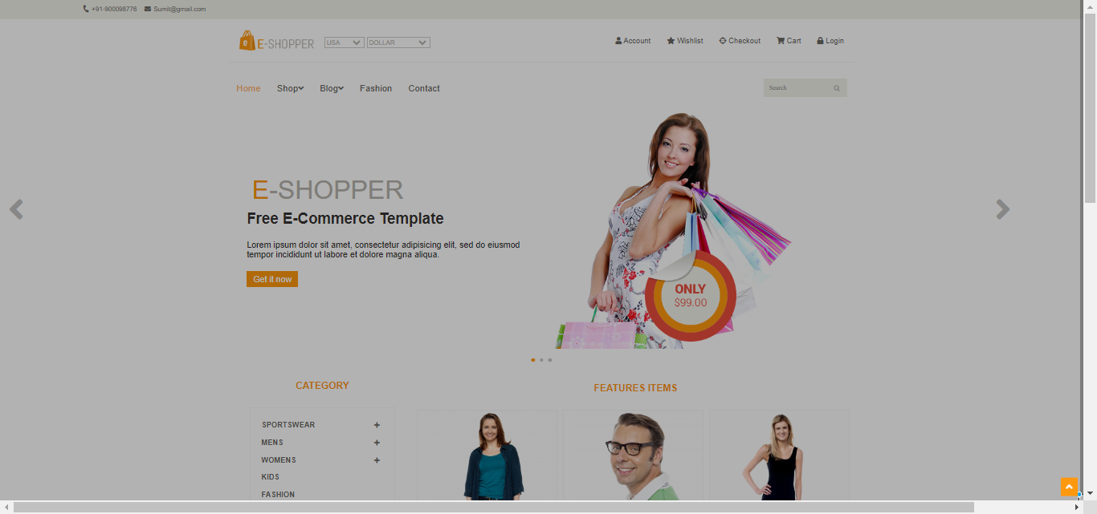

Fig 5.2 Page Details

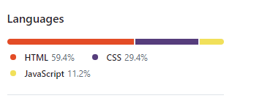

6. Conclusions

Undertaking the project jointly shall be enriching for our knowledge as we labor on it. We decided to work on this project because we want to promote quality learning experience with our application.
- During the development of this project, we have learned different skills like
- How to work under pressure.
- How to work with time and manage our work.
- Knowledge of new technologies like React.js , Materialize CSS etc.
- We have made a good interactive User Interface so that the user will not face any difficulty while using our application.
- Our project is completed but we will continuously try to make it more reliable, secure and add more features.

7. References
- VS Code: https://code.visualstudio.com/
- W3 School: https://www.w3schools.com/
- Express: https://expressjs.com/
- React: https://reactjs.org/docs/getting-started.html
- Font Awesome: https://fontawesome.com/
- Materialize CSS - https://materializecss.com/
- Stack Overflow: https://stackoverflow.com/

