|  |  |
| --- | --- |
|  | **Fsoft logo for Words-Small.gif** |

**Design Document**

**For AB-SERVICE**

*Prepared for*

**Monday, September 19, 2011**

**Version 0.1**

*Prepared by*

**Pham Trung Hai**

Revision and Signoff Sheet

Change Record

|  |  |  |  |
| --- | --- | --- | --- |
| **Date** | **Author** | **Version** | **Change reference** |
| 09/18/2011 | Pham Trung Hai | 0.1 | Create new |
|  |  |  |  |
|  |  |  |  |

Reviewers

|  |  |  |  |
| --- | --- | --- | --- |
| **Name** | **Version** | **Position** | **Date** |
| Nguyen Trung Kien | 0.1 | QA | 08-Sep-2010 |
| Nguyen Minh Tien | 0.1 | QA | 08-Sep-2010 |

Table of Contents

1 Introduction 30

1.1 Purpose 30

1.2 Scope 30

1.3 Intended Audiences and Document Organization 30

1.4 Acronyms and Abbreviations 30

1.5 References 31

2 Architecture design 31

2.1 Overview 31

2.2 Application Logical Architecture 31

2.1 Component view 33

3 Database design 33

3.1 Entity Relationship Diagram 33

3.2 Schema 34

3.1 Detail Schema 34

4 Application Security 34

4.1 Custom Permission 34

4.2 Security Group 34

4.3 Security Group v.s. List 35

5 Workflow and Business Processing 31

5.1.1 PM Request 32

6 Interface Design 35

6.1 Layout 35

6.2 Themes 35

7 Details design 35

8 Configuration 36

8.1 Application Configuration 36

8.2 System Configuration 36

9 Packaging and Deployment 36

# Introduction

## Purpose

This document contains the detailed design for to be developed application on target platform. It defines, technically, how applications will operate. Developers will base on this document and corresponding SRS to conduct development plan, task assignment and implementation of the new application.

## Scope

This document is prepared for the application in scope of the MOCK project of FRESHER05.

## Intended Audiences and Document Organization

This document is intended for:

* Development team: Developers and Testers
* Rollout Technical Team: Responsible for deploying applications to UAT and Production environments.
* Customer Representatives: Responsible to review & approve the document.

Below are main sections of the document:

* **Introduction** : This section describes the general introduction of this document
* **Architecture Design :** This section describes the high-level technical assessments and decisions for the application.
* **Data Design**: This section describesin detail how data is structured and manipulated in this application.
* **Interface Design:** This section describesin detail how UI is designed in general ( layout , theme ).
* **Application Security**: This section describles security matrix in detail
* **Configuration:** This section describes all configuration needed for the application to function properly.
* **Packaging and Deployment:** This section describles how applications could be packaged and deployed.
* Note:Please refer section 1.4 for all acronyms and abbreviations you may encounter within this document.

## Acronyms and Abbreviations

|  |  |  |
| --- | --- | --- |
| # | Item | Description |
| 1 | ASP | ActiveX Server Page |
| 6 | JVM | Java Virtual Machine |
| 7 | HTTP | Hypertext-Transfer Protocol |
| 8 | MVC | Model – View – Control |
| 10 | DAO | Data Access Object, this object is responsible for attaching to a system, extracting some information, based on specific requirements, and creating a value object. |
| 11 | VO | Value Object |

## References

**( Mô tả các tài liệu tham khảo ( nếu có ))**

|  |  |  |  |  |
| --- | --- | --- | --- | --- |
| # | Title | Version | File Name / Link | Description |
| 1 | Common Requirements Document | 1.0 | XXXX |  |
| 2 |  |  |  |  |

Table 1.1: List of References

# Architecture design

## User case view

**(*Liệt kê các UC chính và mô tả chi tiết)**

### Overview

The following use cases are required to be to be included in the Service Directory

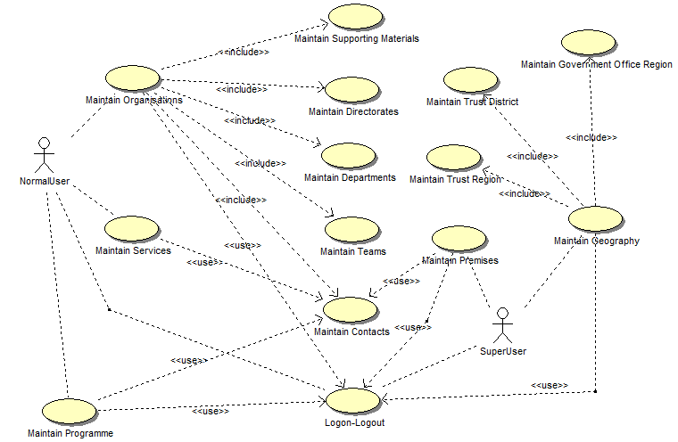

### Description

|  |  |  |
| --- | --- | --- |
| **UC** | **Name** | **Description** |
| UC001 | Logon & Logout | Allowing a user to logon to the system |
| UC002 | Maintain Organisations | Maintain the data within the Organisation area of the system |
| UC003 | Maintain Services | Maintain the data for Services |
| UC004 | Maintain Programmes | Maintain the data for Programme |
| UC005 |  | Maintain the data for premises, facilities and persons |
| UC006 | Maintain Geographic Data | Maintain the data within the Geography area of the system |

## Architectural Representation

**( *Mô tả kiến trúc của ứng dụng ở tầng thứ 2 : Kiến trúc chiều dọc của application )**

The following diagram shows the primary tiers in the proposed n-tier architecture. This diagram shows the main layers in this architecture and the vision of how they fit together.



Figure 1 – N-tier architecture of SD System

### Presentation Layer

This layer controls the display to the end user. For the presentation layer of SD System, the development framework is based on ASP.NET Model architecture. The framework is responsible for:

Managing requests/responses from/to the clients.

Controlling display to the end user.

Assembling a model that can be presented in a view.

Performing UI validation.

Providing a controller to delegate calls to business logic and other upstream processes.

Handling exceptions from other layers.

### Business Layer

This layer manages the business processing rules and logic.

Handling application business logic and business validation.

Managing transactions.

Allowing interfaces for interaction with other layers.

Managing dependencies between business level objects.

Adding flexibility between the presentation and the persistence layer so they do not directly communicate with each other.

Exposing a context to the business layer from the presentation layer to obtain business services.

Managing implementations from the business logic to the persistence layer.

### Data Access Layer

This layer manages access to persistent storage. The primary reason to separate data access from the rest of the application is that it is easier to switch data sources and share Data Access Objects (DAOs) between applications.

This layer manages reading, writing, updating, and deleting stored data.

### Data Layer

In AB SD SYSTEM, the storage is managed by a relational database. SQL SERVER 2005 is used for this layer to provide the management of stored data.

## 2.3 Packages/Components view

**( *Mô tả kiến trúc ứng dụng ở tầng thứ 3 :chi tiết các component/ pakage trong ứng dụng sẽ interactive với nhau như thế nào )** 

### UI Components

This package includes the implementation for the ASP.NET architecture proposed to be used in the Presentation Layer to handle the display to the end user.

**Validation**: All validation of incoming requests parameters to the server should be validated using JavaScript Validation or ASP.NET client side control .

### Business Object

This package includes the implementation of business objects. **Business Object** (BO) layer is used to perform the business operations. The Business Object layer will access the DAO to access database. Transactions should be managed within this business layer.

### Transfer Data Objects ( Entity )

Transfer Data Objects is .NET class, contains lightweight structures for related business information. These are sometimes referred to as data transfer objects. A value object (VO) is a lightweight, serializable object that structures groups of data items into a single logical construct. .In addition, VOs are useful in communication among all layers of the application.

### Data Access Object

This package includes the implementation of Data Access Object. Using SQLCLient object here to make the application more flexible to access database. SQLClient object includes basic functions to work with database: *select, insert, update, delete*.

### Exceptions

This package will include all general exceptions that will typically used by more than one package. The try-catch clauses should be kept to a minimum.

We use :*Microsoft.Practices.EnterpriseLibrary.ExceptionHandling.dll*

### Utils

This package includes all utilities .NET classes will be wisely used in the modules.

### Logging

This package includes implemented logging classes.

We used : [*http://logging.apache.org/log4net/*](http://logging.apache.org/log4net/)

# Technical Solutions

**(*Mô tả chi tiết các giải phaps kỹ thuật áp dụng trong ứng dụng, ví dụ : Loadbalancing, giải pháp fast log khi số lượng user >1M..etc , nếu không có thì remove phần này)**

## Exception handling mechanism

**( *Mô tả giải pháp )**

The try-catch clauses should be kept to a minimum.

Whenever an exception raise , system will log exception detail to Windows event and redirect user to Error page to display standard error message!

## Loging mechanism

# Database design

## Entity Relationship Diagram

**(* Vẽ lược đồ quan hệ ra đây, dùng VISO hoặc capture Diagram từ SQL SERVER..ETC)**



## Schema

**( *Mô tả tên các table và diễn giải từng table ở diagram trên )**

**Overview**

|  |  |  |
| --- | --- | --- |
| **#** | **Name** | **Description** |
| 1 | Request | Store all request |
| 2 | CommentAttachs | Store comments and attach files in request |

## Detail Schema

**(* Mô tả chi tiết cấu trúc từng table gồm filed name ,data type, length, mô tả)**

|  |  |  |  |  |
| --- | --- | --- | --- | --- |
| **category table** | | | | |
|  | **Field name** | **Type** | **Max Length** | **Descrition** |
| 1 | categoryID | String |  | Mã thể loại |
| 2 | categoryName | String |  | Tên thể loại |

# Application Security

**(* Mô tả các permison trong ứng dụng , security matrix, cách thức user đăng nhạp ..etc )**

## Custom Permission

|  |  |
| --- | --- |
| **Name** | **Permission** |
| Requester | New, Read , Edit |
| Reader | Read |
| Full Control | New, Read, Edit,Delete |
| No Acess | N/A |

## Security Group

|  |  |
| --- | --- |
| Name | **Description** |
| [Setup.Admin] | Administrator is responsible to manage request data, manage application config, report  and perform importing functions, etc. |
| [Requester] | A Requester who manages request, submits request for approval. |
| [Application.Admin] | A group of users who has special permission to process all requests in any step of application workflow |

## . Main functions ‘s security matrix

**( Mô tả phân quyền tới từng User case )**

|  |  |  |  |  |  |  |  |
| --- | --- | --- | --- | --- | --- | --- | --- |
| **Usercase** | **Actor** | **Admin** | **Log**  **tracker** | **Biên tập viên** | **Tổng biên tập** | **Người dùng** | **System** |
| Quản lý phim | Thêm mới phim | X |  | X | X |  |  |
| Cật nhập phim | X |  | X | X |  |  |
| Xóa phim | X |  | X | X |  |  |
| Duyệt phim | X |  |  | X |  |  |
| Quản lý thể loại fim | Danh sách thể loại | X |  |  |  |  |  |
| Thêm mới thể loại | X |  |  |  |  |  |
| Cập nhật thể loại | X |  |  |  |  |  |
| Xóa thể loại | X |  |  |  |  |  |
| Quản lý tài khoản | Danh sách tài khoản | X |  |  |  |  |  |
| Thêm mới tài khoản | X |  |  |  |  |  |
| Cập nhật tài khoản | X |  |  |  |  |  |
| Xóa tài khoản | X |  |  |  |  |  |
| Quản lý khách hàng | Thêm mới khách hàng |  |  |  |  |  | X |
| Cập nhật khách hàng |  |  |  |  |  | X |
| Xóa khách hàng |  |  |  |  |  | X |

# Details function design

**(* Phần này mô tả chi tiết từng Use case : Screen design & Data descrition , Class Design , Sequense flow )**

## Use case 01: Logon

### Screen design & Data description

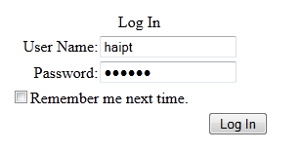

Figure 2 : Login Screen

### Class Diagram



### Sequense flow

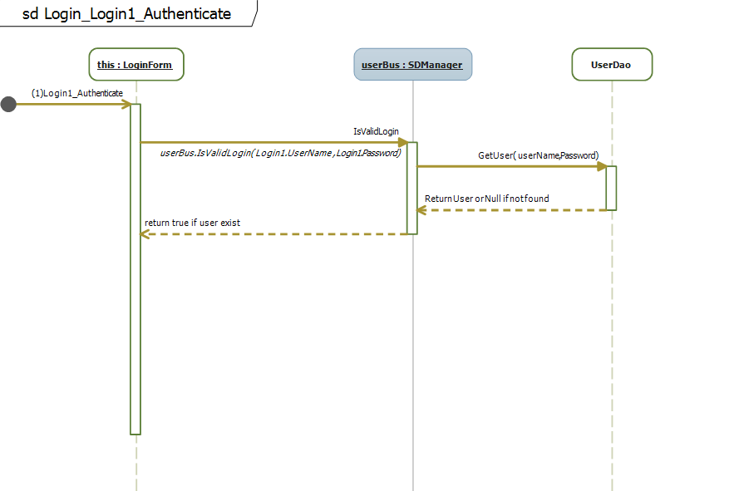

## Use case 2: Lookups

### Screen design & Data description

#### Lookup Address

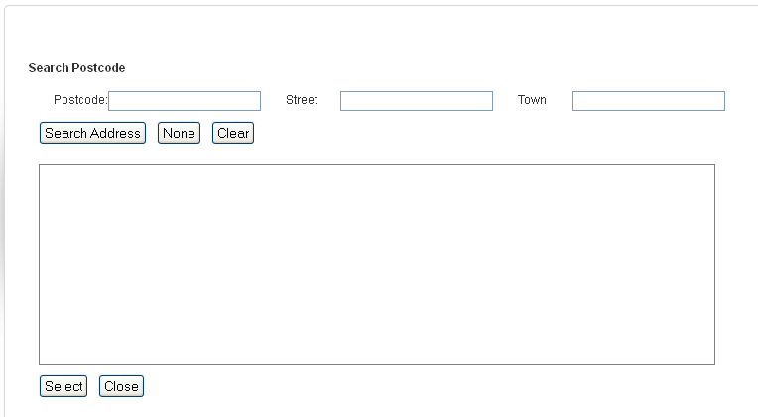

#### Lookup TypeOfBusiness

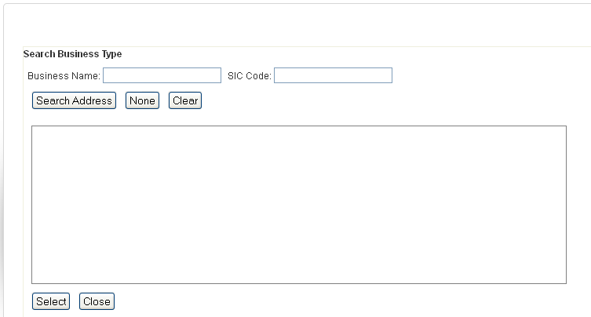

### Class Diagram

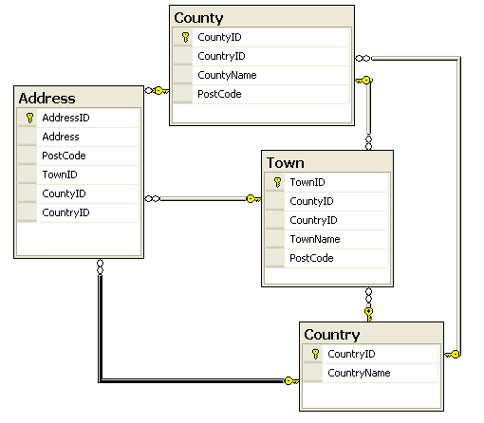

### Sequense flow

# Configuration

**(* mô tả các item cần cấu hình để run ứng dụng ví dụ: config file..etc)**

## Application Configuration

|  |  |  |
| --- | --- | --- |
| Field | Values | Remark |
|  |  |  |
|  |  |  |

## System Configuration

|  |  |  |
| --- | --- | --- |
| Field | Values | Remark |
|  |  |  |
|  |  |  |

# Packaging and Deployment

**( * Mô tả việc deploy ứng dụng )**

# Appendix

**(* Phần này có thể cung cấp tài liệu mô tả các công nghệ có thẻ sử dụng trong app, tài liệu liên quan, các mẫu thiết kế được sử dụng , không có thì bỏ trống)**

## Micrsoft Enterprise library

**(* more detail )**