

Wenzhou-Kean University

Project

CPS2231: Computer Organization and Programming

|  |  |
| --- | --- |
| Student Name: | Chen Yiheng |
| Student ID: | 1163089 |
| Project Name: | Tictactoe |
| Lecture: | Dr. Hemn Barzan Abdalla |

Spring Semester-2021

**Purpose:** It is a Tictactoe game for one or two players by Java. This is a board game. player 1's piece is 1, player 2's piece is 2. 0 means there are no pieces. The chessboard is a nine-palace grid. Two players take turns to choose a position to drop the pieces. When one player’s pieces are three in a row or in a slant, or in a column. That player wins. Or when the chessboard is full, but the winning rule is not triggered. It is a draw. This game has two play modes. One mode is for two players to play. One mode is for one player to play, and the computer acts as the second player. The computer will prevent you from winning the game. When your pieces are two in a row or in a slope, or in a column, the computer will drop a piece at the position where you want to form three in a row or in a slit, or in a column.

**Code：**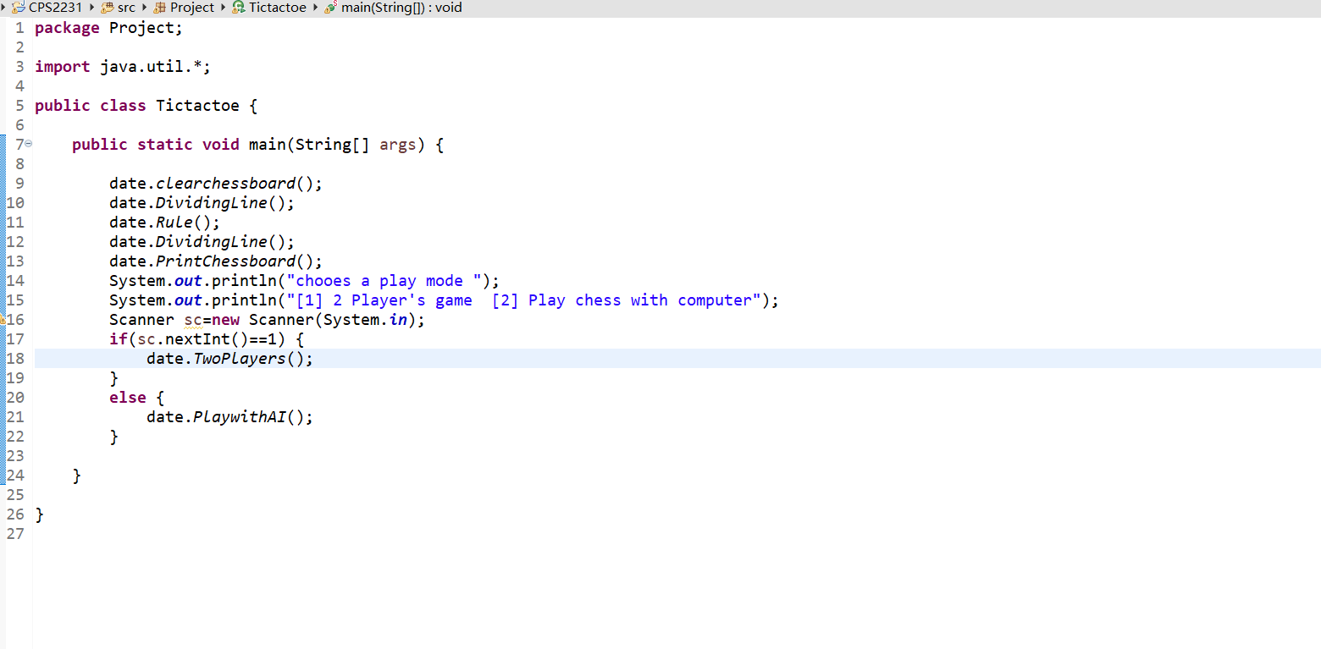

**package** Project;

**import** java.util.Scanner;

**public** **class** date {

**static** **int** *piece*[][]=**new** **int**[3][3];

**static** **int** *position*;

**static** **int** *playerNum*;

**static** **void** clearchessboard() {

**for** (**int** i=0;i<3;i++) {

**for**(**int** j=0;j<3;j++) {

*piece*[i][j]=0;

}

}

}

**static** **void** DividingLine() {

System.***out***.println("----------------------------------------------------------------------------------------");

}

**static** **void** Rule() {

System.***out***.println("Rules:");

System.***out***.println("It is a Tictactoe game for one or two players by Java.\r\nplayer 1's piece is 1, player 2's piece is 2. \r\n0 means there are no pieces.");

System.***out***.println("Enter two-digits number to drop a piece.");

System.***out***.println("The first digit of a number represent the row on the board.");

System.***out***.println("The second digit of a number represents the column on the board.");

System.***out***.println("e.g. 22 is the middle of the chessboard. 11 is the upper left corner of the chessboard");

System.***out***.println("When one player’s pieces are three in a row or in a slant, or in a column. That player wins. \r\nOr when the chessboard is full, but the winning rule is not triggered. It is a draw.");

}

**static** **void** PrintChessboard() {

**for** (**int** i=0;i<3;i++) {

**for**(**int** j=0;j<3;j++) {

System.***out***.print(*piece*[i][j]);

System.***out***.print("|");

}

System.***out***.println("");

}

}

**static** **void** DropPiece(**int** p) {

**while**(p!=11&p!=12&p!=13&p!=21&p!=22&p!=23&p!=31&p!=32&p!=33 || *piece*[p/10-1][p%10-1]!=0) {

System.***out***.println("The selected position does not conform to the rules, please enter again!");

Scanner input=**new** Scanner(System.***in***);

*position*=input.nextInt();

p=*position*;

}

*piece*[p/10-1][p%10-1]=*playerNum*;

}

**static** **void** AIDropPiece() {

**boolean** f=**false**;

String ai="";

**for** (**int** i=0;i<3;i++) {

**if**(*piece*[i][0]==0&*piece*[i][1]==1&*piece*[i][2]==1) {

*piece*[i][0]=*playerNum*;

ai=i+"1";

f=**true**;

**break**;

}

**else** **if**(*piece*[i][0]==1&*piece*[i][1]==0&*piece*[i][2]==1){

*piece*[i][1]=*playerNum*;

ai=i+"2";

f=**true**;

**break**;

}

**else** **if**(*piece*[i][0]==1&*piece*[i][1]==1&*piece*[i][2]==0){

*piece*[i][2]=*playerNum*;

ai=i+"3";

f=**true**;

**break**;

}

}

**if**(!f) {

**for** (**int** i=0;i<3;i++) {

**if**(*piece*[0][i]==0&*piece*[1][i]==1&*piece*[2][i]==1) {

*piece*[0][i]=*playerNum*;

ai="1"+i;

f=**true**;

**break**;

}

**else** **if**(*piece*[0][i]==1&*piece*[1][i]==0&*piece*[2][i]==1){

*piece*[1][i]=*playerNum*;

ai="2"+i;

f=**true**;

**break**;

}

**else** **if**(*piece*[0][i]==1&*piece*[1][i]==1&*piece*[2][i]==0){

*piece*[2][i]=*playerNum*;

ai="3"+i;

f=**true**;

**break**;

}

}

}

**if**(!f) {

**if**(*piece*[0][0]==0&*piece*[1][1]==1&*piece*[2][2]==1) {

*piece*[0][0]=*playerNum*;

ai="11";

f=**true**;

}

**else** **if**(*piece*[0][0]==1&*piece*[1][1]==0&*piece*[2][2]==1){

*piece*[1][1]=*playerNum*;

ai="22";

f=**true**;

}

**else** **if**(*piece*[0][0]==1&*piece*[1][1]==1&*piece*[2][2]==0){

*piece*[2][2]=*playerNum*;

ai="33";

f=**true**;

}

}

**if**(!f) {

**if**(*piece*[1][1]==0&*piece*[0][2]==1&*piece*[2][0]==1) {

*piece*[1][1]=*playerNum*;

ai="22";

f=**true**;

}

**else** **if**(*piece*[1][1]==1&*piece*[0][2]==0&*piece*[2][0]==1){

*piece*[0][2]=*playerNum*;

ai="13";

f=**true**;

}

**else** **if**(*piece*[1][1]==1&*piece*[0][2]==1&*piece*[2][0]==0){

*piece*[2][0]=*playerNum*;

ai="31";

f=**true**;

}

}

**if**(!f) {

**int** p=0;

**while**(p!=11&p!=12&p!=13&p!=21&p!=22&p!=23&p!=31&p!=32&p!=33 || *piece*[p/10-1][p%10-1]!=0) {

p=(**int**)(Math.*random*()*4)*10+(**int**)(Math.*random*()*4);

}

*piece*[p/10-1][p%10-1]=*playerNum*;

ai=Integer.*toString*(p);

}

System.***out***.println("Player 2(computer) choose to drop the piece in "+ai);

}

**static** **boolean** VictoryJudgment() {

**boolean** flag=**false**;

**for** (**int** i=0;i<3;i++) {

**if**(*piece*[i][0]==*playerNum* && *piece*[i][1]==*playerNum* &&*piece*[i][2]==*playerNum*) {

System.***out***.println("Player "+*playerNum*+" wins!");

flag=**true**;

**break**;

}

}

**for** (**int** i=0;i<3;i++) {

**if**(*piece*[0][i]==*playerNum* && *piece*[1][i]==*playerNum* &&*piece*[2][i]==*playerNum*) {

System.***out***.println("Player "+*playerNum*+" wins!");

flag=**true**;

**break**;

}

}

**if**(*piece*[0][0]==*playerNum* && *piece*[1][1]==*playerNum* &&*piece*[2][2]==*playerNum*||*piece*[0][2]==*playerNum* && *piece*[1][1]==*playerNum* &&*piece*[2][0]==*playerNum*) {

System.***out***.println("Player "+*playerNum*+" wins!");

flag=**true**;

}

**return** flag;

}

**public** **static** **void** TwoPlayers() {

System.***out***.println("This mode is for two players to play.");

Scanner input=**new** Scanner(System.***in***);

**for**(**int** i=0;i<9;i++){

*DividingLine*();

System.***out***.println("It is player "+ (i%2+1) +"'s round. Enter the position you want to drop the piece");

*DividingLine*();

*playerNum*=i%2+1;

*position*=input.nextInt();

*DropPiece*(*position*);

*PrintChessboard*();

**if** (*VictoryJudgment*()) {

**break**;

}

**if**(i==8) {

System.***out***.println("It is a draw");

}

}

}

**public** **static** **void** PlaywithAI() {

System.***out***.println("This mode is for one player to play, and the computer acts as the second player.");

Scanner input=**new** Scanner(System.***in***);

**for**(**int** i=0;i<9;i++){

*DividingLine*();

**if**(i%2==0) {

System.***out***.println("It is your round. Enter the position you want to drop the piece");

*DividingLine*();

*playerNum*=i%2+1;

*position*=input.nextInt();

*DropPiece*(*position*);

*PrintChessboard*();

**if** (*VictoryJudgment*()) {

**break**;

}

**if**(i==8) {

System.***out***.println("It is a draw");

}

}

**else** {

System.***out***.println("It is computer's round.");

*DividingLine*();

*playerNum*=i%2+1;

*AIDropPiece*();

*PrintChessboard*();

**if** (*VictoryJudgment*()) {

**break**;

}

**if**(i==8) {

System.***out***.println("It is a draw");

}

}

}

}

**public** **static** **void** main(String[] args) {

}

}

**Output1:**

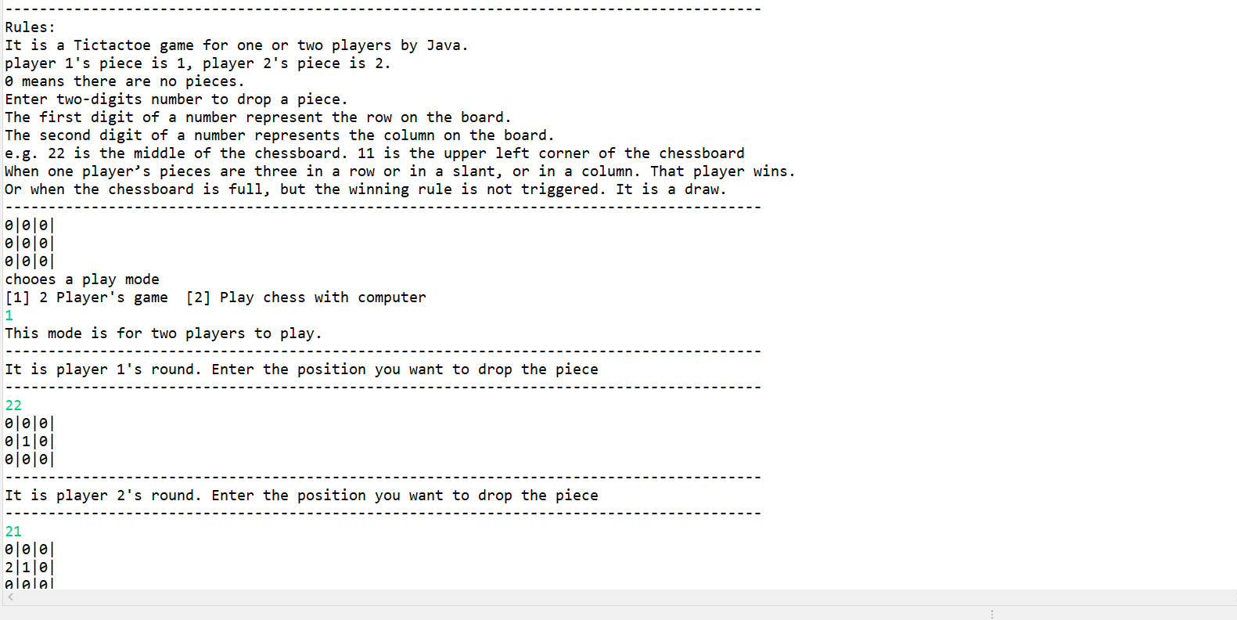

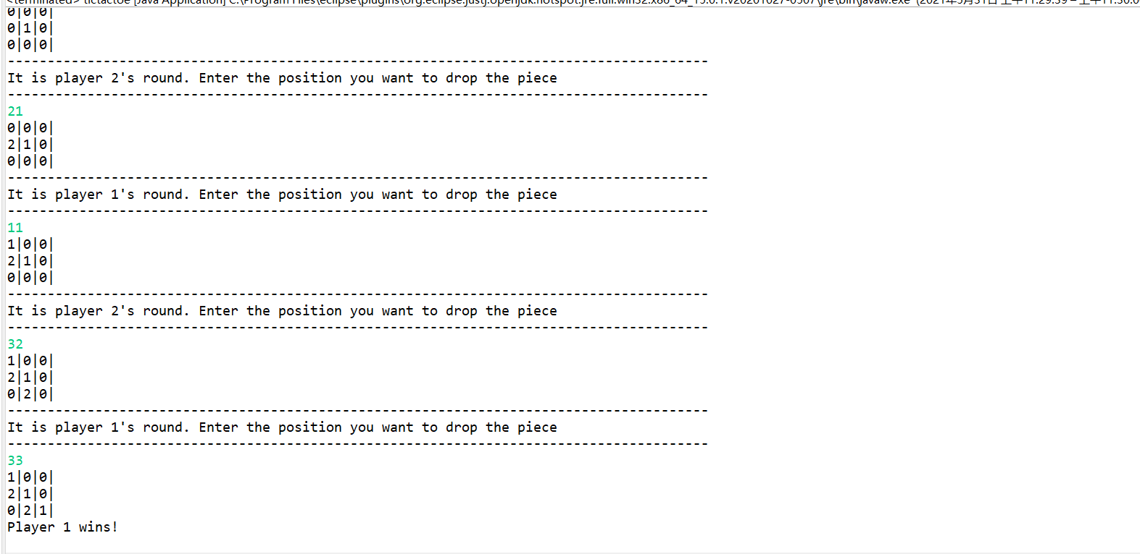

**Output2:**

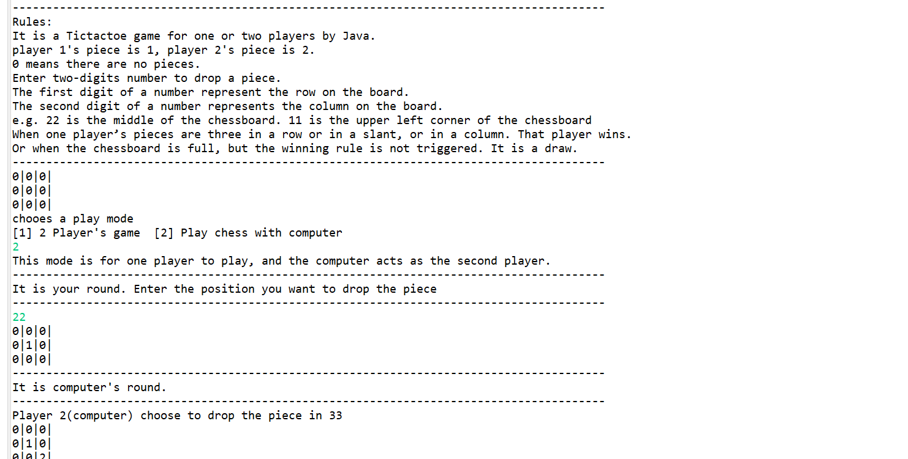

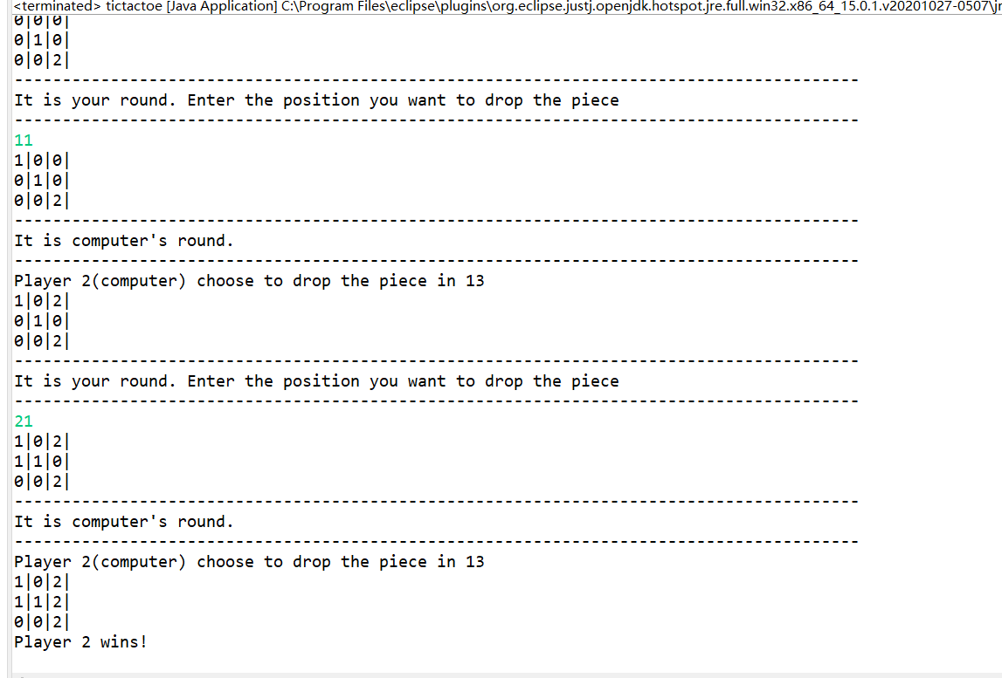

**Output3:**

