**Question 1**

**HTML**

<!DOCTYPE html>

<head>

       <title>Css Selectors</title>

        <link rel="stylesheet" href="style.css">

</head>

<body>

    <h1>CSS Selectors</h1>

     <p class="center">This is a paragraph with the class Center.</p>

     <p>This is a Normal Pragraph.</p>

     <div>

     <h2 id="box">Heading inside a div.</h2>

     <p>This is a paragraph inside a div.</p>

     </div>

     <ul>

        <li>First item</li>

        <li>second item</li>

        <li>Third item</li>

     </ul>

</body>

</html>

**CSS**

*{

    font-family: Arial, Helvetica, sans-serif;

    background-color:lightpink;

}

h1{

    color:darkblue;

    text-align: center;

    font-weight: bold;

    font-display: underline;

}

.center{

    font-size: 18px;

    color: green;

}

div{

    font-size: medium;

    font-style: italic;

    color: black;

    font-family: 'Times New Roman', Times, serif;

}

#box{

    font-size: large;

    font-family: 'Courier New', Courier, monospace;

    font-weight: 2px;

    font-style: oblique;

    color:darkolivegreen;

}

p{

    border-color: black;

    color: blueviolet;

    font-size: medium;

    font-family: 'Gill Sans', 'Gill Sans MT', Calibri, 'Trebuchet MS', sans-serif;

}

ul{

    color: darkturquoise;

    font-size:large; file:///C:/WDD/ass2_p1.html

    font-weight: 400px;

    font-style: unset;

}

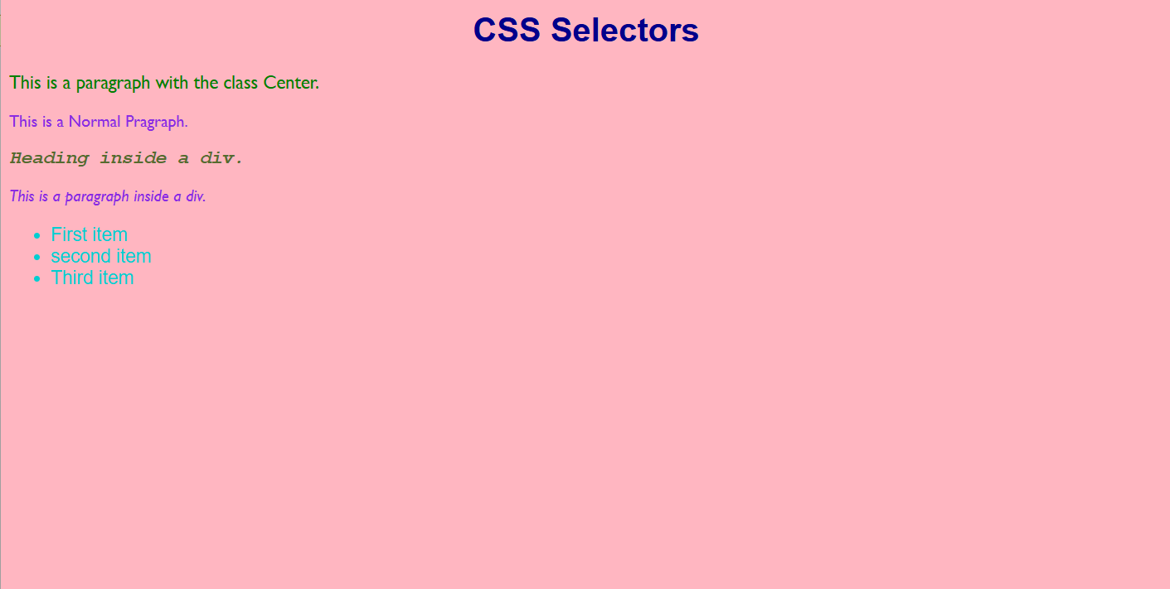

**QUESTION 2**

**HTML**

<!DOCTYPE html>

<head>

    <title>Box Model Example</title>

    <link rel="stylesheet" href="a2_p2.css">

</head>

<body>

     <div class="box">

        <h1>Box Model Example</h1>

        <p>This is a paragraph of text inside the box model.</p>

     </div>

</body>

</html>

**CSS**

**.**box{

        width: 300px;

        margin: 50px auto;

        padding: 30px;

        border: 5px solid black;

        background-color: lightgray;

        text-align: center;

    }

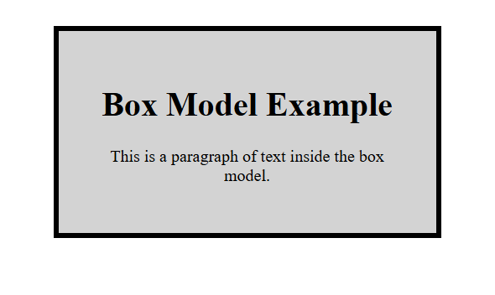

**QUESTION 3**

**HTML**

<!DOCTYPE html>

<head>

    <title>Html Form</title>

</head>

<body bgcolor="aqua">

    <table border="1" align="center" height="9%" width="40%">

    <tr>

    <td> <h2 align="center"><u>Registration Form</u></h2></td>

     </tr>

    </table>

    <form>

        <br><br>

        Enter your First Name:<br>

        <input type="text" placeholder="Enter your Full Name"><br><br>

        Enter your E-mail: <br>

        <input type="text" placeholder="yourname@example.com"><br><br>

        Gender:<br><br>

        <input type="radio" id="Male" Name="Gender" value="Male">Male <br><br>

        <input type="radio" id="Female" name="Gender" value="Female">Female <br><br>

        <input type="radio" id="Other" name="Gender" value="Other">Other <br><br>

        Interests: <br><br>

        <input type="checkbox" id="Reading" Name="Interests" value="Reading">Reading

        <input type="checkbox" id="Music" Name="Interests" value="Music">Music

        <input type="checkbox" id="Sports" Name="Interests"value="Sports">Sports <br><br>

        <button type="submit">submit</button><br><br>

        <button type="reset">Reset</button>

    </form>

</body>

</html>

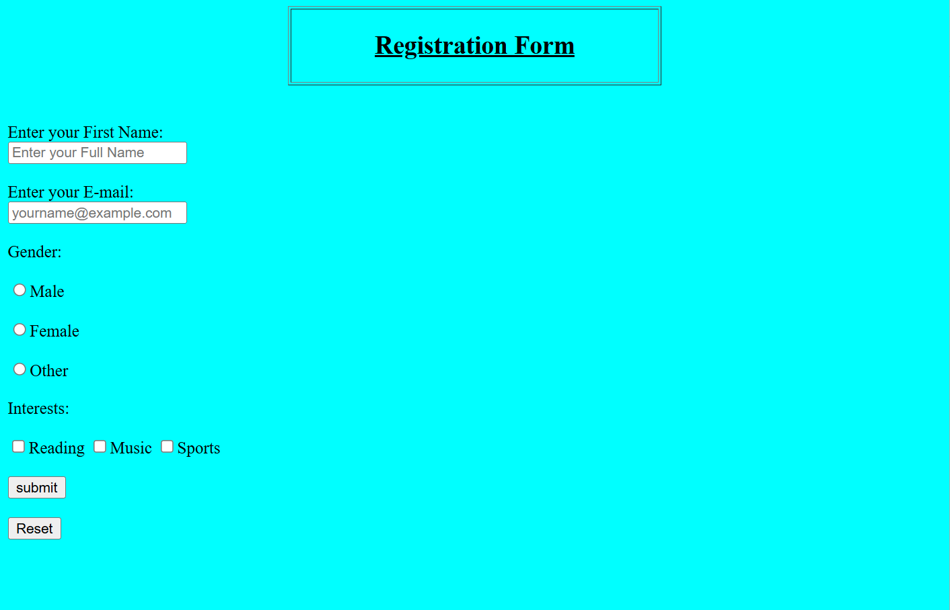

**QUESTION 4**

**HTML**

<html lan="en">

    <head>

        <meta charset="UTF-8">

        <meta name="viewport" content="width=device-width, intial scale=1.0">

        <title>Document</title>

        </head>

    <body>

        <h1 align="center">Media Query Example</h1>

        <div>

            Lorem ipsum dolor sit, amet consectetur adipisicing elit. Recusandae perspiciatis fuga dolore, ab dolor odio necessitatibus hic praesentium! Unde quasi magni eveniet voluptates quod sapiente consectetur. Beatae optio eos necessitatibus.

            Eaque, suscipit quasi ea voluptatibus maiores nihil ut, dolores, illum blanditiis provident modi tempora corrupti magni autem quam necessitatibus. Ipsa voluptate hic eveniet doloremque, voluptatibus provident consequatur eum debitis vitae.

            Fugiat cum eum doloremque qui atque odit quos accusantium itaque beatae repellendus quam nesciunt saepe ullam quod sint, reprehenderit porro, culpa odio explicabo modi! Deleniti, nam. Veniam distinctio tenetur quas!

            Voluptas dolorem voluptate facere sapiente modi. Debitis, fuga asperiores minus officia animi iure numquam incidunt optio pariatur consequatur, blanditiis fugit aperiam facilis quasi voluptatum voluptates consectetur eligendi nihil fugiat sed!

            Deleniti ea quae quis dicta debitis quia quasi. Sequi modi ipsa dolorum tempore dicta repudiandae magnam quibusdam maxime error hic officia labore quae eligendi velit ipsum commodi, reiciendis ducimus distinctio.

        </div>

        <link rel="stylesheet" href="a2_p4.css">

    </body>

</html>

**CSS**

div{

    background-color:lightblue;

    font-size: 18px;

    text-align: left;

}

@media only screen and (max-width:600px)

{

    div{

        background-color: lightcoral;

        font-size: 16px;

        text-align: center;

        text-transform: uppercase;

        color: aliceblue;

    }

}

@media only screen (max-width:400px)

{

    div{

        font-size:14px;

    }

}

@media only screen (max-width:200px)

{

    div{

        font-size:12px;

    }

}

