**PRACTICAL 1**

<!DOCTYPE html>

<head>

<title>Time Table</title>

</head>

<body>

    <table border="1" align="center" cellspacing="0.1px" height="50%" width="50%">

    <th colspan="6">Time Table</th>

    <tr align="center">

        <td rowspan="6">Hours</td>

        <td>Mon</td>

        <td>Tue</td>

        <td>Wed</td>

        <td>Thu</td>

        <td>Fri</td>

    </tr>

    <tr align="center">

        <td>Math</td>

        <td>Science</td>

        <td>Math</td>

        <td>Science</td>

        <td>Arts</td>

    </tr>

    <tr align="center">

        <td>Math</td>

        <td>Science</td>

        <td>Math</td>

        <td>Science</td>

        <td>Arts</td>

    </tr>

    <tr align="center">

        <td colspan="5">Lunch</td>

    </tr>

    <tr align="center">

        <td>Math</td>

        <td>Science</td>

        <td>Math</td>

        <td rowspan="2" colspan="2">Project</td>

     </tr>

    <tr align="center">

        <td>Math</td>

        <td>Science</td>

        <td>Math</td>

    </tr>

</table>

</body>

</html>

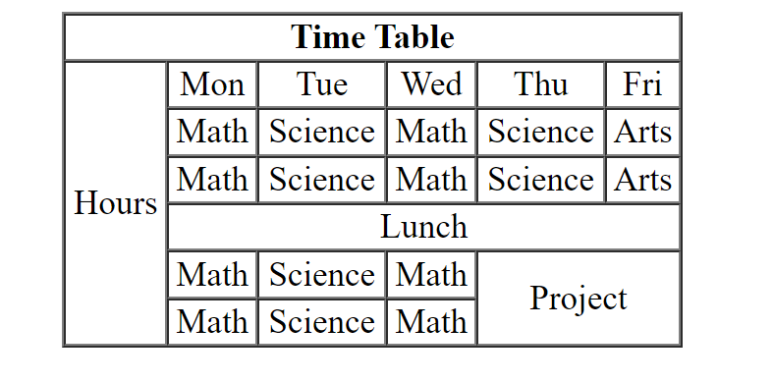

**PRACTICAL 2**

<!DOCTYPE html>

<head>

<title>Time Table</title>

</head>

<body>

   <center><h3>TIME TABLE</h3></center>

    <table border="1" align="center" height="50%" width="50%">

    <tr align="center">

        <th>Day/period</th>

        <th>I <br> 9:30-<br>10:20</th>

        <th>II <br>10:20-<br>11:10</th>

        <th>III <br>12:00-<br>12:40</th>

        <th >12:00-<br>12:40</th>

        <th>IV <br>12:40-<br>1:30</th>

        <th>V <br>1:30-<br>2:20</th>

        <th>VI <br>2:20-<br>3:10</th>

        <th>VII <br>3:10-<br>4:00</th>

    </tr>

    <tr align="center">

        <td>Monday</td>

        <td>Eng</td>

        <td>Mat</td>

        <td>Che</td>

        <td rowspan="5">LUNCH</td>

        <td colspan="3">LAB</td>

        <td>Phy</td>

    </tr>

    <tr align="center">

        <td>Tuesday</td>

        <td colspan="3">LAB</td>

        <td>Eng</td>

        <td>Che</td>

        <td>Mat</td>

        <td>SPORTS</td>

    </tr>

    <tr align="center">

        <td>Wednesday</td>

        <td>Mat</td>

        <td>Phy</td>

        <td>Eng</td>

        <td>Che</td>

        <td colspan="3">LIBRARY</td>

     </tr>

     <tr align="center">

        <td>Thursday</td>

        <td>Phy</td>

        <td>Eng</td>

        <td>Che</td>

        <td colspan="3">LAB</td>

        <td>Mat</td>

    </tr>

    <tr align="center">

        <td>Friday</td>

        <td>Phy</td>

        <td>Eng</td>

        <td>Che</td>

        <td colspan="3">LAB</td>

        <td>Mat</td>

    </tr>

    </table>

    </body>

    </html>

