**AWS**

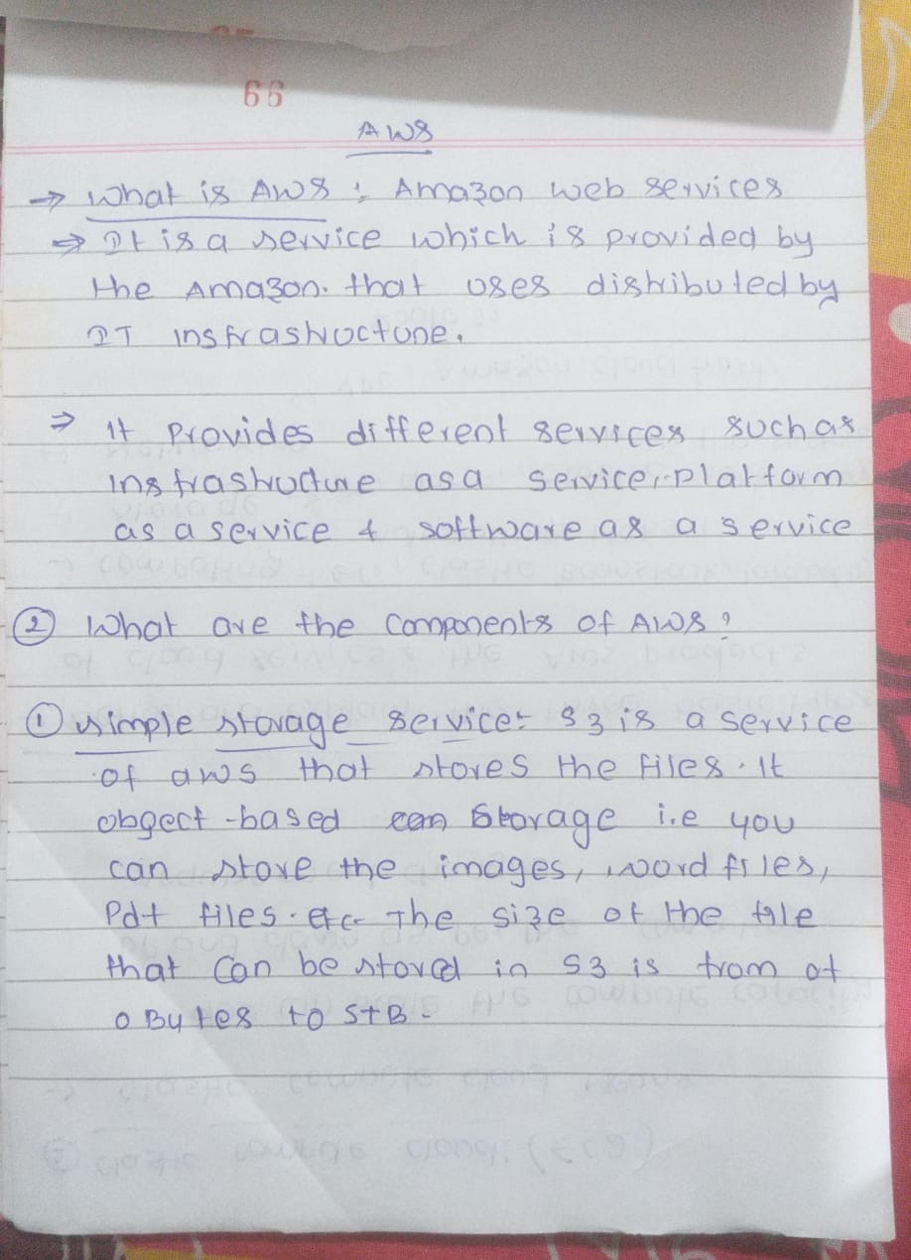

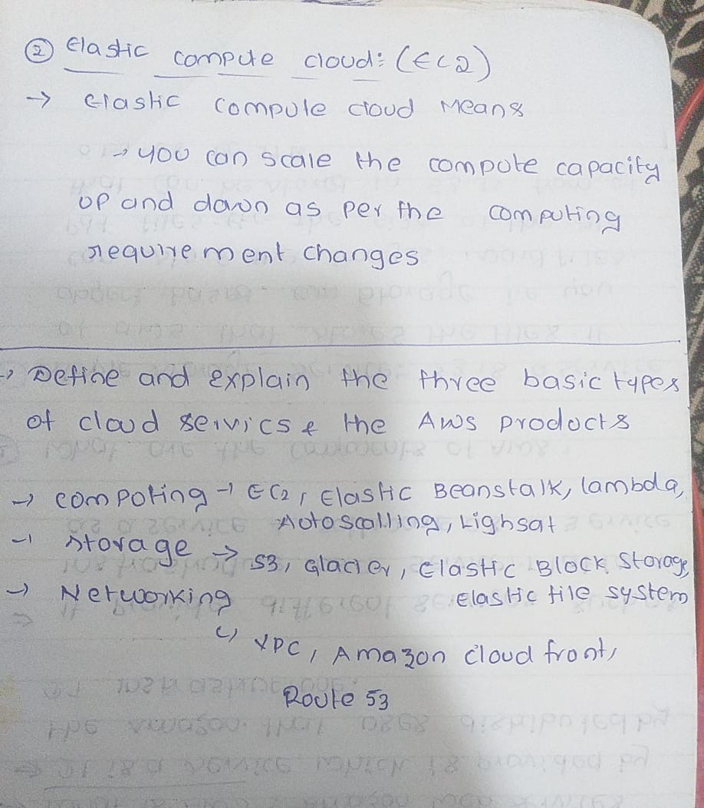

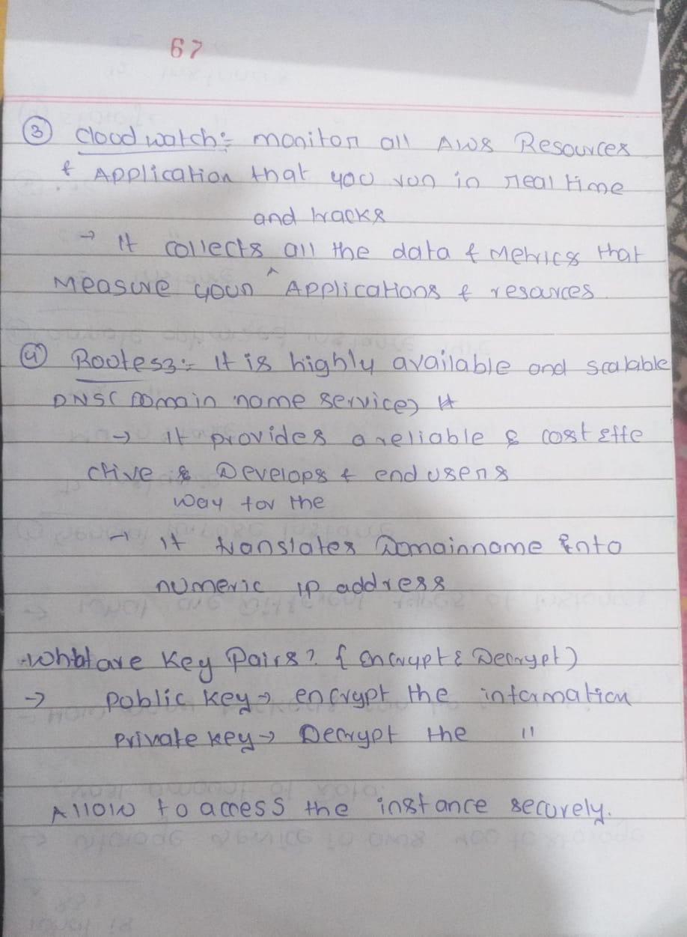

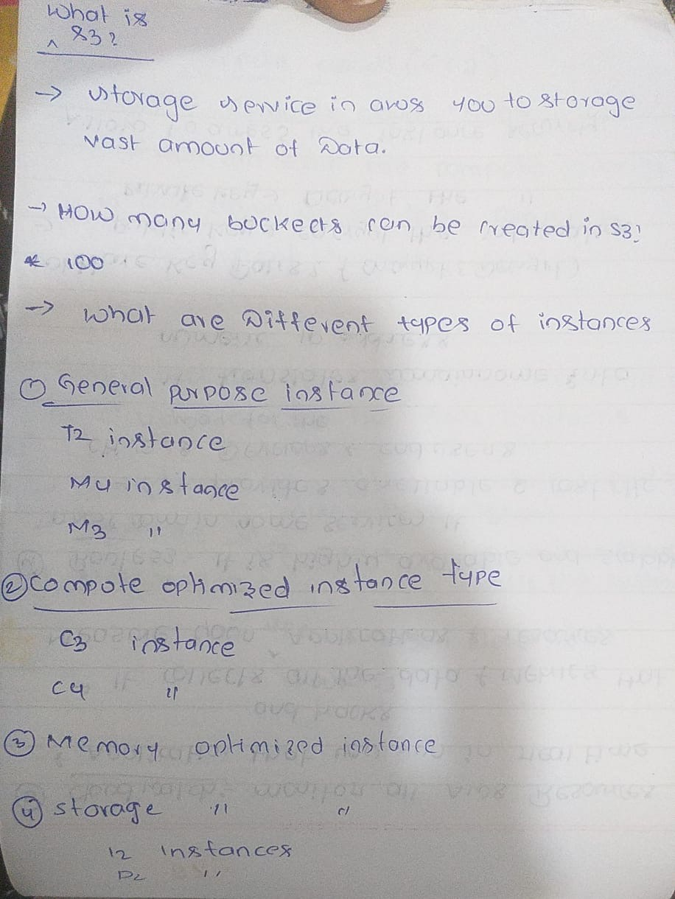

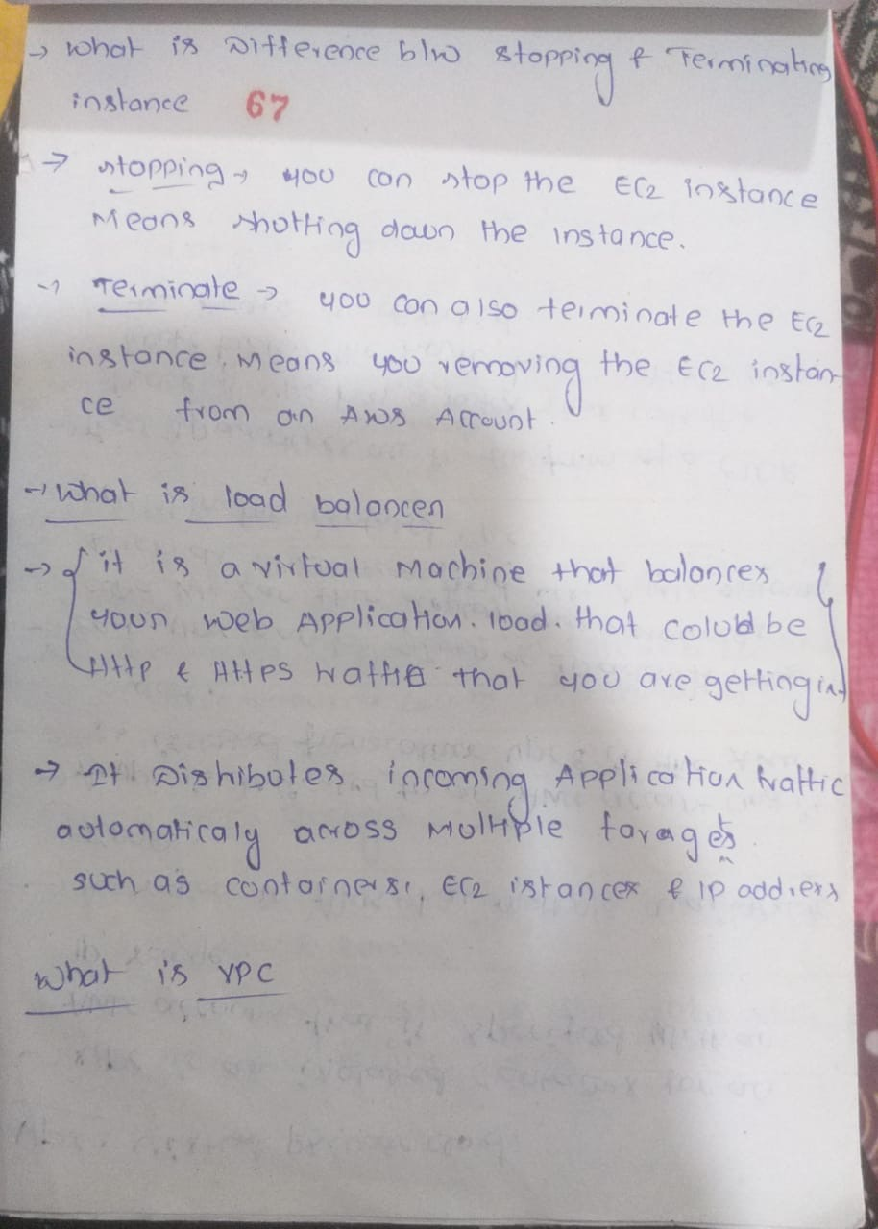

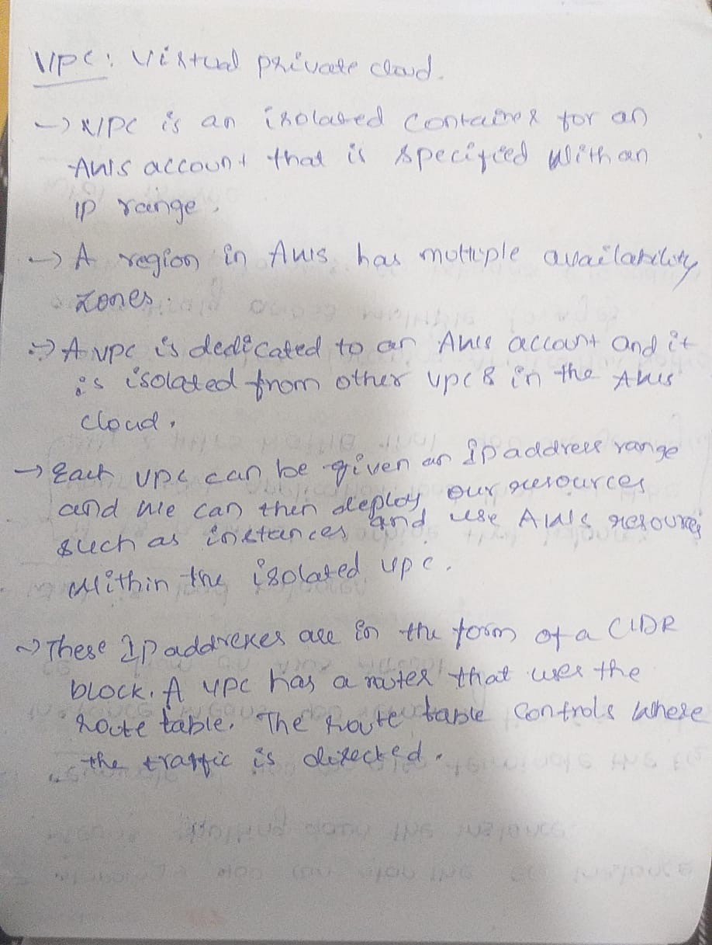

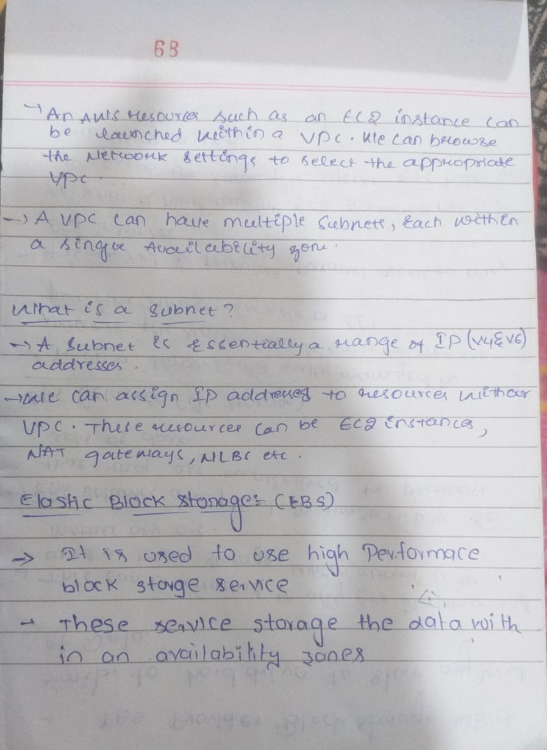

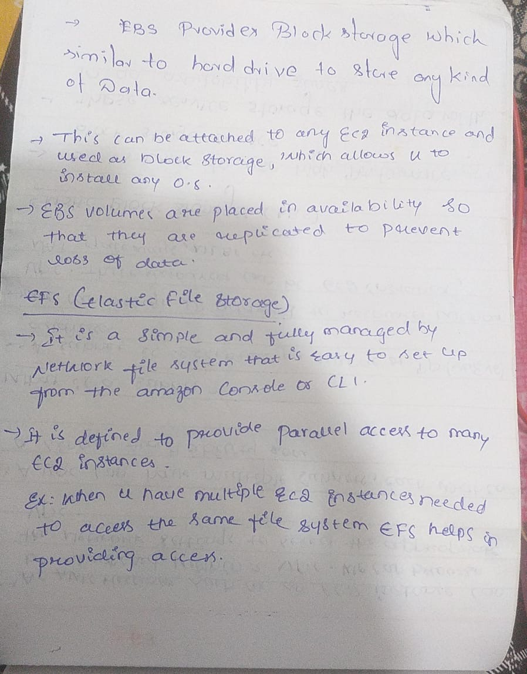



**VPC**

It's a virtual network that you can set up within AWS to isolate and control your cloud resources. Think of it as your private slice of the AWS cloud **where we can define your own IP address range, create subnets, configure routing tables, and control network access through security groups and network ACLs (Access Control Lists).**

**SUBNET:**

Subnet, on the other hand, is a part of your VPC. It's a range of IP addresses in your VPC's IP address range that you can assign to a group of resources. **Subnets are used to logically divide your VPC into smaller networks.**

**AVAILABILITY ZONE:**

Availability Zone (AZ), which is a data center in a specific geographic location, and you can deploy your resources, like EC2 instances or RDS databases, into these subnets to ensure high availability and fault tolerance

**NAT GATEWAY**

Network Address Translation (NAT) gateway is a network device that allows multiple devices on a private network to share a single public IP address for outbound internet traffic.

**SECURITY GROUPS:**

It acts as a virtual firewall for your Amazon Elastic Compute Cloud (Amazon EC2) instances to control inbound and outbound traffic.

**Inbound and Outbound Rules**: You can configure inbound and outbound rules in a Security Group to control traffic. Inbound rules specify which traffic is allowed to reach your EC2 instance, while outbound rules specify which traffic is allowed to leave the instance.