**HOW TO WRITE DOCKER FILE**

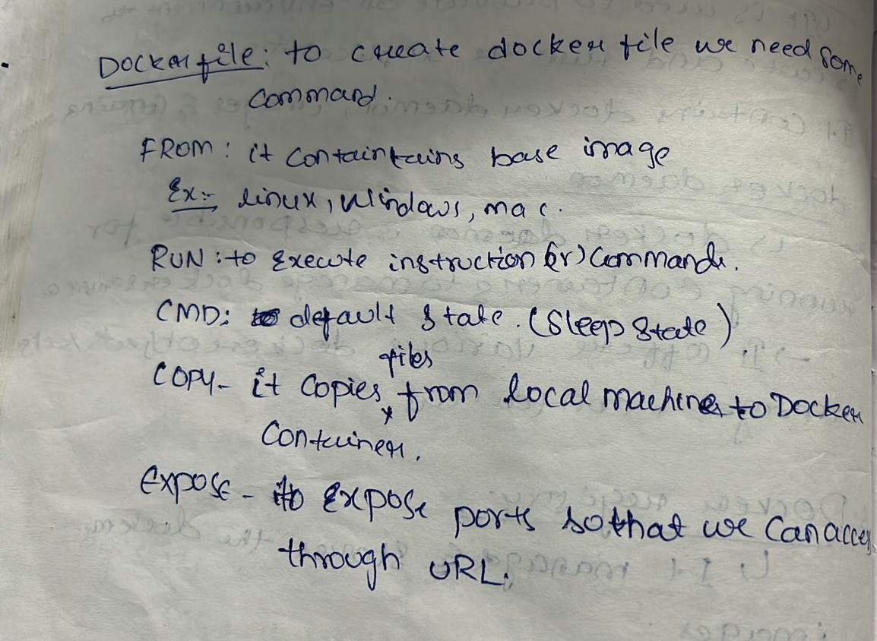

**DOCKER COMMANDS**

1**.docker --version**: To check the version of the docker

2.**docker build** . :To build an image from dockerfile

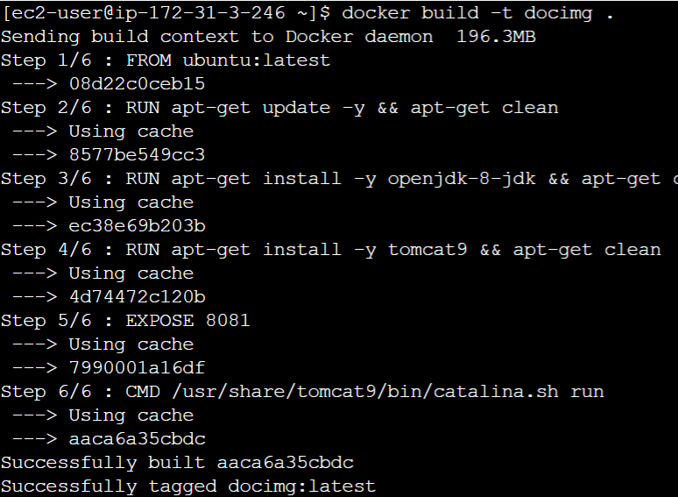

3.**docker run –d imagename:** This command is used to create a container from an image



4.**docker ps**: To list the running containers

5**.docker ps –a:** To list all the containers which are running and not running



6.**docker container rm containerid:** To remove a container



7.**docker images**: To list available docker images

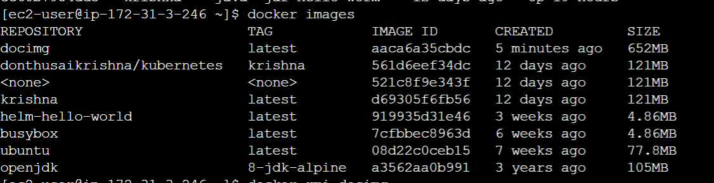

8.**docker rmi imagename:** To remove an image

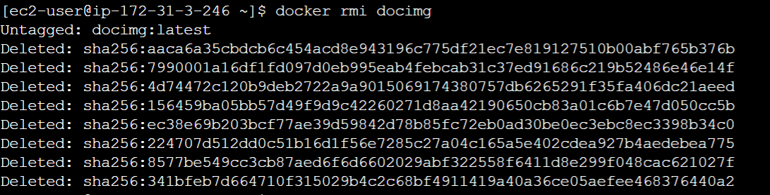

9. **docker exec -it <container id> bash**: This command is used to access the running container

10**.docker pull imagename:** This command is used to pull an image from docker repository.

11.**docker stop containerid**: This command stops the running container

12.**docker login**: This command is used to login to the docker hub repository

13**.docker push**: This command is used to push an image to the docker hub repository

**If you didn't remove that particular stopped container**( killed but not destroyed ) you can access its logs by using the docker command

**docker logs <container_id>**

**You can get the stopped container Id by using**

docker ps -f "status=exited"

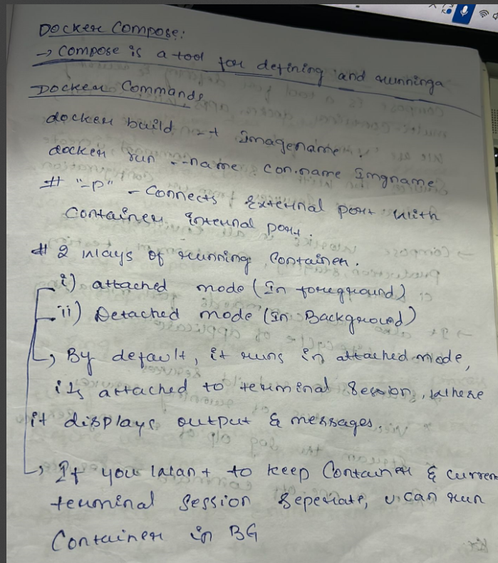**DOCKER COMPSE**

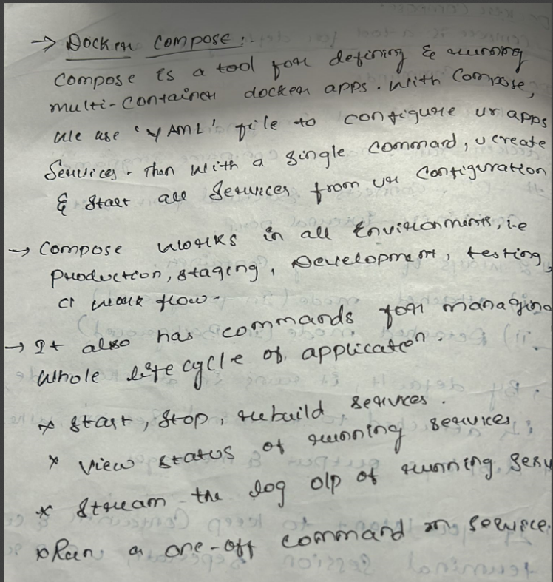

**HOW TO WRITE DOCKER COMPOSE FILE**

