title: voiceVault — Project Report (Web Prototype)
date: 2026-04-20
repo: voiceVault
---

1) Executive summary
voiceVault is a local-first, voice-first web prototype that lets you:
- **Capture** audio notes in the browser (record or upload).
- **Index** them locally by transcribing audio **offline** using Whisper via `faster-whisper`.
- **Retrieve** notes by searching across transcripts, including **voice query** search (record a short query → transcribe offline → search).
This prototype focuses on delivering the core “voice in → searchable knowledge out” loop described in VoiceVault.md, but implements full‑text search (SQLite FTS5) rather than vector/semantic search.

1.1) Screenshots
voiceVault home screen (web prototype)
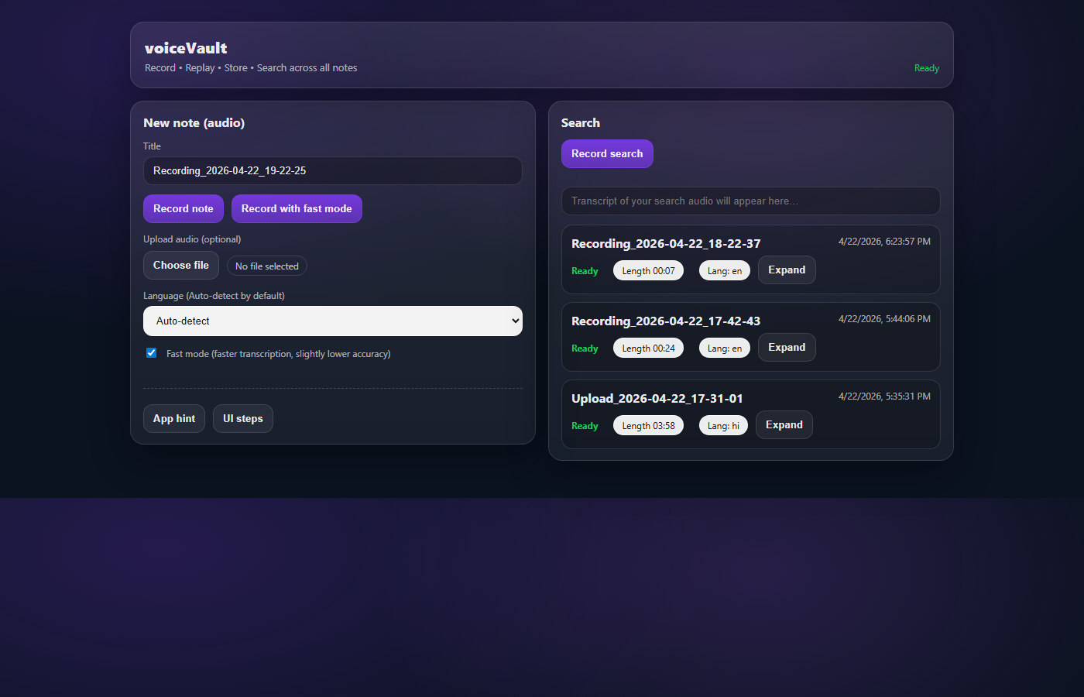

2) Scope of this prototype (what it is / isn’t)
- **Is**: A working local web app that records audio, stores it on disk, transcribes offline, and supports transcript search + audio playback/download.
- **Is not**: A mobile app, cloud service, or multi-user product; does not include authentication, embeddings/vector DB, or LLM-based Q&A synthesis.

3) Product goals aligned to `VoiceVault.md`
From VoiceVault.md, the three pillars are Capture / Index / Retrieve.
- **Capture (implemented)**:
- In-browser recording (microphone).
- File upload (audio note ingestion).
- UI timers and “processing” status.
- **Index (implemented, local)**:
- Offline STT using Whisper (faster-whisper).
- Local SQLite persistence of metadata + transcript.
- Background/asynchronous transcription after note creation.
- Optional language selection + auto-detect (depending on flow).
- **Retrieve (implemented, full-text)**:
- Search by typing.
- Search by speaking a query (audio query → offline STT → search).

4) Current feature set (implemented)

Notes
- **Create notes**
- Record an audio note in-browser and save it.
- Upload an existing audio file and save it as a note.
- **Background transcription**
- On save, notes enter processing state and later become ready (or error on failure).
- **Playback & export**
- Play note audio in the UI.
- Download note audio.
- Download transcript text.
- **Edit & delete**
- Edit transcript and title (and language metadata) after processing.
- Delete a note (removes DB row and associated audio file).
- Retry transcription for failed notes.

Search
- **Full-text search (SQLite FTS5)** across title + body.
- **Voice query search** (record a short “search” audio query → transcribe offline → search).
- **Robustness improvements**:
- FTS query normalization to avoid punctuation/operator errors.
- Fallback to safe substring search when FTS throws.

Language + models
- **Language selection**: UI can request a specific language code, or allow auto-detect (depending on endpoint).
- **Fast mode vs quality mode**:
- “Fast mode” uses tiny by default.
- “Quality mode” uses medium by default.
- Both are configurable via env vars (see below).

5) Architecture and data flow

Components
- **Frontend**: Static UI in `public/` (vanilla HTML/CSS/JS).
- **Backend**: Node.js + Express in `server/`.
- **DB**: SQLite via `better-sqlite3`.
- **Transcription**: Python (`server/transcribe.py`) using `faster-whisper`; requires `ffmpeg` on PATH.

Storage (local-first)
- **Audio files**: `data/audio/<noteId>.<ext>`
- **Database**: `data/voicevault.sqlite`
These are intentionally local runtime artifacts (not meant to be committed).

Note creation flow (simplified)
1. Browser records or uploads audio.
2. Backend POST /api/notes stores audio on disk and inserts a DB row as processing.
3. Backend runs offline transcription asynchronously (Python).
4. Backend updates DB row with transcript, detected/selected language, and final status.

Search flow (simplified)
- **Text search**: `GET /api/notes?q=...` runs FTS5 (or safe LIKE fallback).
- **Voice search**: UI records query audio → `POST /api/transcribe` → uses returned transcript as the search string.

6) Tech stack
- **Node.js**: `>=20` (see `package.json`)
- **Backend**: Express, Multer (uploads)
- **SQLite**: `better-sqlite3`
- **Python**: 3.10+
- **Offline STT**: `faster-whisper`
- **Media**: `ffmpeg` on PATH

7) Configuration (env vars)
The server supports these environment variables:
- `PORT`: server port (default `5177`)
- `WHISPER_MODEL`: main/quality model (default: `medium`)
- `WHISPER_FAST_MODEL`: fast model (default: `tiny`)
- `WHISPER_LANG_MODEL`: model for language detection/live preview (default: `tiny`)
- `WHISPER_LANGUAGE`: default language override (empty = auto where supported)
- `VOICEVAULT_VAD`: `1` to enable VAD filtering; default is off (`0`)

8) Local run & testing (Windows-focused)

Prerequisites
- Node.js 20+
- Python 3.10+
- `ffmpeg` installed and on PATH

One-time setup
Run from project root:
.\scripts\install-ffmpeg.ps1
.\scripts\setup-transcription.ps1
Then:
npm install
npm run dev
Open http://localhost:5177.

Test plan (quick)
- **Record → Save**: record 10–20 seconds, save; confirm note appears as `processing` then `ready`.
- **Playback**: play audio; confirm it matches recording.
- **Transcript**: confirm transcript is visible; edit it and verify it persists.
- **Search by text**: search for a phrase from transcript; confirm note appears.
- **Search by voice**: record a short search query; confirm results match.
- **Delete**: delete a note; confirm it disappears and audio is removed.
- **Failure path**: break Python/ffmpeg temporarily; confirm note becomes `error`; then fix deps and click retry.

9) Known constraints (current prototype)
- **No semantic/vector search** (only FTS text search).
- **No timestamped clip retrieval** (search returns notes, not time offsets inside audio).
- **Single-user local app** (no auth, no cloud sync).
- **CPU-only transcription** by default; long notes can take time and can be hardware dependent.
- **No diarization / speaker labels**.

10) Cross-check vs original documents (what’s still missing)
This section cross-checks the current prototype against the “semantic search / voice Q&A” blueprint in VoiceVault.md and the baseline goals described in report1.md.

Missing relative to `VoiceVault.md` (blueprint)
- **Semantic retrieval**:
- No embeddings, no vector DB (pgvector/Pinecone/Weaviate), no ANN search.
- No reranking pipeline (top‑k retrieval + rerank).
- **Grounded Q&A**:
- No LLM answer synthesis (“when is X’s birthday?” style direct answers).
- No citations into retrieved chunks.
- **Timestamp-level results**:
- No chunk index with timestamp metadata.
- No “jump to exact timestamp” playback.
- **Chunking pipeline**:
- No semantic chunking (100–200 token chunks) or pause/topic segmentation stored as searchable units.
- **Mobile-first product**:
- Prototype is a local web app, not React Native/Flutter iOS/Android.
- **Cloud components**:
- No ingestion service queue, blob storage (S3), Postgres, auth (Supabase/Firebase), etc.
- **Product surfaces**:
- No proactive reminders, integrations (calendar/reminders/contacts), collaboration, or ambient mode.

Items from `report1.md` (baseline) that are covered
- In-browser recording + upload
- Local storage (`data/`)
- Offline transcription + SQLite persistence
- Audio query search

`VoiceVault.docx`
VoiceVault.docx is present in the repo and its extracted content matches the same blueprint/requirements described in VoiceVault.md (capture → transcribe/index → semantic retrieval → grounded answers + timestamped clips). The “missing” items above therefore apply equally to VoiceVault.docx.

