E-Portfolio Links

Avani – https://portfolium.com/entry/capstone-20265

Mukti – https://portfolium.com/entry/coit20265-capstone

Pooja - https://portfolium.com/entry/coit20265

Technical progress since the start of the project.

From the previous project submission, we have progressed into this project, and have started working on cisco packet tracer. Along with this, the given network design was changed to new one, and aims to add a new one. Further, the focus shifted to new designs for developing bring your own device policy, and aims to include connections between the different devices.

The team members have started work on previous assignment improvement according to feedback obtained from tutors. Furthermore, the major focus shifted on developing a solutions to include all concepts required to prepare a good bring your own device policy for TechSolutons Inc.

Tasks completed since the previous report.

From previous reports, the development process started in packet tracer, and aimed to development a new design. Further, all members have developed their own e-portfolio on the systems, and displays the results as followed:

Pooja

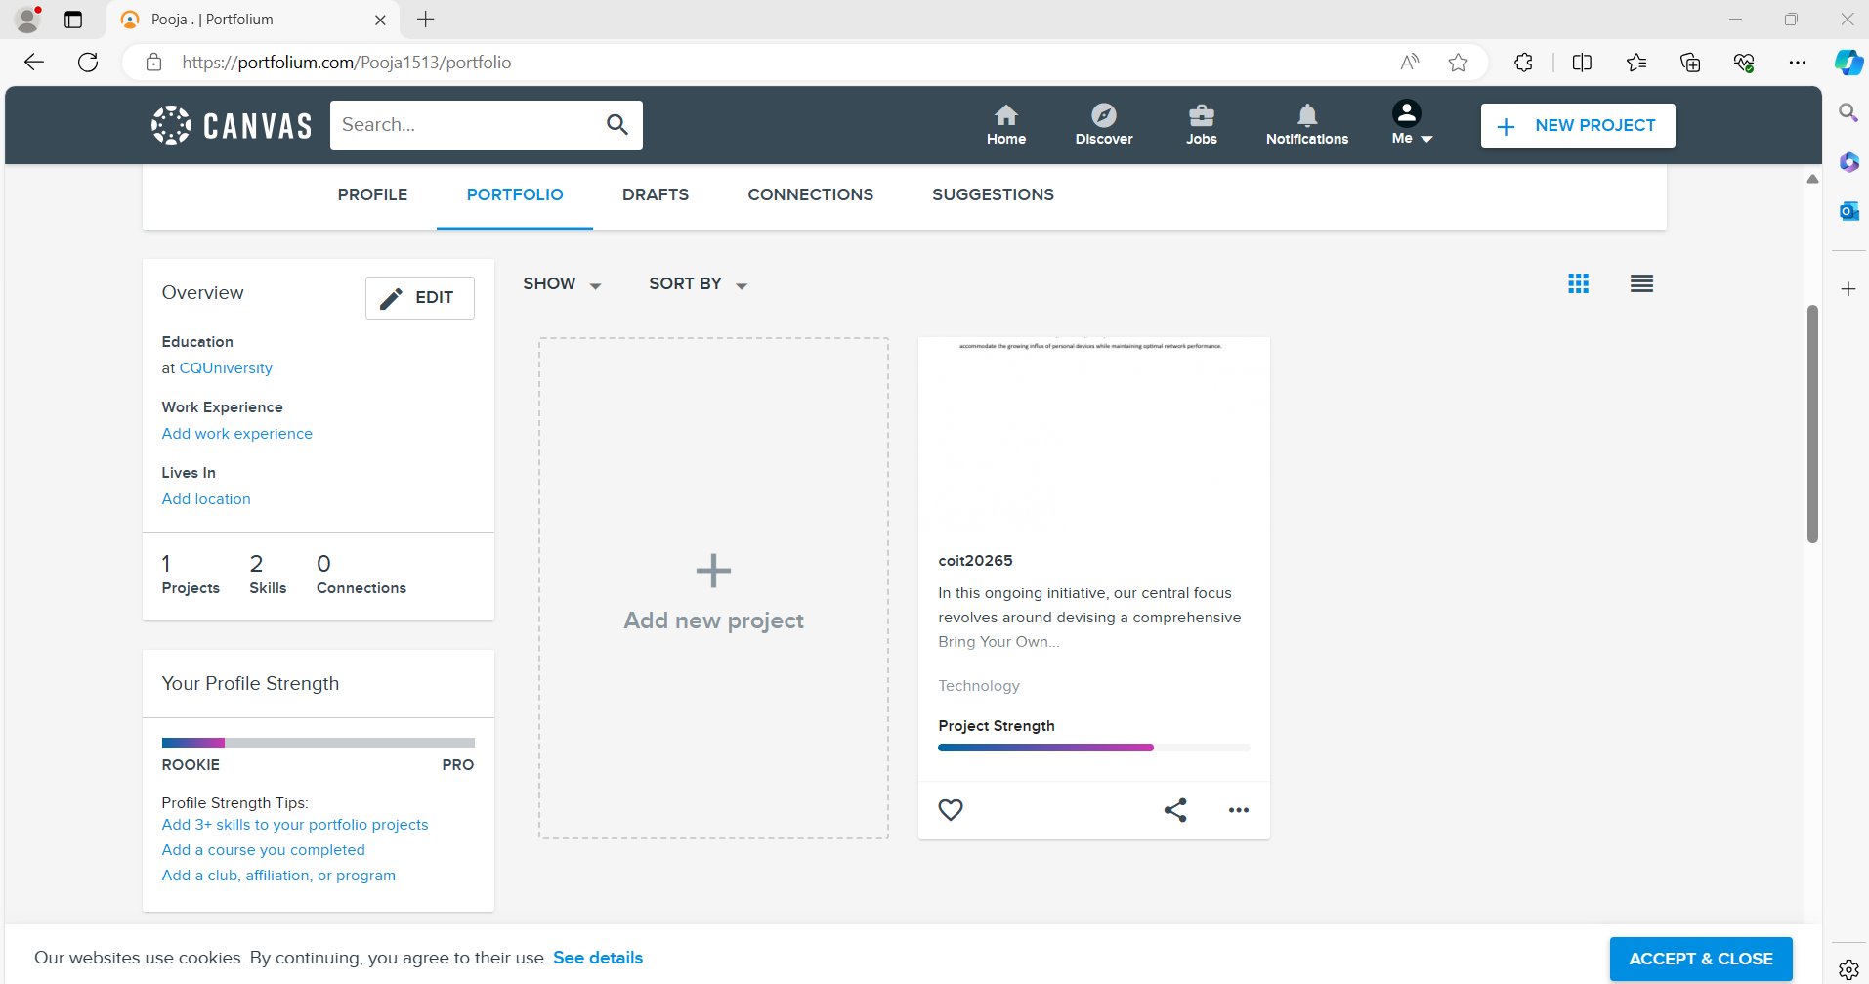

Avani

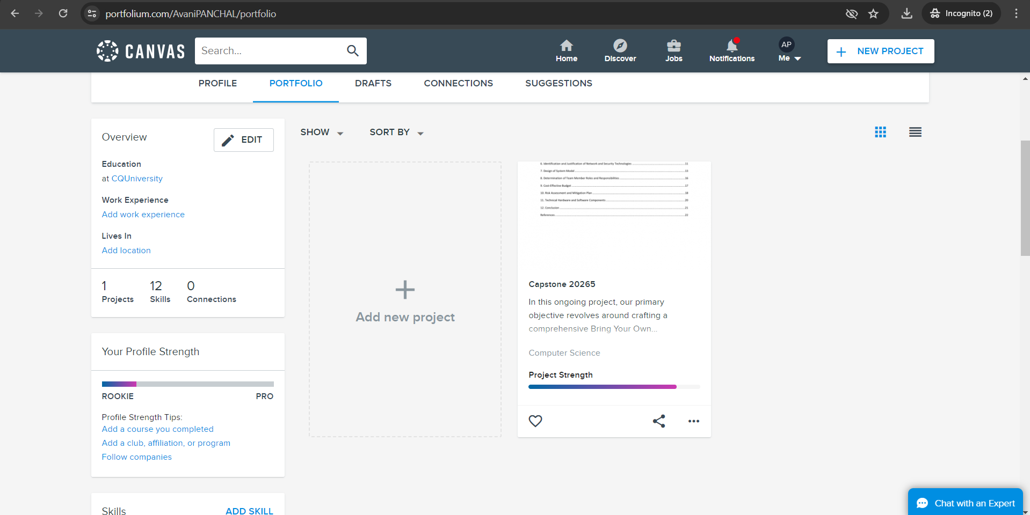

Mukti

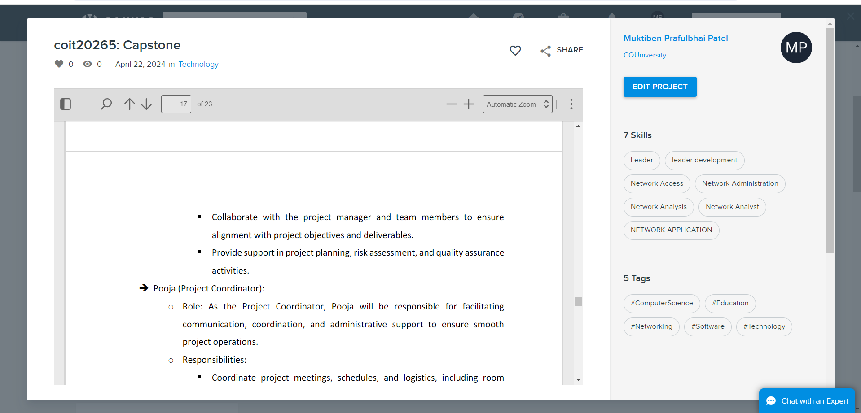

From onwards, the progress documents will be submitted to new portal and details are shared on time before meeting.

Significant changes concerning the Project Plan.

The following are numerous changes made significantly to the project plan: -

1. Grammatical issues have been resolved from the technical report.
2. It also includes modifications of documentation according to the other feedback made by our stakeholders.
3. The network design shifted and changed as the progress started on developing a new design to include all networking components to illustrate working.
4. Research made on different approaches, which can be used to illustrate working of network design, and collected data to demonstrate the working of systems.

Issues and challenges with approaches to addressing them.

The following are issues and challenges related to the approaches: -

1. A problem emerges in gathering proper information, which can be used on the network design, and collects byod policy details from different sources.
2. Furthermore, the challenge was to perform a practical demonstration of Cisco packet tracer which was challenging because don’t have much information about it.
3. To solve them, lots of tutorials on youtube have been followed and used:
   1. <https://www.youtube.com/watch?v=g4TMM7FrmzI>
   2. <https://www.youtube.com/watch?v=M24LzPto05E>
   3. <https://www.youtube.com/watch?v=wQh4Vcdoe_k>
   4. https://www.youtube.com/watch?v=M9gykuQedug

Priority tasks for the next phase of work.

1. Fully preparing a network design with logical and physical view.
2. Setting up initial drafts of bring your own device policy.
3. Adding important concepts according to research document.
4. Preparing submission for next weeks.