Final Report: Hospital Management System (HMS)

# Hospital Management System

# Overview

The Hospital Management System (HMS) is a web application designed to simplify the management of hospital activities. It provides an interface for hospital staff to view patient records, doctor information, and doctors can see the patient details from time to time and patient can view it. If anything is unusual the doctor can run tests and be on caution and this help keep the details in safe no modification or no one can change it even if it is changed then we will get update in the timeline when it is written so no foul play can happen .

# Goals & Objectives

- Digitize hospital workflows and record-keeping.  
- Allow hospital staff to view and update patient and doctor records.  
- Provide an easy-to-use web-based interface.  
- Ensure data consistency and integrity with a reliable backend.

# Target Users

- Hospital administrators  
- Doctors  
- Nurses/Staff

# Features

|  |  |  |
| --- | --- | --- |
| **Feature** | **Description** | **Priority** |
| View Patient Records | Displays a list of all registered patients. | High |
| Doctor Dashboard | Displays doctor details and their schedules. | High |
| View Individual Records | Detailed view of a specific patient. | High |
| User Authentication | Secure access for authorized staff. | Medium |
| Responsive UI | Mobile-friendly and clean design | Medium |

# Functional Requirements

- Patient Management: Store and display patient details (Name, ID, etc.)  
- Doctor Dashboard: Display doctor info and their patient lists  
- Individual Patient View: Show details of a specific patient  
- Authentication: Login/logout functionality for staff

# UI/UX

- Clean, responsive design  
- Navigation:  
 - Home Page: Welcome page/dashboard  
 - Doctor Dashboard  
 - Patient Records  
 - Patient Detail View  
 - Login/Logout

# Tech Stack

- Frontend: HTML, CSS  
- Backend: Django  
- Database: SQLite

**Screen Short**

Login for both doctor and patient:

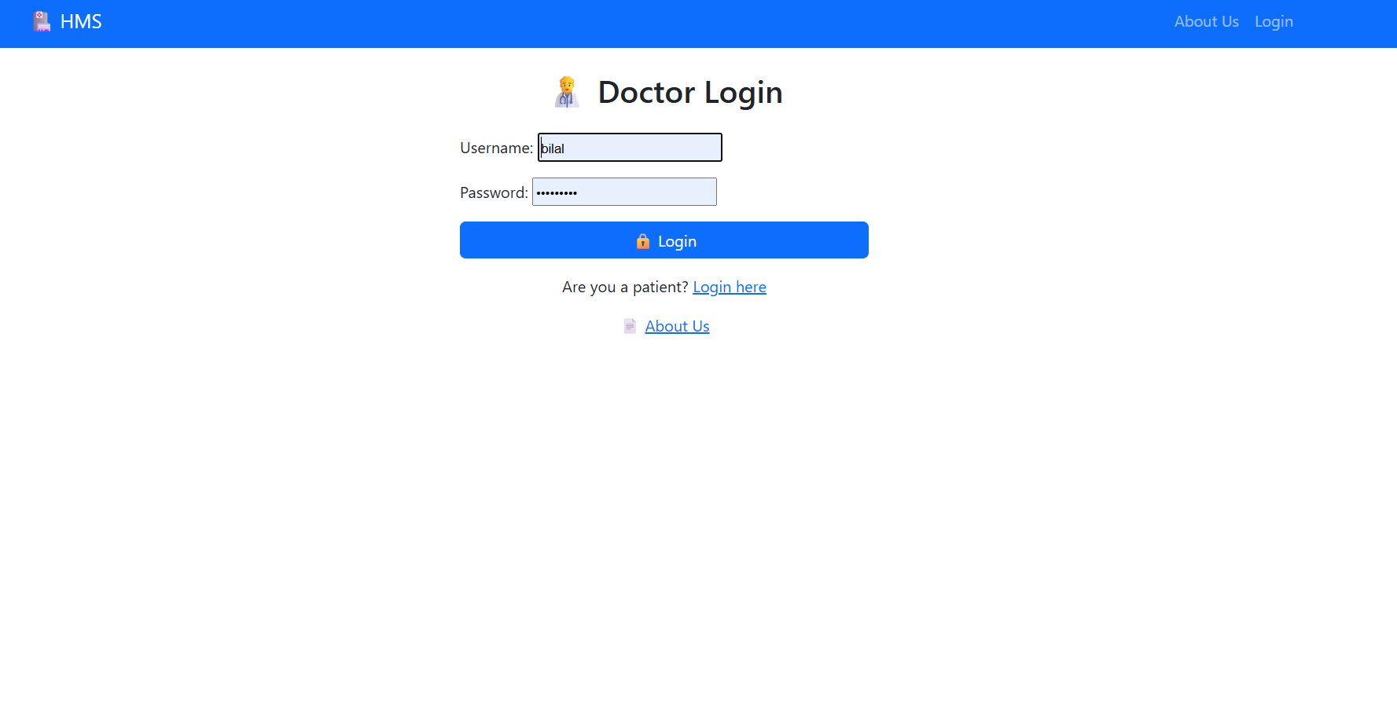

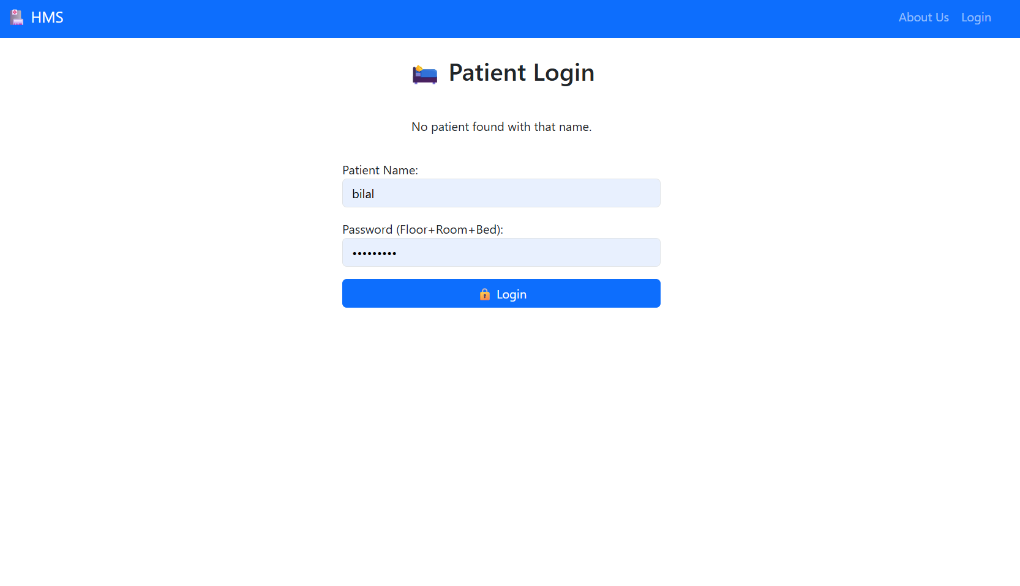

Doctor View:

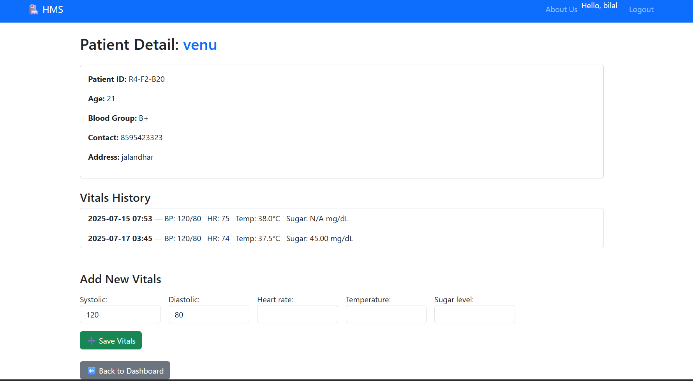

Patient View:

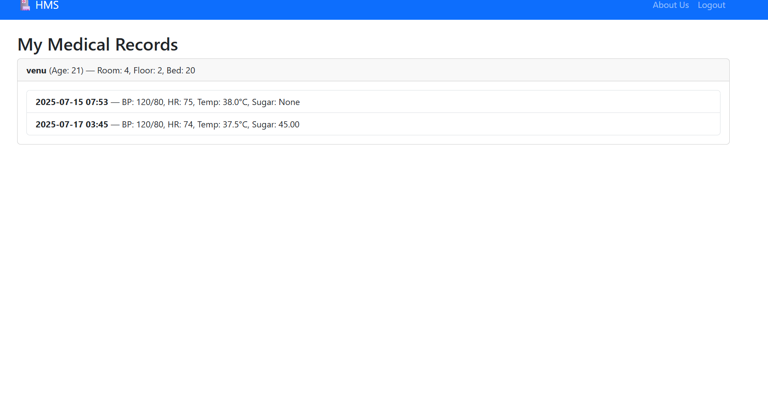

|  |
| --- |
| Timeline |
| |  |  | | --- | --- | | Task | Status | | Requirement Finalization | Day 1 | | UI Wireframes | Day 3 | | Implement Views & Models | Day 5 | | Authentication | Day 7 | | Testing | Day 9 | | Final Touches & Report | Day 15 | |

# Success Criteria

- App loads and displays patient and doctor data  
- User can navigate to patient detail view  
- Mobile-friendly layout  
- No major bugs during testing

# Deliverables

- Working app deployed at: [deployment link if any]  
- Source code: https://github.com/12203781bilal/PythonProject18  
- Demo video: [link to your demo video if available]

# Contributors

- Mohammed Bilal.