BRICS TRACK 2 • SUSTAINABILITY • INDIA-FIRST PROTOTYPE

AirSentinel
Locality-aware clean-air early warning
and human authority review
Working prototype, evidence-first claims
Six-pollutant monitoring • 181.9-day locality evidence • 1h/3h/4h forecasts • sudden-spike review • citizen multimodal support • secure Google Cloud path

FINAL PROJECT REPORT
26 August 2026
Status: local implementation verified; cloud deployment requires team-owned credentials and billing.

Executive summary
AirSentinel closes the gap between city-wide air-quality visibility and a local government decision. It combines provenance-labelled outdoor observations, weather, contextual satellite layers and consented community evidence; forecasts one to four hours ahead; detects unsupported coverage or a sudden forecast miss; and creates a cause-unverified case for authenticated human review.
Main result
Najafgarh retains 7,516 PM2.5 rows and Safdarjung 7,889 rows across 181.9 days, with two reporting stations each. Their stored PM2.5 completeness is 86.1% and 90.4%, respectively. The source is labelled OpenAQ fallback data, not an authorised CPCB archive.

What judges can evaluate end to end
1. Inspect national/city conditions and locality evidence quality.
2. View a one-, three- or four-hour historical prototype forecast and uncertainty range.
3. Open an unexpected-spike or evidence-gap case whose cause remains unverified.
4. Submit privacy-minimised citizen evidence and keep it pending moderation.
5. Record a local demonstration review action, or use the private authorised API path for production-mode action testing.
6. Inspect honest Google integration readiness and secure deployment boundaries.

Truth boundary
- Not official AQI, a medical device, source attribution or automatic enforcement.
- OpenAQ is a labelled historical-development fallback, not presented as an authorised CPCB archive.
- No Google Cloud deployment is claimed until a team-owned project and verified URLs exist.
- Deep-learning and federated-learning models are not promoted in this submission.

1. Problem and solution

The four gaps
Gap | Why it matters | AirSentinel response
Scale | A city value can hide local events. | Separate locality anchors/geometries and evidence gates.
Coverage | Sparse or stale stations create false precision. | Show evidence gaps, station provenance, distance and completeness.
Forecast failure | A sudden event may lie outside the expected range. | Create a cause-unverified review case and seek corroboration.
Coordination | Station, weather, satellite and citizen data use different trust levels. | Canonical records, contextual labels, identity and audit.

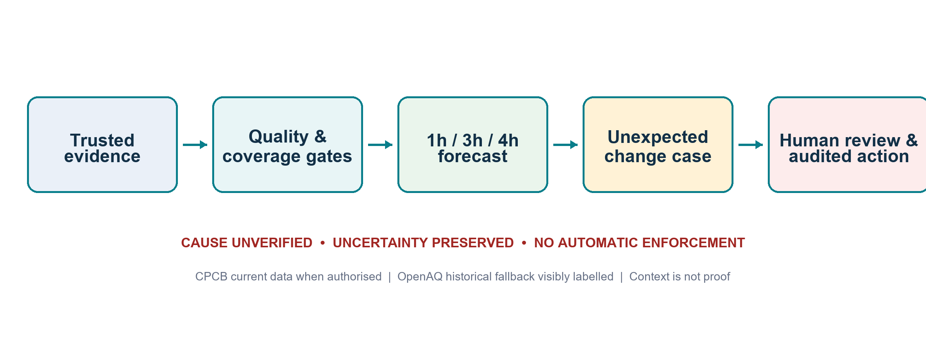
Figure 1. Evidence is gated before forecasting; a sudden mismatch ends in human review, not automated blame.

2. Data improvement and trust
The historical collector now supports date chunks, pagination, retries, active-sensor probes, two working sensors per locality/pollutant, deduplication and safe merging. It preserves source-system labels so a coverage gate cannot silently upgrade a fallback into an official source.
Locality | PM2.5 rows | Span | Completeness | Stations | Pollutants
Najafgarh pilot area | 7,516 | 181.9 days | 86.1% | 2 | PM2.5, PM10, NO2, O3, SO2, CO
Safdarjung Enclave pilot area | 7,889 | 181.9 days | 90.4% | 2 | PM2.5, PM10, NO2, O3, SO2, CO

Evidence gate passed—not operational promotion
Both localities now support a controlled conventional baseline comparison. They still need approved geometry, station mapping, calibration/uptime context, weather alignment and fresh chronological evaluation before operational use.

Source hierarchy and alternatives
Priority | Source | Use | Limit
1 | CPCB/data.gov.in current catalogue | Preferred official Indian current observations | Authorised key/configuration required; current data is not a guaranteed historical archive.
2 | CPCB/SPCB/PCC approved export | Historical production evidence | Requires authority access, calibration and station metadata.
Fallback | OpenAQ | Historical development and discovery | Keep provider provenance and visible fallback label.
Context | Open-Meteo / Earth Engine / FIRMS | Weather, satellite gas/aerosol and fire context | Cannot independently prove surface PM2.5 or a source.

3. Forecasting and sudden-event handling
- Direct one-, three- and four-hour targets rather than recursively compounding a one-hour model.
- Leakage-safe lag, rolling, weather and available pollutant features.
- Time-ordered training/validation and newest untouched hold-out.
- Persistence first; established tree boosting only when it demonstrates stable improvement.
- Empirical residual ranges and an explicit research/prototype label.

What happens when the model is wrong
1. Detect that a fresh observation lies well outside the expected residual distribution.
2. Create an unexpected local spike case and preserve the observation/forecast evidence.
3. Mark the cause unverified; do not infer burning, industry, traffic or sensor failure.
4. Ask a reviewer to check nearby stations, sensor health, weather, satellite/fire context and moderated citizen signals.
5. Record the reviewer’s monitor/inspect/escalate/close decision in the audit trail.
Model policy
The submission does not promote deep learning or federated learning. Vertex AI is only an optional host for a conventional, human-approved model that has earned promotion on approved data.

4. Working system components
Component | Job | Safety boundary
Public dashboard | Reviewed city/locality aggregates, coverage and forecast ranges | No personal evidence or enforcement actions
Citizen interface | Consented coarse-area text/photo/voice reports | Unverified pending evidence; exact location minimised
Authority portal | Case evidence and reviewer ownership; production UI is view-only | Writes use private authorised API; no automated external action
FastAPI | Typed contracts, readiness and integration endpoints | Fail-closed production authentication
Data pipeline | Discovery, collection, validation, provenance and coverage | Fallback labels cannot be promoted by volume
Forecast/anomaly | Short-horizon estimates and residual review cases | Historical prototype and cause-unverified language

5. Google technology architecture
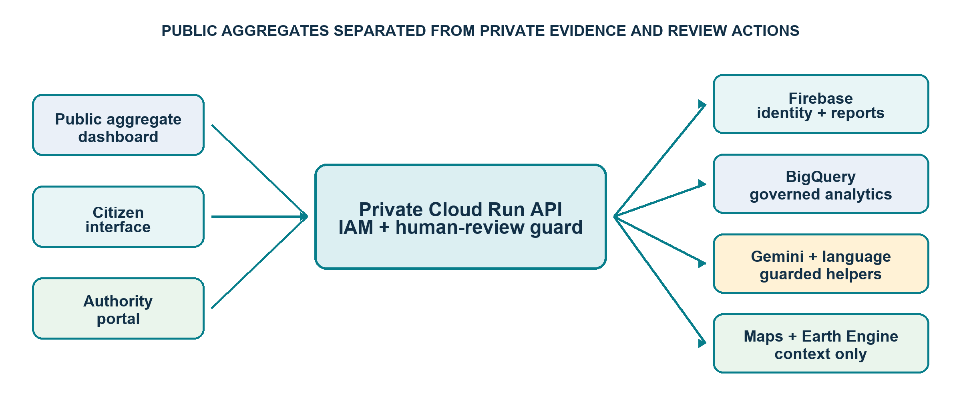
Figure 2. Public aggregates are separated from private evidence, identity and authority actions.
Technology | Meaningful job | Activation requirement
Gemini API / AI Studio | Guarded case explanation and in-memory photo description | Secret Manager value, feature review and output audit
Vertex AI | Optional conventional-model hosting/monitoring | Approved model, model card and monitoring plan
Firebase | Citizen identity and minimum pending-review metadata | Project, Auth, Firestore, rules, retention and abuse controls
BigQuery | Governed coverage/readiness/reviewed analytical tables | Dataset region, IAM, retention and cost policy
Maps / Earth Engine | Pilot-location and satellite contextual layers | Restricted key / registered project; contextual-only policy
STT / Translation / TTS | Accessible multilingual report and guidance workflow | Consent, language QA, retention and enabled APIs
Cloud Run | Public aggregate, private API and private authority services | Billing, IAM, secrets and URL/identity tests

6. Privacy, security and human governance
- Verified citizen identity in production; stronger reviewer identity for authority operations.
- Deny-by-default direct Firestore and Storage rules; server access through least-privilege cloud identities.
- No exact private address, raw media or unnecessary contact data in analytical tables.
- Bounded image/audio types and sizes; Gemini output cannot claim AQI, liability, enforcement or health diagnosis.
- Secrets stay in Secret Manager and are excluded from Git, Docker context and documentation.
- Production authority dashboard actions are view-only; writes must pass the private API's authenticated role policy and require durable storage before a pilot.
- The public Cloud Run image is built from a temporary six-file aggregate allowlist; private queues, moderation summaries and model features are excluded.
- Thirty-eight offline tests pass, including real in-process ASGI request-boundary checks and fail-closed cloud-adapter tests.
Government-facing operating rule
AirSentinel may recommend what to verify next. An authorised officer decides whether to monitor, inspect, coordinate, issue guidance or close the case through the appropriate official process.

7. Revised phases and ownership
Phase | Delivered | External owner action
0 Foundation | Project, exclusions, evidence language and tests | Nominate data/privacy owner
1 Trusted data | Six-pollutant sources, contract and QA | Authorised CPCB history/current access
2 Long history | Najafgarh/Safdarjung 181.9-day fallback evidence | Verify mapping/calibration/geometry
3 Forecast & anomaly | 1h/3h/4h research candidates and residual cases | Fresh approved-data re-evaluation
4 Authority review | Private queue, actions and audit | Official roles and escalation SLA
5 Citizen/accessibility | Text/photo/voice and moderation contracts | Firebase Auth, consent, retention, abuse response
6 Google services | Adapters and readiness checks | Project, APIs, secrets and quotas
7 Deployment | Docker and Cloud Run scripts | Run/test real deployment and identities
8 Submission | Reports, deck, script and checklist | Push GitHub, record video, insert URLs

8. Deployment and operational path
1. Create/select a team-owned GCP project, billing account, region and retention policy.
2. Authenticate gcloud and run the least-privilege bootstrap script.
3. Add reviewed secrets directly to Secret Manager and configure Firebase Auth/rules.
4. Create BigQuery governed tables and upload only approved analytical artifacts.
5. Deploy the private API and private authority portal from the private image; deploy the public dashboard from its temporary allowlisted context.
6. Test citizen identity, reviewer identity, audit persistence, negative access cases and all generated URLs.
7. Replace fallback/local file paths with approved persistent services before any operational pilot.
Current deployment truth
No GCP project, billing account, gcloud authentication or public URL exists in the local environment. The code and scripts are ready; the account-bound execution remains a team owner task.

9. Demo and submission package
Required item | Prepared artifact | Final human action
Source repository | Secret-safe source tree and release manifest | Create/push GitHub and add URL
3–5 minute video | Timed script and demo runbook | Record narration/screen and upload
10–12 slide deck | AirSentinel_Hackathon_Pitch_Deck.pptx | Add final URLs/team names if needed
Short description | SHORT_PROJECT_DESCRIPTION.md | Paste into submission form
Deployed link | Cloud Run scripts and status template | Deploy/test and add verified URL

Recommended demo story
1. Show the local monitoring gap and evidence quality.
2. Show Najafgarh/Safdarjung’s improved historical coverage.
3. Show a short-horizon forecast and uncertainty.
4. Show a forecast miss becoming a cause-unverified case.
5. Show citizen evidence and a human authority action.
6. Show the Google service boundary and name the remaining account-bound steps honestly.

10. Limitations and next decisions
- Fallback history is not an approved government archive.
- Locality pilots are station-proxy areas until geometry and physical mapping are approved.
- Historical forecast performance is not live operational performance.
- Satellite vertical-column products are not surface PM2.5 in micrograms per cubic metre.
- Citizen, purifier and photo evidence supports triage but does not substitute for verified outdoor monitoring.
- Cloud Run local disk is ephemeral; operational reports/actions require Firestore/BigQuery persistence.
- Public warnings, health advice, source attribution and enforcement need the competent authority’s policy and approval.

11. Source references
- CPCB/data.gov.in real-time air-quality catalogue — https://www.data.gov.in/catalog/real-time-air-quality-index
- OpenAQ API documentation — https://docs.openaq.org/
- Open-Meteo historical weather — https://open-meteo.com/en/docs/historical-weather-api
- Google Cloud Run authentication — https://cloud.google.com/run/docs/authenticating/overview
- Firebase security rules and authentication — https://firebase.google.com/docs/rules/rules-and-auth
- Gemini image understanding — https://ai.google.dev/gemini-api/docs/image-understanding
- Earth Engine Sentinel-5P catalogue — https://developers.google.com/earth-engine/datasets/catalog/sentinel-5p
- NASA FIRMS — https://firms.modaps.eosdis.nasa.gov/

Appendix A. Local commands
cd C:\Users\Rupesh\AirSentinel\AirSentinel

.\.venv\Scripts\python.exe -m unittest discover -s tests -v

.\.venv\Scripts\python.exe -m streamlit run app.py

.\.venv\Scripts\python.exe -m streamlit run authority_app.py --server.port 8502

.\.venv\Scripts\python.exe -m streamlit run citizen_app.py --server.port 8503

.\.venv\Scripts\python.exe -m uvicorn src.api.main:app --port 8000

Appendix B. Submission message
AirSentinel
A locality-aware clean-air early-warning and human-review platform that combines provenance-labelled station data, weather, satellite context and consented community evidence to detect unsupported coverage and unexpected pollution changes, forecast one to four hours ahead, and guide an auditable sustainable response—without inventing hyper-local precision or automating blame.

