AIR SENTINEL

How AirSentinel Works
The complete working of a locality-aware clean-air review system
Purpose
This is the system explanation you can give to teammates, judges and reviewers. It shows the real workflow, the safety boundary and the difference between a working prototype and a live government service.

What is inside
- The problem and the users
- End-to-end workflow
- Locality, forecasting and anomaly handling
- Citizen evidence and authority review
- Google Cloud architecture, limits and decision rules
Prepared from the verified local AirSentinel repository. It clearly separates what already works from work that needs your team’s accounts, approvals or field validation.

1. The system in one sentence
AirSentinel
AirSentinel helps a verified human reviewer move from city-scale visibility to a specific locality evidence gap or unexpected pollution event, using station data, weather, satellite context and privacy-minimised community evidence—while preserving uncertainty and preventing automatic blame or enforcement.

2. Problem statement
Major BRICS cities may monitor macro air quality but miss hyper-local and cross-border events such as industrial emissions, agricultural burning or trans-boundary smog. A city average cannot describe every locality, village edge, industrial cluster or transport corridor. The result is a scale gap, a coverage gap, a forecast-failure gap and a coordination gap.
Gap | What can go wrong | AirSentinel response
Scale | Delhi-wide information hides a potential issue near Najafgarh, Rohini, Mehrauli or Safdarjung. | Uses locality pilot anchors, evidence profiles and nearby-station proxy language.
Coverage | No fresh, trusted station evidence supports a precise locality claim. | Shows evidence gap and asks for coverage review instead of inventing AQI.
Forecast failure | A sudden dust/burning/traffic/sensor event differs from expected conditions. | Creates a cause-unverified residual review case with corroboration steps.
Coordination | Stations, weather, satellite and citizen reports are difficult to review together. | Creates a provenance-labelled, human-reviewed authority queue.

3. The people and systems involved
Actor | What they do | What they cannot do
Public user | Views reviewed aggregate conditions and system transparency. | See raw citizen evidence or take authority action.
Citizen reporter | Submits consented coarse text/photo/voice evidence. | Create an official measurement or accuse a pollution source.
Authority reviewer | Examines cases, requests verification and records a human decision. | Rely on a model alone for enforcement or cause attribution.
Data/ML team | Maintains quality gates, source labels, forecasts and tests. | Label fallback development data as official.
Google services | Provide optional storage, AI, maps, satellite or language capability. | Bypass consent, review, authentication or quality gates.
-

4. End-to-end working flow
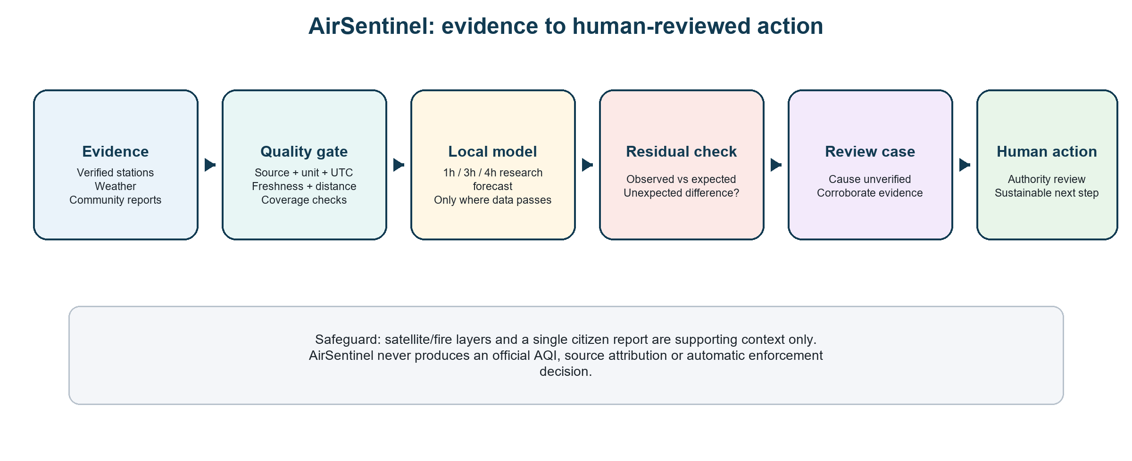
End-to-end AirSentinel workflow: evidence enters through quality gates, then supports forecast, review and auditable action.

What happens in practice
1. Collect — Download station observations for PM2.5, PM10, NO₂, O₃, SO₂ and CO; collect weather; optionally prepare satellite and moderated community context.
2. Label and validate — Every record keeps source/provenance, time, units, station details and quality/coverage checks.
3. Resolve locality — Relate station evidence to named pilot anchors. Until geometry and physical mapping are approved, it is a nearby-station proxy.
4. Forecast — Use past PM2.5, weather and time features to build research candidates for the next 1, 3 or 4 hours.
5. Check mismatch — When later data arrives, compare it with the prior forecast and assess whether the residual is unusually large.
6. Create review case — Either an evidence gap or an unexpected residual goes into a human authority queue.
7. Decide and audit — A reviewer verifies evidence, chooses a documented next step and records an audit event.

5. Data trust: from source to safe use
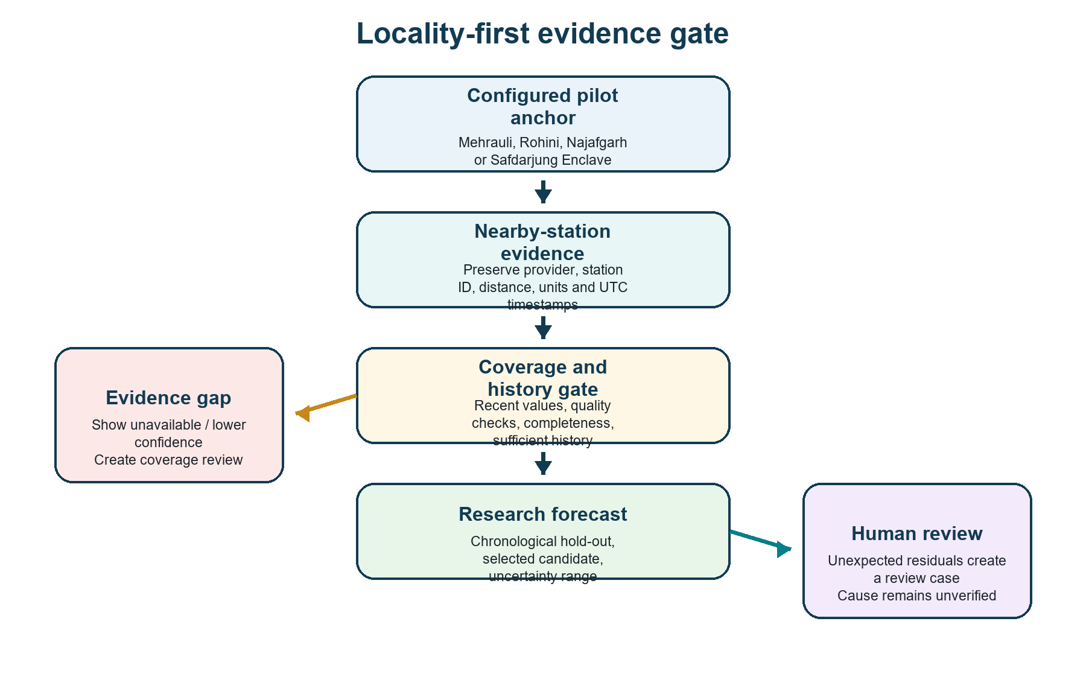
Locality evidence gate: the system stops a locality-level claim when coverage, freshness or station relationship evidence is insufficient.
Data type | Role | Limit
CPCB/data.gov.in or approved authority export | Preferred official current/production data source. | Requires authorised access, station metadata and policy approval.
OpenAQ | Historical development fallback used for prototype research. | Must remain visibly labelled; it is not an authorised CPCB archive.
Open-Meteo / approved weather | Weather features/context for dispersion and persistence. | Weather does not prove a pollution cause.
Earth Engine/Sentinel-5P | Satellite context such as broad NO₂/CO/SO₂ signals. | Vertical-column products are not surface PM2.5 or locality proof.
Citizen/photo/purifier evidence | Supporting context for triage and corroboration. | Not a calibrated outdoor monitoring replacement.

Locality truth rule
If there are no fresh, approved or sufficiently related observations, AirSentinel displays a coverage gap and places a review request. It never manufactures a locality AQI to fill the gap.

6. Forecasting and early warning
The prototype predicts PM2.5 one, three and four hours ahead because that can give a reviewer time to verify conditions and coordinate a response. It uses conventional, explainable tabular models with past PM2.5 lags, rolling averages, time of day and weather features. Earlier data is used for training and later data for testing.
Step | Meaning
Create lag/weather features | Only use values available before the prediction time.
Compare with persistence | A simple ‘next value equals current value’ baseline ensures the model earns its complexity.
Chronological test | Test on later time, not random rows, to imitate a real forecast.
Show uncertainty | Display empirical lower/upper ranges based on historical errors.
Apply promotion gate | Keep insufficient or weak locality candidates out of operational use.

Current honest status
The locality 1h/3h/4h outputs are historical prototype forecasts, not live official alerts. Najafgarh and Safdarjung need 240 leakage-safe aligned evaluation rows per horizon before controlled baseline comparison; current counts are below that threshold.

7. How the system handles a sudden spike
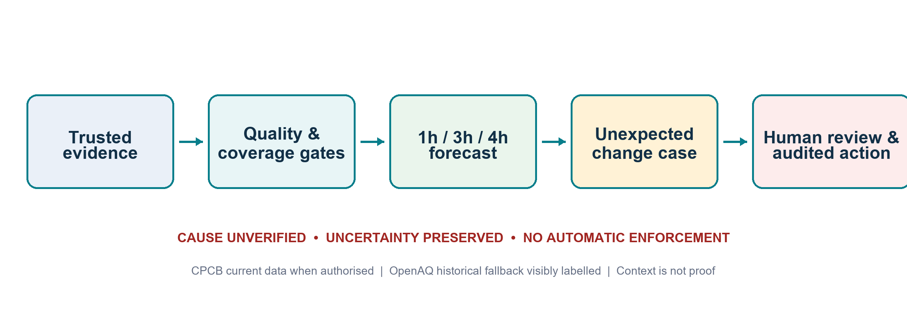
Evidence-to-action safety flow: unexpected signals become reviewed cases, not automatic source attribution or enforcement.
Example: the forecast estimates PM2.5 of 28 µg/m³ but a later verified observation is 38 µg/m³. AirSentinel records a residual of +10. It compares this residual with historical residuals. If unusual, the system creates an ‘unexpected spike review’ case.
- The system checks whether fresh nearby station readings agree or conflict.
- It adds weather and available satellite/context evidence without converting it into proof.
- It may show moderated, consented community evidence as supporting context.
- It keeps cause_status = unverified. The system does not claim parali, a factory, traffic or a person caused the spike.
- An authority reviewer is assigned a verification action. Any action is human initiated and audited.
Why this is safer
A forecast can be wrong for legitimate reasons: an unexpected emission, dust event, sensor issue, missing data or conditions not present in training history. The safe response is evidence review, not automatic blame.

8. Citizen evidence and accessibility
The citizen interface accepts consented text, photos and voice reports. A user may describe smoke, dust or a burning smell in a coarse area. The system minimises personal data, keeps evidence pending review and does not label the report an official sensor reading.
Capability | How it helps | Safeguard
Text report | Adds a local observation for a reviewer to consider. | Coarse location, consent, moderation and retention rule.
Photo + Gemini | Provides a bounded description of visible context. | No diagnosis, AQI, source attribution or enforcement advice.
Voice/STT | Improves access for users who prefer speaking. | Consent and transcription handling.
Translation/TTS | Helps reporters and reviewers use different languages. | Language QA; reviewer still makes the decision.
Purifier/home device | Can suggest a local indoor context signal. | Cannot replace calibrated outdoor station evidence; only supporting context.

9. Authority workflow and audit
The authority queue combines evidence-gap cases and unexpected-spike cases. Every case has a status, recommended next step, owner and audit record. In the local prototype, this demonstrates the workflow. In a real deployment, production actions must use protected FastAPI routes and durable Firestore/BigQuery persistence.
Case type | Reason | Reviewer next step
Evidence gap | There is not enough verified local evidence to support a locality claim. | Check station coverage, geometry, fresh data and approved access.
Unexpected spike review | Observation differs unusually from historical forecast expectation. | Corroborate with fresh stations, weather and moderated context; assign human review.
Citizen report review | A consented report needs moderation and relevance review. | Validate, keep coarse/pending and decide whether it supports a case.

No automatic enforcement
The system may recommend verification or a sustainable response path. It does not issue fines, command inspections, diagnose health impacts or decide that a source is guilty.

10. Google Cloud architecture
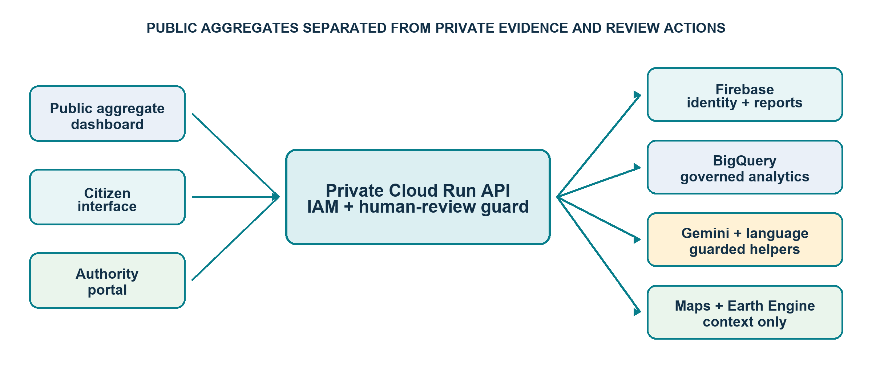
Separated Google Cloud architecture: public aggregate dashboard, private authority/API services, controlled data stores and optional bounded AI/context services.
Component | Operational function
Public Cloud Run dashboard | A separate image/context with only reviewed aggregate information.
Private Cloud Run API + authority dashboard | Protected by identity/role checks and used for reviewed actions.
Firebase Auth + rules | Verified citizen/reviewer identity and deny-by-default client rules.
Firestore / BigQuery | Pending evidence and approved analytical/audit persistence; do not rely on Cloud Run local disk.
Secret Manager | Holds API keys/configuration so source code and command lines do not expose them.
Gemini / Maps / Earth Engine / language APIs | Feature-flagged, bounded context functions that still obey the human review boundary.

11. What works now versus what needs the team
Already implemented locally | Needs external team ownership
Data contract, fallbacks, coverage reports, feature/model/anomaly/case pipelines. | Authorised CPCB/data.gov.in access, station mapping/calibration and official history.
Public/citizen/authority dashboard code, FastAPI protection, tests and audit workflow. | Firebase/GCP identities, retention/moderation policy and real persistence verification.
Cloud Run/Docker/GCP scaffolding and Google adapters. | GCP project, billing, Secret Manager values, API enablement, deployment and public URLs.
Reports, flowcharts, pitch deck, demo script and curated submission package. | Team GitHub repository, video recording and final form links.

12. Limits that make the claim credible
- It is a historical/local prototype decision-support system, not an official AQI publication service.
- Nearby station data is a proxy until locality boundaries and physical station relationships are validated.
- Satellite, purifier and citizen evidence are contextual signals, not proof or substitute measurements.
- A conventional model is only one evidence layer. It can be wrong, so uncertainty and residual review are shown.
- No source attribution or enforcement is automated; a competent human authority is needed for operational action.
- Google integrations are not claimed live until the team configures the project, secrets, identities and service quotas.

13. The judge-facing explanation
30-second explanation
AirSentinel is a locality-aware clean-air early-warning and human-review platform. It combines provenance-labelled outdoor monitoring, weather, satellite context and consented community evidence to find coverage gaps and unexpected pollution changes, forecast one to four hours ahead, and guide a transparent sustainable response. It does not invent hyper-local AQI, automate blame or replace official regulatory judgement.

Useful source documents
- README.md — local start instructions and current truth.
- HANDOFF.md — team status and remaining external tasks.
- SYSTEM_ARCHITECTURE.md and docs/FLOWCHARTS.md — architecture/workflow details.
- docs/DATA_SOURCE_AND_FALLBACK_POLICY.md — provenance and approved-source rules.
- docs/LOCALITY_MODEL_CARD.md — model limits, metrics and promotion boundary.
- deploy/README_GOOGLE_CLOUD.md — team-owned cloud deployment plan.

