


Gyalpozhing College of Information Technology
Royal University of Bhutan
Kabjisa, Chamjekha, Thimphu

School of Computing
Bachelor of Computer Science

PRJ202 Second Year Project
March 2026

Personalized Music Recommendation System Using Hybrid Machine Learning Techniques

Submitted by:
Sumeran Chhetri 12240080
Uttam Sharam 12240107
Tshering Wangda 12240101
Tenzin Wangchuk 12240091
Thinley Wangdi 12240093

Supervisor: Mr. Choki Dorji

Contents
Chapter 1. Introduction 2
1.1. Project Background 2
1.2. Problem Statement 3
1.3. Aim 3
1.4. Goal 3
1.5. Objectives 4
1.6. Scope 4
1.7 Requirements 5
Literature Review 8
Keywords 11
Chapter 2. Methodology 12
2.1 Methodology of the study 12
2.2 Design 15
2.3 System Description 17
2.4 Work Plan 21
Chapter 3. Bibliography 24

Chapter 1. Introduction

1.1. Project Background
The rapid growth of digital music platforms has resulted in the availability of millions of songs for users worldwide. While this abundance of content offers greater diversity, it also creates challenges for users attempting to discover music that aligns with their preferences. Traditional search mechanisms are often insufficient because users may not always know which songs or artists they want to listen to.
To address this challenge, recommender systems have become an essential component of modern digital platforms. These systems analyze large volumes of data, including user interactions and item characteristics, to generate personalized recommendations. Music streaming services such as Spotify and Apple Music utilize sophisticated recommendation algorithms to improve user satisfaction and increase engagement (Ricci et al., 2015).
One of the primary challenges faced by recommender systems is the Cold Start Problem, which occurs when a system has limited or no information about new users or new items (Schein et al., 2002). This project addresses this challenge by collecting initial user preferences during the onboarding stage and gradually improving recommendations through machine learning techniques.
The aim of this project is to design and develop a music recommendation system capable of providing personalized song suggestions based on user preferences, listening history, and song similarity.

1.2. Problem Statement

With the rapid expansion of digital music libraries, users are often overwhelmed by the vast amount of available content. Discovering relevant music manually can be time-consuming and inefficient. Although modern streaming platforms provide recommendation services, developing such systems requires the integration of various machine learning techniques and the analysis of large datasets.
Furthermore, new users joining a music platform typically have limited interaction history, making it difficult for recommendation systems to generate accurate suggestions. This issue highlights the need for systems capable of generating meaningful recommendations even with minimal user data.
Therefore, this project aims to design and implement a hybrid music recommendation system that integrates multiple recommendation techniques to provide personalized music suggestions based on both user preferences and listening behavior.

1.3. Aim
To design and implement a hybrid music recommendation system that generates personalized song recommendations based on user preferences, listening history, and song similarity.

1.4. Goal
The goal of this project is to build a functional application that demonstrates how modern recommendation systems used by music streaming platforms can be implemented using machine learning and data-driven approaches.

1.5. Objectives
- To collect and preprocess music datasets from multiple publicly available sources.
- To implement a content-based filtering model using audio features of songs.
- To develop a collaborative filtering model based on user interaction data.
- To integrate a hybrid recommendation model combining multiple recommendation techniques.
- To develop a user interface for interacting with the recommendation system.
- To evaluate the performance of the recommendation system using standard evaluation metrics.

1.6. Scope

1.6.1 System Scope
The system will allow users to enter their music preferences and receive personalized recommendations. The application will include the following features:
- User preference selection
- Song recommendation engine
- Personalized music suggestions
- Tracking user interactions
- Recommendation ranking
The system focuses on recommendation generation rather than full music streaming functionality.

1.6.2 User Scope

Users will be able to:
- Select preferred genres, artists, and moods
- Receive recommended songs
- Interact with recommendations by liking or skipping songs
- Discover new music based on their preferences

1.6.3 Constraints /Feasibility

Technical Constraints
- Limited computational resources for training large machine learning models.
- Availability and quality of music datasets.
Time Constraints
- The project must be completed within the academic semester.
Feasibility
The project is technically feasible because publicly available music datasets and machine learning frameworks allow efficient implementation of recommendation algorithms.

1.7 Requirements

1.7.1 Functional requirements
The system must:
- Allow users to input music preferences.
- Store user interaction data.
- Generate music recommendations.
- Display recommended songs to users.
- Update recommendations based on user behavior.

1.7.2 Non-Functional Requirements
Some of the non-functional requirements of music recommendation system should be:
1. Reliability: The system should be able to operate consistently and reliably, with a low probability of failure.

2. Security: The system should be secure, with appropriate measures in place to prevent unauthorized access or misuse of data.

3. Scalability: The system should be able to handle large volumes of data and be scalable to accommodate increasing data requirements over time.

4. Maintainability: The system should be easy to maintain and repair, with simple and clear documentation.

5. Usability: The system should be intuitive and easy to use, with user-friendly interfaces and training materials.

6. Performance: The system should perform well in terms of accuracy, speed, and
sensitivity, with minimal delays or downtime.

7. Wireframe: The system should provide clear ideas about the UI and UX of the web
application.

1.7.3. System Requirements

Hardware
- Processor: Intel Core i5 or equivalent
- RAM: Minimum 8 GB
- Storage: Minimum 256 GB SSD
- Internet connection for accessing datasets and APIs
Software

Front-end
- Programming Language: JavaScript
- Framework: React.js
- UI Framework: Tailwind CSS

Back-end
- Programming Language: Python
- Framework: Flask
- API Communication: REST API
Machine Learning Libraries
- Pandas – data processing
- NumPy – numerical computation
- Scikit-learn – recommendation algorithms
- TensorFlow / PyTorch – deep learning models
- Surprise – collaborative filtering
Database
- PostgreSQL
Development Tools
- Visual Studio Code
- Visual design tool: Figma
- Jupyter Notebook
- Git
- Postman

Literature Review

Introduction

Recommendation systems have become a fundamental component of modern digital platforms. They assist users in discovering relevant content from large datasets by predicting user preferences based on historical interactions and item characteristics. In the music industry, recommendation systems are widely used by streaming services such as Spotify and Apple Music to personalize music discovery and enhance user experience.
The rapid growth of digital music libraries has resulted in the availability of millions of songs, making manual discovery difficult for users. As a result, intelligent recommendation algorithms are required to filter content and deliver personalized suggestions. Researchers have proposed several approaches to recommendation systems, including content-based filtering, collaborative filtering, and hybrid recommendation models (Ricci et al., 2015).
This chapter reviews the major research contributions and techniques used in recommender systems, particularly those applied to music recommendation.
Recommender Systems
A recommender system is an information filtering system that predicts the preferences of users for items such as movies, music, products, or news articles. These systems analyze patterns in user behavior and item attributes to suggest relevant content.
According to Ricci et al. (2015), recommender systems help reduce information overload by providing personalized suggestions tailored to individual users. They are widely applied in industries such as e-commerce, entertainment, and social media.
Modern recommendation systems rely on machine learning techniques and large-scale data analysis to understand user preferences and deliver relevant recommendations. In the context of music streaming, recommendation systems play a crucial role in maintaining user engagement by continuously suggesting songs that match user tastes.

Content-Based Filtering
Content-based filtering is one of the earliest and most widely used recommendation techniques. This approach recommends items to users based on the similarity between item features and the user’s preferences.
In music recommendation systems, content-based filtering uses song attributes such as genre, tempo, energy, loudness, and danceability to determine similarity between songs. If a user enjoys a particular song, the system recommends other songs with similar characteristics.
Research by Celma (2010) demonstrated that analyzing audio features and metadata can effectively identify similarities between songs and improve music recommendation quality. Content-based methods are particularly useful in scenarios where limited user interaction data is available.
However, content-based systems have certain limitations. They may struggle to recommend diverse content and can become overly specialized by recommending items too similar to those already consumed by the user (Ricci et al., 2015).
Collaborative Filtering
Collaborative filtering is one of the most widely used recommendation techniques in modern digital platforms. This approach generates recommendations by analyzing the behavior and preferences of multiple users.
Collaborative filtering assumes that users who have similar preferences in the past will likely have similar preferences in the future. Therefore, the system recommends items liked by similar users.
Koren et al. (2009) introduced matrix factorization techniques that significantly improved the accuracy of collaborative filtering systems. These techniques analyze user-item interaction matrices to identify latent patterns in user preferences.
Collaborative filtering has been successfully applied in large-scale recommendation systems used by platforms such as Netflix and Spotify.
Despite its effectiveness, collaborative filtering faces challenges when dealing with sparse datasets or new users with limited interaction history.
The Cold Start Problem
One of the major challenges in recommender systems is the Cold Start Problem, which occurs when the system has insufficient information about new users or new items.
Schein et al. (2002) explained that collaborative filtering systems rely heavily on historical interaction data. When a new user joins the system and has no prior interaction history, the system cannot accurately generate recommendations.
To address this issue, many platforms collect initial user preferences during onboarding, such as favorite genres, artists, or moods. This information allows the system to generate initial recommendations before sufficient interaction data becomes available.
Hybrid Recommendation Systems
Hybrid recommendation systems combine multiple recommendation techniques to improve recommendation accuracy and overcome the limitations of individual approaches.
According to Burke (2002), hybrid recommender systems integrate content-based filtering and collaborative filtering methods to provide more reliable and diverse recommendations. By combining multiple data sources and algorithms, hybrid systems can generate recommendations even in situations where one method alone would perform poorly.
Many modern music streaming platforms implement hybrid recommendation models to enhance personalization and improve recommendation quality. These systems utilize various data sources, including audio features, user listening history, playlists, and contextual information.
Deep Learning in Music Recommendation
Recent advancements in machine learning have introduced deep learning techniques for recommender systems. Deep learning models can learn complex patterns in user behavior and item features, allowing them to generate more accurate recommendations.
Neural collaborative filtering models use neural networks to learn latent representations of users and items. These models can capture nonlinear relationships in data and improve recommendation performance compared to traditional methods.
Research has shown that deep learning techniques can effectively analyze audio signals, extract meaningful music features, and enhance music recommendation systems.
Summary
The literature reviewed in this chapter highlights the evolution of recommender systems from simple filtering methods to complex machine learning models. Content-based filtering and collaborative filtering remain the most widely used techniques for generating personalized recommendations.
However, each approach has its limitations when used independently. Hybrid recommender systems address these limitations by combining multiple techniques to improve recommendation accuracy and diversity.
Based on the findings from previous research, this project adopts a hybrid recommendation approach that integrates content-based filtering, collaborative filtering, and machine learning techniques to develop an effective music recommendation system.

Keywords
Music Recommendation System, Machine Learning, Collaborative Filtering, Content-Based Filtering, Hybrid Recommendation, Personalization, User Preferences,

Chapter 2. Methodology

2.1 Methodology of the study
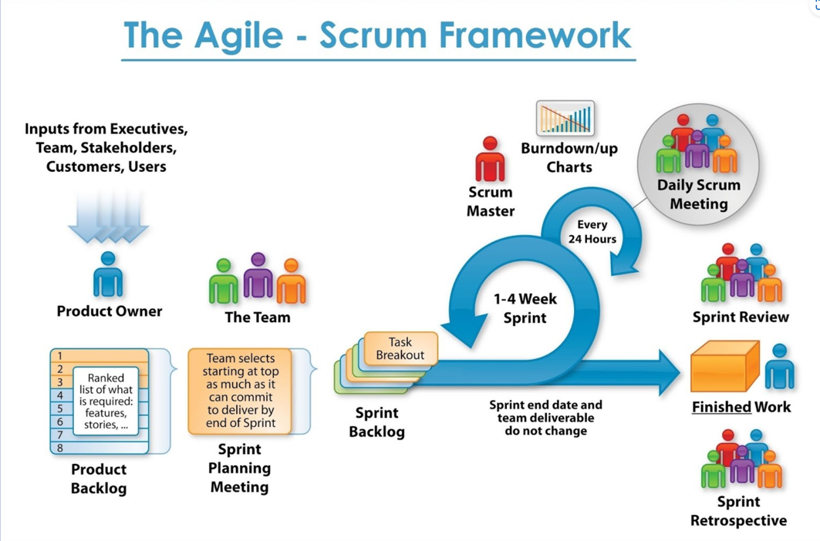
The Agile methodology was followed/used for the development of both the systems; “Stipend Deduction Authorization System”, and the, “Student Welfare Management System”. Agile project management is not a singular framework; it can be used as an umbrella term to include many different frameworks. For these systems, the SCRUM framework was used as it is most suited for the software development. Scrum framework consists of meetings, roles, and tools to help teams working on complex projects collaborate, better structure and manage the workload.

Figure 1 Agile methodology
The stages of agile methodology that were followed are:

2.1.1 Project initiation
The product owner, scrum master, and development team compose the scrum team during this phase. The team held discussions to determine the project's requirements and came to a thorough knowledge of its goals. By connecting with and interviewing the student service officers and the finance department team, the team worked with the stack holders to obtain the needs. Following that, User Stories were created to represent the requirements that had been determined. The user stories are prioritized in the product backlog taking into account dependencies and stakeholder feedback.

2.1.2 Design
The project's design is created based on the requirements gathered, and this includes developing a prototype as well as the architectural, user interface, and database designs.

2.1.3 Planning and Estimate
The team decided which user stories from the product backlog to work on during the sprint during this phase. The team decided on the sprint target, listed the tasks needed to finish the chosen backlog items, and calculated the amount of time needed for each work.

2.1.4 Implementation
The team began working on the tasks listed in the sprint backlog as soon as the sprint planning was finished. Also assessed simultaneously were other tasks. Daily stand-up meetings, often known as daily scrums, are quick gatherings held throughout the sprint to coordinate work, talk about progress, and identify and remove any obstacles. Each team member discussed the tasks they completed the day before, the tasks they planned to complete today, and any challenges they were currently facing.

2.1.5 Review and Perspective
The team held a sprint review meeting at the conclusion of each sprint to provide stakeholders with the finished products created during the sprint. It assisted in ensuring that the project is on schedule and in line with the expectations of the stakeholders. The team was able to learn from their experiences and make the required adjustments for subsequent sprints thanks to the continuous improvement-focused approach.
Three sprints, each lasting three weeks, were used to separate the development process for this project. Once a sprint is completed and evaluated, the process often loops back to the planning and estimates stage, when a new sprint planning phase starts. Scrum's iterative methodology enables regular feedback, flexibility, and ongoing project improvement.

2.2 Design

2.2.1 Architecture Design
The proposed Music Recommendation System follows a three-tier architecture combined with the MVC (Model–View–Controller) design pattern to ensure modularity and scalability.
The architecture consists of three layers:
Presentation Layer (Frontend)
This layer provides the user interface where users interact with the system. It allows users to log in, select music preferences, and view personalized recommendations. The frontend will be developed using React.js with Tailwind CSS for responsive and user-friendly design.
Application Layer (Backend)
This layer handles the core system logic and the recommendation algorithms. It processes user requests, communicates with the database, and generates personalized song recommendations. The backend will be implemented using Python with Flask, which exposes REST APIs for communication with the frontend.
Data Layer (Database)
The data layer stores system data such as user profiles, song metadata, user preferences, and interaction history. The system uses PostgreSQL to ensure reliable and scalable data storage.
This architecture enables easy integration of machine learning models and improves maintainability of the system.

2.2.2 Model Design
The system follows the Model–View–Controller (MVC) design pattern to separate responsibilities.
Model
The model represents the data and business logic of the system. It manages interactions with the database and stores information such as users, songs, preferences, and interactions. It also contains the machine learning algorithms responsible for generating recommendations.
View
The view represents the graphical user interface that displays information to the user. It includes pages such as login, preference selection, and the recommendation dashboard.
Controller
The controller acts as the intermediary between the model and the view. It processes user requests, retrieves data from the model, and returns the results to the interface for display.
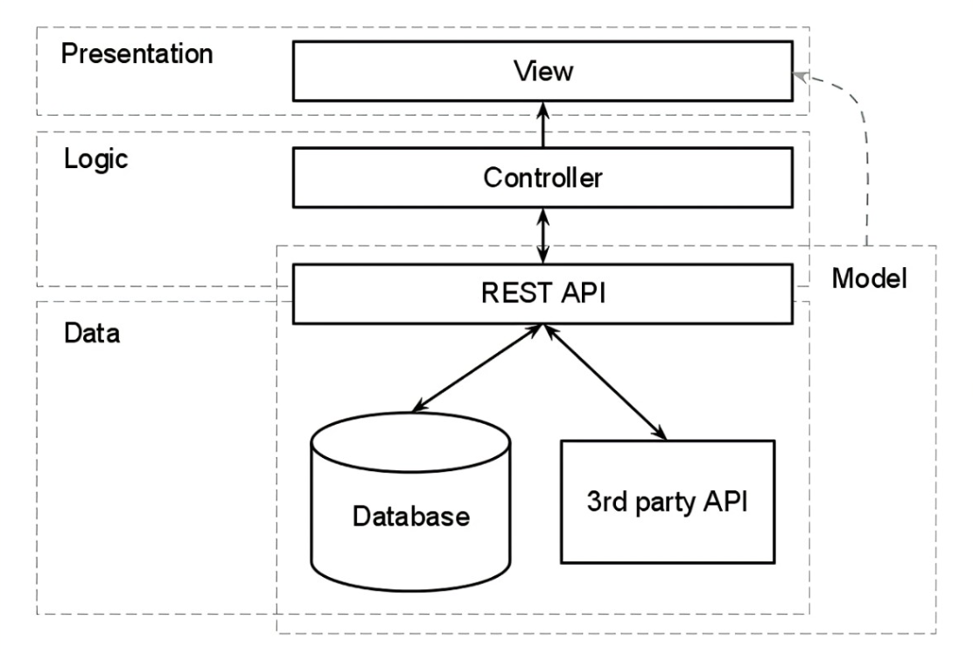
Figure 2 MVC Model-brief description

2.2.3 User Dashboard
The User Dashboard is the main interface where users access personalized music recommendations.
After logging in, users can:
- View recommended songs
- Search for artists or songs
- Like or skip recommendations
- Explore suggested playlists
The recommendations displayed on the dashboard are generated using the system’s hybrid recommendation algorithm, which improves as more user interaction data is collected.

2.3 System Description

2.3.1 System Architecture
The system follows a three-tier structure:
- Presentation Tier – React-based web interface that collects user input and displays recommendations.
- Application Tier – Flask-based backend that processes requests and runs the recommendation algorithm.
- Database Tier – PostgreSQL database storing user data, song metadata, and interaction history.
This layered architecture ensures better scalability and system performance.
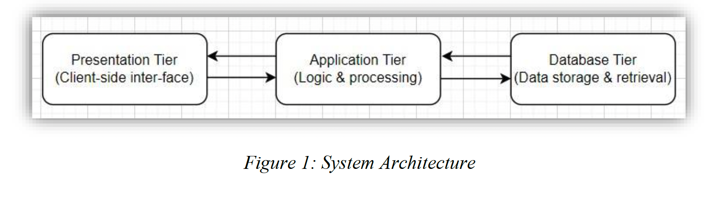

2.3.2 Workflow

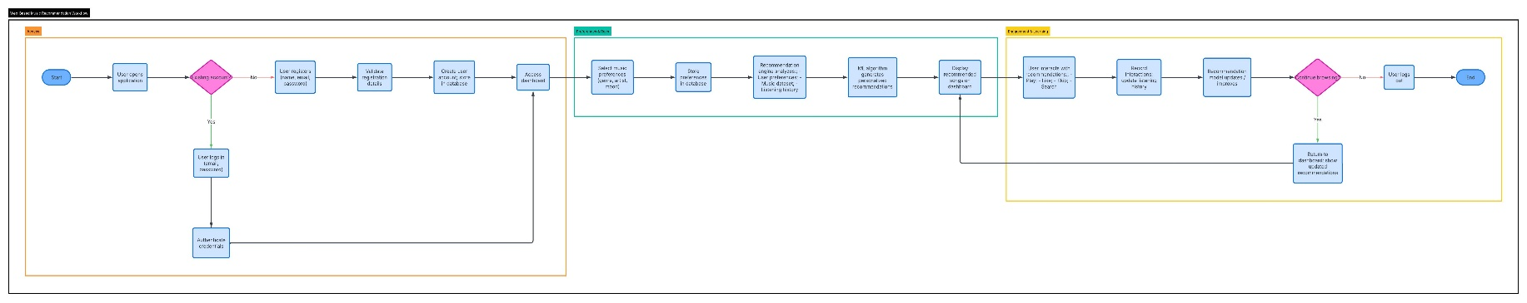
A workflow diagram (also known as a workflow) provides a graphic overview of the business process. Using standardized symbols and shapes, the workflow shows step by step how your work is completed from start to finish. It also shows who is responsible for work at what point in the process. Designing a workflow involves first conducting a thorough workflow analysis, which can expose potential weaknesses. A workflow analysis can help you define, standardize, and identify critical areas of your process.

Link to workflow diagram(https://url-shortener.me/GZX6)

2.3.3 Use Case Diagram

In the Unified Modeling Language (UML), a use case diagram can summarize the details of your system's users (also known as actors) and their interactions with the system. To build one, you'll use a set of specialized symbols and connectors. An effective use case diagram can help your team discuss and represent:

- Scenarios in which your system or application interacts with people, organizations, or external systems
- Goals that your system or application helps those entities (known as actors) achieve
- The scope of your system

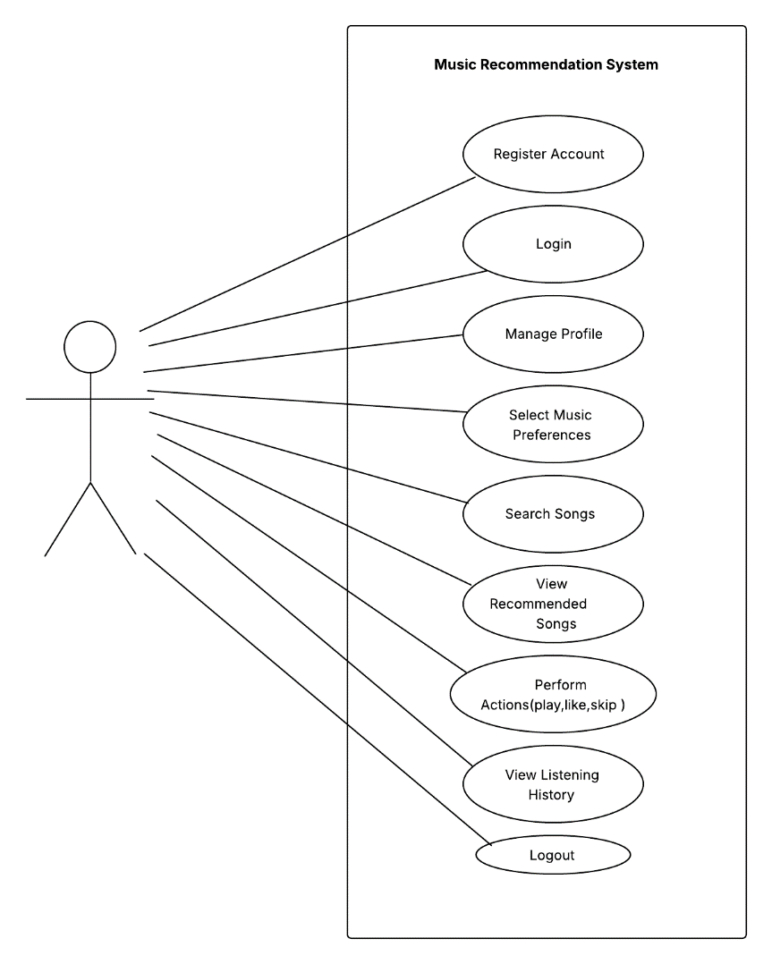

2.3.4 Entity Relationship Diagram
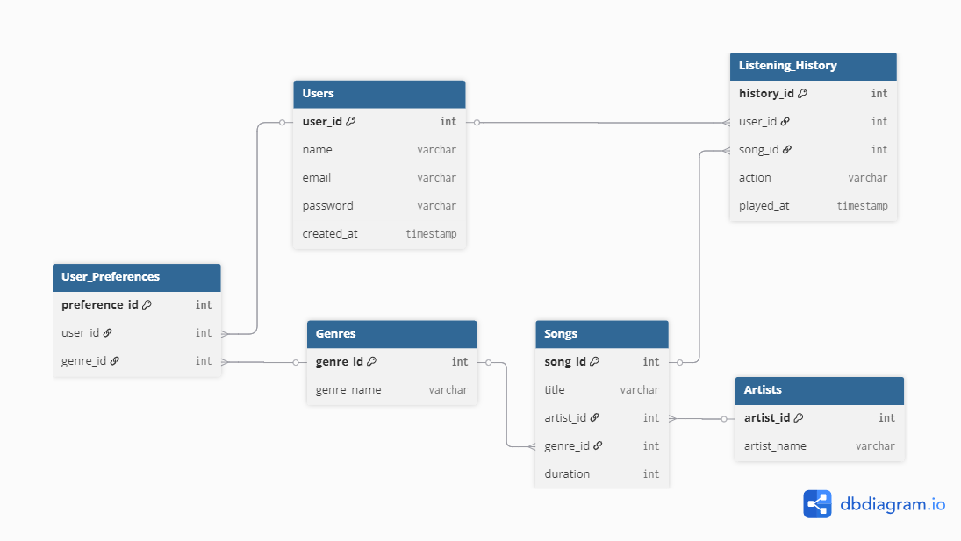
ERD stands for entity relationship diagram. People also call these types of diagrams ER diagrams and Entity Relationship Models. An ERD visualizes the relationships between entities like people, things, or concepts in a database. An ERD will also often visualize the attributes of these entities
Figure SEQ Figure \* ARABIC 5 ERD Logical Data Model-Explain Briefly

2.4 Work Plan

2.4.1 Roles and Responsibilities
The project team consists of five members, each responsible for specific tasks in order to ensure efficient development and successful completion of the Music Recommendation System.
1. Project Manager / Team Leader
Member: Sumeran Chhetri
Responsibilities:
- Coordinating and managing the overall project activities.
- Planning the project schedule and ensuring milestones are achieved on time.
- Communicating with the project supervisor and stakeholders.
- Monitoring team progress and resolving project-related issues.
- Ensuring proper documentation and organization of project deliverables.
2. Backend Developer
Member: Tenzin Wangchuk
Responsibilities:
- Developing the backend server using Python Flask.
- Designing and implementing REST APIs for communication between frontend and backend.
- Handling system logic and integrating recommendation algorithms.
- Managing data processing and interaction with the database.
- Ensuring system performance and reliability.

3. Frontend Developer / UI Designer
Member: Uttam Sharma
Responsibilities:
- Designing and developing the user interface using React.js and Tailwind CSS.
- Creating responsive and user-friendly web pages.
- Implementing the user dashboard for displaying recommendations.
- Ensuring smooth interaction between users and the system.
- Improving the overall user experience and usability.

4. Machine Learning Engineer / Data Analyst
Member: Tshering Wanga
Responsibilities:
- Collecting and preprocessing music datasets.
- Implementing content-based filtering and collaborative filtering models.
- Developing the hybrid recommendation algorithm.
- Evaluating model performance using recommendation metrics.
- Optimizing the recommendation model for better accuracy.
5. Database & System Integration Developer

Member: Thinley Wangdi
Responsibilities:
- Designing and managing the PostgreSQL database.
- Storing and organizing user data, music metadata, and interaction history.
- Integrating frontend, backend, and machine learning components.
- Managing system testing and debugging.
- Supporting deployment and final system integration.

2.4.2 Gantt Chart
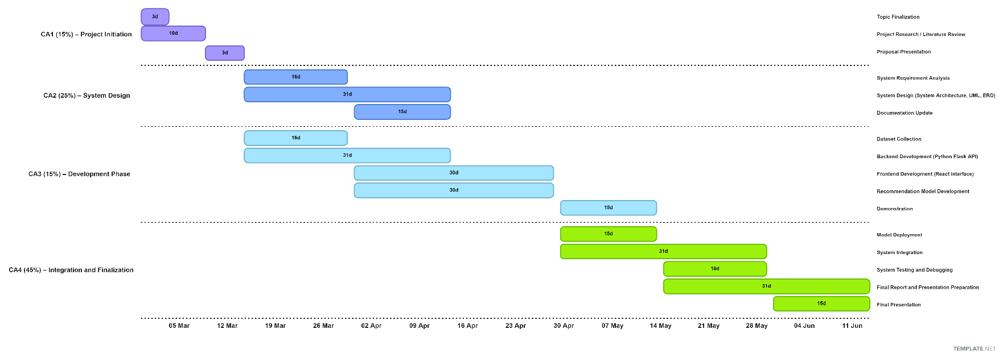
A Gantt chart is a project management tool assisting in the planning and scheduling of projects of all sizes; they are particularly useful for visualizing projects. A Gantt chart is defined as a graphical representation of activity against time; it helps project professionals monitor progress.

2.4.3 Project Schedule
Task no |  | Assignment Title |  | Duration | Start Date | End date
1 | CA1 |  | Planning and Proposal | 13days | March 1, 2026 | March 13, 2026
2 | CA2 |  | Design and Development | 31 days | March 16,  2026 | April 15, 2026
3 | CA3 |  | Iteration and Integration | 61 days | March 16, 2026 | May 15, 2026
4 | CA4 |  | Final Delivery and Deployment | 46 days | May 1, 2026 | June 15, 2026

Chapter 3. Bibliography

Bertin-Mahieux, T., Ellis, D. P. W., Whitman, B., & Lamere, P. (2011). The Million Song Dataset. Proceedings of the 12th International Society for Music Information Retrieval Conference (ISMIR 2011), 591–596.
Bertin-Mahieux, T., Ellis, D. P. W., Whitman, B., & Lamere, P. (2011). The Million Song Dataset. http://millionsongdataset.com/
Burke, R. (2002). Hybrid recommender systems: Survey and experiments. User Modeling and User-Adapted Interaction, 12(4), 331–370. https://doi.org/10.1023/A:1021240730564
Celma, O. (2010). Music recommendation and discovery in the long tail. Springer. https://doi.org/10.1007/978-3-642-13287-2
Harper, F. M., & Konstan, J. A. (2016). The MovieLens datasets: History and context. ACM Transactions on Interactive Intelligent Systems, 5(4), 1–19. https://doi.org/10.1145/2827872
Koren, Y., Bell, R., & Volinsky, C. (2009). Matrix factorization techniques for recommender systems. Computer, 42(8), 30–37. https://doi.org/10.1109/MC.2009.263
Last.fm. (2020). Last.fm dataset. https://www.last.fm
Ricci, F., Rokach, L., & Shapira, B. (Eds.). (2015). Recommender systems handbook (2nd ed.). Springer. https://doi.org/10.1007/978-1-4899-7637-6
Schein, A. I., Popescul, A., Ungar, L. H., & Pennock, D. M. (2002). Methods and metrics for cold-start recommendations. In Proceedings of the 25th Annual International ACM SIGIR Conference on Research and Development in Information Retrieval (pp. 253–260). Association for Computing Machinery. https://doi.org/10.1145/564376.564421
Schedl, M., Gómez, E., & Urbano, J. (2014). Music information retrieval: Recent developments and applications. Foundations and Trends in Information Retrieval, 8(2–3), 127–261. https://doi.org/10.1561/1500000042
Spotify. (2020). Spotify audio features dataset. https://developer.spotify.com/documentation/web-api/
Zhang, S., Yao, L., Sun, A., & Tay, Y. (2019). Deep learning based recommender system: A survey and new perspectives. ACM Computing Surveys, 52(1), 1–38. https://doi.org/10.1145/3285029

