**TASK-2**

**Consider that you want to start an open-source project in your organization. Perform all the standard operation to create a repository with minimal permission for all the users. It should contain.**

**Proper opensource structure And Proper Readme**

* Click on New Like This

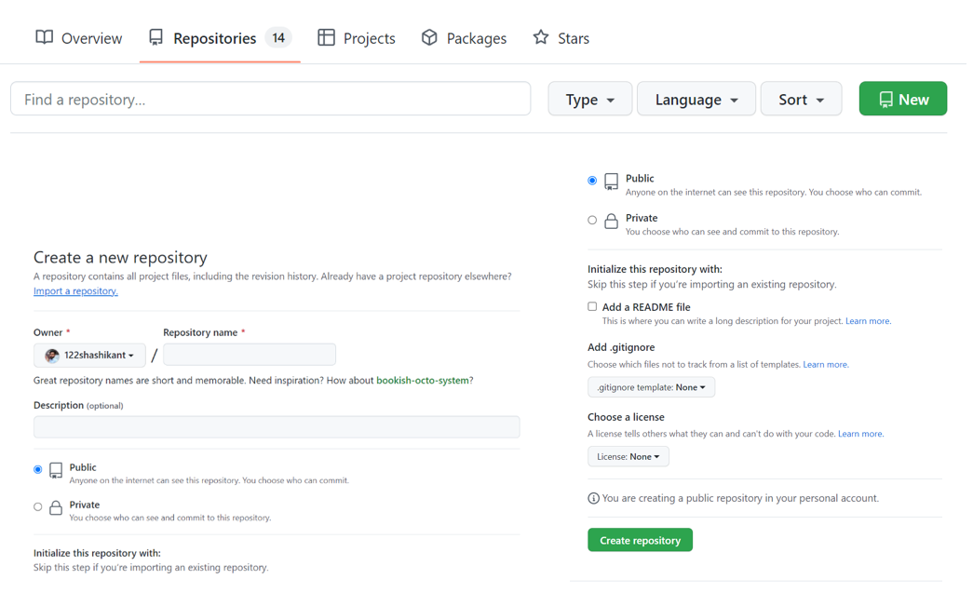

* Create README.md and other required files like app.py, requirements.txt and push to GitHub repo as show in following images.

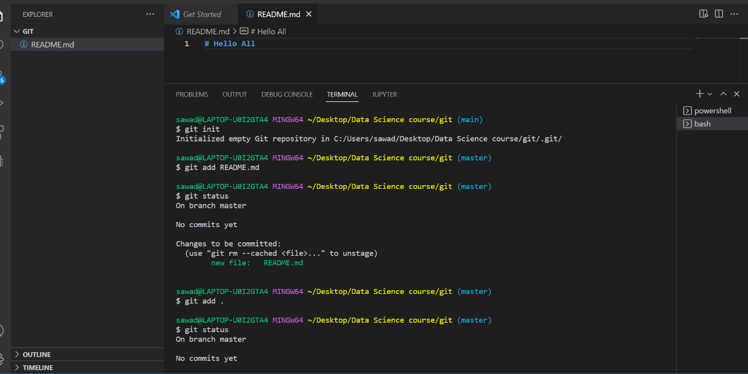

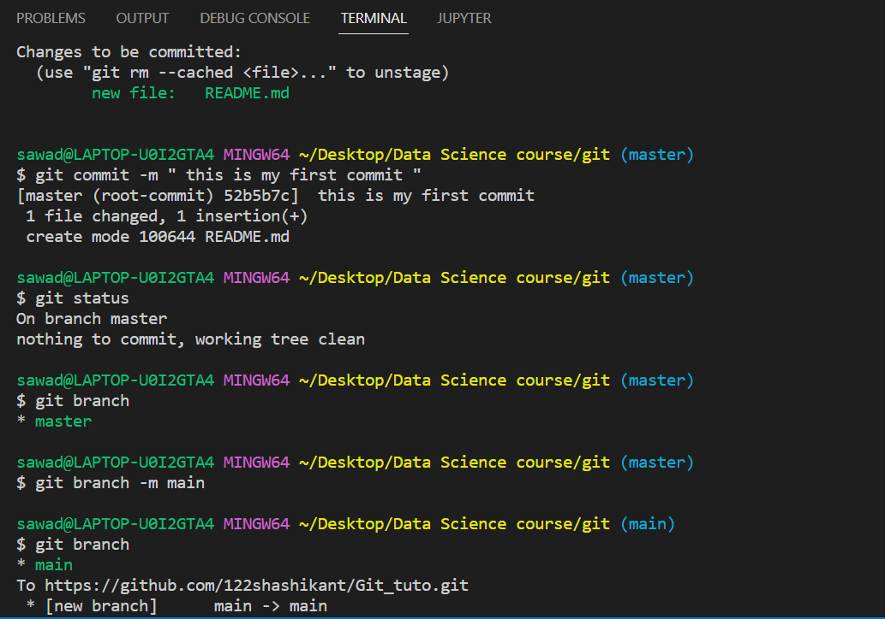

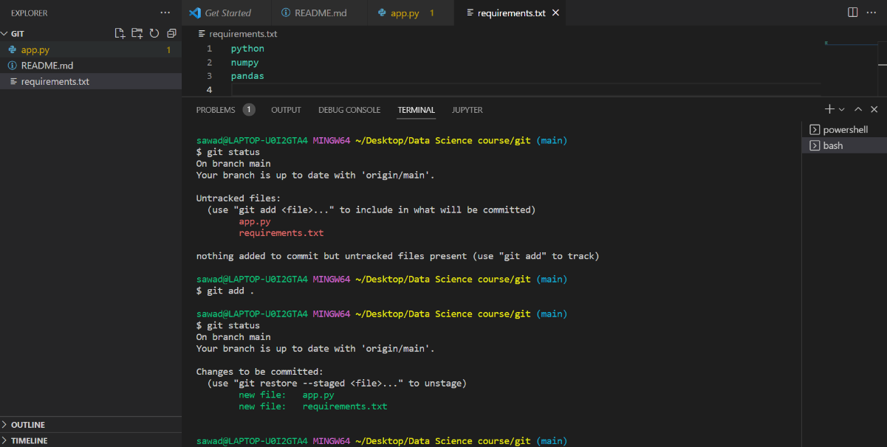

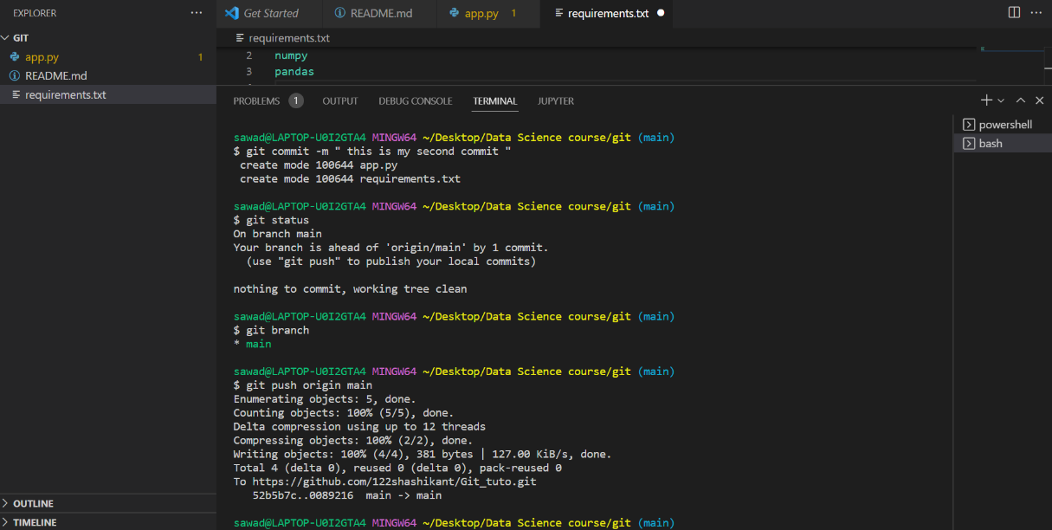

* Finally repo is complete as show in following image.

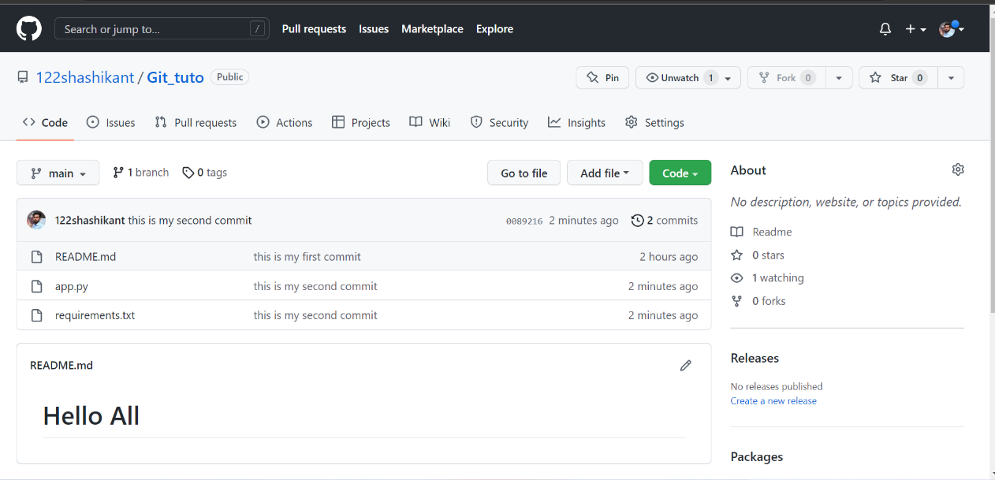

**Add 2 collaborator**

**Collaborator :-** Collaborators on a personal repository can **pull (read) the contents of the repository and push (write) changes to the repository**. Note: In a private repository, repository owners can only grant write access to collaborators. Collaborators can't have read-only access to repositories owned by a personal account.

Go to **setting > collaborators > Add People(with her/him repo name)**

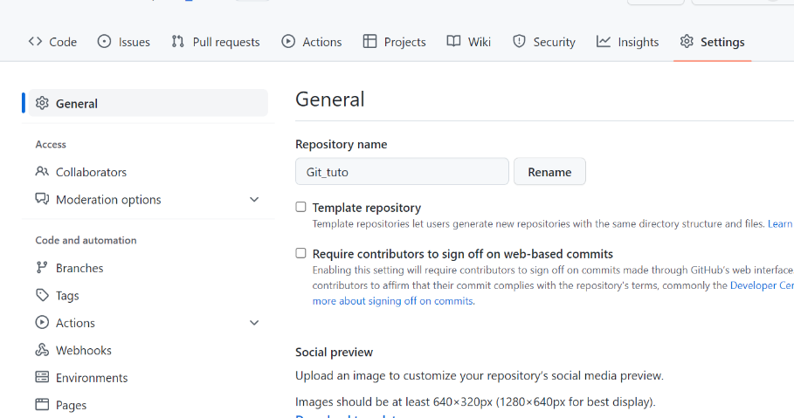

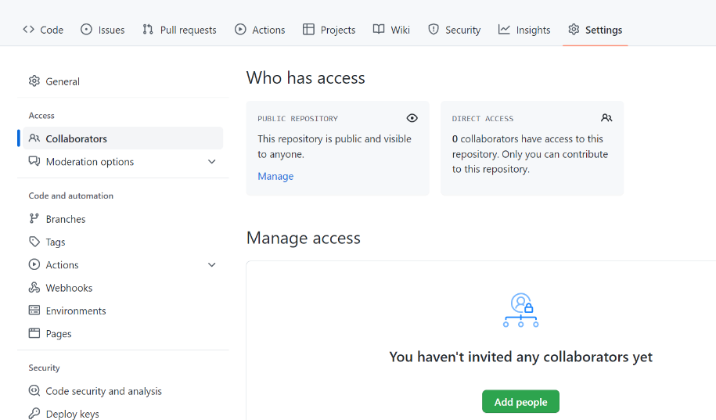

**The People Add You**

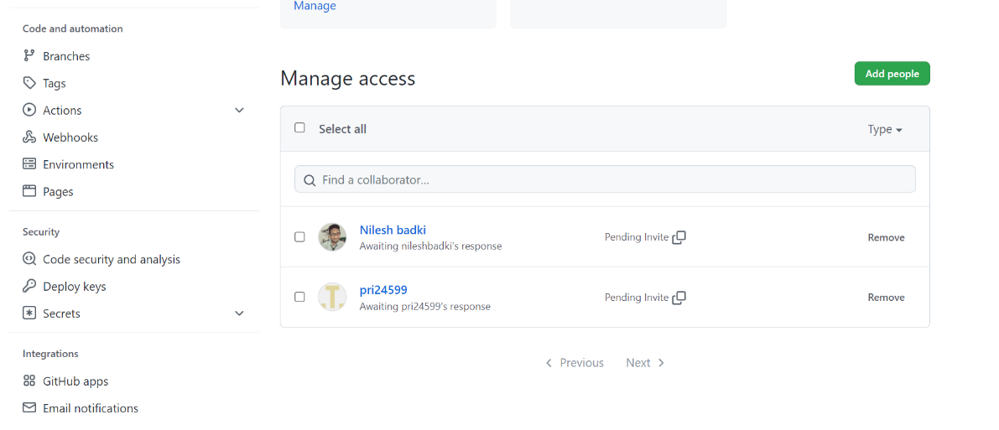

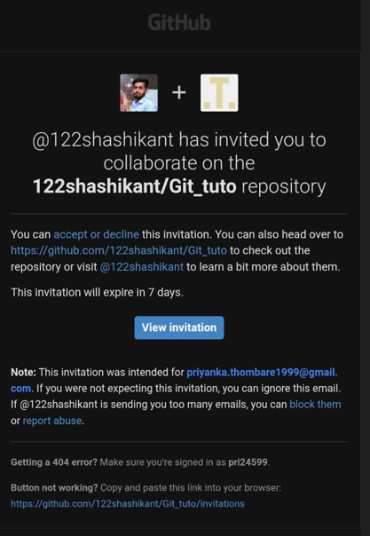**The People Add You they received some mails like this**

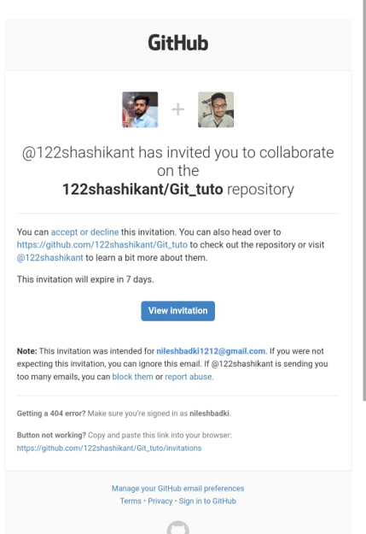

**After they accept request, they made collaborator**

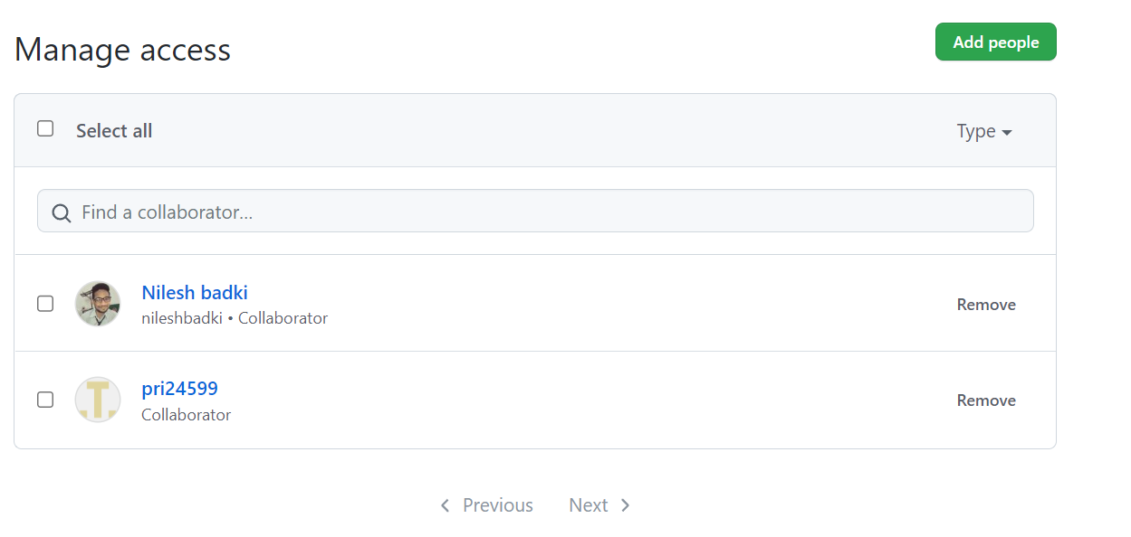

**Fork the project after making collaboretor to see project file to our Repo**

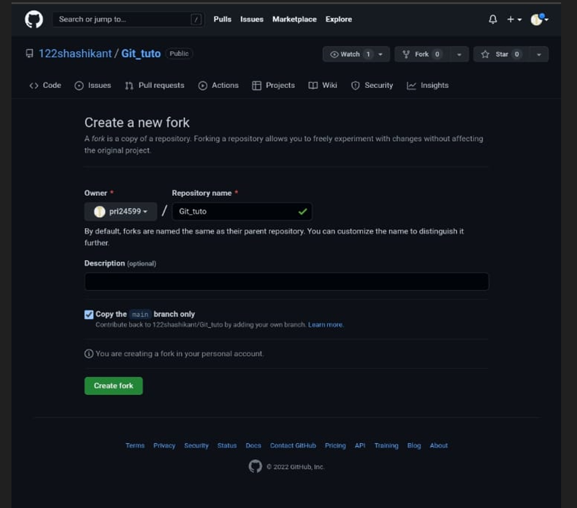

**And then we seen it to our Repo**

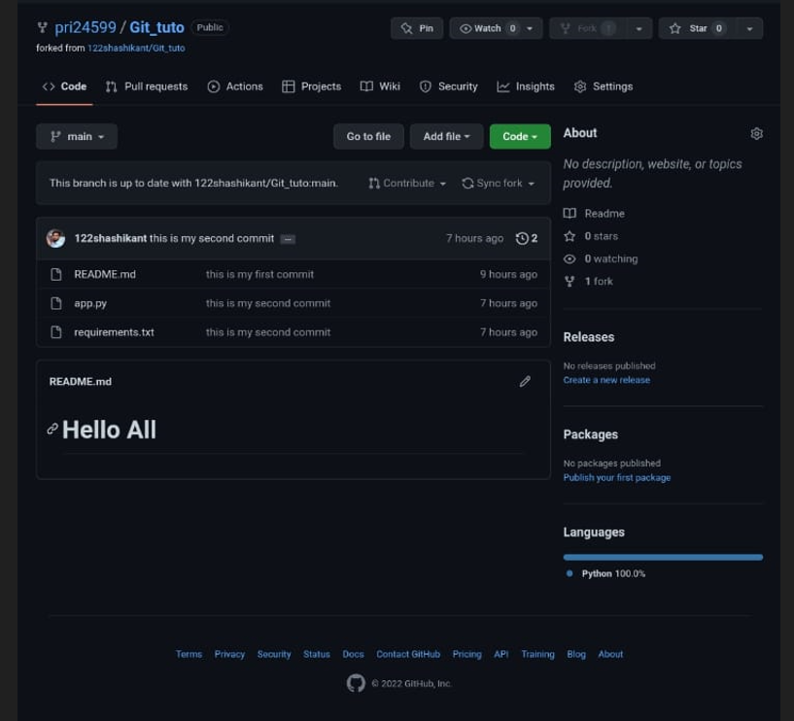

**Host GitHub Pages using settings (Designed to host your personal, organization, or project pages from a GitHub repository)**

**Go to create new repo > Add project page file > open repo > go to setting > pages >**

**Change the setting in source to main branch > then folder /root > save**

