SIDDAGANGA INSTITUTE OF TECHNOLOGY, TUMAKURU-572103
(An Autonomous Institute under Visvesvaraya Technological University)



MACHINE LEARNING ABL-2 ON
“Loan Default Prediction Using Logistic Regression”

BACHELOR OF ENGINEERING
IN
ELECTRONICS AND TELECOMMUNICATION ENGINEERING

Submitted by
JAYADIXITHA S P 1SI23ET019
MOHAMMED FURQAN 1SI23ET030
NAGAPRIYA K G 1SI23ET031

Submitted to,
Dr. R N Sathish sir
Assistant Professor
Department of ETE
SIT, Tumkur

2025-26
1. Abstract
This project presents a Logistic Regression model developed to analyze the relationship between borrower age and the probability of loan default. The dataset consists of grouped loan records categorized by different age ranges. The main objective is to understand whether age has a significant influence on loan default behavior and to evaluate the predictive performance of the model using standard classification metrics such as Accuracy, Confusion Matrix, ROC Curve, and AUC Score.
2. Introduction
Loan default prediction plays a crucial role in the banking and financial industry. Financial institutions must assess risk before approving loans to minimize losses. Machine Learning techniques, particularly classification algorithms, help automate this risk assessment process.
In this project, Logistic Regression is used as a binary classification model to classify loans into two categories: Good Loan (0) and Bad Loan (1). The focus is to study how age impacts the probability of default.
3. Dataset Description
The dataset used in this study consists of aggregated loan records grouped by borrower age categories. The data was obtained in tabular format and contains 15 age groups ranging from 20 to 62 years.
Each record contains the following attributes:
- Age_Mid – Midpoint of the age group
- Total_Loans – Total number of loans issued in that age group
- Bad_Loans – Number of loans that resulted in default
- Good_Loans – Number of non-defaulted loans
- Bad_Probability – Ratio of Bad_Loans to Total_Loans
The total number of loans in the dataset is 60,816, out of which:
- 59,292 are Good Loans
- 1,524 are Bad Loans
This indicates a strong class imbalance, with bad loans forming approximately 2.5% of the total dataset.
Since Logistic Regression requires individual-level data, the aggregated dataset was expanded into 60,816 loan-level observations, where:
- 0 represents Good Loan
- 1 represents Bad Loan

4. Methodology
4.1 Data Preparation
The dataset was loaded using the Pandas library.
The Good_Loans column and Bad_Probability column were verified from the dataset.
Basic exploratory checks were performed to confirm totals and class distribution.

4.2 Dataset Expansion
Because the dataset contained grouped counts rather than individual loan records, it was expanded into loan-level binary samples.
For each age group:
- The number of bad loans were encoded as 1
- The number of good loans were encoded as 0
This resulted in 60,816 individual training samples.

4.3 Train-Test Split
The dataset was divided into:
- 70% Training Data
- 30% Testing Data
A stratified split was used to maintain the same class distribution in both sets due to severe class imbalance.

4.4 Feature Scaling
The Age_Mid feature was standardized using StandardScaler to improve model convergence and numerical stability.

4.5 Model Training
A Logistic Regression classifier from Scikit-learn was trained using:
- Independent Variable: Age_Mid
- Target Variable: Loan Status (0 or 1)
To address class imbalance, the parameter:
class_weight = 'balanced'
was used so that minority class (Bad Loans) receives higher importance during training.

4.6 Model Evaluation
The model was evaluated using:
- Confusion Matrix
- Accuracy
- Precision
- Recall
- F1 Score
- Log Loss
- ROC Curve and AUC Score
- Precision-Recall Curve
- Calibration Curve
These metrics provide a comprehensive understanding of model performance under class imbalance conditions.

5. Results
The Logistic Regression model was evaluated using stratified train-test split, scaling, and class imbalance handling. The following results were obtained:

Confusion Matrix:
 | Predicted: Good (0) | Predicted: Bad (1)

Actual Good (0) | 10949 | 6839

Actual Bad (1) | 238 | 219
Accuracy: 0.6121
Precision: 0.0310
Recall: 0.4792
F1 Score: 0.0582
AUC Score: 0.5847
Log Loss: 0.6808
The ROC Curve shows moderate discriminative ability. The Precision-Recall curve indicates that although recall is moderate, precision is very low due to class imbalance.
The negative coefficient (β₁ = -0.3395) indicates that as age increases, the probability of loan default decreases.
The Odds Ratio (0.7121) suggests that for every one-unit increase in standardized age, the odds of default decrease by approximately 28.8%.
Although the model handles imbalance using class weighting, age alone is not a strong predictor of loan default.
5.1 Confusion Matrix
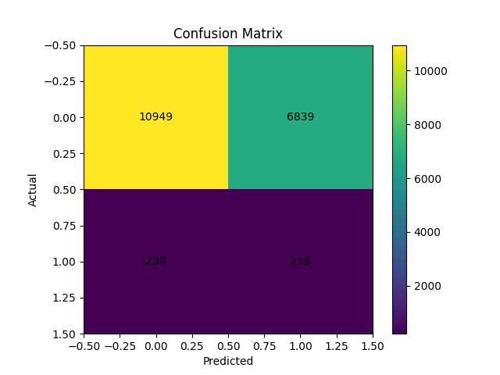
- The model correctly classified 10949 good loans.
- 219 bad loans were correctly identified.
- However, 6839 good loans were misclassified.
- This indicates difficulty in separating classes using age alone
5.2 ROC Curve
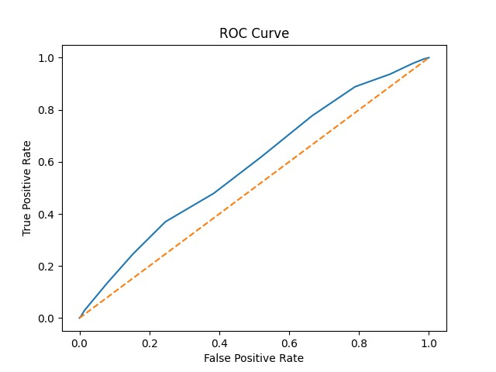
- AUC Score = 0.5847
- The curve lies slightly above diagonal.
- Indicates moderate discrimination ability
5.3 Precision–Recall Curve

- Recall is moderate.
- Precision is very low due to class imbalance.
- Indicates many false positives

5.4 Probability Distribution Plot
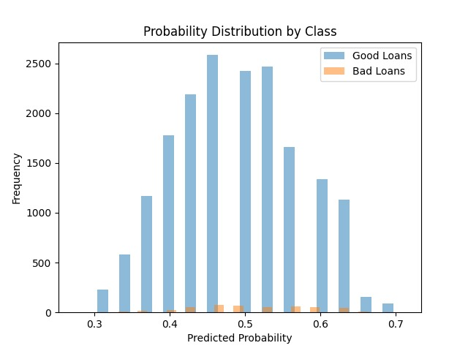
- Overlap between good and bad loan probabilities.
- Shows weak separability using age alone.

5.5 Calibration Curve
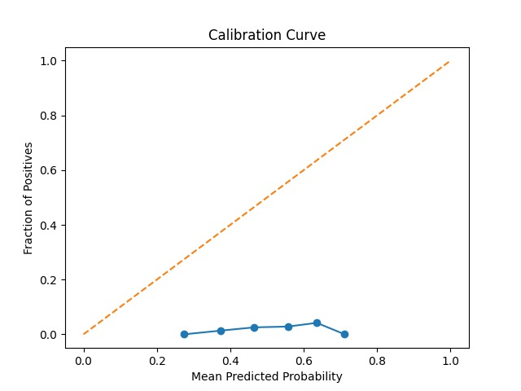
- Curve deviates from ideal diagonal.
- Indicates predicted probabilities are not perfectly calibrated.

5.6 Sigmoid Curve (Age vs Probability)
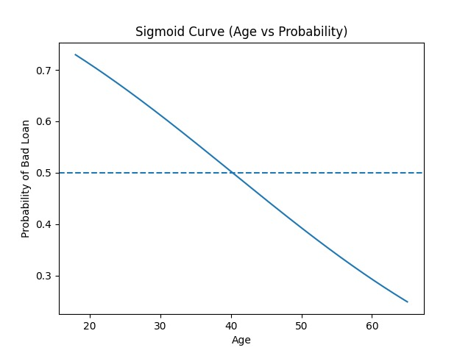
- Probability decreases as age increases.
- Confirms negative coefficient interpretation.

6. Conclusion
This project demonstrates the implementation of Logistic Regression for loan default prediction using age as the independent variable. The model was improved using stratified sampling, feature scaling, and class imbalance handling.
The results indicate that increasing age reduces the probability of loan default. However, performance metrics such as low precision and moderate AUC score suggest that age alone is insufficient for accurate prediction.
Therefore, loan default prediction requires multiple financial and behavioral features to achieve strong predictive performance.

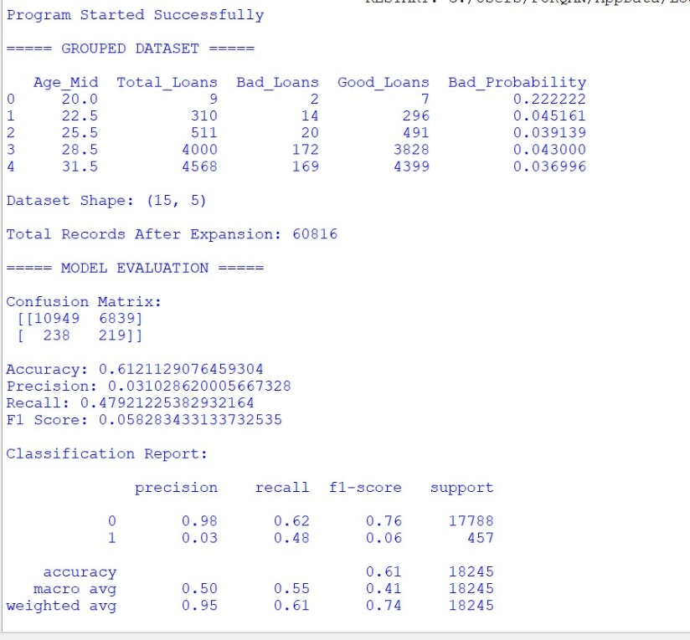
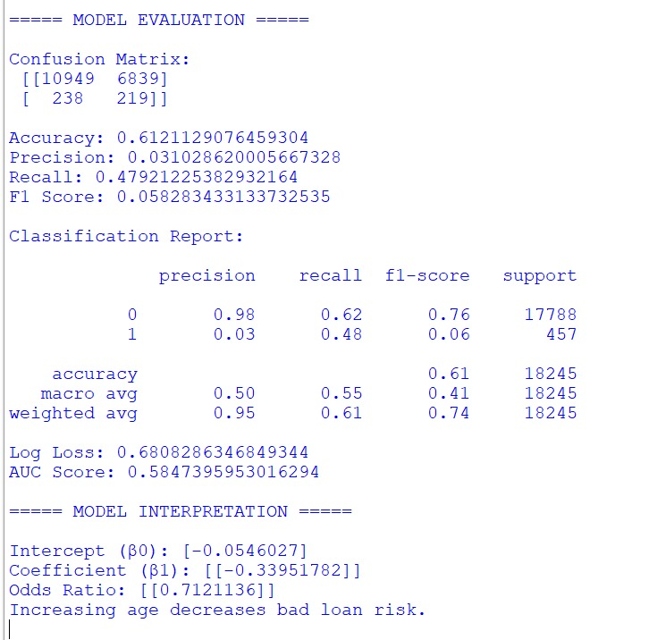

7. Future Scope
Future improvements can include adding more relevant features such as income level, credit score, employment status, and loan amount. Advanced machine learning models like Random Forest, Support Vector Machine, or Gradient Boosting can also be explored to improve predictive accuracy.

