University of Sialkot
Department of Software Engineering
Local Store Inventory Management System
Backend-Side Architecture Report — Semester Project, Deliverable 2
Student Name: M.Faizan , Laiba Naveed
Roll Number: 23010101-116, 23010101-116
Instructor: Museb Khalid
July 2026

ABSTRACT
This report documents the client-side architecture of the Local Store Inventory Management System, developed as Deliverable 1 of the semester project. The frontend is implemented using Vue 3 and Vite, and is organized around three core pillars: Single Page Application (SPA) routing via Vue Router, a modular and reusable component hierarchy, and structured inter-component communication using props and custom events. The report presents the project's directory structure, the routing configuration and navigation guards, representative code snippets demonstrating props and $emit usage, and screenshots of the interface running on localhost. Backend integration (Express.js and MongoDB) is outside the scope of this deliverable and will be addressed in a later phase; a minimal API layer was used here only to validate the frontend data flow during local testing.
Index Terms—Vue 3, Vite, Vue Router, Single Page Application, Component-Based Architecture, Props, Custom Events.

I. INTRODUCTION
Modern web applications increasingly rely on Single Page Application (SPA) frameworks to deliver fast, app-like user experiences without full page reloads. For this semester project, the Local Store Inventory Management System was designed to help a small retail store manage products, categories, suppliers, stock movements, and sales, alongside reporting features for inventory, sales, and purchases.
This first deliverable focuses exclusively on the client-side (frontend) architecture. It was built using Vue 3 with the Composition API and Vite as the build tool. The objective was to fully architect and implement the frontend before backend services are introduced in a later deliverable. To validate data flow during development, the interface was connected to a lightweight Express.js and MongoDB backend; however, that backend is not part of the graded scope of this report and is mentioned only where it clarifies how the frontend consumes data.
The remainder of this report is organized as follows. Section II outlines the technology stack. Section III presents the project directory structure and component architecture tree. Section IV describes SPA routing using Vue Router. Section V explains the modular component hierarchy. Section VI demonstrates inter-component communication through props and custom events. Section VII provides screenshots of the running application, and Section VIII concludes the report.

II. TECHNOLOGY STACK
The client-side application was built using the following technologies:
- Vue 3 — core UI framework, used with the Composition API (<script setup>) for concise, type-safe component logic.
- Vite — development server and build tool, providing fast hot-module-reload during development.
- Vue Router 4 — handles all client-side navigation and route-level access control.
- Axios — a thin wrapper (src/api/axios.js) used to centralize HTTP requests and error-message handling.
- Plain CSS (component-scoped style blocks) — used for layout, card components, and the dashboard/table styling seen in the screenshots.
This stack was chosen because it keeps the frontend fully decoupled from the backend: every view communicates with the server only through the api module, so the backend implementation (to be completed in the next deliverable) can change without requiring changes to component logic.

III. PROJECT DIRECTORY STRUCTURE (ARCHITECTURE TREE)
Fig. 1 shows the schematic component/directory tree of the frontend. Two folders drive the architecture: components/, which holds small reusable UI pieces shared across pages (e.g., Sidebar, Navbar, AddProductForm, ProductRow), and views/, which holds one top-level component per route (e.g., Dashboard, Products, Categories). This separation keeps page-level logic (data fetching, state) in views/ while components/ stays presentational and reusable.

Frontend/
├─ index.html
├─ package.json
└─ src/
├─ main.js
├─ App.vue
├─ api/
└─ axios.js
├─ router/
└─ index.js
├─ stores/
├─ components/
├─ Sidebar.vue
├─ Navbar.vue
├─ AddProductForm.vue
└─ ProductRow.vue
└─ views/
├─ Login.vue
├─ Dashboard.vue
├─ Products.vue
├─ Categories.vue
├─ Suppliers.vue
├─ StockIn.vue
├─ Sales.vue
├─ InventoryReport.vue
├─ SalesReport.vue
├─ PurchaseReport.vue
├─ Users.vue
├─ Settings.vue
└─ Profile.vue
Fig. 1. Frontend directory structure and Vue component hierarchy.
Fig. 2 confirms the same structure as seen directly in the code editor during development, alongside the components/ and views/ folders.
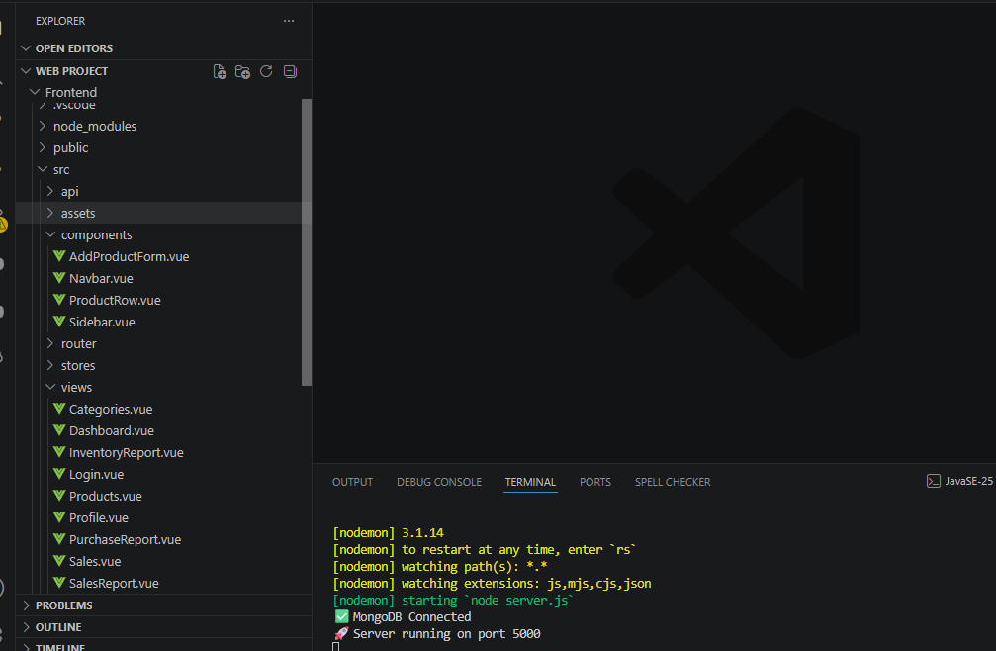
Fig. 2. Project explorer showing the Frontend/src directory (components, router, stores, views).

IV. SPA ROUTING WITH VUE ROUTER
Vue Router is configured in src/router/index.js using createRouter and createWebHistory, giving the application clean, history-based URLs without a trailing hash. Each route is lazily loaded via a dynamic import (e.g., () => import("../views/Dashboard.vue")), which splits the production build into smaller chunks and improves initial load time. Route metadata (meta.requiresAuth, meta.guestOnly) is attached per route and drives a global navigation guard.
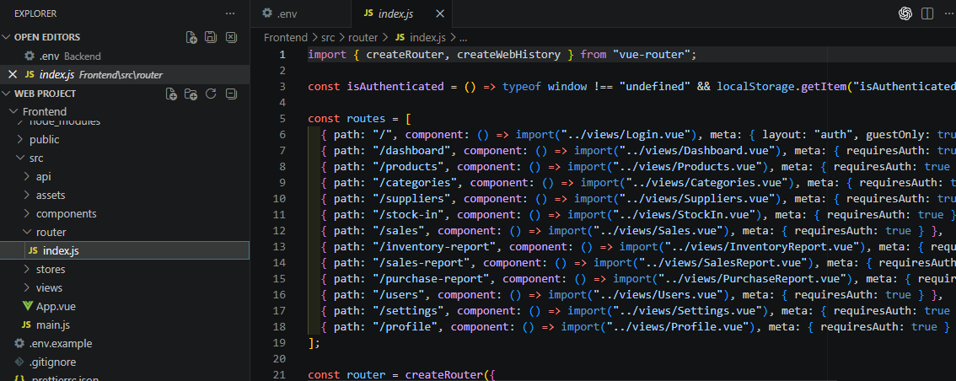
Fig. 3. Route table in router/index.js, mapping each URL path to its view component and access-control metadata.
A router.beforeEach navigation guard (Fig. 4) inspects this metadata on every navigation: authenticated-only routes redirect an unauthenticated user back to the login page, while guest-only routes (such as the login page itself) redirect an already-authenticated user forward to the dashboard. This keeps access-control logic in a single, centralized place rather than duplicated inside individual views.
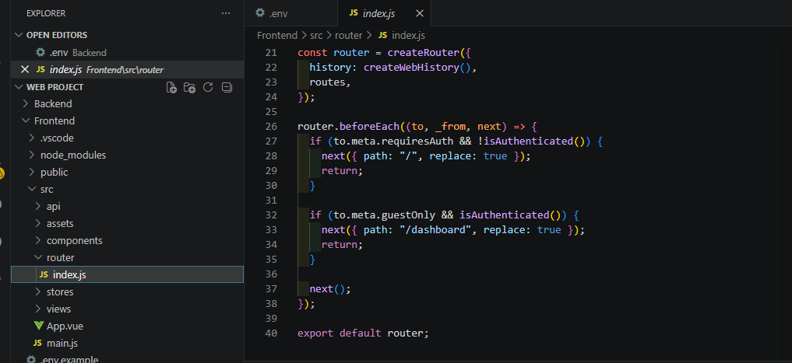
Fig. 4. Global navigation guard enforcing requiresAuth and guestOnly rules before each route change.
Layout wiring is handled in App.vue (Fig. 5). A single <router-view> uses the v-slot="{ Component }" pattern so the resolved component can be rendered dynamically with <component :is="Component">, while shared layout elements — <Sidebar /> and <Navbar /> — wrap every authenticated view. Guest views (such as Login) render without the sidebar/navbar via a v-else branch, since App.vue also reacts to the current route's layout metadata.
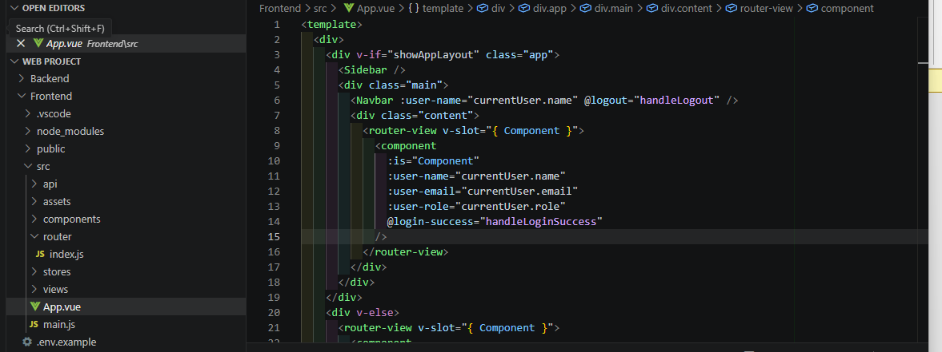
Fig. 5. App.vue: root layout combining RouterView, the persistent Sidebar/Navbar, and props passed down to the active view.
Every view listed in Fig. 3 is reachable through the Sidebar's <RouterLink> entries (visible in Fig. 2/Fig. 8 as Dashboard, Products, Categories, Suppliers, Stock In, Sales, Inventory Report, Sales Report, Purchase Report, Users, Settings, and Profile), giving the application a complete, navigable SPA structure with no full-page reloads.

V. MODULAR COMPONENT ARCHITECTURE
The UI is deconstructed into a small set of reusable components/ and a larger set of route-level views/, summarized in Table I. This keeps each .vue file focused on a single responsibility: reusable components hold no routing knowledge, and views own the data-fetching and page-level state.
TABLE I
Component Inventory and Responsibilities
Component | Type | Responsibility
Sidebar.vue | Reusable | Persistent left-hand navigation menu (RouterLink list) shown on every authenticated page.
Navbar.vue | Reusable | Top bar showing search box, current user name (prop) and a Logout button (emits logout).
AddProductForm.vue | Reusable | Self-contained form for creating a product; emits add-product with the new product payload.
ProductRow.vue | Reusable | Renders one product's row in the products table; receives product fields as props and emits delete.
Dashboard.vue | View | Landing page after login; displays summary cards (total products, low stock, sales, profit).
Products.vue / Categories.vue / Suppliers.vue | View | CRUD pages for the core inventory entities; each composes the reusable form/row components above.
StockIn.vue / Sales.vue | View | Record stock-in and sales transactions.
InventoryReport.vue / SalesReport.vue / PurchaseReport.vue | View | Read-only reporting pages.
Login.vue / Users.vue / Profile.vue / Settings.vue | View | Authentication and account-management pages.
Views compose reusable components rather than duplicating markup. For example, Products.vue (Fig. 7) composes AddProductForm and iterates ProductRow for every product returned by the API, while Categories.vue (Fig. 6) manages its own local list state and calls the API directly since it has no reusable child components.

VI. INTER-COMPONENT COMMUNICATION (PROPS & EMITS)
A. Props — Parent to Child
Props carry typed, read-only data down the component tree. Dashboard.vue (Fig. 6) declares its inputs with defineProps({ userName: { type: String } }), so the same component can display any user's name without hard-coding it. Categories.vue similarly manages local reactive state (name, list, loading) using ref() from the Composition API and requests data from the API layer.
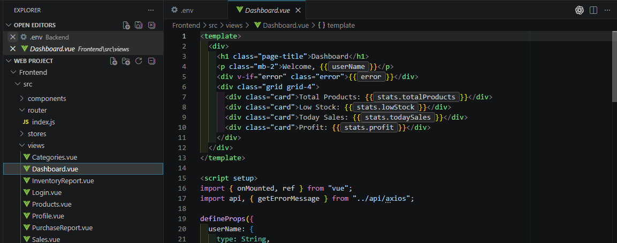
Fig. 6. Dashboard.vue: typed props declared with defineProps and consumed via {{ userName }} in the template.
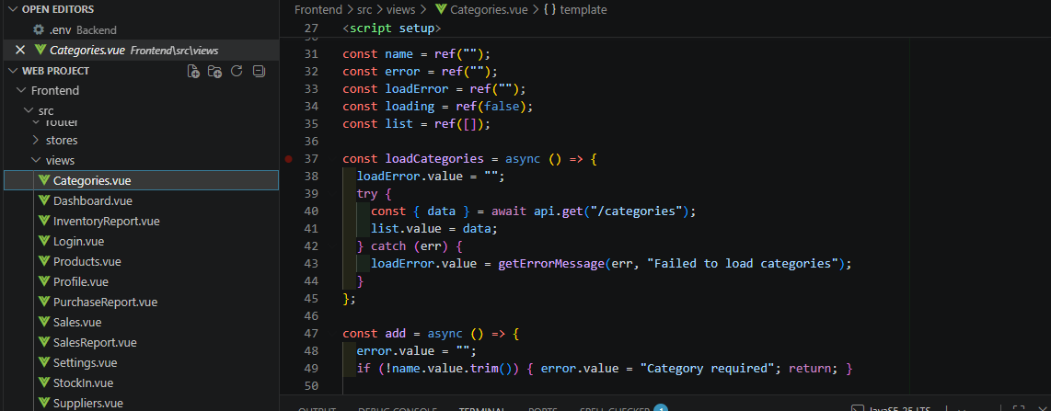
Fig. 6b. Categories.vue: local reactive state (ref) and an async loadCategories() call to the API layer.
At the top of the tree, App.vue (Fig. 5) forwards currentUser.name, currentUser.email and currentUser.role as props into whichever view is currently active, so every view receives consistent identity data without each view fetching it independently.
B. Custom Events — Child to Parent
Custom events ($emit) let a child notify its parent that something happened, without the child needing to know what the parent will do about it. Login.vue (Fig. 7) declares const emit = defineEmits(["login-success"]) and, after a successful API call, emits login-success so the parent (App.vue) can update the authenticated user and redirect. Products.vue (Fig. 8) listens for @add-product on <AddProductForm> to receive a new product payload, and for @delete on each <ProductRow> to remove that specific product — both handled by parent methods (handleAddProduct, removeProduct(p._id)).
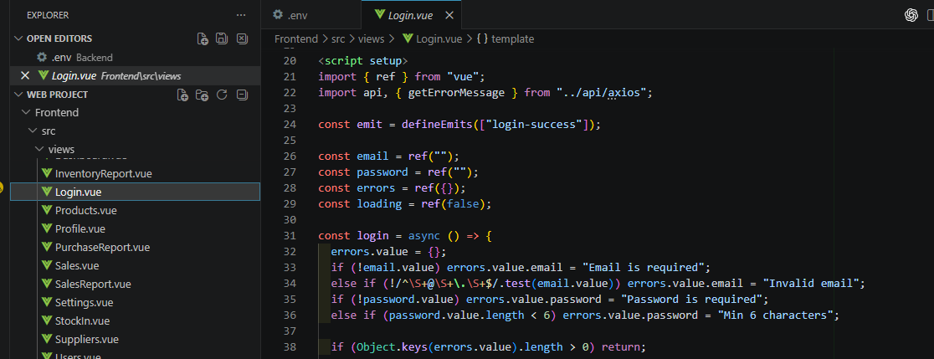
Fig. 7. Login.vue: defineEmits(["login-success"]) declares the event this component can send upward.
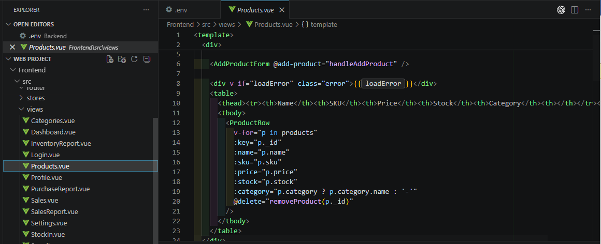
Fig. 8. Products.vue: @add-product and @delete listeners wiring child events to parent handlers.
This props-down / events-up pattern is applied consistently across the application, keeping data flow predictable and each component independently testable.

VII. APPLICATION SCREENSHOTS
The following figures show the application running locally (localhost) with a shared Sidebar/Navbar layout and live data returned from the API layer.
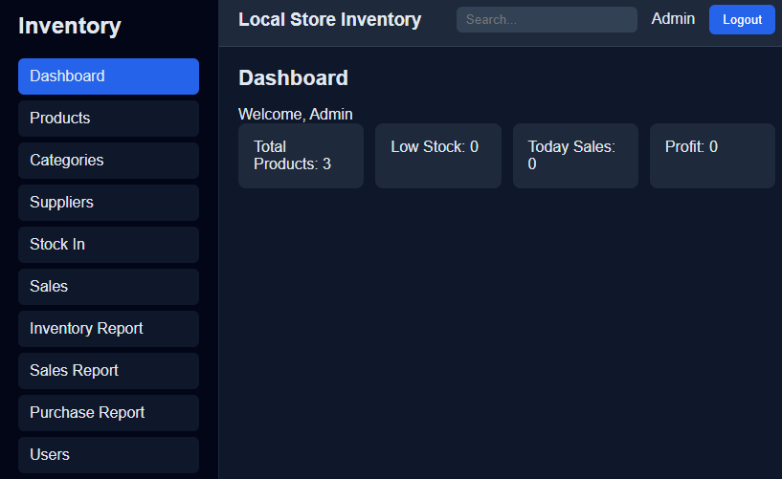
Fig. 9. Dashboard view — summary cards for total products, low stock, today's sales and profit.
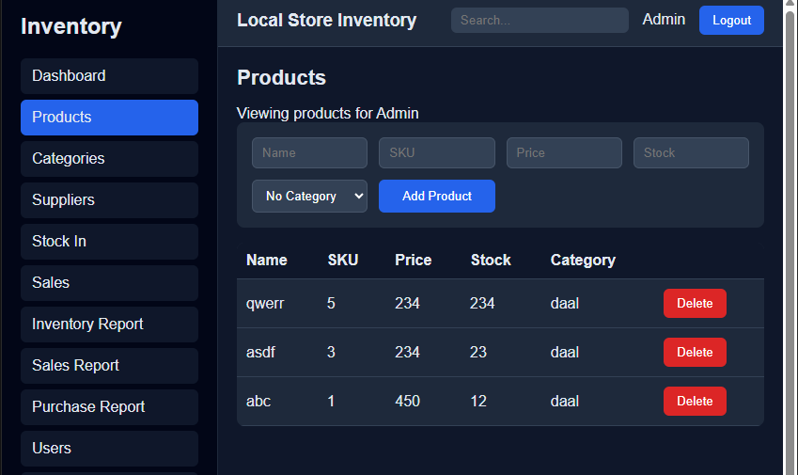
Fig. 10. Products view — filter fields, category dropdown, and the products table rendered via ProductRow.
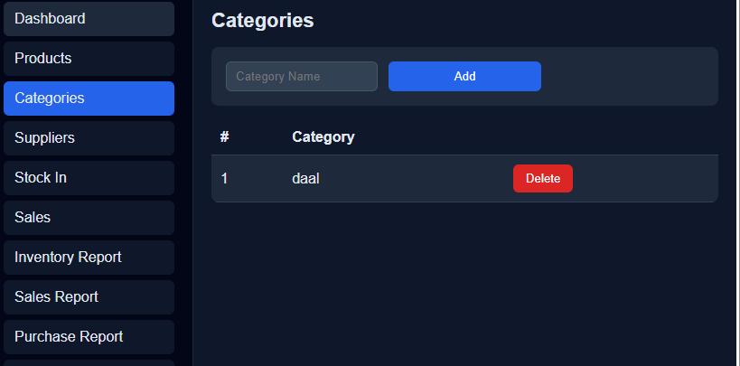
Fig. 11. Categories view — add-category form and category list with delete action.
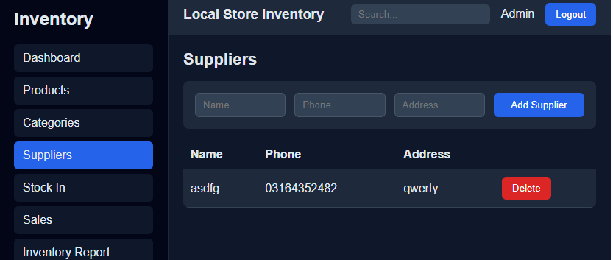
Fig. 12. Suppliers view — add-supplier form and supplier list, following the same CRUD layout pattern.
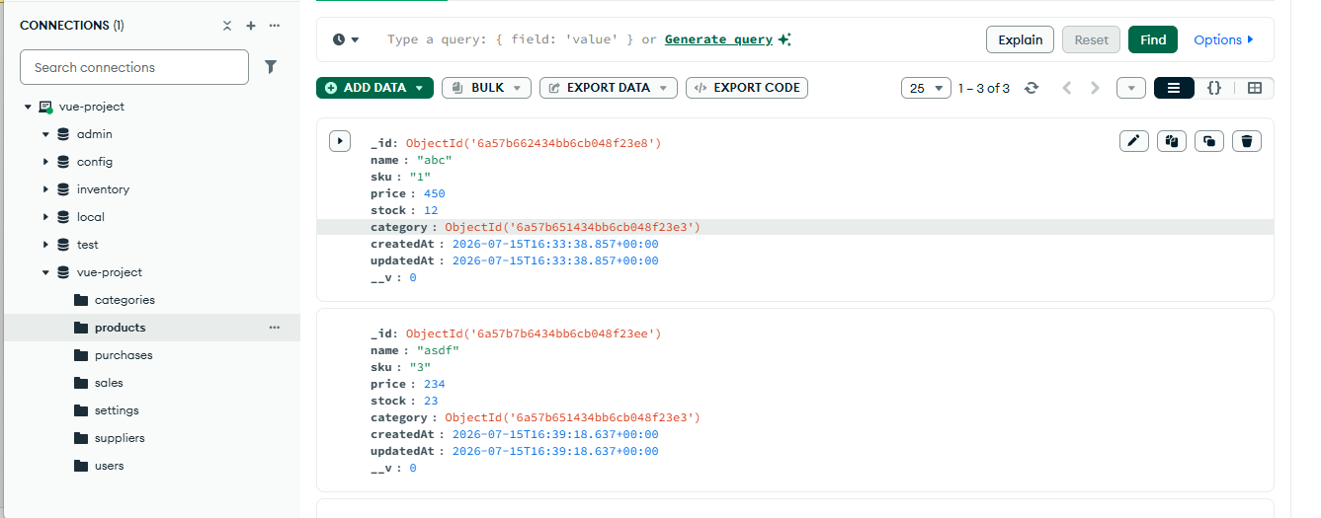
Database ScreenShot:

Fig. 13. Products view — filter fields, category dropdown, and the products table rendered via ProductRow,also change in change data in databse.
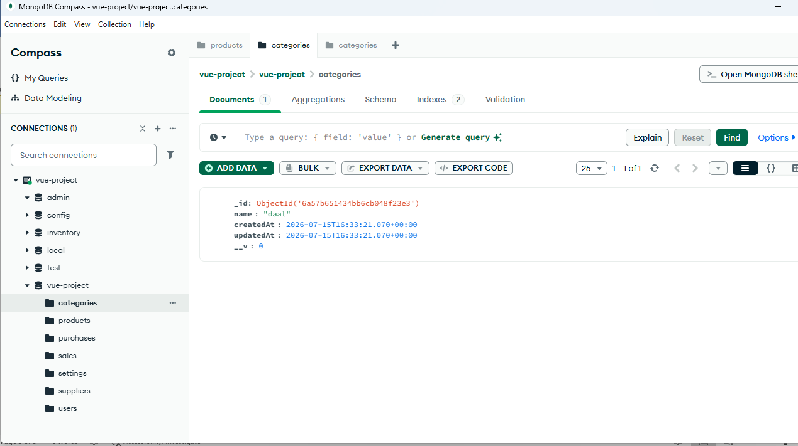

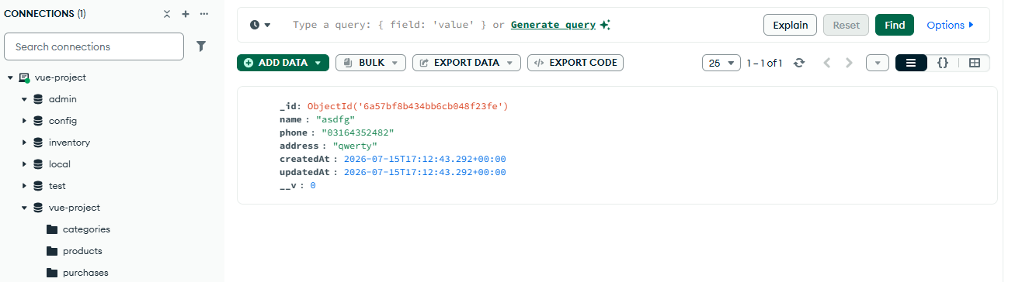
Fig. 14. Categories view — add-category form and category list with delete action, also change in data in database

Fig. 15. Suppliers view — add-supplier form and supplier list, following the same CRUD layout pattern
VIII. CONCLUSION
This deliverable establishes a complete, working client-side architecture for the Local Store Inventory Management System using Vue 3 and Vite. SPA routing is centralized in Vue Router with metadata-driven navigation guards; the UI is decomposed into a small library of reusable components and a larger set of route-level views; and every parent-child relationship follows a consistent props-down / emits-up communication pattern. Together, these choices produce a frontend that is modular, predictable to extend, and ready to be connected to the Express.js and MongoDB backend in the next project phase.

REFERENCES
[1] Vue.js Documentation, "Introduction," vuejs.org. [Online]. Available: https://vuejs.org/guide/introduction.html
[2] Vue Router Documentation, "Getting Started," router.vuejs.org. [Online]. Available: https://router.vuejs.org/guide/
[3] Vite Documentation, "Getting Started," vitejs.dev. [Online]. Available: https://vitejs.dev/guide

