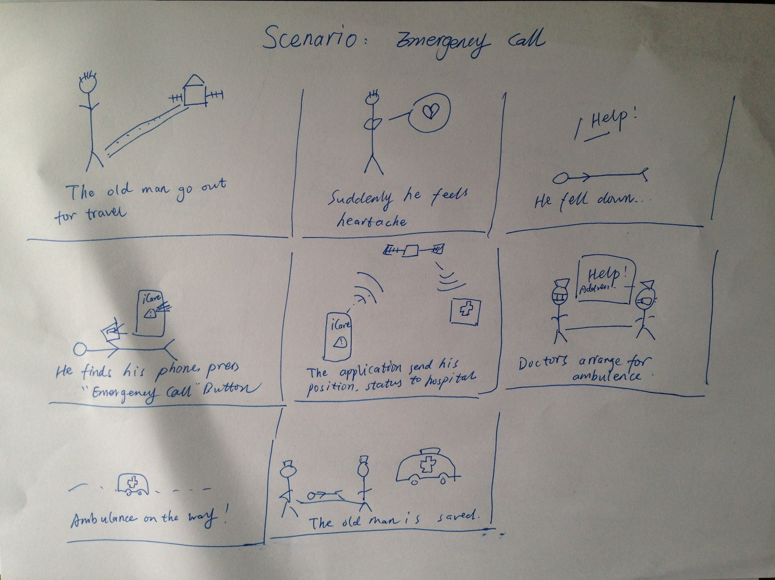

Scenario 1: Emergency Call

Before:

One day, an old man want to go to a park. He need to walk for half an hour. After he leave his house, he felt heartache suddenly, and he felt on ground. But he can’t find anyone who can help him. He took out his phone.

During:

He pressed the red button “Emergency” on the phone screen, then the phone begin to make loud sound and send signal to local hospital.

After:

The local hospital got the message with location and basic information of this old man. An ambulance came in 2 minutes and the old man got saved. The old man thanked this application a lot.

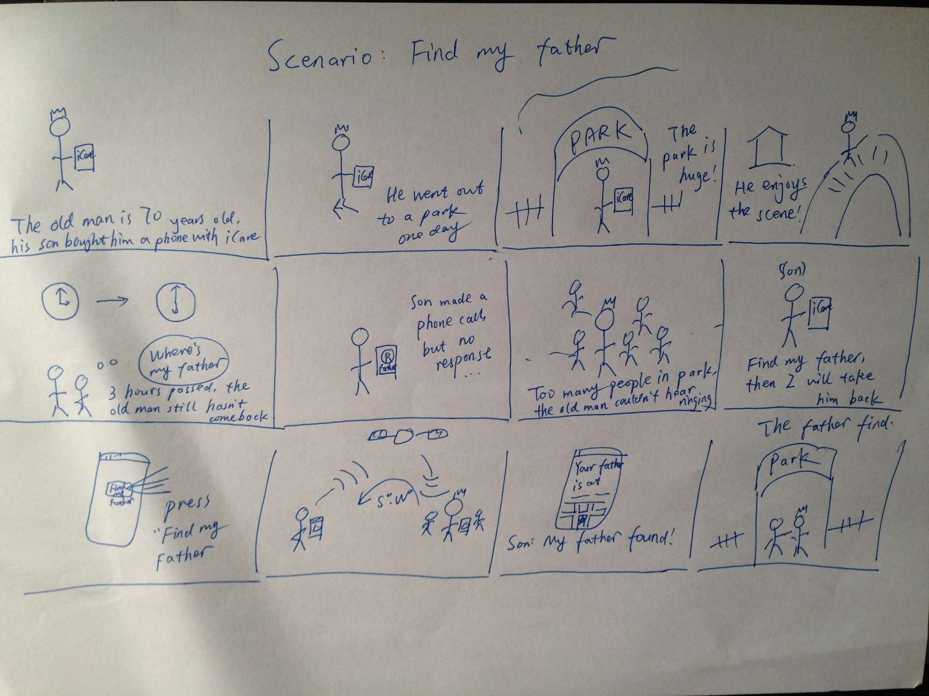

Scenario 2: Find my lost father

Before:

Today is National Day holiday, many people went to Zhongshan Park. One old man went to the park without telling his son who are still work today. But there are too many people in the park, and the park is really huge, the old man couldn’t find his position and go back home. When his son came back from his company, he couldn’t find his father. Then he took out his phone.

During:

The son opened the “iCare”, the application showed that his father has went out with cellphone. Then he pressed button “Get father’s location”. Several minutes later, the phone shows that his father is in the center of the park. Then he driven his car to park.

After:

When the son arrived to the park, his cellphone kept telling him the location of his father every 30 seconds. The lost father was found after several minutes. Both the father and son felt calm and appreciate this application.