BUILDING 1 AND BACKBONE
Elena Molero Padilla-1230112

- MEASURES:
-Private Area of the buildings:
If we take a look of the Legend, 20 meters real world=0,008 meters papper.
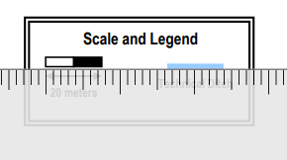

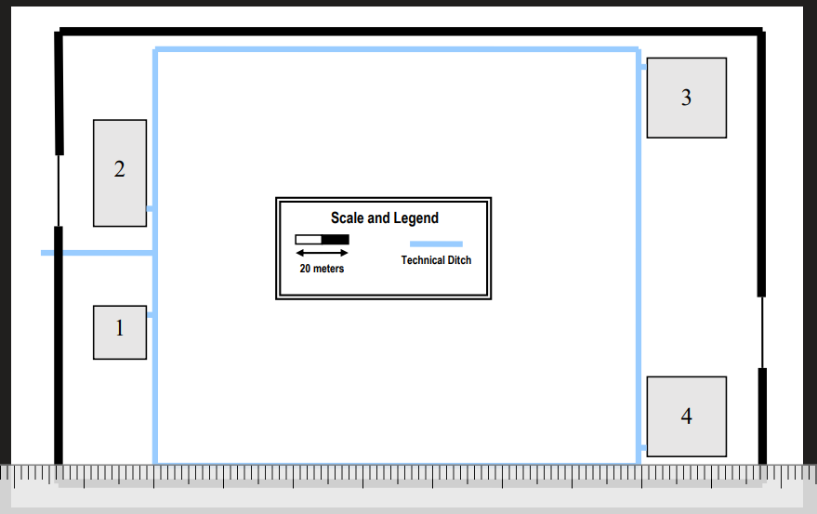
X meters in real world = 0,070 meters papper so, doing math calculations, X = 175meters in real world. Following this rule, we get:
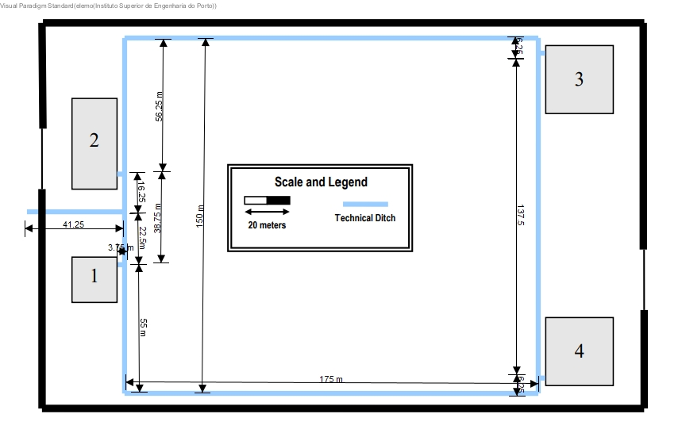

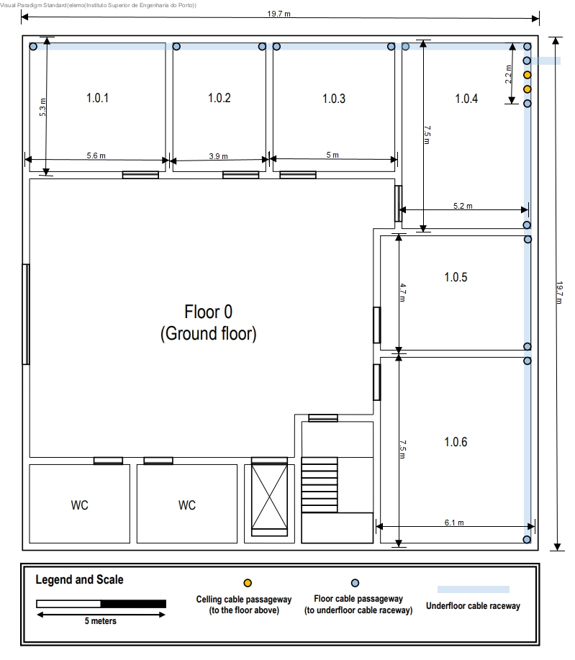
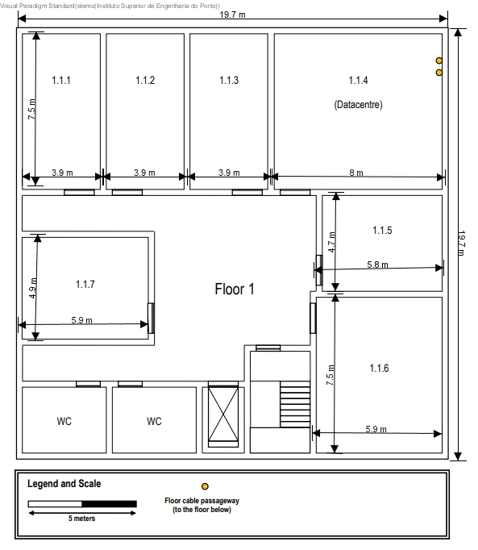
- Outlets
We have to keep in mind:
-2 outlets in 10m2
-Wherever the user equipment is, there should always be an outlet less than three meters away.
-Common areas, like the entrance hall, restrooms, and stairs, require no network outlets.

FLOOR 0
ROOM | LENGHT(m) | WIDTH(m) | AREA(m2) | OUTLETS(u)
1.0.1 | 5.3 | 5.6 | 29.68 | 6
1.0.2 | 5.3 | 3.9 | 20.67 | 6
1.0.3 | 5.3 | 5 | 26.5 | 6
1.0.4 | 7.5 | 5.2 | 39 | 8
1.0.5 | 4.7 | 6.1 | 28.67 | 6
1.0.6 | 7.5 | 6.1 | 45.75 | 10
 |  |  | TOTAL | 42

FLOOR 1
ROOM | LENGHT(m) | WIDTH(m) | AREA(m2) | OUTLETS(u)
1.1.1 | 7.5 | 3.9 | 29.25 | 6
1.1.2 | 7.5 | 3.9 | 29.25 | 6
1.1.3 | 7.5 | 3.9 | 29.25 | 6
1.1.4 | 7.5 | 8 | 60 | 12
1.1.5 | 4.7 | 5.8 | 27.26 | 6
1.1.6 | 7.5 | 5.9 | 44.25 | 10
1.1.7 | 4.9 | 5.9 | 28.91 | 6
 |  |  | TOTAL | 52

We will represent the outlets as pink circles. Now it is time top ut each oulet in its side. Keep in mind the rules, the end-user has to be able to connect his equipment with an outlet with les tan 3 meters of distance.
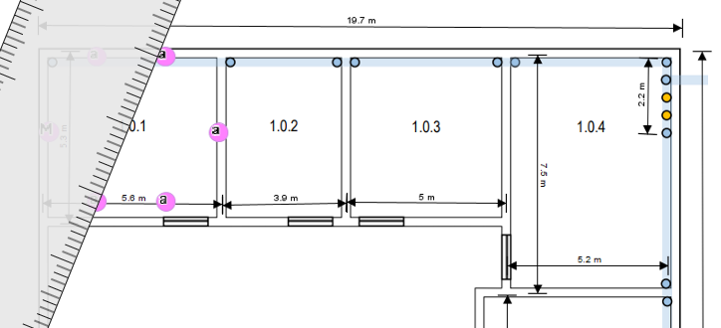
Here, we are taking measures, to be sure that, in the center of the room, you can be connect to an oulet in les than 3 meters.

- ACCESS POINTS:
Grant approximately a 50 meters diameter circle coverage in a Awireless 802.11 local area, so we Will use one for each floor of building 1, since the área is aprox=20x20m2.
As soon as the signal is longer, it could became weaker. For this reason, in the floor 0 is better not to put the Access point in the middle of its, since there are more rooms in the top-right.

- CONSOLIDATION POINTS:
We can use them if it is neccesary to have flexibility to adapt to the future, but they are not mandatory. In fact, we have to untwist cables each time we colocate one of them so, although we can use them, we don’t have to look for use them. However, having them, it is easier to reubicate the position of equipments.
We will use 2 of them in the floor 0 for the farest outlets. This building doesn’t have too much big sizes but we don’t have an especific room to colocate the patch pannels, so maybe is better to have distribuited the telecommunication enclousures. Moureover, in case of reubication, we don`t have to change too much cable. So in this case it could worth it.
In the floor 1 we have the data centre room, where we will host the MCC, ICC and HCC, so it is no problem to have more patch pannels there. Moureover, the size of the floor is not too big, so in this case we will use only one consolidation point.

- PATCH PANELS:
For cooper patch panels we will use ISO 8877 female connector. To connect the cooper cable we will use T-568A, since it has also more compatibility with old equipments.
FLOOR 0
For the consolidation point of the room 1.0.2, we will need a cooper patch panel with 24 ports, to conect 15 outlets and the conection with the HCC.
For the HCC we will need a a cooper patch panel with 24 ports, to connect 17 outlets + 1 access point + 2 CP + the conection with the ICC.
Fort he ICC we will need a fiber optic patch panel with 12 ports, to connect ICC with HCC.
For the consolidation point of the room 1.0.6, we will need a cooper patch panel with 12 ports, to conect 10 outlets + the conection with the HCC.
FLOOR 1
For the consolidation point of the room 1.1.1, we will need a cooper patch panel with 24 ports, to conect 18 outlets and the conection with the HCC.
Fort he HCC we will need a cooper patch panel with 48 ports, to connect 34 oulets + 1CP + 1access point + connection with the ICC.
Fort he ICC we will need a fiber optic patch panel with 12 ports, to connect ICC with HCC.
Fort he MCC we will need a fiber optic patch panel with 12 ports, to connect ICC with MCC( 2 cables) + 6 fibre optic cables to provide the other buildings.

- TELECOMMUNICATION ENCLOUSURES:
We have to keep in mind that we will measure in U rack units (1.75’’/44.45 mm). Typical CAT7 24 ports patch panels have 1U size. The total size in the building is 30 U.
FLOOR 0
For the consolidation point of the room 1.0.2:
(1 U (24 ports patch panel)+ 1U hardware equipment) x2(to keep in mind future changes)= 4 U
For the HCC:
(1 U (24 ports patch panel)+ 1U hardware equipment) x2(to keep in mind future changes)= 4 U
For the consolidation point of the room 1.0.6:
( 0.5 U (12 ports patch panel)+ 1U hardware equipment) x2(to keep in mind future changes)= 3 U
For the ICC:
( 0.5 U (12 ports patch panel)+ 1U hardware equipment) x2(to keep in mind future changes)= 3 U
FLOOR 1
For the consolidation point of the room 1.1.1:
(1 U (24 ports patch panel)+ 1U hardware equipment) x2(to keep in mind future changes)= 4 U
For the HCC:
(2 U (48 ports patch panel)+ 1U hardware equipment) x2(to keep in mind future changes)= 6 U
For the ICC:
( 0.5 U (12 ports patch panel)+ 1U hardware equipment) x2(to keep in mind future changes)= 3 U
For the MCC:
( 0.5 U (12 ports patch panel)+ 1U hardware equipment) x2(to keep in mind future changes)= 3 U

- PATCH-CORDS (0.5 m):
Optical fibre and copper CAT7 patch cords required for each
telecommunication enclosure equals the number of patch panel ports in each.
Patch cords for enclosures should be short length, usually 0.5 meters is enough. For the ports that would be in use:
FLOOR 0:
16 + 21 + 1 +11 = 49 ud;
48 x 0.5 = 24 m of cooper cable
48 x 2 (male ISO 8877 connector on each end) = 96 uds male conectors
1 x 0.5 = 0.5 m of optic fiber
2uds male fibre conectora
FLOOR 1:
19 + 37 + 1 +8 =64 ud;
1(ICC con HCC) + 2 (ICC con MCC) + 6 (to conect the buildings) = 9 uds. Optic fibre cable = 9 x 0.5 = 4.5 m optic fibre cable
16 uds male optic fibre conectors
55 x 0.5 = 27.5 m cooper cable
55 x 2 =110 uds male cooper conectors

- USER-CORDS(5 m):
They are used to connect end user equipment to work area outlets.
FLOOR 0
42outlets x 5 m = 210 m cooper cable
42 outlets x 2(male conectors) = 84 uds cooper cable male conectors
FLOOR 1
52 outlets x 5 m = 260 m cooper cable
52 outlets x 2 (male conectors)= 104 uds cooper cable male conectors

- CABLES:
-CAMPUS BACKBONE:
About the optical fiber cables, we have selected monomode fiber cables. It is better to build a system in which you can trust that it will work and adapt to the future, so although it would be more expensive, and we won’t work with so many long distances, we have prefer to select monomode, to guarantee that dispersión won’t never be a problem.
The optic fiber conection chosen is the LC conector, because they have a small size and they are one of the most used globaly. We Will use the UPC (Ultra-Physical Contact) to polish, sice is the most used for structed cabling.
We Will also use double cable throuwing different paths, having redundancy but being sure that we Will be prepare in case of having any interruption.
We have to check this:
Cables connecting an intermediate cross-connect (IC) to a horizontal crossconnect (HC) are limited to 500 meters long, and cables connecting the main
cross-connect (MC) to an IC are limited to 1500 meters long.
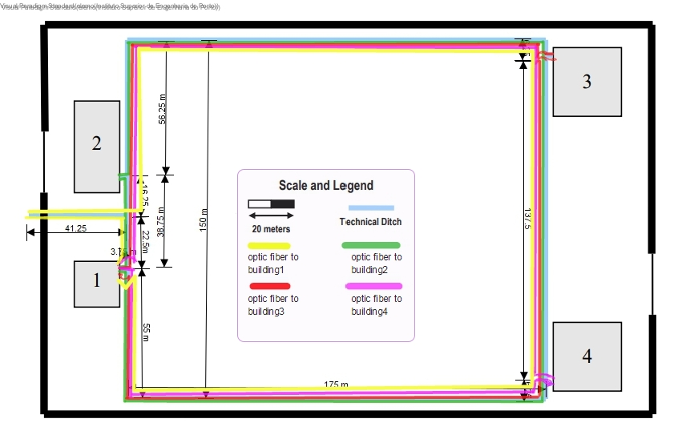
Cables measure Campus Backbone:
The MCC is in the floor 1 of the building 1, so first we calculate the distance from the patch panel to the outside of the building 1:
0.5 m from the telecommunication enclousure to the floor + 1.5 m from the floor to the cable passway + 4 m of ceiling heigh of floor 0 + 0 m of underground (I CAN’T SEE THE MEASURE OF THE UNDERGROUND SO I GUESS IT IS VERY LITTLE)
= 6 m optic fiber cable
Keeping this in mind, from building 1 to building 2:
Path 1: 6 m (to go out the building 1) + 3.75 m + 38.75 m + 3.75 m + 6.4 m(inside the building 2) + 2 m to be connected with the ICC = 60, 65 m optic fibre cable
Path 2: 6 m (to go out the building 1) + 3.75 m + 55 m + 175 m + 6.25 m + 137.5 m + 6.25 m +175 m + 56.25 m + 3.75 m + + 6.4 m(inside the building 2) + 2 m to be connected with the ICC = 633.15 m optic fiber cable
From building 1 to building 3:
Path 1: 6 m (to go out the building 1) + 3.75 m + 38.75 m + 56.25 m + 175 m + 6.25 m + 3.75 m + 49.7 m (inside building 3) + + 2 m to be connected with the ICC = 351.45 m optic fiber cable
Path 2: 6 m (to go out the building 1) + 3.75 m + 55 m + 175 m + 6.25 m + 137.5 m + 3.75 m + 49.7 m (inside building 3) + + 2 m to be connected with the ICC = 438.95 m optic fiber cable

From provider (ISP) to building 1:
Path 1: 41.25 m + 22.5 m + 3.75 + 6m + 0,5 m to be connected with the ICC = 74 m optic fiber cable
Path 2: 41.25 m + 16.25 m + 56.25m + 175 m + 6.25m + 137.5 m + 6.25 m + 175 m + 55 m + 3.75 m + 6 m + 0,5 m to be connected with the ICC = 679 m optic fiber cable
Although I did the drawing showing how could we go to building 4, I won’t calculate, since we are a team with 3 members.

-INTERMEDIATE CROOS-CONNECTING
We will need 0.5 m of optic fiber cable and 0,5 of cooper cable
to conect to the HCC and the ICC in each floor. The ICC act like a distribution point to both type of cables
We will connect the ICC of the floor 1 with the ICC of the floor 0 with 2 paths:
Path 1: 1m + 4m of the ceiling heigh + 0.5 m = 5.5 m optic fiber cable
Path 2: 1m + 4m of the ceiling heigh + 1 m = 6 m optic fiber cable
TOTAL cooper cable: 1 m
TOTAL optic fiber cable: 12.5 m

-HORIZONTAL CROSS-CONECTING:
Optical fibre should be used everywhere but, as end-user equipment is not usually prepared for optical fibre outlets, this on horizontal cabling CAT7 copper Will be a Good option. We have selected CAT7 instead of CAT6 because this last one is limited to 1 Gbps.
Keep in mind:
- The total area covered by an horizontal cross-connect should be less tan 1000 m2.
- Each cable (whatever type) length should be less than 90 meters.
- Straight line distance between the horizontal cross-connect and the outlet
should be less than 80 meters.
FLOOR 0
TOTAL 353.2 m
Cables connected to the HCC:
-ROOM 1.0.4:
(counterclockwise from the HCC)
Outlet1: 0.5 m (from the HCC to the cable passway) + 0.55 m (to the top right corner) + 1.67 m = 2.72 m
Outlet2: 2.72m + 1.11 m = 3.83 m
Outlet3: 3.83m + 1.67 m + 1.67 m = 7.16 m
Outlet4: 7.16m + 3.89 m = 11.05 m
(clockwise from the HCC)
Outlet5: 0.5 m (from the HCC to the cable passway) + 1.10 m = 1.6m
Outlet6: 1.6 m + 3.06 m= 4.66 m
Outlet7: 4.66 m + 3.33 m(to the corner) + 1.67m = 9.66 m
Outlet8: 9.66m + 2.78m = 12.44 m
-ACCESS POINT:
12.44 m + 4.17m = 16.61 m
-ROOM 1.0.5:
Outlet1: 7.99m (to the corner) + 0.5m + 1.8m= 10.29 m
Outlet2: 10.29m +2.85 m = 13.14 m
Outlet3: 7.99m (to the corner) +0.5m + 8.45 m = 16.94 m
Outlet4: 7.99m (to the corner) +0.5m + 2.35 m = 10.84 m
Outlet5: 10.29 m + 4.7 m = 14.99 m
Outlet6: 13.14 m + 4.7 m = 17.84 m
-ROOM 1.0.3:
Outlet1: 0.5 m (from the HCC to the cable passway) + 0.55 m (to the top right corner) + 5.2 m + 1.77 m = 8.02 m
Outlet2: 8.02m + 1.77 m = 9.79 m
Outlet3: 9.79 m + 1.77 m + 2.5 m = 14.06 m
-CONSOLIDATION POINT ROOM 1.0.2:
5.2 m + 5 m + 3.9 m = 14.1 m
-CONSOLIDATION POINT ROOM 1.0.6:
7.5 m + 4.7 m = 12.2 m
Cables connected to the consolidation point room 1.0.2
-ROOM 1.0.1:
Outlet1: 1.87 m
Outlet2: 1.87 m + 1.87 m = 3.73 m
Outlet3: 3.73 m + 2,65 m = 6.38 m
Outlet4: 6.38 m + 2.65 m + 1.87 m = 10.9 m
Outlet5: 10.9m + 1.75 m = 12.65 m
Outlet6; 2.65 m
-ROOM 1.0.2:
Outlet1: 1.76 m
Outlet2: 1.76 m + 1.76 m = 3.53 m
Outlet3: 5.3 m + 1.95 m = 7.25 m
Cables connecter to the consolidation point room 1.0.6
-ROOM 1.0.6:
Outlet1: 2.03 m
Outlet2: 2.03m + 2.03 m = 4.06 m
Outlet3: 1.88 m
Outlet4: 1.88m + 1.88m = 3.75 m
Outlet5: 3.75m + 1.88 m = 5.63 m
Outlet6: 5.63m + 1.88 m + 2.03 m = 9.54 m
Outlet7: 9.54m + 2.03 m = 11.57 m
Outlet8: 11.57 m + 2.03 m + 1.88m = 15.48 m
Outlet9: 15.48 m + 1.88 m = 17.36m
Outlet10: 17.36 m + 1,88m = 19.24 m



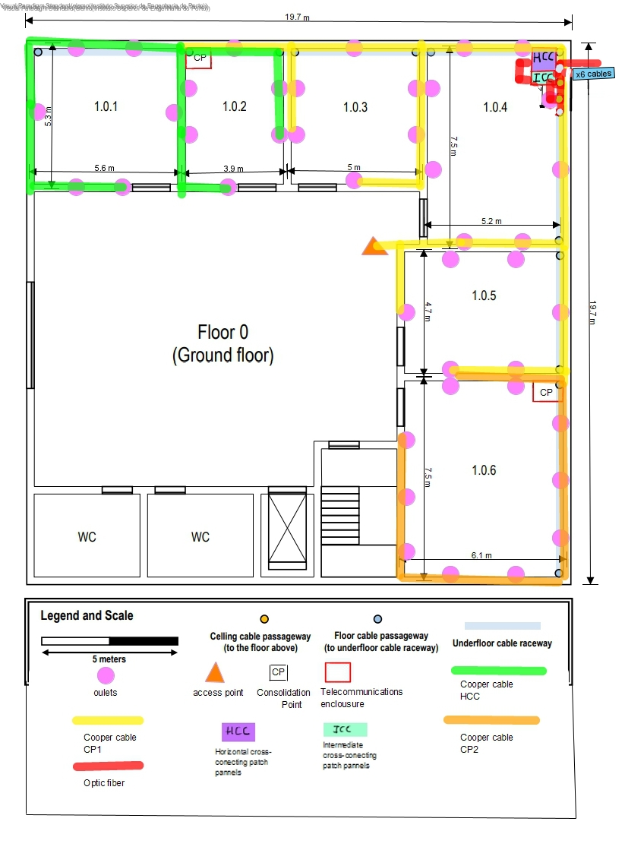

FLOOR 1
As we have a removable droped ceiling from 2.5 meters from the ground, we have installed cable raceway there, and we have done some holes to pass the cables. This way, cables are more protected and aesthetic. TOTAL OF THE RACEWAY : 64.35 m
TOTAL: 971.23 m
Conections with the HCC
-ROOM 1.1.4:
(counterclockwise from the HCC)
Outlet1: 1m + 1.875 m + 2m = 4.875 m
Outlet2: 4.875 m + 2m = 6.875 m
Outlet3: 6.875 m +2 m= 8.875 m
Outlet4: 1 m from the HCC to the wall + 2*2.5 to the dropped ceiling + 8.875 m + 2m + 1.875 m = 18.75 m
Outlet5: 18.75 m + 1.875 m = 20.63 m
Outlet6: 20.63 m + 1.875 m = 22.5 m
(clockwise from the HCC)
Outlet7: 1m + 1,875 m = 2.875 m
Outlet8: 2.875 m + 2m = 4.875 m
Outlet9: 1 m from the HCC to the wall + 2*2.5 to the dropped ceiling + 4.875m +1.5m + 2.67 m = 15.05 m
Outlet10: 15.05m + 2.67 m =17.72 m
Outlet11: 15. 05 m + 1.34 m + 2.4 m = 18.79 m
Outlet12: 18.79m + 2.5 m = 21.29 m
-ACCESS POINT:
22.5 m + 1.8 m + 2.45 m = 26.75 m
-ROOM 1.1.3:
Outlet1: 1 m from the HCC to the wall + 2*2.5 to the dropped ceiling + 8.875m +1.95 m = 16.825 m
Outlet2:16.825 m + 1.95 m + 2.5 m = 21.275 m
Outlet3: 21.275 m + 2.5 m = 23.775 m
Outlet4: 23.775 m + 2.5 m + 1.95m = 28.225 m
Outlet5: 1 m from the HCC to the wall + 2*2.5 to the dropped ceiling + 8.875m + 2.5 m = 17.375 m
Outlet6:17. 375 m + 2.5 m = 19.875 m
-ROOM 1.1.5:
Outlet1: 1 m from the HCC to the wall + 2*2.5 to the dropped ceiling + 4.875m +1.5m + 1,93 m = 14.305 m
Outlet2: 14.305 m + 1.93 m =16,24 m
Outlet3: 16.24m + 1.93 m + 2.45 m = 20.62 m
Outlet 4: 1 m from the HCC to the wall + 2*2.5 to the dropped ceiling + 4.875m +1.5m + 2.45 m = 14.83 m
Outlet5: 14.83m + 2.45 m + 1.93 m = 19.21 m
Outlet6: 19.21 m + 1.93 m = 21.11 m
-ROOM 1.1.6:
Outlet1: 1 m from the HCC to the wall + 2*2.5 to the dropped ceiling + 4.875m +1.5m + 4.9 m + 1.88 m = 19.16 m
Outlet2: 19.16 m + 1.88 m = 21.04 m
Outlet3: 21.04 m + 1.88 m = 22.92 m
Outlet4: 22.92m + 1.88m + 1.97 m = 26.77 m
Outlet5: 26.77 m + 1.97 m = 28.74 m
Outlet6: 28.74 m + 1.97 m +1.88 m = 32.59 m
Outlet7: 32.59 m +1.88 m = 34.47 m
Outlet8: 34.47 m + 1.88 m = 36.35 m
Outlet9: 1 m from the HCC to the wall + 2*2.5 to the dropped ceiling + 4.875m +1.5m + 4.9 m + 1.97 m = 19.25 m
Outlet10: 19.25 m + 1.97m = 21.22 m
-CONSOLIDATION POINT:
19.7m
Consolidation Point
-ROOM 1.1.1
Outlet1: 1m from the HCC to the wall + 2*2.5 to the dropped ceiling + 1.95 m = 7.95 m
Outlet2: 7.95. m + 2.5 m = 10.45m
Outlet3: 10.45 m + 2.5 m = 12.95 m
Outlet4: 1m from the HCC to the wall + 2*2.5 to the dropped ceiling + 2.5 m =
8.5 m
Outlet5: 8.5 m + 2.5 m = 11 m
Outlet6: 11m + 1.95m =12.95 m
-ROOM 1.1.2
Outlet1: 1m from the HCC to the wall + 2*2.5 to the dropped ceiling + 3.9 m + 1.95 m = 11.85 m
Outlet2: 11.85 m + 1.95 m + 2.5 m =16.3 m
Outlet3: 16.3 m + 2.5 m = 18.8 m
Outlet4: 18.8 m + 2.5 m + 1.95 m = 23.25 m
Outlet5: 1m from the HCC to the wall + 2*2.5 to the dropped ceiling + 3.9 m + 2.5 m= 12.4 m
Outlet6: 12.4 m + 2.5 m = 14.9 m
-ROOM 1.1.7
Outlet1: 1m from the HCC to the wall + 2*2.5 to the dropped ceiling + 7.5 m + 2.4 m + 2.45 m = 18.35 m
Outlet2: 18.35 m + 2.45 m + 2.95 m = 23.75 m
Outlet3: 23.75 m + 2.95 m = 26.7 m
Outlet4 1m from the HCC to the wall + 2*2.5 to the dropped ceiling + 7.5 m + 2.4 m + 2.95 m = 18.85 m
Outlet5: 18.85 m +2.95 m =21.8 m
Outlet6: 21.8 m + 2.95 m + 2.45 m = 27.2 m

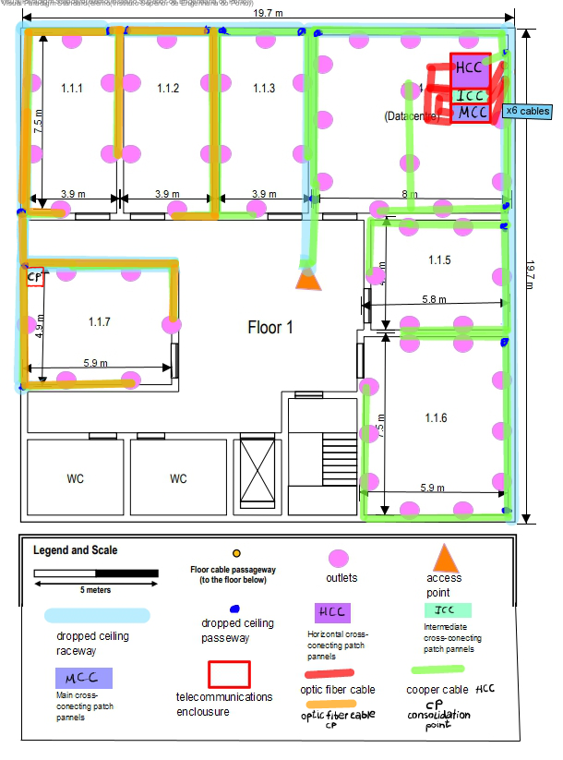

- INVENTARY:
 | OUTLETS(uds) | ACCESS  POINTS(uds) | COOPER PATCH PANEL 48 PORTS (uds) | COOPER PATCH PANEL 12 PORTS (uds) | COOPER PATCH PANEL 24 PORTS  (uds) | OPTIC FIBER PATCH PANEL 12 PORT  (uds) | TELECOMMUNICATION ENCLOSURES SIZE  (U) | RACEWAY(m) | PATCH-CORDS(0.5 m)  (uds) | PATCH-CORDS (5 m)  (uds) | COOPER  CABLE  (m) | OPTIC  FIBER  CABLE  (m)
TOTAL  BUILDING1 | 94 | 2 | 1 | 1 | 3 | 3 | 30 | 64.35 | 103 for coopera n 10 for optic fiber | 94 | 1325.43 | 12.5
TOTAL CAMPUS BACKBONE |  |  |  |  |  |  |  |  |  |  |  | 2237.2
TOTAL OF THIS DOCUMENT | 94 | 2 | 1 | 1 | 3 | 3 | 30 | 63.35 | 103 for coopera n 10 for optic fiber | 94 | 1325.43 | 2249.7

