张倩的模板部分:

Section 2. MANAGEMENT
This section describes each major element of the organization that influences the quality of the software.

2.1 Organization
Good software practice requires a measure of independence for the SQA group. This independence provides a key strength to SQA; that is, SQA has the freedom, if the quality of the product is being jeopardized, to report this possibility directly above the level of the project. While in practice this rarely occurs, for almost all problems are correctly addressed at the project level, the fact that the SQA group can go above the project level gives it the ability to keep many of these problems at the project level.
Figure 2-1 shows the SQA organization with relation to the project organization.
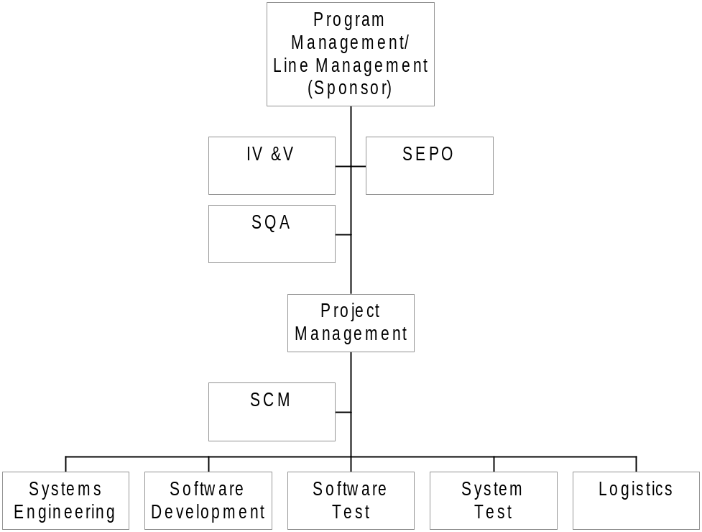
Figure 2-1. [[Project Name]] Organization
Replace Figure 2-1 with your project’s organizational structure or reference the organizational chart’s location. The project may wish to keep a single chart in a central location and reference all of its plans and procedures to that chart to facilitate maintaining the organization char. Provide a description of the functional responsibilities for each functional group in the organizational structure.
In describing the functional responsibilities, answer the questions listed below:
- Who interacts with SQA?
- Who has authority and delegates responsibilities of interacting functions?
- What are the reporting relationships among the interacting elements identifying independence/dependence?
- Who has product release authority?
- Who approves the SQA Plan?
- What are the reporting lines for escalating conflicts and the method by which conflicts are to be resolved among the elements?
In each case, add or delete the functional responsibilities that apply.
SQA is responsible for ensuring compliance with SQA requirements as delineated in this SQA Plan. The SQA organization assures the quality of deliverable software and its documentation, non-deliverable software, and the engineering processes used to produce software.
The following describes the functional groups that influence and control software quality.
- Program Management/Line Management (Sponsor) is responsible for the following items:
  - Establishing a quality program by committing the project to implement the Software Engineering Process Policy, reference (g), and reference (a).
  - Reviewing and approving the [[Project Name]] SQA Plan.
  - Resolving and following-up on any quality issues raised by SQA.
  - Identifying an individual or group independent from the project to audit and report on the project’s SQA function.
  - Identifying the quality factors to be implemented in the system and software.
  - fill-in additional functional responsibilities.
- Project Management is responsible for:
  - Implementing the quality program in accordance with references (g) and (a).
  - Identifying the SQA activities to be performed by SQA.
  - Reviewing and approving the [[Project Name]] SQA Plan.
  - Identifying and funding an individual or group independent from the project to perform the SQA functions.
  - Resolving and following-up on any quality issues raised by SQA.
  - Identifying and ensuring the quality factors to be implemented in the system and software.
  - Identifying, developing and maintaining planning documents such as the Program Management Plan, reference (h), references (e) and (f), Test Plans, and this SQA Plan.
  - fill-in additional functional responsibilities.
- System Engineering is responsible for:
  - Reviewing and commenting on the [[Project Name]] SQA Plan.
  - Implementing the quality program in accordance with this SQA Plan.
  - Resolving and following-up on any quality issues raised by SQA related to software engineering activities.
  - Identifying, implementing, and evaluating the quality factors to be implemented in the system (software and hardware).
  - Implementing the engineering practices, processes, and procedures as defined in reference (e) and other program/project planning documents.
  - fill-in additional functional responsibilities.
- Software Design/Development is responsible for:
  - Reviewing and commenting on the [[Project Name]] SQA Plan.
  - Implementing the quality program in accordance with this SQA Plan.
  - Resolving and following-up on any quality issues raised by SQA related to software design and development.
  - Identifying, implementing, and evaluating the quality factors to be implemented in the software.
  - Implementing the software design/development practices, processes, and procedures as defined in reference (e) and other program/project planning documents.
  - fill-in additional functional responsibilities.
- Software Test is responsible for:
  - Reviewing and commenting on the [[Project Name]] SQA Plan.
  - Implementing the quality program in accordance with this SQA Plan.
  - Resolving and following-up on any quality issues raised by SQA related to software test.
  - Verifying the quality factors are implemented in the system, specifically software.
  - Implementing the software test practices, processes, and procedures as defined in reference (e) and other program/project planning documents.
  - fill-in additional functional responsibilities.
- System Test is responsible for:
  - Reviewing and commenting on the [[Project Name]] SQA Plan.
  - Implementing the quality program in accordance with this SQA Plan.
  - Resolving and following-up on any quality issues raised by SQA as related to system test.
  - Verifying the quality factors are implemented in the system (software and hardware).
  - Implementing the system test practices, processes, and procedures as defined in reference (e) and other program/project planning documents.
  - fill-in additional functional responsibilities.
- Logistics is responsible for:
  - Reviewing and commenting on the [[Project Name]] SQA Plan.
  - Implementing the quality program in accordance with this SQA Plan.
  - fill-in additional functional responsibilities.
- Software Configuration Management (SCM) is responsible for:
  - Reviewing and commenting on the [[Project Name]] SQA Plan.
  - Implementing the quality program in accordance with this SQA Plan.
  - Resolving and following-up on any quality issues raised by SQA related to SCM.
  - Ensuring the quality factors are implemented in the software related to SCM.
  - Implementing the SCM practices, processes, and procedures as defined in reference (e) and other program/project planning documents.
  - fill-in additional functional responsibilities.
- Independent Verification and Validation (IV&V) is responsible for:
  - Reviewing and commenting on the [[Project Name]] SQA Plan.
  - Implementing the quality program in accordance with the [[Project Name]] SQA Plan.
  - Resolving and following-up on any quality issues raised by SQA.
  - Verifying the quality factors are implemented in the system (hardware and software).
  - Implementing the practices, processes, and procedures as defined for IV&V in reference (e) and other program/project planning documents.
  - fill-in additional functional responsibilities.
- Systems Engineering Process Office (SEPO) is responsible for:
  - Keeping references (a) and (g) current.
  - Maintaining the SQA Process, reference (i) and the SQA Plan Template, reference (j).
  - Ensuring SQA training availability, either by vendor or SEPO.
  - Providing assistance in software process engineering and software process improvement.
  - Maintaining the Description of the Space and Naval Warfare System Center San Diego Software Process Assets, reference (k), that describes many artifacts used to support SQA verification activities.

2.2 Resources

2.2.1 Facilities and Equipment
SQA will have access to the facilities and equipment as described in reference (e). SQA will have access to computer resources to perform SQA functions such as process and product evaluations and audits.

2.2.2 Personnel
The SQA effort for this project is person-year effort or indicate the amount of effort if it is less than 100% - ensure the effort agrees with the project Work Breakdown Structure.
Identify the qualification requirements of the SQA Manager
The SQA Manager will be familiar with and will be able to apply the standards and guidelines listed in Section 1.6. Additionally, the SQA Manager will be familiar with software quality, software development-related activities, and structured analysis, design, coding, and testing.

