1. Brainstorming Session Execution
   1. Implementation Details

* Format: Kano model
* Distribution Method: 10-minute per sessions
* Response Period: May 12, 2025
* Participants: Lai Joon Li (Facilitator), Tan Jun Xian (Student), Soukmead Ong Yu Kang(Student) and Eng Wei Jiun (Student)
* **Tools Used: Discord meeting**
  1. Session Structure

[Recording audio prove]  
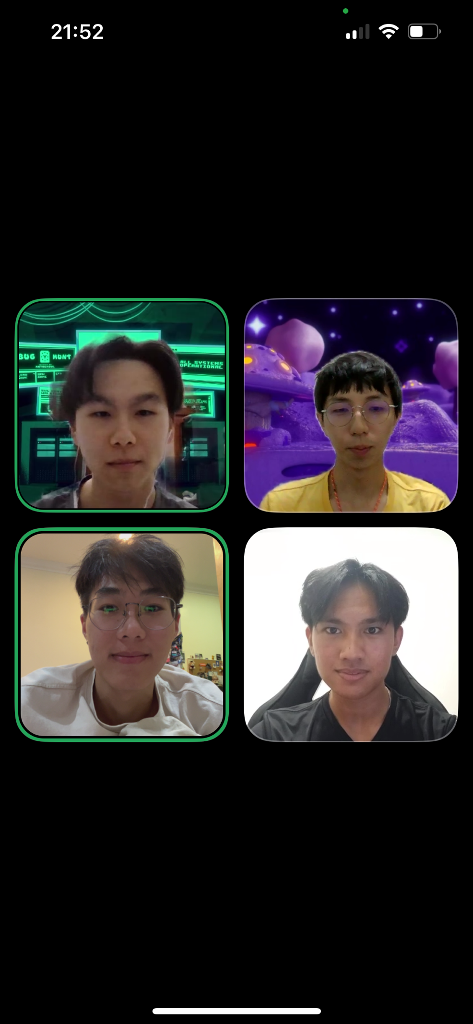

Figure 1:Brainstorming meeting

* 1. Key Findings [Classification questionnaire]
     1. Must-Be (Basic) Requirements
     2. One-Dimensional (Performance) Requirements
     3. Attractive (Delighter) Requirements

1. Questionnaire Execution
   1. Implementation Details

* Platform Used: Google Forms
* Distribution Method: University email lists
* Response Period: 6 days (May 9-13, 2025)
* Total Respondents:
  + Students:
  + Lecturer:
  + Administrators:
  + Parents:
  1. Sample Questionnaire

[Google form image prove]

* 1. Key Findings [Classification questionnaire]
     1. Must-Be (Basic) Requirements
     2. One-Dimensional (Performance) Requirements
     3. Attractive (Delighter) Requirements

1. Requirements Categorization Summary
   1. Must-Be Requirements (Essential Baseline)

|  |  |  |  |
| --- | --- | --- | --- |
| Requirement | Source | Kano Category | Description |
| Login and sign up | Brainstorming | Must-Be | Student able to login and sign up |
| Forgot password | Brainstorming | Must-Be | Student able to |
| Add, Edit, Delete | Brainstorming | Must-Be |  |
| Ability to view student info | Brainstorming | Must-Be |  |
| SMS warnings | Brainstorming | Must-Be | SMS Low attendance warnings to parents or students |

* 1. One-dimensional (Performance) Requirements

|  |  |  |  |
| --- | --- | --- | --- |
| Requirement | Source | Kano Category | Description |
| Loading time | Brainstorming | One-dimensional | Portal loading time must be in an acceptable range |
| SMS reminders | Brainstorming | One-dimensional | SMS reminders for upcoming deadlines |
| Student booking ability | Brainstorming | One-dimensional | Ability to book Lecturer, Admin consultation time or borrow classroom online |
| Document application | Brainstorming | One-dimensional | Document application (such as transcripts, proof of enrollment) can be tracked online |

* 1. Attractive (Delighter) Requirements

|  |  |  |  |
| --- | --- | --- | --- |
| Requirement | Source | Kano Category | Description |
| Personalized dashboard | Brainstorming | Delighter | Personalized dashboard, automatically display the next homework, payment, exam reminder |
| SMS messages | Brainstorming | Delighter | An SMS saying “Congrats! You scored the highest in class” |
| Portal chatbot | Brainstorming | Delighter | Chatbot, can quickly answer questions about courses, payment, office hours |
| One-click export | Brainstorming | Delighter | One-click export of personal semester progress report |

1. Execution Evidence and Documentation
   1. Questionnaire Analytics
   2. Brainstorming Artifacts
      1. Prioritization Matrix

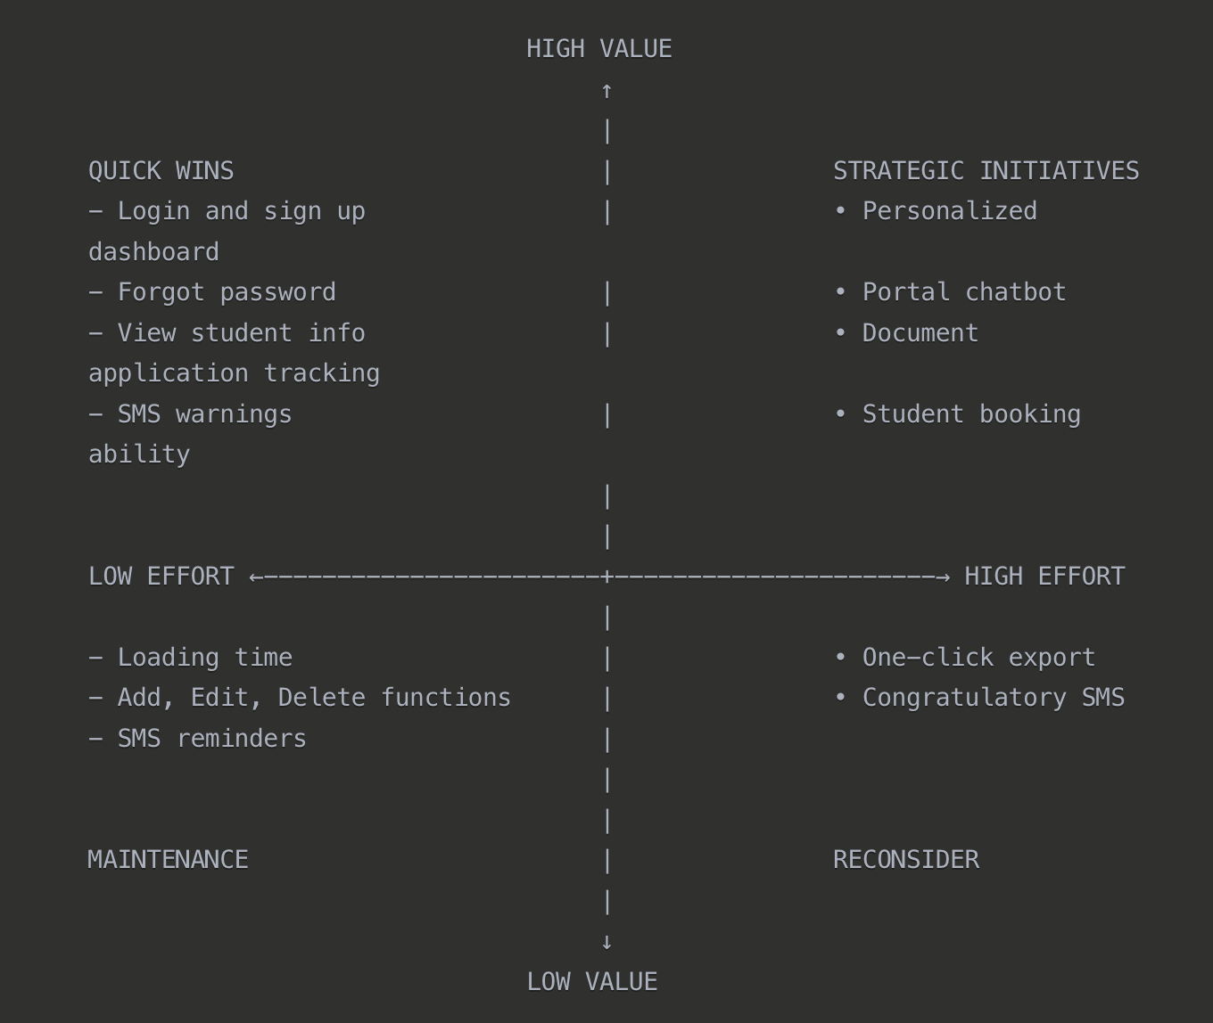

Figure 2: Prioritization matrix for identified requirements.