1. Kano Model Overview (What is kano model)
   1. Dissatisfiers
   2. Satisfiers
   3. delighters.
2. Elicitation Techniques Selection
3. Brainstorming Sessions Plan
   1. Session Structure:
      1. Target Audience
         1. Students
         2. Lecturers
         3. Administrators
         4. Parents
      2. Process
   2. Sample
      1. Session 1: Basic Requirements (Dissatisfiers)
      2. Session 2: Performance Requirements (Satisfiers)
      3. Session 3: Excitement Requirements (Delighters)

Below image can reference

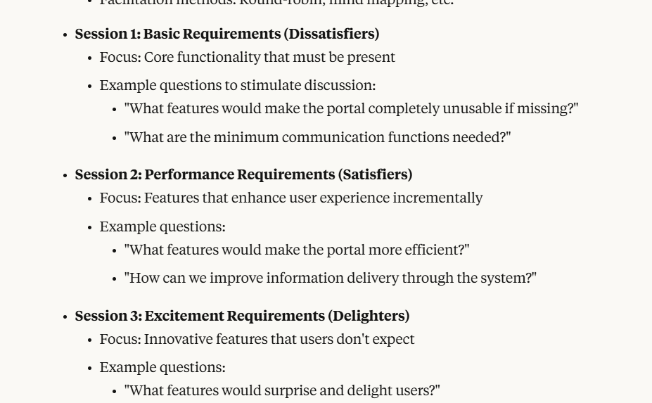

1. Questionnaire Design Using Kano Format
   1. Structure:
      1. Target Audience
         1. Students
         2. Lecturers
         3. Administrators
         4. Parents
      2. Process
   2. Sample Questions (at least 10 examples)
2. Kano Model Application
   1. Requirement Categorization Framework

|  |  |  |
| --- | --- | --- |
| Category | Identification Criteria | Example for Portal |
| Must-Be (Basic) |  |  |
| One-Dimensional (Performance) |  |  |
| Attractive (Delighters) |  |  |

* 1. Kano Evaluation Table

1. Implementation Timeline

|  |  |  |
| --- | --- | --- |
| Week | Activities | Deliverables |
|  |  |  |
|  |  |  |

1. Expected Outcomes
2. f