
CSE 6224 – Software Requirement Engineering
Trimester 2510
Tutorial Session : TT4L
Group Number: G2
Leader: Iman Nadhirah binti Mohd Hafiz
Submission Date: 25/5/2025
Group members:
NO | STUDENT ID | NAME
1 | 1211111073 | IMAN NADHIRAH BINTI MOHD HAFIZ
2 | 1211112294 | PHARTIBAN A/L KUMARHESAN
3 | 1211112191 | SUZANNAH PANCER
4 | 1211108832 | NURUL NATASHA ADILYN BINTI FADZIL

NO | STUDENT ID | NAME
1 | 242UC244V6 | Sokmaed Ong Yu Kang
2 | 242UC2452B | Tan Jun Xian
3 | 242UC2452F | Lai Joon Li
4 | 1231301695 | Muhammad Loqman Bin Ahmad Fariz
Software Requirement
Specification

EduAxis: University Communication and Services Portal
Version: 1.0
Release Date: 25th May 2025

Table of Contents
Table of Contents 2
1. Introduction 7
1.1 Purpose 7
1.2 Scope 7
1.3 Product overview 8
1.3.1 Product perspective 8
1.3.1.1 System interfaces 9
1.3.1.2 User interfaces 12
1.3.1.3 Hardware interfaces 14
1.3.1.4 Software interfaces 15
1.3.1.5 Communication Interfaces 18
1.3.1.6 Memory constraints 20
1.3.1.7 Operations 22
1.3.1.8 Site adaptation requirements 24
1.3.1.9 Interfaces with services 26
1.3.2 Product functions 27
1.3.2.1 Student function 29
1.3.2.2 Parent function 52
1.3.2.3 Lecturer function 64
1.3.2.4 Administrator function 79
1.3.3 User Characteristics 91
1.3.3.1 Student 91
1.3.3.2 Parent or Guardian 91
1.3.3.3 Lecturer 91
1.3.3.4 Administrator 92
1.3.4 Limitations 93
2. References 94
3. Requirements 95
3.1 Apportioning of Requirements 95
3.1.1 Student Module 95
3.1.2 Parent Module 95
3.1.3 Lecturer Module 96
3.1.4 Admin Module 96
3.2 External interfaces 97
3.2.1 University Database Interface 97
3.2.2 Campus Management System (CMS) Interface 97
3.2.3 Learning Management System (LMS) Interface 98
3.2.4 SMS & Email Gateway Interface 98
3.2.5 Authentication Service Interface 99
3.2.6 Payment Gateway Interface 99
3.3 Elicitation Techniques Based on Kano Model 100
3.4 Functional Requirements 101
3.4.1 Dissatisfier Requirements 101
3.4.2 Satisfier Requirements 104
3.4.3 Delighter Requirements 106
3.5 Performance requirements 107
3.5.1 Static Numerical Requirements 107
3.5.2 Dynamic Numerical Requirements 108
3.6 Usability Requirements 109
3.6.1 User Interface 109
3.6.2 User Experience 109
3.6.3 Communication 109
3.6.4 Data protection 110
3.7 Logical Database Requirements 111
3.7.1 Class Diagram 111
3.7.2 Data Entities 112
3.7.3 Relationship 114
3.7.4 Types of Information Used by Various Functions 115
3.7.5 Frequency of Use 116
3.7.6 Accessing Capabilities 117
3.7.7 Integrity Constraints 118
3.7.8 Security 118
3.7.9 Data Retention Requirements 119
3.9 Design Constraints 120
3.9.1 Compliance with Data Privacy Regulations 120
3.9.2 Integration with Existing University Systems 120
3.9.3 Security Standards 120
3.9.4 Accessibility Requirements 120
3.9.5 API Usage Limitations 121
3.9.6 Performance and Scalability 121
3.9.7 User Experience Consistency 121
3.9.8 Data Interoperability 121
3.9.9 Legal and Ethical Considerations 122
3.9.10 Project Budget and Timeline 122
3.9.11 Standards Compliance 122
3.9.11.1 Report Format 122
3.9.11.2 Data Naming 122
3.9.11.3 Accounting Procedures 123
3.9.11.4 Audit Tracing 123
3.10. Software system attributes 124
3.10.1 Reliability 124
3.10.2 Availability 124
3.10.3 Security 124
3.10.4. Maintainability 125
3.10.5. Portability 126
4. Supporting information 127
4.1 Interview 127
4.1.1 Interview 1 127
4.1.1.1 Interview Preparation 127
4.1.1.2 Interview Agenda 127
4.1.1.3 Proof 129
4.1.2 Interview 2 129
4.1.2.1 Interview Preparation 129
4.1.2.2 Interview Agenda 129
4.1.2.3 Proof 131
4.1.3 Interview 3 131
4.1.3.1 Interview Preparation 131
4.1.3.2 Interview Agenda 132
4.1.3.3 Proof 133
4.2. Survey 134
4.2.1 Students 134
4.2.2 Parents 138
4.3 Observation 143
4.3.1 CliC 143
4.3.2 eBwise 146
5. Verification 149
5.1. Verification of External Interfaces (3.2) 149
5.1.1 University Database Interface (3.2.1) 149
5.1.2 Campus Management System (CMS) Interface (3.2.2) 149
5.1.3 Learning Management System (LMS) Interface (3.2.3) 149
5.1.4 SMS/Email Notification Gateway (3.2.4) 150
5.1.5 Authentication Service (SSO/OAuth) Interface (3.2.5) 150
5.1.6 Payment Gateway Interface (3.2.6) 150
5.2 Verification of Functional Requirements 151
5.3. Verification of Usability Requirements (3.6) 156
5.3.1 User Interface (3.6.1) 156
5.3.2 User Experience (3.6.2) 156
5.3.3 Communication (3.6.3) 157
5.3.3 Data Protection (3.6.4) 158
5.4. Verification of Performance Requirements (3.5) 159
5.4.1 Static Numerical Requirements (3.5.1) 159
5.4.1 Dynamic Numerical Requirements (3.5.2) 160
5.5. Verification of Logical Database Requirements (3.8) 162
5.5.1 Data Integrity Enforcement 162
5.5.2 Referential Integrity Checks 162
5.5.3 Normalization Compliance 163
5.5.4 Query Accuracy and Performance 163
5.5.5 Data Redundancy Detection 163
5.5.6 Transactional Consistency (ACID Properties) 163
5.5.7 Backup and Recovery Validation 164
5.6. Verification of Design Constraints (3.9) 164
5.6.1 Compliance with Data Privacy Regulations (3.9.1) 164
5.6.2 Integration with Existing University Systems (3.9.2) 164
5.6.3 Security Standards (3.9.3) 164
5.6.4 Accessibility Requirements (3.9.4) 165
5.6.5 API Usage Limitations (3.9.5) 165
5.6.6 Performance and Scalability (3.9.6) 165
5.6.7 User Experience Consistency (3.9.7) 165
5.6.8 Data Interoperability (3.9.8) 166
5.6.9 Legal and Ethical Considerations (3.9.9) 166
5.6.10 Project Budget and Timeline (3.9.10) 166
5.7 Verification of Software System Attributes (3.10) 167
6. Appendices 169
6.1 Assumptions and dependencies 169
6.2 Acronyms and abbreviations 170
6.3 Glossary 171

Introduction

1.1 Purpose
The purpose of the software to be developed, known as EduAxis is mainly to provide a centralized platform for students, parents, lecturers, and administrators to access academic and administrative information in a transparent and timely manner. This system aims to integrate seamlessly with the university’s existing Campus Management System (CMS) to deliver real-time access to essential data, including academic performance, attendance records, billing, and fee information. Ultimately, the system will ensure effective and timely communication by integrating an SMS Gateway, allowing automated alerts and notifications to be sent directly to students and parents. The EduAxis will also provide access to various online tools and services such as student records, course registration, library resources, and IT support such as streamlining processes, improving efficiency, and saving time for all users.

1.2 Scope
The software product to be developed is the EduAxis, a centralized platform that integrates with existing university systems such as the Learning Management System (LMS), academic calendar, and Campus Management System (CMS). This system aims to streamline communication and academic service delivery for students, parents, lecturers, and administrative staff.
The system will allow students to check grades, attendance, schedules, register for courses, and pay tuition fees. Parents will be able to monitor their child’s academic performance, receive fee reminders, and get SMS alerts on important issues. Lecturers can upload grades, mark attendance, and post course updates, while administrators will manage user access and system configurations.
Key features include real-time SMS alerts for low attendance and unpaid fees, automation of routine tasks, and centralized access to academic notifications and services. The system is designed to reduce manual workload, support timely communication, and enhance user engagement across all roles.
The system shall address the real needs of four primary user groups:
- Students: Must be able to access grades, attendance, fee details, timetables, and submit feedback. They will primarily use mobile devices and require real-time notifications.
- Parents: Can view academic results, fee status, timetables, and receive SMS/email alerts about tuition, attendance, or course registration changes.
- Lecturers: Will manage course grading, attendance, and announcements through dedicated dashboards, with system alerts and visual performance tracking.
- Administrators: Will oversee system integrations (e.g., CMS, LMS), control permissions, manage backups, and resolve common support issues reported by users.
This software aligns with the overall goal of improving communication flow, increasing operational efficiency, and encouraging student accountability. By consolidating key academic functions into a single platform, the system will deliver greater transparency, faster information sharing, and improved access to university services for all stakeholders.

1.3 Product overview

1.3.1 Product perspective
The UEduAxis, an integrated academic management and communication system, plays a central role within the university’s digital ecosystem. It connects multiple internal systems such as the Campus Management System (CMS), Learning Management System (LMS), academic calendar, and university database, serving as a unified access point for students, parents, lecturers, and administrative staff. Through its integration with services like SMS gateways and email servers, the system ensures seamless delivery of notifications, reminders, and academic information across all user groups.
The system operates within a broader institutional infrastructure that includes tools for grading, attendance tracking, course registration, and financial management. Its functionality overlaps with these systems by enabling automated data exchange and reducing reliance on manual processes. For instance, it retrieves student records and schedules from the CMS, syncs course data with the LMS, and pulls academic deadlines from the academic calendar system. It also allows parents to access academic information about their children and receive SMS alerts for issues like low attendance or unpaid tuition fees.
The system interfaces with the larger system landscape through several key connections:
- System Interfaces: Integration with CMS, LMS, SMS Gateway, and authentication services for real-time data synchronization.
- User Interfaces: Intuitive web and mobile interfaces for students, parents, lecturers, and administrators.
- Hardware Interfaces: Accessible on desktops, smartphones, and tablets to support anytime, anywhere use.
- Software Interfaces: Seamless connections with internal software (academic modules, student database) and external services (SMS/email systems).
- Communication Interfaces: Reliable protocols for sending and receiving automated alerts, reminders, and academic announcements.
At the core of the system is a centralized backend that manages user access, notifications, and academic workflows. Modules such as Attendance Management, Course Registration, Grade Upload, and Announcement Delivery are orchestrated through an internal scheduler and database engine. These components interact with each other and with external systems to ensure that users receive accurate, timely, and personalized information, ultimately reducing administrative burden and improving engagement.
Figure 1.3.1.1 illustrates the system’s context diagram, highlighting the key external entities that interact with the EduAxis platform.
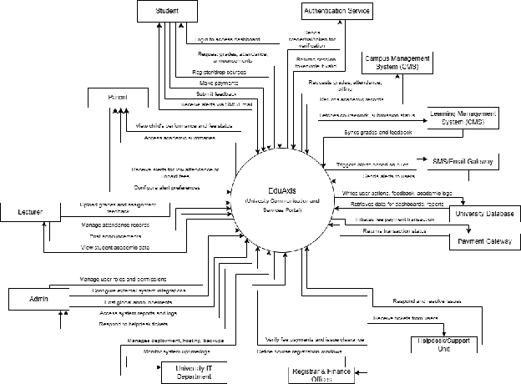
Figure 1.3.1.1: Context Diagram of the EduAxis platform

1.3.1.1 Memory constraints
1. Primary Memory (RAM)
Role: By handling temporary data in the system for quick read and write during operations RAM is used as the main memory for real-time data retrieval during users sessions. It manages the application state while navigating through different modules making smooth and efficient data retrieval even when handling simultaneous users in the system such as students, parents, lecturers, and even administrators.
Limitations: The system’s real-time notification alerts updates require memory for queueing messages and updating user status. Having high concurrency during peak periods like course registration and deadlines, the system will require more RAM for better efficiency in processing high volume data calls.
Requirement: The system must support at least 1,000 concurrent users with a maximum RAM consumption of 4 GB.
2. Secondary Memory (Disk Storage)
Role: Secondary memory in the EduAxis serves as long-term storage for persistent data, including student records, academic performance logs, attendance data, and financial transactions. Unlike volatile primary memory (RAM), it retains data even after system shutdown, ensuring the availability of historical information and backups.
Limitations: The limitations of secondary memory in the EduAnix include slower read and write speeds compared to primary memory, which can lead to delays in report generation and registration processes, especially during peak usage. Its fixed physical capacity can restrict the amount of historical data that can be stored, making it challenging to maintain long-term academic records and system logs without regular cleanup or archiving.
Requirement: The system should be deployable on a server with at least 256 GB SSD storage, supporting data retention for a minimum of 7 years.
3. Caching Mechanism
Role: The caching mechanism plays a crucial role in improving system performance and reducing database load by temporarily storing frequently accessed data. This includes student profiles, academic schedules, attendance records, and course announcements. By keeping this data in fast-access memory, the system can serve requests more quickly without repeatedly querying the database, leading to faster page loads and smoother navigation for users.
Limitations: Caching stores data in RAM, which is limited and expensive. If the cache size grows too large, it can consume critical memory needed for real-time processes. Furthermore, If the cache is not properly invalidated or refreshed, users may see outdated information, such as old grades or attendance records, leading to inconsistencies.
Requirement: The system should be deployable on a server with at least 256 GB SSD storage, supporting data retention for a minimum of 7 years.
4. Session Management
Role: session management is responsible for maintaining user authentication and preserving their interactions during a logged-in session. It enables students, parents, lecturers, and administrators to securely access their personalized dashboards, view academic records, perform course registrations, and receive notifications without repeatedly logging in. Efficient session management ensures data integrity and prevents unauthorized access by controlling session timeouts and handling secure data storage.
Limitations: Scalability challenges in managing large numbers of simultaneous users can consume huge server memory and processing power. Short session timeouts can also disrupt user experience, while long timeouts can increase memory consumption and security risk if not actively managed by any users.
Requirement: The system shall support up to 2,000 active sessions simultaneously with a configurable session timeout of 15 minutes of inactivity.

1.3.1.2 Operations
- Modes of Operations:
- User initiated Operations:
  - Users including students, parents, lecturers, and administrators can initiate actions such as viewing academic records, uploading grades, registering for courses, submitting support tickets, updating profiles, and receiving alerts through the system’s web-based interface.
  - Students: View grades, attendance, schedule, make payments, and submit coursework.
  - Lecturers: Upload grades, post announcements, and mark attendance.
  - Admins: Manage users, configure system settings, and monitor system activity.
- Periods of Operations:
- Interactive Operations:
Users typically interact with the system during standard academic hours (e.g., 8:00 AM – 10:00 PM). During these hours, all functionalities including academic viewing, course registration, announcements, and grade management are fully accessible.
- Unattended Operations:
System-level automated processes such as sending scheduled SMS/email alerts, updating records from CMS, and executing system health checks are conducted during off-peak hours (e.g., overnight) to avoid performance disruption.
- Data processing Support Functions
- Validation and Integration:
The system validates all user-submitted data (e.g., coursework, profile updates) and integrates seamlessly with third-party services such as the SMS gateway, authentication provider, and academic calendar.
- Notifications and Alerts:
Automated alerts are generated and dispatched based on data triggers (e.g., low attendance or unpaid fees), using background jobs to maintain system responsiveness.
- Reporting and Analytics:
Admin users can generate reports on student performance, attendance summaries, and usage metrics to support academic decision-making.
- Backup and Recovery Operations
- Regular Backups:
The system performs scheduled backups of essential data including student records, grade entries, course schedules, and user accounts. Backups are stored securely on cloud infrastructure with redundancy.
- Disaster Recovery:
In the event of a system failure or data corruption, recovery protocols are in place to restore the platform to its last known stable state. Recovery time objectives (RTO) are kept minimal to avoid academic disruptions.
- Version Control:
System codebase and configuration changes are managed through version control (GitHub), enabling rollback and historical tracking in case of issues introduced during updates or new deployments.

1.3.1.3 Site adaptation requirements

- Data and Initialization Sequences
- University-Specific Academic Data:
The system must be adapted to reflect the specific academic structure of each university. This includes configuring academic calendars, semester start/end dates, registration periods, grading policies, course codes, and departmental hierarchies.
- Attendance and Assessment Policies:
The platform should support the initialization of site-specific attendance thresholds, warning levels, and performance criteria used to trigger alerts or academic risk notifications.
- Payment and Billing Setup:
Initialization sequences must allow customization of tuition structures, billing cycles, discount schemes, and payment gateways according to the university’s financial operations.
- Authentication and Access Control:
Adaptation is required for integration with the university’s identity management system, such as Single Sign-On (SSO), LDAP directories, or institutional login systems, to ensure seamless and secure user authentication.
- Notification Triggers and Rules:
The system should allow configuration of SMS/email alert rules (e.g., when attendance drops below X%) based on the institution’s academic and administrative guidelines.
- Site or Mission-Related Features
- Custom Branding and UI Customization:
The platform must support university-specific branding, including logos, colors, header styles, and system names, to reflect the institution’s visual identity.
- Localization and Language Support:
The system should support localization, including the ability to present content in different languages and adapt date/time formats based on the region or user preference.
- Campus-Specific Event Configuration:
Site-specific setup is required for configuring academic events, holidays, registration dates, and system reminders that align with each university’s operational calendar.
- SMS Gateway and Communication Setup:
Adaptation is required to integrate with different SMS/email providers based on university preference or regional availability. This includes setting up API keys, sender IDs, and failover options.
- User Role Configuration and Access Rights:
The platform must support customization of user roles and permissions based on the university’s structure—for example, allowing certain faculties or departments to manage their own announcements or course materials.

1.3.1.4 Interfaces with services
- Cloud Hosting Provider
The EduAxis will be hosted on a cloud infrastructure such as Amazon Web Services (AWS) or Google Cloud Platform (GCP). These services provide scalable and reliable environments for hosting backend services, databases, and application logic. The platform will interface with cloud services to manage virtual servers, allocate resources, configure networking, and ensure system availability through autoscaling, load balancing, and backup services. APIs from the hosting provider will be used for deployment automation, storage management, and health monitoring.
- SMS Gateway Service
To support real-time notifications and alerts (e.g., low attendance, unpaid fees), the platform will integrate with a third-party SMS gateway service such as Twilio or MessageBird. The system will interact with the SMS service via RESTful APIs to send automated text messages to students and parents. This integration will allow queuing of SMS alerts, tracking delivery status, and managing sender identification based on regional requirements. The gateway service ensures timely and reliable communication with stakeholders.
- Email Delivery Service
The platform will interface with email delivery services such as Amazon SES or SendGrid to deliver transactional and system-generated emails. These may include grade updates, registration confirmations, password resets, and academic announcements. Integration will be handled via SMTP or RESTful API calls, enabling the system to manage templates, track bounces, monitor open/click rates, and ensure compliance with delivery standards. The email service also provides logging and analytics for administrative review.
- Authentication and Authorization Services
For secure access and user role management, the platform will integrate with authentication providers such as Google Identity, LDAP, or Microsoft Azure Active Directory. This ensures seamless Single Sign-On (SSO) functionality for students, lecturers, and administrators. The system will use OAuth 2.0 and OpenID Connect protocols to authenticate users, validate tokens, and manage role-based access controls (RBAC). APIs will facilitate session handling, user profile retrieval, and permission enforcement.

1.3.2 Product functions
Table 1.3.2.1 below contains the list of functions to be implemented into the system which are organized by actors defined for this system.
Table 1.3.2.1: EduAxis Functions
Actor | Functions
Student | Login View Academic Grades Check Class Attendance Records Access/View Course Schedule Register/Drop Courses Submit Coursework & View Feedback Pay Tuition & Other Fees View Payment History & Invoices Receive SMS/Email Alerts View Announcements & Notifications Update Personal Profile Information Submit Feedback/Support Tickets Monitor Student Academic Performance Customize Notification Preferences
Parent | Login View Child’s Grade & Attendance View Child’s Payment History & Dues Summary Access Child’s Schedule & Academic Summary View Announcements & Notifications Receive SMS/Email Alerts Customize Notification Preferences
Lecturer | Login Upload Student Grades Manage Coursework Submissions Export Grades & Attendance Reports Manage Attendance View Academic Calendar & Class Schedules Post Class Announcements Submit Helpdesk Tickets
Admin | Login Manage User Accounts Configure & Manage SMS/Email Notification Services Integrate & Sync with CMS, LMS Automate Workflows Post Global Announcements Maintain Data Privacy & Access Permissions Respond to Helpdesk Tickets or System Issues

1.3.2.2 Apportioning of Requirements
This section outlines the allocation of system requirements to specific modules within the EduAxis. Each module is structured to support user-specific functionality for students, parents, lecturers, and administrators, ensuring efficient and secure operations.

1.3.2.2.1 Student Module
Table 1.3.2.2.1 (Student Module table) | Requirement ID | Description | Related Functions | | ————– | ——————————————– | ————————————————————- | | REQ-01 | User authentication and authorization | Login | | REQ-02 | View academic performance and grades | View Academic Grades, Monitor Student Academic Performance | | REQ-03 | Manage course registration | Register/Drop Courses | | REQ-04 | View and pay tuition and fees | Pay Tuition & Other Fees, View Payment History & Dues Summary | | REQ-05 | Access and view class schedules | Access/View Course Schedule | | REQ-06 | Submit feedback and support tickets | Submit Feedback/Support Tickets | | REQ-07 | View announcements and receive notifications | View Announcements & Notifications, Receive SMS/Email Alerts | | REQ-08 | Customize notification preferences | Customize Notification Preferences |

1.3.2.2.2 Parent Module
Table 1.3.2.2.2 (Parent Module table) | Requirement ID | Description | Related Functions | | ————– | ———————————————– | ———————————————————— | | REQ-01 | Monitor child’s academic and attendance summary | View Child’s Grade & Attendance, Access Child’s Schedule | | REQ-02 | View payment and dues summary | View Payment History & Dues Summary | | REQ-03 | View announcements and receive alerts | View Announcements & Notifications, Receive SMS/Email Alerts |

1.3.2.2.3 Lecturer Module
Table 1.3.2.2.3 (Lecturer Module table) | Requirement ID | Description | Related Functions | | ————– | ———————————————– | —————————————————- | | REQ-01 | Post class announcements | Post Class Announcements | | REQ-02 | Upload grades and manage coursework submissions | Upload Student Grades, Manage Coursework Submissions | | REQ-03 | View academic calendar and manage attendance | View Academic Calendar, Manage Attendance | | REQ-04 | Export grades and attendance reports | Export Grades & Attendance Reports | | REQ-05 | Submit helpdesk tickets | Submit Helpdesk Tickets |

1.3.2.2.4 Admin Module
Table 1.3.2.2.4 (Admin Module table) | Requirement ID | Description | Related Functions | | ————– | ——————————————— | ————————————————– | | REQ-01 | User authentication and authorization | Login | | REQ-02 | Manage user accounts and permissions | Manage User Accounts, Maintain Access Permissions | | REQ-03 | Respond to system issues and helpdesk tickets | Respond to Helpdesk Tickets/System Issues | | REQ-04 | Manage data privacy | Maintain Data Privacy | | REQ-05 | Post and manage global announcements | Post Global Announcements | | REQ-06 | Configure and manage SMS/email services | Configure & Manage SMS/Email Notification Services | | REQ-07 | Automate system workflows | Automate Workflows | | REQ-08 | Integrate with CMS and LMS | Integrate & Sync with CMS, LMS |

1.3.3 User Characteristics

1.3.3.1 Student
Educational Level: Undergraduate or postgraduate students enrolled at the university.
Experience: Varies; may include first-year students unfamiliar with university systems to final-year students with moderate experience using institutional systems.
Technical Expertise: Basic to moderate. Familiar with smartphones, web platforms, and learning tools but may require intuitive interfaces for administrative tasks.
Disabilities: Some users may have visual, motor, or cognitive impairments.
Usability Influence: Interfaces must be mobile-responsive, easy to navigate, and include accessibility features such as screen reader support, color contrast, and simple forms. Timely feedback and automation are critical for reducing user frustration.

1.3.3.2 Parent or Guardian
Educational Level: Varies significantly; may include non-university-educated users.
Experience: Limited or no experience with academic systems; typically unfamiliar with institutional systems or digital academic tools.
Technical Expertise: Low to moderate. May only access the system occasionally via mobile devices.
Disabilities: May include older users with visual impairments or limited digital literacy.
Usability Influence: Requires a simple, mobile-friendly interface with clear language, SMS alerts, and minimal navigation layers. SMS notification design is critical due to likely preference for mobile communication over in-system browsing.

1.3.3.3 Lecturer
Educational Level: Postgraduate degree holders with academic or research backgrounds.
Experience: Extensive experience in higher education and academic administration.
Technical Expertise: Moderate to high. Familiar with digital learning tools, spreadsheets, and content management systems.
Disabilities: May include individuals with visual fatigue or repetitive stress injuries.
Usability Influence: system features (e.g., attendance marking, grade uploads, announcements) must be efficient, logically structured, and integrate seamlessly with existing tools like the LMS. Time-saving automation and bulk-processing features are essential.

1.3.3.4 Administrator
Educational Level: Professional or technical staff with tertiary education.
Experience: High level of familiarity with institutional systems and administrative protocols.
Technical Expertise: High. Skilled in managing data, user permissions, system configurations, and troubleshooting.
Disabilities: May vary; considerations for ergonomic design and interface responsiveness apply.
Usability Influence: Requires robust tools for platform configuration, user management, and report generation. Interfaces must support multitasking, advanced filtering/search, and error-handling mechanisms for administrative operations.

1.3.4 Limitations
- Digital Literacy Gaps
Parents or guardians with limited access to technical expertise may struggle to navigate the system, especially if its not fully optimized for mobile devices like smartphones, with simple and user-friendly design. This can lead to difficulties in accessing important academic information, receiving notifications and engaging with students’ records actively.
- High Concurrent User Loads
During peak usage periods such as subject registration or exam results announcements, the platform might experience slowdowns or even crashes if it is not properly optimized for scalability. High traffic volumes can overload servers, causing delays in data retrieval and frustrating users who rely on real-time updates.
- Data Synchronization issues
The system relies on real-time integration with the Campus Managements System (CMS) and Learning Management System (LMS) to deliver up-to-date information. However, synchronisation delays or connection issues between these systems can results in outdated or incomplete data being displayed, potentially affecting decision making and user-trust.
- Security and Privacy Risk
Given the sensitive nature of the data managed by the system, such as student grades, attendance records, and financial information, robust security measures are crucial. Insufficient protection can lead to unauthorized access, data breaches, and privacy violations, compromising student confidentiality and institutional trust.
- Manual Data Entry
The process of lecturers manually entering grades or marking attendance in the database can introduce human errors, such as typos or incorrect records. These inaccuracies can affect student academic records, leading to disputes and requiring time-consuming corrections to maintain data integrity.

2. References
This document is prepared in reference to the following documents:
- ISO/IEC/IEEE 29148:2018(E) - International Standard
- Software Requirement Engineering Lecture Slide

3. Requirements

3.1 Function {#3.1-functions}

3.1 Functional Requirements

3.1.1.1 Dissatisfier Requirements

3.1.1.1.1 Requirement 1
Table 3.1.1.1.1 - User Authentication and Authorization (Requirement 1) | Requirements: | User Authentication and Authorization | | :————————– | :——————————————————————————————————————————————————————————————– | | Description: | The system shall provide a secure login mechanism for students, lecturers, parents, and admins | | Elicitation Activities: | Interview with lecturers, survey conducted towards parents and students | | Responsible Member: | Iman Nadhirah Binti Mohd Hafiz | | Supporting Documents: | Question 1 (Interview 1), Question1 (Interview 2), Question 9 (Parents survey), Question 13 (Student survey) | | Related Function: | Login |

3.1.1.1.2 Requirement 2
Table 3.1.1.1.2 - View Academic Grades (Requirement 2) | Requirements: | View Academic Grades | | :————————– | :————————————————————————————————————————————— | | Description: | The system shall allow users (students,lecturers, parents) to view academic grades securely | | Elicitation Activities: | Interview with lecturers, survey conducted towards parents and student | | Responsible Member: | Phartiban A/L Kumarhesan | | Supporting Documents: | Question 2 and 10 (Interview 1), (Interview 2), Question 1 (Parent Survey) | | Related Function: | View academic grades |

3.1.1.1.3 Requirement 3
Table 3.1.1.1.3 - Access Attendance Records (Requirement 3) | Requirements: | Access Attendance Records | | :————————– | :———————————————————————————————————————————– | | Description: | The system shall allow students, parents, and lecturers to access and monitor attendance records. | | Elicitation Activities: | Interview with lecturers, survey conducted towards parents | | Responsible Member: | Suzannah Pancer | | Supporting Documents: | Question 4&5 (Interview 1),(Interview 2), Question 2&3 (Parent Survey) | | Related Function: | Check class attendance records |

3.1.1.1.4 Requirement 4
Table 3.1.1.1.4 - Access Academic Timetable (Requirement 4) | Requirements: | Access Academic Timetable | | :————————– | :—————————————————————————————————————————— | | Description: | The system shall display each user’s course schedule or timetable. | | Elicitation Activities: | Interview with lecturers, Questionnaire with parents | | Responsible Member: | Nurul Natasha Adilyn Binti Fadzil | | Supporting Documents: | Question 8 (Interview 1),(Interview 2), Question7 (Parent Survey) | | Related Function: | Access and view course schedule/timetable |

3.1.1.1.5 Requirement 5
Table 3.1.1.1.5 - Manage User Accounts and Roles (Requirement 5) | Requirements: | Manage User Accounts and Roles | | :————————– | :——————————————————————————— | | Description: | The system shall enable admin to assign roles and manage user account permissions. | | Elicitation Activities: | Interview with Admin | | Responsible Member: | Iman Nadhirah Binti Mohd Hafiz | | Supporting Documents: | Question 1&8 (interview 3) | | Related Function: | Manage user accounts and system configurations |

3.1.1.1.6 Requirement 6
Table 3.1.1.1.6 - Integration with Campus Systems (Requirement 6) | Requirements: | Integration with Campus Systems | | :————————– | :————————————————————————— | | Description: | The system shall integrate with CMS, LMS, and calendar systems to sync data. | | Elicitation Activities: | Interview with Admin | | Responsible Member: | Phartiban A/L Kumarhesan | | Supporting Documents: | Question 2 (interview 3) | | Related Function: | Integrate and Sync with CMS, LMS, and calendar systems |

3.1.1.1.7 Requirement 7
Table 3.1.1.1.7 - Maintain Data Privacy and Access Permissions (Requirement 7) | Requirements: | Maintain Data Privacy and Access Permissions | | :————————– | :——————————————————————- | | Description: | The system must enforce data security and appropriate access levels. | | Elicitation Activities: | Interview with Admin | | Responsible Member: | Suzannah Pancer | | Supporting Documents: | Question 8 (interview 3) | | Related Function: | Maintain data privacy and access permissions |

3.1.1.1.8 Requirement 8
Table 3.1.1.1.8 - Pay Tuition and Other Fees (Requirement 8) | Requirements: | Pay Tuition and Other Fees | | :————————– | :———————————————- | | Description: | Ability to make fee payments through the system | | Elicitation Activities: | Observation | | Responsible Member: | Phartiban A/L Kumarhesan | | Supporting Documents: | Question 5 (interview 3) | | Related Function: | Pay tuition and other fees |

3.1.1.1.9 Requirement 9
Table 3.1.1.1.9 - View Payment History and Invoices (Requirement 9) | Requirements: | View Payment History and Invoices | | :————————– | :——————————————— | | Description: | View historical tuition and fee records | | Elicitation Activities: | Observation | | Responsible Member: | Phartiban A/L Kumarhesan | | Supporting Documents: | Question 5 (interview 3) | | Related Function: | View Payment History and Invoices |

3.1.1.2 Satisfier Requirements

3.1.1.2.1 Requirement 10
Table 3.1.1.2.1 - Upload and Manage Grades (Requirement 10) | Requirements: | Upload and Manage Grades | | :————————– | :———————————————————————————- | | Description: | Lecturers shall be able to upload, confirm, and manage student grades. | | Elicitation Activities: | Interview with Lecturers | | Responsible Member: | Nurul Natasha Adilyn Binti Fadzil | | Supporting Documents: | Question 2&3(Interview 1),(Interview 2) | | Related Function: | Upload student grades |

3.1.1.2.2 Requirement 11
Table 3.1.1.2.2 - Digital Attendance Tracking (Requirement 11) | Requirements: | Digital Attendance Tracking | | :————————– | :———————————————————————————– | | Description: | The system shall support digital attendance marking and tracking over time. | | Elicitation Activities: | Interview with Lecturers | | Responsible Member: | Iman Nadhirah Binti Mohd Hafiz | | Supporting Documents: | Question 4&5 (Interview 1),(Interview 2) | | Related Function: | Mark and manage attendance records |

3.1.1.2.3 Requirement 12
Table 3.1.1.2.3 - Post Announcements and Updates (Requirement 12) | Requirements: | Post Announcements and Updates | | :————————– | :———————————————————————————– | | Description: | Lecturers and admins shall post class and global announcements | | Elicitation Activities: | Interview with Lecturers | | Responsible Member: | Phartiban A/L Kumarhesan | | Supporting Documents: | Question 6&7 (Interview 1),(Interview 2) | | Related Function: | Post class announcements and updates |

3.1.1.2.4 Requirement 13
Table 3.1.1.2.4 - Dashboard with Performance Overview (Requirement 13) | Requirements: | Dashboard with Performance Overview | | :————————– | :——————————————————————————— | | Description: | The system shall provide academic dashboard with grade and attendance insights. | | Elicitation Activities: | Interview with Lecturers | | Responsible Member: | Suzannah Pancer | | Supporting Documents: | Question 10(Interview 1),(Interview 2) | | Related Function: | Monitor student academic performance |

3.1.1.2.5 Requirement 14
Table 3.1.1.2.5 - Submit Feedback and Support Requests (Requirement 14) | Requirements: | Submit Feedback and Support Requests | | :————————– | :———————————————————————————————- | | Description: | The system shall allow users to submit feedback and helpdesk tickets. | | Elicitation Activities: | Interview with Admin and survey conducted towards students | | Responsible Member: | Nurul Natasha Adilyn Binti Fadzil | | Supporting Documents: | Question 6 (interview 3), Question 18 (Student survey) | | Related Function: | Submit Feedback/Support Tickets, Submit Helpdesk Tickets |

3.1.1.2.6 Requirement 15
Table 3.1.1.2.6 - Alert and Reminder System (Requirement 15) | Requirements: | Alert and Reminder System | | :————————– | :———————————————————————————————————– | | Description: | The system shall send deadline reminders and important alerts to users. | | Elicitation Activities: | Interview with Lecturer and survey towards students | | Responsible Member: | Iman Nadhirah Binti Mohd Hafiz | | Supporting Documents: | Question 9(Interview 1),(Interview 2), Questionnaire Q3, Q4, Q12 | | Related Function: | Receive SMS/Email alerts |

3.1.1.3 Delighter Requirements

3.1.1.3.1 Requirement 16
Table 3.1.1.3.1 - Notification Read Tracking (Requirement 16) | Requirements: | Notification Read Tracking | | :————————– | :—————————————————————————————- | | Description: | The system may notify lecturers or admins when users view or interact with announcements. | | Elicitation Activities: | Interview with lecturers | | Responsible Member: | Phartiban A/L Kumarhesan | | Supporting Documents: | Question 7(Interview 1),(Interview 2) | | Related Function: | View announcements and academic notifications |

3.1.1.3.2 Requirement 17
Table 3.1.1.3.2 - Custom Notification Preferences (Requirement 17) | Requirements: | Custom Notification Preferences | | :————————– | :———————————————————————— | | Description: | Parents may configure notification delivery method (SMS, email, or both). | | Elicitation Activities: | Survey towards parents | | Responsible Member: | Suzannah Pancer | | Supporting Documents: | Question 14 (Parent Survey) | | Related Function: | Receive SMS/Email alerts |

3.1.1.3.3 Requirement 18
Table 3.1.1.3.3 - Visual Performance Analytics (Requirement 18) | Requirements: | Visual Performance Analytics | | :————————– | :———————————————————————————- | | Description: | The system may display graphs and visual trends of student performance over time. | | Elicitation Activities: | Interview with lecturer | | Responsible Member: | Nurul Natasha Adilyn Binti Fadzil | | Supporting Documents: | Question 10 (Interview 1),(Interview 2) | | Related Function: | Monitor student academic performance |

3.1.1.3.4 Requirement 19
Table 3.1.1.3.4 - Mobile-Friendly Responsive Interface (Requirement 19) | Requirements: | Mobile-Friendly Responsive Interface | | :————————– | :———————————————————————————————– | | Description: | The system may be optimized for mobile devices across Android and iPhone. | | Elicitation Activities: | Interview with admin and survey towards students | | Responsible Member: | Iman Nadhirah Binti Mohd Hafiz | | Supporting Documents: | Question 5 (interview 3), Question 7&12(Student survey) | | Related Function: | All access-related functions (Login, View Grades, etc.) |

Figure 3.1.2.1 below shows the generic use case diagram for the EduAxis with Campus Management System and SMS Gateway Integration.
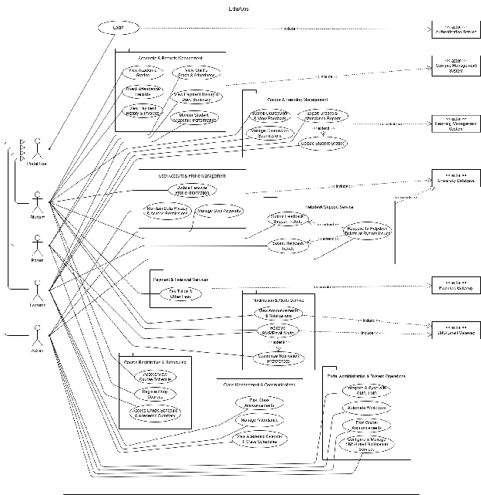
Figure 3.2.1: Generic Use Case Diagram

3.1.2.1 Student function

3.1.2.1.1. Login
Table 3.1.2.1.1. Use case Specification - Login
No. |  | Section | Content
ID | 1.1 | Name | Login
Management | 2.1 | Author | Iman Nadhirah
Context | 3.1 | Source | CliC, ebwise
Use Case Definition | 4.1 | Short Description | The user logs into their account
 | 4.2 | Goal | Authenticate user identity to access the platform’s feature
 | 4.3 | Actor | Student
 | 4.4 | Pre-Condition | The user is registered and Authenticated in the system
 | 4.5 | Post-Condition | The user gains access to personalized features within the system
 | 4.6 | Main Success Scenario | 1. The user navigates to the login page. 2. The user enter their username and password 3. The user clicks the “Login” button. 4. The system validates the credentials The system displays the student’s dashboard
 | 4.7 | Alternative Scenario | 1. The user wants to log in using a social media account such as LinkedIn The system redirects the user to the social media credentials and authorize access The user enters their social media credentials and authorize access The system validates the social media credentials and logs the user in
 | 4.8 | Exception Scenario | 1. The user enter incorrect credentials The system displays an error message indicating invalid credentials The user is prompted to re-enter their username and password.
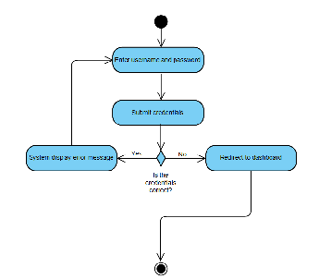
Figure 3.1.2.1.1. Activity Diagram - Login

3.1.2.1.2. View Academic Grades
Table 3.1.2.1.2. Use case Specification - View Academic Grades
No. |  | Section | Content
ID | 1.1 | Name | View academic grades
Management | 2.1 | Author | Iman Nadhirah
Context | 3.1 | Source | CliC
Use Case Definition | 4.1 | Short Description | The student views their academic grades through the platform.
 | 4.2 | Goal | Allow students to access and review their academic performance
 | 4.3 | Actor | Student
 | 4.4 | Pre-Condition | The student is logged into the system
 | 4.5 | Post-Condition | The student displays the student’s academic grades
 | 4.6 | Main Success Scenario | 1. The students logs into the system. 2. The student navigates to the “Grades” section. 3. The system retrieves the student’s grade records. 4. The grades are displayed on the dashboard.
 | 4.7 | Alternative Scenario | 1. No grades data available The system display a message: “No grades found.”
 | 4.8 | Exception Scenario | 1. System error during grade retrieval An error message is shown: “Unable to load grades. Please try again later.”
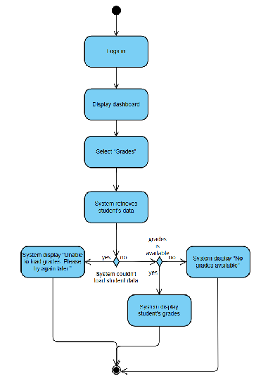
Figure 3.1.2.1.2. Activity Diagram - View Academic Grades

3.1.2.1.3. Check Class Attendance Records
Table 3.1.2.1.3. Use case Specification - Check Class Attendance Records
No. |  | Section | Content
ID | 1.1 | Name | Check Class Attendance Records
Management | 2.1 | Author | Iman Nadhirah
Context | 3.1 | Source | CLiC
Use Case Definition | 4.1 | Short Description | The student views their attendance records percentage for all enrolled courses
 | 4.2 | Goal | To allow students to track their class attendance and stay informed
 | 4.3 | Actor | Student
 | 4.4 | Pre-Condition | The student is successfully logged into the system.
 | 4.5 | Post-Condition | The system displays the student’s attendance summary for each course.
 | 4.6 | Main Success Scenario | 1. The student logs into the system. 2. The student navigates to the “Attendance” section. 3. The system retrieves attendance data for the student. 4. The student views their attendance percentage and record.
 | 4.7 | Alternative Scenario | 1. The student has not attended any classes yet The system displays “No attendance record available.”
 | 4.8 | Exception Scenario | 1. System fails to retrieve data The system displays an error message: “Unable to load attendance. Please try again later.”
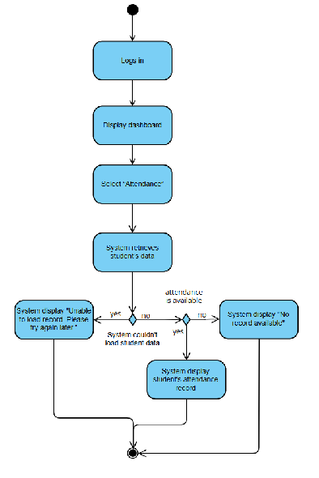
Figure 3.1.2.1.3. Activity Diagram - Check Class Attendance Records

3.1.2.1.4. Access and View Course Schedule/Timetable
Table 3.1.2.1.4. Use case Specification - Access and View Course Schedule/Timetable
No. |  | Section | Content
ID | 1.1 | Name | View Course Schedule
Management | 2.1 | Author | Iman Nadhirah
Context | 3.1 | Source | CLiC
Use Case Definition | 4.1 | Short Description | Student views their course timetable for the current semester.
 | 4.2 | Goal | Provide access to an up-to-date and organized schedule.
 | 4.3 | Actor | Student
 | 4.4 | Pre-Condition | Student is logged into the system
 | 4.5 | Post-Condition | Course schedule is displayed successfully
 | 4.6 | Main Success Scenario | 1. Students logs in. 2. Navigates to “Timetable”. 3. System loads and display schedule.
 | 4.7 | Alternative Scenario | 1. Student select a different semester to view. 2. Schedule data not available System shows: “Timetable not found.”
 | 4.8 | Exception Scenario | 1. System fails to retrieve data The system displays an error message: “Unable to load timetable. Please try again later.”
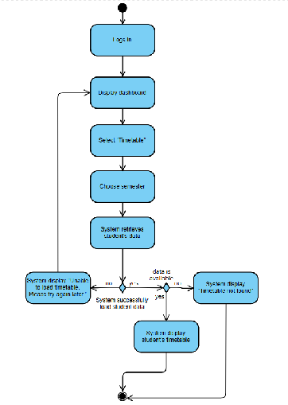
Figure 3.1.2.1.4. Activity Diagram - Access and View Course Schedule/Timetable

3.1.2.1.5 Register or Drop Courses
Table 3.1.2.1.5. Use case Specification - Register or Drop Courses
No. |  | Section | Content
ID | 1.1 | Name | Register or Drop Courses
Management | 2.1 | Author | Iman Nadhirah
Context | 3.1 | Source | CLiC
Use Case Definition | 4.1 | Short Description | Student registers or drops courses for the semester.
 | 4.2 | Goal | Allow students to manage course enrollment.
 | 4.3 | Actor | Student
 | 4.4 | Pre-Condition | Registration period is open.
 | 4.5 | Post-Condition | Courses are updated in the student’s schedule.
 | 4.6 | Main Success Scenario | 1. Student logs in. 2. Goes to “Enrollment”. 3. Add course to My Planner. 4. Go to My Planner. 5. Choose preferred time table for each course. 6. Confirm enrollment.
 | 4.7 | Alternative Scenario | 1. The class is full Student can choose other class
 | 4.8 | Exception Scenario | 2. Student didn’t add any course to My Planner System will display “please add course first”
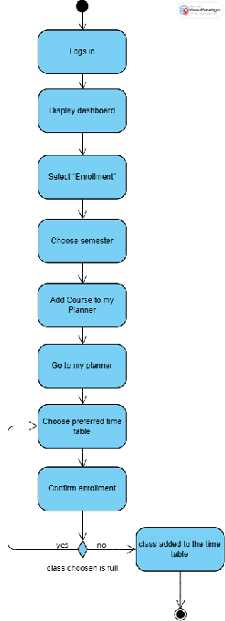
Figure 3.1.2.1.5. Activity Diagram - Register or Drop Courses

3.1.2.1.6 Submit Coursework and View Feedback
Table 3.1.2.1.6. Use case Specification - Submit Coursework and View Feedback
No. |  | Section | Content
ID | 1.1 | Name | Submit Coursework and View Feedback
Management | 2.1 | Author | Iman Nadhirah
Context | 3.1 | Source | ebwise
Use Case Definition | 4.1 | Short Description | Student uploads assignment and views lecturer feedback.
 | 4.2 | Goal | Provide digital submission and feedback viewing function.
 | 4.3 | Actor | Student
 | 4.4 | Pre-Condition | Coursework submission is opened by the lecturer
 | 4.5 | Post-Condition | File is submitted and feedback is given by the lecturer
 | 4.6 | Main Success Scenario | 1. Student logs in 2. Select a course 3. Go to coursework assigned by the lecturer 4. Uploads file 5. Confirm submission 6. View feedback once marked by the lecturer.
 | 4.7 | Alternative Scenario | 1. Students can upload multiple files.
 | 4.8 | Exception Scenario | 1. File upload fail - system shows: “Upload unsuccessful. Try again.”
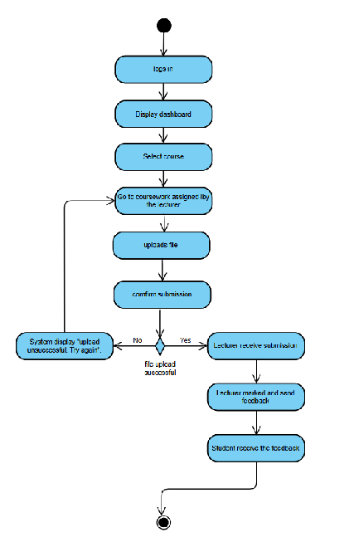
Figure 3.1.2.1.6. Activity Diagram - Submit Coursework and View Feedback

3.1.2.1.7. Pay Tuition and Other Fees
Table 3.1.2.1.7. Use case Specification - Pay Tuition and Other Fees
No. |  | Section | Content
ID | 1.1 | Name | Pay tuition and Fees
Management | 2.1 | Author | Iman Nadhirah
Context | 3.1 | Source | CLiC
Use Case Definition | 4.1 | Short Description | Student pays outstanding tuition or miscellaneous fees online.
 | 4.2 | Goal | Enable fast and secure fee payment
 | 4.3 | Actor | Student
 | 4.4 | Pre-Condition | Student has unpaid fees.
 | 4.5 | Post-Condition | Payment is recorded and receipt issued.
 | 4.6 | Main Success Scenario | 1. Students log in. 2. Goes to “Payments”. 3. System shows outstanding bills. 4. Students select bills that they want to pay. 5. Enter payment info 6. Receives confirmation
 | 4.7 | Alternative Scenario | 1. Student saves payment info for later. 2. No outstanding balance System show “You have no outstanding balance”
 | 4.8 | Exception Scenario | 1. Payment fails System shows: “Transaction declined.”
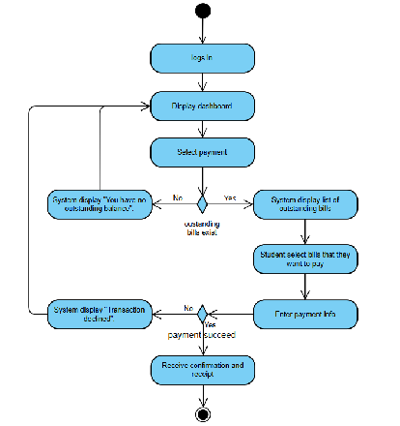
Figure 3.1.2.1.7. Activity Diagram - Pay Tuition and Other Fees

3.1.2.1.8. View Payment History and Invoices
Table 3.1.2.1.8. Use case Specification - View Payment History and Invoices
No. |  | Section | Content
ID | 1.1 | Name | View Payment History and Invoices
Management | 2.1 | Author | Iman Nadhirah
Context | 3.1 | Source | Cimb bank
Use Case Definition | 4.1 | Short Description | Student views list of paid Invoices and receipts
 | 4.2 | Goal | Help student track financial history.
 | 4.3 | Actor | Student
 | 4.4 | Pre-Condition | Students have made payments before.
 | 4.5 | Post-Condition | Payment records are displayed.
 | 4.6 | Main Success Scenario | 1. Students log in. 2. Goes to “Payment History” 3. Views or downloads invoices
 | 4.7 | Alternative Scenario | 1. Filter payment history by semester.
 | 4.8 | Exception Scenario | 1. No records The system shows: “No payment history found.”
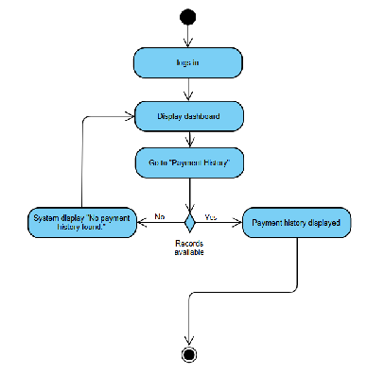
Figure 3.1.2.1.8. Activity Diagram - View Payment History and Invoices

3.1.2.1.9. Receive SMS/Email Alerts
Table 3.1.2.1.9. Use case Specification - Receive SMS/Email Alerts
No. |  | Section | Content
ID | 1.1 | Name | Receive alerts
Management | 2.1 | Author | Iman Nadhirah
Context | 3.1 | Source
Use Case Definition | 4.1 | Short Description | Student receives automated alerts vias SMS/email
 | 4.2 | Goal | Notify students of critical academic and financial updates
 | 4.3 | Actor | student
 | 4.4 | Pre-Condition | Student is registered and notifications are enabled
 | 4.5 | Post-Condition | Alerts are received in inbox/SMS.
 | 4.6 | Main Success Scenario | 1. Event trigger (example; low attendance) 2. System sends message 3. Student receives it
 | 4.7 | Alternative Scenario | Students configure alerts and preferences.
 | 4.8 | Exception Scenario | 1. Delivery fails System logs error and retries
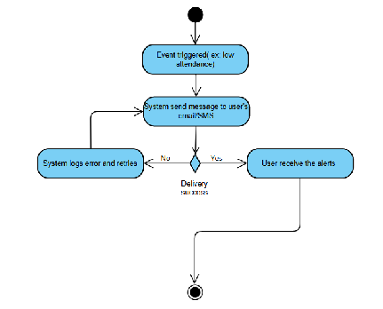
Figure 3.1.2.1.9. Activity Diagram - Receive SMS/Email Alerts

3.1.2.1.10 View Announcements and Academic Notifications
Table 3.1.2.1.10. Use case Specification - View Announcements and Academic Notifications
No. |  | Section | Content
ID | 1.1 | Name | View Announcements
Management | 2.1 | Author | Iman Nadhirah
Context | 3.1 | Source | Ebwise
Use Case Definition | 4.1 | Short Description | Student views posted updates from lecturers/admins
 | 4.2 | Goal | Ensure student are informed of academic key notices.
 | 4.3 | Actor | Student
 | 4.4 | Pre-Condition | Announcements are posted.
 | 4.5 | Post-Condition | Notifications are read.
 | 4.6 | Main Success Scenario | 1. Students log in. 2. Goes to “Announcements”. 3. View list of announcements.
 | 4.7 | Alternative Scenario | 1. Filters announcements by course
 | 4.8 | Exception Scenario | 1. System fails to load System shows: “Unable to retrieve announcements.”
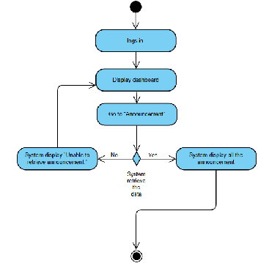
Figure 3.1.2.1.10. Activity DIagram - View Announcements and Academic Notifications

3.1.2.1.11 Update Personal Profile Information
Table 3.1.2.1.11. Use case Specification - Update Personal Profile Information
No. |  | Section | Content
ID | 1.1 | Name | Update profile
Management | 2.1 | Author | Iman Nadhirah
Context | 3.1 | Source | CLiC
Use Case Definition | 4.1 | Short Description | Student edits personal information
 | 4.2 | Goal | Keep student contact details up to date
 | 4.3 | Actor | Student
 | 4.4 | Pre-Condition | Student is logged in.
 | 4.5 | Post-Condition | Updated info is saved in the system.
 | 4.6 | Main Success Scenario | 1. Student logs in. 2. Goes to “Profile” 3. Edits info. 4. Clicks “Save”.
 | 4.7 | Alternative Scenario | Student cancels changes
 | 4.8 | Exception Scenario | Save fails - system shows: “Update unsuccessful.”
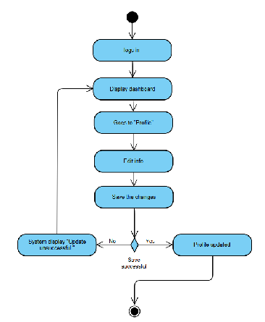
Figure 3.1.2.1.11. Activity Diagram - Update Personal Profile Information

3.1.2.1.12 Submit Feedback/ Support Tickets
Table 3.1.2.1.12. Use case Specification - Submit Feedback/ Support Tickets
No. |  | Section | Content
ID | 1.1 | Name | Submit Support Ticket
Management | 2.1 | Author | Iman Nadhirah
Context | 3.1 | Source | CLiC
Use Case Definition | 4.1 | Short Description | Student submits a complaint or technical support request.
 | 4.2 | Goal | Allow student to report issues and get assistance
 | 4.3 | Actor | Student
 | 4.4 | Pre-Condition | Student has access to the helpdesk module.
 | 4.5 | Post-Condition | Ticket is created and assigned for review.
 | 4.6 | Main Success Scenario | 1. Students logs in. 2. Students goes to “Help/Support”. 3. Students fills out issue form. 4. Submit a ticket. 5. Receives confirmation.
 | 4.7 | Alternative Scenario | 1. Student views past ticket status.
 | 4.8 | Exception Scenario | 1. Submission fails System shows: “Unable to submit ticket.”
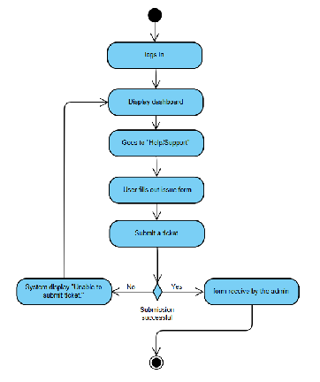
Figure 3.1.2.1.12. Activity Diagram - Submit Feedback/ Support Tickets

3.1.2.1.13 Monitor Student Academic Performance
Table 3.1.2.1.13. Use case Specification - Monitor Student Academic Performance
No. |  | Section | Content
ID | 1.1 | Name | Monitor Academic Performance
Management | 2.1 | Author | Iman Nadhirah
Context | 3.1 | Source
Use Case Definition | 4.1 | Short Description | Student views a summary of their academic performance, including grades and attendance.
 | 4.2 | Goal | Enable students to track their academic progress independently.
 | 4.3 | Actor | Student
 | 4.4 | Pre-Condition | Academic data (grades, attendance) is available in the system.
 | 4.5 | Post-Condition | Student has reviewed performance data.
 | 4.6 | Main Success Scenario | 1. Student logs in. 2. Navigates to “Academic Dashboard”. 3. Views performance charts and grade summary.
 | 4.7 | Alternative Scenario | 1. Filters performance by semester or subject.
 | 4.8 | Exception Scenario | 1. Dashboard fails to load. System shows: “Unable to display academic performance.”

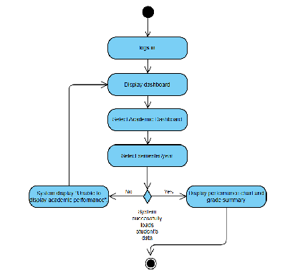
Figure 3.1.2.1.13. Activity Diagram - Monitor Student Academic Performance

3.1.2.1.14 Customize Notification Preferences
Table 3.1.2.1.14 Use case Specification - Customize Notification Preferences
No. |  | Section | Content
ID | 1.1 | Name | Customize Notification Preferences
Management | 2.1 | Author | Iman Nadhirah
Context | 3.1 | Source | MsTeams
Use Case Definition | 4.1 | Short Description | Student selects preferred notification method for academic alerts (SMS, email, or both).
 | 4.2 | Goal | Allow students to receive alerts in a format that suits their preference.
 | 4.3 | Actor | Student
 | 4.4 | Pre-Condition | Student has login to their account
 | 4.5 | Post-Condition | Notification preferences are saved and applied.
 | 4.6 | Main Success Scenario | 1. Student logs in. 2. Goes to “Notification Settings”. 3. Selects preferred channel (SMS/email/both). 4. Save settings.
 | 4.7 | Alternative Scenario | 1. Different settings for different alert types (e.g., SMS for fees, email for grades).
 | 4.8 | Exception Scenario | 1. Settings fail to save. System shows: “Notification preferences update failed.”

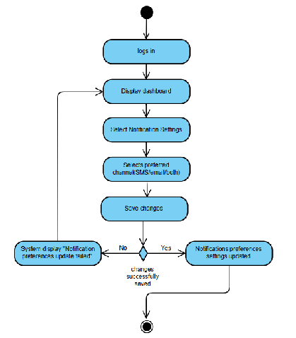
Figure 3.1.2.1.14. Activity Diagram - Customize Notification Preferences

3.1.2.2 Parent function
3.1.2.2.1 Login
Table 3.1.2.2.1. Use case Specification - Login
No. |  | Section | Content
ID | 1.1 | Name | Login
Management | 2.1 | Author | Suzannah Pancer
Context | 3.1 | Source | CLiC
Use Case Definition | 4.1 | Short Description | Parent accesses the system using valid login credentials.
 | 4.2 | Goal | To authenticate and grant parent access to the system.
 | 4.3 | Actor | Parent
 | 4.4 | Pre-Condition | Parent has an active account in the system.
 | 4.5 | Post-Condition | Parent is redirected to the dashboard.
 | 4.6 | Main Success Scenario | Parent navigates to login page. Enters username and password. Clicks “Login”. System authenticates credentials. Dashboard is displayed.
 | 4.7 | Alternative Scenario | 1. Parent cancels login attempt.
 | 4.8 | Exception Scenario | 1. Invalid credentials – system shows: “Login failed. Please try again.”
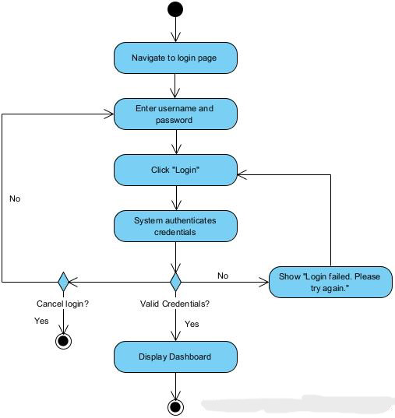
Figure 3.1.2.2.1. Activity Diagram - Login
3.1.2.2.2 View Child’s Grades and Attendance
Table 3.1.2.2.2. Use case Specification - View Child’s Grades and Attendance
No. |  | Section | Content
ID | 1.1 | Name | View Child’s Grades and Attendance
Management | 2.1 | Author | Suzannah Pancer
Context | 3.1 | Source | CLiC
Use Case Definition | 4.1 | Short Description | Parent views their child’s academic grades and class attendance.
 | 4.2 | Goal | To allow parents to monitor student academic performance.
 | 4.3 | Actor | Parent
 | 4.4 | Pre-Condition | Parent is successfully logged into the system.
 | 4.5 | Post-Condition | The child’s grades and attendance records are displayed.
 | 4.6 | Main Success Scenario | 1. Parent logs in. 2. Dashboard is displayed. 3. Parent selects “Grades & Attendance”. 4. System retrieves and displays grades and attendance.
 | 4.7 | Alternative Scenario | 1. Parent cancels the request or navigates away from the page.
 | 4.8 | Exception Scenario | 1. System fails to retrieve data – system shows: “Unable to fetch records.”

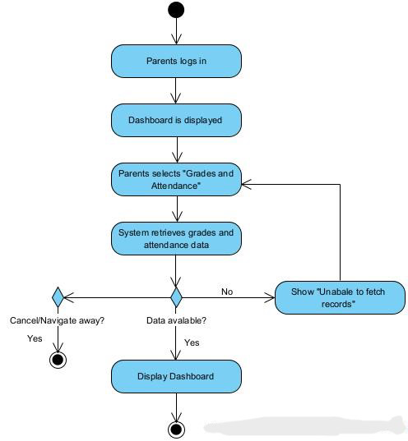
Figure 3.1.2.2.2. Activity Diagram - View Child’s Grades and Attendance
3.1.2.2.3 Receive SMS/Email alerts (e.g. Low Attendance, Financial Dues)
Table 3.1.2.2.3. Use case Specification - Receive SMS/Email alerts
No. |  | Section | Content
ID | 1.1 | Name | Receive Alerts (e.g. Low Attendance, Financial Dues)
Management | 2.1 | Author | Suzannah Pancer
Context | 3.1 | Source | CLiC
Use Case Definition | 4.1 | Short Description | Parent receives automatic alerts via SMS or email when child’s attendance is low or dues are pending.
 | 4.2 | Goal | To keep parents informed about critical academic or financial issues concerning their child.
 | 4.3 | Actor | Parent
 | 4.4 | Pre-Condition | Notification preferences are set and contact details are updated.
 | 4.5 | Post-Condition | Parent is notified through SMS/email when predefined alert conditions are triggered.
 | 4.6 | Main Success Scenario | System detects low attendance or unpaid dues. Alert message is generated. Message is sent to parent’s registered contact via SMS or email. Parent receives and reads the notification.
 | 4.7 | Alternative Scenario | 1. Parent has disabled one of the notification types (e.g., only SMS or only email is active).
 | 4.8 | Exception Scenario | 1. System fails to send the alert – system logs error and retries or prompts admin.
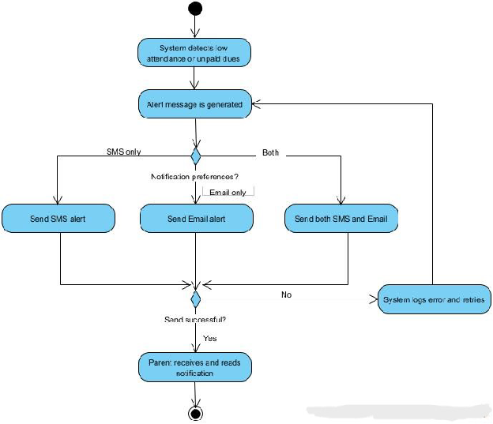
Figure 3.1.2.2.3. Activity Diagram - Receive SMS/Email alerts
3.1.2.2.4 Access Child’s Schedule and Academic Summary
Table 3.1.2.2.4. Use case Specification - Access Child’s Schedule and Academic Summary
No. |  | Section | Content
ID | 1.1 | Name | Access Child’s Schedule and Academic Summary
Management | 2.1 | Author | Suzannah Pancer
Context | 3.1 | Source | CLiC
Use Case Definition | 4.1 | Short Description | Parents view their child’s class schedule, subjects, and academic performance summaries.
 | 4.2 | Goal | To enable parents to monitor their child’s academic plan and performance easily.
 | 4.3 | Actor | Parent
 | 4.4 | Pre-Condition | Parent is logged in and associated with the child’s student profile.
 | 4.5 | Post-Condition | Parent successfully views the child’s schedule and academic summary on the system.
 | 4.6 | Main Success Scenario | Parent logs into the system. Navigates to “Child Schedule” or “Academic Summary” section. System retrieves and displays the child’s class schedule and summary of academic performance.
 | 4.7 | Alternative Scenario | 1. No schedule or summary is available for the current academic term — system shows a message.
 | 4.8 | Exception Scenario | 1. Data retrieval error — system displays “Unable to load schedule/summary. Please try again.”
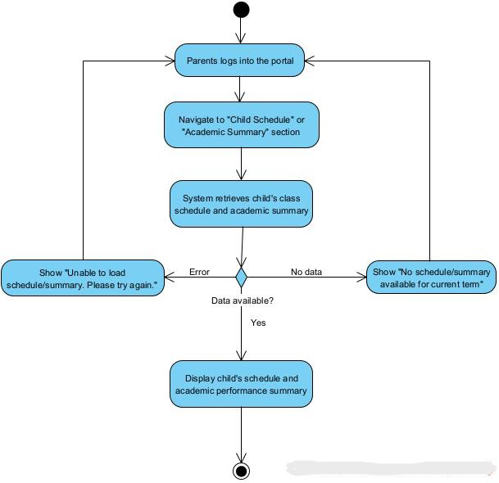
Figure 3.1.2.2.4. Activity Diagram - Access Child’s Schedule and Academic Summary
3.1.2.2.5 Customize Notification Preferences (SMS/email)
Table 3.1.2.2.5. Use case Specification - Customize Notification Preferences (SMS/email)
No. |  | Section | Content
ID | 1.1 | Name | Customize Notification Preferences (SMS/email)
Management | 2.1 | Author | Suzannah Pancer
Context | 3.1 | Source | MsTeams
Use Case Definition | 4.1 | Short Description | Parent updates their preferred notification method (SMS, email, or both) for alerts.
 | 4.2 | Goal | To allow parents to control how they receive important alerts regarding their child.
 | 4.3 | Actor | Parent
 | 4.4 | Pre-Condition | Parent is logged in. Notification settings are available in the system.
 | 4.5 | Post-Condition | Notification preferences are successfully updated and saved in the system.
 | 4.6 | Main Success Scenario | 1. Parent logs into the system. 2. Navigates to the Notification Settings section. 3. Selects preferred method(s) (SMS, email). 4. Clicks “Save Preferences”. 5. System confirms the changes.
 | 4.7 | Alternative Scenario | 1. Parent selects no method — system prompts that at least one method must be selected.
 | 4.8 | Exception Scenario | 1. Save operation fails — system displays: “Failed to update preferences. Please try again.”
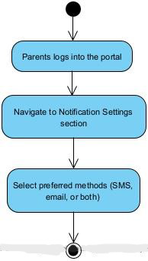
Figure 3.1.2.2.5. Activity Diagram - Customize Notification Preferences (SMS/email)
3.1.2.2.6 View Payment History and Dues Summary
Table 3.1.2.2.6. Use case Specification - View Payment History and Dues Summary
No. |  | Section | Content
ID | 1.1 | Name | View Payment History and Dues Summary
Management | 2.1 | Author | Suzannah Pancer
Context | 3.1 | Source | CLiC
Use Case Definition | 4.1 | Short Description | Parent views the history of past payments and outstanding dues for their child.
 | 4.2 | Goal | To provide financial transparency and allow timely fee settlements.
 | 4.3 | Actor | Parent
 | 4.4 | Pre-Condition | Parent is logged in and linked to at least one student.
 | 4.5 | Post-Condition | System displays up-to-date payment history and current dues summary.
 | 4.6 | Main Success Scenario | 1. Parent logs into the system. 2. Navigates to the “Payments” section. 3. Selects “View History & Dues”. 4. System displays payment transactions and outstanding dues.
 | 4.7 | Alternative Scenario | 1. No payments made yet — system shows “No transactions found.”
 | 4.8 | Exception Scenario | 1. Payment data retrieval fails — system displays: “Unable to fetch payment records.”
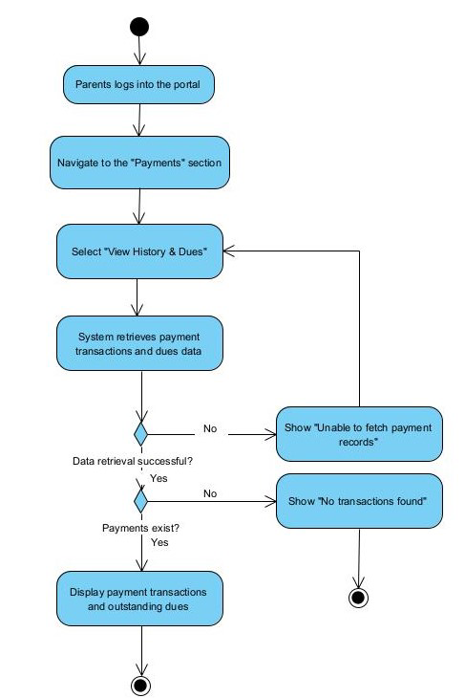
Figure Activity Diagram - View Payment History and Dues Summary

3.1.2.3 Lecturer function
3.1.2.3.1 Login
Table 3.1.2.3.1 Use case Specification - Login
No. |  | Section | Content
ID | 1.1 | Name | Login
Management | 2.1 | Author | Natasha Adilyn
Context | 3.1 | Source | Clic, ebwise
Use Case Definition | 4.1 | Short Description | The user logs into their account
 | 4.2 | Goal | Authenticate user identity to access the platform’s feature
 | 4.3 | Actor | Lecturer
 | 4.4 | Pre-Condition | The user is registered and Authenticated in the system
 | 4.5 | Post-Condition | The user gains access to personalized features within the system
 | 4.6 | Main Success Scenario | 1. The user navigates to the login page. 2. The user enter their username and password 3. The user clicks the “Login” button. 4. The system validates the credentials The system displays the student’s dashboard
 | 4.7 | Alternative Scenario | 1. The user wants to log in using a social media account such as LinkedIn The system redirects the user to the social media credentials and authorize access The user enters their social media credentials and authorize access The system validates the social media credentials and logs the user in
 | 4.8 | Exception Scenario | 1. The user enter incorrect credentials The system displays an error message indicating invalid credentials The user is prompted to re-enter their username and password.

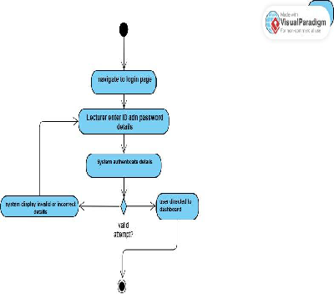
Figure 3.1.2.3.1 Activity Diagram - Login
3.1.2.3.2 Upload student grades
Table 3.1.2.3.2. Use case Specification - Upload student grades
No. |  | Section | Content
ID | 1.1 | Name | Upload student grades
Management | 2.1 | Author | Natasha Adilyn
Context | 3.1 | Source | Clic, ebwise
Use Case Definition | 4.1 | Short Description | The user updates grades of student
 | 4.2 | Goal | Upload and store grades for students to get updates on Academic Transcripts
 | 4.3 | Actor | Lecturer
 | 4.4 | Pre-Condition | The user gains access to make updates in system
 | 4.5 | Post-Condition | Updated info is saved in the system.
 | 4.6 | Main Success Scenario | 1. The user navigates to the Academic records page. 2. The user enters the course and student ID of students grade to be updated. 3. Enters grade credited for specific students. 4. The user clicks the “Confirm” button. 5. The system validates the details and stores them in the database.
 | 4.7 | Alternative Scenario | 1. The user inserts “bulk updates” and uploads a pre-formatted excel file containing student ID and their corresponding grades. 2. The system parses the file, validates the data and displays a summary of updates.
 | 4.8 | Exception Scenario | 1. The user enter incorrect credentials The system displays an error message indicating invalid credentials The user is prompted to re-enter the student IDs and grades.
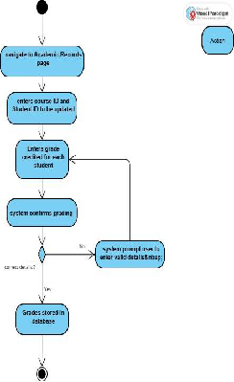
Figure 3.1.2.3.2 Activity Diagram - Upload students grade
3.1.2.3.3 Mark and manage attendance records
Table 3.1.2.3.3 Use case Specification - Mark and manage attendance records
No. |  | Section | Content
ID | 1.1 | Name | Mark and manage attendance records
Management | 2.1 | Author | Natasha Adilyn
Context | 3.1 | Source | Clic
Use Case Definition | 4.1 | Short Description | The user marks and updates students’ attendance in Student’s records.
 | 4.2 | Goal | Mark and update students’ class attendance in the system by the end of class.
 | 4.3 | Actor | Lecturer
 | 4.4 | Pre-Condition | The user gains access to make updates in system
 | 4.5 | Post-Condition | Updated attendance is saved in the system.
 | 4.6 | Main Success Scenario | 1. The user navigates to the Attendance records page. 2. The user enters the course ID and time of class for attendance to be taken. 3. The system generates one-time QR code with session timeout. 4. The system receives details of student logging into the session. 5. The system validates the details and stores them in the database.
 | 4.7 | Alternative Scenario | 1. The user manually ticks students within the class according to the list sorted. 2. After confirmation the user will click “confirm” 3. Student’s Attendance will be updated into the system.
 | 4.8 | Exception Scenario | 1. The student attempts to scan the Qr code after the session expires. 2. The system detects teh expired session and displays an “ Attendance session expired” error message. 3. The student’s attendance is not recorded, and system logs failed.

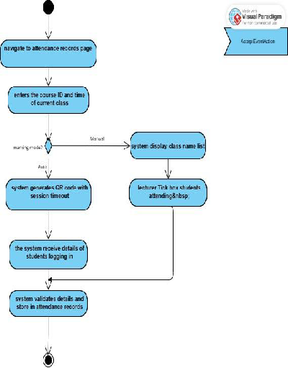
Figure 3.1.2.3.3 Activity Diagram - Mark and update student attendance
3.1.2.3.4 Post class announcements and updates
Table 3.1.2.3.4 Use case Specification - Post class announcements and updates
No. |  | Section | Content
ID | 1.1 | Name | Post class announcements and updates
Management | 2.1 | Author | Natasha Adilyn
Context | 3.1 | Source | Ebwise
Use Case Definition | 4.1 | Short Description | The user posts announcements or updates in the system for students’ reference.
 | 4.2 | Goal | Students receive and get updates on announcements and updates made by the lecturer.
 | 4.3 | Actor | Lecturer
 | 4.4 | Pre-Condition | The user gains access to make updates in system
 | 4.5 | Post-Condition | Announcements is passed to all or selected section of students class
 | 4.6 | Main Success Scenario | 1. The user navigates to the main page for specific subject or section 2. Lecturer navigate to announcements section 3. Include context or announcements to be delivered. 4. The lecturers selected the recipient and posted an announcement. 5. The system delivers the announcement via in-system notification and optionally triggers email of the selected recipients.
 | 4.8 | Exception Scenario | 1. The lecturer attached unsupported files or with bigger size than the limit. 2. The system displays an error message.
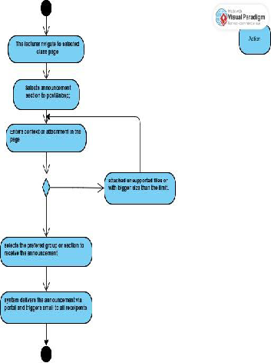
Figure 3.1.2.3.4 Activity Diagram - Post class announcements and updates
3.1.2.3.5 View academic calendar and class schedules
Table 3.1.2.3.5 Use case Specification - View academic calendar and class schedules
No. |  | Section | Content
ID | 1.1 | Name | View academic calendar and class schedules
Management | 2.1 | Author | Natasha Adilyn
Context | 3.1 | Source | Clic
Use Case Definition | 4.1 | Short Description | The user views their academic calendar and class schedule that has been updated
 | 4.2 | Goal | Lecturers get their own academic calendar printout and arranged class schedule for the semester.
 | 4.3 | Actor | Lecturer
 | 4.4 | Pre-Condition | The user is gains access to receive updates in system
 | 4.5 | Post-Condition | Views academic calendar and arranged class schedule.
 | 4.6 | Main Success Scenario | 1. The user navigates to the class schedule page. 2. The user enters the Term and subject code 3. The system displays the academic calendar and class schedule that has been set up by administration.
 | 4.8 | Exception Scenario | 1. The user enters invalid subject code 2. The system displays “No schedule found for the selected term and subject” error message.

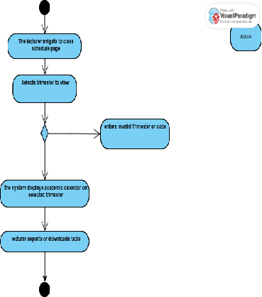
Figure 3.1.2.3.5.1 Activity Diagram -View academic calendar and class schedules
3.1.2.3.6 Monitor student academic performance
Table 3.1.2.3.6 Use case Specification - Monitor student academic performance
No. |  | Section | Content
ID | 1.1 | Name | Monitor student academic performance
Management | 2.1 | Author | Natasha Adilyn
Context | 3.1 | Source | Clic, Ebiwise
Use Case Definition | 4.1 | Short Description | The user monitors a list of students’ academic performance grades.
 | 4.2 | Goal | Lecturers gets to oversee students grade
 | 4.3 | Actor | Lecturer
 | 4.4 | Pre-Condition | The user gains access to read updates in the system
 | 4.5 | Post-Condition | View and oversee students grades performance
 | 4.6 | Main Success Scenario | 1. The user navigates to the Students records page. 2. The user enters the student ID or select name from dropdown list 3. The system retrieves the student’s academic records 4. The system displays the data in a structured format
 | 4.8 | Exception Scenario | 1. The user enters invalid student ID code 2. The system displays “academic records not available for the selected student and term” error message.
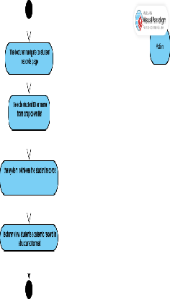
Figure 3.1.2.3.6 Activity Diagram -Monitor student academic performance
3.1.2.3.7 Export Grades and Attendance Reports
Table 3.1.2.3.7 Use case Specification - Export Grades and Attendance Reports
No. |  | Section | Content
ID | 1.1 | Name | Export Grades and Attendance Reports
Management | 2.1 | Author | Natasha Adilyn
Context | 3.1 | Source | Clic, Ebwise
Use Case Definition | 4.1 | Short Description | The user generates or downloads records on grades and attendance reports.
 | 4.2 | Goal | Users are able to get a copy of grades and attendance reports in desired file format for record keeping.
 | 4.3 | Actor | Lecturer
 | 4.4 | Pre-Condition | The user gains access to receive updates in system
 | 4.5 | Post-Condition | Copies of reports are generated.
 | 4.6 | Main Success Scenario | 1. The user navigates to the Attendance records page. 2. The user selects exports grades and attendance reports 3. The system retrieves relevant data from the database. 4. The system generates previews of the report. 5. The user clicks the “confirm export” button. 6. System compiles data and prompts users to download the file.
 | 4.8 | Exception Scenario | 1. The user selects exports grades and attendance reports 2. The system retrieves relevant data from the database. 3. the system displays an “Export Failed: Unable to retrieve data” error message.

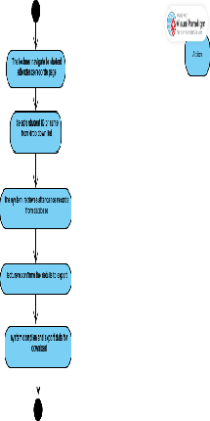
Figure 3.1.2.3.7 Activity Diagram -Export grades and attendance reports
3.1.2.3.8 Manage Coursework Submissions
Table 3.1.2.3.8 Use case Specification - Manage Coursework submission
No. |  | Section | Content
ID | 1.1 | Name | Manage coursework submission
Management | 2.1 | Author | Natasha Adilyn
Context | 3.1 | Source | Ebwise
Use Case Definition | 4.1 | Short Description | The user creates, monitor and mark assignments
 | 4.2 | Goal | Grade student’s contribution in the assignment given
 | 4.3 | Actor | Lecturer
 | 4.4 | Pre-Condition | The user gains access to make updates in system.
 | 4.5 | Post-Condition | Updated grades on coursework assigned.
 | 4.6 | Main Success Scenario | 1. The user navigates to Coursework page of chosen class 2. The lecturer writes and creates assignments specifications. 3. Coursework posted with a due date set. 4. The system triggers email or students assigned for the assignment 5. The lecturer can monitor students who handed in or not. 6. Give marks or grades respectively to the coursework.
 | 4.7 | Alternative Scenario | 1. The coursework given does not have a due date set 2. System accepts late submissions and flags it as “late”.
 | 4.8 | Exception Scenario | 1. The student attempt to upload unsupported file type or have disrupted network 2. System detects the issue and prevents the submission. 3. Student is prompted to re-upload the file with correct format and strong internet connectivity

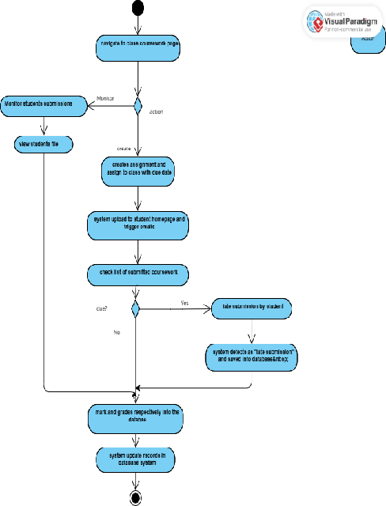
Figure 3.1.2.3.8 Activity Diagram -Manage Coursework Submission
3.1.2.3.9 Submit Helpdesk tickets
Table 3.1.2.4.9. Use case Specification - Submit helpdesk tickets
No. |  | Section | Content
ID | 1.1 | Name | Submit Helpdesk Tickets or System Issues
Management | 2.1 | Author | Natasha Adilyn
Context | 3.1 | Source | Helpdesk & Support Module
Use Case Definition | 4.1 | Short Description | Lecturer submits form or tickets upon issues faced in the system.
 | 4.2 | Goal | Shares user issues and for future improvements
 | 4.3 | Actor | Lecturer
 | 4.4 | Pre-Condition | Support tickets must exist in the system.
 | 4.5 | Post-Condition | Tickets are resolved, updated, or escalated.
 | 4.6 | Main Success Scenario | Lecturer opens the ticket dashboard. submit new tickets on issues gone through. System validates the form and store in support database System updates admins on ticket issued
 | 4.8 | Exception Scenario | The system flags for user follow-up if the ticket is invalid or incomplete.
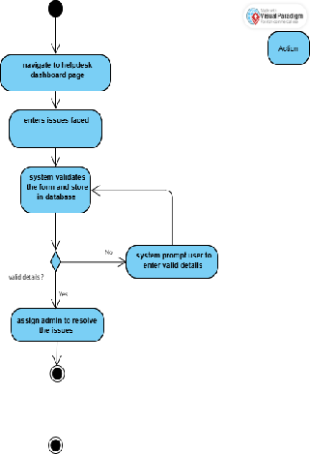
Figure 3.1.2.3.9 Activity Diagram - Submit helpdesk tickets

3.1.2.4 Administrator function
3.1.2.4.1 Login
Table 3.1.2.4.1. Use case Specification - Login
No. |  | Section | Content
ID | 1.1 | Name | Login
Management | 2.1 | Author | Pharthiban A/L Kumarhesan
Context | 3.1 | Source | EduAxis (Auth integrated with centralized Authentication Service)
Use Case Definition | 4.1 | Short Description | The user logs in to access personalized features in the EduAxis.
 | 4.2 | Goal | Authenticate user identity to access the platform’s features.
 | 4.3 | Actor | Admin
 | 4.4 | Pre-Condition | The user must be registered and their account must exist in the system.
 | 4.5 | Post-Condition | The user is granted access to their dashboard and personalized features.
 | 4.6 | Main Success Scenario | The user navigates to the login page. The user enters their username and password. The user clicks the “Login” button. The system authenticates the credentials via the Authentication Service. The system redirects the user to their role-specific dashboard.
 | 4.7 | Alternative Scenario | The user logs in via centralized university SSO (Single Sign-On). The system redirects to the university SSO login page. The user enters SSO credentials and grants access. The system validates the credentials via Authentication Service. The user is redirected to their system dashboard.
 | 4.8 | Exception Scenario | The user enters incorrect credentials. The system shows an error message: “Invalid username or password.” The user is prompted to re-enter credentials or reset password.
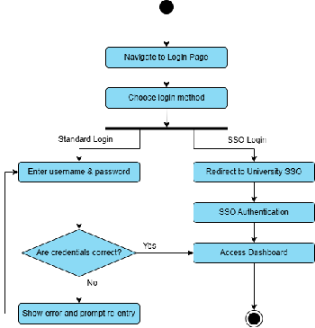
Figure 3.1.2.4.1. Activity Diagram - Login
3.1.2.4.2 Manage User Accounts
Table 3.1.2.4.2. Use case Specification - Manage User Accounts
No. |  | Section | Content
ID | 1.1 | Name | Manage User Accounts
Management | 2.1 | Author | Pharthiban A/L Kumarhesan
Context | 3.1 | Source | EduAxis – Admin Module
Use Case Definition | 4.1 | Short Description | The Admin manages user creation, updates, and deactivation.
 | 4.2 | Goal | Maintain user account lifecycle securely and efficiently.
 | 4.3 | Actor | Admin
 | 4.4 | Pre-Condition | Admin must be authenticated with necessary privileges.
 | 4.5 | Post-Condition | User accounts are added, updated, or removed as required.
 | 4.6 | Main Success Scenario | Admin accesses User Management Panel. Selects Create, Edit, or Delete action. The system updates the University Database accordingly. Success confirmation is displayed.
 | 4.7 | Alternative Scenario | Admin bulk uploads accounts using a template CSV. System processes and confirms successful imports.
 | 4.8 | Exception Scenario | If user data is invalid or username exists, the system returns an error for correction.
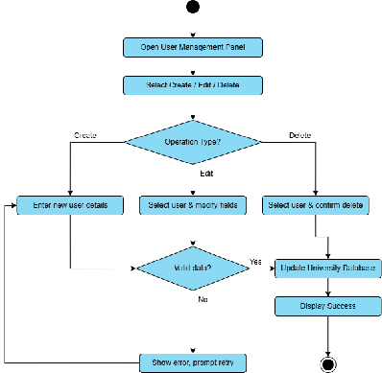
Figure 3.1.2.4.2. Activity Diagram - Manage User Accounts
3.1.2.4.3 Configure & Manage SMS/Email Notification Services
Table 3.1.2.4.3. Use case Specification - Configure & Manage SMS/Email Notification Services
No. |  | Section | Content
ID | 1.1 | Name | Configure & Manage SMS/Email Notification Services
Management | 2.1 | Author | Pharthiban A/L Kumarhesan
Context | 3.1 | Source | Notification Module, Admin Dashboard
Use Case Definition | 4.1 | Short Description | Admin configures alert templates and manages sending services.
 | 4.2 | Goal | Ensure effective communication via automated alerts.
 | 4.3 | Actor | Admin
 | 4.4 | Pre-Condition | Admin has system settings access and configured gateway credentials.
 | 4.5 | Post-Condition | Notification templates are saved and services are connected.
 | 4.6 | Main Success Scenario | Admin opens Notification Settings. Edits or adds SMS/email templates. Links with active SMS Gateway. The system confirms and enables service.
 | 4.7 | Alternative Scenario | Admin enables or disables notifications per user type or alert category.
 | 4.8 | Exception Scenario | Alert and retry option is displayed when the system fails to connect to the SMS Gateway.
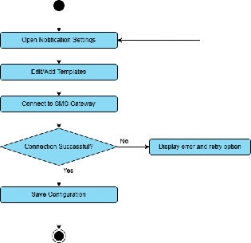
Figure 3.1.2.4.3. Activity Diagram - Configure & Manage SMS/Email Notification Services
3.1.2.4.4 Integrate & Sync with CMS, LMS
Table 3.1.2.4.4. Use case Specification - Integrate & Sync with CMS, LMS
No. |  | Section | Content
ID | 1.1 | Name | Integrate & Sync with CMS, LMS
Management | 2.1 | Author | Pharthiban A/L Kumarhesan
Context | 3.1 | Source | Integration Settings – External Systems
Use Case Definition | 4.1 | Short Description | Admin configures integration with academic & learning systems.
 | 4.2 | Goal | Synchronize data from external systems like grades, attendance, and coursework.
 | 4.3 | Actor | Admin
 | 4.4 | Pre-Condition | External system credentials and API endpoints must be configured.
 | 4.5 | Post-Condition | The system is successfully synced with external CMS or LMS.
 | 4.6 | Main Success Scenario | Admin opens the Integration Panel. Enters LMS/CMS API settings. Initiates sync. The system pulls data and confirms success.
 | 4.7 | Alternative Scenario | Admin sets auto-sync intervals such as daily at midnight.
 | 4.8 | Exception Scenario | System logs and notifies admin when sync is failed due to invalid credentials or timeout.
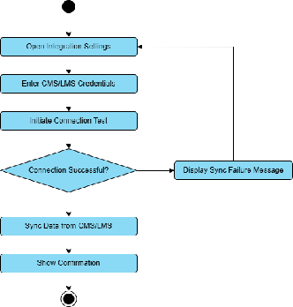
Figure 3.1.2.4.4. Activity Diagram - Integrate & Sync with CMS, LMS
3.1.2.4.5 Automate Workflows
Table 3.1.2.4.5. Use case Specification - Automate Workflows
No. |  | Section | Content
ID | 1.1 | Name | Automate Workflows
Management | 2.1 | Author | Pharthiban A/L Kumarhesan
Context | 3.1 | Source | Workflow Automation Module
Use Case Definition | 4.1 | Short Description | Admin sets up automation for repetitive tasks like grade processing or fee alerts.
 | 4.2 | Goal | Reduce manual work and ensure timely task execution.
 | 4.3 | Actor | Admin
 | 4.4 | Pre-Condition | Trigger conditions and tasks must be defined.
 | 4.5 | Post-Condition | Workflows are saved and activated.
 | 4.6 | Main Success Scenario | Admin creates a new workflow. Defines trigger conditions such as attendance < 80%. Assigns actions such as sending alerts. Saves and activates workflow.
 | 4.7 | Alternative Scenario | Admin clones or edits existing workflows.
 | 4.8 | Exception Scenario | System logs error and disables rule when workflow fails due to missing rule.
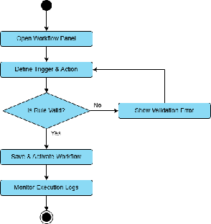
Figure 3.1.2.4.5. Activity Diagram - Automate Workflows
3.1.2.4.6 Post Global Announcements
Table 3.1.2.4.6. Use case Specification - Post Global Announcements
No. |  | Section | Content
ID | 1.1 | Name | Post Global Announcements
Management | 2.1 | Author | Pharthiban A/L Kumarhesan
Context | 3.1 | Source | Announcement Module
Use Case Definition | 4.1 | Short Description | Admin publishes announcements visible to all users.
 | 4.2 | Goal | Broadcast important university-wide messages.
 | 4.3 | Actor | Admin
 | 4.4 | Pre-Condition | Admin is logged in and has announcement privileges.
 | 4.5 | Post-Condition | Announcements are published and visible to the target audience.
 | 4.6 | Main Success Scenario | Admin opens the Announcement Panel. Composes message. Sets audience and schedule. Publishes announcement.
 | 4.7 | Alternative Scenario | Admin schedules the announcement to auto-publish later.
 | 4.8 | Exception Scenario | System prompts correction when content validation fails (missing fields).
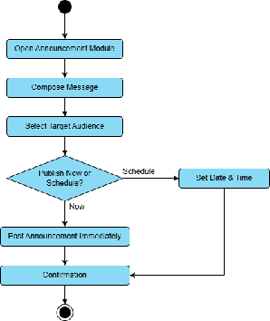
Figure 3.1.2.4.6. Activity Diagram - Post Global Announcements
3.1.2.4.7 Maintain Data Privacy & Access Permissions
Table 3.1.2.4.7. Use case Specification - Maintain Data Privacy & Access Permissions
No. |  | Section | Content
ID | 1.1 | Name | Maintain Data Privacy & Access Permissions
Management | 2.1 | Author | Pharthiban A/L Kumarhesan
Context | 3.1 | Source | System Access Control Panel
Use Case Definition | 4.1 | Short Description | Admin sets access levels and privacy rules for users.
 | 4.2 | Goal | Ensure only authorized users can access sensitive data.
 | 4.3 | Actor | Admin
 | 4.4 | Pre-Condition | Roles and permission sets are defined in the system.
 | 4.5 | Post-Condition | User access levels are enforced and updated.
 | 4.6 | Main Success Scenario | Admin opens Access Control Panel. Selects user/role. Assigns or modifies permissions. Saves changes.
 | 4.7 | Alternative Scenario | Admin imports permission templates by role.
 | 4.8 | Exception Scenario | The system prompts resolution when conflicting access levels are detected.
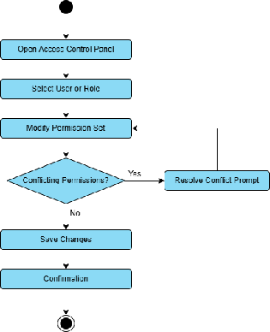
Figure 3.1.2.4.7. Activity Diagram - Maintain Data Privacy & Access Permissions
3.1.2.4.8 Respond to Helpdesk Tickets or System Issues
Table 3.1.2.4.8. Use case Specification - Respond to Helpdesk Tickets or System Issues
No. |  | Section | Content
ID | 1.1 | Name | Respond to Helpdesk Tickets or System Issues
Management | 2.1 | Author | Pharthiban A/L Kumarhesan
Context | 3.1 | Source | Helpdesk & Support Module
Use Case Definition | 4.1 | Short Description | Admin views and responds to user-submitted support tickets.
 | 4.2 | Goal | Resolve user issues and improve user satisfaction.
 | 4.3 | Actor | Admin
 | 4.4 | Pre-Condition | Support tickets must exist in the system.
 | 4.5 | Post-Condition | Tickets are resolved, updated, or escalated.
 | 4.6 | Main Success Scenario | Admin opens ticket dashboard. Views new/unresolved tickets. Assigns and responds. Updates ticket status (closed, escalated, resolved).
 | 4.7 | Alternative Scenario | Admin responds using canned responses or knowledge base links.
 | 4.8 | Exception Scenario | The system flags for user follow-up if the ticket is invalid or incomplete.
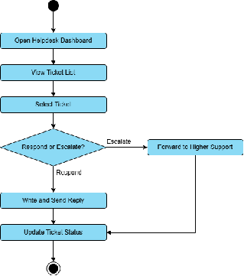
Figure 3.1.2.4.8. Activity Diagram - Respond to Helpdesk Tickets or System Issues

3.2 Performance requirements
The performance requirements for the EduAxis are specified below. These requirements include both static and dynamic numerical requirements, ensuring the system meets necessary performance standards for usability and efficiency.

3.2.1 Static Numerical Requirements
- Storage Scalability
- The system shall support a minimum of 2 TB of storage 10TB maximum capacity for academic records, attendance logs, user data and media uploads. However data storage usage does not exceed the maximum during peak periods for load controls.
- The system shall perform database backups every 12 hours to prevent data lost in the system. Back ups are stored securely and restorable within 30 mins of request.
- The system shall retrieve students records, attendance and schedules within ≤ 2 seconds of request submission
- Simultaneous user capacity
- The system shall accommodate up to 5,000 current users during peak usage periods. The system shall remain stable without crashes or latency over 2 seconds for most of user actions.
- The system shall automatically timeout a user session after 15 minutes of inactivity. Inactive sessions are logged out securely with session data cleared all the time.

3.2.2 Dynamic Numerical Requirements
- Task handling
- The system shall maintain a 99.5% task completion success rate for automated operations such as notifications handout, QR code generation, and schedule exports. With automated logs showing less than 0.5% failure rate in task processing.
- The system shall maintain an uptime of 99.9% on a monthly basis, accounting for maintenance windows which is a critical criteria for every system
- The system shall maintain a 95% responsiveness rate across all core features in the system such as in dashboard, notifications, and user profile update. User interaction logs will confirm the stable performance.
- During concurrent usage of more than 5,000 users, the system shall maintain a task success rate of above 95% across all modules.
- Data Processing
- The system shall ensure that more than 98% of background data synchronization tasks with University Management System and Campus Management System are completed within 5 seconds of interaction. Audit logs will show timely and accurate data reflection.
- The system shall ensure that more than 97% of submitted grade uploads are processed without manual intervention or error correction.
- The system shall deliver more than 95% of generated reports on grades or attendance to the user within 10 seconds under normal load.
- Peak Load Conditions
- Under peak load conditions the system shall process at least 90% of user requests within 5 seconds. Stress testing results must be less than 10% for slow or failed requests.
- Transaction handling
- The system shall successfully process more than 95% of all transactions including login, course registration and grade submissions within 2 seconds under normal operating conditions. The transaction logs will show 95% of actions completed under 2 seconds.
These performance requirements ensure that the system will be responsive and efficient, providing a seamless experience for students, parents, and lecturers even under heavy usage conditions. Each requirement is stated in measurable terms to facilitate testing and validation.

3.3 Usability Requirements
The usability and quality in user requirements for the EduAxis aims to ensure that the software is efficient, satisfying and productive for the intended users. These requirements encompass measurable criteria for effectiveness, efficiency and satisfaction and the prevention of future issues that could arise from its user specific contexts.

3.3.1 User Interface
- Consistent Layout and Design
- The system shall provide a consistent and intuitive user interface across all modules to support users with varying levels of technical expertise, especially first year students and parents with limited digital literacy.
- Responsive Design
- The system shall support responsive web design, ensuring usability across desktop, tablet and mobile devices without requiring separate systems.

3.3.2 User Experience
- Efficient Navigation
- The system shall provide intuitive navigation pathways through the system, to enable quick and smooth allocation of information and functionalities navigation.
- The system shall minimize the number of steps required to reach an intended function like viewing grades, checking attendance and registering courses.
- Personalized Recommendations
- The system shall adhere to Web Content Accessibility Guidelines (WCAG 2.1 Level AA) to ensure usability for users with impaired disabilities, including screen reader compatibility, keyboard navigation and appropriate colour contrast.

3.3.3 Communication
- Feedback Mechanism
- The system shall offer real time feedback after user’s actions such as form submission, file uploads or registration to enhance user confidence and clarity.
- Language Standards
- The system shall use clear, non-technical language in all on-screen instructions, alerts and error messages to accommodate users with diverse educational backgrounds.
- Notification Managements
- The system shall allow users to customize notification preferences, including SMS alerts and email notifications, to improve communications effectiveness and user satisfaction.

3.3.4 Data protection
- Data Encryption
- The system shall automatically log out users after a period of inactivity to prevent unauthorized access to sensitive data and protect users sessions.
- Server controls
- The system shall use encrypted channels (HTTPS) for all communication between clients and server, ensuring data transmission is secure from interception.

3.4 Interface Requirements

3.4.1 System interfaces
1. Authentication Service Interface
Functionality: Enables secure user login and role-based access control.
Interface Description: OAuth2-compliant API for verifying credentials and managing user sessions.
Constraints/Standards: Must support multi-factor authentication (MFA) and integrate with institutional single sign-on (SSO) services.
Data Flow: Bidirectional – users send credentials; server returns access tokens or denial.
2. Campus Management System Interface
Functionality: Provides academic records, enrollment data, and tuition details.
Interface Description: RESTful API to retrieve and update course registrations, grades, schedules, and financial records.
Constraints: Requires secure HTTPS communication, JSON data format, and role-based access.
Dependency: Real-time updates from this system are essential for accurate student dashboards and administrative tools.
3. University Database Interface
Functionality: Acts as the central data store for user profiles, academic histories, payment records, and access logs.
Interface Description: Structured API endpoints for CRUD (Create, Read, Update, Delete) operations on academic and personal data.
Constraints: Must comply with university data privacy regulations (e.g., GDPR, PDPA).
Data Flow: Bidirectional – supports user-initiated updates and system-initiated queries.
4. Learning Management System (LMS) Interface
Functionality: Syncs coursework, submissions, grades, and lecturer feedback.
Interface Description: RESTful API to access course materials, manage assessments, and update student performance data.
Constraints: Requires LMS-compatible data structure and secure token-based access.
5. SMS/Email Gateway Interface
Functionality: Facilitates communication via SMS and email alerts.
Interface Description: External messaging service (e.g., Twilio, SendGrid) integration for sending real-time alerts and notifications.
Constraints: Must support high availability and comply with opt-in/opt-out notification policies.
6. CMS Integration Interface (Content Management System)
Functionality: Allows admin to post global announcements and update web content.
Interface Description: Headless CMS API integration (e.g., Strapi or Contentful) for publishing dynamic content to the system.
Constraints: Requires real-time syncing and admin authentication tokens.
7. Helpdesk & Support Ticketing Interface
Functionality: Manages support requests from students, lecturers, and administrators.
Interface Description: Internal ticketing system or integration with services like Freshdesk/Zendesk via APIs.
Constraints: Should support status tracking, prioritization, and role-based ticket visibility.
8. User Interface (Human-System Interface)
Functionality: Provides a responsive, role-sensitive web/mobile UI for all users.
Interface Description: Web-based interface designed with accessibility and usability in mind; supports keyboard navigation, screen readers, and WCAG 2.1 Level AA compliance.
Constraints: Optimized for mobile and desktop access; must adapt to the roles (Student, Parent, Lecturer, Admin) with corresponding permissions and menus.
9. Notification Preference Management Interface
Functionality: Allows users to customize communication preferences.
Interface Description: UI component linked with SMS/Email Gateway APIs for toggling notification channels (email/SMS/app).

3.4.2 User interfaces

- Student Dashboard
The student dashboard serves as the centralized interface to manage academic and administrative activities. This dashboard integrates with LMS and CMS for real-time updates on grades and coursework progress. Students of the university can securely log in and access the personalized information as listed below.
- Class schedule, registered courses, and academic calendar
- Academic performance such as grades and attendance records
- Tuition payment status and history
- Notification and alerts including for low attendance and unpaid fees
- Coursework submission status and feedback from lecturers
- Announcement and academic updates
- Profile settings to update student’s personal details and notification preferences
- Parent Dashboard
This dashboard is optimised for concise overviews and direct alerts to ensure parents stay informed without overwhelming detail. Parents and guardians can log in via a secure system to monitor their child’s academic progress. The key features are listed below.
- Viewing the child’s grades and attendance status
- Access to course schedule and academic summary
- Notifications for critical issues such as low attendance and outstanding fees
- Customizable SMS/email alert preferences
- Lecturer Dashboard
Lecturers have access to a role-based dashboard to support teaching and communication tasks. This dashboard integrates with LMS to handle assignments and grade synchronization seamlessly. This dashboard allows lecturers to perform the tasks or actions as listed below.
- Uploading and updating student grades
- Marking and tracking student attendance
- Posting class announcement and updates
- Viewing academic calendar and teaching schedules
- Monitoring overall student performance and participation
- Administrative Control Panel
Administrators use a centralized control panel to manage the system’s operations and configurations. Key interface features for this control panel are listed below.
- User account management for students, lecturers and parents
- System integration tools for syncing with CMS, LMS and notification systems
- Workflow automation configuration for fee reminders, grade processing, etc.
- Moderation of global announcements and academic communications
- Help Desk ticket management and issue response tracking
- Notification services setup for SMS/email gateway settings
- Access control and data privacy configurations
- Display logs and dashboards for tracking system usage and engagement
- Notification and Alerts Console (Admin-side and System-triggered)
This module manages and monitors all automated notifications sent by the system. In this console Admins can perform the following actions.
- Configure and test SMS/email templates
- View history of alerts triggered by attendance drops, unpaid fees, or grade releases
- Set thresholds and conditions for alert generation
- Monitor system queue via the notification scheduler module
- Helpdesk Support Interface
Both users and admin will have access to helpdesk interfaces where they can perform the following tasks as listed below.
- Students, parents, and lecturers can submit support tickets
- Admins can respond, update, and close tickets via the dashboard
- The interface includes status tracking, ticket history, and response logs

3.4.3 Hardware interfaces
- Device Compatibility
The EduAxis is designed to be accessible across multiple device types of hardware requirements. Those devices include desktop and laptop computers running Windows, macOS or Linux operating systems with standard web browser such as Chrome, Microsoft, and Google.
- It also supports mobile devices, with fully responsive design optimized for Android and iOS smartphones and tablets, that enables student, parents and lecturers to access information conveniently at any circumstances.. Having multi-device compatibility ensures users can engage with the platform efficiently, enhancing user experience itself.
- Minimum server specifications for deployment are as follows:
  - CPU: Quad-core (4-core) processor
  - RAM: 8 GB
  - Storage: 256 GB SSD
- Internet Connectivity
Reliable internet connectivity is pivotal for components in the EduAxis, it facilitates real-time updates on communication and data synchronization with the university’s backend systems.
- To secure a seamless experience:
  - Basic access: at least 1 Mbps bandwidth
  - Peak performance (heavy traffic): 5 Mbps or more
- The system supports both ethernet and Wi-Fi networks, with integration into university-managed wifi to provide stable access for users within campus. Additionally, the system also supports cloud based access to enable off-campus usage with real-time data availability and synchronization in all locations. This potent structure will ensure fast, engaging communication between the system and users.
- Data Storage
To accommodate large numbers of academic and administrative data, the EduAxis relies on robust storage solutions that include both cloud storage and the university’s local storage framework:
  - Primary cloud storage: scalable and secure, used for student records, grades, attendance, and course materials.
  - Local backup servers at the university data center: mirror critical data to provide quick recovery if the cloud is unavailable.
- The dual-layered approach of cloud and local storage ensures that the system remains secured, and capable of handling high data loads while maintaining real time synchronization with all users.

3.4.4 Software interfaces

- Database Management System (DBMS)
- Name: PostgreSQL
- Mnemonic: DBMS
- Specification Number: N/A
- Version Number: Latest stable release (PostgreSQL 15+)
- Source: PostgreSQL Global Development Group (Open Source)
- Interface Purpose: The DBMS stores all user data, including student profiles, grades, attendance, notification preferences, payment records, helpdesk tickets, and system logs. It supports relational queries for internal modules and secure transactions during academic workflows.
- Web Server
- Name: NGINX
- Mnemonic: Web Server
- Specification Number: N/A
- Version Number: Latest stable version
- Source: F5 NGINX (Open Source)
- Interface Purpose: The web server hosts the university web application. It serves the frontend content and routes HTTP(S) requests to the backend application. It also acts as a reverse proxy API handling and SSL termination.
- Backend Framework
- Name: Django
- Mnemonic: Backend
- Specification Number: N/A
- Version Number: Django 4.x (Latest LTS)
- Source: Django Software Foundation (Open Source)
- Interface Purpose: The backend framework implements core business logic of the system, including user authentication, data processing, internal workflows such as grading and registration, and integration points to external systems such as LMS, CMS and SMS gateway.
- Messaging Protocol
- Name: RESTful API (Representational State Transfer)
- Mnemonic: REST API
- Specification Number: RFC 7231
- Version Number: N/A
- Source: Internet Engineering Task Force (IETF)
- Interface Purpose: This protocol defines the HTTP-based protocol used to exchange data between the system and the external systems like the CMS, LMS, SMS Gateway, and Payment Gateway. This follows REST conventions for GET, POST, PUT, DELETE operations.
- External Authentication Service
- Name: OAuth 2.0 / SSO via Central Auth
- Mnemonic: Auth Service
- Specification Number: RFC 6749
- Version Number: Depends on university infrastructure
- Source: University IT Dept / External Identity Provider
- Interface Purpose: The service is used during login to verify user identity via centralized authentication, typically integrated with campus-wide Single Sign-On systems. Ensures secure and role-based access to the system.
- SMS/Email Notification Gateway
- Name: Twilio / SMTP
- Mnemonic: Notification Service
- Specification Number: N/A
- Version Number: Latest supported API
- Source: Twilio Cloud API / Mail Server
- Interface Purpose: This gateway sends real-time alerts and reminders via SMS and email to students, parents, and lecturers. Triggered by internal events such as low attendance, fee due which is configured through the admin dashboard.
- Learning Management System (LMS) Integration
- Name: eBwise (Moodle LMS)
- Mnemonic: LMS
- Specification Number: N/A
- Version Number: As per campus deployment
- Source: University e-learning platform
- Interface Purpose: This integration allows seamless interaction with learning materials and assignment submissions. Students and lecturers can access coursework links, grade sync, and feedback exchange via API-based integration.
- Campus Management System (CMS) Integration
- Name: Campus Lifecycle Management System (CLiC)
- Mnemonic: CMS
- Specification Number: Internal
- Version Number: Depends on campus deployment
- Source: University Academic System
- Interface Purpose: This integration supplies academic data such as grades, attendance records, and billing info. This allows the system to fetch verified academic records for display to students, parents, and lecturers.
- Payment Gateway
- Name: iPay88 / Stripe / FPX Gateway
- Mnemonic: Payment API
- Specification Number: Depends on payment provider
- Version Number: Latest available API
- Source: Third-party payment processor
- Interface Purpose: This gateway handles secure payment processing for tuition and fees. This is integrated with the system for checkout, receipt generation, and payment history syncing.

3.4.5 Communication Interfaces
The EduAxis relies on multiple communication protocols to enable secure, efficient, and real-time data exchange between clients, servers, and integrated third-party systems.
To support real-time alerts, live data synchronization, and a smooth user experience, the following network performance requirements must be met:
- Client-side bandwidth: Minimum 5 Mbps internet connection
- Server-side bandwidth: Minimum 100 Mbps uplink capacity
- Latency: Maximum 100 milliseconds round-trip time for time-sensitive operations such as attendance alerts and notification updates
- The messaging system must handle the 160-character limit for SMS
- It shall support international phone number formats (e.g., +60, +1) and implement delivery confirmation tracking to ensure message reliability
1. HTTP/HTTPS Protocol
Purpose: HTTP/HTTPS is used as the foundational communication protocol between clients (students, parents, lecturers, admins) and the university system’s web server. It enables secure transmission of data during login, course registration, fee payment, and other user-initiated activities.
Message Content and Format:
Request: HTTP headers include request methods such as GET, POST, PUT, and DELETE, along with URLs and optionally a JSON-formatted body for POST/PUT operations (e.g., submitting feedback or updating profile).
Response: Includes status codes (e.g., 200 OK, 403 Forbidden), Content-Type headers (e.g., application/json, text/html), and payloads (HTML for page rendering, JSON for data APIs).
2. WebSocket Protocol
Purpose: WebSocket enables real-time, two-way communication between the system server and clients for features such as:
- Instant SMS/email alert updates.
- Live helpdesk chat (if implemented).
- Real-time coursework submission statuses or attendance updates.
- 160-character limit with message splitting for longer content.
- Support international phone formats (+60, +1, etc.).
Message Content and Format: Messages use lightweight JSON structures for real-time updates (e.g., { “type”: “notification”, “message”: “Your payment is due.” }). Binary format may be used for file or attachment transmissions in coursework or helpdesk uploads.
3. SMTP Protocol
Purpose: SMTP is used to send automated email messages to users for:
- Account registration and password recovery.
- Course registration confirmations.
- Tuition invoice alerts.
- Announcements and deadlines.
Message Content and Format: SMTP messages conform to [RFC 5321] standards and include fields such as:
- From, To, Subject, and Body.
- MIME headers for HTML formatting or file attachments (e.g., application/pdf for fee receipts).
4. API Integration Protocols
Purpose: REST APIs are employed to interface with external systems:
- Authentication Service for login and session management.
- Campus Management System for accessing grades, fees, and academic records.
- Learning Management System (LMS) for coursework and feedback.
- University Database for student and staff data.
Message Content and Format: API requests and responses are formatted in JSON, using standard REST methods:
- GET for retrieving data (e.g., academic calendar).
- POST for actions like submitting coursework or feedback.
- PUT for updating profiles.
- DELETE for course withdrawal.
Headers include Authorization (bearer tokens), Content-Type: application/json, and optional pagination/filtering parameters.

3.4.6 External interfaces

3.4.6.1 University Database Interface
Table 3.4.6.1 - University Database Interface | Name of Item | University Database Interface | | :—————————————— | :———————————————————————————————————————————————————– | | Description of Purpose | To store and retrieve student, lecturer, parent, and admin data, including profiles, access permissions, academic history, preferences, and support tickets. | | Source of Input/Destination of Output | University central PostgreSQL database | | Valid Range, Accuracy, and/or Tolerance | High accuracy; only verified and registered user and academic records are stored. | | Units of Measure | N/A | | Timing | On-demand queries and periodic backups/sync jobs | | Relationships to Other Inputs/Outputs | Used by authentication, user management, academic, and helpdesk modules | | Data Formats | JSON | | Command Formats | RESTful API requests (GET, POST, PUT, DELETE) | | Data Items Included | User profiles, grades, attendance, preferences, ticket logs | | Author | Pharthiban A/L Kumarhesan |

3.4.6.2 Campus Management System (CMS) Interface
Table 3.4.6.2 - Campus Management System (CMS) Interface | Name of Item | CMS (Campus Management System) Integration | | :—————————————— | :———————————————————————————————————- | | Description of Purpose | To fetch verified academic records including grades, billing, attendance from the campus ERP (CMS) system. | | Source of Input/Destination of Output | CMS (Campus ERP) System | | Valid Range, Accuracy, and/or Tolerance | Verified academic data; matches registrar-approved records | | Units of Measure | Grades (GPA/Percentage), Attendance (%) | | Timing | Scheduled sync (nightly), or on-demand trigger | | Relationships to Other Inputs/Outputs | Supplies data to student, lecturer, and parent dashboards | | Data Formats | JSON | | Command Formats | RESTful API requests (GET, POST) with token auth | | Data Items Included | Grades, attendance, course registration info, fee status | | Author | Pharthiban A/L Kumarhesan |

3.4.6.3 Learning Management System (LMS) Interface
Table 3.4.6.3 - Learning Management System (LMS) Interface | Name of Item | LMS (Moodle/eBwise) Interface | | :—————————————— | :——————————————————————————————————— | | Description of Purpose | To synchronize assignment submissions, course materials, and grade uploads between the system and the LMS. | | Source of Input/Destination of Output | University LMS | | Valid Range, Accuracy, and/or Tolerance | High accuracy; syncs with instructor-uploaded data | | Units of Measure | Submission timestamps, file count, grade values | | Timing | On-demand or triggered during submission events | | Relationships to Other Inputs/Outputs | Connects student and lecturer dashboard to LMS coursework | | Data Formats | JSON | | Command Formats | RESTful API (GET, POST, PUT) | | Data Items Included | Assignment files, feedback, grades, course links | | Author | Pharthiban A/L Kumarhesan |

3.4.6.4 SMS & Email Gateway Interface
Table 3.4.6.5 - SMS & Email Gateway Interface | Name of Item | Notification Gateway Integration | | :—————————————— | :——————————————————————————————————————- | | Description of Purpose | To send automated SMS and email alerts related to grades, attendance, fee dues, announcements, and helpdesk updates. | | Source of Input/Destination of Output | SMS/Email Gateway Provider (Twilio, SMTP service) | | Valid Range, Accuracy, and/or Tolerance | Requires verified phone/email addresses; delivery statuses tracked | | Units of Measure | Message status (sent, failed), timestamp | | Timing | Trigger-based (event-driven notifications) | | Relationships to Other Inputs/Outputs | Triggered by workflows in notification module | | Data Formats | JSON, SMTP Text | | Command Formats | HTTP POST for API-based SMS, SMTP for emails | | Data Items Included | Recipient info, message content, timestamp, delivery status | | Author | Pharthiban A/L Kumarhesan |

3.4.6.5 Authentication Service Interface
Table 3.4.6.5 - Authentication Service Interface | Name of Item | Central Authentication Service | | :—————————————— | :—————————————————————————————– | | Description of Purpose | To authenticate system users using centralized university login credentials (such as SSO). | | Source of Input/Destination of Output | University SSO system or OAuth 2.0 provider | | Valid Range, Accuracy, and/or Tolerance | Auth tokens must be valid and unexpired | | Units of Measure | Token expiry (minutes), login attempts | | Timing | On every login session | | Relationships to Other Inputs/Outputs | Connects to system login form and session manager | | Data Formats | JSON | | Command Formats | OAuth 2.0 (POST, Token Exchange), SAML, or JWT | | Data Items Included | User ID, access token, session info | | Author | Pharthiban A/L Kumarhesan |

3.4.6.6 Payment Gateway Interface
Table 3.4.6.6 - Payment Gateway Interface | Name of Item | Online Payment Gateway | | :—————————————— | :——————————————————————————- | | Description of Purpose | To process tuition and other fee payments securely from students and/or parents. | | Source of Input/Destination of Output | Payment provider (such as FPX, Stripe, iPay88) | | Valid Range, Accuracy, and/or Tolerance | Amounts must match invoice records; high transactional accuracy | | Units of Measure | Amount (MYR), transaction ID | | Timing | Triggered on user-initiated payment | | Relationships to Other Inputs/Outputs | Connects to student dashboard and university accounting system | | Data Formats | JSON | | Command Formats | RESTful API (POST, GET) | | Data Items Included | Payment ID, invoice ID, status, timestamp, amount | | Author | Pharthiban A/L Kumarhesan |

3.5 Logical Database Requirements
The logical requirements section defines the essential components and operations of an integrated platform designed to support academic communication and services for students, parents, lecturers, and administrators. It outlines the types of academic and administrative data accessed by each user group, the frequency of operations such as grade uploads, attendance monitoring, and course registration, and access privileges based on user roles. It also includes integrity constraints to maintain consistent academic records, security protocols such as authentication and role-based access control, and data retention requirements to preserve historical academic and financial data in compliance with institutional policies.

3.5.1 Class Diagram
The following figure shows the class diagram of EduAxis.
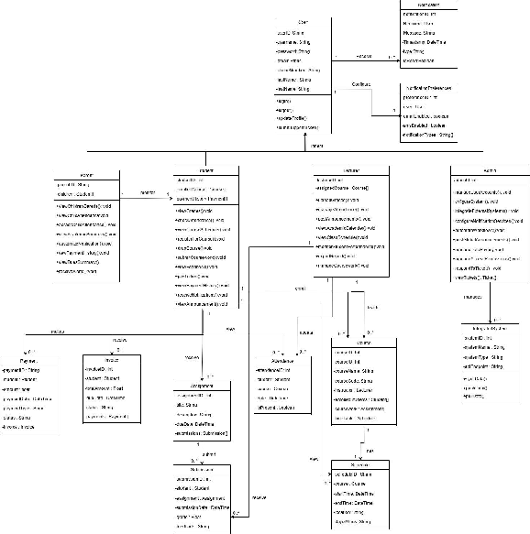
Figure 3.8.1 Class Diagram

3.5.2 Data Entities
The following table describes the key data entities and their functionalities in the EduAxis.
Table 3.8.2.1 Data Entities and Descriptions
Data Entity | Description
User | An abstract class representing all users (Student, Parent, Lecturer, Admin). Each user can register, log in, and access role-based features.
Student | A subclass of User with attributes such as studentID, name, program, year, and parentID. Students can view grades, attendance, and make payments.
Parent | A subclass of User with parentID and linked student accounts. Parents can monitor academic records and tuition status of their children.
Lecturer | A subclass of User with attributes such as lecturerID, department, and courseList. Lecturers can manage grades, attendance, and announcements.
Admin | A class representing the system administrator, responsible for user management, system configuration, and integration of third-party tools.
Course | A class representing academic courses offered by the institution. Attributes include courseID, courseName, creditHours, semester, and lecturerID.
Registration | An association class linking Students and Courses for each semester. Attributes include registrationID, studentID, courseID, and semester.
Grade | A class storing student grades for courses. Attributes include gradeID, studentID, courseID, and gradeValue.
Attendance | A class tracking student attendance. Attributes include attendanceID, studentID, courseID, date, and status.
Payment | A class recording tuition and other fee transactions. Attributes include paymentID, studentID, amount, dueDate, datePaid, and status.
Message | A class for internal messaging among users. Attributes include messageID, senderID, receiverID, content, and timestamp.
Announcement | A class for official notifications from lecturers or admins. Includes announcementID, title, content, createdBy, targetGroup, and timestamp.
FeedbackTicket | A class representing user-submitted feedback or issues. Attributes include ticketID, userID, description, status, and createdDate.

3.5.3 Relationship
The following table describes the relationships between each class in the EduAxis system.
Table 3.5.3.1 Relationships between Classes
Entity | Description
User | This abstract class is inherited by Student, Parent, Lecturer, and Admin. Each user can log in and access features according to their role.
Student | Students can register for courses, view grades and attendance, submit feedback, make payments, and receive messages. Each student is linked to one or more parents.
Parent | Parents monitor academic records and payment status for one or more children (students). Each parent is associated with one user account.
Lecturer | Lecturers manage attendance, upload grades, post announcements, and oversee courses they teach. A lecturer is associated with one user account and multiple courses.
Admin | Admins manage system configurations, users, integrations, announcements, and helpdesk support. Each admin is a standalone user.
Course | Courses are managed by lecturers and linked to students through the Registration entity. Each course is taught by one lecturer and can have many students.
Registration | Associates students with courses for a specific semester. A student can register for multiple courses and a course can have many students.
Grade | Grades are recorded for students per course. Each grade entry is linked to one student and one course.
Attendance | Attendance records are associated with a specific student and course on a given date. One student has many attendance entries.
Payment | Payment records are created per student. Each student can have multiple payments linked to invoices and fee types.
Message | Internal messages are exchanged between users. A user can send and receive many messages.
Announcement | Announcements are created by lecturers or admins and targeted to specific user groups such as students or parents. Each user can view multiple announcements.
FeedbackTicket | Feedback or complaints are submitted by users. Each ticket is linked to one user and may be addressed by admin.

3.5.4 Types of Information Used by Various Functions
Table 3.5.4.1 Types of Information, Classes Involved, and Functions
Type | Classes Involved | Functions
User Information | User, Student, Parent, Lecturer, Admin | Login, authentication, profile management, permission assignment
Academic Record Information | Grade, Course, Attendance | Viewing academic performance, calculating GPA, managing class records
Course Registration Information | Registration, Course | Registering/dropping courses, assigning lecturers, timetable generation
Financial Information | Payment, Invoice | Fee payment tracking, generating payment history, triggering payment reminders
Communication Information | Message, Announcement | Internal messaging, posting system-wide or class-specific announcements
Support & Feedback | FeedbackTicket | Submitting, tracking, and responding to student/parent/lecturer feedback
Notification Preferences | Notification, NotificationPreferences | Configuring and triggering SMS/Email alerts
Integration Information | ExternalSystem | Syncing with CMS, LMS, Auth service, SMS gateway, and payment APIs

3.5.5 Frequency of Use
Table 3.5.5 Frequency of Operation Usage and Description
Operation | Frequency | Description
User Authentication | High | Includes user login and logout for students, parents, lecturers and administrators. Access personalized system features securely.
Academic Data Management | Medium | Includes entering, updating and retrieving grades, reports and academic progress by lecturers and students.
Attendance Processing | High | QR code generation, student check-in, attendance validation and database updates.
Course Management | Low | Encompasses course registration, schedule view and updates, course swap or drop by students and lecturers
Financial Records Handling | Medium | Involves fee billing, payments confirmation, balance checking by students and parents.
Communication and Notifications | High | Includes SMS alerts, email notifications, and system announcements related to attendance, grades and fees.
Data Report and Export | Medium | Includes generation and download of grade lists, attendance summaries and performance reports in PDF/CSV format.
Resource Access | Medium | Includes accessing integrated systems such as LMS, library resources and academic support services from the system.

3.5.6 Accessing Capabilities
Table 3.5.6 Users Roles and Accessing Capabilities in the System
Role | Capabilities
Students | Access and manage academic records, course registration, fee payment, attendance and receive timely notifications.
Parents | Monitor a child’s academic performance, financial status, and receive alerts via SMS for better engagements.
Lecturers | Manage course related activities including uploading academic grades, recording attendance, sharing announcements and generating academic reports.
Administrators | Full control over user management, system configuration, academic scheduling, communication settings and data reporting across the system

3.5.7 Integrity Constraints
- User Role Validation:
Each user must have exactly one role from the following set: Student, Lecturer, Parent, Admin. Role values must be validated upon registration and during profile updates using predefined enumerations.
- Unique Identifiers:
All primary entities such as Users, Courses, Grades, Attendance, Transactions must have globally unique identifiers (UUIDs or auto-incremented IDs) to ensure integrity and traceability during data operations.
- Foreign Keys & Referential Actions:
  - Grades ↔ Courses: ON DELETE CASCADE – Deleting a course will automatically delete all related grade records.
  - Grades ↔ Students: ON DELETE RESTRICT – Students cannot be deleted if they have associated grade records.
  - Courses ↔ Lecturers: ON UPDATE SET NULL – If a lecturer record is modified or removed, the course’s lecturer_id field is set to NULL and flagged for reassignment.
  - Parents ↔ Students: Referential links must be enforced between parent accounts and their associated children using validated parent-student mappings.
  - All foreign keys must be validated upon insertion and update to ensure referential integrity is upheld across the schema.
- Check Constraints:
  - Grades (Numeric): Must fall within the valid range of 0 to 100.
  - Grades (Letter): If using a letter grading scale, must be one of: A, B, C, D, E, F.
  - Attendance Percentage: Must be between 0% and 100%.
  - Transaction Amounts: Must be ≥ 0.
- Composite Unique Constraints:
To prevent duplicate academic entries, a unique constraint must be applied on the combination of student_id + course_id + semester_id in the Grade table.
- Data Normalization & Consistency:
All relational tables must adhere to at least Third Normal Form (3NF) to avoid data redundancy and maintain data integrity during updates, deletions, and inserts.

3.5.8 Security
- Authentication and Authorization:
All users must log in using secure credentials. Access to system features will be managed using Role-Based Access Control (RBAC) to ensure users can only perform actions permitted by their role.
- Data Encryption:
Sensitive data such as passwords and authentication tokens must be encrypted using industry-standard encryption algorithms to ensure confidentiality and prevent unauthorized access.
- Audit Trails:
The system must maintain logs for key activities such as grade submissions, attendance updates, profile changes, and payment transactions. Each log must include a timestamp, the user ID, and a description of the action performed.

3.5.9 Data Retention Requirements
- User Data
Retained for the duration of system use and up to 2 years after account deactivation, or longer if legally required.
- Academic Records (Grades, Attendance, Schedule)
Retained permanently for accreditation, transcript generation, and historical reference.
- Alert and Notification Logs
Stored for up to 12 months for system audit and tracking purposes.
- Payment Records
Retained for at least 7 years in compliance with university finance policies and national tax regulations.

3.6 Design Constraints

3.6.1 Compliance with Data Privacy Regulations
Constraint Description | The system must comply with relevant Malaysian data protection laws such as the Personal Data Protection Act (PDPA), ensuring the security and confidentiality of all student, parent, and staff data.
Source | External regulatory requirements.
Impact | All data collection, storage, and processing activities must enforce consent policies, encrypted data transmission, anonymization practices (where applicable), and role-based access to sensitive information.

3.6.2 Integration with Existing University Systems
Constraint Description | The platform must seamlessly integrate with the university’s existing systems, including the Campus Management System (CMS), Learning Management System (LMS), authentication systems, and SMS/email gateways, using REST APIs over HTTPS and exchanging data in JSON format.
Source | Project limitations.
Impact | The system must support RESTful APIs and conform to the schemas and endpoints defined by current university IT systems, ensuring backward compatibility and minimal disruption.

3.6.3 Security Standards
Constraint Description | The system must follow best-practice security protocols and adhere to OWASP guidelines by implementing password encryption, secure login mechanisms, activity logging, secure data transmission, robust access control, and comprehensive input validation.
Source | External standards.
Impact | All modules must include secure authentication, password hashing, input sanitization, session timeout, and audit logging. Penetration testing and security reviews must be conducted regularly.

3.6.4 Accessibility Requirements
Constraint Description | The platform must comply with WCAG 2.1 Level AA(Web Content Accessibility Guidelines) to ensure equal access to all user groups, including users with disabilities.
Source | External accessibility standards.
Impact | Support for screen readers, keyboard-only navigation, and high contrast themes must be integrated. Form fields and interactive content must be labeled clearly for accessibility tools.

3.6.5 API Usage Limitations
Constraint Description | The system must respect usage limitations for third-party APIs (e.g., Twilio SMS Gateway, LMS/CMS APIs), adhering to defined rate limits and authentication policies. To manage throttling effectively, the system shall implement exponential backoff strategies (e.g., 1s, 2s, 4s, 8s delays), queue non-critical requests for deferred processing, and return HTTP 429 responses with appropriate Retry-After headers. User notifications must be provided in cases of degraded service availability. Additionally, critical operations—such as attendance marking and emergency alerts—shall be handled via dedicated priority queues to ensure timely execution even during rate-limited conditions.
Source | External API standards.
Impact | The system must implement throttling, retry mechanisms, and error handling routines to avoid service disruptions when API limits are exceeded.

3.6.6 Performance and Scalability
Constraint Description | The system must scale to support large user loads, particularly during critical periods such as registration, grade release, or announcement events.
Source | Project limitations.
Impact | Use of load balancing, caching strategies, database indexing, and asynchronous operations is required to maintain system responsiveness.

3.6.7 User Experience Consistency
Constraint Description | The system must provide a consistent and intuitive experience across mobile and desktop devices.
Source | Project limitations.
Impact | Interfaces must be responsive and user-friendly, minimizing clicks and displaying contextually relevant information based on user roles (student, parent, lecturer, admin).

3.6.8 Data Interoperability
Constraint Description | The system must support data exchange between different systems via standard formats such as JSON.
Source | External standards.
Impact | All integrations must use RESTful APIs with defined input/output schemas to ensure smooth data flow with minimal transformation overhead.

3.6.9 Legal and Ethical Considerations
Constraint Description | The system must protect user rights concerning the use, access, and visibility of their data, especially in educational and financial contexts.
Source | External legal requirements and ethical principles.
Impact | Consent mechanisms must be enforced. Users should be able to view what data is stored about them and request updates or removals in accordance with policy.

3.6.10 Project Budget and Timeline
Constraint Description | The project must remain within the allocated budget and development timeline set by the university or academic committee.
Source | Project limitations.
Impact | Design decisions must consider trade-offs between feature richness and cost-efficiency. MVP-level features must be prioritized to meet deadlines.

3.6.11 Standards Compliance

3.6.11.1 Report Format
Requirements:
- Reports involving personal or academic data must be exported in PDF format.
- Reports must include system logs, student performance summaries, fee transactions, and attendance reports.
- Exported documents must maintain secure formatting, showing access dates, editors, and audit trails.

3.6.11.2 Data Naming
Requirements:
- Personal data fields must follow clear naming conventions (e.g., student_id, first_name, phone_number).
- Sensitive fields such as passwords must be encrypted and labeled (e.g., hashed_password, jwt_token).
- API endpoints must be REST-compliant and named semantically (e.g., /api/v1/students/:id/courses, /api/v1/payments/:id).

3.6.11.3 Accounting Procedures
Requirements:
- Data access logs must capture who accessed what, when, and what action was performed.
- Audits must be scheduled quarterly, covering access control, backup recovery, and data leaks.
- API usage statistics and failure rates must be recorded.
- Financial records and invoice statuses must be traceable to user ID and timestamp.

3.6.11.4 Audit Tracing
Requirements:
- All sensitive changes (profile updates, password resets, permission changes) must be logged.
- Transactions and ticket actions must be time stamped with admin/actor details.
- Failed login attempts and suspicious API activity must trigger system alerts.
- Changes to access rules, course records, or student academic data must include before/after values.
All standards and practices referenced are aligned with: PDPA (Malaysia), OWASP, WCAG 2.1 Level AA, RESTful API (RFC 7231), and internal academic IT policies.

3.7. Software system attributes

3.7.1 Reliability
3.7.1.1. System Uptime
The EduAxis shall maintain an uptime of 99.9%, ensuring continuous availability for students, lecturers, parents, and administrators.
3.7.1.2. Data Integrity
The system shall maintain data integrity by enforcing transactional controls and validation checks. All data updates shall follow ACID principles to prevent data corruption.
3.7.1.3. Backup and Recovery
The system shall perform automated daily backups of essential data, including user profiles, academic records, and payment transactions. Backup data shall be stored securely, with automated recovery procedures in place for system failures.

3.7.2 Availability
3.7.2.1 Redundancy
The system shall utilize redundant servers and failover mechanisms to maintain service availability during hardware failures or maintenance periods.
3.7.2.2. Maintenance Windows
Scheduled maintenance windows shall be communicated to users at least 48 hours in advance, and maintenance activities shall be planned during off-peak hours to minimize disruption.
3.7.2.3. Real Time monitoring
The system shall implement real-time monitoring tools to track system performance and availability, allowing for immediate detection and response to any issues that arise.

3.7.3 Security
3.7.3.1. Cryptographic Techniques
The system shall utilize industry-standard cryptographic techniques to protect sensitive data. All user passwords shall be hashed using a strong hashing algorithm, and all sensitive data transmissions shall be encrypted using TLS (Transport Layer Security).
3.7.3.2. Logging and Monitoring
The system shall maintain detailed logs of all user activities and system events. These logs shall be stored securely and monitored regularly to detect and respond to suspicious activities.
3.7.3.3. Module Separation
Authentication, academic processing, and financial modules shall be logically separated to reduce the risk of unauthorized access or data leakage.
3.7.3.4. Communication Restrictions
Access between modules shall be restricted based on the principle of least privilege, ensuring only authorized components interact with sensitive services.
3.7.3.5. Data Integrity Checks
Automated integrity checks shall verify the consistency of critical records (e.g., grade reports, fee balances), with alerts for unauthorized or inconsistent changes.
3.7.3.6. Data Privacy Assurance
The system shall implement privacy controls, allowing users to manage their data and preferences, and ensuring compliance with data protection regulations.

3.7.4. Maintainability
3.7.4.1. Modular Design
The platform shall be developed using a modular architecture, allowing components (e.g., grade module, attendance module) to be independently updated or maintained.
3.7.4.2. Documentation
Comprehensive system documentation shall include code-level comments, API references, user manuals, and deployment guides to support future development and maintenance.
3.7.4.3. Bug Tracking and Resolution
A comprehensive bug tracking system shall be implemented to log, prioritize, and resolve issues efficiently. Bugs will be classified by severity with the following response time commitments: Critical (system down – response within 2 hours), High (major feature broken – response within 8 hours), Medium (minor feature issue – response within 48 hours), and Low (cosmetic issues – response within 1 week). A priority matrix combining user impact and business criticality will guide prioritization. Clear escalation procedures will be established for unresolved issues beyond response time thresholds, including automated alerts to higher-level support or management. Regular communication with stakeholders is required throughout the resolution process, including initial acknowledgment, status updates, and resolution confirmation.

3.7.5. Portability
3.7.5.1. Platform Independence
The system shall be designed to be platform-independent, supporting deployment on Windows, Linux, or macOS environments without major rework.
3.7.5.2. Containerization
The system shall support Docker-based containerization, ensuring consistent deployment across development, staging, and production environments.
3.7.5.3. External Libraries and Dependencies
Dependencies on platform-specific tools shall be minimized. Cross-platform libraries shall be prioritized to improve portability and long-term support.

3.8 Supporting information

3.8.1 Elicitation Techniques Based on Kano Model
The requirements for the EduAxis were gathered and prioritized using the Kano Model, which helps in understanding and categorizing customer needs. The Kano Model categorizes requirements into five categories:
- Dissatisfier (Must-Be Requirements): Basic features that users expect. If these are not fulfilled, users will be dissatisfied.
- Satisfier (One-Dimensional Requirements): Features that result in satisfaction when fulfilled and dissatisfaction when not fulfilled.
- Delighter (Attractive Requirements): Features that delight users when fulfilled but do not cause dissatisfaction when not fulfilled.
Table 3.8.1.1.1 Prioritization Categories of Functional Requirements
Prioritization Categories | Requirements
Dissatisfier | User authentication and Authorization View academic Grades Access Attendance Records Access Academic Timetable Manage User Accounts and Roles Integration with Campus System (CMS,LMS,Calendar) Maintain Data Privacy and Access Permissions Pay Tuition and Other Fees View Payment History and Invoices
Satisfier | Upload and Manage Grades Digital Attendance Tracking Post Announcement and Updates Dashboard with Performance Overview Submit Feedback and Support Requests Alert and Reminder System
Delighter | Notification Read Tracking Custom Notification Preferences Visual Performance Analytics Mobile-Friendly Responsive Interface
Table 3.8.1.1.2 Timeline for Software Requirements Specification of EduAxis platform
Weeks
1 | 2 | 3 | 4 | 5 | 6 | 7 | 8 | 9 | 10 | 11 | 12
Preliminary
 |  | Elicitation Planning
 |  |  |  |  | Elicitation Execution
 |  |  |  |  |  |  |  | Implementation

3.8.1.2.1 Interview
The purpose of these interview sessions is to elicit requirements and insights for the EduAxis from students, parents, lecturers and administrators of the system itself. The focus of this interview is to obtain opinion on the system’s functions, features and design for improvements and developments.

3.8.1.2.1.1 Interview 1

3.8.1.2.1.1.1 Interview Preparation
Stakeholder Details: | Mr. Deepak Kumar Lecturers of Multimedia University
Date and Time: | 15/5/2025
Interviewers: | Suzannah Pancer
 | Iman Nadhirah Binti Modh Hafiz

3.8.1.2.1.1.2 Interview Agenda
No. | Question | Response
1. | How important is it for you to log in quickly and securely to access the academic system? | Quick and secure login is important to ensure smooth access to teaching tools and student data, which supports efficiency in handling daily academic tasks.
2. | What challenges do you currently face when uploading student grades, and how would a grade upload feature help you? | Although I prefer manual methods, an efficient grade upload feature would reduce manual effort, improve consistency, and simplify the grading process, especially when handling large numbers of students.
3. | How would you feel about a system that confirms and saves each grade you upload automatically? | A system that automatically confirms and saves grades would be helpful in minimizing errors and ensuring that no data is lost during entry, which adds reliability to the grading process.
4. | How do you currently mark attendance, and would a digital attendance tracker improve your efficiency? | Attendance is currently taken manually during class, with flexibility for absences based on valid student explanations. I acknowledge that a digital attendance tracker would improve efficiency, even though they still prefer manual observation for personal engagement.
5. | Would it be helpful if the system allowed you to view, edit, and monitor attendance records over time? | Yes, the ability to view, edit, and track attendance records digitally would support better monitoring and make it easier to manage exceptions or identify patterns in student attendance.
6. | How useful would it be to post announcements or class updates in one place where all students can see them? | A centralized platform for announcements would be useful to ensure that all students receive updates consistently and in a timely manner, supporting better communication.
7. | Do you think receiving a notification when students view or respond to announcements would be beneficial? | Yes, receiving such notifications would be beneficial for tracking student responsiveness and ensuring that important information is being read and acknowledged.
8. | How often do you refer to the academic calendar, and how important is it for you to have it integrated into your dashboard? | Integration of the academic calendar into the dashboard would be valuable for keeping track of schedules and aligning class activities with institutional deadlines.
9. | Would you find it valuable if the system alerted you about upcoming deadlines, like grade submissions or exam dates? | Yes, alerts for upcoming deadlines would be very helpful in managing time-sensitive academic tasks and avoiding last-minute pressure.
10. | How helpful would it be if the system could show an overview of each student’s performance, including grades and attendance? | This feature would definitely be helpful. While I rely heavily on personal observation and judgment in class, having a centralized performance overview would support better tracking and offer additional insight into student progress.

3.8.1.2.1.3 Proof

Figure 3.8.1.2.1.3- Interview with Mr Deepak Kumar, FCI Lecturer Of Multimedia University Cyberjaya
The Lecturer provides valuable feedback throughout the interview on functions and features of the system usability and preferences. Lecturer inputs have been incorporated into the functional requirements to ensure practical and academic relevance.

3.8.1.2.2 Interview 2

3.8.1.2.2.1 Interview Preparation
Stakeholder Details: | Dr. Kairulanuar Bin Ab kadir Lecturers of Multimedia University
Date and Time: | 15/5/2025
Interviewers: | Suzannah Pancer
 | Iman Nadhirah Binti Modh Hafiz

3.8.1.2.2.2 Interview Agenda
No. | Question | Response
1. | How important is it for you to log in quickly and securely to access the academic system? | Quick and secure login is important for accessing the system efficiently, especially when managing large numbers of students and time-sensitive tasks like grade submissions and attendance tracking.
2. | What challenges do you currently face when uploading student grades, and how would a grade upload feature help you? | I face significant challenges due to the large volume of students (sometimes 800–1000) and numerous assessments such as quizzes, tests, and projects. It becomes time-consuming and tedious to upload multiple components manually. There’s also difficulty in ensuring consistency across different lecturers, with no automated alerts if discrepancies arise in grading. A well-designed grade upload feature could streamline the process, offer validation or alerts for inconsistencies, and reduce errors before final submission to the examination unit.
3. | How would you feel about a system that confirms and saves each grade you upload automatically? | This would be highly beneficial. Having a confirmation system that flags potential issues before submission—especially when working with other lecturers—would reduce human errors and prevent issues during the review by the examination unit.
4. | How do you currently mark attendance, and would a digital attendance tracker improve your efficiency? | Previously, attendance was taken manually (calling names), and later using QR codes. The lecturer agrees that a digital tracker would improve efficiency, especially since MMU is already working with system developers to enhance the credit-based system. Digital tracking would also make the process faster and more organized.
5. | Would it be helpful if the system allowed you to view, edit, and monitor attendance records over time? | Yes, having a history of attendance records would be helpful to evaluate patterns or identify students with poor attendance. It would also support more data-driven interventions if integrated properly.
6. | How useful would it be to post announcements or class updates in one place where all students can see them? | Centralized announcement posting is implied to be useful as I discussed integrating multiple student engagement and communication functions within the system.
7. | Do you think receiving a notification when students view or respond to announcements would be beneficial? | Usually I monitor student engagement through the system. Therefore, having such a feature would be considered useful for tracking responsiveness and encouraging accountability among students.
8. | How often do you refer to the academic calendar, and how important is it for you to have it integrated into your dashboard? | Time pressure was mentioned as a key challenge—especially during grading periods—so having academic deadlines and the calendar integrated into the dashboard would help in better planning and time management.
9. | Would you find it valuable if the system alerted you about upcoming deadlines, like grade submissions or exam dates? | Absolutely. A I have mentioned the tight timeframes for marking exams, especially when exam schedules fall near the end of the semester. System alerts would help ensure that deadlines are met without last-minute stress.
10. | How helpful would it be if the system could show an overview of each student’s performance, including grades and attendance? | Very helpful. I strongly support this idea, suggesting features like visual progress tracking (e.g., graphs over semesters), predictive analytics, and data-driven feedback. They also proposed using such data for early intervention or even AI-based predictions of future performance. This level of detail would allow lecturers to analyze trends and offer more tailored academic support.

3.8.1.2.2.3 Proof
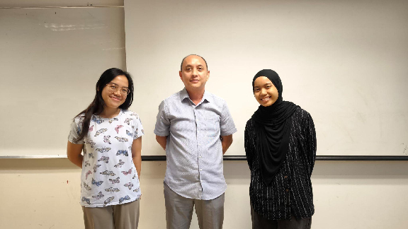
Figure 4.1..3.1- Interview with Dr Kairulanuar , FCI Lecturer Of Multimedia University Cyberjaya
The Lecturer provides valuable feedback throughout the interview on the importance of data visibility, automation, and customization in supporting lecturers’ teaching workflows. Their feedback will guide the enhancement of the academic modules and ensure the EduAxis aligns with teaching needs across faculties.

3.8.1.2.3 Interview 3

3.8.1.2.3.1 Interview Preparation
Stakeholder Details: | Mr. Zaki Syahmi Bin Zulkifli, Officer of Multimedia University Student Lifestyle and Experience Department
Date and Time: | 15/5/2025
Interviewers: | Phartiban , Natasha Adilyn

3.8.1.2.3.2 Interview Agenda
No. | Question | Response
1. | How should user roles (student, lecturer, admin, parent) be managed and provisioned in the system? | User roles should be provided based on verified student and staff records in the CMS. Role creation should be automated through syncing with CMS where students, lecturers, and parents are auto-assigned their roles upon registration. On the other part, admin roles should be manually assigned with strict approval workflows.
2. | How should the EduAxis integrate with existing systems such as the Campus Management System (CMS), LMS, and SMS gateway? | Integrating with CMS is really crucial for syncing data such as grades, attendance, and fee records. For the LMS in our case, it should pull the assignment statuses and push grades. Also, SMS gateway should be connected to the system to trigger alerts for low attendance, overdue payments and other announcements.
3. | How often should backups be performed, and where should they be stored? | Backups should be performed daily for critical databases like user data and academic records. We are looking forward to both on-site and cloud-based backups where a copy of backup is stored on MMU’s internal backup server and is also pushed to secure cloud location something like AWS S3 with encryption.
4. | What are the most common support requests or issues reported by users recently? | The most common issues reported by users are mostly on attendance records and notification delivery problems. Occasionally, we get parent inquiries about login issues or problems in fee info.
5. | Should the system be optimized for mobile use? If yes, what devices are most commonly used? | It would be better if the system is optimized for mobile use as the majority of students and lecturers use mobile phones to access systems. Android smartphone devices are the most commonly used based on our findings, followed by iPhones. The UI should be responsive especially for functions like viewing announcements, checking schedules, submitting feedbacks and so on.
6. | Should students be able to submit complaints or feedback through the system? | Yes, sure. This feature is useful for both students and admin side, which is us so that the raised feedback or complaints can be routed to the relevant department or admin. This is important as we can improvise the system in future which also involves the benefit of transparency and faster issue resolution.
7. | What specific information or tasks should each user type (student, lecturer, parent, admin) be able to access or perform? | In terms of specific information or tasks each user should be able to access or perform, it might be that first of all, let’s go for the students’ side. Students should be able to view grades, attendance, announcements, pay fees, submit coursework and feedback. On the other side, parents should be given access to view a child’s grades and fee status, get alerts, and optionally view timetables. Moving on to lecturers, they should be able to upload grades, mark attendance, post class updates, manage assignments. Finally, admins should have the access to manage accounts, handle integrations, send announcements, control permissions, and respond to helpdesk tickets.
8. | What level of user management and permissions control is required? | It should be role-based at a minimum, with the ability to assign custom permissions for sub-roles such as department-level admins. Certain functions like announcements or user deletion should only be allowed by system admins.

3.8.1.2.3.3 Proof

Figure 3.8.1.2.3.3.1- Interview with Mr. Zaki Syahmi Bin Zulkifli, Officer of Multimedia University Student Lifestyle and Experience Department
The system Administrator provided critical insights into the technical backbone and operational expectations of the system. Their input will shape the infrastructure design, security measures and integration strategies to ensure system reliability and compliance.

3.8.1.3 Survey

3.8.1.3.1 Students
Question 1: How do you currently access the following information?
-Grades and Academic Performance
- Attendance and Class Schedule
-Tuition Fee information and Payments
-Meeting or Consultation Hours
-Notifications or Announcements from Lecturers
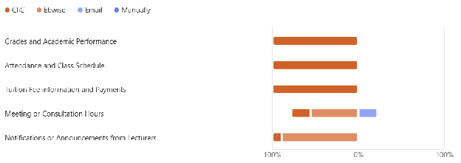 Figure 3.8.1.3.1.1 - How Students Currently Access Grades and Academic Performance Information Question 2: Are you satisfied with the current process for accessing that information?
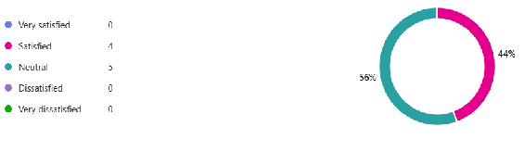 Figure 3.8.1.3.1.2 - Student Satisfaction with Current Information Access Process
Question 3:Which platform do you find most convenient for accessing university services and information?
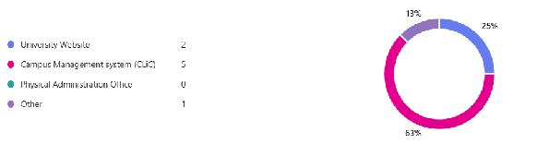
Figure 3.8.1.3.1.3 - Most Convenient Platform for Accessing University Services and Information Question 4: Which of the following features would you like to have in the system?
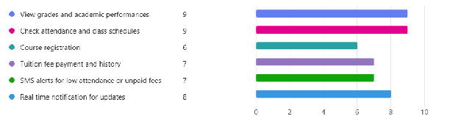
Figure 3.8.1.3.1.4 - Desired System Features by Students Question 5: How important is it for the system to have a User-Friendly interface?
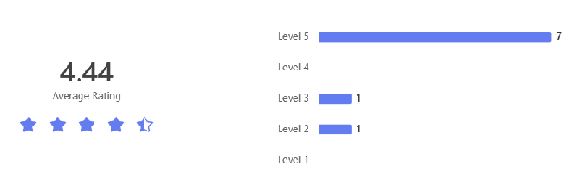
Figure 3.8.1.3.1.5 - Importance of User-Friendly Interface Question 6: How important is it for the system to have Data Accuracy
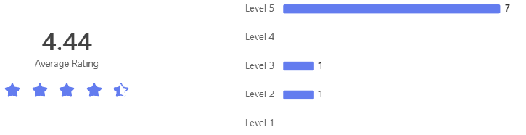
Figure 3.8.1.3.1.6 - Importance of Data Accuracy Question 7:How important is it for the system to be Mobile Friendly
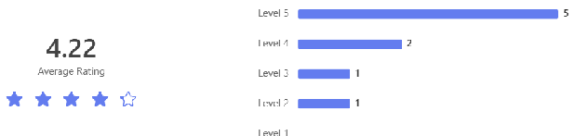
Figure 3.8.1.3.1.7 - Importance of Mobile Friendly System Question 8: How important is it for the system to have Fast Loading Speed
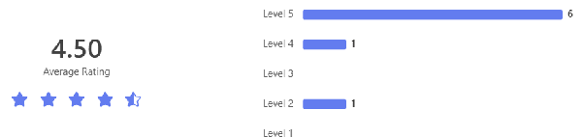
Figure 3.8.1.3.1.8 - Importance of Fast Loading Speed Question 9: How important is it for the system to be integrated with the Campus Management System
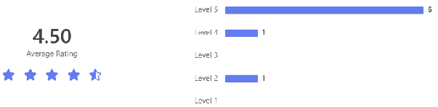
Figure 3.8.1.3.1.9 - Importance of Campus Management System Integration Question 10: Would you prefer the system to be available as:
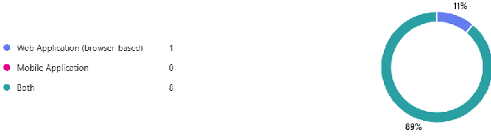
Figure 3.8.1.3.1.10 - Preferred System Availability Format Question 11: How often do you experience difficulties in accessing university- related information?
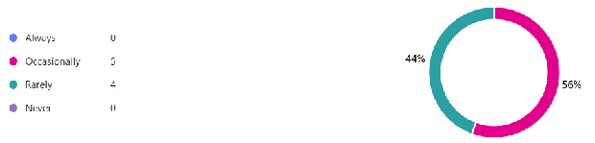
Figure 3.8.1.3.1.11 - Frequency of Difficulties in Accessing University Information Question 12: What device do you primarily use to access university services?
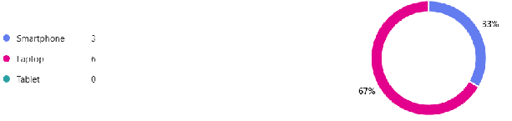
Figure 3.8.1.3.1.12 - Primary Device Used to Access University Services Question 13: Which method of authentication would you prefer for secure access?
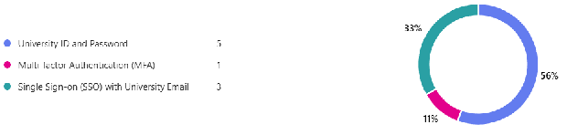
Figure 3.8.1.3.1.13 - Preferred Authentication Method for Secure Access Question 14: How would you like to receive important university notifications?
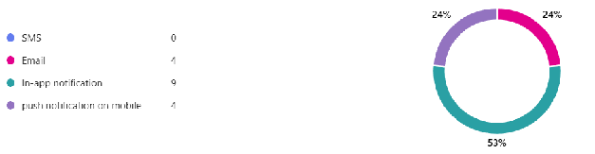
Figure 3.8.1.3.1.14 - Preferred Method for Receiving University Notifications Question 15: What kind of alerts would you prefer to receive?
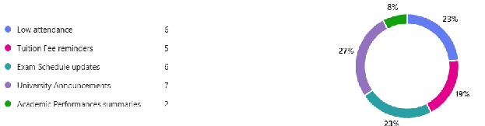
Figure 3.8.1.3.1.15 - Preferred Types of Alerts Question 16: How frequently do you prefer to receive communication updates?
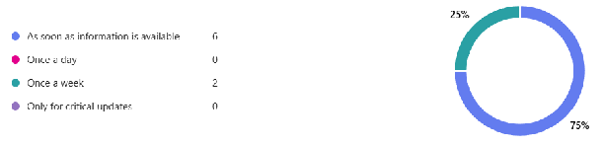
Figure 3.8.1.3.1.16 - Preferred Frequency of Communication Updates Question 17: In your experience, what gaps exist in the way university information is shared with students?
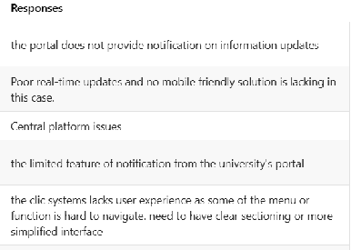
Figure 3.8.1.3.1.17 - Identified Gaps in University Information Sharing Question 18:If you could add one feature to the EduAxis, what would it be and why?
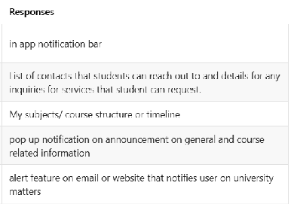 Figure 3.8.1.3.1.18 - Suggested Additional Features for EduAxis System

3.8.1.3.2 Parents
Question 1: How important is it for you to be able to view your child’s academic grades through the system?
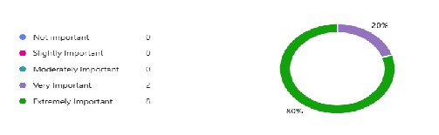
Figure 3.8.1.3.2.1 - Importance of Viewing Child’s Academic Grades Through System Question 2: How important is it for you to be able to see your child’s attendance records?
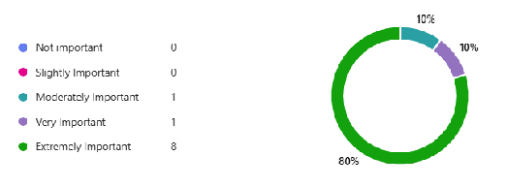
Figure 3.8.1.3.2.2 - Importance of Viewing Child’s Attendance Records Question 3: How important is it for you to receive SMS alerts if your child has low attendance?
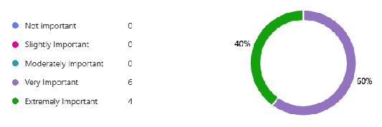
Figure 3.8.1.3.2.3 - Importance of SMS Alerts for Low Attendance Question 4: How important is it to receive SMS reminders when tuition fees are due or unpaid?
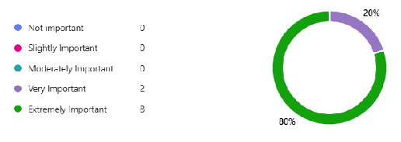
Figure 3.8.1.3.2.4 - Importance of SMS Reminders for Tuition Fee Payments Question 5: How important is it to have a dashboard that shows your child’s academic performance clearly in one place?
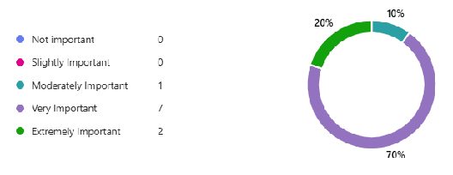
Figure 3.8.1.3.2.5 - Importance of Academic Performance Dashboard Question 6: How important is it for you to receive notifications when your child’s grades are uploaded or updated?
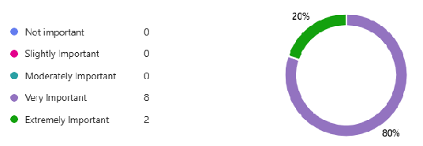
Figure 3.8.1.3.2.6 - Importance of Grade Update Notifications Question 7: How important is it for you to view your child’s class schedule or timetable through the system?
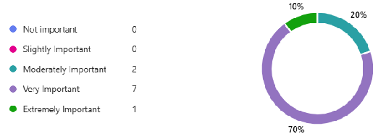
Figure 3.8.1.3.2.7 - Importance of Viewing Child’s Class Schedule Question 8: How important is it for the system to also send updates and alerts via email in addition to SMS?
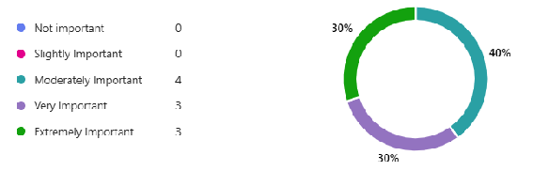
Figure 3.8.1.3.2.8 - Importance of Email Updates in Addition to SMS Question 9: How important is it for the system to have a secure and private login for accessing your child’s information?
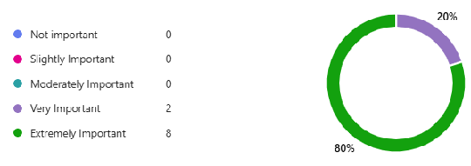
Figure 3.8.1.3.2.9 - Importance of Secure and Private Login System Question 10: How important is it for the system to work well on mobile phones or tablets?
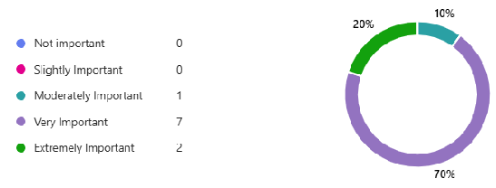
Figure 3.8.1.3.2.10 - Importance of Mobile Device Compatibility Question 11: How important is it for you to have access to payment status and history for tuition and other fees?
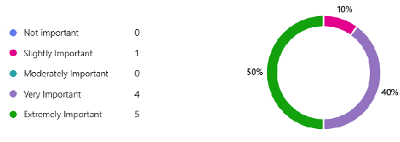
Figure 3.8.1.3.2.11 - Importance of Payment Status and History Access Question 12: How important is it to receive reminders about key academic deadlines (e.g., registration, exam dates)?
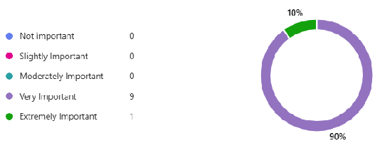
Figure 3.8.1.3.2.12 - Importance of Academic Deadline Reminders Question 13: How important is it to receive alerts when your child registers for or drops a course?
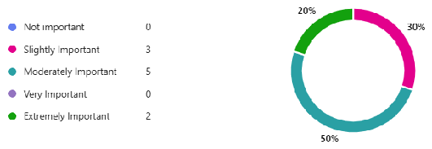
Figure 3.8.1.3.2.13 - Importance of Course Registration/Drop Alerts Question 14: How important is it to have the option to choose how you receive alerts (SMS only, email only, or both)?
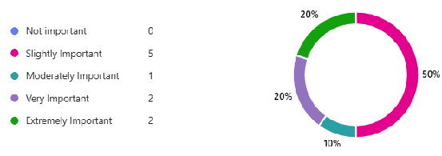 Figure 3.8.1.3.2.14 - Importance of Alert Delivery Method Options

3.8.1.4 Observation

3.8.1.4.1 CliC
url : https://clic.mmu.edu.my
Description: CLiC is a University Management Service system that serves functions for users like students, lecturers and administrators or Multimedia University (MMU) to manage and perform actions and get records on academic and personal resources.
3.8.1.4.1.1 Log In
Description: allow users to log in with credentials given.
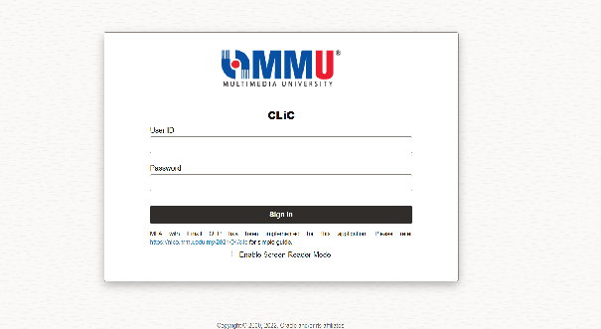
Figure 3.8.1.4.1.1 screenshot of CLiC login interface
3.8.1.4.1.2 Dashboard Features
Description: All functions and features related to the user being logged in will be provided in the dashboard. Students will be provided with relevant functions such as personal information, campus finances, attendance and academic records that are fully functional.
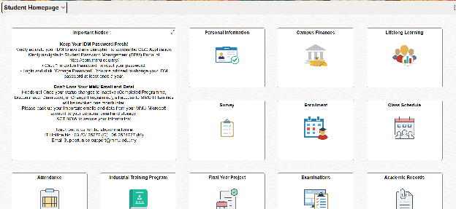
Figure 3.8.1.4.1.2 screenshot of CLiC Student Dashboard interface
3.8.1.4.1.3 Attendance records
description : The attendance management allows students to keep track of their class attendance progress throughout the trimester. This feature also triggers students and parents’ email when a certain class percentage drops below 80% that serves as an alert to the barring process.
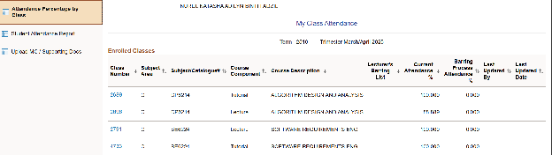
Figure 3.8.1.4.1.3 screenshot of CLiC Student Attendance interface
3.8.1.4.1.4 Campus Finances
description : The Campus Finances homepage provides a summary view of a student’s financial status at the university. It clearly displays the total amount due, differentiating between “Due Now” and “Future Due” payments. This centralized financial dashboard helps students manage their tuition and other financial matters efficiently.
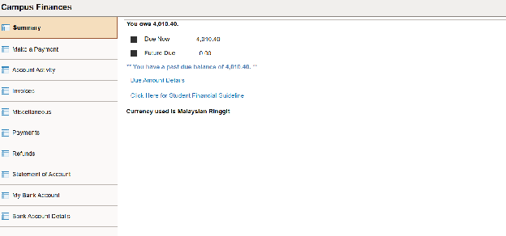
Figure 3.8.1.4.1.4 screenshot of CLiC Student Campus finances interface
3.8.1.4.1.5 Class Schedule
Description: The Class Schedule page interface provides students with a clear, organized view of their academic timetable for the selected trimester. This interface is designed to visually assist students in tracking and managing their weekly class schedule with intuitive date and time-based navigation.
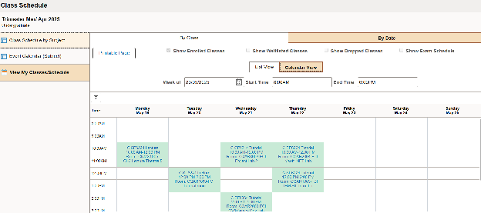
Figure 3.8.1.4.1.5 screenshot of CLiC Student Class Schedule interface
3.8.1.4.1.6 Academic Records
Description : The Academic Records Management interface provides students with a centralized dashboard to access and manage essential academic information throughout their studies. The other features include a summary of academic progress, academic achievement and other that is relevant to the student.
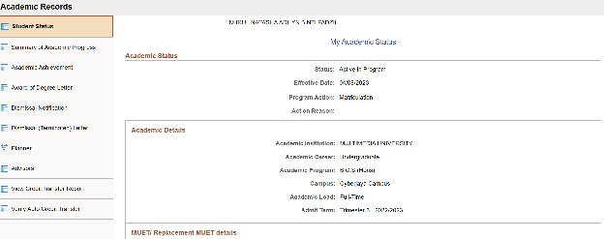
Figure 3.8.1.4.1.6 screenshot of CLiC Student Academic Records interface

3.8.1.4.2 eBwise
Url: https://ebwise.mmu.edu.my
3.8.1.4.2.1 Login Page
Description: Allows user to log in using SSO authentication.
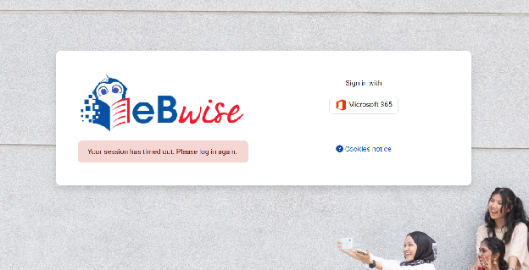
Figure 3.8.1.4.2.1 screenshot of eBwise Student login interface
3.8.1.4.2.2 Academic Managements Dashboard
Description: The eBwise serves as a Communication system for both student and lecturers to make and get updates on academic matters such as announcements, assignments, and comments on class.
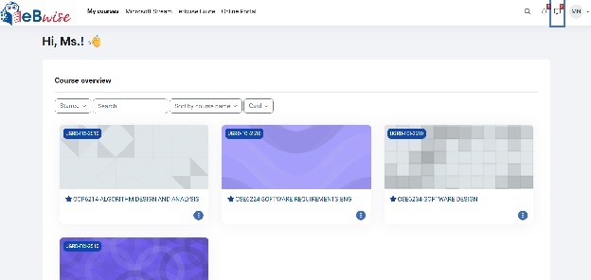
Figure 3.8.1.4.2.2 screenshot of eBwise Student homepage interface
3.8.1.4.2.3 Announcement Page
Description: The lecturer will be able to communicate and post announcements to all or selected sections to notify students on important updates.
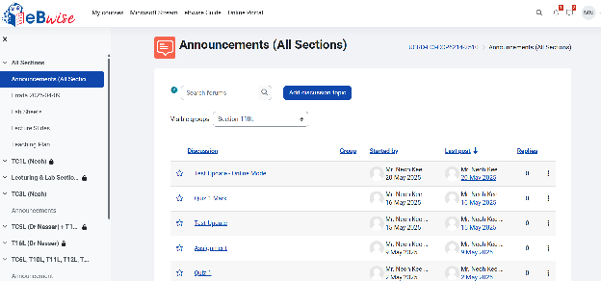
Figure 3.8.1.4.2.3 screenshot of eBwise Student announcements page interface
3.8.1.4.2.4 Assignment Submission Managements
Description: The lecturer assigns assignments with due date being set and add submission button for file uploading purposes.
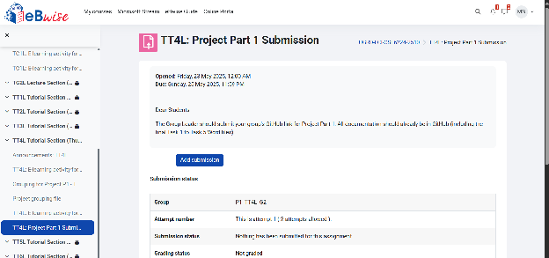
Figure 3.8.1.4.2.4 screenshot of eBwise Student Assignment submission page interface
Description: The systems update submission status to the database and notify lecturer on marking process.
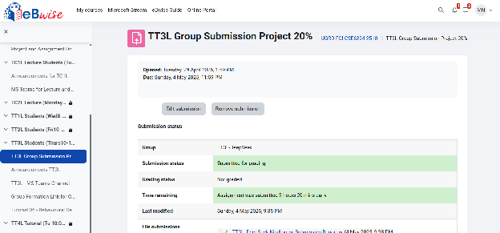
Figure 3.8.1.4.2.5 screenshot of eBwise Student Submitted Assignment follow up page interface

3.8.2.4Sample Input/Output Formats**
3.8.2.4.1 API Request/Response Examples - Login API: POST /api/auth/login Request: {“username”: “student123”, “password”: “****”} Response: {“token”: “jwt…”, “role”: “student”} 3.8.2.4.2 SMS Notification Templates - Low Attendance: “Alert: Your attendance for [Course] is [X]%. Minimum 80% required.” 3.8.2.4.3 Report Export Formats - Grade Report CSV: “StudentID,Name,Course,Grade,Semester”

4. Verification

4.1. Verification of External Interfaces (3.2) {#4.1.-verification-of-external-interfaces-(3.2)}

4.1.1 University Database Interface (3.2.1) {#4.1.1-university-database-interface-(3.2.1)}
Methods | Execute API calls to the PostgreSQL university database and compare the response with expected student, academic, and fee records. Scripts will be used to test CRUD operations and role-based data retrieval (such as student vs admin access).
Responsibility | QA team and database administrators.
Verification time | During integration testing and prior to each deployment cycle.
Environment | Development, staging, and production environments.

4.1.2 Campus Management System (CMS) Interface (3.2.2) {#4.1.2-campus-management-system-(CMS)-interface-(3.2.2)}
Methods | Perform API testing to verify grade, course registration, and attendance data pulled from CMS matches internal student profiles. Use real enrollment data and validate mapped fields.
Responsibility | QA team and project integration lead.
Verification time | During initial integration setup and after every schema change or API update.
Environment | Staging and production with controlled test users.

4.1.3 Learning Management System (LMS) Interface (3.2.3) {#4.1.3-learning-management-system-(LMS)-interface-(3.2.3)}
Methods | Verify grade upload and assignment sync via LMS API. Compare LMS-side student submissions and scores against system display. Test API failures and timeouts.
Responsibility | QA team and LMS admin.
Verification time | During LMS sync cycles and before academic term launch.
Environment | Development and staging LMS environments.

4.1.4 SMS/Email Notification Gateway (3.2.4) {#4.1.4-sms/email-notification-gateway-(3.2.4)}
Methods | Trigger real alerts (test accounts) for various actions (such as low attendance, fee due). Confirm delivery status, content accuracy, and user preference configurations.
Responsibility | QA team and notification service lead.
Verification time | During functional testing of alert workflows and any template update.
Environment | Staging and production with sandbox API keys.

4.1.5 Authentication Service (SSO/OAuth) Interface (3.2.5) {#4.1.5-authentication-service-(sso/oauth)-interface-(3.2.5)}
Methods | Test login with valid and invalid credentials through the SSO gateway. Validate token generation, session handling, and role-based dashboard redirection.
Responsibility | QA team and university IT security team.
Verification time | At user provisioning rollout and before new semester sessions.
Environment | Staging and production SSO sandbox environments.

4.1.6 Payment Gateway Interface (3.2.6) {#4.1.6-payment-gateway-interface-(3.2.6)}
Methods | Simulate payment flow using test invoice and validate payment status updates. Test payment failure handling, timeout recovery, and transaction logging.
Responsibility | QA team and finance IT representative.
Verification time | Before fee collection windows and after API updates from provider.
Environment | Test sandbox and staging gateway environments (such as FPX/iPay88 test mode).

4.2 Verification of Functional Requirements
4.2.1 User Authentication and Authorization(3.4.1.1)
Methods: | Functional testing, penetration testing, MFA validation, and code review for secure login. Test cases will include successful login, failed login (wrong credentials), expired session handling, brute-force protection, and failed MFA attempts. Token expiration, login retry logic, and lockout thresholds will also be validated.
Responsibility: | Development team and external security consultant.
Verification Time: | During development and before production release; periodic audits post-deployment.
Environment: | Development and staging servers.

4.2.2 View Academic Grades(3.4.1.2)
Methods: | Functional testing, data validation checks, and role-based access testing. Validate large-scale grade retrieval (e.g., for students enrolled in 30+ subjects). Test pagination, sorting, and filtering of grade records to handle edge cases.
Responsibility: | QA team.
Verification Time: | During system integration testing.
Environment: | Staging environment with test student data.

4.2.3 Access Attendance Records(3.4.1.3)
Methods: | Functional testing of attendance logs, filters, and export options.
Responsibility: | QA team.
Verification Time: | Pre-deployment testing.
Environment: | Development and staging environments.

4.2.4 Access Academic Timetable (3.4.1.4)
Methods: | Usability and functional testing with real-time calendar integration validation.
Responsibility: | Product and QA team.
Verification Time: | During feature roll-out testing.
Environment: | Development environment and UAT (User Acceptance Testing) stage.
4.2.5 Manage User Accounts and Roles(3.4.1.5)
Methods: | Functional testing for role creation, permissions handling, and user lifecycle management. Include audit log verification to track role changes, permission modifications, and user deactivation/reactivation actions.
Responsibility: | Admin module team.
Verification Time: | During user management module implementation.
Environment: | Development and admin-controlled test environments.
4.2.6 Integration with Campus Systems(3.4.1.6)
Methods: | API integration testing, mock service simulation, and data sync validation.
Responsibility: | Integration team.
Verification Time: | During system interfacing and staging rollout.
Environment: | Development with mock CMS, LMS, and CMS endpoints.
4.2.7 Maintain Data Privacy and Permissions(3.4.1.7)
Methods: | Role-based access control (RBAC) testing, audit logs, and compliance checks (PDPA, GDPR).
Responsibility: | Security compliance team.
Verification Time: | Before deployment and during periodic audits.
Environment: | Controlled test environment.
4.2.8 Pay Tuition and Other Fees(3.4.1.8)
Methods: | Integration testing with payment gateway and transaction validation. Simulate both successful and failed payment scenarios, including payment timeouts, invalid inputs, transaction reattempts, and system unavailability. Validate rollback behavior, error messages, and log entries for failed transactions.
Responsibility: | Backend development and finance integration teams.
Verification Time: | After payment module is integrated.
Environment: | Staging environment with sandbox payment credentials.
4.2.9 View Payment History and Invoices (3.4.1.9)
Methods: | Functional testing, data accuracy checks, and user accessibility validation.
Responsibility: | QA and finance module team.
Verification Time: | During post-transaction validation testing.
Environment: | Staging environment.
4.2.10 Upload and Manage Grades(3.4.2.1)
Methods: | Functional testing, input validation, bulk upload checks.
Responsibility: | Lecturer-side QA and dev team.
Verification Time: | During internal testing phase.
Environment: | Staging environment with mock class data.
4.2.11 Digital Attendance Tracking (3.4.2.2)
Methods: | QR code scanning simulation, manual input testing, record validation.
Responsibility: | QA Team
Verification Time: | Pre-deployment phase.
Environment: | Mobile emulator and browser staging environment.
4.2.12 Post Announcement and Updates(3.4.2.3)
Methods: | Functional testing for announcement creation, user delivery tracking, and UI feedback.
Responsibility: | Content and dev team.
Verification Time: | After CMS integration.
Environment: | Development and staging server.
4.2.13 Dashboard with Performance Overview(3.4.2.4)
Methods: | Visualization rendering test, data aggregation validation, UI responsiveness testing.
Responsibility: | Frontend and analytics team.
Verification Time: | Post-integration testing phase.
Environment: | UAT and staging.
4.2.14 Submit Feedback and Support Requests(3.4.2.5)
Methods: | Form validation, ticket creation flow, and routing logic testing.
Responsibility: | Support system team.
Verification Time: | Upon internal beta testing.
Environment: | Test helpdesk environment.
4.2.15 Alert and Reminder System(3.4.2.6)
Methods: | Notification trigger simulation, queue monitoring, delivery validation. Test user preference handling such as opt-in/opt-out and confirm mandatory alerts such as payment deadlines override suppression preferences as per policy.
Responsibility: | Backend notification service team.
Verification Time: | Before release and during reliability audits.
Environment: | Text messaging environment using Twilio/SMS sandbox
4.2.16 Notification Read Tracking(3.4.3.1)
Methods: | User interaction logging test, status flag tracking, read/unread state toggling.
Responsibility: | UI/UX telemetry team.
Verification Time: | During real-user simulation testing.
Environment: | Staging with event tracking tools.
4.2.17 Custom Notification Preferences(3.4.3.2)
Methods: | Preference update test, delivery filter checks, setting persistence validation.
Responsibility: | User settings module team.
Verification Time: | Pre-launch personalization feature test.
Environment: | Settings sandbox environment.
4.2.18 Visual Performance Analytics(3.4.3.3)
Methods: | Graph rendering checks, accuracy tests with mock data, and responsiveness testing.
Responsibility: | Data visualization and frontend teams.
Verification Time: | After analytics engine integration.
Environment: | Development and analytics testing stage.
4.2.19 Mobile-Friendly Responsive Interface(3.4.3.4)
Methods: | Cross-device UI tests, responsive CSS checks, and accessibility validation (WCAG). Test across Chrome, Firefox, Safari, and mobile resolutions (320px, 768px, 1280px) using tools like BrowserStack.
Responsibility: | UI/UX team.
Verification Time: | During frontend QA.
Environment: | Browser stack/mobile testing platforms.

4.3. Verification of Usability Requirements (3.6) {#4.3.-verification-of-usability-requirements-(3.6)}

4.3.1 User Interface (3.6.1) {#4.3.1-user-interface-(3.6.1)}
4.3.1.1 Consistent Layout and Design
Methods: | Conduct evaluation and consistency checks across modules to ensure uniform layout.
Responsibility: | UI/UX team.
Verification Time: | During interface design review and at UAT stage.
Environment: | Staging with different user roles

4.3.1.2 Responsive Design
Methods: | Test system on desktop, tablet and mobile for layout sync and functionality
Responsibility: | Front-end and QA team
Verification Time: | During front end testing
Environment: | Multiple browsers and device in staging

4.3.2 User Experience (3.6.2) {#4.3.2-user-experience-(3.6.2)}
4.3.2.1 Efficient Navigation
Methods: | Test the quickness of the user to reach key features like grades and registration. Measure number of clicks and task time
Responsibility: | UX and QA teams
Verification Time: | During UAT and design review
Environment: | Staging using student and lecturer accounts

4.3.2.2 Accessibility and Personalized Experience
Methods: | Use screen readers and accessibility tools to test WCAG 2.1 Level AA compliance. Check course suggestions and contrast.
Responsibility: | QA and accessibility team
Verification Time: | During UI testing and after updates
Environment: | Staging on various devices and assistive tools

4.3.3 Communication (3.6.3) {#4.3.3-communication-(3.6.3)}
4.3.3.1 Feedback Mechanism
Methods: | Check if confirmation or error messages appear after actions like form submission or uploads.
Responsibility: | QA and UX teams
Verification Time: | During functional testing
Environment: | Staging across key features

4.3.3.2 Language Standards
Methods: | Review system text for clear, non-technical language in instructions and alerts.
Responsibility: | Content reviewer and QA team
Verification Time: | During UI review and content proofreading
Environment: | Design and staging environments

4.3.3.3 Notification Management
Methods: | Test SMS/email settings to ensure users can change notification preferences.
Responsibility: | QA and communication integration team.
Verification Time: | During integration and UAT.
Environment: | Staging environment with test user roles

4.3.4 Data Protection (3.6.4) {#4.3.3-data-protection-(3.6.4)}
4.3.4.1 Data Encryption
Methods: | Leave session idle and verify if the user is logged out automatically after the timeout period.
Responsibility: | QA and security teams.
Verification Time: | During security and usability testing.
Environment: | Staging environment with test user sessions.

4.3.4.2 Server Controls
Methods: | Use browser Developer Tools (Chrome/Firefox) to confirm HTTPS is enforced on all pages by checking certificate validity, protocol (TLS 1.2/1.3), and absence of mixed content warnings. Run SSL scanning tools such as Qualys SSL Labs to validate proper redirection from HTTP to HTTPS and confirm absence of SSL vulnerabilities.
Responsibility: | DevOps and security teams.
Verification Time: | During deployment and penetration testing.
Environment: | Staging and production environments.

4.4. Verification of Performance Requirements {#4.4.-verification-of-performance-requirements-(3.5)}

4.4.1 Static Numerical Requirements {#4.4.1-static-numerical-requirements-(3.5.1)}
4.4.1.1 Storage Scalability
Methods: | Test storage handling with mock academic and media data to reach 2TB. Check backup interval and recovery time.
Responsibility: | QA and DevOps teams.
Verification Time: | During performance testing.
Environment: | Staging with real-time load simulation.

4.4.1.2 Database Backups
Methods: | Check data backup storage allocation every 24 hours for data tracking and retrieval
Responsibility: | DevOps and security teams
Verification Time: | During performance testing.
Environment: | Staging with real-time load simulation.

4.4.1.3 Data Retrieval Speed
Methods: | Send multiple queries for student records, schedules, and attendance, and measure response time.
Responsibility: | QA teams.
Verification Time: | During performance testing.
Environment: | Staging with real-time load simulation.

4.4.1.4 Simultaneous User Capacity
Methods: | Simulate 4,000 users performing key actions. Monitor system load, latency, and crash reports.
Responsibility: | Performance and QA teams.
Verification Time: | During stress testing and scalability evaluation.
Environment: | Load testing tools in a staging environment.

4.4.1.5 Session Timeout
Methods: | Leave sessions inactive for 15 minutes and verify auto logout and session data clearance.
Responsibility: | QA and security team
Verification Time: | During security and usability testing.
Environment: | Staging with role-based test users.

4.4.2 Dynamic Numerical Requirements {#4.4.1-dynamic-numerical-requirements-(3.5.2)}
4.4.2.1 Task Handling
Methods: | Task completion analysis on automated logs and error rate reports
Responsibility: | Performance and QA teams
Verification Time: | During performance and integration testing
Environment: | Staging environment with simulated data loads and automation triggers
4.4.2.2 System Uptime
Methods: | Deploy system monitoring using uptime tracking tools. Simulate failure and recovery scenarios.
Responsibility: | DevOps team
Verification Time: | Post-deployment monitoring
Environment: | Pre-production staging with simulated failover
4.4.2.3 Feature Responsiveness
Methods: | Perform response time tests on core modules with simulated user actions.
Responsibility: | QA Team
Verification Time: | Performance Testing
Environment: | Staging with simulated user workflows

4.4.2.4 Background Data Synchronization
Methods: | Mock synchronization events between systems using simulated updates.
Responsibility: | Integration QA Team
Verification Time: | During data testing
Environment: | Staging with real-time sync simulators

4.4.2.5 Grade Upload Processing
Methods: | Test grade files with varied data types and formats. Monitor system logs and error handling reports to confirm error-free processing
Responsibility: | QA Team
Verification Time: | Data Handling Test Phase
Environment: | Staging environment with simulated academic records

4.4.2.6 Report Generation
Methods: | Generate reports with test data under standard usage. Log and analyze response time per report
Responsibility: | QA Team
Verification Time: | Functional and Load Testing
Environment: | staging with typical usage patterns and academic datasets

4.4.2.7 Peak load Response Time
Methods: | Load testing tools to simulate concurrent users executing various tasks. Measure response times and confirm less than 10% of total requests are delayed or failed.
Responsibility: | Performance Team
Verification Time: | Stress and Load Testing Phase
Environment: | Scaled staging environment replicating peak university usage

4.4.2.8 Transaction Processing
Methods: | Simulate transactions for login, course enrollment, and grade input. Track completion times and validate
Responsibility: | QA and BAck-end Team
Verification Time: | Functional Performance Testing
Environment: | Staging with emulated normal daily user activity

4.5. Verification of Logical Database Requirements (3.8) {#5.5.-verification-of-logical-database-requirements-(3.8)}

4.5.1 Data Integrity Enforcement
Methods: | Test insertion, update, and deletion of records to confirm enforcement of constraints (e.g., NOT NULL, UNIQUE, CHECK). Validate business rules through automated test cases.
Responsibility: | Database developers and QA team.
Verification Time: | During integration testing and database testing phases.
Environment: | Staging database environment with mock academic datasets.

4.5.2 Referential Integrity Checks
Methods: | Execute queries that involve foreign key relationships to ensure cascading updates/deletes behave correctly. Attempt violations to test constraint enforcement.
Responsibility: | QA and database administration teams.
Verification Time: | During schema validation and functional database testing.
Environment: | Controlled staging database with test relationships.

4.5.3 Normalization Compliance
Methods: | Review schema design for adherence to at least 3NF. Conduct manual and automated checks for redundancy and anomalies in table structures.
Responsibility: | Database architects and QA reviewers.
Verification Time: | During design and code review stages.
Environment: | Database design documentation and test schema review environment.

4.5.4 Query Accuracy and Performance
Methods: | Execute frequently used queries (e.g., fetch student records, schedules, attendance) to validate data correctness and acceptable execution time (< 2 seconds for most queries).
Responsibility: | QA and performance teams.
Verification Time: | During performance and UAT testing phases.
Environment: | Staging environment with realistic data volumes.

4.5.5 Data Redundancy Detection
Methods: | Use SQL scripts to identify duplicate entries in key tables (e.g., student profiles, course lists). Monitor ETL processes to avoid redundant data insertion.
Responsibility: | Data engineering and QA team.
Verification Time: | During integration and data migration testing.
Environment: | Staging environment with migration datasets.

4.5.6 Transactional Consistency (ACID Properties) {#4.5.6-transactional-consistency-(acid-properties)}
Methods: | Simulate multi-step transactions (e.g., student enrollment and payment) to ensure atomicity, consistency, isolation, and durability.
Responsibility: | Backend development and QA teams.
Verification Time: | During database transaction testing and security testing.
Environment: | Staging environment with transactional logs enabled.

4.5.7 Backup and Recovery Validation
Methods: | Trigger backup creation and simulate failure scenarios to ensure database restoration maintains logical integrity (e.g., no orphaned records or corruption).
Responsibility: | DevOps and DBA teams.
Verification Time: | During disaster recovery drills and release cycles.
Environment: | Backup/recovery sandbox with versioned snapshots.

4.6. Verification of Design Constraints (3.9) {#4.6.-verification-of-design-constraints-(3.9)}

4.6.1 Compliance with Data Privacy Regulations (3.9.1) {#4.6.1-compliance-with-data-privacy-regulations-(3.9.1)}
Methods | Conduct documentation reviews and technical tests to ensure compliance with data retention policies: retain user data for 2 years after account closure, keep academic records indefinitely, and store payment records for 7 years. Simulate scenarios for personal data access and validate encryption and consent enforcement mechanisms.
Responsibility | Compliance officer and product team.
Verification time | During the requirements definition, testing, and before production rollout.
Environment | Development, staging, and remote documentation environments.

4.6.2 Integration with Existing University Systems {#4.6.2-integration-with-existing-university-systems-(3.9.2)}
Methods | Perform API contract testing with CMS and LMS. Conduct data mapping verification and simulate student data sync flows to ensure field compatibility.
Responsibility | Integration lead and product team.
Verification time | During API integration phase and post-deployment patches.
Environment | Staging and production sandbox environments.

4.6.3 Security Standards (3.9.3) {#4.6.3-security-standards-(3.9.3)}
Methods | Run OWASP-based security scans, static code analysis, and penetration tests. Validate token expiry, password encryption, and XSS/SQL injection protection.
Responsibility | Security team and QA testers.
Verification time | Before each deployment cycle and during security audits.
Environment | Staging and vulnerability assessment environments.

4.6.4 Accessibility Requirements (3.9.4) {#4.6.4-accessibility-requirements-(3.9.4)}
Methods | Use tools such as WAVE, aXe, and manual tab testing to validate keyboard navigation, alt text, ARIA labels, and color contrast as per WCAG 2.1 Level AA standards.
Responsibility | UI/UX designers and QA team.
Verification time | During front-end development and UI freeze.
Environment | Cross-browser test environments and accessibility tools.

4.6.5 API Usage Limitations (3.9.5) {#4.6.5-api-usage-limitations-(3.9.5)}
Methods | Simulate multiple API calls using Postman and Locust to verify API rate limits and retry mechanisms. Confirm request throttling for SMS gateway and payment APIs.
Responsibility | Backend devs and QA testers.
Verification time | During API testing and before system stress tests.
Environment | Staging and pre-production integration environments.

4.6.6 Performance and Scalability (3.9.6) {#4.6.6-performance-and-scalability-(3.9.6)}
Methods | Use JMeter and k6 to simulate 500+ concurrent logins, grade queries, and SMS triggers. Measure response time and memory consumption under stress.
Responsibility | Performance engineering team.
Verification time | Before semester starts or exam periods.
Environment | Performance test server environment.

4.6.7 User Experience Consistency {#4.6.7-user-experience-consistency-(3.9.7)}
Methods | Conduct usability testing with real users on phones, tablets, and desktops. Use BrowserStack to test consistency across Chrome, Firefox, Safari.
Responsibility | UI/UX team and QA.
Verification time | During front-end iterations and usability evaluation.
Environment | Responsive browser/device test lab.

4.6.8 Data Interoperability {#4.6.8-data-interoperability-(3.9.8)}
Methods | Check that all integrated systems send/receive JSON objects according to API documentation. Validate encoding, timestamp formats, and key consistency.
Responsibility | Integration devs and QA team.
Verification time | During data flow tests and third-party integrations.
Environment | Staging systems and integration endpoints.

4.6.9 Legal and Ethical Considerations {#5.6.9-legal-and-ethical-considerations-(3.9.9)}
Methods | Verify audit trail coverage, data consent logs, and compliance features for student rights to data access and deletion.
Responsibility | Legal liaison and product owner.
Verification time | During requirements finalization and before go-live.
Environment | Documentation review and simulated compliance environment.

4.6.10 Project Budget and Timeline {#4.6.10-project-budget-and-timeline-(3.9.10)}
Methods | Use Gantt charts and financial logs to track project milestones and budget variance. Perform monthly reviews with the PMO.
Responsibility | Project manager and finance representative.
Verification time | Continuously across all project phases.
Environment | Project management dashboard and cost tracking system.

4.7 Verification of Software System Attributes (3.10) {#4.7-verification-of-software-system-attributes-(3.10)}
4.7.1 Reliability (3.10.1)
Methods: | Stress testing, reliability testing, data integrity validation, backup and recovery drills
Responsibility: | QA team
Verification time: | Post implementation, pre-deployment
Environment: | Staging environment
4.7.2 Availability (3.10.2)
Methods: | Load testing, redundancy testing, monitoring validation
Responsibility: | QA team
Verification time: | Post implementation, pre-deployment
Environment: | Staging environment
4.7.3 Security (3.10.3)
Methods: | Penetration testing, code review, cryptographic validation, logging audits
Responsibility: | Security team and external auditors
Verification time: | Pre-deployment and periodic reviews
Environment: | Staging and production environments
4.7.4 Maintainability (3.10.4)
Methods: | Code review, modularity analysis, bug tracking audit
Responsibility: | Development and QA teams
Verification time: | Throughout deployment and pre-deployment
Environment: | Development environment
4.7.5 Portability (3.10.5)
Methods: | Cross-platform testing, Docker/containerization testing
Responsibility: | Development and QA teams
Verification time: | Testing phase post-implementation
Environment: | Staging environment on multiple OS platforms

5. Appendices

5.1 Assumptions and dependencies

Assumptions:
- Statement: The system shall have pre-registered parent, student, and admin accounts with verified email and phone numbers. Impact: We don’t need to build a registration or account setup page. Risk if Violated: Without pre-registered accounts, the system must include user onboarding, account creation, and verification flows, increasing development complexity and timeline.
- Statement: The system shall be accessible via modern internet browsers (e.g., Chrome, Firefox, Edge). Impact: The system will look and work properly with these browsers. Risk if Violated: If user uses an old browser, the pages might not work or show correctly. We may have to fix this later.
- Statement: The system shall have a list of FCI students and their academic records preloaded in the database. Impact: Students can see their grades, attendance, and other info right away. Risk if Violated: If the data is not ready, some features won’t work, and developers must need to add data manually or build tools to do it.
- The system shall store parent-student relationship mappings within the database. Impact: Enables the parent dashboard and related alert functionalities to work correctly. Risk if Violated: Notifications may be sent to the wrong users, or fail entirely, leading to privacy breaches or communication errors.
- The system shall support English language as the primary language interface. Impact: We only need to write and check one language. Risk if Violated: If users want other languages, we will need to add translation features later, which can be hard and time-consuming.
- The system shall have integrated notification services (SMS/Email API) properly configured. Impact: The system can send alerts (like low attendance or fee reminders) automatically. Risk if Violated: Notifications may be delayed or not sent, impacting stakeholder communication and reducing system reliability.

Dependencies:
- The system shall require a stable internet connection for both clients and servers.
- The system shall require a device with an internet browser (desktop, tablet, or mobile).
- The system shall depend on third-party email and SMS gateways (e.g., SMTP, Twilio) for alert delivery.
- The system shall depend on a relational database (e.g., MySQL/PostgreSQL) to store and manage user and academic data.
- The system shall rely on authentication mechanisms (e.g., JWT or OAuth2) to validate users and maintain session security.

5.2 Acronyms and abbreviations
- CliC: Campus Life and Information Centre
- SMS: Short Message Service
- JSON: JavaScript Object Notation
- IT: Information Technology
- LMS: Learning Management System
- CMS: Campus Management System
- API: Application Programming Interface
- MFA: Multi-Factor Authentication
- SSO: Single Sign-On
- CRUD: Create,Read,Update,Delete
- UI: User Interface
- UX: User Experience
- HTTPS: HyperText Transfer Protocol Secure
- GDPR: General Data Protection Regulation
- PDPA: Personal Data Protection Act(Malaysia)
- REST: Representational State Transfer
- DBMS: Database Management System
- SQL: Structured Query Language
- SSL: Secure Sockets Layer
- WCAG: Web Content Accessibility Guidelines
- LTS: Long-Term Support
- SMTP: Simple Mail Transfer Protocol
- RFC: Request for Comments
- MIME: Multipurpose Internet Mail Extensions
- HTML: HyperText Markup Language
- RAM: Random Access Memory
- RTO: Recovery Time Objective
- LDAP: Lightweight Directory Access Protocol
- ID: Identifier
- AWS: Amazon Web Services
- GCP: Google Cloud Platform
- ERP: Enterprise Resource Planning
- MMU: Multimedia University
- MVP: Minimum Viable Product
- OWASP: Open Worldwide Application Security Project
- ACID: Atomicity, Consistency, Isolation, Durability
- TLS: Transport Layer Security
- RBAC: Role-Based Access Control
- UAT: User Acceptance Testing

5.3 Glossary
- Authentication: Process of verifying identity of a user/system.
- Auth Service: Service that handles user authentication
- Twilio: Cloud platform for SMS, voice, and messaging APIs.
- Cache: Temporary storage for frequently accessed data to improve speed.
- PostGreSQL: Open-source relational database system
- Containerization: Packaging software and dependencies into isolated units
- Cryptographic: Related to cryptography, techniques for secure communication.
- OAuth 2.0: A way to let users log in securely without typing their password directly into the system
- SSO (Single Sign-On): A system that lets users log in once and access many related apps or systems without logging in again.
- WCAG 2.1: A set of rules to make websites easier to use for people with disabilities (for example: screen reader support or keyboard-only navigation).
- CRUD: Stands for Create, Read, Update, and Delete. These are the basic actions you can do with data in a database.
- PDPA / GDPR: PDPA – Personal Data Protection Act, a Malaysian law that protects users’ personal information. GDPR – General Data Protection Regulation, a European law for protecting personal data and privacy.
- ACID: A set of rules to make sure data in a database stays correct and safe, even if something goes wrong. It stands for Atomicity, Consistency, Isolation, and Durability.

