DESCRIPTIVE AND EXPLORATORY ANALYSIS

1.1 Executive Summary
The purpose of this first section was to establish a clear descriptive picture of how teachers reported their implementation of the six Teacher Quality Standard (TQS) domains across the four survey years, and how Year 4 professional learning needs aligned with those same domains. At this stage, the goal was not to test causal mechanisms or evaluate intervention effects. Rather, the objective was to identify the overall pattern in the data: where teachers appear strongest, where implementation appears weaker, how much responses vary across teachers, and whether these patterns remain stable over time.
To do this, individual survey items were grouped into six TQS competency domains based on the appendix mappings. For each teacher, a domain score was calculated by averaging the responses to the items assigned to that domain. This produced one composite score per domain, allowing the results to be interpreted at the level of meaningful professional constructs rather than individual survey questions. The same domain-scoring approach was applied to implementation in all four years, and to professional learning need in Year 4.
A strong and consistent pattern emerged immediately. Across all four survey years, the implementation profile was highly stable. In every year, Inclusive Environments (Comp4) and Legal Frameworks and Policies (Comp6) were among the highest-rated domains, whereas FNMI Knowledge (Comp5) was consistently the lowest-rated. For example, the mean implementation score for Inclusive Environments was 4.21 in Year 1, 4.13 in Year 2, 4.08 in Year 3, and 4.17 in Year 4. Legal Frameworks and Policies was similarly high across the four years, with means of 4.34, 4.17, 4.15, and 4.19. In contrast, FNMI Knowledge remained substantially lower, with means of 3.00, 3.22, 3.21, and 3.25. This stability suggests that the broad profile of relative strengths and weaker areas is not a temporary or year-specific feature of the data; it appears repeatedly across the project period.
A second important finding is that the lowest-scoring domain was also the most variable. FNMI Knowledge had the largest standard deviation in every year, ranging from 0.89 to 1.00. This means that teachers were not only reporting lower implementation in this area on average, but were also less consistent in their responses. By comparison, domains such as Inclusive Environments and Legal Frameworks and Policies were both relatively high and less dispersed, indicating stronger and more consistent self-reported implementation across respondents.
The Year 4 results sharpened this descriptive picture. The six implementation means in Year 4 were 3.61 for Fostering Effective Relationships, 3.91 for Engaging in Career-Long Learning, 3.99 for Professional Body of Knowledge, 4.17 for Inclusive Environments, 3.25 for FNMI Knowledge, and 4.19 for Legal Frameworks and Policies. This indicates that Year 4 teachers reported generally high implementation across most domains, but not uniformly so. The strongest self-reported areas were Legal Frameworks and Policies and Inclusive Environments, while FNMI Knowledge remained the weakest by a clear margin.
The Year 4 professional learning need profile complements these findings in a substantively meaningful way. The need-domain means were 2.25 for Fostering Effective Relationships, 2.21 for Engaging in Career-Long Learning, 2.33 for Professional Body of Knowledge, 2.34 for Inclusive Environments, 2.67 for FNMI Knowledge, and 2.04 for Legal Frameworks and Policies. In other words, the domain with the lowest implementation was also the domain with the highest reported learning need, while one of the strongest implementation domains also had the lowest reported need. Even before formal inferential modeling, this provides a coherent descriptive signal that the Year 4 implementation and need profiles are aligned in an interpretable way.
The Year 4 correlation analysis adds another important dimension. All six competency domains were positively correlated, with correlations ranging from 0.36 to 0.67. The strongest relationship was between Inclusive Environments and Legal Frameworks and Policies (r = 0.668), followed by Professional Body of Knowledge with Inclusive Environments (r = 0.656), and Engaging in Career-Long Learning with Inclusive Environments (r = 0.646). These findings suggest that the competency domains do not operate as isolated silos; rather, they behave as related components of a broader professional practice profile.
At the same time, some domains appear more central to that profile than others. Based on average absolute correlation with the remaining five domains, the most interconnected Year 4 domain was Inclusive Environments (0.579), followed by Engaging in Career-Long Learning (0.567) and Professional Body of Knowledge (0.545). FNMI Knowledge was the least interconnected domain (0.411). This is important because it means FNMI Knowledge stands out in several ways at once: it is the lowest-scoring domain, the most variable, the highest-need domain, and the least integrated with the broader competency structure.
The reliability results support the use of these composite scores for descriptive purposes. Year 4 Cronbach’s alpha coefficients ranged from 0.68 to 0.75 for most domains, indicating acceptable internal consistency for summary scoring, while FNMI Knowledge showed a very high alpha of 0.95. Although reliability does not by itself guarantee construct validity, it does indicate that the grouped items within each domain move together in a coherent way.
Taken together, the descriptive evidence points to a clear and stable story. Teachers’ self-reported implementation appears generally strong across most domains, but not evenly so. Inclusive Environments and Legal Frameworks and Policies emerge as relative strengths. FNMI Knowledge emerges as the clearest relative challenge: it has the lowest implementation, the greatest variability, the highest professional learning need, and the weakest integration with the rest of the competency profile. From a consulting perspective, this section provides the essential map for what follows: it identifies the broad structure of the data and highlights the domains that warrant the greatest interpretive and strategic attention.
Several cautions should remain in view. First, the domain mappings differ somewhat between Year 1 and the later years, so cross-year comparisons should be treated as descriptive trend comparisons rather than strict measurement-equivalent change unless additional harmonization is performed. Second, the Year 4 appendix notes repeated question numbers between some implementation and professional learning need mappings, so those mappings should be confirmed before final interpretation of the need results. Third, need-domain comparisons should be interpreted cautiously until the client confirms that all Year 4 need domains are measured on compatible response scales.
Overall, this first section provides a strong descriptive foundation for the rest of the report. It shows that the data already contain a stable and interpretable pattern, identifies which domains appear relatively stronger and weaker, and prepares the ground for subsequent inferential analyses in a more informed and focused way.

1.2 Analytical Approach and Technical Methods

1.2.1 Analytical objectives. Section 1 addressed three descriptive and exploratory questions. First, it examined the overall levels and distributions of teacher competency implementation across the six Teacher Quality Standard domains for each survey year. Second, it compared Year 4 implementation scores with Year 4 professional learning need scores across the same six domains. Third, it assessed the relationships among the six implementation domains using correlations among teacher-level composite scores.

1.2.2 Domain construction. Domain-level item mappings were defined from the appendix tables supplied with the project materials. Year 1 competency domains were constructed using the Year 1 item sets listed in Table 3. Years 2 and 3 used the revised mappings documented in Table 3. Year 4 implementation mappings were taken from Table 4, and Year 4 professional learning need mappings were also taken from Table 4. Because the appendix explicitly warned that some Year 4 implementation and need blocks contain repeated question numbers, those mappings were preserved exactly as documented for the present analysis and simultaneously flagged for client confirmation before final reporting.

1.2.3 Data preparation. Years 1 through 3 were imported from Qualtrics-style CSV files. These files contained metadata rows immediately following the header row, and these metadata rows were removed prior to analysis. Year 4 was imported directly from Excel. Only the item variables required for domain scoring were converted to numeric format; other variables were left unchanged at this stage.

1.2.4 Composite scoring. Teacher-level domain scores were computed as row means across the items assigned to each domain. A minimum completion rule was applied so that a teacher received a domain score only if at least 50% of the items within that domain were non-missing. If fewer than half of the items were observed, the composite score for that domain was set to missing. This rule was chosen to balance retention of respondents with protection against unstable scores based on very limited item information.

1.2.5 Descriptive summaries. To address the first descriptive question, implementation domain scores were summarized within each survey year using the number of non-missing observations, mean, standard deviation, median, minimum, and maximum. Non-missing implementation counts were large in all four years, ranging from approximately 1,776–1,783 in Year 1, 816–822 in Year 2, 537–541 in Year 3, and 851–858 in Year 4, depending on the domain. These summaries were accompanied by grouped bar plots with standard error bars and year-specific boxplots to visualize both central tendency and score dispersion.
The resulting domain means showed a highly stable ordering across years. Inclusive Environments and Legal Frameworks and Policies were consistently among the highest-scoring domains, whereas FNMI Knowledge was consistently the lowest. In Year 1, Legal Frameworks and Policies had the highest mean (4.34), and across Years 2–4 the top two domains remained Inclusive Environments and Legal Frameworks and Policies, with means ranging from 4.13 to 4.19. FNMI Knowledge remained the lowest domain in every year, with means ranging from 3.00 to 3.25. Dispersion measures and boxplots further indicated that FNMI Knowledge had the largest variability in every survey year.

1.2.6 Year 4 implementation–need comparison. To address the second question, Year 4 implementation and professional learning need scores were summarized separately across the six domains. Means and spread measures were computed for both constructs, and separate bar plots and boxplots were produced. In Year 4, implementation means ranged from 3.25 for FNMI Knowledge to 4.19 for Legal Frameworks and Policies, while professional learning need means ranged from 2.04 for Legal Frameworks and Policies to 2.67 for FNMI Knowledge. This descriptive contrast suggests that weaker implementation tended to coincide with greater reported need. However, this interpretation remains provisional until the client confirms that all Year 4 need-domain blocks are measured on comparable raw response scales.

1.2.7 Correlation structure. To address the third question, pairwise Pearson correlations among the six implementation domains were calculated separately for each survey year using pairwise complete observations. In Year 4, all domain correlations were positive and moderate in size. The strongest associations were Comp4–Comp6 = 0.668, Comp3–Comp4 = 0.656, and Comp2–Comp4 = 0.646, whereas the weakest were Comp5–Comp6 = 0.358, Comp3–Comp5 = 0.381, and Comp4–Comp5 = 0.390. These findings suggest that the domains form part of a broader competency profile while still retaining enough domain-specific structure to remain meaningfully distinct.
To complement the correlation matrix, the average absolute correlation of each domain with the other five was computed for Year 4. This ranking identified Inclusive Environments as the most interconnected domain (0.579), followed by Engaging in Career-Long Learning (0.567) and Professional Body of Knowledge (0.545), whereas FNMI Knowledge was the least interconnected (0.411).

1.2.8 Reliability assessment. As a descriptive internal-consistency check, Cronbach’s alpha was calculated for each Year 4 implementation domain. The alpha coefficients were 0.75 for Comp1, 0.72 for Comp2, 0.68 for Comp3, 0.72 for Comp4, 0.95 for Comp5, and 0.71 for Comp6. These values suggest acceptable internal consistency for most domains and very strong internal consistency for FNMI Knowledge. These results support the coherence of the composite scoring approach, while not replacing later latent-variable analyses.

1.2.9 Methodological cautions. Several limitations should be noted. First, the item sets used to define the domains are not fully identical across years, particularly between Year 1 and Years 2–4. Consequently, cross-year differences should be interpreted as descriptive trend comparisons rather than strict evidence of measurement-invariant change unless further harmonization is undertaken. Second, the Year 4 professional learning need mappings include repeated question numbers that overlap with some implementation mappings, and this documentation issue should be resolved before final interpretation of the need results. Third, the analysis assumes that higher response values consistently indicate higher implementation or higher need; any reverse-coded items would need to be identified and recoded prior to final reporting. In summary, Section 1 establishes the descriptive structure of the teacher survey data across years and domains. It demonstrates that the implementation profile is stable across the project period, that FNMI Knowledge stands out as the lowest-implementation and highest-need domain in Year 4, and that the six domains are positively related while not fully redundant. This section therefore provides the empirical foundation for the inferential analyses that follow.

1.3 Appendix: Tables and Figures

1.3.1 Tables
Table 1. Mean implementation scores across Teacher Quality Standard domains by survey year. Values are teacher-level composite means computed from domain-specific item averages. Cross-year comparisons should be interpreted descriptively because domain item composition differs somewhat between Year 1 and later years.
Domain | Year 1 | Year 2 | Year 3 | Year 4
Comp1: Fostering Effective Relationships | 3.55 | 3.54 | 3.56 | 3.61
Comp2: Engaging in Career-Long Learning | 3.96 | 3.91 | 3.89 | 3.91
Comp3: Professional Body of Knowledge | 3.96 | 3.96 | 3.95 | 3.99
Comp4: Inclusive Environments | 4.21 | 4.13 | 4.08 | 4.17
Comp5: FNMI Knowledge | 3.00 | 3.22 | 3.21 | 3.25
Comp6: Legal Frameworks and Policies | 4.34 | 4.17 | 4.15 | 4.19

Table 2. Year 4 implementation and professional learning need scores by domain. Need-domain comparisons should be interpreted cautiously until Year 4 response-scale comparability is confirmed by the client.
Domain pair | Implementation mean | Professional learning need mean
Domain 1: Fostering Effective Relationships | 3.61 | 2.25
Domain 2: Engaging in Career-Long Learning | 3.91 | 2.21
Domain 3: Professional Body of Knowledge | 3.99 | 2.33
Domain 4: Inclusive Environments | 4.17 | 2.34
Domain 5: FNMI Knowledge | 3.25 | 2.67
Domain 6: Legal Frameworks and Policies | 4.19 | 2.04

Table 3. Year 4 correlations among implementation domains. Correlations were computed using pairwise complete observations.
 | Comp1 | Comp2 | Comp3 | Comp4 | Comp5 | Comp6
Comp1 | 1.00 | 0.57 | 0.49 | 0.54 | 0.53 | 0.44
Comp2 | 0.57 | 1.00 | 0.63 | 0.65 | 0.40 | 0.59
Comp3 | 0.49 | 0.63 | 1.00 | 0.66 | 0.38 | 0.57
Comp4 | 0.54 | 0.65 | 0.66 | 1.00 | 0.39 | 0.67
Comp5 | 0.53 | 0.40 | 0.38 | 0.39 | 1.00 | 0.36
Comp6 | 0.44 | 0.59 | 0.57 | 0.67 | 0.36 | 1.00

Table 4. Average absolute correlation of each Year 4 implementation domain with the remaining domains.
Domain | Average absolute correlation
Comp4: Inclusive Environments | 0.579
Comp2: Engaging in Career-Long Learning | 0.567
Comp3: Professional Body of Knowledge | 0.545
Comp6: Legal Frameworks and Policies | 0.526
Comp1: Fostering Effective Relationships | 0.514
Comp5: FNMI Knowledge | 0.411

Table 5. Cronbach’s alpha for Year 4 implementation domains. These reliability coefficients are presented as descriptive internal-consistency checks for the Year 4 implementation composites.
Domain | Cronbach’s alpha
Comp1: Fostering Effective Relationships | 0.75
Comp2: Engaging in Career-Long Learning | 0.72
Comp3: Professional Body of Knowledge | 0.68
Comp4: Inclusive Environments | 0.72
Comp5: FNMI Knowledge | 0.95
Comp6: Legal Frameworks and Policies | 0.71

1.3.2 Figure captions

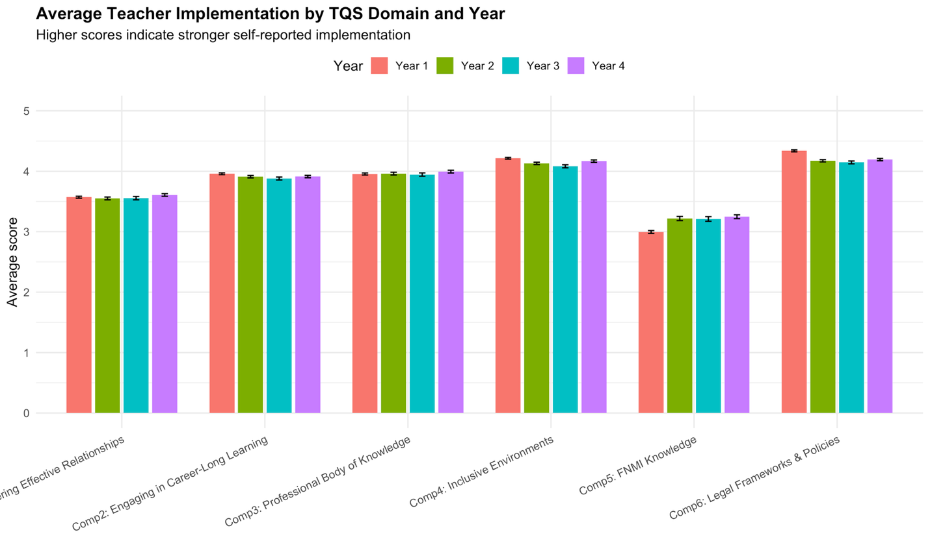
Figure 1. Average teacher self-reported implementation scores across the six Teacher Quality Standard competency domains for each survey year (Years 1–4). Domain scores represent teacher-level composite means calculated by averaging item responses mapped to each domain. Error bars represent standard errors of the mean. Across all four years, the relative ordering of domains is highly stable: Inclusive Environments (Comp4) and Legal Frameworks and Policies (Comp6) consistently appear among the highest-rated domains, while FNMI Knowledge (Comp5) remains the lowest. This repeated pattern suggests that the relative strengths and weaker areas of the competency framework are persistent rather than driven by year-to-year fluctuation. Cross-year comparisons should be interpreted descriptively because the domain item composition differs somewhat between Year 1 and later survey waves.

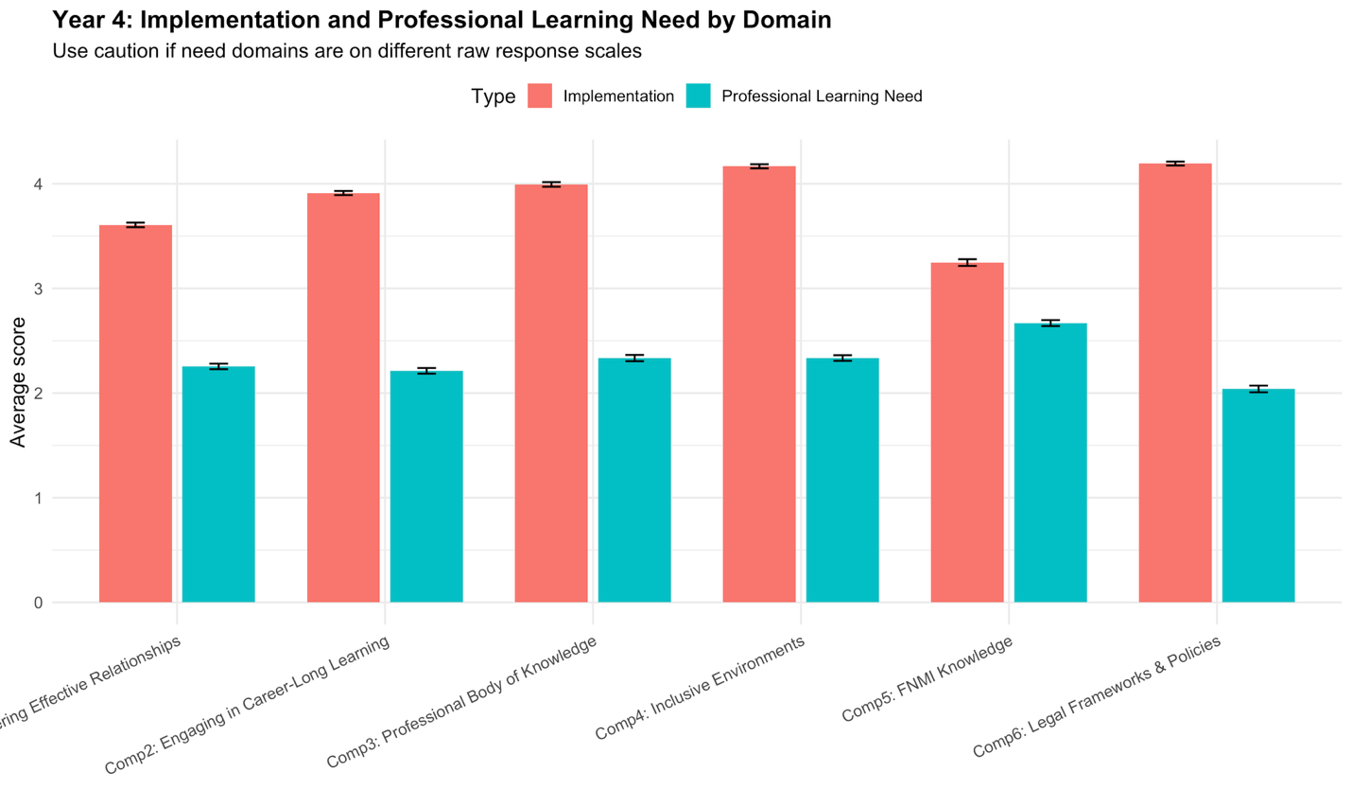
Figure 2. Comparison of Year 4 teacher implementation scores and professional learning need scores across the six Teacher Quality Standard domains. Bars show mean domain scores computed from teacher-level composite averages. FNMI Knowledge (Domain 5) shows both the lowest implementation score and the highest reported professional learning need, whereas Legal Frameworks and Policies (Domain 6) shows among the highest implementation scores and the lowest reported need. This inverse descriptive pattern suggests internal coherence in the Year 4 survey responses, although comparisons should be interpreted cautiously until the client confirms that all professional learning need domains use compatible response scales.
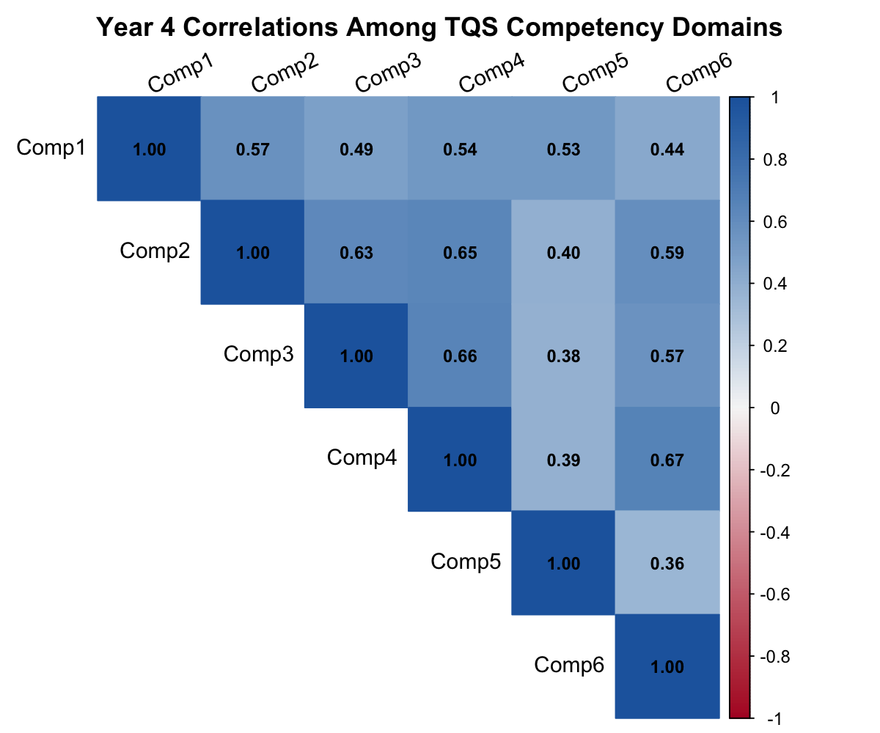
Figure 3. Correlation heatmap showing pairwise Pearson correlations among Year 4 implementation composite scores for the six Teacher Quality Standard domains. All domain correlations are positive and moderate in magnitude, ranging from r = 0.36 to r = 0.67, indicating that the domains reflect related aspects of a broader professional practice profile. The strongest association appears between Inclusive Environments (Comp4) and Legal Frameworks and Policies (Comp6), whereas FNMI Knowledge (Comp5) shows weaker correlations with the other domains. This pattern suggests that while all domains contribute to a common competency framework, FNMI Knowledge is somewhat less integrated with the rest of the profile.
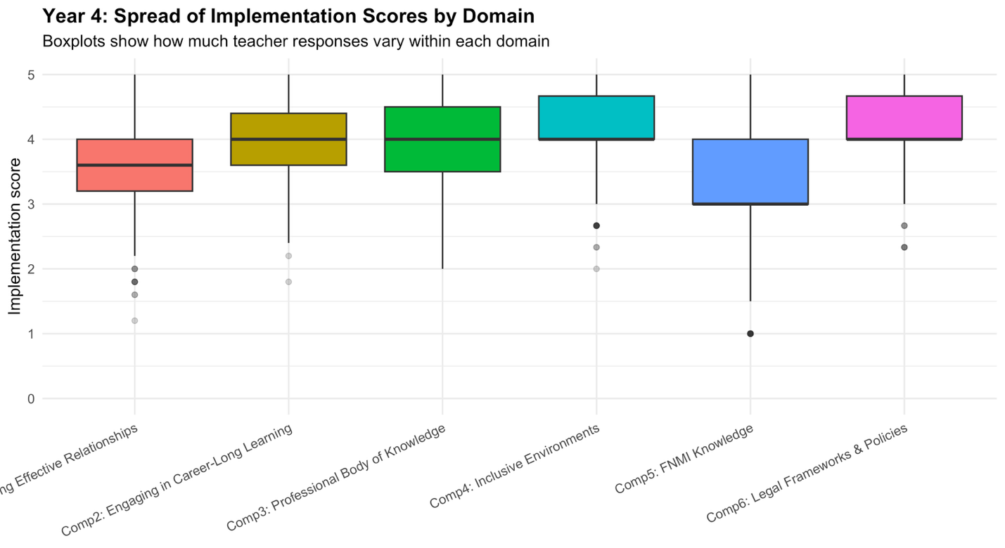
Figure 4. Boxplots showing the distribution of teacher-level implementation composite scores for each Teacher Quality Standard domain in Year 4. The central line in each box represents the median, the box indicates the interquartile range, and the whiskers extend to the range of typical observations. FNMI Knowledge (Comp5) exhibits the greatest spread in responses, indicating greater heterogeneity in teacher implementation levels, whereas Inclusive Environments (Comp4) and Legal Frameworks and Policies (Comp6) show relatively tighter distributions with higher central tendency. This pattern reinforces the descriptive finding that FNMI Knowledge is both the lowest-scoring and most variable competency domain.

1.4 Client clarifications
First, the Year 4 professional learning need mappings in Table 4 should be verified, especially where question numbers overlap with implementation items. Because the appendix explicitly warns about repeated question numbers, this is an important documentation issue that affects interpretation. Second, the response scales used for implementation and professional learning need should be confirmed, including whether all Year 4 need domains were measured on the same raw scale. If different need blocks use different ranges, direct mean comparisons may not be appropriate without standardization or rescaling.
Third, the client should clarify whether the intent is to compare domain scores directly across years. If strong cross-year comparability is required, a harmonized common-item strategy may be preferable to the current descriptive trend approach.
Fourth, it should be confirmed whether any items are reverse-coded. The current implementation assumes that higher values consistently indicate higher implementation or higher learning need, and this assumption should be checked before the report is finalized.

