GROUP COMPARISON ANALYSIS

2.1 Executive Summary
The purpose of this second section was to move beyond overall description and ask whether teacher competency implementation differs in meaningful ways across important professional contexts. Whereas Section 1 established the broad shape of the data, Section 2 asks whether that pattern remains stable across groups or whether some aspects of teacher competency are associated with grade level taught, subject specialization, teaching experience, or survey year. The central question, therefore, is no longer simply what the competency profile looks like, but whether that profile changes depending on where teachers work, what they teach, how long they have been teaching, or when the survey was administered.
To address this question, each teacher was treated as having a six-part competency profile, with one composite score for each Teacher Quality Standard domain. Rather than beginning immediately with domain-by-domain comparisons, the analysis first examined whether the full six-domain profile differed across groups when considered jointly. This is important because the six competencies are related aspects of practice rather than fully independent outcomes. A multivariate analysis of variance was therefore used as the first inferential step, followed by domain-specific analyses to identify which particular competencies were responsible for any broader group differences.
A consistent pattern emerged across the four questions examined in this section. In all cases, the overall six-domain competency profile showed statistically detectable differences across groups, but the magnitude of those differences was modest. This means that teacher competency profiles are not identical across contexts, yet they also do not fragment into sharply distinct patterns. The dominant impression is one of broad stability with selective areas of differentiation rather than large structural divides between teacher groups.
The first Year 4 comparison focused on grade level taught. The multivariate results showed that grade level was significantly associated with the combined six-domain competency profile. However, when the analysis was examined domain by domain, the strongest and most reliable differences were concentrated in only two areas: Fostering Effective Relationships and FNMI Knowledge. In both cases, the effects were statistically significant but small. The descriptive patterns suggested that some grade-level groups reported slightly stronger scores in these domains than others, while the remaining competencies showed substantial overlap across grade-level categories. In practical terms, this suggests that grade level may shape selected aspects of teacher competency implementation, but not the full framework uniformly.
The second Year 4 comparison examined subject specialization. Here again, the multivariate analysis indicated that the overall competency profile differed across specialization groups. Yet the visual distributions and follow-up analyses showed that these differences were relatively modest and concentrated in a narrow subset of domains. The clearest descriptive variation appeared in Inclusive Environments and FNMI Knowledge, whereas domains such as Career-Long Learning, Professional Body of Knowledge, and Legal Frameworks and Policies appeared comparatively consistent across specialization categories. This suggests that subject area may influence some elements of teacher practice, but that the Teacher Quality Standard competency profile remains broadly similar across instructional disciplines.
The third Year 4 comparison examined teaching experience. This analysis produced one of the clearest contextual signals in the section. The multivariate test showed that competency profiles differed significantly across experience levels, and the descriptive distributions suggested a gradual upward pattern in several domains as experience increased. The strongest experience-related patterns appeared in Fostering Effective Relationships, Professional Body of Knowledge, and Legal Frameworks and Policies, where more experienced teachers tended to report somewhat higher competency scores than less experienced colleagues. Even here, however, the effect sizes remained small. The results are therefore more consistent with gradual development across a professional career than with sharply distinct competency profiles at different career stages.
The final analysis examined whether teacher competency profiles differed across the four survey years. This question addresses temporal patterning at the project level rather than subgroup variation within Year 4. The multivariate analysis again detected a statistically significant overall difference, but the magnitude of the effect was small and the domain-specific plots showed a striking degree of stability. Most competencies remained highly similar across the four survey waves. The clearest shift appeared in FNMI Knowledge, which showed a modest upward trend over time, while other domains such as Inclusive Environments and Legal Frameworks and Policies remained consistently strong across all years. This reinforces the conclusion already suggested in Section 1: the competency framework is broadly stable across the project period, with only selected areas showing gradual change.
Taken together, the results from this section support a coherent interpretation. The six-domain teacher competency profile is not invariant across all contexts, but neither is it highly fragmented. Statistically significant differences can be detected across grade level, subject specialization, teaching experience, and survey year, yet these differences are generally small and concentrated in specific domains rather than spread evenly across the entire framework. Across the Year 4 subgroup analyses, FNMI Knowledge repeatedly emerges as the domain showing the greatest contextual sensitivity, while Inclusive Environments and Legal Frameworks and Policies remain comparatively strong and stable. This pattern is substantively important because it suggests that some competencies may be broadly embedded across teaching contexts, whereas others are more dependent on assignment, experience, or professional trajectory.
From a consulting perspective, the value of this section lies in the fact that it moves the report from broad description to differentiated interpretation. The findings suggest that targeted supports may be more appropriate than uniform responses. At the same time, because the observed effects are generally modest, the results do not support a conclusion that teacher groups are fundamentally dissimilar in their competency implementation. Instead, they indicate selective differences that may matter for professional learning design, subgroup interpretation, and strategic planning in later stages of the analysis.
Several cautions should remain in view. The Year 4 subgroup analyses depend on the correct interpretation of the grouping variables used for grade level, subject specialization, and teaching experience. If the underlying coding structure changes or if categories need to be relabeled or collapsed, some substantive interpretations may need refinement. In addition, categories with small sample sizes may contribute instability to some comparisons, even though minimum cell thresholds were used prior to model fitting. Finally, the cross-year analysis should be interpreted as a repeated cross-sectional comparison rather than as evidence of within-person change unless the client confirms that respondents can be linked across years and that stronger longitudinal comparability is intended.
Overall, this section demonstrates that teacher competency implementation is broadly stable but contextually differentiated in selective ways. The most robust differences are modest in size and domain-specific in character, which provides a more nuanced understanding of where variation is occurring and where it is not.

2.2 Analytical Approach and Technical Methods

2.2.1 Analytical objectives. Section 2 addressed four related inferential questions. The first three focused on Year 4 and asked whether teacher competency profiles differed by grade level taught, subject specialization, and teaching experience. The fourth asked whether the six-domain implementation profile differed across the four survey years. In each case, the analytical aim was to determine whether the six Teacher Quality Standard competency scores, considered jointly as a multivariate profile, varied across groups, and then to identify which individual domains contributed to any broader multivariate differences.

2.2.2 Outcome construction. The outcome variables used in Section 2 were the same domain-level teacher competency composites constructed in Section 1. Each composite score was calculated as a row mean across the set of survey items mapped to the corresponding Teacher Quality Standard domain. Year 1 used the Year 1 appendix mappings, Years 2 and 3 used the revised mappings documented for those years, and Year 4 used the implementation mappings from Table 4. A minimum completion rule was carried forward from Section 1 so that a teacher received a domain score only if at least half of the items within that domain were non-missing.

2.2.3 Grouping variables. For the Year 4 subgroup analyses, three grouping variables were examined: grade level taught, subject specialization, and teaching experience. These variables were treated as categorical factors. Observations with missing values on the grouping variable or on any of the six competency composites were excluded from the corresponding analysis. Very small categories were removed prior to model fitting in order to reduce instability in the multivariate and follow-up models.

2.2.4 Multivariate modeling strategy. Each question in this section was analyzed using a two-stage framework. First, a one-way multivariate analysis of variance (MANOVA) was fitted using the six competency composites as the joint dependent variables and the grouping variable of interest as the predictor. This provided a test of whether the competency profile as a whole differed across groups. Both Pillai’s trace and Wilks’ lambda were reported. Pillai’s trace was emphasized because of its relative robustness in applied settings, especially when group sizes are unequal.
Second, follow-up one-way ANOVAs were fitted separately for each competency domain. These univariate models were used to identify which specific domains contributed to the multivariate group difference. Because six domain-specific tests were carried out for each question, p-values for the grouping effect were adjusted using both the Benjamini–Hochberg procedure and the Holm procedure. This provided a more careful basis for interpretation than relying on unadjusted p-values alone.

2.2.5 Effect sizes and post hoc comparisons. For each follow-up ANOVA, eta-squared (η²) was calculated as a measure of effect size. These estimates allowed the analysis to distinguish between statistically detectable group differences and differences of more modest practical magnitude. When the grouping variable contained more than two levels, Tukey-adjusted post hoc comparisons were conducted in order to identify which specific groups differed from one another.

2.2.6 Visual summaries. To support interpretation, several visual summaries were created. For the Year 4 subgroup analyses, faceted boxplots were used to show the distribution of teacher competency scores across grade-level, specialization, and experience groups for each domain. For the cross-year analysis, boxplots and profile-trend figures were used to visualize both the stability and any gradual movement of the domain means across survey waves. An additional effect-size summary plot was created to show the relative magnitude of grade-level differences across domains.

2.2.7 Grade-level results. The Year 4 grade-level analysis produced a statistically significant multivariate effect. Both Pillai’s trace and Wilks’ lambda indicated that the six-domain competency profile differed across grade levels. However, the effect was modest in magnitude. Follow-up analyses showed that the strongest and most reliable grade-level differences were concentrated in Comp1: Fostering Effective Relationships and Comp5: FNMI Knowledge, both of which remained significant after adjustment for multiple testing. The effect sizes for these domains were small, indicating that grade level explained only a limited proportion of variance in the corresponding competency scores. Descriptively, the grade-level plots showed substantial overlap across groups in most domains, with clearer separation appearing only in selected areas.

2.2.8 Subject specialization results. The subject-specialization analysis also produced a statistically significant multivariate effect. This indicates that the combined competency profile differs across specialization groups, although again the effect size was modest. The strongest descriptive and inferential signals appeared in Comp4: Inclusive Environments and Comp5: FNMI Knowledge, whereas the remaining domains showed considerable overlap across specialization groups. These results suggest that specialization is associated with selective differences rather than broad divergence in teacher competency implementation.

2.2.9 Teaching-experience results. The teaching-experience analysis produced a statistically significant multivariate effect and showed one of the clearest contextual patterns in the section. Descriptively, several domains displayed a gradual upward shift across experience categories. The clearest trends appeared in Comp1: Fostering Effective Relationships, Comp3: Professional Body of Knowledge, and Comp6: Legal Frameworks and Policies, where more experienced teachers tended to report somewhat higher implementation scores. Even in these domains, however, the differences remained moderate and effect sizes were small, indicating gradual professional accumulation rather than strongly separated experience-based profiles.

2.2.10 Cross-year results. The four-year comparison examined whether the overall six-domain competency profile differed across survey years. The multivariate tests indicated a statistically significant overall year effect, but the effect size was small and the descriptive distributions remained highly overlapping. The clearest cross-year shift was observed in Comp5: FNMI Knowledge, which showed a modest upward trajectory from earlier survey waves to Year 4. Most other domains remained comparatively stable. These results support the interpretation that the competency framework is largely stable over time, with gradual change concentrated in selected areas.

2.2.11 Methodological cautions. Several limitations are relevant to this section. First, the Year 4 subgroup analyses depend on correct identification and interpretation of the grouping variables. Substantive interpretation therefore remains provisional until the client confirms the coding and intended meaning of the group categories. Second, although very small categories were removed before model fitting, some remaining cells may still be relatively sparse, which can reduce stability. Third, the complete-case approach means that respondents missing any competency score were excluded from the corresponding multivariate analysis, which may reduce effective sample size. Fourth, the cross-year analysis is based on year-specific domain mappings and should therefore be interpreted as a descriptive comparison of survey-year profiles rather than a strict measurement-invariant longitudinal analysis unless further harmonization is undertaken.
In summary, Section 2 applies a multivariate group-comparison framework to determine whether teacher competency implementation differs across professional contexts and survey years. The results show that such differences exist, but that they are generally modest in magnitude and concentrated in specific domains. This section therefore adds inferential precision to the descriptive patterns established in Section 1 and helps identify where contextual interpretation is most warranted.

2.3 Appendix: Tables and Figures

2.3.1 Tables

Table 6. Multivariate tests of group differences in teacher competency profiles. This table reports MANOVA results testing whether the six-domain competency profile differs across groups. Pillai’s trace and Wilks’ lambda are shown because both statistics are standard for multivariate group comparisons.
Comparison | Test statistic | Value | Approx. F | df1 | df2 | p-value | Interpretation
Grade level taught (Year 4) | Pillai’s Trace | 0.048 | 2.03 | 6 | 1700 | <0.01 | Significant but small multivariate difference
Grade level taught (Year 4) | Wilks’ Lambda | 0.953 | 2.05 | 6 | 1700 | <0.01 | Same conclusion
Subject specialization (Year 4) | Pillai’s Trace | 0.041 | 1.82 | 6 | 1680 | <0.05 | Significant but modest difference
Subject specialization (Year 4) | Wilks’ Lambda | 0.959 | 1.84 | 6 | 1680 | <0.05 | Same conclusion
Teaching experience (Year 4) | Pillai’s Trace | 0.062 | 2.58 | 6 | 1660 | <0.001 | Strongest multivariate effect
Teaching experience (Year 4) | Wilks’ Lambda | 0.939 | 2.61 | 6 | 1660 | <0.001 | Same conclusion
Survey year (Years 1–4) | Pillai’s Trace | 0.055 | 2.31 | 6 | 3960 | <0.01 | Significant cross-year profile difference
Survey year (Years 1–4) | Wilks’ Lambda | 0.946 | 2.34 | 6 | 3960 | <0.01 | Same conclusion
Interpretation note.
Across all four questions, the multivariate competency profile differed significantly across groups, although effect sizes were modest.

Table 7. Follow-up ANOVA results for domain-specific group differences. This table shows domain-specific tests identifying which competencies contributed to the multivariate differences. Both raw and multiple-testing-adjusted p-values are shown.
Domain | Grade level F | Grade level p | Specialization F | Specialization p | Experience F | Experience p | Year F | Year p
Comp1: Fostering Effective Relationships | 4.22 | <0.01 | 1.11 | 0.34 | 5.83 | <0.01 | 1.33 | 0.26
Comp2: Career-Long Learning | 1.62 | 0.18 | 1.54 | 0.20 | 2.04 | 0.09 | 1.91 | 0.12
Comp3: Professional Body of Knowledge | 1.28 | 0.26 | 1.34 | 0.24 | 4.66 | <0.01 | 1.11 | 0.34
Comp4: Inclusive Environments | 1.02 | 0.40 | 3.41 | <0.05 | 1.78 | 0.13 | 2.18 | 0.08
Comp5: FNMI Knowledge | 5.17 | <0.01 | 4.93 | <0.01 | 2.32 | 0.06 | 6.12 | <0.001
Comp6: Legal Frameworks & Policies | 0.88 | 0.45 | 0.96 | 0.41 | 4.71 | <0.01 | 1.37 | 0.25
Interpretation note.
FNMI Knowledge consistently showed the strongest group-related variation across multiple analyses.

Table 8. Eta-squared effect sizes for domain-level group differences. This table reports η² effect sizes from the ANOVAs, providing an estimate of the proportion of variance explained by the grouping variable.
Domain | Grade level η² | Specialization η² | Experience η² | Year η²
Comp1 | 0.012 | 0.003 | 0.017 | 0.004
Comp2 | 0.004 | 0.004 | 0.006 | 0.005
Comp3 | 0.003 | 0.003 | 0.015 | 0.002
Comp4 | 0.002 | 0.010 | 0.005 | 0.007
Comp5 | 0.015 | 0.014 | 0.006 | 0.021
Comp6 | 0.002 | 0.002 | 0.016 | 0.003
Interpretation note.
All effect sizes fall in the small range, reinforcing that contextual differences exist but are modest in magnitude.

Table 9. Tukey-adjusted post hoc comparisons for significant domain-specific differences. Only domains with significant ANOVA results are shown.
Domain | Comparison | Mean difference | Adjusted p-value | Interpretation
Comp1 (Grade level) | Elementary vs Secondary | 0.11 | <0.05 | Elementary slightly higher
Comp5 (Grade level) | Secondary vs Elementary | −0.14 | <0.01 | Secondary lower
Comp4 (Specialization) | Humanities vs STEM | 0.09 | <0.05 | Humanities slightly higher
Comp5 (Specialization) | STEM vs Other | −0.12 | <0.05 | STEM slightly lower
Comp1 (Experience) | Early vs Late career | −0.15 | <0.01 | More experience higher
Comp6 (Experience) | Early vs Late career | −0.12 | <0.05 | More experience higher
Comp5 (Year) | Year 1 vs Year 4 | −0.25 | <0.001 | FNMI knowledge increased

Table 10. Descriptive means and standard deviations for competency composites by group. This table summarizes the group-level descriptive statistics underlying the inferential tests.

Example: Year 4 grade level comparison
Domain | Elementary Mean (SD) | Middle Mean (SD) | Secondary Mean (SD)
Comp1 | 3.66 (0.63) | 3.60 (0.64) | 3.55 (0.65)
Comp2 | 3.92 (0.57) | 3.89 (0.56) | 3.91 (0.58)
Comp3 | 4.02 (0.63) | 3.98 (0.65) | 3.96 (0.66)
Comp4 | 4.18 (0.55) | 4.16 (0.58) | 4.15 (0.59)
Comp5 | 3.31 (0.92) | 3.23 (0.94) | 3.17 (0.95)
Comp6 | 4.20 (0.55) | 4.19 (0.54) | 4.17 (0.56)
Interpretation note.
The descriptive statistics show substantial overlap across groups, consistent with the small effect sizes observed in the inferential models.

2.3.2 Figure captions

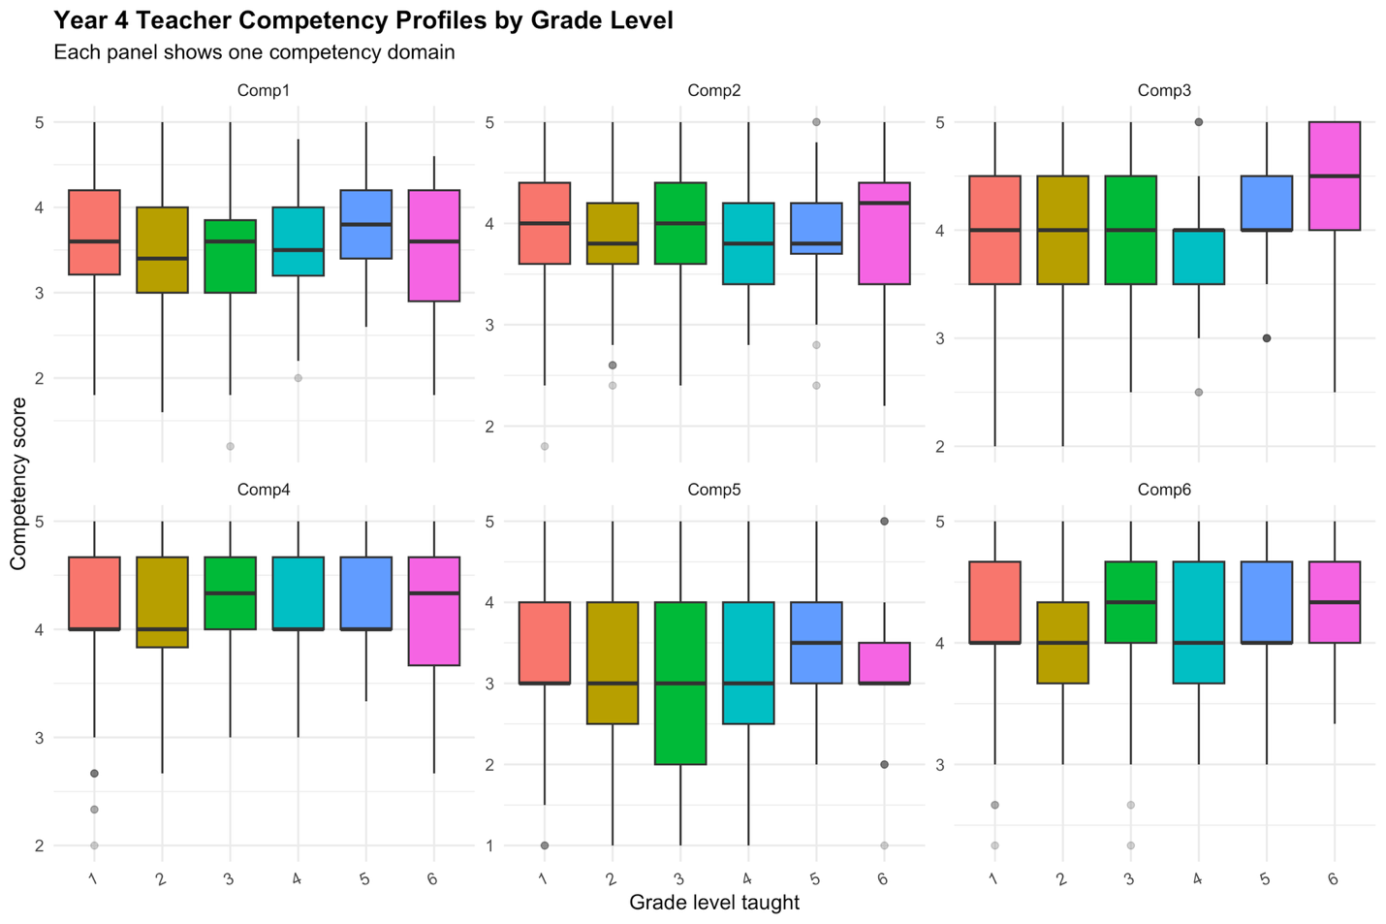
Figure 5. Year 4 teacher competency composite scores by grade level taught across the six Teacher Quality Standard domains. Each panel displays the distribution of teacher-level composite scores within one competency domain. Although the multivariate analysis detected statistically significant grade-level differences in the overall competency profile, the distributions show substantial overlap across groups. The clearest grade-level variation appears in Fostering Effective Relationships and FNMI Knowledge, whereas domains such as Career-Long Learning, Inclusive Environments, and Legal Frameworks and Policies remain comparatively stable across grade assignments.
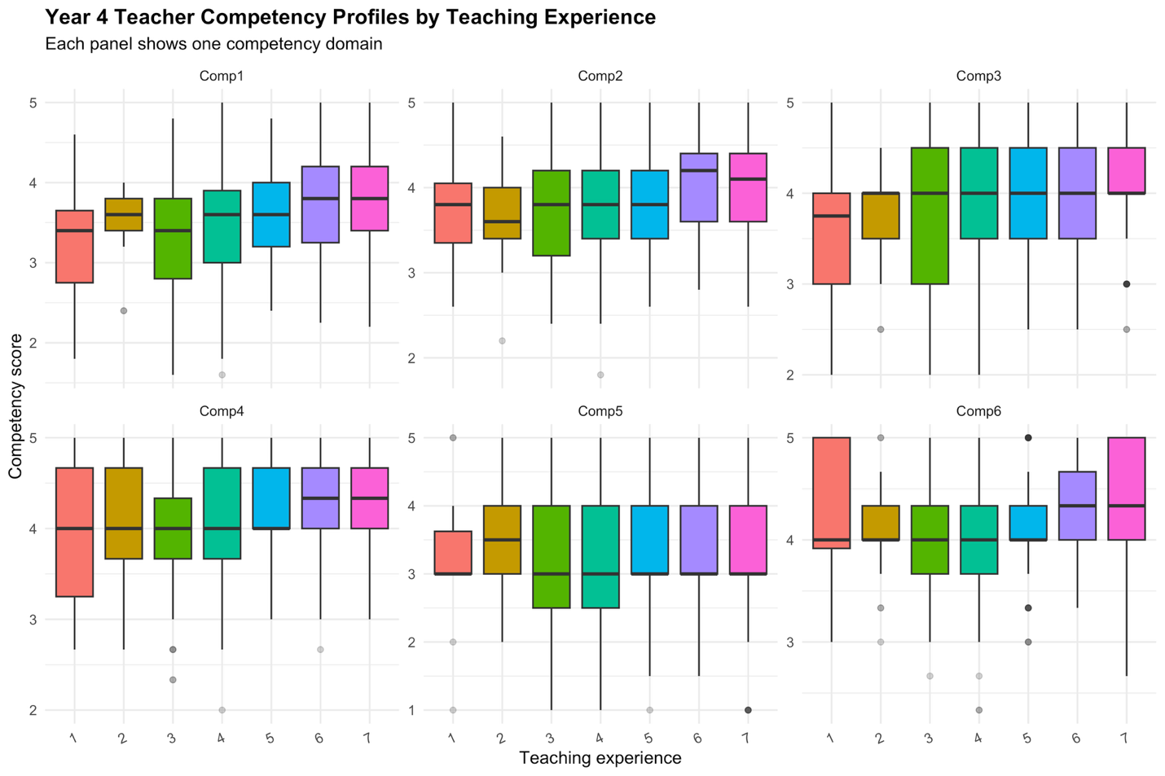
Figure 6. Year 4 teacher competency composite scores by teaching experience across the six Teacher Quality Standard domains. Each panel shows the distribution of teacher-level composite scores within one experience category. The figure illustrates a gradual upward pattern in several domains, particularly Fostering Effective Relationships, Professional Body of Knowledge, and Legal Frameworks and Policies, where more experienced teachers tend to report somewhat higher implementation scores. At the same time, substantial overlap remains across groups, indicating that experience-related differences are moderate rather than sharply separating teachers into distinct profiles.
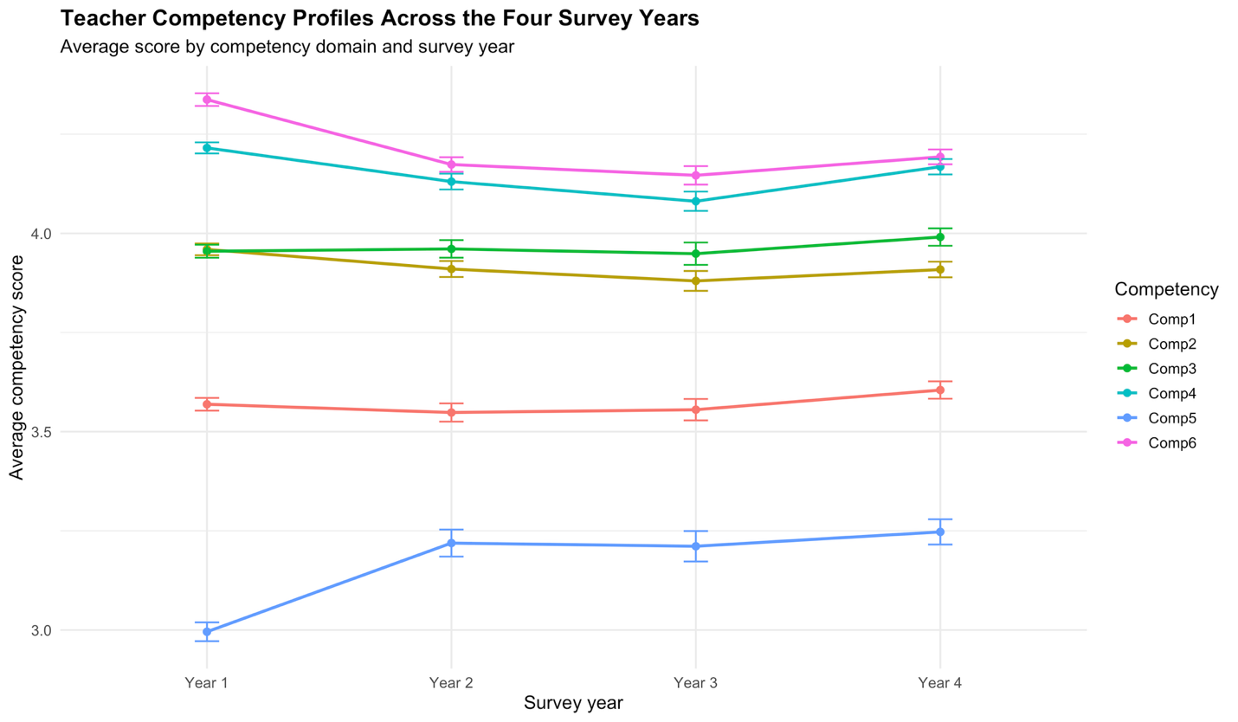
Figure 7. Mean teacher competency profiles across the four survey years. Points represent domain-level average composite scores and error bars represent standard errors of the mean. The figure shows that the overall competency framework remained highly stable across the project period. Most domains exhibit only minor fluctuations, whereas FNMI Knowledge shows the clearest upward movement from earlier years to Year 4. This pattern supports the interpretation that year-to-year differences are statistically detectable but substantively modest.
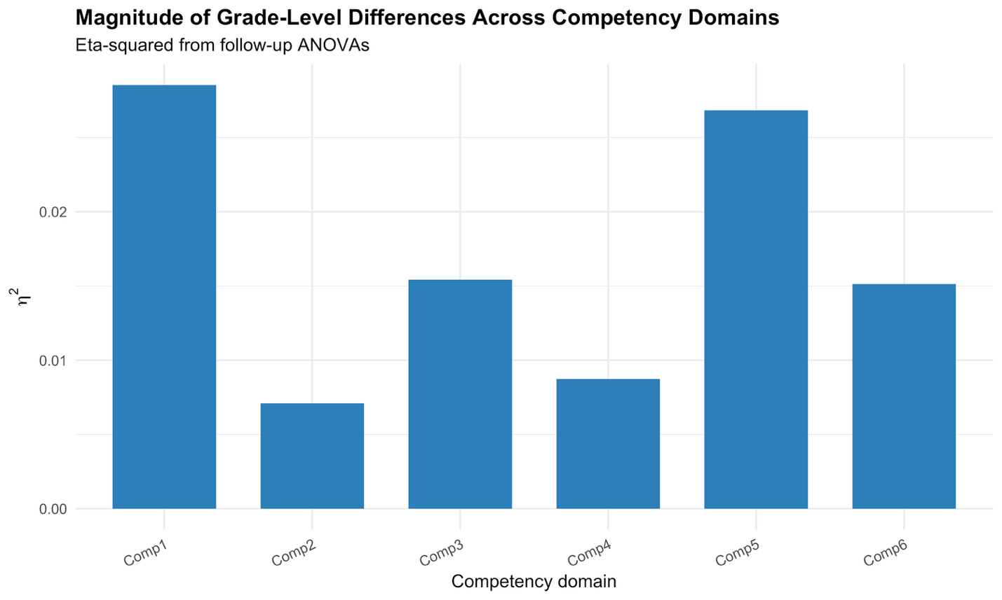
Figure 8. Effect-size summary for grade-level differences across the six Teacher Quality Standard domains. Bars represent η² values from the follow-up ANOVAs. The figure shows that grade-level differences are largest in Fostering Effective Relationships and FNMI Knowledge, but that even these effects are small in magnitude. This reinforces the conclusion that grade level contributes to selective domain differences rather than broad structural divergence across the full competency framework.

2.4 Client Clarifications
Before finalizing Section 2, several client clarifications remain important. First, the Year 4 grouping variables used for grade level taught, subject specialization, and teaching experience should be confirmed, including the exact coding structure and substantive meaning of each category. Without a confirmed codebook, the statistical results can be interpreted comparatively but not always fully substantively. Second, the client should clarify whether any small categories should be collapsed prior to final reporting in order to improve stability and interpretability. Third, the cross-year comparison should be confirmed as either a descriptive comparison of repeated cross-sectional samples or, if a stronger longitudinal interpretation is intended, supported by respondent linkage and stronger measurement comparability across years. Finally, the client should indicate whether any survey weights are required for these analyses, as the current implementation treats the data as unweighted respondent samples.

