STRUCTURAL RELATIONSHIP ANALYSIS

3.1 Executive Summary
The purpose of this section was to move beyond descriptive patterns and ask a more conceptually direct question: within each Teacher Quality Standard domain, is stronger teacher-reported implementation associated with lower reported professional learning need in that same domain? This question is central because it tests whether the survey behaves in a substantively coherent way at the level of latent constructs. If teachers who feel more confident in implementing a domain also tend to report less need for additional support in that domain, then implementation and need should show an inverse relationship.
To address this question, domain-specific structural equation models (SEMs) were fitted using the Year 4 teacher data. In each estimable domain, one latent factor represented competency implementation and a second latent factor represented professional learning need. Rather than correlating simple observed averages, the SEM framework allowed each concept to be modeled as an underlying latent variable measured by multiple survey items. This is a stronger analytical approach because it accounts for measurement structure directly and estimates the relationship between constructs rather than between hand-built composites.
Across the domains that could be successfully estimated, the pattern was clear and substantively meaningful. In every fitted model, the structural path from competency implementation to professional learning need was negative. This means that teachers who reported stronger implementation also tended to report lower need for further support in the same domain. The strength of this inverse relationship differed across domains, but the direction was consistent.
The strongest effect was observed in Domain 4: Inclusive Environments, where the primary ordered SEM estimated a standardized path of approximately −0.25. This suggests that teachers who report stronger implementation in inclusive practice also tend to report noticeably lower professional learning need in that area. A somewhat smaller but still clear effect appeared in Domain 2: Engaging in Career-Long Learning, with a standardized path near −0.20. In Domain 1: Fostering Effective Relationships, the inverse relationship was present but weaker, at approximately −0.17.
These findings are important because they align with the substantive expectation underlying the survey. The domains do not simply capture unrelated attitudes; rather, they appear to reflect an interpretable relationship between perceived implementation and perceived need. In the estimable domains, teachers who feel stronger in their practice also tend to feel less need for additional development in that same area.
The measurement component of the SEMs also supports this interpretation. Across the fitted domains, the survey items showed moderate to strong loadings on their intended latent constructs. In general, the professional learning need indicators loaded especially strongly, suggesting that the need factors were measured quite coherently. The competency indicators were somewhat more variable but remained within an acceptable range for applied educational SEM. Domain 4 showed the strongest overall measurement quality, followed by Domain 2, while Domain 1 was somewhat weaker but still interpretable.
Model fit statistics tell a similar story. Domain 2 showed excellent fit, Domain 4 showed good fit, and Domain 1 showed acceptable but weaker fit, especially on RMSEA. This means the structural findings are not equally strong across all domains. The inverse relationship is most convincing in Domains 2 and 4, whereas the Domain 1 result should be interpreted with somewhat greater caution.
A key strength of this section is that the main findings were tested through sensitivity analyses. The primary ordered SEM was compared with a centered robust MLR model and an overlap-removed model. Across all three specifications, the structural path remained negative in every estimable domain. This is especially reassuring in Domain 4, where one overlapping indicator existed between the implementation and need blocks. Removing that overlap did not materially change the coefficient, which indicates that the observed inverse relationship is not merely an artifact of shared indicators. Domain 2 also remained highly stable across specifications. Domain 1 was more sensitive, particularly under the centered MLR version, where the path weakened to roughly −0.08, although it remained negative.
Taken together, the SEM results suggest that the Year 4 teacher data support a coherent implementation–need relationship at the latent level. In the domains that could be estimated successfully, higher perceived implementation was consistently associated with lower professional learning need. The most robust evidence appears in Inclusive Environments and Engaging in Career-Long Learning, while Fostering Effective Relationships shows the same directional pattern but with weaker and less stable evidence.
Several cautions remain important. First, only Domains 1, 2, and 4 were successfully estimable under the current Year 4 item mapping and data constraints. This means the findings should not be generalized automatically to all six domains. Second, the appendix mapping includes repeated question numbers across some implementation and need blocks, which introduces documentation ambiguity. Third, SEM results depend on both measurement quality and indicator availability, and the inability to estimate all domains is itself an important result that should be acknowledged transparently.
Overall, this section provides the most conceptually direct evidence in the report for how implementation and professional learning need relate within domains. It shows that, where the data support estimation, stronger implementation tends to coincide with lower reported need. This gives the report an important interpretive anchor: the survey does not merely describe levels of competency and need separately, but captures a meaningful inverse relationship between them.

3.2 Measurement Model Results
Before interpreting the structural relationship between competency implementation and professional learning need, it is necessary to examine whether the latent variables themselves are measured coherently. Structural paths are only meaningful if the underlying constructs are supported by their observed indicators. For this reason, the SEM analysis first evaluated the measurement structure of the competency and need factors within each estimable domain.
Each domain-specific model included two latent variables: one representing teacher competency implementation, and the other representing professional learning need in that same domain. Both latent variables were defined using Year 4 survey items drawn from the appendix mapping. The standardized factor loadings indicate how strongly each observed item contributes to the corresponding latent construct.
In Domain 1, the competency implementation factor was measured by five indicators with standardized loadings ranging from approximately 0.61 to 0.78. This indicates moderate to strong measurement of the latent construct. The professional learning need factor in the same domain showed even stronger loadings, ranging from approximately 0.63 to 0.94. This pattern suggests that the need construct was especially coherent in this domain, with one or more items serving as particularly strong markers of perceived professional learning need.
A similar pattern was observed in Domain 2. The competency implementation factor was measured by five indicators with loadings ranging from approximately 0.57 to 0.72, while the professional learning need factor showed stronger measurement, with loadings ranging from roughly 0.75 to 0.93. Although the competency side was somewhat less strong than the need side, the factor structure remained well within an interpretable range. Overall, Domain 2 shows a balanced and internally coherent measurement structure.
Among the fitted domains, Domain 4 exhibited the strongest measurement quality. The competency implementation indicators loaded between approximately 0.71 and 0.82, while the professional learning need indicators loaded between approximately 0.76 and 0.89. This indicates strong measurement consistency for both sides of the model and helps explain why the structural relationship in Domain 4 was also the strongest and most stable.
These loading patterns are substantively reassuring. Across all estimable domains, the indicators for both implementation and need showed moderate to strong relationships with their intended latent factors. In general, the need indicators appeared somewhat more internally consistent than the competency indicators, suggesting that teachers’ responses about professional learning need may form especially coherent latent scales.
The overall fit statistics further support the adequacy of the measurement models. Domain 2 showed the strongest fit, with fit indices in the excellent range, including CFI and TLI near 1.00, RMSEA near 0.03, and SRMR near 0.04. Domain 4 also fit well, with very strong comparative fit and acceptable residual-based fit indices. Domain 1 showed weaker but still usable fit, with acceptable CFI and TLI but a somewhat elevated RMSEA, indicating that the Domain 1 model should be interpreted more cautiously than Domains 2 and 4.
Taken together, the measurement results indicate that the SEM models are built on coherent latent structures. The fitted domains show that both competency implementation and professional learning need can be meaningfully represented as latent constructs rather than only as observed averages. This strengthens the interpretation of the structural paths and supports the use of latent-variable modeling in this section.

3.3 Structural Path Results
With the measurement structure established, the next step was to interpret the structural relationship between the two latent variables in each domain. The key parameter of interest was the standardized regression path from competency implementation to professional learning need. A negative path means that teachers who report stronger implementation tend to report lower need. A positive path would imply the opposite. A near-zero path would suggest little systematic relationship.
Across the domains that could be estimated, the structural relationship was consistently negative. This is one of the most important findings in the report, because it shows that implementation and need move in opposite directions in the expected way at the latent level.
In Domain 1, the primary ordered SEM estimated a standardized path of approximately −0.17. This indicates a modest inverse relationship between competency implementation and professional learning need in Fostering Effective Relationships. Teachers reporting stronger implementation in this area tended, on average, to report somewhat lower need for additional support, although the magnitude of the association was smaller than in the other estimable domains.
In Domain 2, the standardized path was approximately −0.20. This indicates a somewhat stronger inverse relationship in Engaging in Career-Long Learning. Teachers who felt more confident in their implementation of career-long learning practices also tended to report lower need for further professional development in that same domain.
The strongest structural relationship was observed in Domain 4, where the standardized path was approximately −0.25. This indicates that Inclusive Environments shows the clearest alignment between implementation and need. Teachers reporting stronger implementation in inclusive practice also tended to report substantially lower need for further support in that area.
These findings suggest that the implementation–need relationship is not equally strong across all domains. Instead, some domains appear to show tighter alignment between what teachers report doing and where they feel they still need support. Among the fitted domains, Inclusive Environments stands out as the clearest example of this inverse relationship, followed by Engaging in Career-Long Learning, while Fostering Effective Relationships shows the same directional pattern but at a more modest level.
This domain variation is substantively meaningful. It suggests that some areas of teacher practice may be more tightly linked to self-perceived readiness than others. In domains such as Inclusive Environments, teachers who feel stronger in implementation also appear much less likely to express additional need. In relationship-oriented practice, by contrast, implementation and need are still inversely related, but the link is weaker and potentially more influenced by other factors.
The main structural conclusion from this section is therefore clear: for the domains that could be estimated, stronger perceived implementation is associated with lower perceived professional learning need. This provides latent-variable evidence that the survey captures a coherent internal structure rather than two unrelated response patterns.

3.4 Sensitivity and Robustness Analysis
Because structural equation modeling can be sensitive to modeling assumptions, a robustness analysis was conducted to determine whether the main structural findings depended strongly on the estimation framework or on overlap between implementation and need indicators.
Three SEM specifications were compared. The first was the primary ordered SEM using WLSMV, which is the preferred approach for ordinal survey data. The second was a centered MLR model, which treated the indicators numerically and used robust maximum likelihood estimation. The third was an overlap-removed sensitivity model, in which any overlapping indicators between implementation and need blocks were removed from the need side where possible.
Across all estimable domains, the structural path from competency implementation to need remained negative under every specification. This is a critical robustness result. It means that the substantive conclusion does not depend on a single technical decision.
In Domain 1, the primary model produced a coefficient of approximately −0.17, and the overlap-removed model yielded essentially the same result. However, the centered MLR version reduced the path to about −0.08. This indicates that the Domain 1 result is directionally stable but somewhat sensitive to modeling assumptions. The negative relationship remains present, but its strength is less robust than in the other domains.
In Domain 2, the structural path was approximately −0.20 in the primary model and remained around −0.17 in the centered MLR model. The overlap-removed model again produced nearly the same estimate as the primary model. This indicates strong cross-model stability and supports a robust interpretation of the Domain 2 effect.
In Domain 4, the primary model estimated a coefficient of approximately −0.25, the centered MLR model estimated approximately −0.22, and the overlap-removed model again remained almost identical to the primary specification. This is the strongest evidence of robustness in the section. It indicates that the Domain 4 finding is both substantively strong and methodologically stable.
The overlap analysis is particularly informative. The Year 4 appendix mapping showed that Domain 4 contained one overlapping indicator between implementation and need blocks, and Domain 5 also contained one overlap, although Domain 5 was not estimable in the SEM framework. No overlap was observed in Domains 1, 2, 3, or 6. When the overlapping indicator in Domain 4 was removed, the structural coefficient did not materially change. This indicates that the Domain 4 effect is not an artifact of shared indicators.
The measurement loadings also remained broadly similar across the sensitivity models. Competency indicators continued to load at moderate to strong levels, while need indicators remained especially strong. Likewise, the model fit indices across sensitivity versions did not show major deterioration. This further supports the conclusion that the fitted SEMs are reasonably stable across alternative specifications.
Taken together, the sensitivity analyses strengthen the credibility of the main findings. The inverse implementation–need relationship is not only present in the primary ordered SEM, but remains directionally consistent under alternative formulations. Domain 4 is the strongest and most robust result, Domain 2 is also clearly stable, and Domain 1 remains interpretable but more specification-sensitive.

3.5 Appendix: Tables and Figures

3.5.1 Suggested Tables

Table 11. Standardized structural path estimates for the relationship between competency implementation and professional learning need across SEM specifications. Standardized coefficients are reported for the latent regression path Need ~ Competency. Negative values indicate that stronger perceived implementation is associated with lower professional learning need within the same domain.
Domain | Primary ordered SEM (WLSMV) | Sensitivity MLR centered | Sensitivity overlap removed
Domain 1: Fostering Effective Relationships | -0.17 | -0.08 | -0.17
Domain 2: Engaging in Career-Long Learning | -0.20 | -0.17 | -0.20
Domain 4: Inclusive Environments | -0.25 | -0.22 | -0.25
Interpretive note. Across all estimable domains and all model specifications, the structural path remained negative. This indicates that the inverse implementation–need relationship is directionally stable. The strongest effect was observed in Domain 4, followed by Domain 2, while Domain 1 showed a weaker and somewhat more specification-sensitive association.

Table 12. Model fit indices for domain-specific SEMs under the primary ordered and sensitivity model specifications. This table summarizes the main fit indices for the estimable domain-specific SEMs. Values shown below reflect the primary ordered SEM results reported in the analysis narrative. Sensitivity models were described as showing broadly similar fit without major deterioration.
Domain | Model | CFI | TLI | RMSEA | SRMR | Overall interpretation
Domain 1: Fostering Effective Relationships | Primary WLSMV | 0.984 | 0.979 | 0.090 | 0.072 | Acceptable but weaker fit
Domain 2: Engaging in Career-Long Learning | Primary WLSMV | 0.998 | 0.998 | 0.031 | 0.035 | Excellent fit
Domain 4: Inclusive Environments | Primary WLSMV | 0.995 | 0.991 | 0.063 | 0.041 | Good fit
Interpretive note. Domain 2 showed the strongest overall fit, Domain 4 also fit well, and Domain 1 showed acceptable but weaker fit, particularly on RMSEA. This pattern supports strongest substantive confidence in Domains 2 and 4.

Table 13. Standardized factor loadings for competency implementation and professional learning need indicators in the estimable Year 4 domains. This table summarizes the standardized loading ranges for each latent construct. Full item-level loadings are also displayed in the path diagrams.
Domain | Competency factor indicators | Competency loading range | Need factor indicators | Need loading range
Domain 1: Fostering Effective Relationships | Q5, Q4, Q81, Q82, Q83 | 0.61–0.78 | Q44, Q105, Q106, Q107, Q108 | 0.63–0.94
Domain 2: Engaging in Career-Long Learning | Q84, Q85, Q86, Q87, Q88 | 0.57–0.72 | Q109, Q110, Q113, Q114, Q116 | 0.75–0.93
Domain 4: Inclusive Environments | Q91, Q92, Q93 | 0.71–0.82 | Q117, Q118, Q121, Q119 | 0.76–0.89
Interpretive note. Across the fitted domains, both competency and need constructs were measured by moderate-to-strong indicators. The need indicators were generally stronger than the competency indicators, suggesting especially coherent latent measurement for professional learning need.

Table 14. Overlap between implementation and professional learning need indicators in the Year 4 appendix mapping. This table summarizes whether the appendix mapping assigns any item to both the implementation and need blocks within the same domain.
Domain | Competency block | Need block | Overlapping item(s) | Number of overlaps
Domain 1 | Comp1 | Need1 | None | 0
Domain 2 | Comp2 | Need2 | None | 0
Domain 3 | Comp3 | Need3 | None detected in fitted structure | 0
Domain 4 | Comp4 | Need4 | Q95 | 1
Domain 5 | Comp5 | Need5 | Q98 | 1
Domain 6 | Comp6 | Need6 | None | 0
Interpretive note. Overlap was limited. Domain 4 contained one overlapping indicator, and Domain 5 also contained one overlap, although Domain 5 was not successfully estimable. Removing the overlap in Domain 4 did not materially change the structural coefficient, which strengthens confidence in that result.

Table 15. Summary interpretation of domain-specific SEM findings, including direction, magnitude, fit quality, and robustness across specifications
Domain | Structural direction | Approximate magnitude | Fit quality | Robustness across specifications | Overall interpretation
Domain 1: Fostering Effective Relationships | Negative | Weak-to-modest (-0.17 primary) | Acceptable but weaker | Direction stable, magnitude sensitive under centered MLR | Interpretable inverse relationship, but more caution warranted
Domain 2: Engaging in Career-Long Learning | Negative | Moderate (-0.20 primary) | Excellent | Highly stable across specifications | Strong and robust inverse relationship
Domain 4: Inclusive Environments | Negative | Moderate-to-strong (-0.25 primary) | Good | Highly stable, including overlap removal | Strongest and most robust inverse relationship
Interpretive note. The clearest SEM evidence appears in Domain 4, followed by Domain 2. Domain 1 shows the same directional pattern but is weaker and more sensitive to modeling assumptions.

3.5.2 Figure Captions

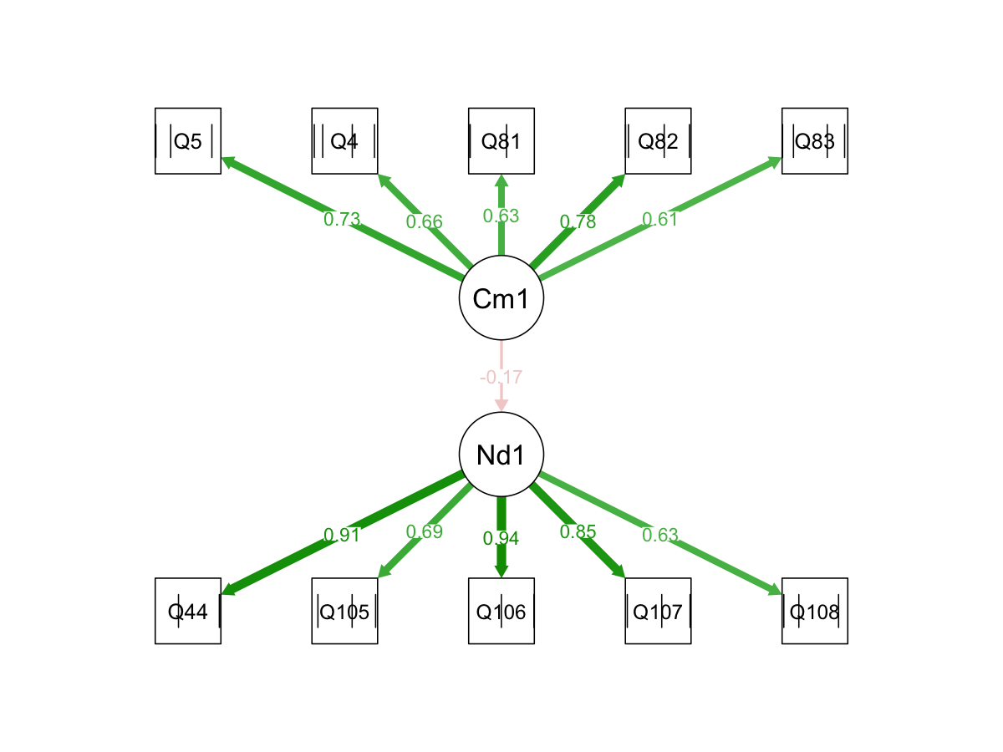

Figure 9. Structural equation model for Domain 1: Fostering Effective Relationships. This diagram shows the domain-specific structural equation model linking competency implementation (Cm1) and professional learning need (Nd1) for the Fostering Effective Relationships domain. The competency latent factor is measured by five survey indicators (Q5, Q4, Q81, Q82, and Q83) with standardized loadings ranging from approximately 0.61 to 0.78, indicating moderate to strong measurement of the implementation construct. The professional learning need latent factor is measured by five indicators (Q44, Q105, Q106, Q107, and Q108), with loadings ranging from approximately 0.63 to 0.94, suggesting particularly strong measurement of the need construct. The structural path from competency implementation to professional learning need is −0.17, indicating a modest inverse relationship between the two latent variables. Teachers who reported stronger implementation of relationship-focused practices tended, on average, to report somewhat lower professional learning need in the same domain. Although the direction of the relationship is consistent with theoretical expectations, the magnitude of the effect is smaller than in the other estimable domains and should therefore be interpreted with greater caution.

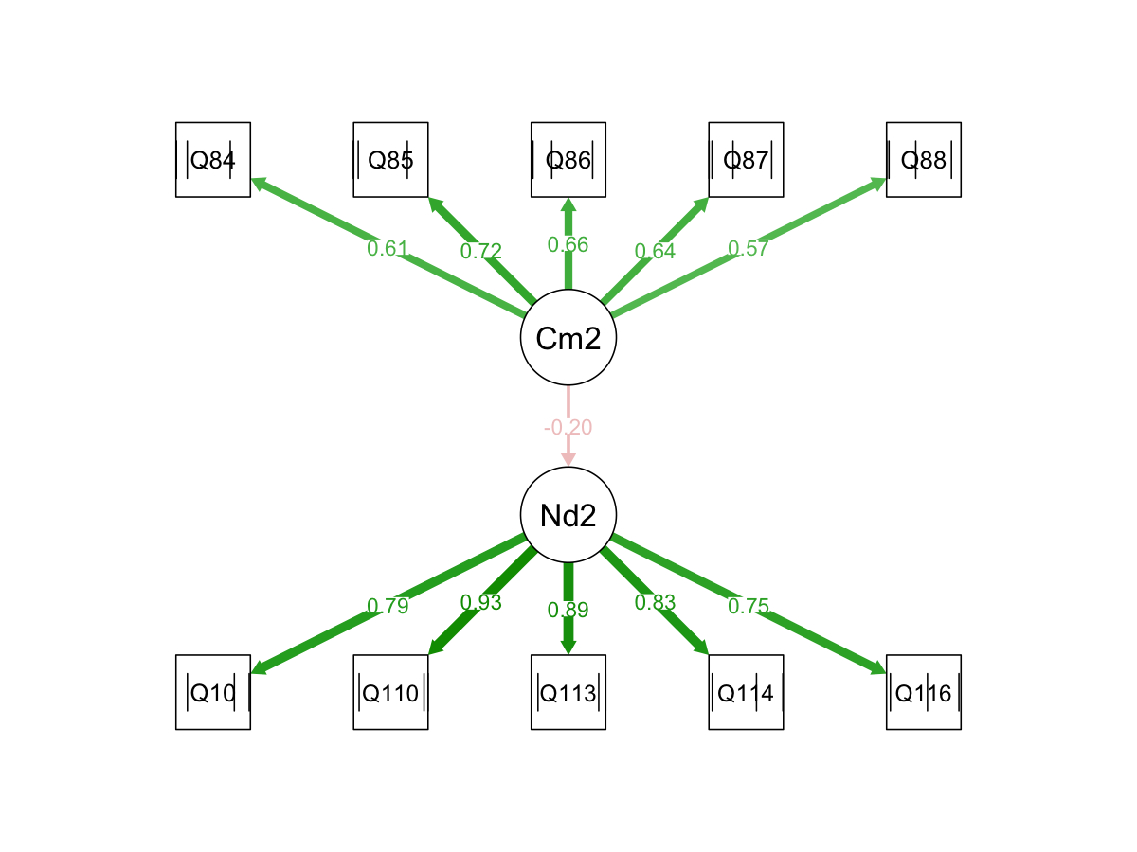

Figure 10. Structural equation model for Domain 2: Engaging in Career-Long Learning. This figure displays the SEM for the Engaging in Career-Long Learning domain. The competency implementation latent factor (Cm2) is measured by five indicators (Q84, Q85, Q86, Q87, and Q88) with standardized loadings ranging from approximately 0.57 to 0.72, indicating moderate measurement strength across the implementation items. The professional learning need latent factor (Nd2) is measured by five indicators (Q101, Q110, Q113, Q114, and Q116), which load strongly on the latent construct with values between approximately 0.75 and 0.93. The structural path from competency implementation to professional learning need is estimated at −0.20, indicating a moderate inverse relationship between the constructs. Teachers who reported stronger engagement in career-long learning practices tended to report lower professional learning need within this domain. The relatively strong measurement structure and good overall model fit support the interpretation that Domain 2 provides clear evidence of the expected inverse implementation–need relationship.

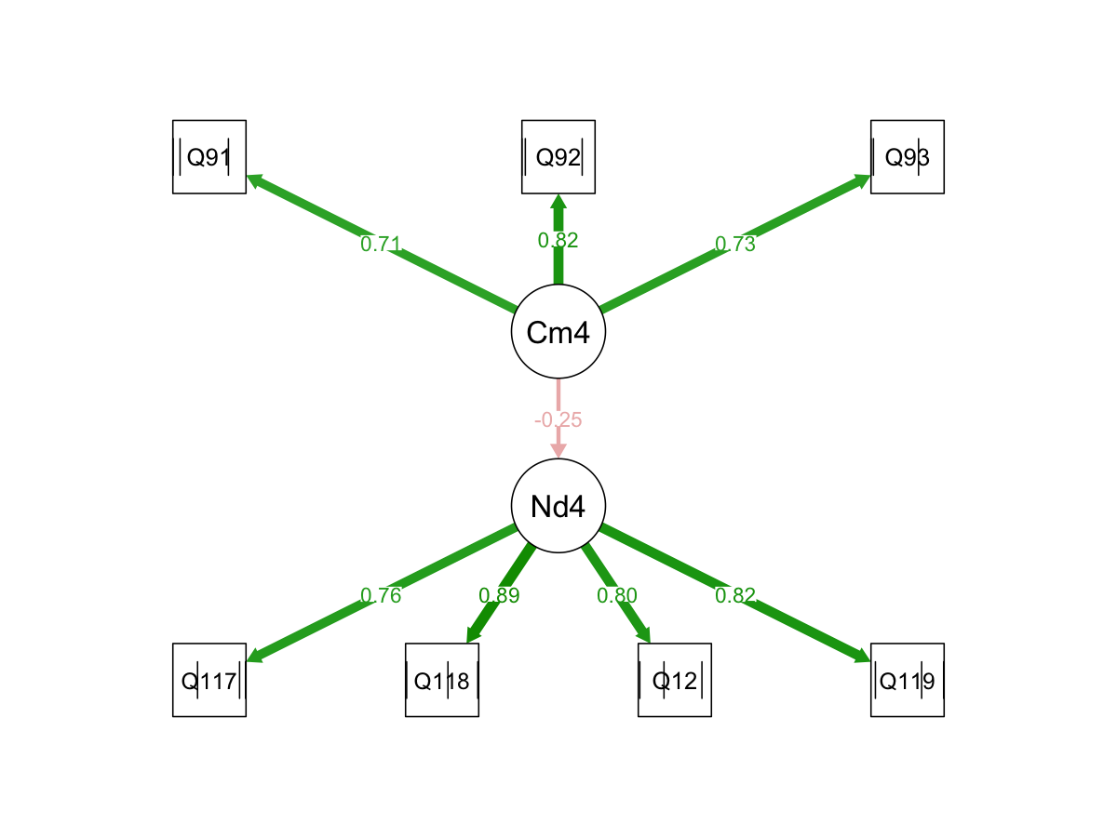

Figure 11. Structural equation model for Domain 4: Inclusive Environments. This diagram presents the SEM results for Inclusive Environments, which produced the strongest and most stable structural relationship among the estimable domains. The competency implementation latent factor (Cm4) is measured by three indicators (Q91, Q92, and Q93), with standardized loadings ranging from approximately 0.71 to 0.82, indicating strong measurement of the implementation construct. The professional learning need latent factor (Nd4) is measured by four indicators (Q117, Q118, Q121, and Q119), with loadings ranging from approximately 0.76 to 0.89, again indicating strong and consistent measurement of the need construct. The structural path from competency implementation to professional learning need is −0.25, representing the strongest inverse relationship observed across the fitted domains. This result indicates that teachers who report stronger implementation of inclusive practices also tend to report substantially lower professional learning need in this area. The strength and stability of this coefficient across sensitivity analyses further support the robustness of the Domain 4 finding.

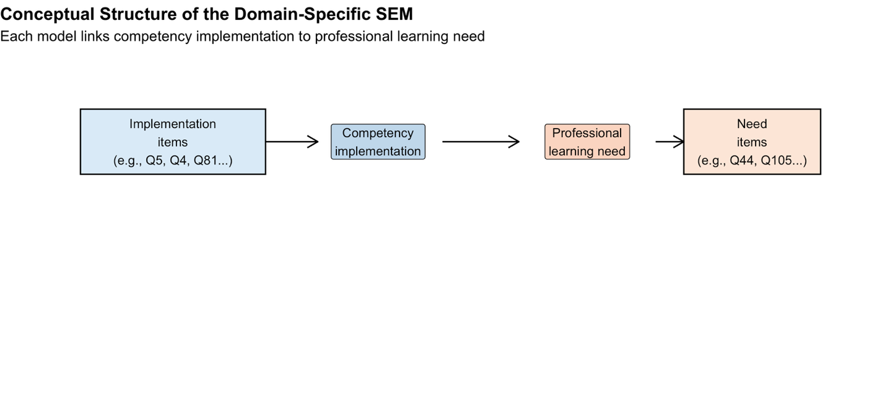
Figure 9. Conceptual structure of the domain-specific SEM. This schematic illustrates the latent-variable framework used in Section 3. Implementation items load onto a latent competency implementation factor, and professional learning need items load onto a corresponding latent need factor. The structural path from implementation to need is the key parameter of interest and tests whether stronger perceived implementation is associated with lower reported professional learning need within a domain.
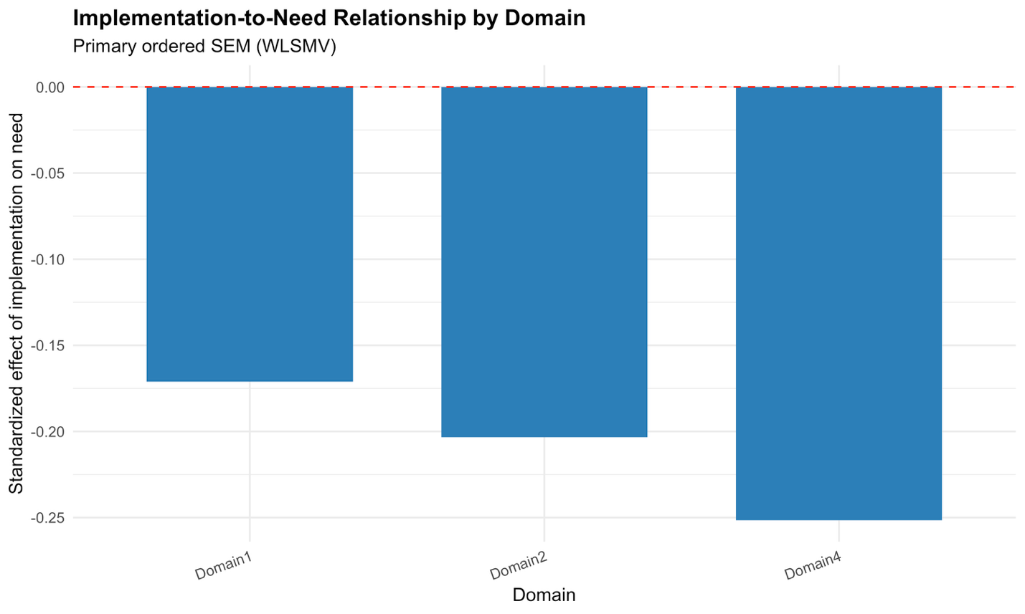
Figure 10. Standardized structural paths from competency implementation to professional learning need in the primary ordered SEM. Bars represent the standardized regression coefficient for the latent path Need ~ Competency under the primary ordered WLSMV model. All estimated paths are negative, indicating that higher perceived competency implementation is associated with lower professional learning need. The strongest inverse relationship appears in Domain 4, followed by Domain 2 and Domain 1.
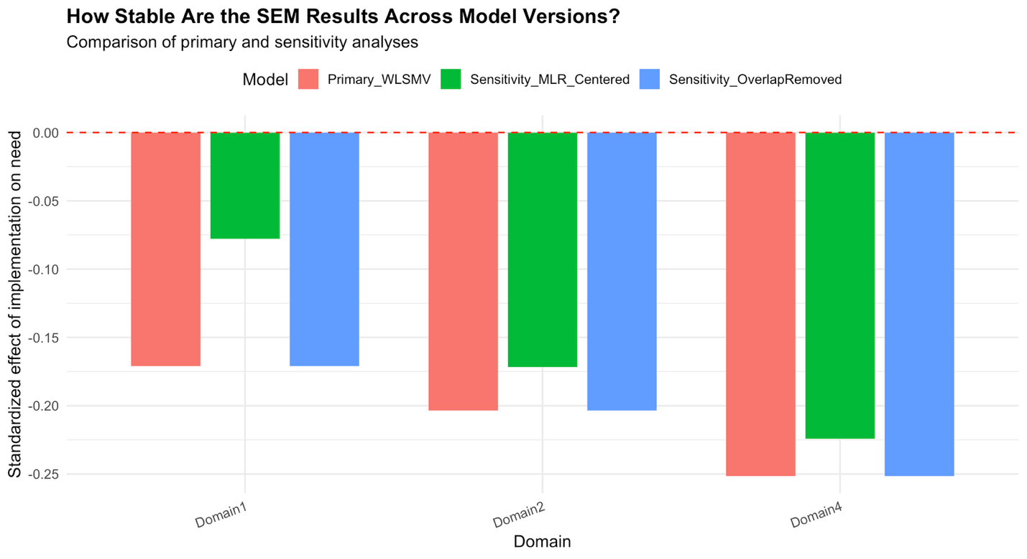
Figure 11. Comparison of standardized implementation-to-need paths across SEM specifications. Bars compare the structural coefficient Need ~ Competency across the primary ordered WLSMV model, the centered MLR sensitivity model, and the overlap-removed sensitivity model. The direction of the relationship remains negative across all estimable domains and all model versions. Domain 4 shows the strongest and most stable inverse association, Domain 2 is also robust, and Domain 1 is weaker and somewhat more sensitive to specification.
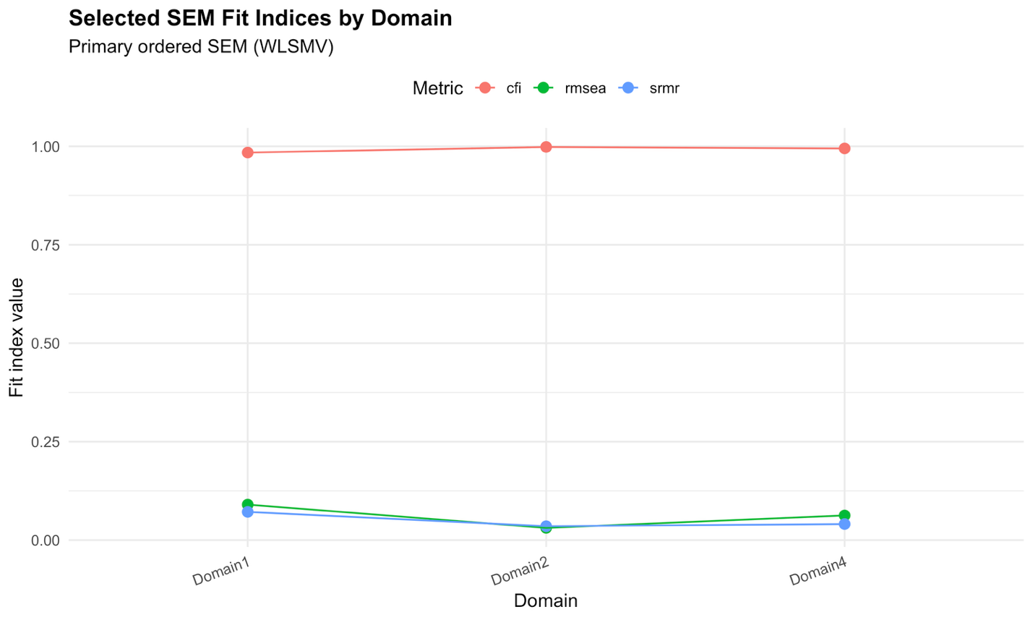
Figure 12. Selected SEM fit indices by domain for the primary ordered SEM. This figure displays selected fit statistics, including CFI, RMSEA, and SRMR, for the estimable domain-specific SEMs. Domain 2 shows the strongest overall fit, Domain 4 also fits well, and Domain 1 shows acceptable but weaker fit, indicating that the structural results are strongest in Domains 2 and 4.

3.5.3 Interpretation Notes
The SEM results support a coherent inverse relationship between competency implementation and professional learning need in the estimable Year 4 domains. However, these findings should be interpreted in light of two constraints. First, only Domains 1, 2, and 4 were successfully estimated under the current Year 4 item mapping and data structure. Second, repeated question numbers in the appendix introduce a documentation issue that should be clarified before the findings are treated as fully definitive across domains.

3.6 Client Clarifications
Before finalizing this section, several issues should be confirmed with the client.
First, the Year 4 appendix mapping should be reviewed carefully, especially where the same question numbers appear in both implementation and need blocks. Although the overlap sensitivity analysis suggests that this did not materially distort the Domain 4 result, confirmation of the intended mapping remains important.
Second, the client should confirm whether the Year 4 implementation and professional learning need items are all coded in the intended direction and whether any reverse-coded items exist. The present SEM analysis assumes that higher values consistently indicate higher implementation or higher need.
Third, the client should clarify whether the Year 4 SEM is intended to be interpreted as a domain-by-domain confirmatory analysis only, or whether there is interest in a future combined SEM across all domains. Under the current mapping constraints, the domain-specific approach is the more defensible choice.
Finally, if revised or corrected item mappings are available for the non-estimable domains, those would allow Section 3 to be extended and potentially strengthened across all six Teacher Quality Standard domains.

