LONGITUDINAL CONTEXT ANALYSIS

4.1 Executive Summary
The purpose of this section was to place the Year 4 findings into a broader multi-year project context. The central question was not only what the Year 4 results look like on their own, but whether they fit an ongoing pattern already visible in the earlier survey years. In practical terms, this section asks two related questions. First, do implementation patterns change across project years? Second, does Year 4 resemble the earlier years closely enough to be interpreted as a continuation of the same general profile rather than as a marked departure?
A key methodological issue emerged immediately from the appendix documentation. The item mappings required to construct implementation domains are available across Years 1 through 4, which makes a four-year longitudinal implementation comparison defensible. By contrast, explicit domain mappings for professional learning need are currently available only for Year 4. This means that the project documentation supports a repeated cross-year analysis of implementation, but does not yet support a defensible longitudinal analysis of professional learning need across the full project period. This distinction matters analytically and substantively. The responsible interpretation is not simply what one would like to compare, but what the existing data structure and documentation genuinely allow.
For that reason, this section focuses primarily on implementation trends across Years 1 to 4, while describing the Year 4 professional learning need profile separately and transparently noting that multi-year need trends cannot yet be estimated without additional mappings for Years 1 to 3.
The four-year implementation results show a remarkably stable pattern. Across all project years, the same broad domain ordering is retained. Legal Frameworks and Policies (Comp6) and Inclusive Environments (Comp4) remain among the highest-scoring domains throughout the project period, while FNMI Knowledge (Comp5) remains clearly the lowest-scoring domain in every year. The mean implementation score for FNMI Knowledge rose from approximately 3.00 in Year 1 to 3.25 in Year 4, suggesting some improvement over time, but it remained well below the other domains. At the other end of the profile, Legal Frameworks and Policies was highest in Year 1 at 4.34, dipped in Years 2 and 3, and returned to 4.19 in Year 4, still among the strongest domains overall. Inclusive Environments followed a similarly high and stable pattern, ranging from 4.08 to 4.21 across the four years.
Formal testing confirms that not all domains changed across years in the same way. After adjustment for multiple testing, statistically reliable year effects were observed for Comp4: Inclusive Environments, Comp5: FNMI Knowledge, and Comp6: Legal Frameworks and Policies. The strongest year-related variation appeared in FNMI Knowledge and Legal Frameworks and Policies, with very small p-values even after Benjamini–Hochberg and Holm correction. Inclusive Environments also showed a reliable year effect, though smaller. By contrast, Comp1 and Comp3 did not show significant year-to-year change, and Comp2 showed only modest evidence of change that did not remain significant under the more conservative Holm adjustment. This means that some aspects of teacher implementation shifted across the project years, but the overall framework remained highly recognizable.
The descriptive trend figures reinforce this interpretation. The domain means across years remain tightly clustered within each domain, and the boxplots show substantial overlap in the score distributions from year to year. This indicates that although some mean differences are statistically detectable, the general shape of the implementation profile is much more notable for its continuity than for dramatic change. In other words, Year 4 does not look like a fundamentally new implementation landscape. It looks like a later point on a broadly stable trajectory.
The strongest support for that conclusion comes from the profile consistency correlations. When the six-domain Year 4 mean profile was compared with the corresponding domain profiles from earlier years, the correlations were extremely high: approximately 0.994 with Year 1, 0.999 with Year 2, and 0.999 with Year 3. These values indicate that the relative pattern of strengths and weaker areas in Year 4 is almost identical to the earlier years. This is one of the most important findings in the section. Even when absolute scores shift somewhat, the overall domain configuration remains essentially unchanged. From a strategic perspective, this means that the Year 4 findings can reasonably be interpreted as part of an enduring implementation pattern rather than as a one-year anomaly.
The rank-order analysis leads to the same conclusion. In each year, Legal Frameworks and Policies and Inclusive Environments remain near the top of the implementation profile, while FNMI Knowledge remains last. Some small reordering occurs in the middle domains, especially between Career-Long Learning and Professional Body of Knowledge, but the broader structure remains highly stable. This repeated pattern matters because it suggests that the strongest and weakest areas are persistent features of the project rather than transient fluctuations.
The Year 4 professional learning need profile adds a useful complementary perspective. Although the current appendix does not allow multi-year need analysis, the Year 4 need results themselves are clear. Need was highest in Need5: FNMI Knowledge at approximately 2.67, and lowest in Need6: Legal Frameworks and Policies at approximately 2.04. This mirrors the implementation profile in an intuitively meaningful way: the weakest implementation domain remains the highest-need domain, while one of the strongest implementation domains is also the lowest-need domain. This parallel reinforces the interpretation already developed in earlier sections and suggests that the Year 4 need profile is substantively aligned with the longer-term implementation story.
At the same time, this section should be interpreted with appropriate caution. The four survey years do not currently appear to represent a linked panel in which the same teachers were followed over time. The present analysis is therefore best interpreted as a repeated cross-sectional comparison of yearly respondent groups, not as within-person longitudinal change. In addition, the item composition of some domains differs between Year 1 and later years, which means the cross-year comparisons should be treated as trend context rather than as strict measurement-invariant longitudinal inference.
Taken together, the evidence supports a clear conclusion. Year 4 is highly consistent with the broader implementation pattern observed across the project. The strongest domains remain strong, the weakest domain remains weak, and the overall six-domain configuration is almost unchanged from earlier years. Some domains show modest year-to-year movement, especially FNMI Knowledge, Inclusive Environments, and Legal Frameworks and Policies, but these changes occur within a broadly stable structure. The professional learning need question, by contrast, cannot yet be answered longitudinally with the same level of defensibility because the required mappings for Years 1 to 3 are not yet available. This is not a weakness of the analysis; it is an important boundary of what the current documentation supports.

4.2 Analytical Approach and Technical Methods

4.2.1 Analytical objectives. Section 4 addressed two broader longitudinal-context questions. The first was whether professional learning needs changed over time across project years. The second was whether the implementation pattern observed in Year 4 was consistent with trends seen in earlier years. These questions required a distinction between what the appendix fully supports and what remains only partially supported.

4.2.2 Longitudinal scope supported by the appendix. The appendix provides sufficient item mappings to construct the six implementation domains across Years 1, 2, 3, and 4. This allowed a defensible longitudinal comparison of implementation trends. However, the appendix provides explicit mappings for professional learning need only in Year 4. As a result, a true multi-year trend analysis for need is not currently supportable. The present section therefore treats the longitudinal implementation analysis as the main analytic component and the Year 4 need profile as a descriptive companion rather than a repeated-year trend.

4.2.3 Domain scoring across years. Teacher-level implementation domain scores were computed separately within each year by taking row means across the items assigned to each Teacher Quality Standard domain. A minimum completion rule was used, requiring at least 50% of the items in a domain to be observed before assigning a composite score. If fewer than half of the domain items were present, the domain score was set to missing. This scoring rule was consistent with the earlier sections and was intended to balance respondent retention with score stability.
Once the domains were scored within year, the six implementation composites were standardized to a common naming structure so that the four yearly datasets could be combined into a single repeated cross-sectional long-format file. In this combined structure, each row represented one teacher’s score on one domain in one survey year.

4.2.4 Descriptive trend summaries. For each year-by-domain combination, the analysis calculated the number of non-missing observations, mean, standard deviation, median, and interquartile-range information. These summaries were designed to characterize both central tendency and spread over time. The resulting implementation trend table showed that the domain profile was highly stable across years, with especially persistent separation between the higher-scoring domains (Comp4 and Comp6) and the lower-scoring domain (Comp5).
Two primary visualizations were created for implementation trends. The first was a mean trend plot with standard error bars, allowing direct comparison of average implementation across the four survey years. The second was a set of domain-specific boxplots by year, showing how the distribution of teacher scores varied across years within each domain.

4.2.5 Formal tests of year differences. To test whether average implementation differed across years, a separate one-way ANOVA was fitted within each of the six domains using survey year as the grouping factor. This produced a domain-specific test of whether that domain’s mean implementation score varied across the project years. Because six parallel ANOVAs were conducted, p-values for the year effect were adjusted using both the Benjamini–Hochberg and Holm procedures.
The adjusted results showed strong evidence of year differences for Comp4, Comp5, and Comp6, modest evidence for Comp2 under the BH adjustment only, and no reliable year effect for Comp1 or Comp3. These results indicate that some domains shifted more than others, but they do not suggest wholesale restructuring of the implementation profile.

4.2.6 Year 4 consistency with earlier years. To answer the question of whether Year 4 is consistent with earlier years, two complementary approaches were used. First, within each year, the six domains were ranked by their mean implementation score. This created a simple descriptive summary of how the domain ordering changed or remained stable across the project. Second, the domain mean profiles were compared directly by calculating the correlation between the six-domain Year 4 mean vector and the corresponding vectors from Years 1, 2, and 3.
These profile correlations were extraordinarily high, ranging from approximately 0.994 to 0.999, providing strong evidence that Year 4 retained essentially the same domain pattern as earlier years. This is one of the clearest indicators in the section that Year 4 belongs to a stable longitudinal pattern.

4.2.7 Year 4 professional learning need profile. Because explicit multi-year need mappings were not available, the analysis of professional learning need was limited to Year 4. Need-domain composites were calculated using the documented Year 4 appendix mapping, and summary statistics were computed for each domain. A Year 4 need boxplot was also produced to visualize the relative distribution of need scores across domains.
The Year 4 results showed the highest need in Need5: FNMI Knowledge and the lowest in Need6: Legal Frameworks and Policies, reinforcing the general alignment between lower implementation and higher need already observed in earlier sections.

4.2.8 Methodological cautions. Several limitations are important for interpretation. First, the analysis is best understood as repeated cross-sectional, not person-level longitudinal, because the current materials do not establish that the same respondents were followed from year to year. Second, the item composition of the domains is not fully identical across all four years, particularly between Year 1 and the later waves. Accordingly, the cross-year comparisons are best interpreted as trend comparisons rather than strict measurement-invariant longitudinal estimates. Third, the inability to estimate multi-year professional learning need trends reflects a documentation limitation, not a coding or modeling failure. The necessary item mappings for Years 1 to 3 are not currently available.

4.3 Appendix: Tables and Figures

4.3.1 Tables

Table 16. Longitudinal implementation trend summary by year and Teacher Quality Standard domain. Values are teacher-level composite summaries for each implementation domain across Years 1–4. Means are shown with standard deviations in parentheses.
Domain | Year 1 | Year 2 | Year 3 | Year 4
Comp1: Fostering Effective Relationships | 3.57 (0.67) | 3.55 (0.66) | 3.56 (0.63) | 3.61 (0.64)
Comp2: Engaging in Career-Long Learning | 3.96 (0.62) | 3.91 (0.58) | 3.88 (0.58) | 3.91 (0.57)
Comp3: Professional Body of Knowledge | 3.96 (0.69) | 3.96 (0.63) | 3.94 (0.66) | 3.99 (0.64)
Comp4: Inclusive Environments | 4.21 (0.59) | 4.13 (0.57) | 4.08 (0.56) | 4.17 (0.57)
Comp5: FNMI Knowledge | 3.00 (1.00) | 3.22 (0.97) | 3.21 (0.89) | 3.25 (0.93)
Comp6: Legal Frameworks & Policies | 4.34 (0.67) | 4.17 (0.53) | 4.15 (0.54) | 4.19 (0.55)
A fuller version with sample size, median, and quartiles is below.
Year | Domain | n | Mean | SD | Median | Q1 | Q3
Year 1 | Comp1: Fostering Effective Relationships | 1783 | 3.57 | 0.67 | 3.67 | 3.00 | 4.00
Year 1 | Comp2: Engaging in Career-Long Learning | 1782 | 3.96 | 0.62 | 4.00 | 3.50 | 4.50
Year 1 | Comp3: Professional Body of Knowledge | 1780 | 3.96 | 0.69 | 4.00 | 3.50 | 4.50
Year 1 | Comp4: Inclusive Environments | 1780 | 4.21 | 0.59 | 4.00 | 4.00 | 4.50
Year 1 | Comp5: FNMI Knowledge | 1776 | 3.00 | 1.00 | 3.00 | 2.00 | 3.75
Year 1 | Comp6: Legal Frameworks & Policies | 1776 | 4.34 | 0.67 | 4.00 | 4.00 | 5.00
Year 2 | Comp1: Fostering Effective Relationships | 822 | 3.55 | 0.66 | 3.60 | 3.00 | 4.00
Year 2 | Comp2: Engaging in Career-Long Learning | 821 | 3.91 | 0.58 | 4.00 | 3.60 | 4.40
Year 2 | Comp3: Professional Body of Knowledge | 818 | 3.96 | 0.63 | 4.00 | 3.50 | 4.50
Year 2 | Comp4: Inclusive Environments | 816 | 4.13 | 0.57 | 4.00 | 3.92 | 4.67
Year 2 | Comp5: FNMI Knowledge | 819 | 3.22 | 0.97 | 3.00 | 2.67 | 4.00
Year 2 | Comp6: Legal Frameworks & Policies | 816 | 4.17 | 0.53 | 4.00 | 4.00 | 4.67
Year 3 | Comp1: Fostering Effective Relationships | 541 | 3.56 | 0.63 | 3.60 | 3.20 | 4.00
Year 3 | Comp2: Engaging in Career-Long Learning | 540 | 3.88 | 0.58 | 3.80 | 3.40 | 4.20
Year 3 | Comp3: Professional Body of Knowledge | 538 | 3.94 | 0.66 | 4.00 | 3.50 | 4.50
Year 3 | Comp4: Inclusive Environments | 537 | 4.08 | 0.56 | 4.00 | 3.67 | 4.33
Year 3 | Comp5: FNMI Knowledge | 539 | 3.21 | 0.89 | 3.00 | 2.67 | 4.00
Year 3 | Comp6: Legal Frameworks & Policies | 537 | 4.15 | 0.54 | 4.00 | 4.00 | 4.67
Year 4 | Comp1: Fostering Effective Relationships | 858 | 3.61 | 0.64 | 3.60 | 3.20 | 4.00
Year 4 | Comp2: Engaging in Career-Long Learning | 857 | 3.91 | 0.57 | 4.00 | 3.60 | 4.40
Year 4 | Comp3: Professional Body of Knowledge | 855 | 3.99 | 0.64 | 4.00 | 3.50 | 4.50
Year 4 | Comp4: Inclusive Environments | 851 | 4.17 | 0.57 | 4.00 | 4.00 | 4.67
Year 4 | Comp5: FNMI Knowledge | 854 | 3.25 | 0.93 | 3.00 | 3.00 | 4.00
Year 4 | Comp6: Legal Frameworks & Policies | 851 | 4.19 | 0.55 | 4.00 | 4.00 | 4.67

Table 17. Domain-specific ANOVA results for year differences in implementation scores. This table presents the one-way ANOVA test of whether mean implementation differed across Years 1–4 within each domain.
Domain | F statistic | Raw p-value
Comp1: Fostering Effective Relationships | 1.227 | 0.2983
Comp2: Engaging in Career-Long Learning | 3.186 | 0.02284
Comp3: Professional Body of Knowledge | 0.826 | 0.4792
Comp4: Inclusive Environments | 9.042 | 5.785e-06
Comp5: FNMI Knowledge | 19.198 | 2.343e-12
Comp6: Legal Frameworks & Policies | 24.830 | 6.556e-16

Table 18. Multiple-testing-adjusted year effects across implementation domains. This table reports Benjamini–Hochberg and Holm adjusted p-values for the six domain-specific year comparisons.
Domain | F statistic | Raw p-value | BH-adjusted p | Holm-adjusted p
Comp1: Fostering Effective Relationships | 1.227 | 0.2983 | 0.3580 | 0.5967
Comp2: Engaging in Career-Long Learning | 3.186 | 0.02284 | 0.03426 | 0.06852
Comp3: Professional Body of Knowledge | 0.826 | 0.4792 | 0.4792 | 0.5967
Comp4: Inclusive Environments | 9.042 | 5.785e-06 | 1.157e-05 | 2.314e-05
Comp5: FNMI Knowledge | 19.198 | 2.343e-12 | 7.030e-12 | 1.172e-11
Comp6: Legal Frameworks & Policies | 24.830 | 6.556e-16 | 3.934e-15 | 3.934e-15

Table 19. Rank ordering of implementation domains within each survey year. This table shows the within-year ordering of domains by mean implementation score.
Rank within year | Year 1 | Year 2 | Year 3 | Year 4
1 | Comp6: Legal Frameworks & Policies | Comp6: Legal Frameworks & Policies | Comp6: Legal Frameworks & Policies | Comp6: Legal Frameworks & Policies
2 | Comp4: Inclusive Environments | Comp4: Inclusive Environments | Comp4: Inclusive Environments | Comp4: Inclusive Environments
3 | Comp2: Engaging in Career-Long Learning | Comp3: Professional Body of Knowledge | Comp3: Professional Body of Knowledge | Comp3: Professional Body of Knowledge
4 | Comp3: Professional Body of Knowledge | Comp2: Engaging in Career-Long Learning | Comp2: Engaging in Career-Long Learning | Comp2: Engaging in Career-Long Learning
5 | Comp1: Fostering Effective Relationships | Comp1: Fostering Effective Relationships | Comp1: Fostering Effective Relationships | Comp1: Fostering Effective Relationships
6 | Comp5: FNMI Knowledge | Comp5: FNMI Knowledge | Comp5: FNMI Knowledge | Comp5: FNMI Knowledge

Table 20. Correlation of the Year 4 domain profile with earlier yearly implementation profiles. This table quantifies the similarity of the Year 4 six-domain mean profile to Years 1, 2, and 3.
Comparison | Correlation
Year4 vs Year1 | 0.9936
Year4 vs Year2 | 0.9989
Year4 vs Year3 | 0.9990

Table 21. Year 4 professional learning need summary by domain. This table reports the number of non-missing observations, mean, standard deviation, and median for the six Year 4 need domains.
Need domain | n | Mean | SD | Median
Need1 | 736 | 2.25 | 0.72 | 2.20
Need2 | 735 | 2.21 | 0.74 | 2.20
Need3 | 735 | 2.33 | 0.81 | 2.33
Need4 | 735 | 2.34 | 0.74 | 2.25
Need5 | 735 | 2.67 | 0.77 | 3.00
Need6 | 735 | 2.04 | 0.87 | 2.00

4.3.2 Figure Captions

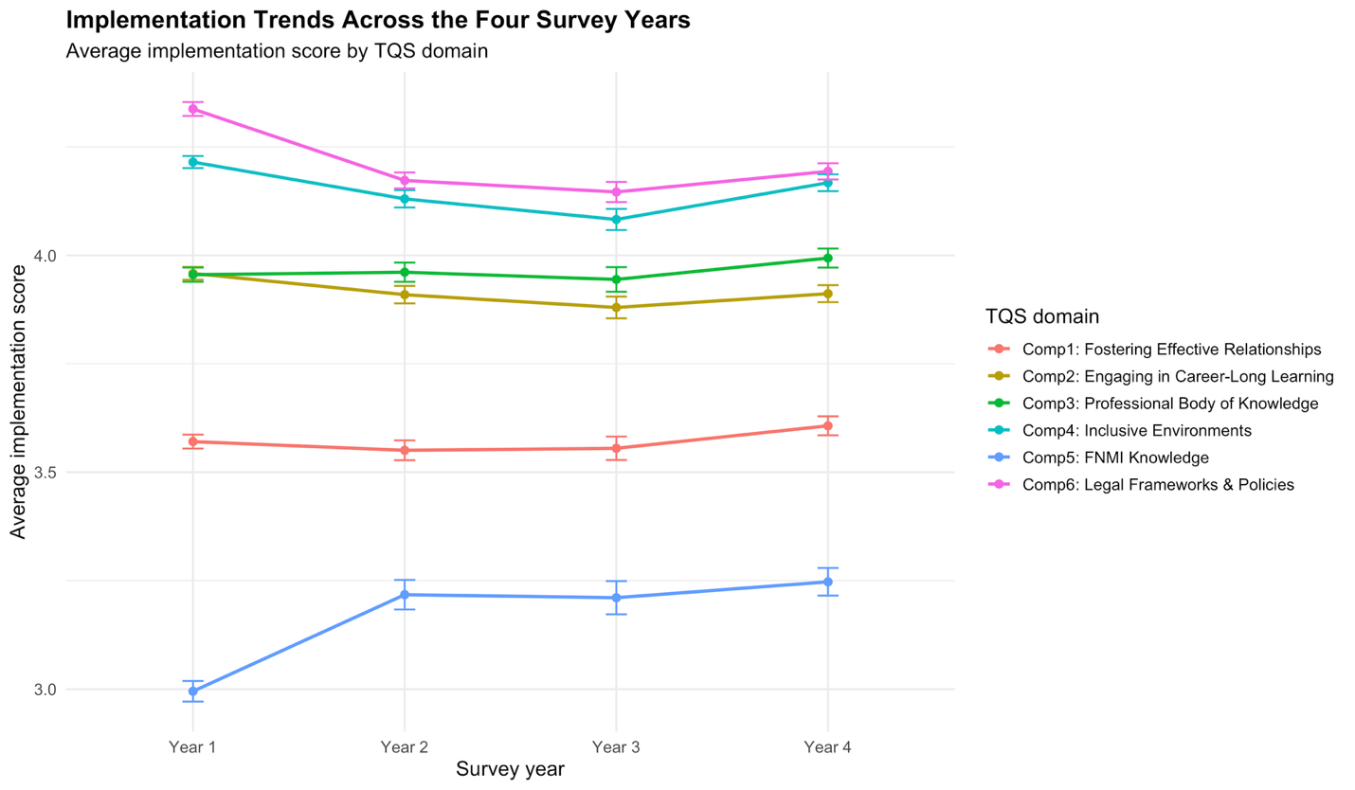
Figure 13. Implementation trends across project years by Teacher Quality Standard domain. Lines show mean teacher implementation scores for the six Teacher Quality Standard domains across Years 1–4, with error bars representing standard errors of the mean. The figure highlights the stability of the overall implementation profile over time. Legal Frameworks and Policies (Comp6) and Inclusive Environments (Comp4) remain among the highest-scoring domains throughout the project period, whereas FNMI Knowledge (Comp5) remains the lowest in every year despite modest improvement after Year 1. The substantial parallelism of the lines indicates continuity in the relative domain structure across years.
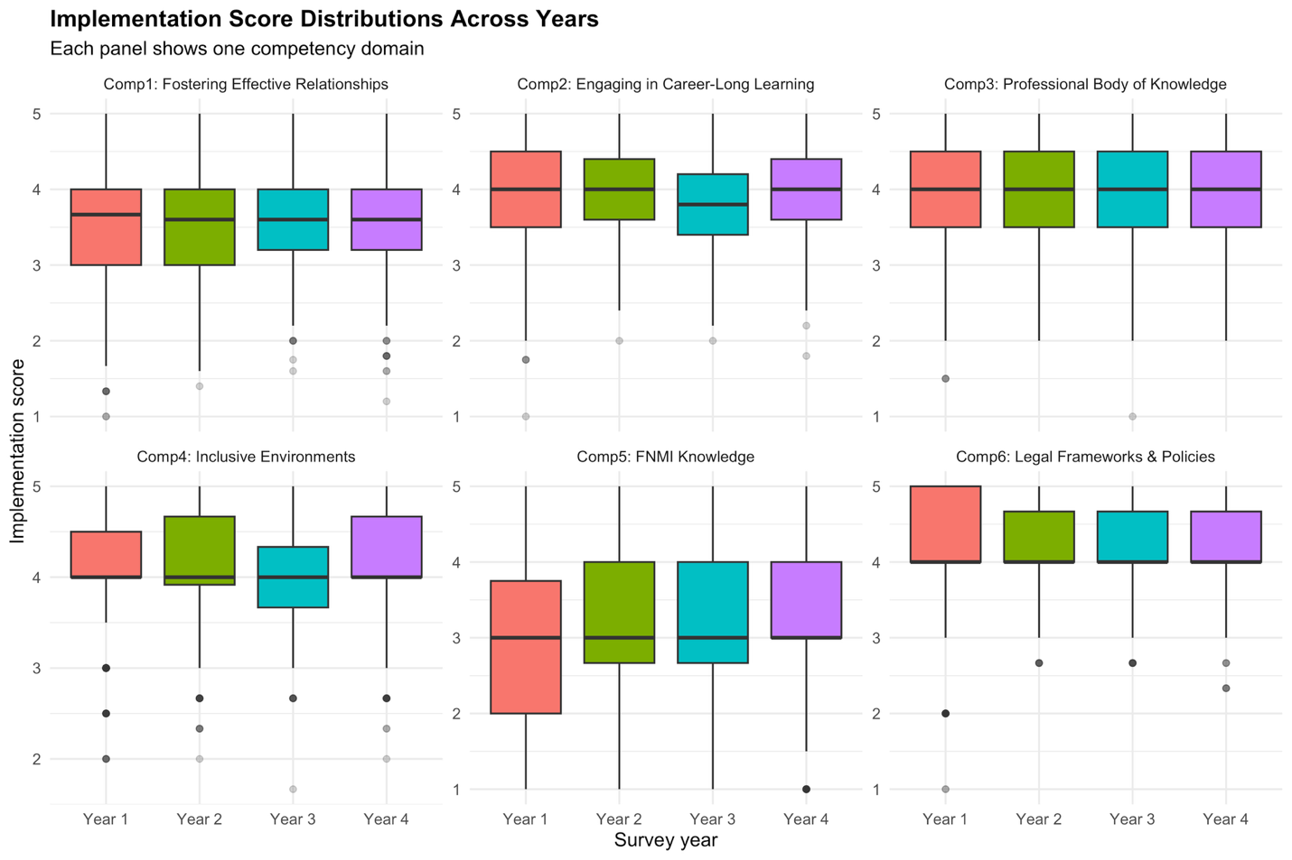
Figure 14. Distribution of implementation scores across years by domain. Each panel displays boxplots of teacher-level implementation composite scores across Years 1–4 for one Teacher Quality Standard domain. The central line indicates the median, the box shows the interquartile range, and whiskers reflect the spread of typical observations. The large overlap across years within most domains suggests that, although some year effects are statistically detectable, the implementation profile is characterized more by stability than by dramatic change. FNMI Knowledge (Comp5) shows the lowest central tendency and greatest spread across all years.
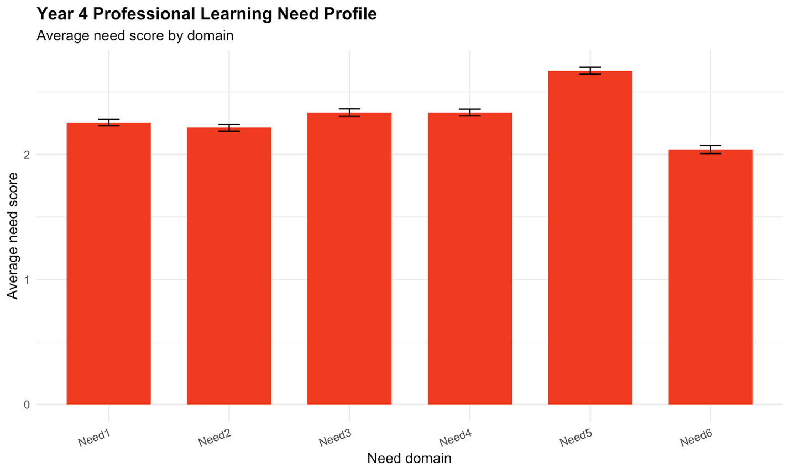
Figure 15. Year 4 professional learning need profile by domain. This figure summarizes the Year 4 professional learning need composites across the six domains. FNMI Knowledge (Need5) shows the highest average reported need, whereas Legal Frameworks and Policies (Need6) shows the lowest. This pattern mirrors the Year 4 implementation profile and suggests that domains with lower reported implementation tend to coincide with higher reported need.

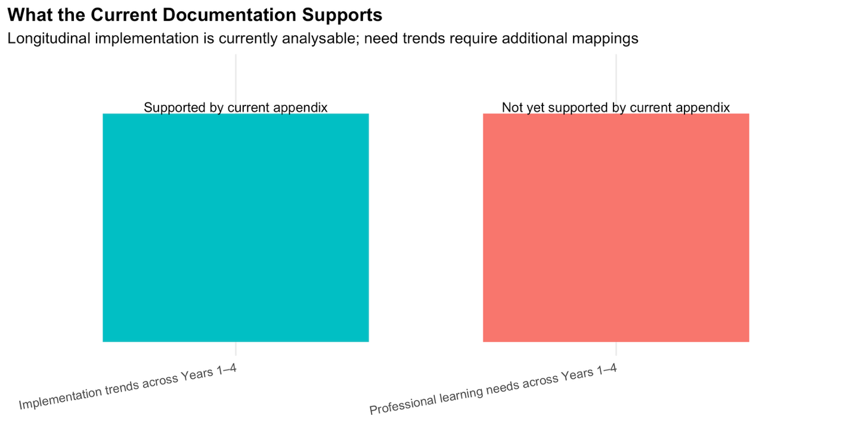
Figure 16. Current documentation support for longitudinal analyses. This figure summarizes what the existing appendix mappings currently support. Implementation trends are analyzable across Years 1–4 because domain mappings are available for all four survey years. By contrast, professional learning need trends are not yet analyzable longitudinally because explicit need-domain mappings are currently documented only for Year 4. The figure is intended as a transparency device showing the boundary between defensible inference and currently unsupported comparison.

4.4 Client Clarifications
Before finalizing this section, several points should be confirmed with the client.
First, the client should confirm whether professional learning need items were collected in Years 1, 2, and 3, and if so, provide the corresponding domain mappings. Without those mappings, the question of how professional learning needs changed over time cannot be answered defensibly.
Second, the client should clarify whether the yearly datasets represent independent cross-sectional respondent groups or whether an anonymous identifier exists that links the same individuals across years. This matters because the interpretation changes substantially depending on whether the analysis reflects repeated cross-sections or true longitudinal follow-up.
Third, the client should confirm whether strict cross-year comparability is expected. Because the domain item composition differs somewhat between Year 1 and the later years, the present analysis interprets the results as trend context rather than as strict harmonized longitudinal measurement. If stronger comparability is required, a common-item harmonization strategy may be needed.
Fourth, the client should note whether any major policy, implementation, or professional learning changes occurred between survey years that should be considered when interpreting the trend results. Some of the observed domain shifts, especially in FNMI Knowledge and Legal Frameworks and Policies, may be more meaningful if situated within the project’s operational context.
Finally, if survey weights exist and are intended to support broader inference, the client should clarify whether weighted analyses are required. The current longitudinal comparison treats the yearly samples as unweighted respondent groups.

