AI ???????????
???AI ???? Discord ????
?????????????? AI ?????????????????/?????????????????????????????????????????

??????
?? | ?? | ???? | ????
?1?AI?????? | 10 | 10 | ???????????????????????
?2?Prompt???? | 15 | 15 | ??/??/??/??/????/??? Prompt/????
?3?AI???????? | 12 | 12 | React ???????????????MetaMask?????
?4?AI?????????? | 15 | 15 | Solidity ?????????????????Sepolia ????
?5?AI??Bug???? | 12 | 12 | ???????AI?????????????????
??????64 / 64 ?? ???????????????????????? 5 ?????????????????????

??????????
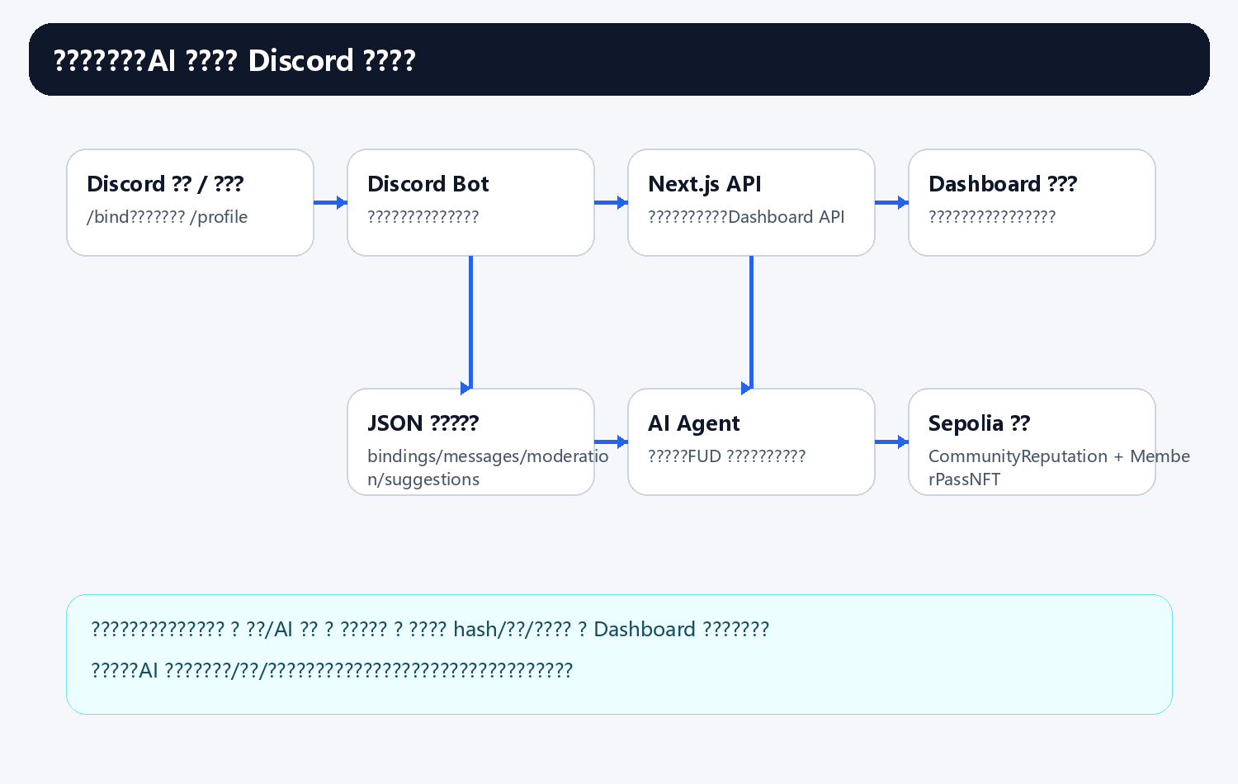

?1?AI??????
1.1 AI?????????? 2 ??
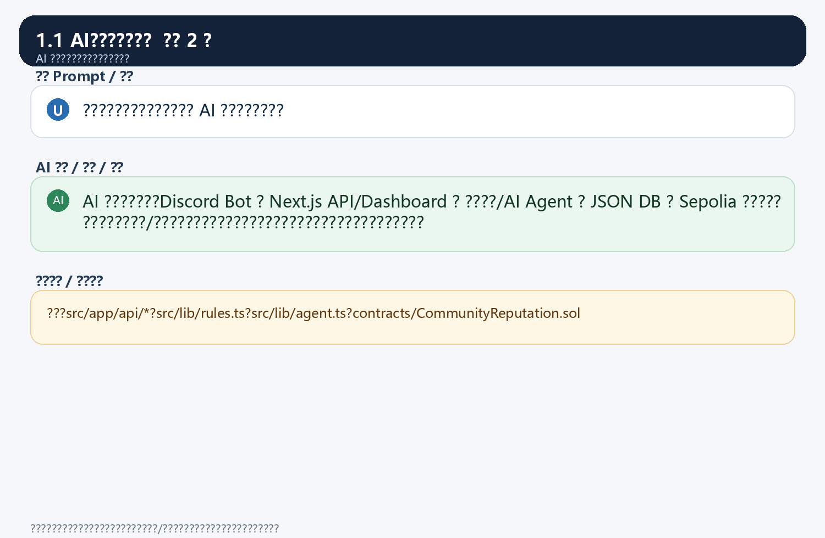
1.2 AI????????? 2 ??
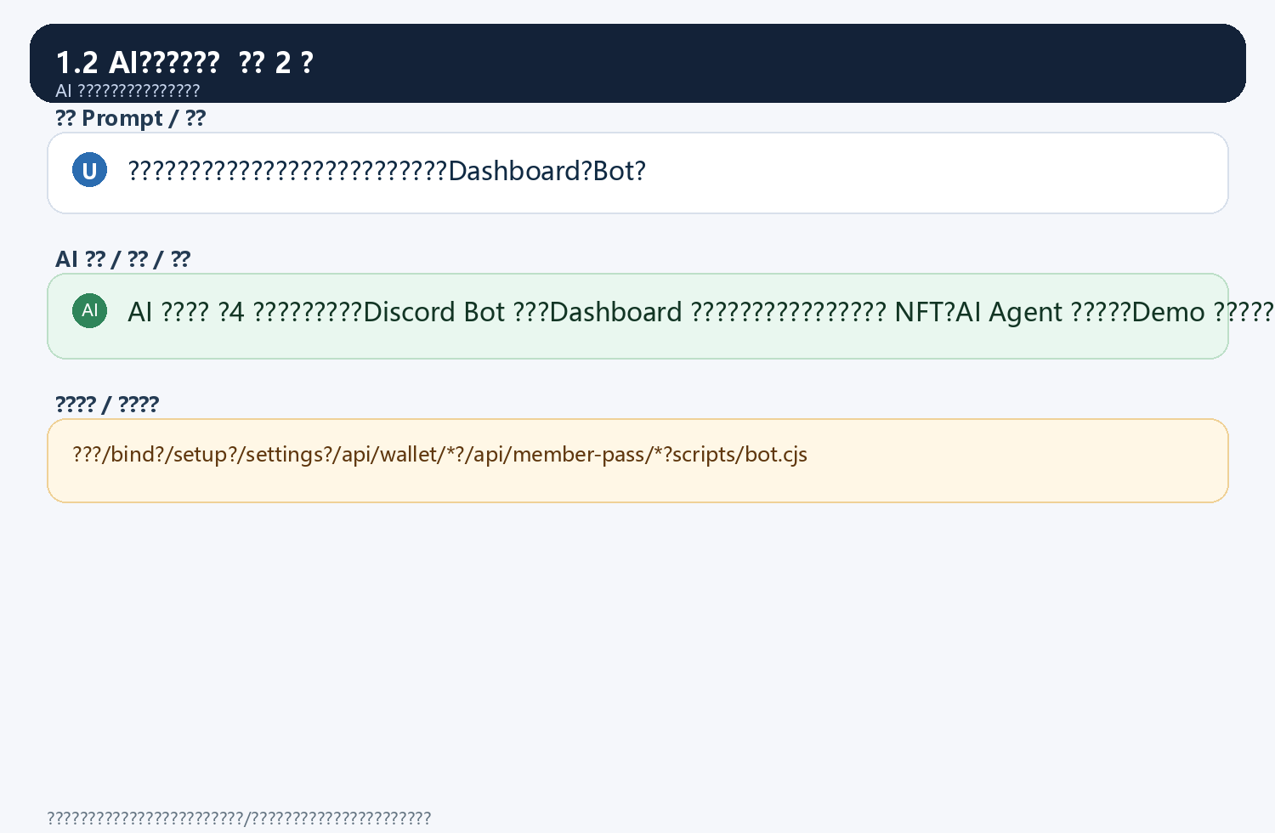
1.3 AI????????? 2 ??
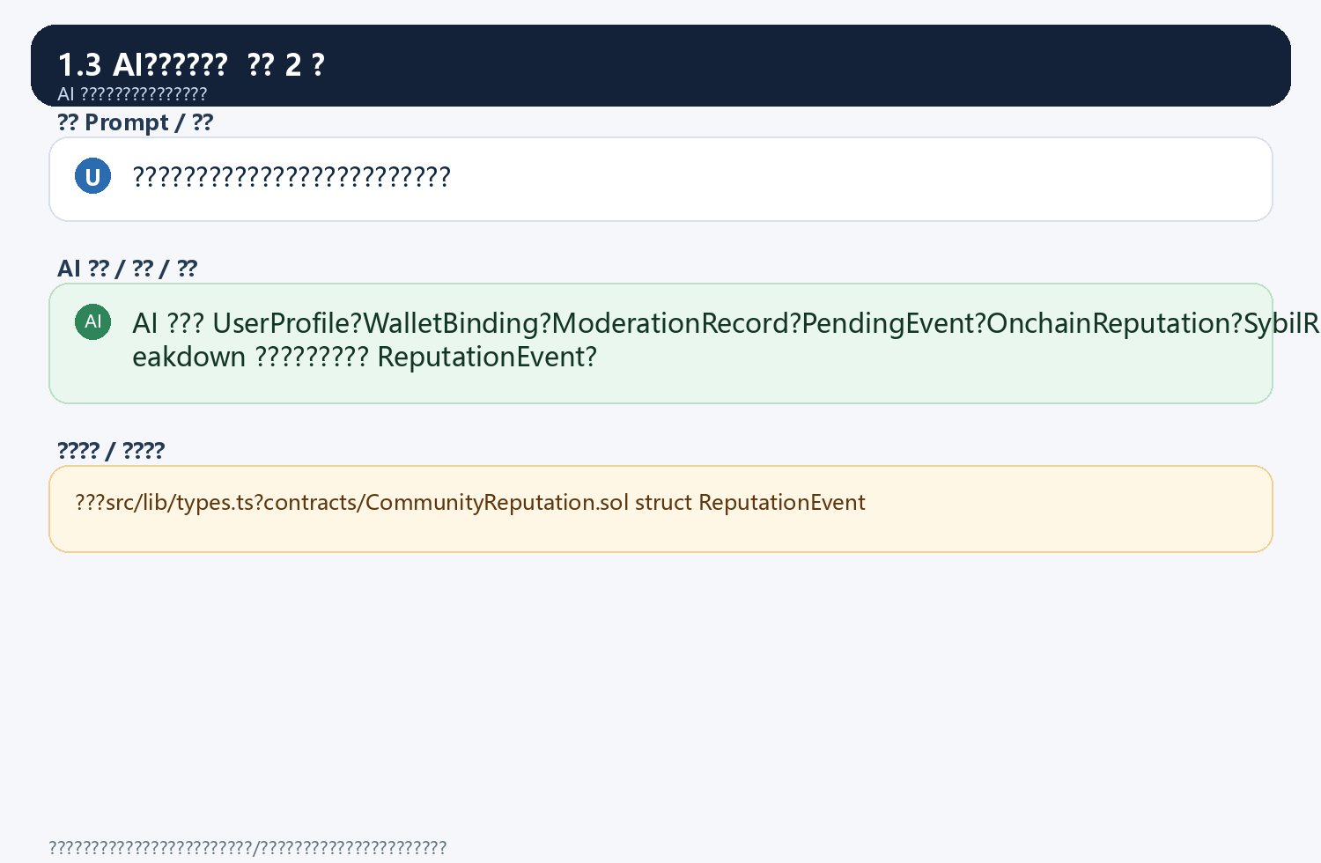
1.4 AI????????? 2 ??
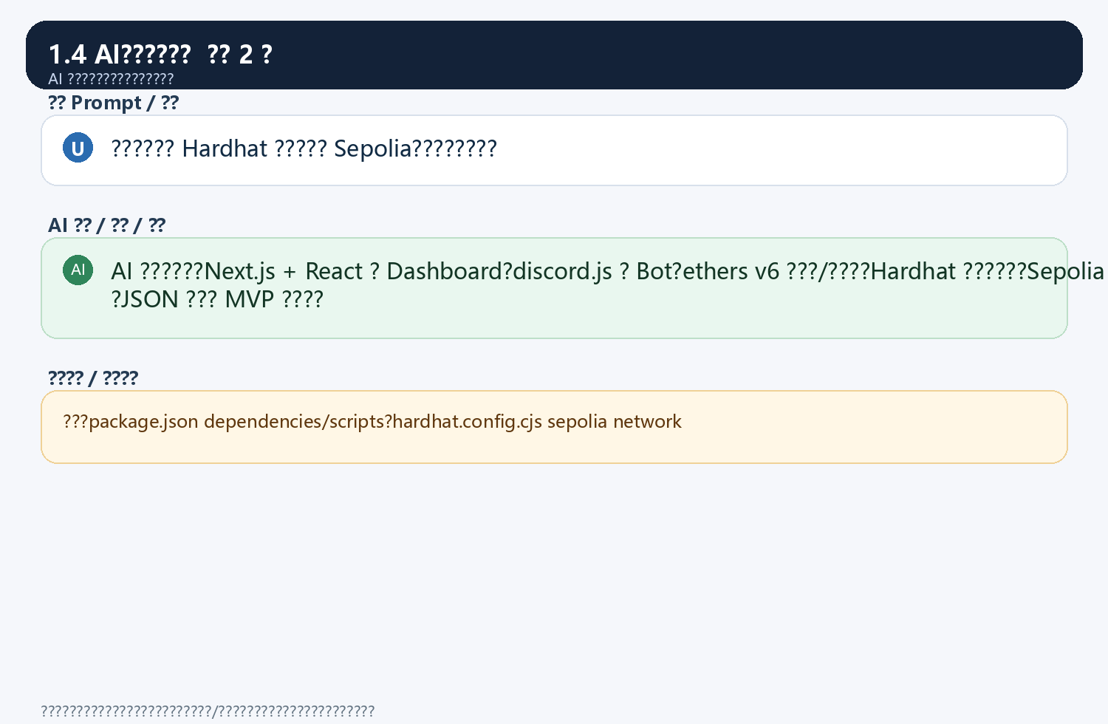
1.5 AI????????? 2 ??
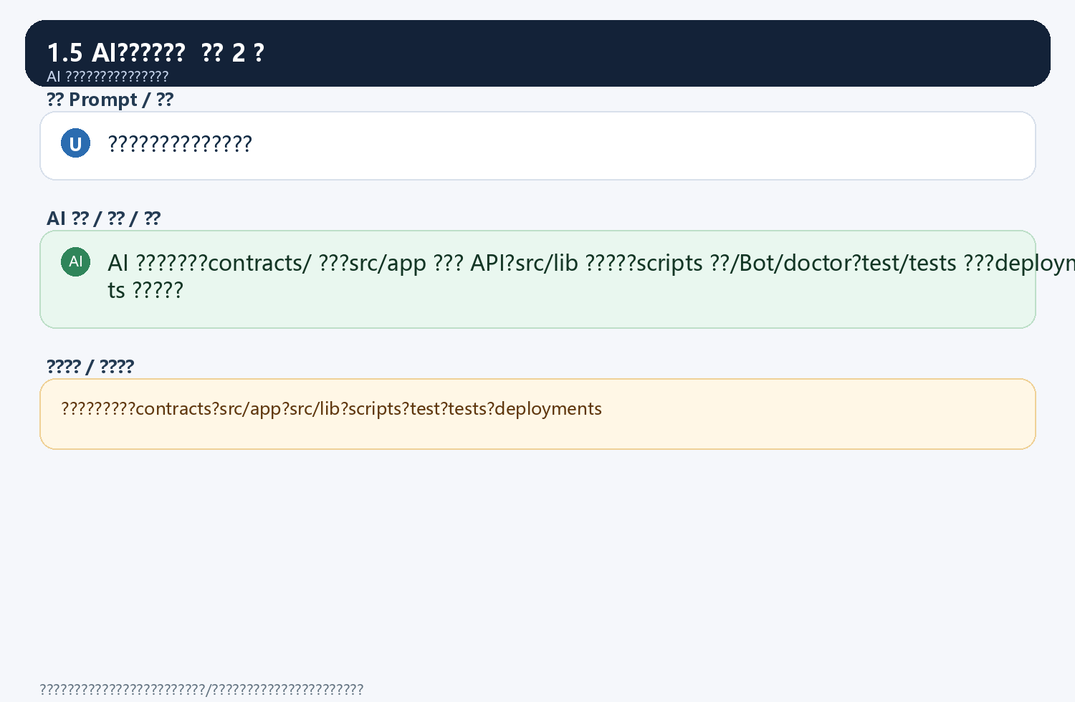

?2?Prompt????
2.1 ????????? 2 ??
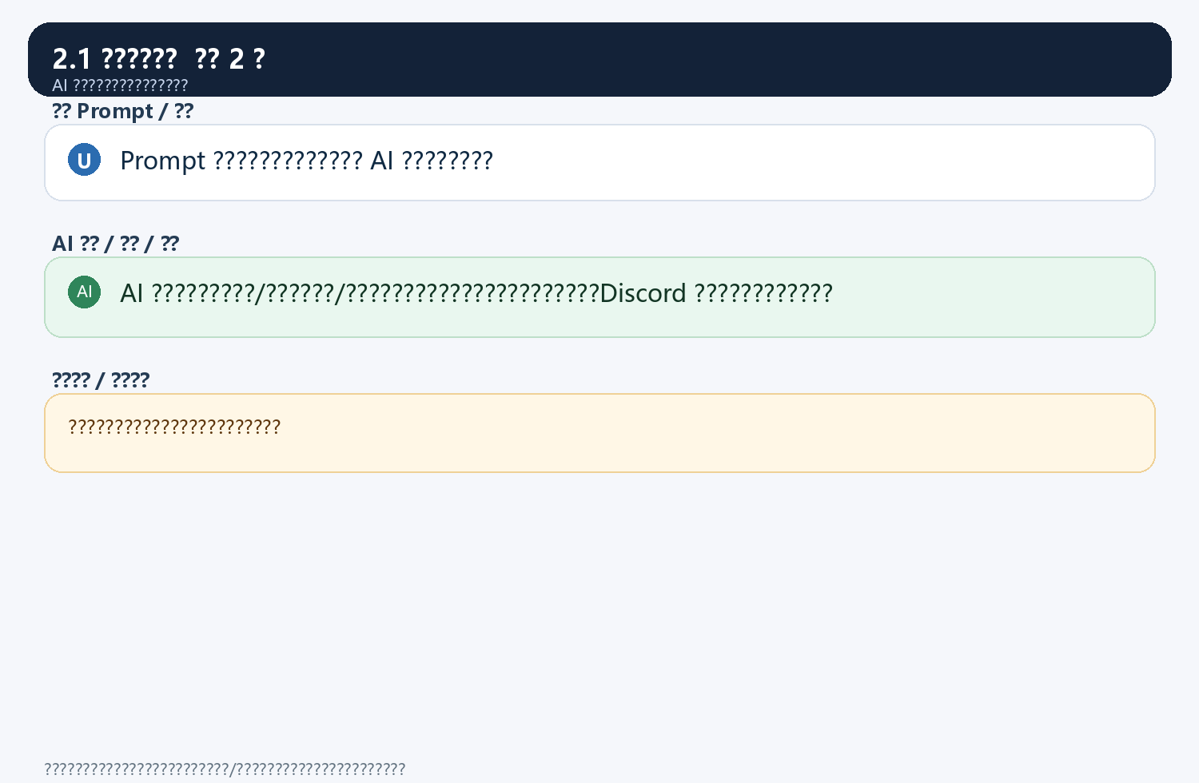
2.2 ????????? 2 ??
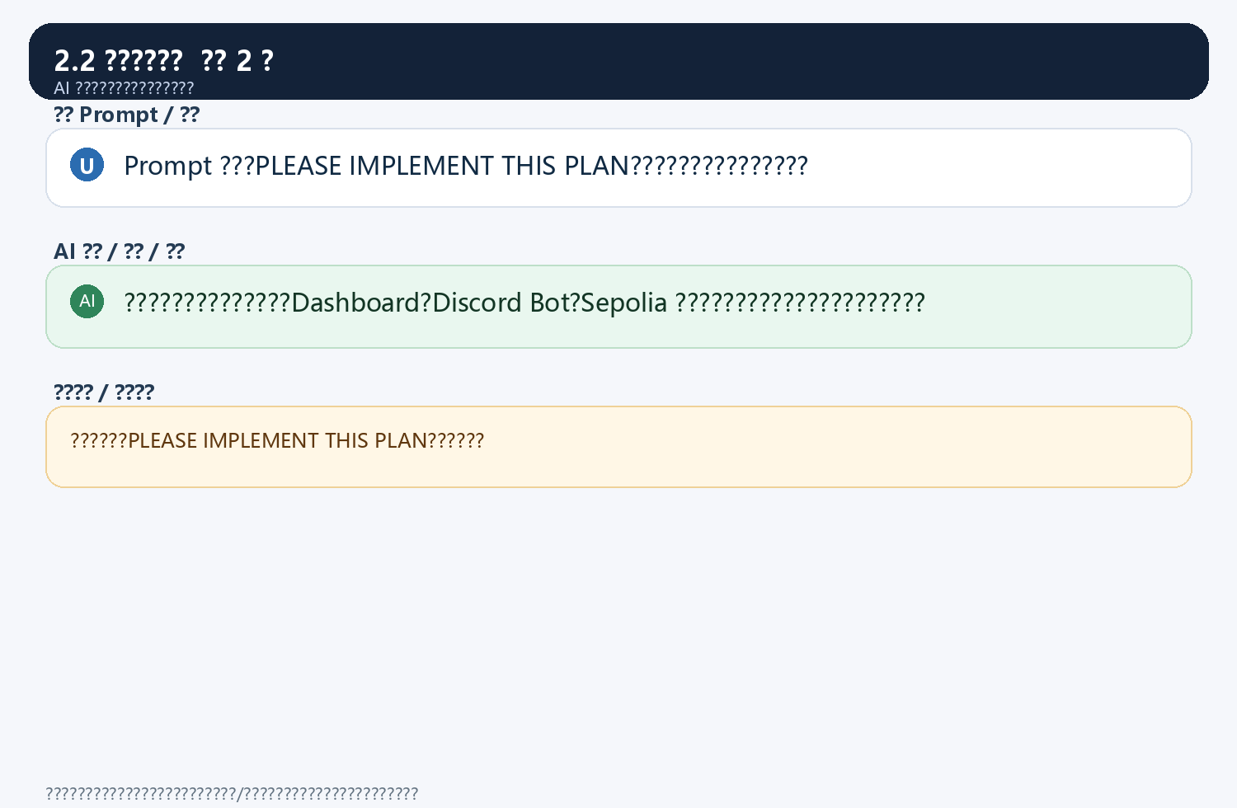
2.3 ????????? 2 ??
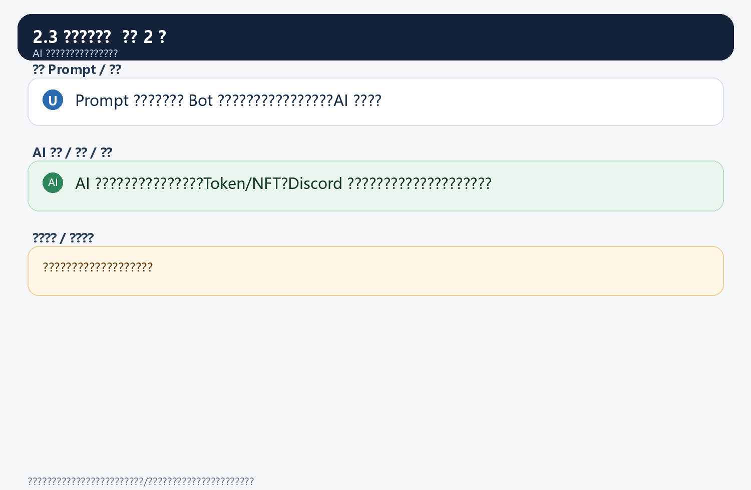
2.4 ????????? 2 ??
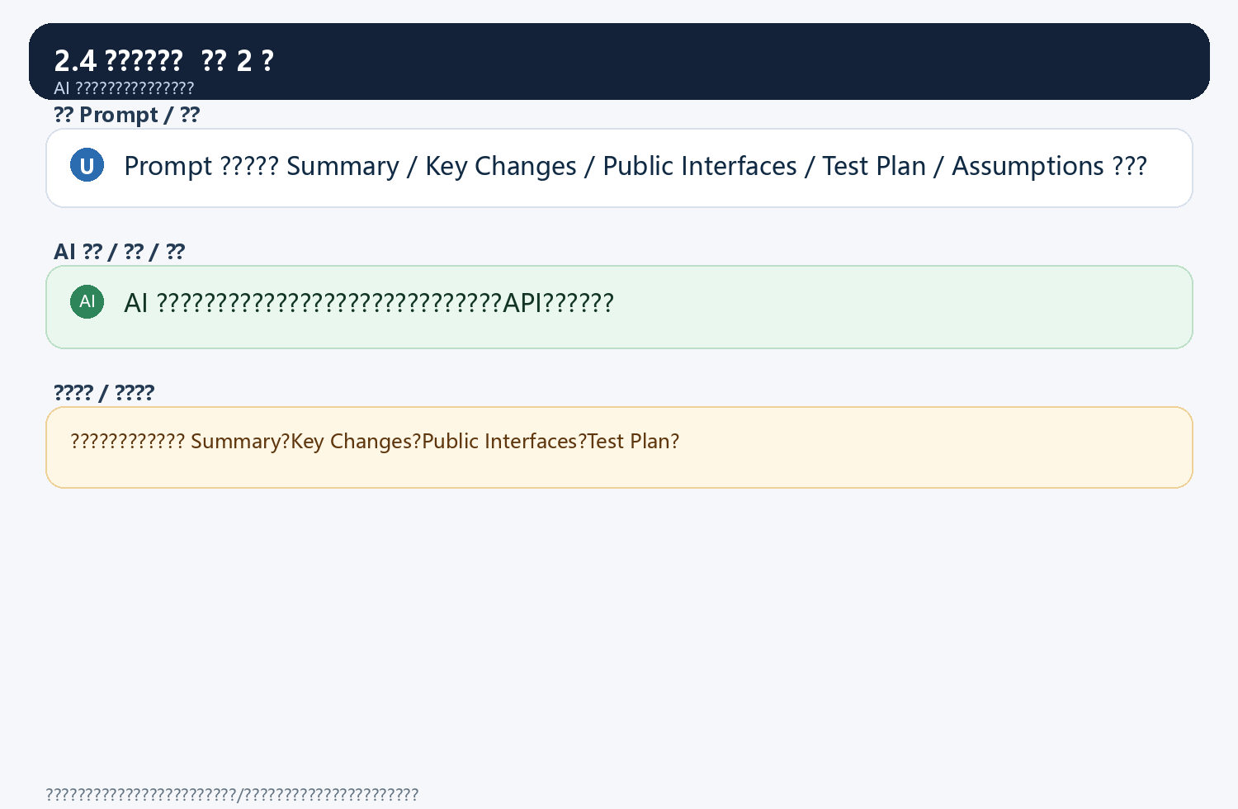
2.5 ??????????? 4 ??
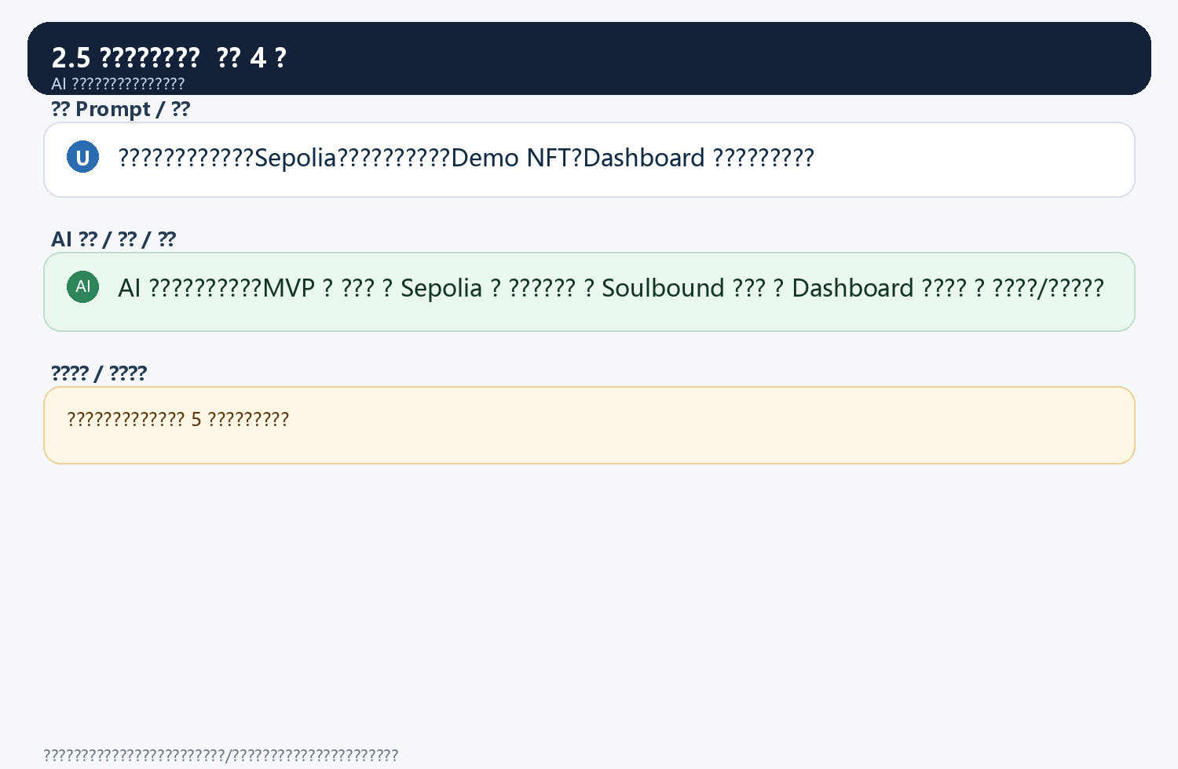
2.7 Prompt??????? 1 ??
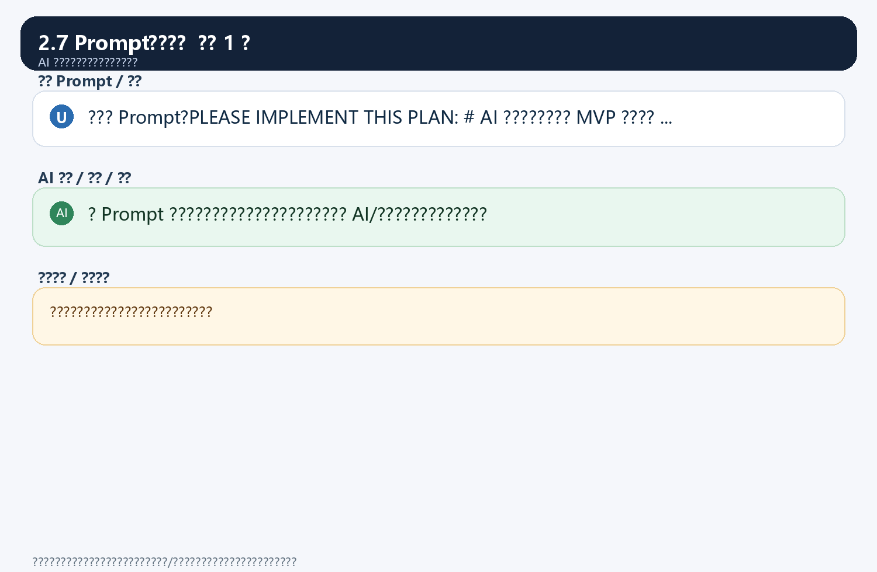
2.8 ????????? 2 ??
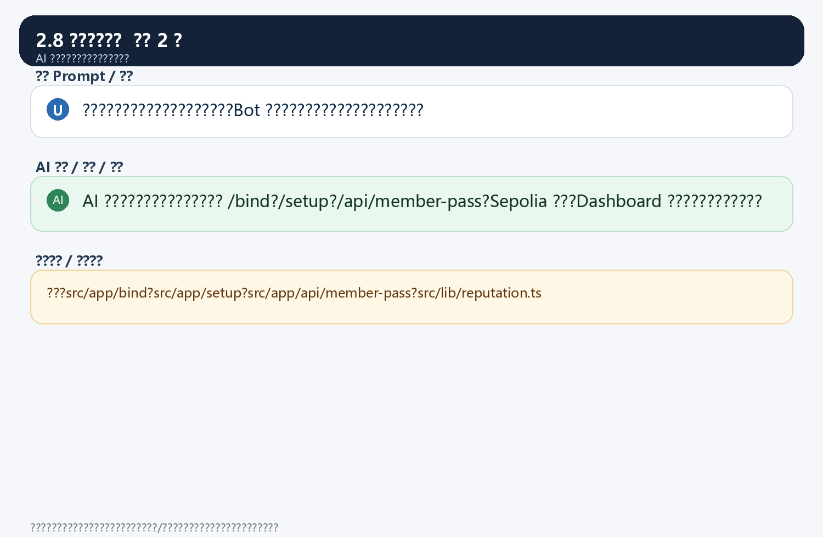

?3?AI????????
3.1 AI????????? 2 ??
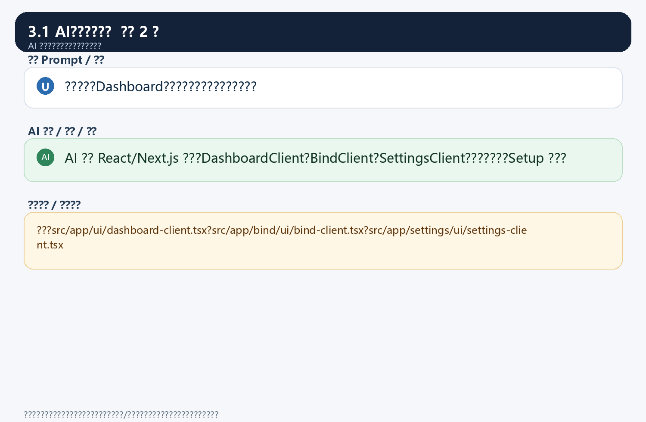
3.2 ???????? 2 ??
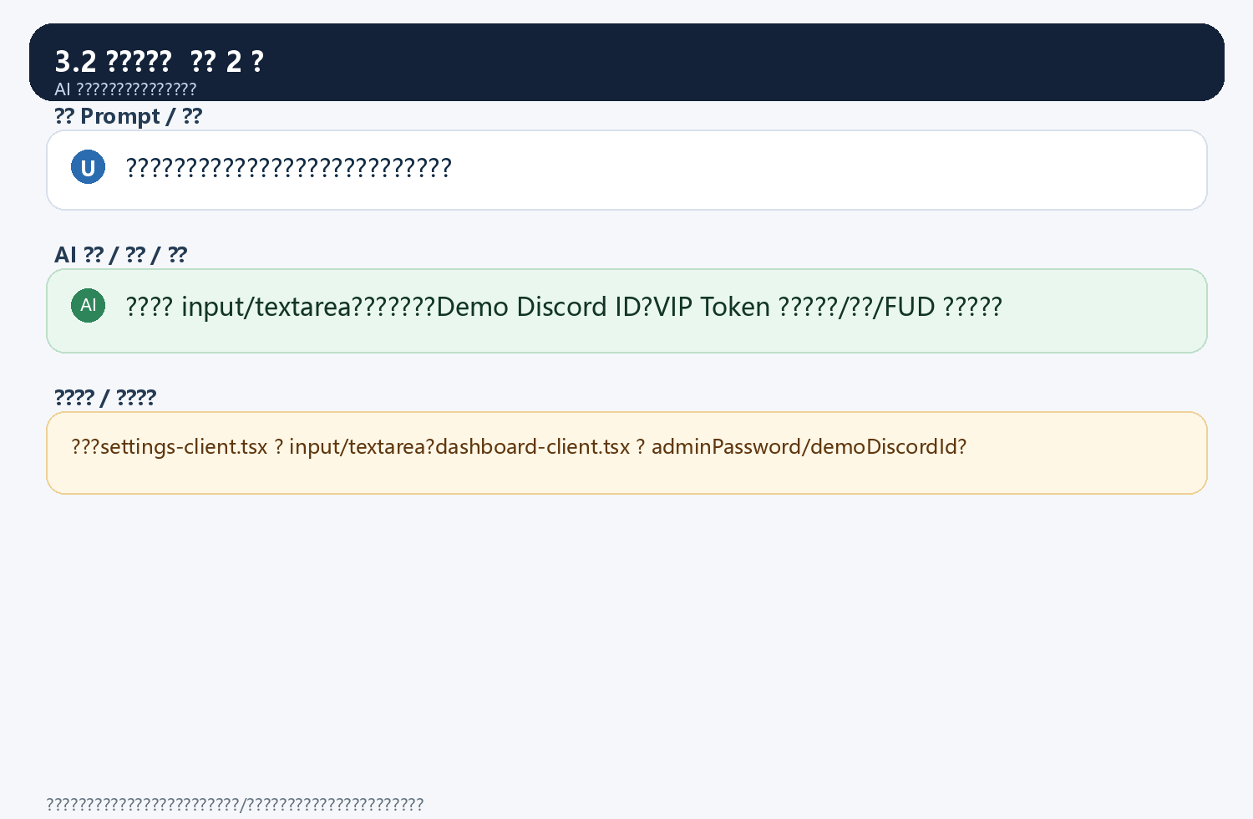
3.3 ??????? 2 ??
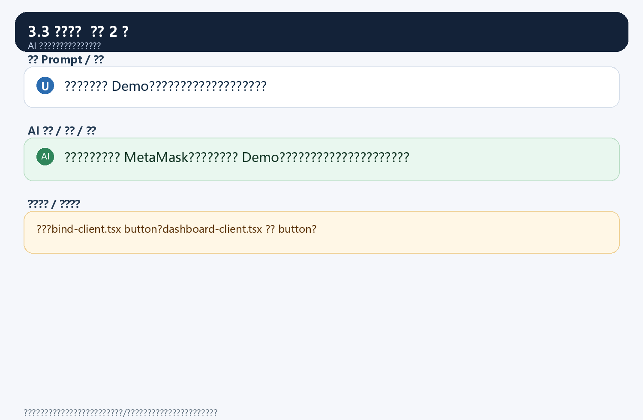
3.4 ?????????? 2 ??
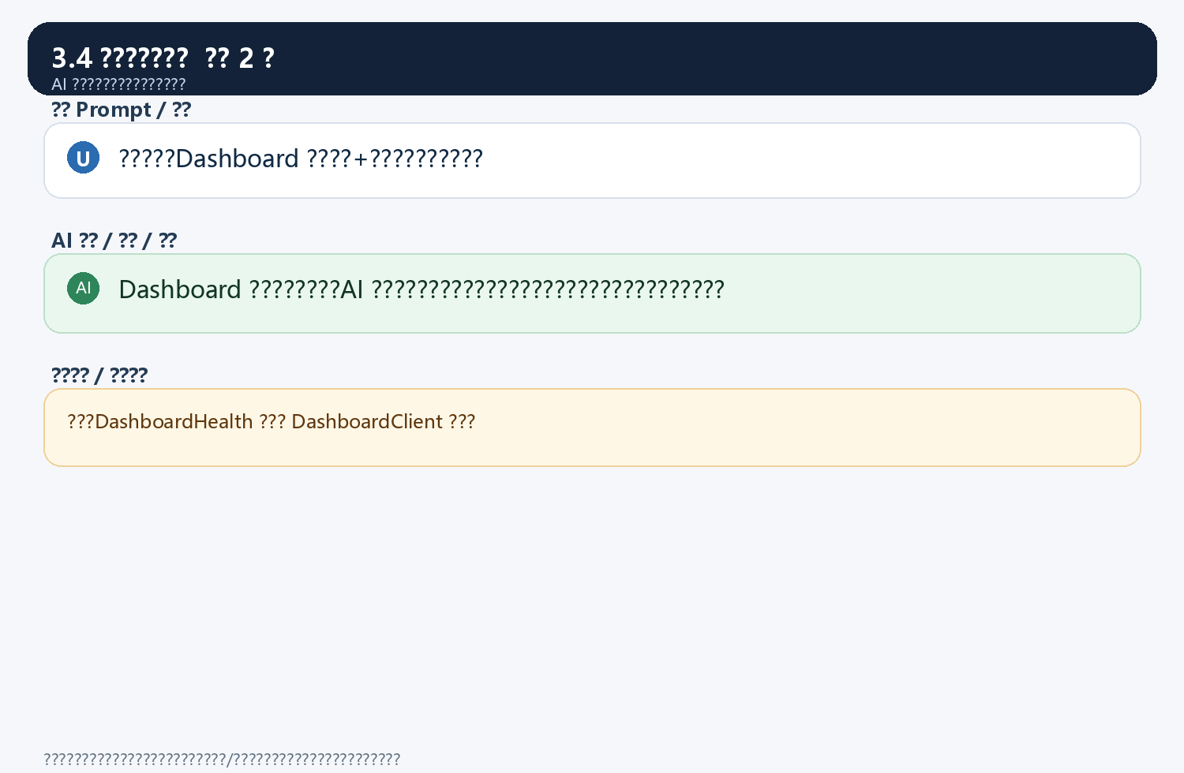
3.5 ????????? 2 ??
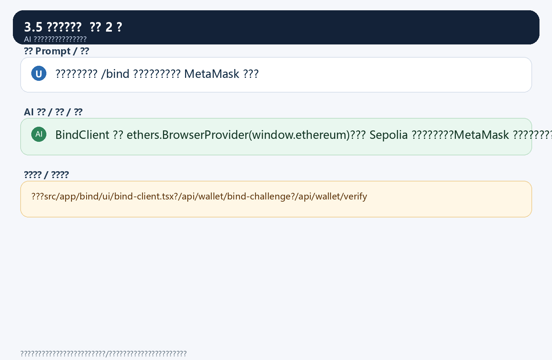
3.6 ?????3???? 2 ??
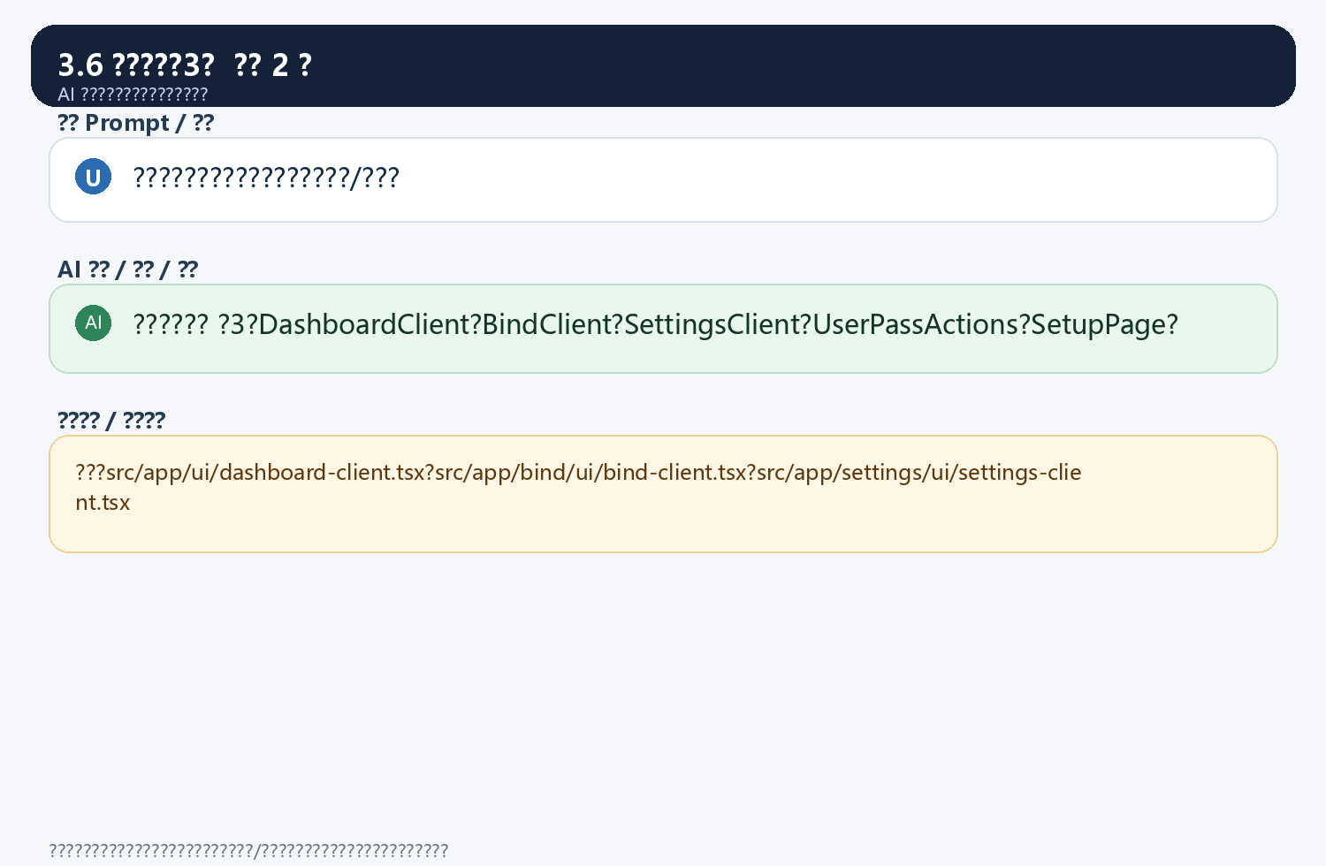

?4?AI??????????
4.1 AI????????? 2 ??
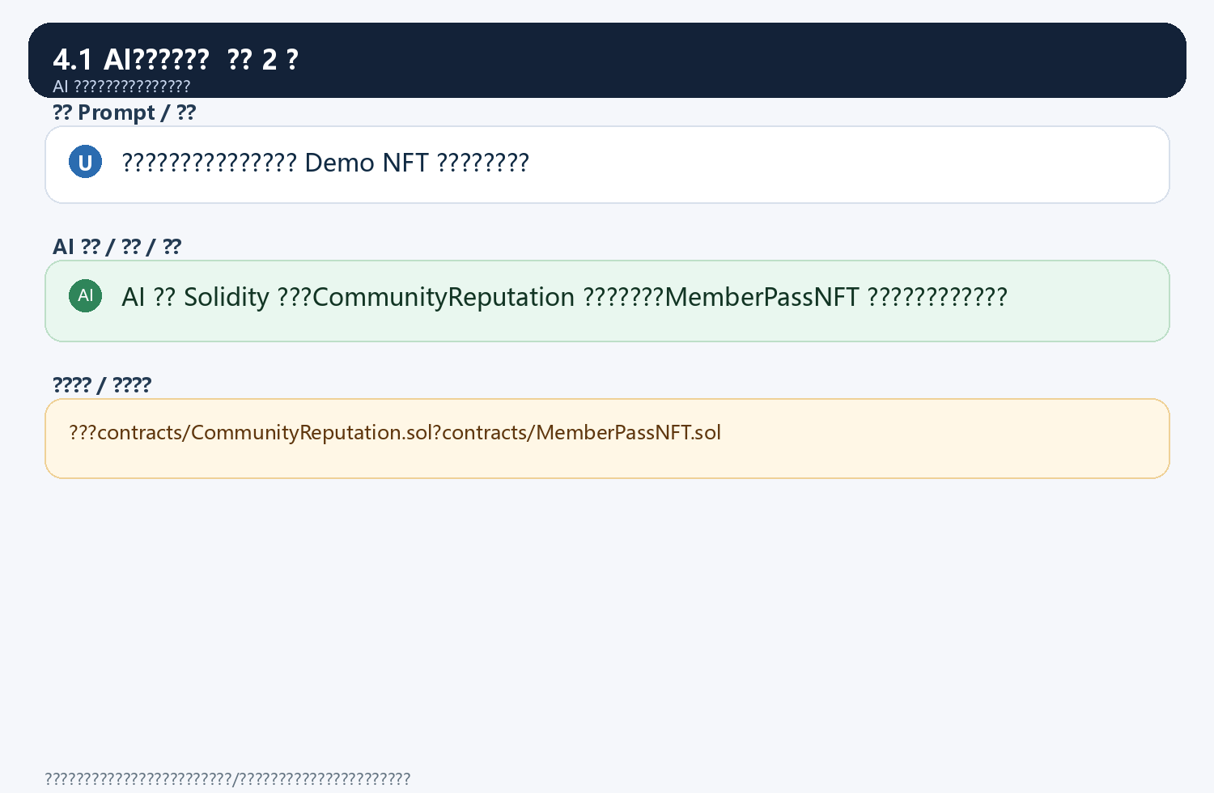
4.2 ????????? 2 ??
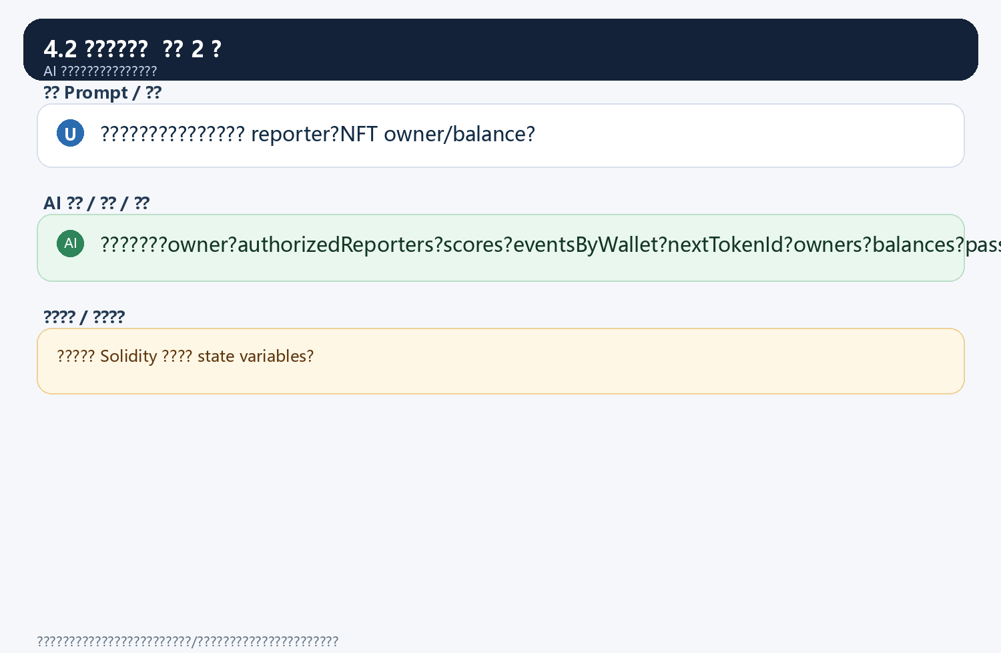
4.3 ?????????? 4 ??
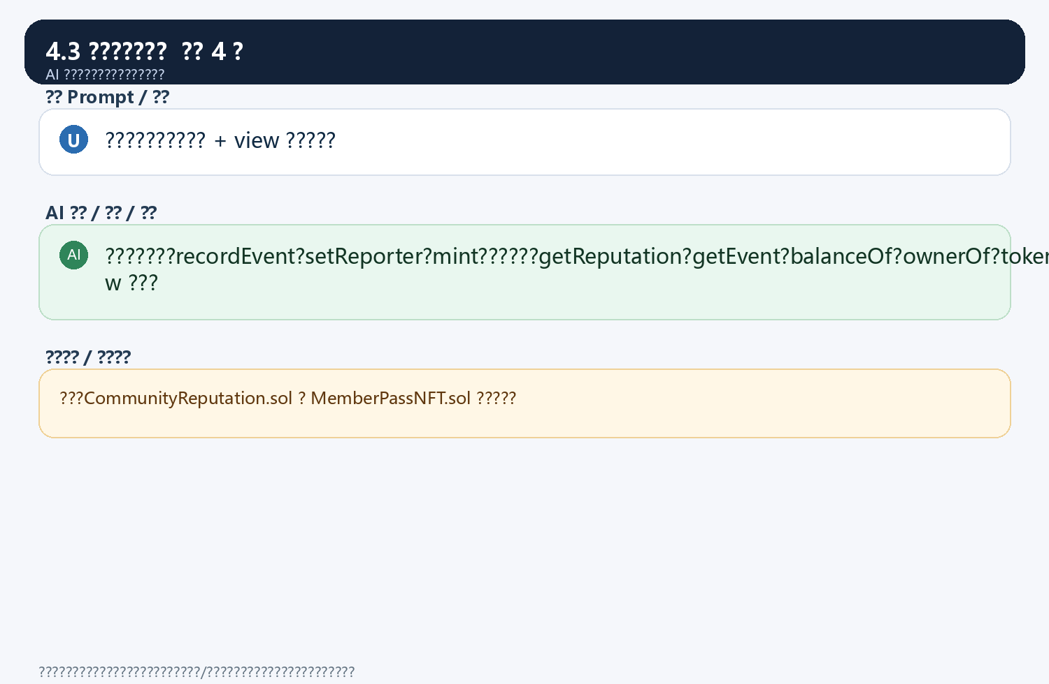
4.5 ????Event??? 2 ??
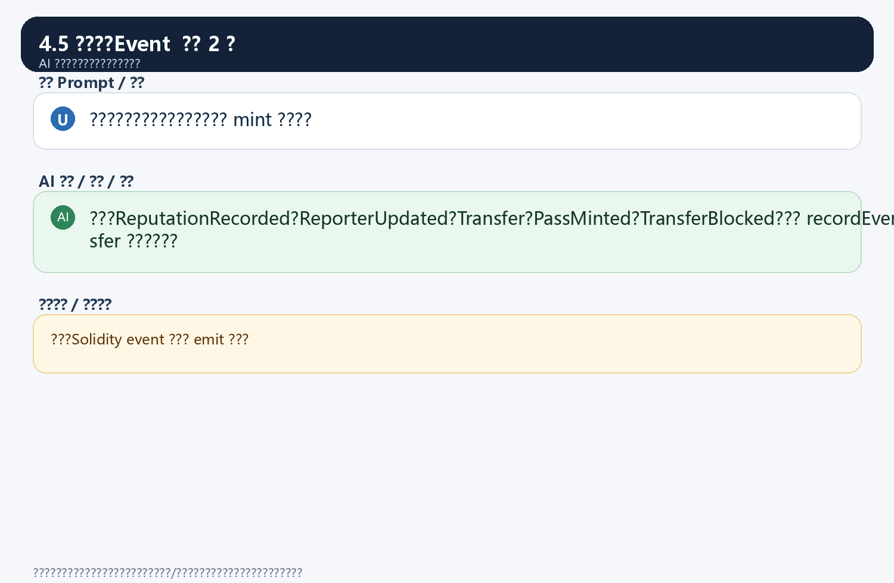
4.6 ????????? 2 ??
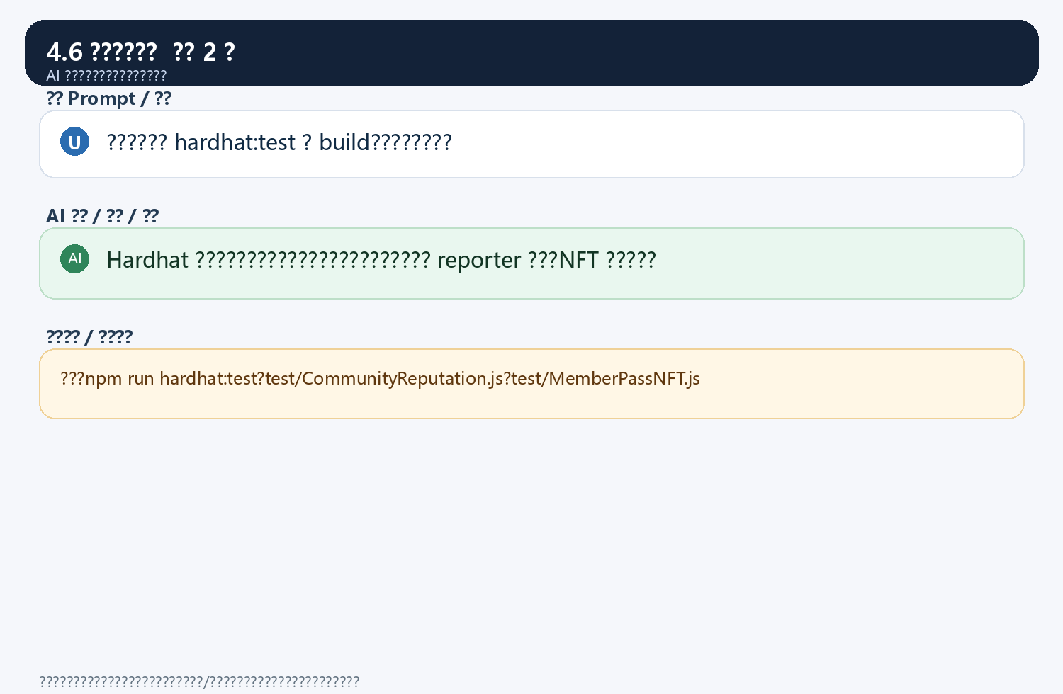
4.7 ????????? 3 ??
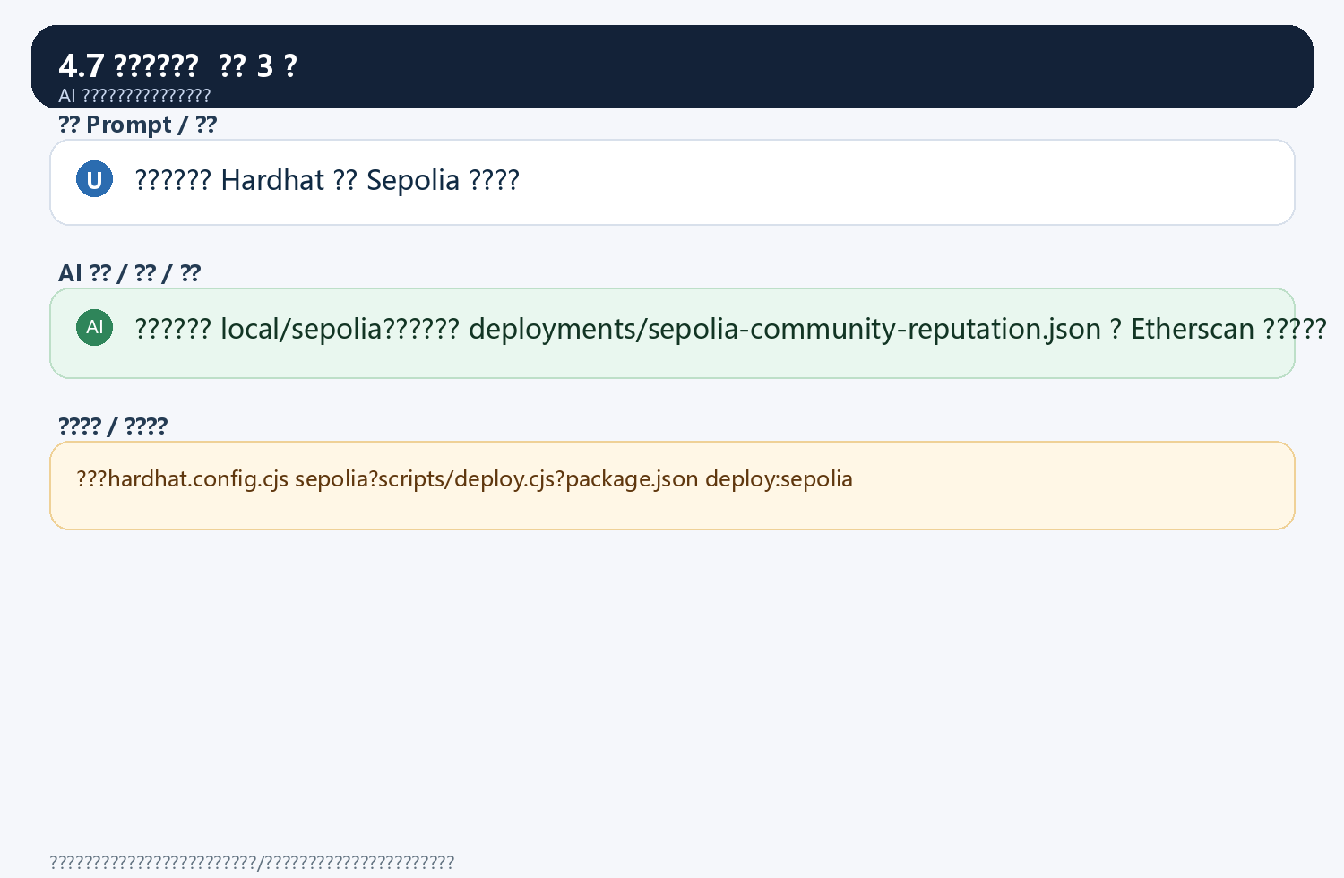

?5?AI??Bug????
5.1 ??????/????? 2 ??
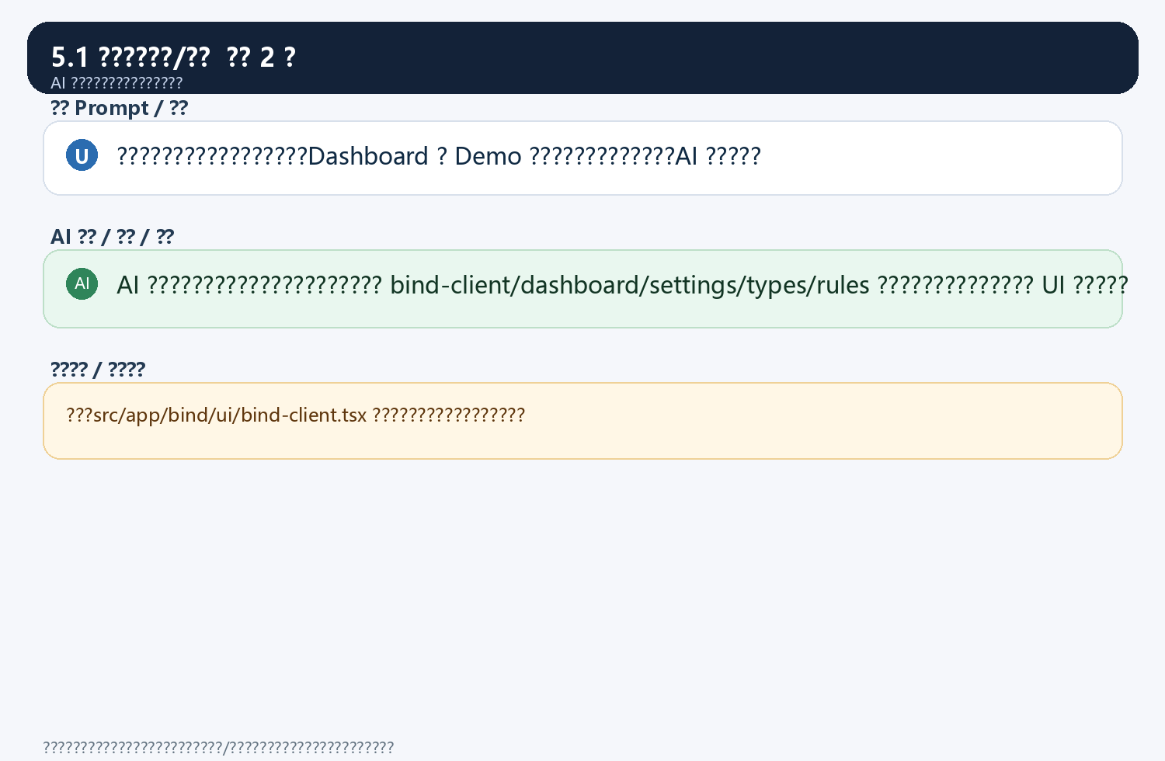
5.2 ????AI??? 2 ??
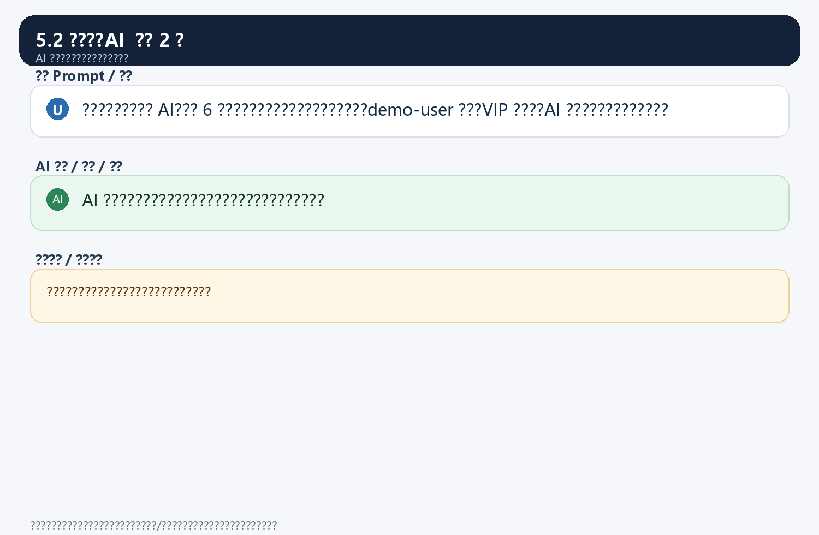
5.3 AI??????? 2 ??
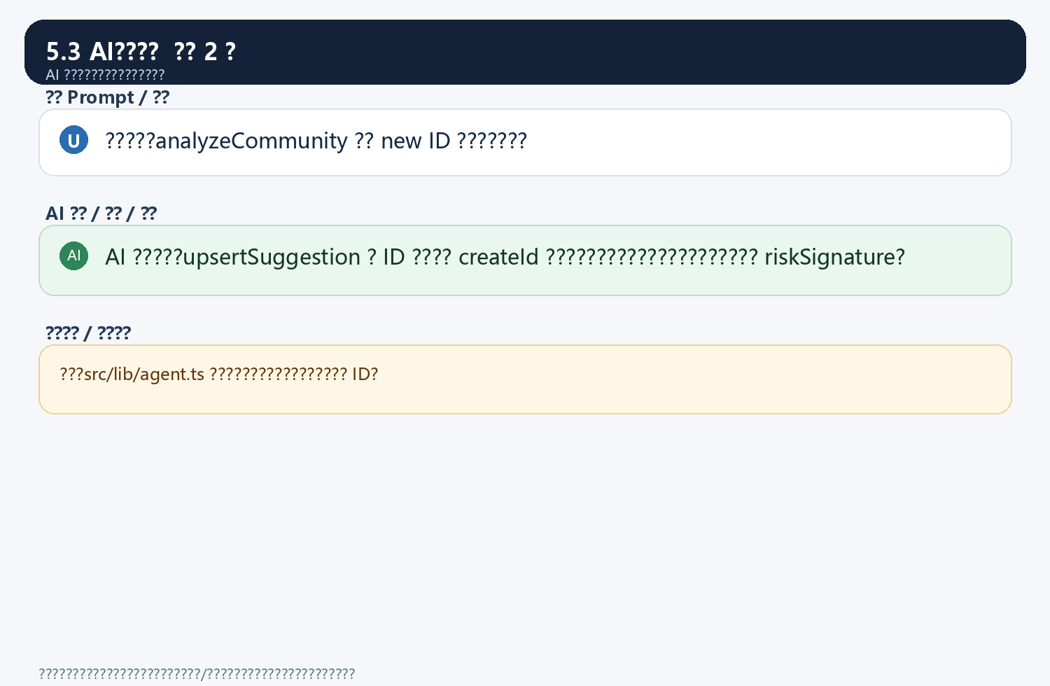
5.4 ????????? 2 ??
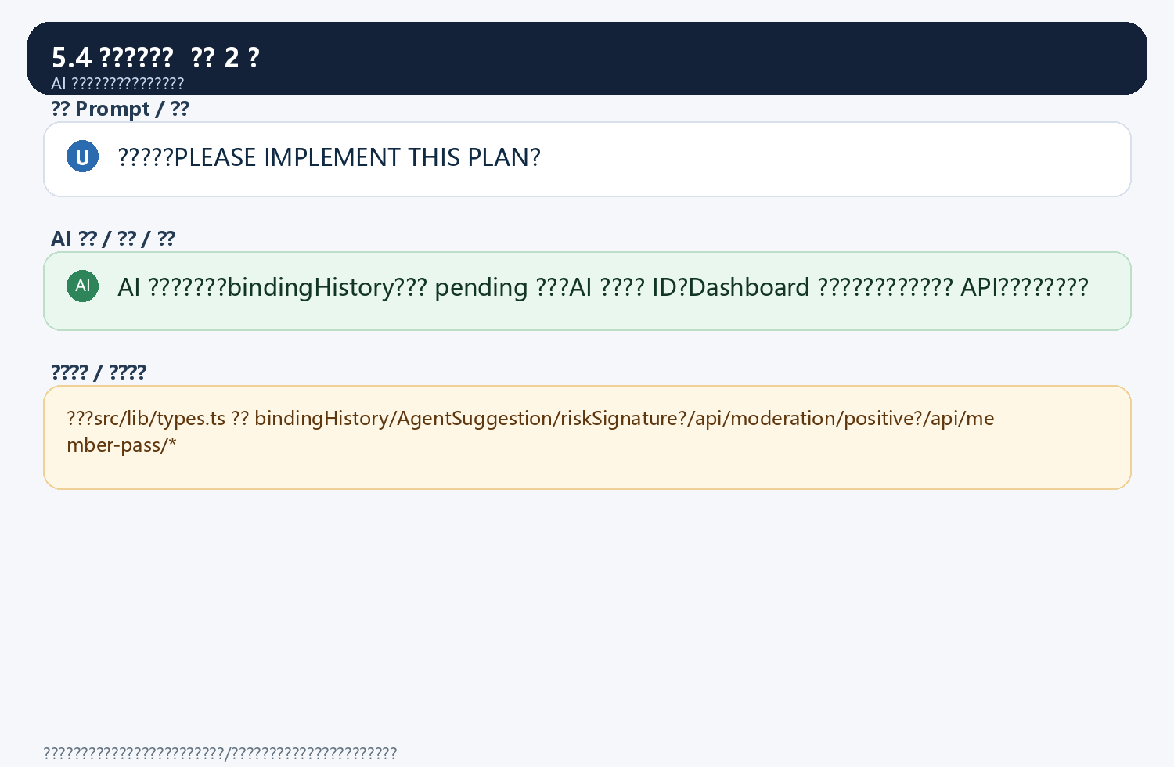
5.5 ??????? 2 ??
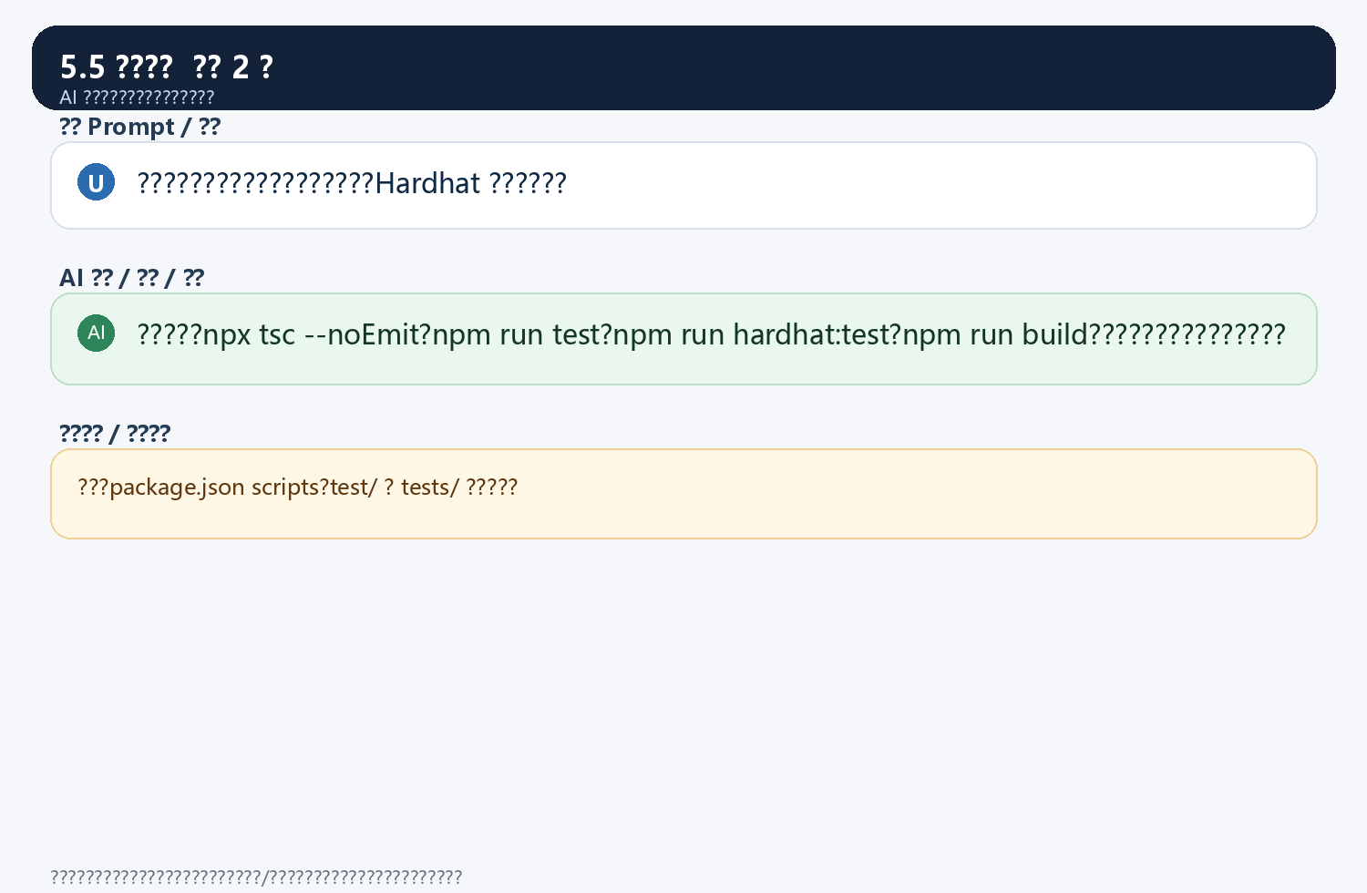
5.6 ????????? 2 ??
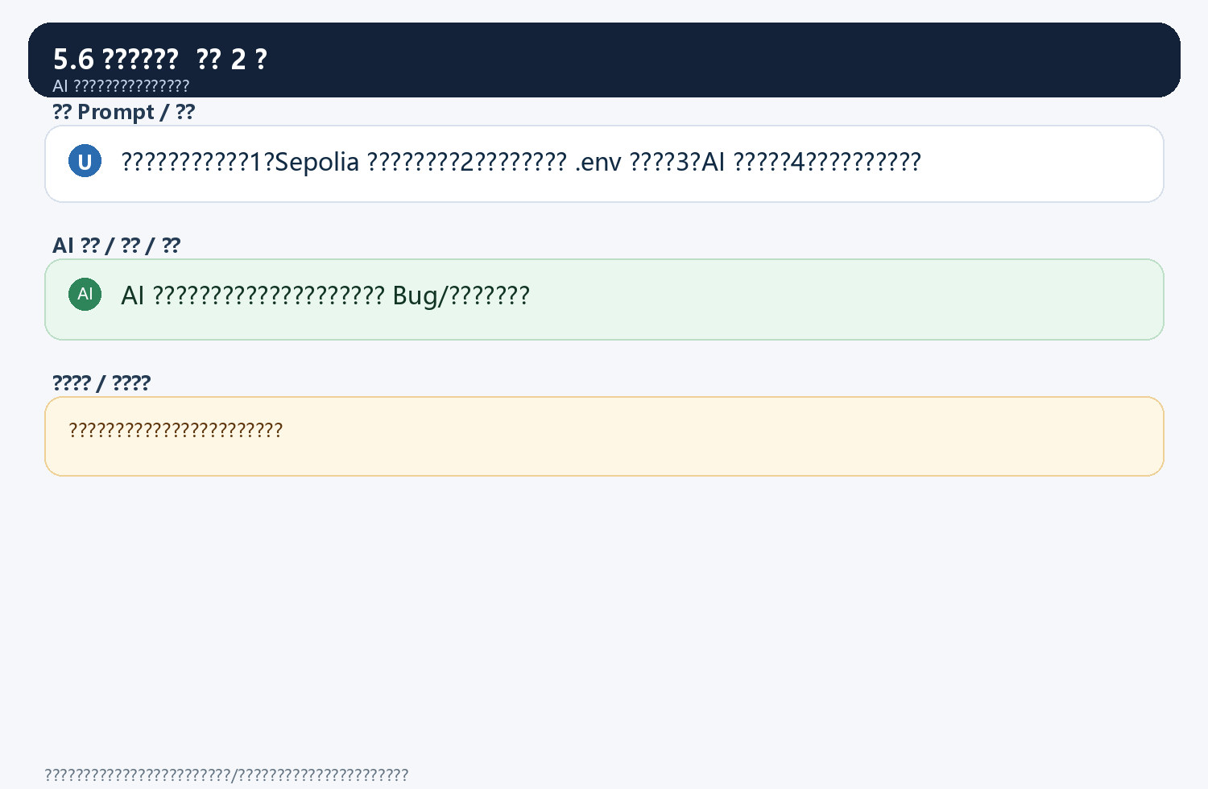

???????????????
package.json
hardhat.config.cjs
contracts/CommunityReputation.sol
contracts/MemberPassNFT.sol
src/app/ui/dashboard-client.tsx
src/app/bind/ui/bind-client.tsx
src/app/settings/ui/settings-client.tsx
src/lib/types.ts
src/lib/rules.ts
src/lib/reputation.ts
src/lib/member-pass.ts
scripts/deploy.cjs
scripts/deploy-pass.cjs
test/CommunityReputation.js
test/MemberPassNFT.js
tests/rules.test.ts
tests/agent.test.ts

