**Testing Challenge #6 - Boundary testing**

**Specification**

This is a form to book a TAXI. The application has to work only in 2017 for a taxi company in Amsterdam.  
Taxis have to be ordered at least 1 hour in advance.   
If the time is less than 1 hour customers cannot order online. They have to call.   
Date format is DD/MM/YYYY HH:MM.   
  
For testing purposes the default value is current date and time (in Amsterdam), but set for 2017 plus one hour and 10 minutes. You have logged in the application, and specified location. All you have to do is to specify the date and time.

**Your challenge** is to test all the **invalid boundaries** for the date and time field. Test one boundary at a time. Do not test with missing values (eg missing month 03/ /2017 04:44).

Dates containing other chars than numbers or unrecognized date format will be ignored

**Scenarios:**

* Input
  + Valid
    - Date and time are in the correct format.
    - Date and time are within valid ranges.
  + Invalid
    - Date or time contain character other than numbers.
    - Unrecognized date format.
* Output
  + “A taxi has been booked.”
  + Error message.

|  |  |  |  |  |  |  |
| --- | --- | --- | --- | --- | --- | --- |
| Test Case # | DD | MM | yyyy | HH | MM | Expected Result |
| 1 | 31 | 12 | 2016 | 23 | 59 | Invalid |
| 2 | 01 | 01 | 2018 | 00 | 00 | Invalid |
| 3 | 40 | 07 | 2017 | 09 | 09 | Invalid |
| 4 | 04 | 17 | 2017 | 09 | 09 | Invalid |
| 5 | 04 | 07 | 9999 | 09 | 09 | Invalid |
| 6 | 04 | 07 | 2017 | 99 | 09 | Invalid |
| 7 | 04 | 07 | 2017 | 09 | 99 | Invalid |
| 8 | 40 | 17 | 9999 | 99 | 99 | Invalid |
| 9 | AA | AA | AAAA | AA | AA | Invalid |

**Logged in as** [**Stanislav Petrov**](https://en.wikipedia.org/wiki/Stanislav_Petrov)

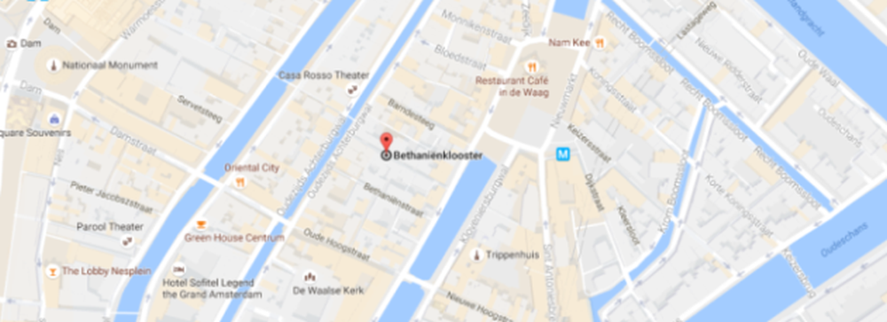

Top of Form

Please select date and time* 

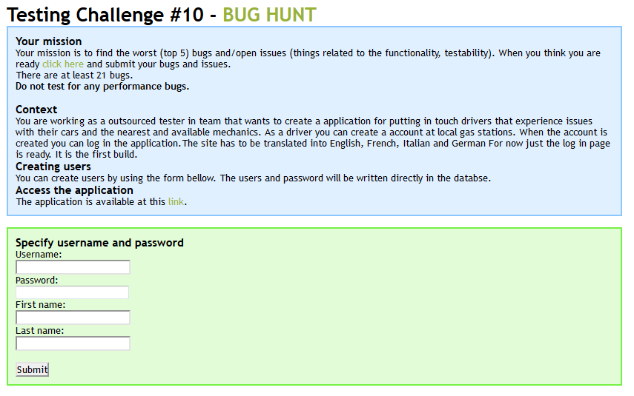

**Top 5 Bugs:**

1. User can login with only a valid username.
2. User can login with only a valid password.
3. User can sign in with other users’ passwords.
4. No check for same combination of information being entered into the table multiple times.
5. No character limit to username.

**Top 5 Issues:**

1. User not found and login successful messages both show up at the same time.
2. Feedback is not translated to other languages beyond English.
3. No feedback for an empty login.
4. “Successful” is spelled incorrectly in “Log In Successfull”.
5. “Log In Successfull” is bolded unlike “Username Not Found”.

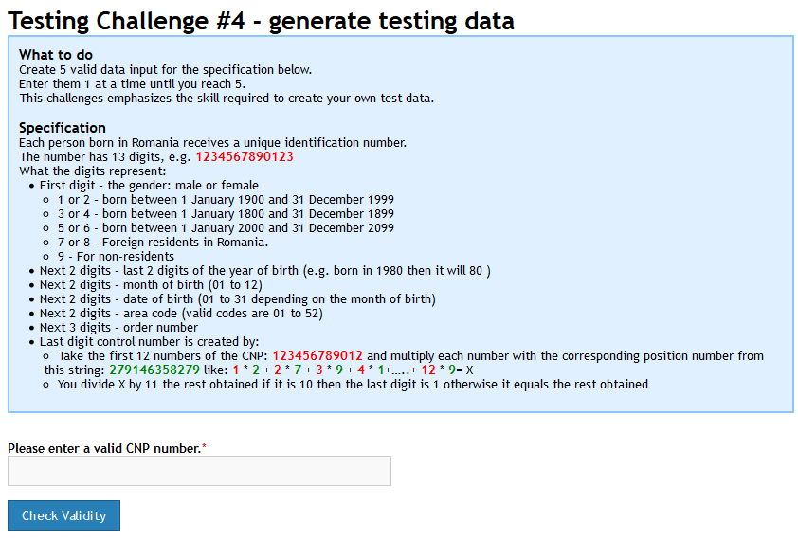

|  |  |  |  |  |  |  |  |
| --- | --- | --- | --- | --- | --- | --- | --- |
| Gender  (1-9; 1) | Last Birth Year Digits  (00-99; 2) | Birth Month  (01-12; 2) | Birth Day  (01-31; 2) | Area Code  (01-52; 2) | Order Number  (001-999; 3) | Special  (?; 1) | Full ID Number |
| 1 | 00 | 01 | 01 | 01 | 111 | 2 | 1000101011112 |
| 2 | 00 | 01 | 01 | 01 | 111 | 4 | 2000101011114 |
| 3 | 00 | 01 | 01 | 01 | 111 | 6 | 3000101011116 |
| 4 | 00 | 01 | 01 | 01 | 111 | 8 | 4000101011118 |
| 5 | 00 | 01 | 01 | 01 | 111 | 1 | 5000101011111 |