**Password Policy**

1. Must contain at least 7 characters.
2. Must contain at most 16 characters.
3. Must contain at least one number.
4. Must contain at least one uppercase character.
5. Must contain at least one lowercase character.
6. Cannot be the same as the last five passwords.
7. Must contain at least one of these ‘special’ characters: !@#$%^&*() . . .

|  |  |  |  |
| --- | --- | --- | --- |
| Requirement | Test Data | Valid/Invalid | Outcome |
| 1 | Abcd1! | Invalid | “Invalid password. Password must contain at least 7 characters.” |
| 2 | Abcdefghijklmnopqrs1! | Invalid | “Invalid password. Password must contain at most 16 characters.” |
| 3 | Abcdefg!! | Invalid | “Invalid password. Password must contain at least one number.” |
| 4 | abcdefg1! | Invalid | “Invalid password. Password must contain at least one uppercase character.” |
| 5 | ABCDEG1! | Invalid | “Invalid password. Password must contain at least on lowercase character.” |
| 6 | Abcdefgh1!  Abcdefgh2!  Abcdefgh3!  Abcdefgh4!  Abcdefgh5!  Abcdefgh1! | Invalid | “Invalid password. Password cannot be the same as the last five characters.” |
| 6 | Abcdefgh1!  Abcdefgh2!  Abcdefgh3!  Abcdefgh4!  Abcdefgh5!  Abcdefgh5! | Invalid | “Invalid password. Password cannot be the same as the last five characters.” |
| 7 | Abcdefg11 | Invalid | “Invalid password. Password must contain at least one of these ‘special’ characters: !@#$%^&*() . . .” |
| 1, 2, 3, 4, 5, 6, 7 | a | Invalid | “Invalid password. Multiple password errors have occurred. Consult the password policy.” |
| 1, 2, 3, 4, 5, 6, 7 |  | Invalid | “Invalid password. Multiple password errors have occurred. Consult the password policy.” |
| 1, 2, 3, 4, 5, 6, 7 | Abcdefg1! | Valid | “Valid password.” |
|  |  |  |  |
|  |  |  |  |
|  |  |  |  |
|  |  |  |  |
|  |  |  |  |
|  |  |  |  |
|  |  |  |  |
|  |  |  |  |

**Validation Rules**

Improve the quality of your data using validation rules. Validation rules verify that the data a user enters in a record meets the standards you specify before the user can save the record. A validation rule can contain a formula or expression that evaluates the data in one or more fields and returns a value of “True” or “False”. Validation rules also include an error message to display to the user when the rule returns a value of “True” due to an invalid value.

After you have defined validation rules:

1. The user chooses to create a record or edit an existing record.
2. The user clicks Save.
3. All validation rules are verified.
   * If all data is valid, the record is saved.
   * If any data is invalid, the associated error message displays without saving the record.
4. The user makes the necessary changes and clicks Save again.

You can specify the error message to display when a record fails validation and where to display it. For example, your error message can be “The close date must occur after today's date.” You can choose to display it near a field or at the top of the page. Like all other error messages, validation rule errors display in red text and begin with the word “Error”.

* Must contain at least 7 characters.
* Must contain at least 16 characters.
* Must contain at least one number.
* Must contain at least one uppercase character.
* Must contain at least one lowercase character.
* Cannot be the same as the last five passwords.
* Must contain at least one of these ‘special’ characters: !@#$%^&*() . . .

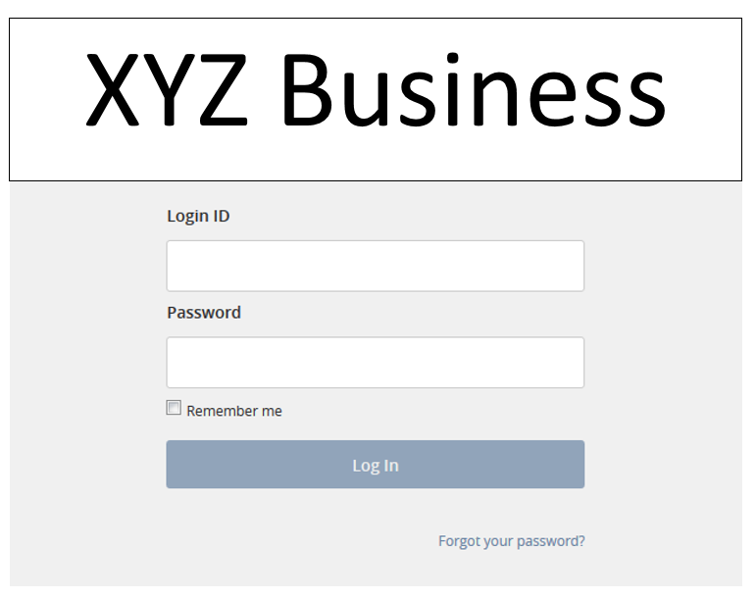

Scenarios:

Valid login to the system

Prerequisites:

* User already has an account with XYZ Business. Their login ID and password are valid.
* User is on a browser that can run the page.

1. User enters the login screen.
   1. User is on the login page.
2. User clicks on the “Login ID” box.
   1. User can now enter information into “Login ID” box.
3. User enters in a valid login ID into the “Login ID” box.
   1. A valid login ID has been entered in. This login ID is not case sensitive.
4. User clicks on the “Password” box.
   1. User can now enter information into the “Password” box.
5. User enters in a valid password into the “Password” box.
   1. A valid password has been entered in.
6. User clicks on “Log In”.
   1. User is logged into the system.

Remember me functionality

Prerequisites:

* User already has an account with XYZ Business. Their login ID and password are valid.
* User is on a browser that can run the page.

1. User enters the login screen.
   1. User is on the login page.
2. User clicks on the “Login ID” box.
   1. User can now enter information into “Login ID” box.
3. User enters in a valid login ID into the “Login ID” box.
   1. A valid login ID has been entered in. This login ID is not case sensitive.
4. User clicks on the “Password” box.
   1. User can now enter information into the “Password” box.
5. User enters in a valid password into the “Password” box.
   1. A valid password has been entered in.
6. User checks the “Remember Me” box.
   1. User’s login ID will be saved for future logins, while this box remains checked.
7. User clicks on “Log In”.
   1. User is logged into the system.
8. User logs out of the system.
   1. User is no longer logged into the system.
9. User enters the login screen.
   1. User is on the login page with their credentials already filled in.
10. User clicks on “Log In”.
    1. User is logged into the system.

Forgot your password

Prerequisites:

* User already has an account with XYZ Business. Their login ID and password are valid.
* User is on a browser that can run the page.

1. User clicks on the “Forgot your password?” hyperlink.
   1. User will be taken to the page for forgotten passwords.

Valid login ID, invalid password

Prerequisites:

* User already has an account with XYZ Business. Their login ID and password are valid.
* User is on a browser that can run the page.

1. User enters the login screen.
   1. User is on the login page.
2. User clicks on the “Login ID” box.
   1. User can now enter information into “Login ID” box.
3. User enters in a valid login ID into the “Login ID” box.
   1. A valid login ID has been entered in. This login ID is not case sensitive.
4. User clicks on the “Password” box.
   1. User can now enter information into the “Password” box.
5. User enters in an invalid password into the “Password” box.
   1. An invalid password has been entered in.
6. User clicks on “Log In”.
   1. User will be displayed an error message the states the password is incorrect for the given login ID.

Invalid login ID

Prerequisites:

* User already has an account with XYZ Business. Their login ID and password are valid.
* User is on a browser that can run the page.

1. User enters the login screen.
   1. User is on the login page.
2. User clicks on the “Login ID” box.
   1. User can now enter information into “Login ID” box.
3. User enters in an invalid login ID into the “Login ID” box.
   1. An invalid login ID has been entered in. This login ID is not case sensitive.
4. User clicks on the “Password” box.
   1. User can now enter information into the “Password” box.
5. User enters in an invalid password into the “Password” box.
   1. An invalid password has been entered in.
6. User clicks on “Log In”.
   1. User will be displayed an error message the states the password is incorrect for the given login ID.