**Software Development Process**

**1. Problem statement**

You should write a program so that users could play “Find the Pairs” game.

1. You program should provide users with the ability to

(1) Create an account.

(2) Login the account.

(3) Delete the account.

(4) Logout.

The account should contain user name, password and game history.

The account can be store in data file which is accessed by the program.

2. After the user login the game, they will move to the game menu

they can

(1) Start a new game

(2) View the game history

(3) Delete the game history

(4) Back to the login menu

3. The game map should have a size of 4*4.

4. After starting the game, the user could have some time to remember the numbers on the map.

5. The program could let players select pairs of objects to uncover according to the provided coordinates.

6. These remain uncovered if they match and are re-covered if they do not match after a short delay.

7. The total number of guesses it takes to uncover all pairs should be recorded.

8. If the player has won the game, the program will back to the game menu.

9. Normally, the use of global variables is not allowed. Any use of global variables must be fully justified.

10. The game should allow the player to exit to the menu at any time.

**2. Analysis**

**1) On the input:**

The program should print out enough messages so that the users will know what they should do next. What is more, the program could check the legality of the input. If user inputs irrelevant character, the program should let user input again.

**2) On the output:**

The output will show the solution after the input was calculated by the computer program. Thus, the user could do the following steps according to the output. In different stages, the output can be different.

If your input is legal:

a) In the login menu, game menu or record menu, you may jump to another window or log out the game.

b) When you play the game, the program will print out that you choose the correct thing and you can continue the game.

If your input is illegal:

a) In the login menu or game menu, your input will be deleted and you should input again.

b) When you play the game, the program will print out why your input is illegal and let you input again.

**3) Data Structure**

The program can be divided into several functions. Each function could do different things. Then, these functions will be organized together to achieve the goal.

We firstly define an account structure, which points to two smaller structures. Then, we define two smaller structures. One is for username and password while another one is for the game record.

For the login and game menu, we use flow control to do choices between different functions. “While” loop will be used to check whether you input the wrong thing.

In order to store the account. We should define a pointer which points to the text file. Then, use flow control to check whether there is a text file to store the information. Create a file if there is no file. When you create your account with a user name and password, the program will record them and you can check them in the text file. What is more, you can change the password if you want.

The structure to store the game record is quite similar to the structure to store account. Every time you finish the game. The program will record down the information and save it into a file. The program will show you the player number and time costs. The attempt time will show you after you finish the game. It will not be shown in the record menu.

For the game, use “for” loop to produce a 1-dimensional array and print it out according to the corresponding number. Two functions “rand” and “srand” will be used to produce random numbers for the map. The “delay” function which is created by myself will be used to stop the program for several seconds so that players have time to remember the map. Then, four “for” loop will be used to check whether you choose the correct thing and it is also used to record the attempt time.

An overview of core functions used in the program are shown below:

**4)** **Algorithm:**

The core algorithm is to produce a 4*4 randomised pair grid. Thus, the value of the first eight numbers should be equivalent to the last eight numbers.

rand()%(n-m+1)+m is the function to produce random number.

{start=time(NULL);

end=time(NULL);

p.time=(int)difftime(end,start); } This is the algorithm to calculate the time cost.

**3. Design**

Three structures are defined at the top of the program.

typedef struct account /*Define the structure of account*/

{

struct z*zp; /*User name and password*/

struct player*playerp; /*Game history*/

} f;

struct e/*Define the user name and password */

{

char a[10];

char b[10];

}z;

typedef struct Player /*define the record information for every player*/

{

int number;

int time;

}player;

Three variables are defined at the top of the program.

player py [5] means each account could contain 5 players.

player p = {0,0} means the record menu will show the player’s number and the time.

int record=5 means the maximum game record number is 5.

**For the login menu**

Change the password:

Begin

Other: Input again

1. User login

No account

Create an account

Input username

Input password

Account has been created

Input username

Right

Change the password?

Jump to Game menu

Input password

Wrong

Check the document and input again. (Back to "Begin")

2.Delete account

0. Exit

Back to “Begin”

1). Print out: “Do you want to change your password? Yes(y)or No(n)” and you should input your choice. If you input wrong thing the program will allow you to input again.

2). If you input “n”, you will jump to the game menu.

3). If you input “y”, you can create a new password. After you input the new password, the program will jump to the game menu.

**For the game menu**

**When you start the game**, the program will start to record the time and you will see the uncovered map for several seconds. Then, all the numbers will be covered with “0” and you will also see the corresponding number. The program will ask you to input two numbers which are separated by a blank, which is shown in figure 1.

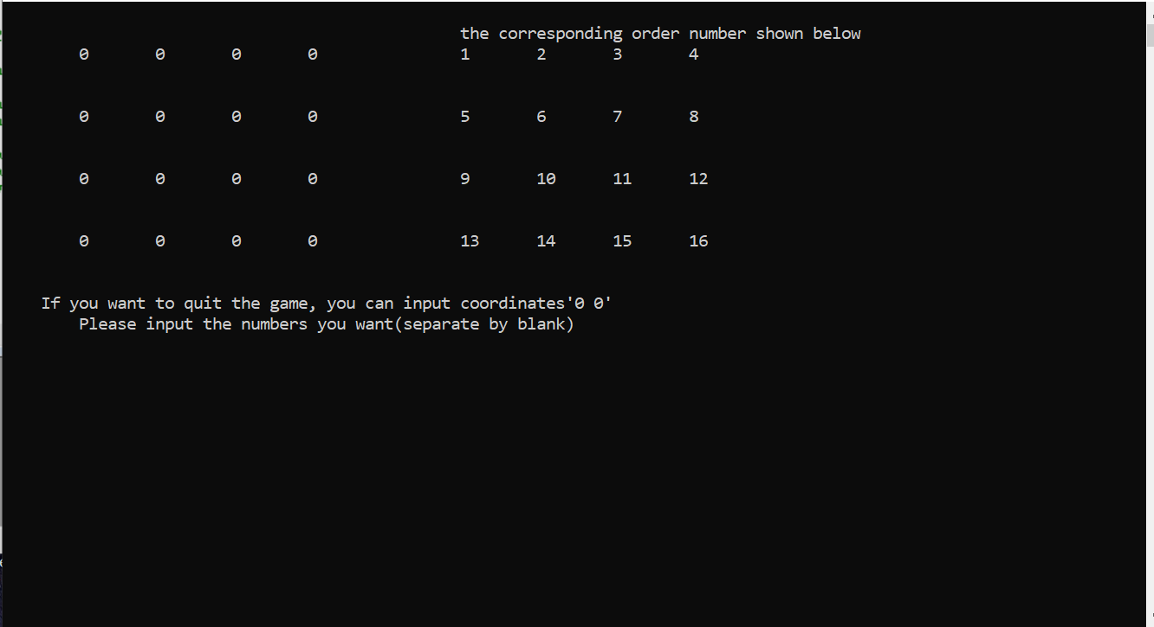

Figure 1: Game interface

The program will show different messages according to what you input.

1) If you input the same corresponding number, the program will print out you input the same number and you should input again.

2) If the numbers you input is smaller than 0 or larger than 16, the program will print out your input is wrong. You should input again.

3) If your input is not two numbers, the program will print out that your input is wrong, you should try again.

4) If your input contains numbers which you have chosen before, the program will print out that your chosen is wrong. You should input again.

5) The corresponding numbers you input do not point to the same thing. The program will show you what are the two corresponding numbers point to and wait for several seconds. Then, the map will be recovered and you can input again.

6) The corresponding numbers your input point to the same thing. The program will print out “correct” and uncover them.

7) You are not suggested to quit when you start to play the game. If you really want to quit the game, you can input coordinates “0 0” to exit. The program will firstly print out that you win and the time you cost. Just ignore it. After several minutes. You will go back to the game menu and you can play again. What is more, you should clear the game history, because your player number and time will also be recorded by the program even though you quit the game. The maximum player for the account is 5.

Every time you input two corresponding numbers. Your input will be tested under these seven conditions and the attempt time will plus one.

**After** **all the numbers have been uncovered**, the program will print out you win the game and show you the attempt time and the total time you cost. After several seconds, you will go back to the game menu. Then, you can check your record. The record menu contains the player’s number and time cost.

**If you want to play again**, you need to print “1” and repeat all these things. One account could contain 5 players. After you play 5 times, the program will not record the player’s information.

**4. Implementation**

See the C code 1928748_2.c with comments.

**5. Testing**

**For login menu:**

**Test 1:**

*Welcome to play the game *

*1.Users login *

*2. Delete account *

*0. Exit *

Please input your choice1

There is no account

Please create a new account

User name

a

Password

123

You have created an account

Please wait for a moment

**Test 2:**

Use the account which created in Test 1.

*Welcome to play the game *

*1.Users login *

*2. Delete account *

*0. Exit *

Please input your choice1

Input your username a

Input your password123

Do you want to change your password? Yes(y)or No(n)y

1234

Successful

**Test 3**

*Welcome to play the game *

*1.Users login *

*2. Delete account *

*0. Exit *

Please input your choice1

Input your username a

Input your password123

Do you want to change your password? Yes(y)or No(n)n

* Play find the pairs and enjoy the game *

* 1.Start the game *

* 2.See the record *

* 3.Delete the record *

* 0.exit *

Please input your choice:

**Test 4**

*Welcome to play the game *

*1.Users login *

*2. Delete account *

*0. Exit *

Please input your choice 2

Your account have been removed

*Welcome to play the game *

*1.Users login *

*2. Delete account *

* 3.Delete the record *

*0. Exit *

Please input your choice1

There is no account

Please create a new account

User name

**Test 5**

*Welcome to play the game *

*1.Users login *

*2. Delete account *

*0. Exit *

Please input your choice0

--------------------------------

Process exited after 103.6 seconds with return value 0

**Test 6**

*Welcome to play the game *

*1.Users login *

*2. Delete account *

*0. Exit *

Please input your choice c

*Welcome to play the game *

*1.Users login *

*2. Delete account *

* 3. Delete the record *

*0. Exit *

Please input your choice

**Test 7**

*Welcome to play the game *

*1.Users login *

*2. Delete account *

*0. Exit *

Please input your choice 7

*Welcome to play the game *

*1.Users login *

*2. Delete account *

*0. Exit *

Please input your choice

**Test 8**

*Welcome to play the game *

*1.Users login *

*2. Delete account *

*0. Exit *

Please input your choice *&^(U

*Welcome to play the game *

*1.Users login *

*2. Delete account *

*0. Exit *

Please input your choice *

**Test 9**

*Welcome to play the game *

*1.Users login *

*2. Delete account *

*0. Exit *

Please input your choice1

Input your username a

Input your password123

Do you want to change your password? Yes(y)or No(n)

ccdd

Wrong input, try again

**Bug that not fixed:**

*Welcome to play the game *

*1.Users login *

*2. Delete account *

*0. Exit *

Please input your choice1

Input your username a 123

Input your passwordDo you want to change your password? Yes(y)or No(n)

**For the game menu**

**Test 1:**

* Play find the pairs and enjoy the game *

* 1.Start the game *

* 2.See the record *

* 3.Delete the record *

* 0.exit *

Please input your choice:2

*****************************************************

* player time *

*****************************************************

press 0 to leave:0

* Play find the pairs and enjoy the game *

* 1.Start the game *

* 2.See the record *

* 3.Delete the record *

* 0.exit *

Please input your choice:

**Test 2**

*Welcome to play the game *

*1.Users login *

*2. Delete account *

*0. Exit *

Please input your choice0

*Welcome to play the game *

*1.Users login *

*2. Delete account *

* 3.Delete the record *

*0. Exit *

Please input your choice

**Test 3**

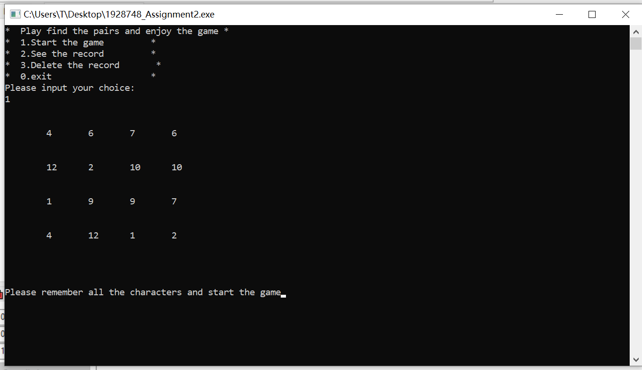

**Test 5**

* Play find the pairs and enjoy the game *

* 1.Start the game *

* 2.See the record *

* 3. Delete the record*

* 0.exit *

Please input your choice: wsqwdn

* Play find the pairs and enjoy the game *

* 1.Start the game *

* 2.See the record *

* 3. Delete the record*

* 0.exit *

Please input your choice:

**Test 6**

* Play find the pairs and enjoy the game *

* 1.Start the game *

* 2.See the record *

* 3. Delete the record*

* 0.exit *

Please input your choice: 3445

* Play find the pairs and enjoy the game *

* 1.Start the game *

* 2.See the record *

* 3. Delete the record*

* 0.exit *

Please input your choice:

**Test 7**

* Play find the pairs and enjoy the game *

* 1.Start the game *

* 2.See the record *

* 3. Delete the record*

* 0.exit *

Please input your choice: $%@

* Play find the pairs and enjoy the game *

* 1.Start the game *

* 2.See the record *

* 3. Delete the record*

* 0.exit *

Please input your choice:

**When you start the game**

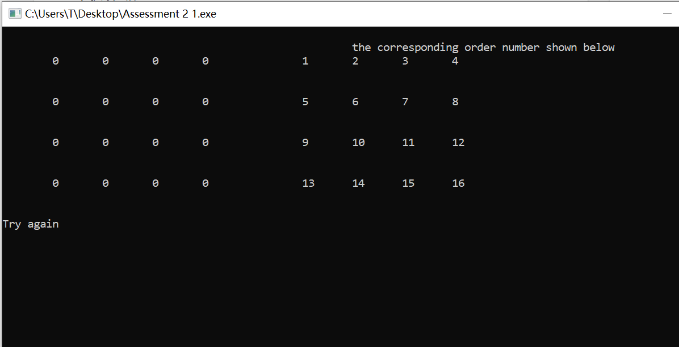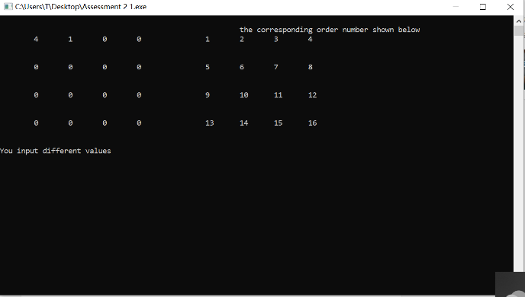**Test 1**

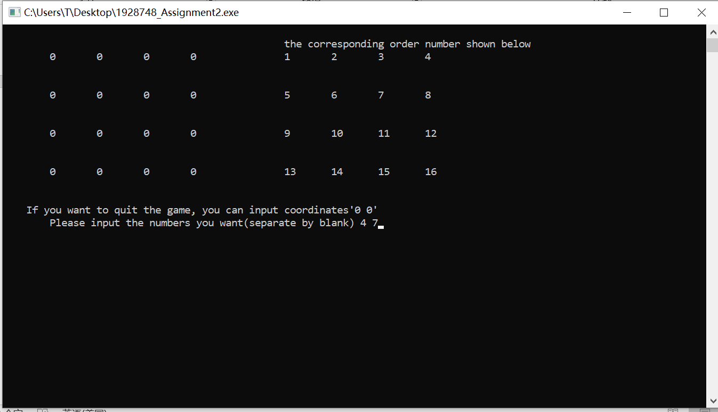**Test 2:**

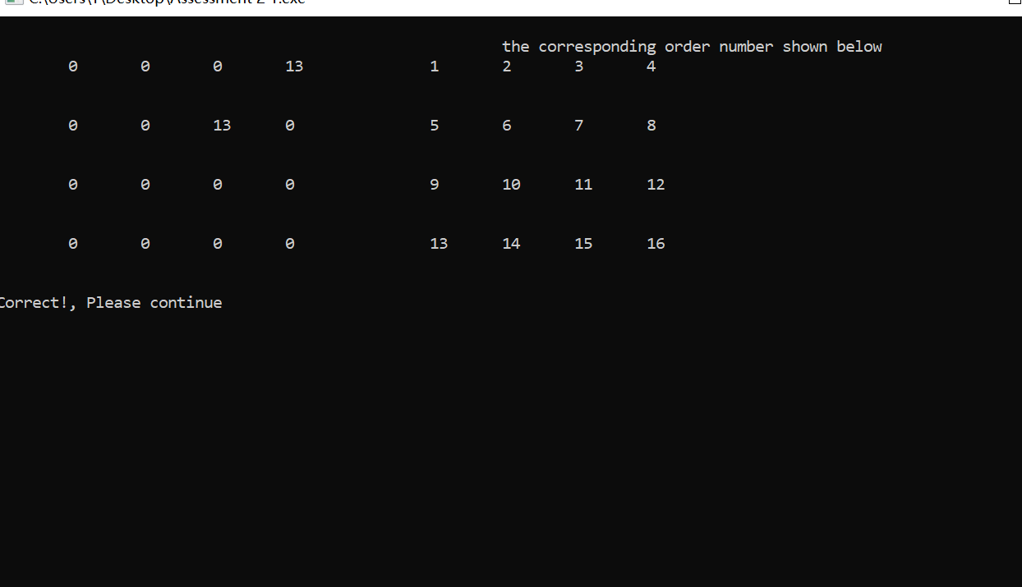

**Test 3**

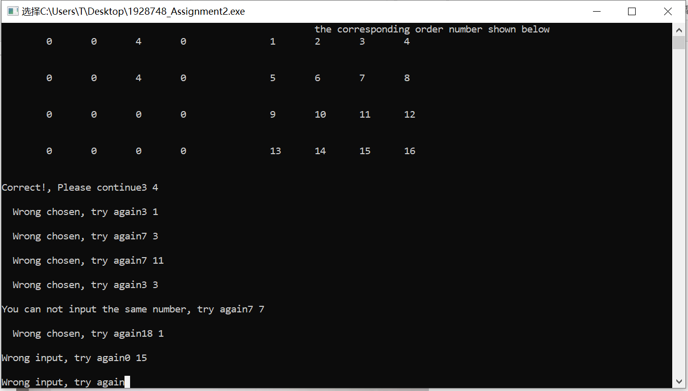

**Test 4**

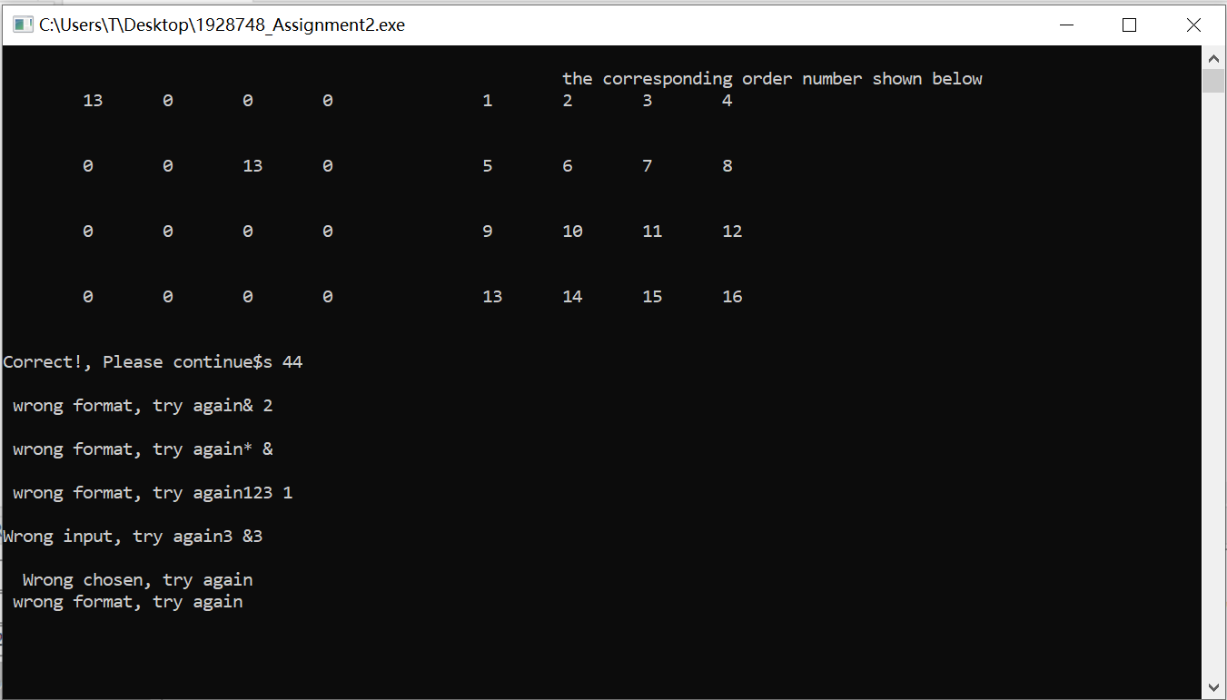

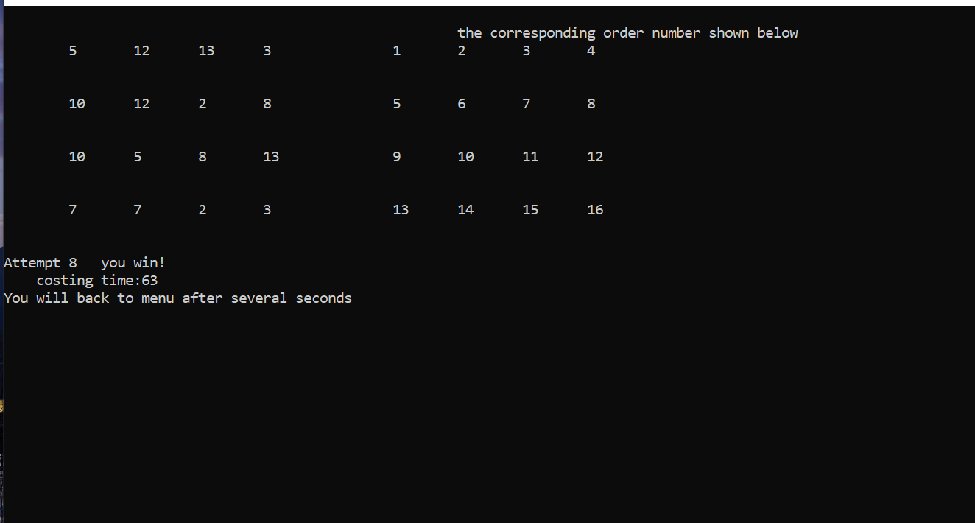**Test 5**

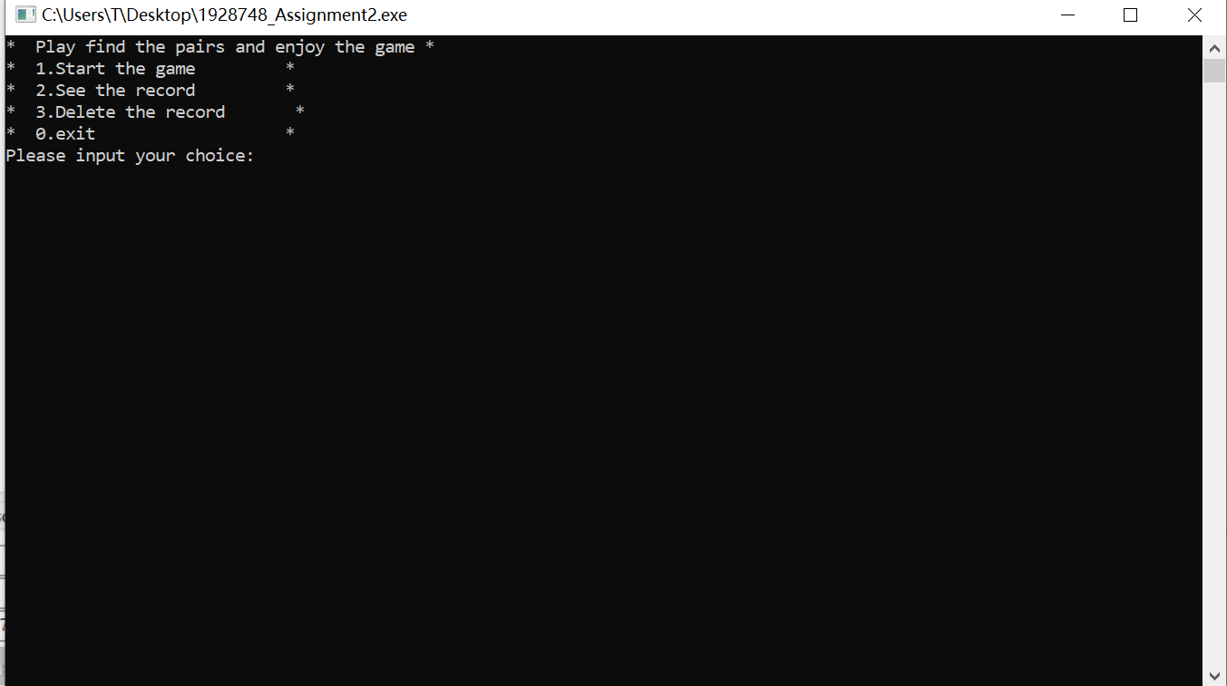

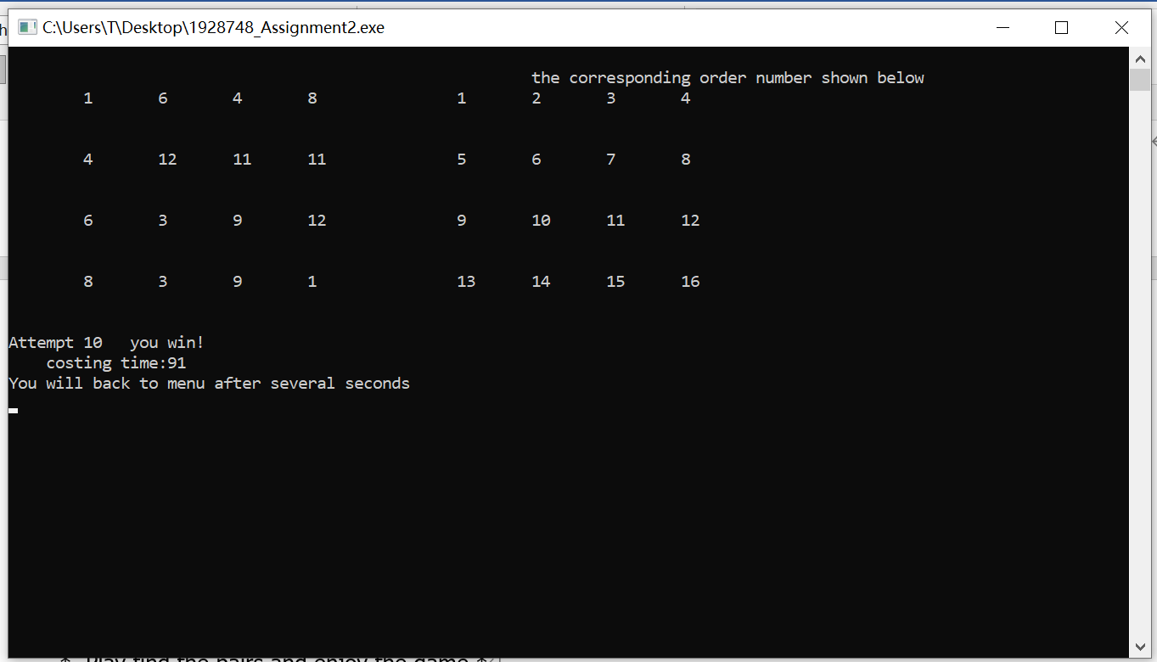**Test 6**

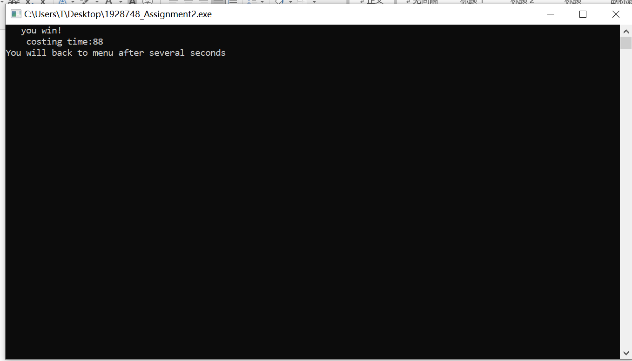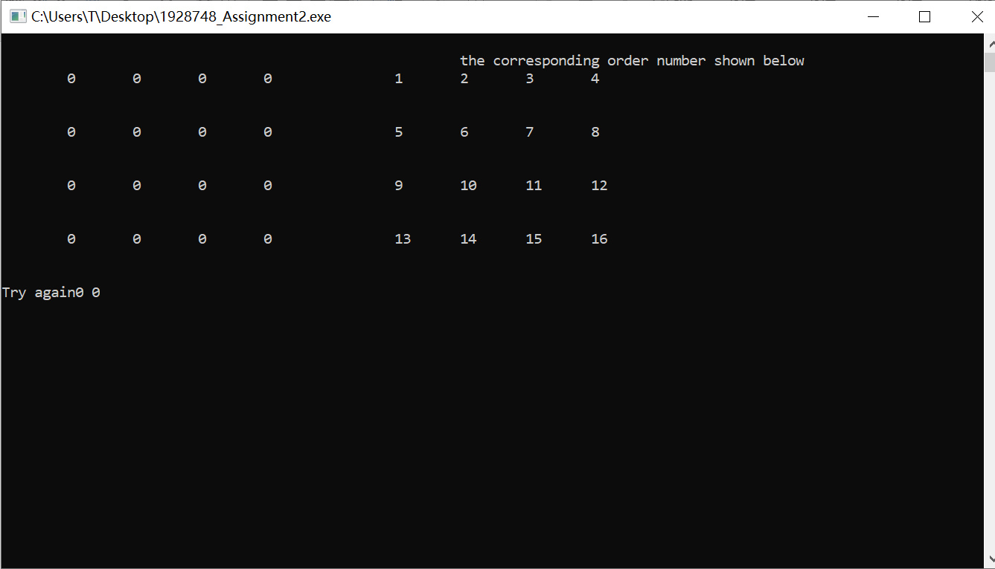**Test 7**

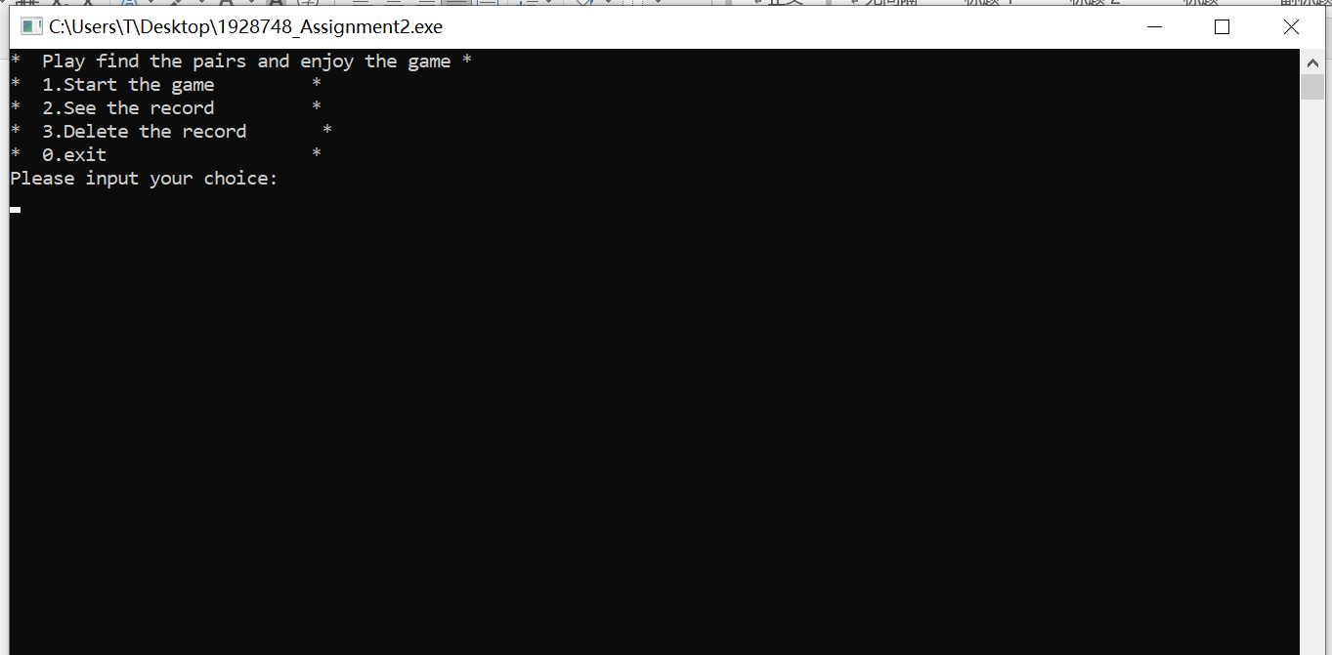

**After the game:**

**Test 1**

* Play find the pairs and enjoy the game *

* 1.Start the game *

* 2.See the record *

* 3. Delete the record*

* 0.exit *

Please input your choice:

2

*****************************************************

* player time *

* 1 108 *

* 2 62 *

*****************************************************

press 0 to leave:

**Test 2**

Follow the test 1

* Play find the pairs and enjoy the game *

* 1.Start the game *

* 2.See the record *

* 3. Delete the record*

* 0.exit *

Please input your choice:3

Your record has been removed, please login again.

*Welcome to play the game *

*1.Users login *

*2. Delete account *

*0. Exit *

Please input your choice

**After login again:**

* Play find the pairs and enjoy the game *

* 1.Start the game *

* 2.See the record *

* 3. Delete the record*

* 0.exit *

Please input your choice:

2

*****************************************************

* player time *

*****************************************************

press 0 to leave:

**Test 3**

*****************************************************

* player time *

*****************************************************

press 0 to leave:jrnjrjfrfr

Please input 0 to leave**&………………@&

Please input 0 to leave%4932432

Please input 0 to leave 329423

Please input 0 to leave