CoachAI
AI Real-Time Coach for HSC Enterprise Computing

Project Progress & Technical Report

Team iSoft AI Innovation
Prepared by: Xing (new member) | 2 September 2026
Version 1.0

Try It Live
Two working demos accompany this report. Open them on any phone.
1) Live AI marking demo (real engine, real answers): https://provincial-sticks-currency-eng.trycloudflare.com
This is the real pipeline: choose a 2025 HSC question, type or load a sample answer, and the Marker + Verifier engine grades it against the official rubric (30-60 s per answer). Note: it is served from the team laptop via a temporary tunnel, so it is online whenever the laptop is running. If the link stops working, ask Xing to restart the tunnel.
2) Concept demo (static, always online): https://12345666ddwa.github.io/coachai-mvp/
The design mock-up of the intended user experience - no backend, instant, phone-friendly. Good for showing the UX flow before touching the live engine.
3) Source code and this report: https://github.com/12345666ddwa/coachai-mvp
Full repository (code, question bank, RAG index script, Golden Set, figures).

1. Executive Summary
This report documents everything the team has produced since Xing joined: the architecture, the working codebase, the verification methodology, and the measured results. The deliverable is a working proof of concept: an AI that marks HSC Enterprise Computing short answers against the official NESA marking guidelines, with confidence levels and teacher-in-the-loop review.
Headline numbers:
Asset | Status | Detail
Question bank | Done | 18 questions from the 2025 HSC Enterprise Computing exam (the subject's first-ever HSC paper), with official marking guidelines transcribed verbatim from the NESA marking guidelines PDF
RAG knowledge base | Done | 4 official NESA Teacher Support Resources (Year 12 modules) indexed into Chroma: 1,046 chunks
Marking engine | Done | LangGraph state machine: Marker Agent + Verifier Agent + RAG retrieval + confidence blending + retry loop
Model abstraction | Done | One config line swaps the LLM provider (DeepSeek active now; Gemini free tier / local Ollama ready)
Frontend | Done | Gradio app (phone-friendly, EN/CN toggle) with a live public demo link (Cloudflare Tunnel); see 'Try It Live' on the next page
Verification | Done | Golden Set: 32 simulated answers (8 questions x 4 quality bands), expected marks from official rubric
Verification result | Measured | 32/32 graded within +/-1 band of the official rubric (100%); exact match 78.1%; zero wild misses

2. What We Built (System Overview)
The system follows our chosen architecture from the team document: NESA materials are the single source of truth; two LangGraph workflows share a RAG knowledge base; every LLM call goes through one abstraction layer; students and teachers interact through a mobile-friendly web UI.
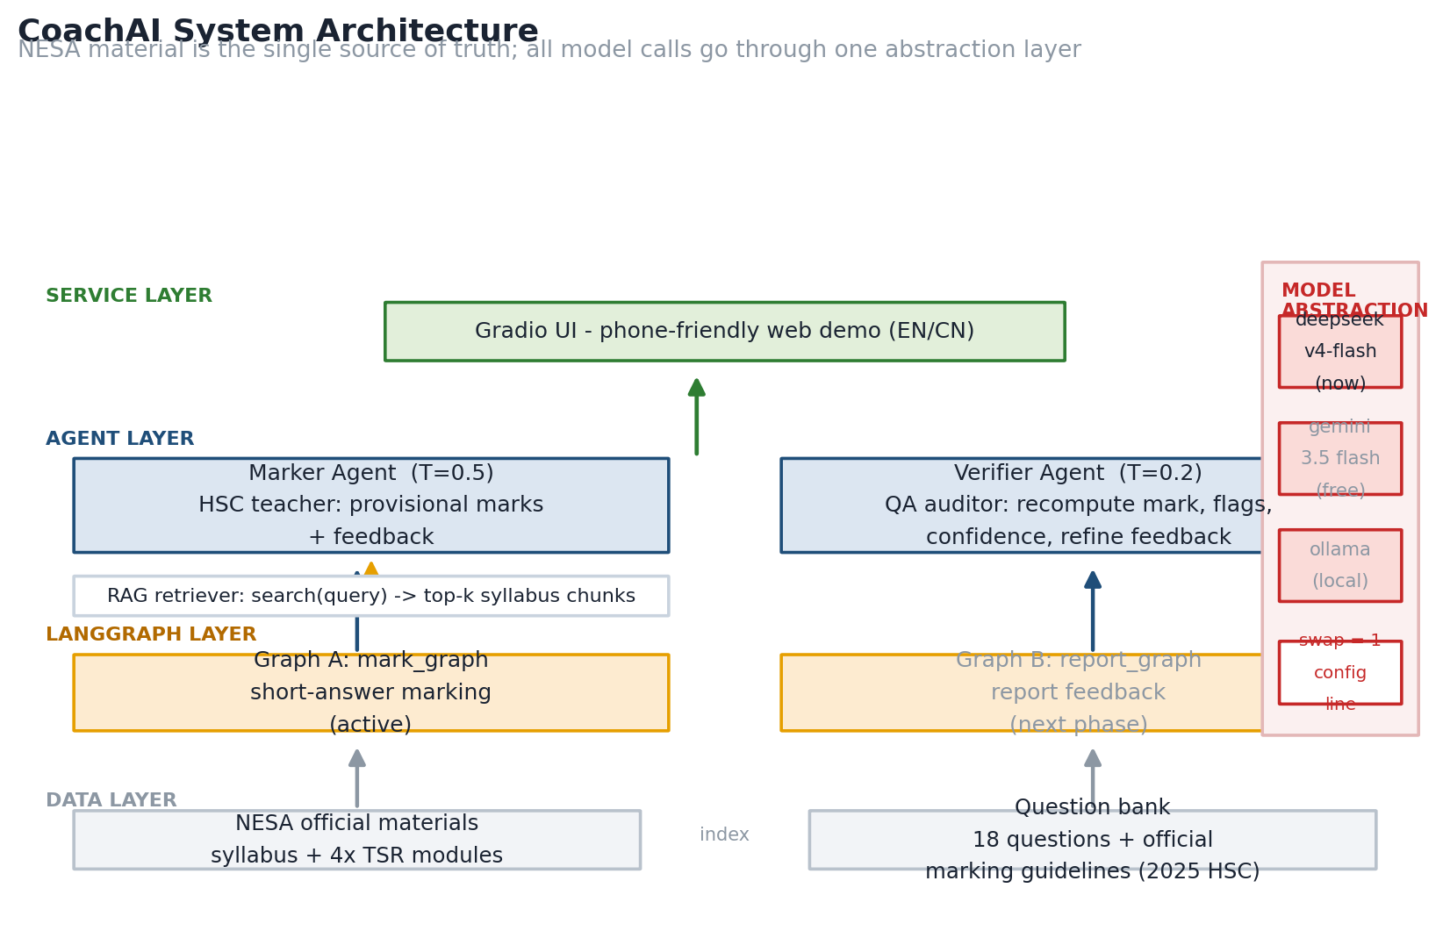
Figure 1 - System architecture overview
3. Codebase Map
ai-coach/
|-- app.py # Gradio UI (question picker, answer input, results)
|-- agents/
| |-- models.py # Model abstraction layer - complete() is the ONLY LLM entry point
| |-- marker.py # Marker Agent: HSC teacher role, T=0.5, provisional marks + feedback
| `-- verifier.py # Verifier Agent: NESA QA auditor role, T=0.2, audit + confidence
|-- graphs/
| `-- mark_graph.py # LangGraph state machine (Workflow 1) + mark_answer() public API
|-- rag/
| |-- indexer.py # TSR docx -> chunks -> Chroma (1,046 chunks, MiniLM-L6-v2)
| `-- retriever.py # search(query, k, topic) used by the graph's retrieve node
|-- data/
| |-- questions.json # 18-question bank with official marking guidelines
| `-- chroma_db/ # persistent vector store
|-- tests/
| |-- golden_set.json # 32 answers with expected marks + justification
| |-- run_golden.py # regression runner: AI mark vs expected mark
| |-- test_mark.py # workflow smoke tests
| `-- test_llm.py # model connectivity test
|-- raw/ # source PDFs + extracted text (2025 HSC MG, full-mark samples)
`-- docs/figures/ # report figures
The public contract used by the UI: mark_answer(question_id, student_answer) returns a dict with status (approved / flagged / error), marks, max_marks, confidence_pct, confidence_level, feedback items and flags. Errors never raise - they are returned as status=error so the UI can show a friendly message.
4. Key Design Decisions
4.1 Model abstraction - switching LLM providers costs nothing
A recurring team concern was: if we start with one API and later move to another (e.g. Gemini free tier or a local open-weight model), do we redo everything? No. Every agent calls agents.models.complete() and nothing else. The provider is resolved from configuration.
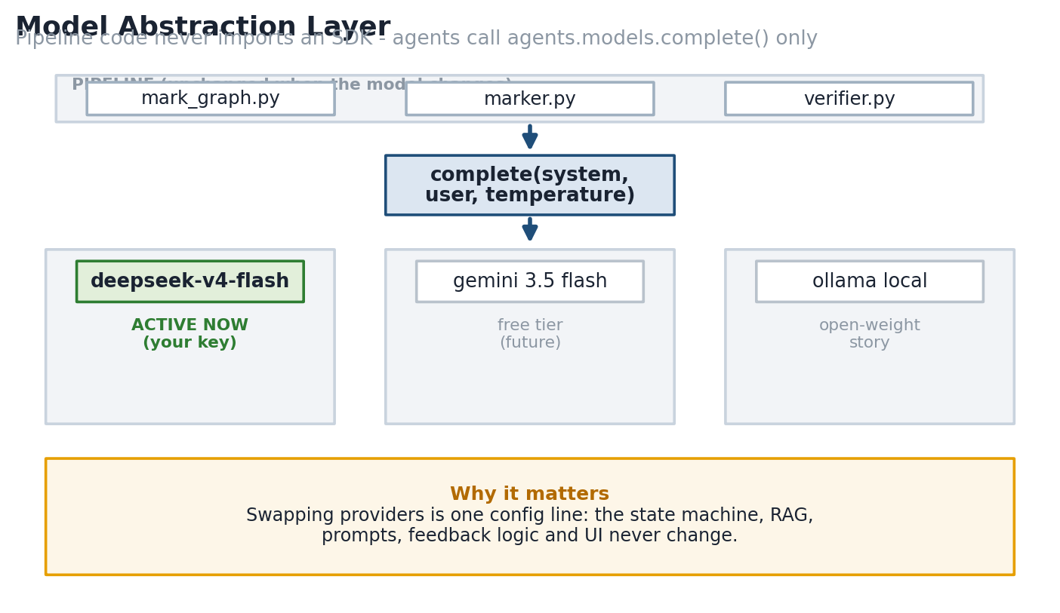
Figure 2 - Model abstraction layer
DeepSeek deepseek-v4-flash is active now (cheap, reliable, we already had a key). Gemini 3.5 Flash free tier and local Ollama are one-line additions when we need them.
4.2 Two-agent marking engine (Workflow 1)
The core pipeline implements the team's original design: a Marker grades generously with contextual interpretation (T=0.5); an independent Verifier audits sceptically (T=0.2) - recomputing the mark, hunting for hallucinated concepts against the retrieved syllabus material, and rejecting verdicts it does not agree with.
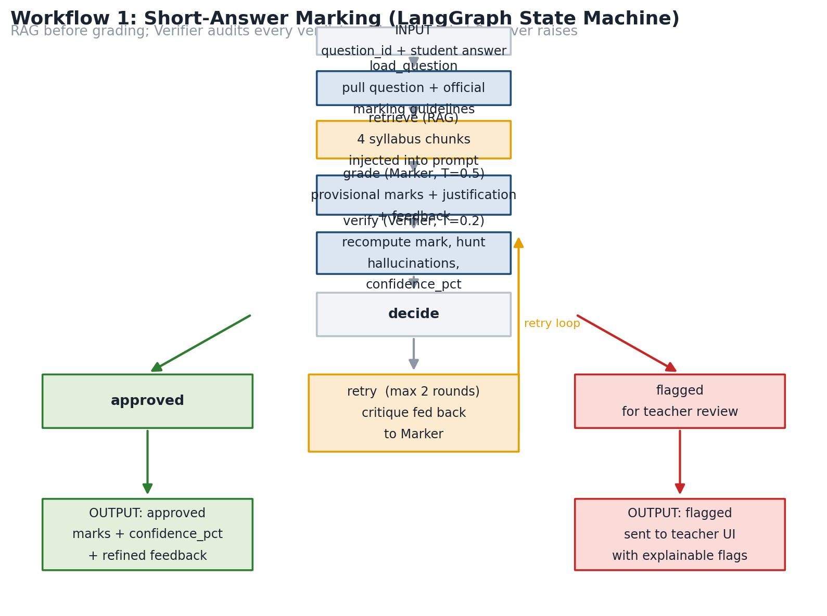
Figure 3 - Workflow 1: LangGraph state machine
4.3 Confidence score - not a model guess
The Verifier self-reports confidence, but we blend it with objective signals so the number is explainable and audit-friendly:
confidence = 0.6 x verifier_self_report
+ 20 if marker and verifier marks agree
+ 10 if they differ by exactly 1 band
+ 10 if the verifier approved
clamped to [25, 95] (never 100%: a human always has the last word)
Mapping: >=80 high (auto-ship), 50-79 medium, <50 low (flagged for teacher review).
4.4 Retrieval-first RAG
RAG retrieval runs BEFORE grading: the retrieved NESA syllabus chunks are injected into the Marker's prompt as grading context, not appended afterwards as an afterthought. Only official NESA material is indexed - this is our answer to the 'internet contradicts the course' problem.
4.5 Retry loop with a hard cap
When the Verifier rejects a verdict, the critique is fed back to the Marker for one re-grade round (max 2 rounds). If it still disagrees, the answer is flagged for a human teacher - no infinite loop, no wasted API budget.
4.6 Model training data and fine-tuning (clarification)
Question from the team: what was the model trained on? Clear answer: we do NOT fine-tune or train the model at all. The LLM is DeepSeek v4-flash, a general-purpose pretrained model - it has never seen our question bank or the HSC materials during training (0 epochs of fine-tuning, by design).
All HSC-specific knowledge enters the system at inference time through two channels:
1) The question bank (data/questions.json): 18 real 2025 HSC questions with their official NESA marking guidelines, transcribed verbatim from the marking guidelines PDF
2) RAG retrieval: the 4 NESA Teacher Support Resources are indexed (1,046 chunks) and the relevant chunks are injected into the Marker's prompt for each answer. (So the system touches 5 official documents in total: the 4 TSRs plus the marking guidelines held in the question bank.)
Why no fine-tuning in the MVP:
Evidence: Published evidence: open-weight LLMs prompted with rubric criteria grade competitively without fine-tuning (ACM 2025, Automatic Short Answer Grading with LLMs). Our own Golden Set result (78.1% exact, 100% within +/-1 band, zero misses on 32 answers) confirms this holds for our pipeline.
Coverage: RAG already gives the model the exact official wording it needs at marking time - equivalent to 'looking up the syllabus' rather than memorising it.
Brief: The team's own planning note said 'potentially we will not even need to do any fine tuning and instead just the prompt' - we built exactly that and it works.
If we later need fine-tuning (e.g. to run offline without retrieval, or to push accuracy higher), the 4 TSRs are the right training corpus - that is when 'fine-tuning on the 4 teacher support resources' becomes true. It is deliberately not done yet.
4.7 Fine-tuning roadmap: where it would sit, how, and what it buys us
If we fine-tune, nothing changes in the runtime graph. Fine-tuning is an offline step that replaces the Marker's base model (and optionally the Verifier's). The model abstraction layer (agents/models.py) was designed for exactly this: after fine-tuning, pointing the Marker at a local fine-tuned model is a configuration change - zero pipeline edits.
The sequence we would follow:
1. Data first: Grow the Golden Set from 32 to roughly 300 labelled (answer, score, feedback) triples - AI-assisted first pass, human review. The existing 32 answers stay reserved as a held-out test set; they are never used for training (that would leak the evaluation).
2. Method: LoRA / QLoRA parameter-efficient fine-tuning on a small open-weight base (Qwen3-4B class). Not full fine-tuning - cheaper and easier to keep under control.
3. Objective: Output the same strict JSON contract (marks, justification, feedback) aligned with NESA rubric language, with the 4 TSRs as background corpus so the model internalises syllabus terms. This is the step where 'fine-tuning on the 4 TSRs' genuinely happens.
4. Evaluation gate: Re-run the same Golden Set regression. Acceptance criteria: accuracy no worse than today (78.1% exact, 100% within +/-1 band) AND latency/cost clearly better. Only then do we swap the provider.
5. Rollout: Marker runs on the fine-tuned local model (Ollama / vLLM); RAG stays (official wording is still injected); the Verifier remains on the stronger cloud model as the independent auditor. Division of labour: a fast local Marker, a sceptical cloud Verifier.
What fine-tuning would buy us: near-zero marginal cost per marking (local inference); latency from 30-70 s down to seconds on a laptop GPU; true offline capability (the complete 'runs on a device' story for the pitch and for schools with no reliable internet); student answers never leaving the device (a real selling point for schools); and no API rate limits or output truncation failures.
The costs and risks: roughly 300 quality labels require human time; small models have a ceiling on long, subtle answers (which is why the Verifier stays on the big model); overfitting is mitigated by the held-out test set and LoRA.
Timing: after the competition core is stable - not before the deadline with 32 samples. If a judge asks whether we fine-tuned: 'The MVP does not need it - published evidence and our own 32-answer regression show rubric-conditioned prompting with RAG is sufficient. We have a concrete roadmap to add fine-tuning for offline deployment, with the 4 TSRs as the training corpus.'
5. How We Verified (Methodology)
To measure quality honestly we built a Golden Set - the same pattern used in academic grading research:
Questions: 8 real 2025 HSC questions were selected (text-answerable ones across all four syllabus modules)
Answers: For each question we wrote 4 simulated student answers: excellent, good, weak, borderline (32 total) - deliberately imperfect, with the occasional spelling slip, like real students
Expected marks: Expected marks were derived strictly from the official NESA marking guidelines; every answer carries a note stating which band criterion justifies its expected mark
Runner: tests/run_golden.py feeds each answer through the real pipeline and compares AI marks against expected marks
Self-audit: During human review one expectation was itself revised (q24 weak: 1 -> 2 marks) because the official band-2 criterion ('Identifies some features...') clearly applied - the correction is logged in golden_set.json with its rationale
6. Verification Results
Metric | Value
Answers graded successfully | 32 / 32 (0 skipped, 0 errors)
Exact match with official rubric | 25 / 32 = 78.1%
Within +/-1 band of official rubric | 32 / 32 = 100%
Wild misses (>=2 bands off) | 0

By answer quality:
Quality band | Exact match | Within +/-1 band | Notes
Excellent (top answers) | 8/8 = 100% | 100% | The engine reliably recognises high-quality answers
Good | 7/8 = 87.5% | 100%
Weak | 6/8 = 75% | 100%
Borderline (trickiest) | 4/8 = 50% | 100% | Disagreement here is expected - this is exactly what the Verifier flags for the teacher

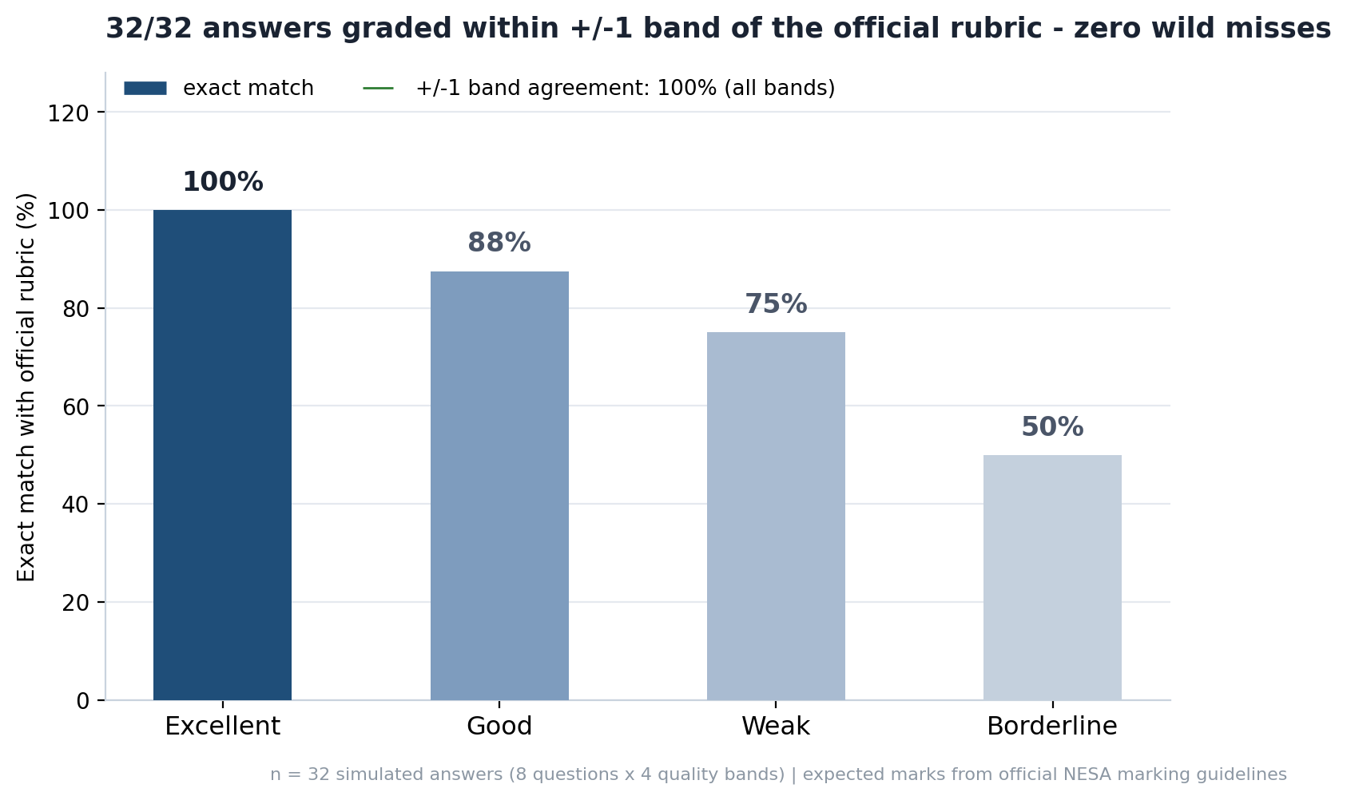
Figure 4 - Golden Set results (n=32)
Interpretation: zero wild misses means no 'great answer failed' or 'bad answer rewarded' cases. The 50% exact rate on borderline answers is not a weakness - real HSC markers disagree on borderline scripts too; our design routes exactly those cases to the teacher through the Verifier flag.
7. Issues Found and How We Fixed Them
Issue | Root cause | Fix
Verifier output truncated on long questions (q24, 5 marks) | Default max_tokens=4096 cut long JSON replies mid-string | max_tokens raised to 8192 for the Verifier + prompt now asks for compact feedback (<40 words per item)
2/32 golden answers skipped with JSON parse errors | Same truncation issue | Fixed above - re-run graded 32/32 with zero skips
One expected mark looked too harsh (q24 weak: expected 1) | Human labelling of the 'weak' answer was stricter than the official band-2 criterion | Re-derived from the rubric: expected 2. Logged in golden_set.json with rationale
Model name 'deepseek-chat' failed | DeepSeek API serves model ids deepseek-v4-flash / deepseek-v4-pro | Default model corrected to deepseek-v4-flash (verified via /models endpoint)
No PDF past papers exist for this subject | Enterprise Computing is examined fully online; 2025 was its first HSC year | Question stems captured from the official online exam system (fam.hsconline.nesa.nsw.edu.au); marking guidelines PDF downloaded from nsw.gov.au
Slow per-answer latency (30-70 s) | Each answer costs 2-4 LLM calls on DeepSeek | In-memory cache keyed on question + answer prefix; demo flow reuses cached results
Team UI feedback: full question was not visible; interface felt less professional (emoji, round cards) | Question text truncated to 78 chars in the picker; playful styling | Full question preview panel added under the picker; emoji removed; corners squared; layout widened (1180 px) with more white space

8. How to Run It
cd ai-coach
pip install -r requirements.txt # openai, python-dotenv, langgraph, chromadb, gradio, sentence-transformers
# .env: DEEPSEEK_API_KEY=sk-... DEEPSEEK_BASE_URL=https://api.deepseek.com/v1
python3 app.py # Gradio UI at http://127.0.0.1:7860
python3 tests/test_llm.py # model connectivity
python3 tests/run_golden.py # full 32-answer regression (~30-45 min)
The demo concept page (ai-coach/demo/index.html) shows the intended UX without any backend.
9. What Is Next
Public demo: Live now via a Cloudflare Tunnel (see 'Try It Live'). Optional upgrade: a permanent host (e.g. HF Spaces PRO or Render) so the demo is online without the laptop
Report feedback: Workflow 2 (report generation from spreadsheets) on the second graph slot in the architecture
Coaching chat: Follow-up chat so a student can ask 'why did I lose the mark?' - the real-time coach experience
Handwritten answers: Photo upload with DeepSeek's vision model (deepseek-v4-flash-vision-exp exists on our key) or a local vision model
Model swap demo: Gemini free tier / local Ollama swap to tell the open-weight story in the pitch
Fine-tuning: Roadmap in section 4.7: grow the Golden Set to ~300 labels, LoRA-fine-tune a small open-weight Marker, keep the cloud Verifier as auditor, and run fully offline
Appendix A - Data Sources
2025 HSC Enterprise Computing marking guidelines: nsw.gov.au (33 pages, downloaded 2026-09-02)
2025 HSC full-mark sample responses: nsw.gov.au (11 pages)
Question stems: official online exam system fam.hsconline.nesa.nsw.edu.au
4x NESA Teacher Support Resources (Year 12: data science, data visualisation, enterprise project, intelligent systems) - shared by the team
All artifacts live in /home/gaogao/workspace/ai-coach/ with raw source files kept under raw/ for traceability

