affidavit

I the undersigned Mr. Abdullah Arshad Fazal, Age: 29, Occupation: Graphic Designer, Religion: 🕉️ HINDUISM, Residing at: Burj Khalifa, Rammurthy nagar, Bangalore-560016, hereby solemnly affirm according to my faith that…
My BROTHER named PRAGATI BEN CHOWATIYA passed away on 24-06-2020 (date) at UDHAN AMAN SOCIETY (place). Due to an oversight on our part, her death was not registered with the Surat Municipal Corporation, the Gram Panchayat office, or any other government/semi-government offices. Therefore, it has now become necessary to register her death and obtain the death certificate. Hence, I am making this affidavit.
The details of the deceased are as follows:

- Name of the deceased: PRAGATI BEN CHOWATIYA
- Date of death: 24-06-2020
- Name of husband/father of the deceased: YO JOGINDER THARA BHAI
- Name of mother of the deceased: PRATYUSHA
- Caste of the deceased: 🕉️ HINDUISM
- Cause of death: BIMAR HATA
- Place of death: UDHAN AMAN SOCIETY
- Permanent address of the deceased: UDHAN AMAN SOCIETY
- Aadhaar card number of the deceased: 123456789012
The above-mentioned details are true to the best of my knowledge and belief. I am aware that giving false information in an affidavit is a criminal offence.

Place UDHAN AMAN SOCIETY
Dated : 06-07-2026
Adhar Card Front
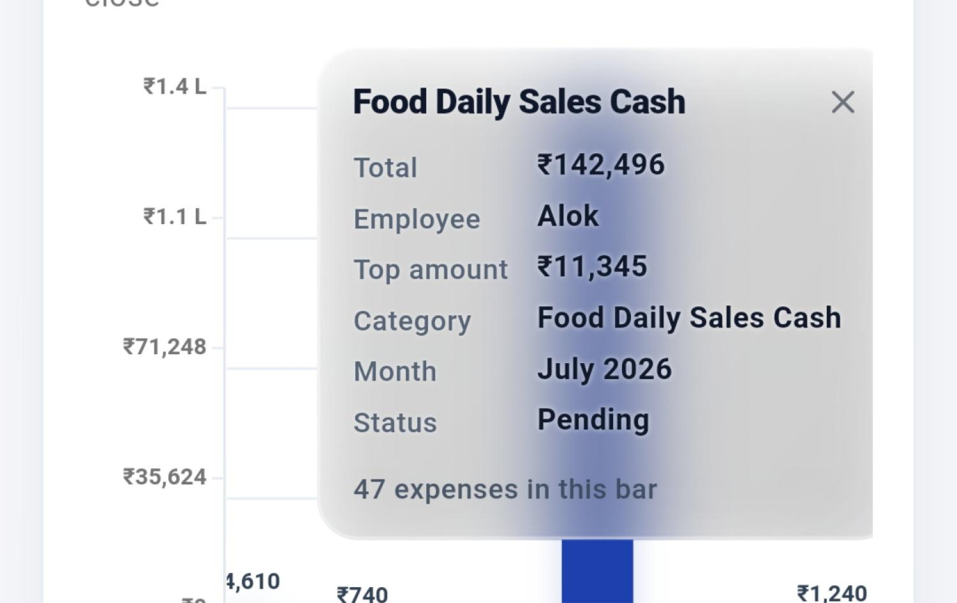
Adhar Card Back
