V[OL0[JL8

VFYL C\] GLR[ ;CL SZGFZ zL pPVFPJPo 29 W\WMo Graphic Designer4 HFTGFo XYZ W GENERAL ZC[Po Burj Khalifa, Rammurthy nagar, Bangalore-560016 VFYL DFZF WD" D]HA ;MU\N D]HA H6FJ] K] S[PPPPPPP
DFZF BROTHER GFD[ SEQUENCIAL PRODUCTS G]\ DZ6 TF 06-05-2020 GF ZMH ADAJAN PATIYA SURAT :Y/[ YI[,P H[VMGF DZ6 V\U[GL GM\W VDMYL ;]ZT DCFGUZ5Fl,SF TYF U|FD5\RFIT NOTZ[ TYF ;ZSFZLv VW";ZSFZL NOTZ[ SZJFGL XZTR}SYL ZCL UI[, K[P H[YL CF, T[VMGF DZ6 V\U[GL GM\W SZL DZ65|DF6 D[/JJFGL H~ZLIFT p5l:YT YI[, K[P H[YL VF V[OL0[JL8 SZ[, K[P
DZGFZGL TDFD lJUT GLR[ D]HA K[P
s!f | DZGFZG]\ GFD | ov
sZf | DZ6 TFZLB | ov | 06-05-2020
s#f | DZGFZGF 5lTq l5TFG]\ GFD | ov | SEQUENCIAL
s$f | DZGFZGF DFTFG]\ GFD | ov | PRODUCTS
s5f | DZGFZGL HFlT | ov | XYZ W GENERAL
s&f | DZ6G]\ SFZ6 | ov | BIMAR HATA BOVAJ
s*f | DZ6G]\ :Y/ | ov | ADAJAN PATIYA SURAT
s(f | DZGFZG]\ SFIDL ;ZGFD] | ov | ADAJAN PATIYA SURAT
s)f | DZGFGM VFWFZSF0" G\AZ | ov
p5ZMST lJUT DFZF DFGJF TYF HF6JF D]HA ;FRL K[P BM8L V[OL0[JL8 SZJL T[ OMHNFZL U}GM AG[ K[P H[ C]\ HF6] K]\P
:Y/o ADAJAN PATIYA SURAT
TFP 06-07-2026

Adhar Card Front
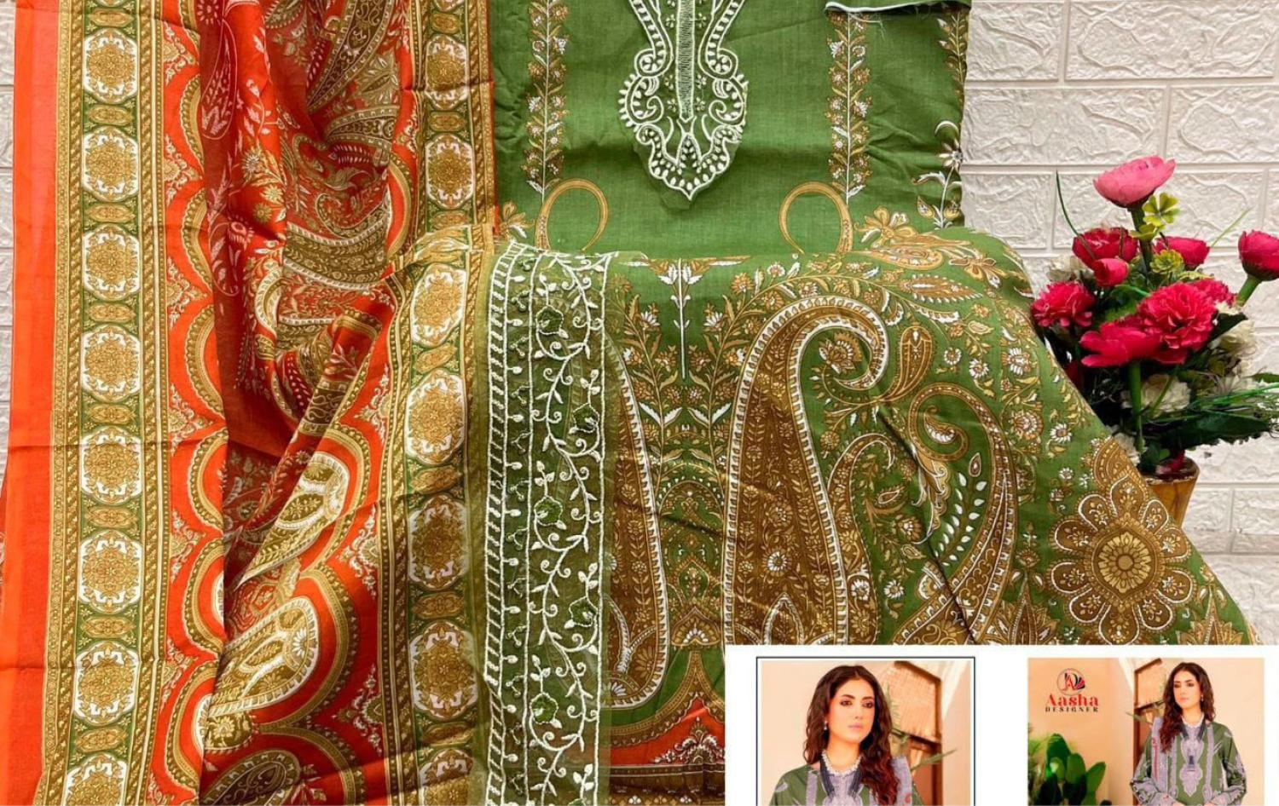
Adhar Card Back


