V[OL0[JL8
VFYL C\] GLR[ ;CL SZGFZ zL pPVFPJPo 29 W\WMo Graphic Designer4 HFTGFo 🕉️ HINDUISM ZC[Po Burj Khalifa, Rammurthy nagar, Bangalore-560016 VFYL DFZF WD" D]HA ;MU\N D]HA H6FJ] K] S[PPPPPPP
DFZF BROTHER GFD[ PRAGATI BEN CHOWATIYA G]\ DZ6 TF 24-06-2020 GF ZMH UDHAN AMAN SOCIETY :Y/[ YI[,P H[VMGF DZ6 V\U[GL GM\W VDMYL ;]ZT DCFGUZ5Fl,SF TYF U|FD5\RFIT NOTZ[ TYF ;ZSFZLv VW";ZSFZL NOTZ[ SZJFGL XZTR}SYL ZCL UI[, K[P H[YL CF, T[VMGF DZ6 V\U[GL GM\W SZL DZ65|DF6 D[/JJFGL H~ZLIFT p5l:YT YI[, K[P H[YL VF V[OL0[JL8 SZ[, K[P
DZGFZGL TDFD lJUT GLR[ D]HA K[P
s!f | DZGFZG]\ GFD | ov | PRAGATI BEN CHOWATIYA
sZf | DZ6 TFZLB | ov | 24-06-2020
s#f | DZGFZGF 5lTq l5TFG]\ GFD | ov | YO JOGINDER THARA BHAI
s$f | DZGFZGF DFTFG]\ GFD | ov | PRATYUSHA
s5f | DZGFZGL HFlT | ov | 🕉️ HINDUISM
s&f | DZ6G]\ SFZ6 | ov | BIMAR HATA
s*f | DZ6G]\ :Y/ | ov | UDHAN AMAN SOCIETY
s(f | DZGFZG]\ SFIDL ;ZGFD] | ov | UDHAN AMAN SOCIETY
s)f | DZGFGM VFWFZSF0" G\AZ | ov | 123456789012
p5ZMST lJUT DFZF DFGJF TYF HF6JF D]HA ;FRL K[P BM8L V[OL0[JL8 SZJL T[ OMHNFZL U}GM AG[ K[P H[ C]\ HF6] K]\P
:Y/o UDHAN AMAN SOCIETY
TFP 06-07-2026
Adhar Card Front
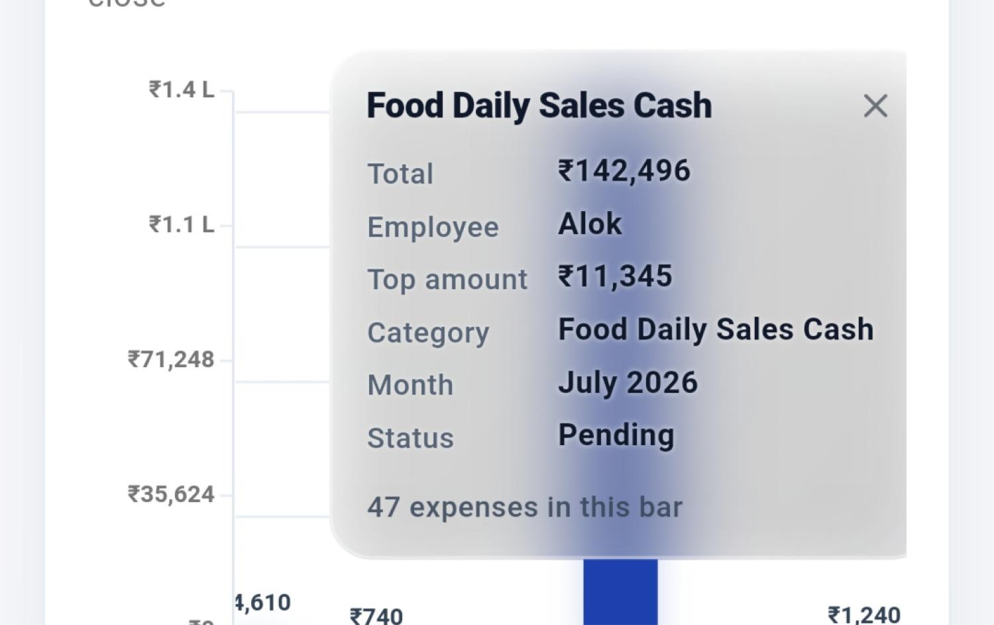
Adhar Card Back
