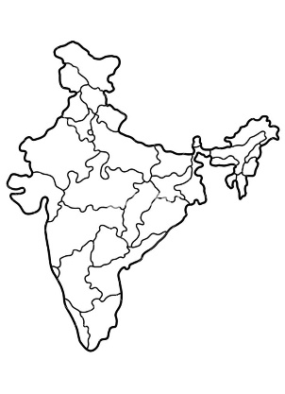 | F/A  Platform : Fast Agreements Application
Digital E - Rent Car Agreement Details
Date |  | : | 16-07-2026
First Party Name (Renter) |  | : | Abdullah Arshad Fazal
First Party Mobile Number |  | : | 8780805047
Second Party Name (Owner) |  | : | ABDULLAH ARSHAD FAZAL
Second Party Mobile Number |  | : | 9825143601
Description |  | : | Digital E- Rent Car Agreement
Location |  | : | AVADH ARENA, Bharthana, Surat, Gujarat, India, 395007
Rent Car price Amount |  | : | 2,500
RTO Car Number plate |  | : | cahsc
Chassis Number |  | : | faa
Engine Number |  | : | a hs
Company Name & Model |  | : | gsvs & cjas
Driving License Number |  | : | vshz

-:: rent agreement for vehicle ::-

Today the said rent Car agreement implemented on 16-07-2026 in English Day.
this rent Agreement for Vehicle is executed in favour of the party of the first part i.e. the renter :-
Name: Abdullah Arshad Fazal
Aged about: 29 yrs, Occupation: Graphic Designer,
Residing at: Burj Khalifa, Rammurthy nagar, Bangalore-560016
(Hereinafter referred to called as a "First Party" i.e. "Renter" in this agreement. Which expression includes the party of the second part himself and his heirs, guardians, successors, assignees, executors from time to time)
And
this rent agreement for vehicle is executed by the party of the second part i.e. the Owner :-
Name: ABDULLAH ARSHAD FAZAL
Aged about: 26, Occupation: Application Designer,
Residing at: Avuvaiagajcajcajcs Gaiga
(Hereinafter referred to called as a "Second Party" owner in this agreement. Which expression includes the party of the second part himself and his heirs, guardians, successors, assignees, executors from time to time) We, the undersigned second party, hereby provide this written sale agreement to you, the first party, stating as follows:

:: Details of the Vehicle rent CAR::
The vehicle belonging to we the second party, is a gsvs two-wheeler, registered at the Surat RTO under registration number cahsc. The chassis number is faa and the engine number is a hs. The model year is 16-07-2026.
This vehicle has been in the ownership, possession, and use of we the second party. We possessed full rights and authority to manage of the vehicle in any manner. In exercise of these rights, we have agreed to rent the above vehicle to you, the first party, for a Rent price of Rs. 2,500/- (Rupees Two Thousand Five Hundred). The said amount has been paid in cash by you, the first party, to we the second party, on 16-07-2026.
The rent agreement was pending, and therefore today we execute this sale deed. In the future, we (second party) will not raise any objection or dispute regarding the adequacy of this consideration amount.

:: Terms & Conditions ::
- The deposit of Rs. 25,000/- (Rupees Twenty Five Thousand) has been fixed for this vehicle (Car).
- The party of the First party has taken this vehicle (Car) from the party of the Second party for use for 2 Years 1 Day day on the date 16-07-2026.
- The rent for the bike must be paid in advance before taking the bike.
- The rented vehicle (Car) is given only for usage purposes. All other expenses such as petrol/diesel/CNG or any other fuel will be borne by the party of the first party.
- The party of the First party must possess a valid driving licence (for Car). driving licence Number is The vehicle (Car) is given only to the party of the First party for usage purposes. Apart from this, the vehicle shall not be used for any other purpose and shall not be given on rent or sub-rent to anyone else.
- This vehicle (Car) is given only to the party of the First party for usage purposes. Apart from this, the vehicle shall not be used for any other purpose and shall not be given on rent or sub-rent to anyone else.
- The tenant shall use the vehicle only for lawful purposes and agrees to comply with all laws and regulations governing the operation and use of the vehicle.
- That wearing a Seat Belt is mandatory while using this vehicle (Car). Otherwise, the bike will not be rented out.
- The party of the First party shall not cause any damage or breakage to the rented bike/car and must return the vehicle in the same good condition as it was received.
- While using the vehicle, no activities that cause nuisance to people nearby shall be carried out.
- This vehicle (Car) shall not be used to carry flammable substances or any prohibited or intoxicating items banned by the government, and the rules of the Government of India must be strictly followed. No violations shall be committed.
- After taking this vehicle (Car) on rent, the full responsibility lies with the party of the First party. If any damage occurs, the party of the First party shall bear the full cost.
- This agreement shall remain active and in full effect until the rented vehicle is returned to the owner.
- If any damage occurs to the rented vehicle/car, the party of the First party must bear the full cost.
- During the use of this Car, if any police complaint, RTO memo, or accident occurs due to the party of the First party, the party of the First party shall be fully responsible for its resolution.
- The party of the First party shall not consume intoxicating substances while operating the vehicle. If intoxicants are consumed and the police detain the party of the First party, full responsibility shall lie with the party of the First party.
- If any person dies or suffers grievous injury while the vehicle is being driven, and during FIR investigation the party of the First party is found at fault, in such circumstances the bike may be seized, and the entire legal responsibility shall lie with the party of the First party.
- If any of the above conditions are violated, the party of the Second party shall have the right to take back possession of the vehicle immediately, without notice or objection.

The party of the first party i.e. renter

Document Font Side Photo

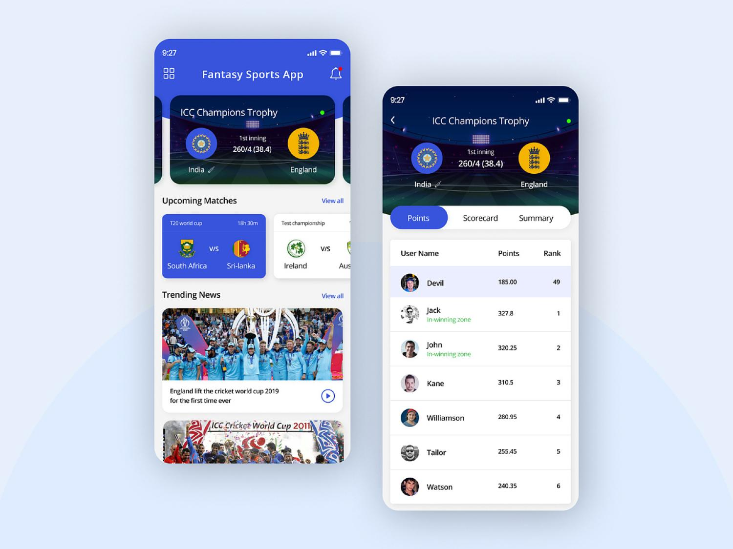

Document Back Side Photo



party of the second party i.e. owner

Document Font Side Photo

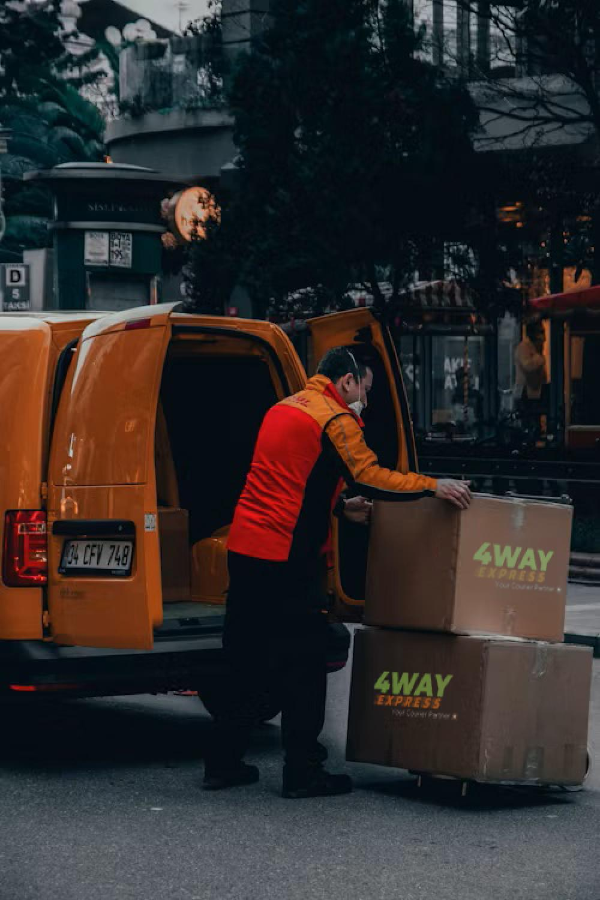

Document Back Side Photo


We, the First party, declare that this vehicle Rent car agreement has been read, explained, understood, considered, and executed by us willingly, without any pressure, force, or influence, and in a fully sound and conscious state of mind. This agreement is binding upon us and our heirs, guardians, and successors.
The party of the first party i.e. renter

name and Signature photo left hand
thumb impression



SIGNATURE: 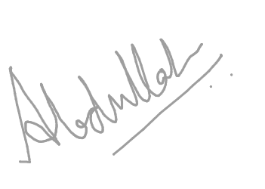

NAME: Abdullah Arshad Fazal

party of the second party i.e. owner



SIGNATURE: 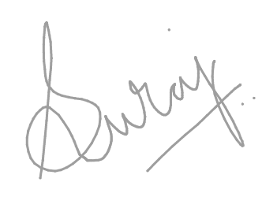

NAME: ABDULLAH ARSHAD FAZAL

WITNESSES:-

1. Name: Fichvhvhvhv | Mobile Number: 8686860696
2. Name: | Mobile Number:

VEHICLE PHOTOS

FRONT   | BACK  
LEFT   | RIGHT  

