 | F/A  Platform: Fast Agreements Application
Digital E - Rent Car Agreement Details
Date |  | : | 04-07-2026
First Party Name sEF0[ ZFBGFZf |  | : | Abdullah Arshad Fazal
First Party Mobile Number |  | : | 8780805047
Second Party NamesEF0[ VF5GFZf |  | : | ABDULLAH ARSHAD FAZAL
Second Party Mobile Number |  | : | 9825143601
Description |  | : | Digital E- Rent Car Agreement
Location |  | : | 43, Vesu, Surat, Gujarat, India, 395007
Rent Car price Amount |  | : | 2,500
RTO Car Number plate |  | : | AG77HF7165
Chassis Number |  | : | AGF715AGFA626
Engine Number |  | : | AGD6252G
Company Name & Model |  | : | HIRAL INFO 2026
Driving License Number |  | : | AGGA5HS7262

voo JFCGGM EF0F SZFZ oov
VF JFCGGM EF0F SZFZ VFH ZMH TFZLB 04-07-2026 GF V\U|[HL lNG[ YL VD, U6JFGM ZC[X[P
VF JFCGGM EF0F SZFZ ,BFJL ,[GFZ IFG[ T[ 5C[,F 51FGF sEF0[ ZFBGFZf o v
GFDo Abdullah Arshad Fazal
pPVFPJP 29 JØ"4 W\WMo Graphic Designer4
ZC[P o Burj Khalifa, Rammurthy nagar, Bangalore-560016
H[VMG[ CJ[ 5KL VF SZFZDF\ 5C[,F 51FGF VUZ EF0[ ZFBGFZ TZLS[ ;\AMWJFDF\ VFJ[, K[P H[VMGF ;\5}6" VY"DF\ 5C[,F 51FGF 5MT[ TYF T[VMGF J\XvJF,L4 JFZ;M4 V[;F.GM4 V[ShLSI]8;" .tIFNLGM ;DFJ[X Y. HFI K[P
VF JFCGGM EF0F SZFZ ,BL VF5GFZ IFG[ T[ ALHF 51FGF sEF0[ VF5GFZf ov
GFDo ABDULLAH ARSHAD FAZAL
pPVFPJP 26 JØ"4 W\WMo Application Designer4
ZC[P o Avuvaiagajcajcajcs Gaiga
H[VMG[ CJ[ 5KL VF SZFZDF\ ALHF 51FGF EF0[ VF5GFZ TZLS[ ;\AMWJFDF\ VFJ[, K[P H[VMGF ;\5}6" VY"DF\ ALHF 51FGF 5MT[ TYF T[VMGF J\XvJF,L4 JFZ;M4 V[;F.GM4 V[ShLSI]8;" .tIFNLGM ;DFJ[X Y. HFI K[P
HT VF JFCGGM J[RF6 SZFZ YL VF56[ A\G[ 51FSFZM V[SALHFG[ ,BL VF5L H6FJLV[ KLV[ S[PPPP4
HT VFHZMH CDM A\G[ 51FSFZM VF JFCGGM EF0F SZFZGF ,[B YSL A\WF.V[ KLV[ S[ PPPPPPP

voo EF0F YL VF5[, JFCGGL lJUT oov
CDM ,BL VF5GFZ ALHF 51FGFGL DF,LSLGL HIRAL INFO SFZ jCL,Z K[4 H[ VFZ8LVMGL SR[ZLDF\ AG77HF7165 YL GM\WFI[, K[P H[GM R[RL; G\P AGF715AGFA626 TYF V[lgHG G\P AGD6252G K[P H[ ;G[ 2026 G\] DM0, K[P H[ ;NZC\] UF0L CDM ALHF 51FGFGL DFl,SL VG[ SAHF4 EMUJ8F C[9/ RF,L VFJ[, K[P VG[ CDM ALHF 51FGFG[ ;NZC\] JFCGGM NZ[S 5|SFZ[ lGSF, VG[ jIJ:YF SZJFGM CSS VG[ VlWSFZ CMI4 T[ CSS VG[ VlWSFZGL ~V[ T[ JFCG CDM ALHF 51FGFV[ TDM 5C[,F 51FGFG[ EF0[YL VF5JFG\] GSSL SZTF T[GL EF0F lS\DT ~FP 2,500qv V\S[ ~l5IF Two Thousand Five Hundred 5]ZF GSSL SZ[, K[P H[ GF6F\ CDM 5C[,F 51FGFV[ TDM ALHF 51FGFG[ TFP GF ZMH ZMS0F R]SJL VF5[, K[P H[GM EF0F SZFZ SZJFGM AFSL CTM T[ VFHZMH VF56[ SZ[, K[P H[ AFAT[ ElJQIDF\ VJ[H VMKM D?IFGL CDM ALHF 51FGFV[ SM.56 HFTGM JF\WFvlJZMW S[ TZvTSZFZ SZJFGL GYLP
voo XZTM oov

!P | ;NZC\] JFCG sSFZf GL 0L5MhL8 5[8[ V\S[ ~l5IF Twenty Five Thousand GSSL SZ[, K[P
ZP | ;NZC]\ JFCG sSFZf CDM 5C[,F 51FGFV[ TDM ALHF 51FGF 5F;[YL TFP 04-07-2026 GF ZMH 1 Day lNJ;GL D]N'T[ J5ZFX DF8[ ZFB[, K[P
#P | ;NZC\] EF0[ VF5[, AF.SG]\ EF0] 5C[,F VF%IF AFN SFZ ,. HJFGL ZC[X[P
$P | ;NZC]\ EF0[ VF5[, JFCG sSFZf J5ZFXGF C[T]YL VF5JFDF\ VFJ[, K[P H[DF\ VgI BR" 5[8=M,q0Lh,q ;LV[GHL lJU[Z[ .\W6GM BR" 5C[,F 51FGFV[ SZJFGM ZC[X[P
5P | 5C[,F 51FGF 5F;[ 0=F.JL\U ,F.;g; sSFZf CMJ] H~ZL K[P H[GM G\AZ AGGA5HS7262
&P | ;NZC\] JFCG sSFZf OST VDM 5C[,F 51FGFG[ J5ZFX C[T]YL ZFB[, K[P T[ l;JFI ALHM SM. p5IMU SZJFGM GYL T[DH SM.G[ EF0[4 5[8F EF0[YL VF5JFGL GYLP
*P | JFCGGM p5IMU EF0]VFT DF+ SFIN[;ZGF C[T]VM DF8[ H JFCGGM p5IMU SZJF VD[ JFCGGF p5IMU ;\RFFl,T SZTF TDFD SFINF VG[ lGIDMG]\ 5F,G SZJF ;\DT YFI K[P
(P | ;NZC\] JFCG sSFZf GM p5IMU SZM tIFZ[ XL<8A[<8 OZHLIFT 5C[ZJ][ GlCTZ SFZ EF0[ VF5JFDF\ VFJX[ GCLP
)P | ;NZC]\ EF0[YL VF5[, SFZDF\ VDM 5C[,F 51FGFV[ SM. EF\UTM0 S[ G]SXFG SZJFG]\ GYL VG[ lD,ST H[JL ;FZL l:YlTDF\ JF5ZJFDF\ VFJ[,K[ T[JL H ;FZL l:YlTDF\ 5ZT SZJFGL ZC[X[P
!_P | JFCG R,FJTL JBT[ VFH]AFH]JF/FVMG[ gI];g; YFI T[JF SM. S'tI SZJFv SZFJJFGF GYLP
!!P | ;NZC\] JFCG sSFZf TZT ;/UL p9[ T[JF 5NFYM" T[DH ;ZSFZ[ DGF. OZDFJ[, 5NFYM" IFG[ GXL,F 5NFYM" ,. HJF GCL TYF EFZT ;ZSFZGF lGIDMG]\ ;\5}6"56[ 5F,G SZJFG]\ ZC[X[ T[G]\ p<,\3G SZJ] GCLP
!ZP | ;NZC\] JFCG sSFZf EF0[YL ,. UIF AFN ;\5}6" HJFANFZL CDM 5C[,F 51FGFGL ZC[X[P T[DF\ SM.56 G]SXFG YFI TM T[GL EZ5F. SZJFGL HJFANFZL 5C[,F 51FGFGL ZC[X[P
!#P | EF0FGL VJlW HIF\ ;]WL JFCG DFl,SG[ 5FK] VF5JFDF\ G VFJ[ tIF\ ;]WL VF SZFZ X~ ZC[X[ VG[ ;\5}6" A/ VG 5|EFJDF\ ZC[X[ T[ ;\DT K[P
!$P | ;NZC]\ EF0[YL VF5[, JFCGq SFZDF\ SM. G]SXFG YFI TM T[GM ;\5}6" BR" CDM 5C[,F 51FGFV[ VF5JFGM ZC[[X[P
!5P | 5C[,F 51F ;NZ SFZGF J5ZFX NZdIFG TDM 5C[,F 51FGF wJFZF 5M,L; OZLIFN S[ VFZP8LPVMP D[DM VFJ[ S[ VS:DFT YFI TM lGSF, SZJFGL ;\5}6" HJFANFZL 5C[,F 51FSFZGL ZC[X[P
!&P | ;NZC]\ JFCG R,FJTL JBT[ GXL,F 5NFYM"G]\ ;[JG SZJ] GCL VG[ HM GXL,F 5NFYM"G]\ ;[JG SI]" CX[ VG[ 5M,L; wJFZF V8SFIT SZJFDF\ VFJ[ TM T[GL ;\5}6" HJFANFZL 5C[,F 51FSFZGL ZC[X[P
!*P | ;NZC]\ JFCG R,FJTL JBT[ HM SM. jIlSTG]\ D'tI] VYJF U\ELZ .HF YFI VG[ V[OPVFZPVF.P RSF;6L NZdIFG HM jIlST ALHF 51FSFZ NMlQFT ;FlAT YFIP VF ;DI[ AF.S HDF SZJFDF\ VFJ[ T[DH ;\5}6" lGSF, SZJFGL HJFANFZL 5C[,F 51FGFGL ZC[X[P
!(P | ;NZC\] JFCGGL CDM 5C[,F 51FGFV[ TDM ALHF 51FGFG[ VF EF0F SZFZYL VF5L NLW[, K[P CJ[ 5KL ElJQIDF\ SM. 5|SZ6 pE] YFI S[ ElJQIDF\ D[.g8[Gg; BR" pEM YFI S[ VgI SM. BR" pEF YFI TM T[GL TDFD HJFANFZL TDM 5C[,F 51FGFGL ZC[X[P
!)P | p5ZGL SM.56 XZTMGM E\U YFI TM TDM 5C[,F 51FGF lJGF GM8L;[ VG[ lJGF TSZFZ ;NZC]\ J5ZFX DF8[ VF5[, JFCGGM SAHM 5ZT ,[JF CSNFZ KM ;CLPPPPP
V[6L lJUTGM VF JFCGGM EF0F SZFZ VDM 5C[,F 51FGFVMV[ SM.GF SM.56 HFTGF NFAvNAF6 JUZ JF\RLvJ\RFJL4 ;DHLv;F\E/L4 lJRFZL4 TGvDGGL ;FJW VJ:YFDF\ lAGS[OL CF,T[ X]wW A]lwW5]J"S ALHF 51FG[ SZL VF5[, K[P H[ VDMG[ TYF VDFZF J\XvJF,LvJFZ;M .tIFNL TDFDG[ SA],4 D\H]Z VG[ A\WGSTF" K[P VG[ ZC[X[ ;CLP
V+[PPPPPPPPPPPPPPPPPPPPPPPPPPPPPPPPPD¿] T+[PPPPPPPPPPPPPPPPPPPPPPPPPPPPPPPPPPXFB

VF JFCGGM EF0F SZFZ ,BFJL ,[GFZ IFG[ sEF0[ ZFBGFZf T[ 5C[,F 51FGF
5]ZFJFGL VFU/GL AFH]JFZM OM8M
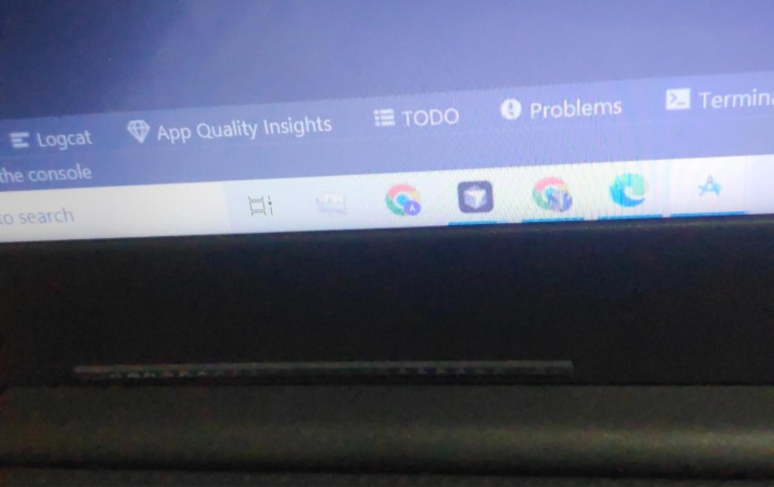

5]ZFJFGL 5FK/GL AFH]JFZM OM8M


VF JFCGGM EF0F SZFZ ,BL VF5GFZ IFG[ sEF0[ VF5GFZf T[ ALHF 51FGF ov
5]ZFJFGL VFU/GL AFH]JFZM OM8M
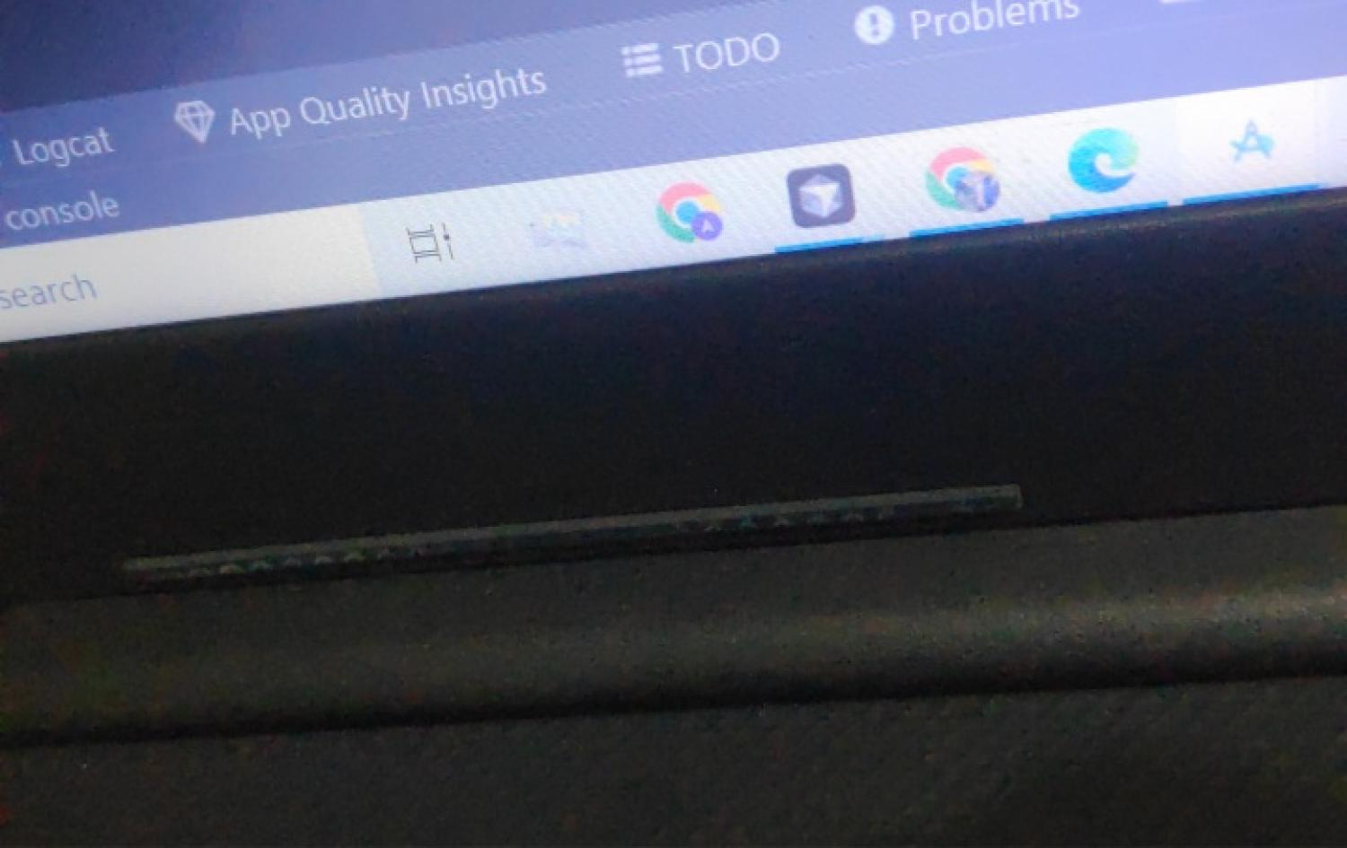

5]ZFJFGL 5FK/GL AFH]JFZM OM8M


s!f VF JFCGGM EF0F SZFZ ,BFJL ,[GFZ IFG[ sEF0[ ZFBGFZf T[ 5C[,F 51FGF

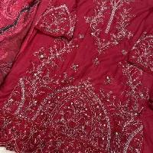

;CLP 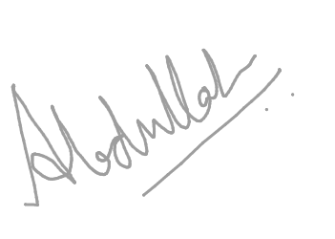
GFD o Abdullah Arshad Fazal

sZf VF JFCGGM EF0F SZFZ ,BL VF5GFZ IFG[ sEF0[ VF5GFZf T[ ALHF 51FGF
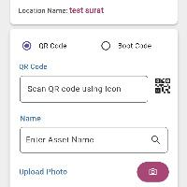

;CLP 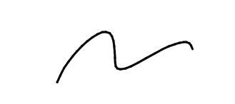
GFD o ABDULLAH ARSHAD FAZAL

;F1FL oov
s!f GFD o Ahmed | DMAF., G\AZ o 6484616868
sZf GFD o | DMAF., G\AZ o

VEHICLE PHOTOS
FRONT  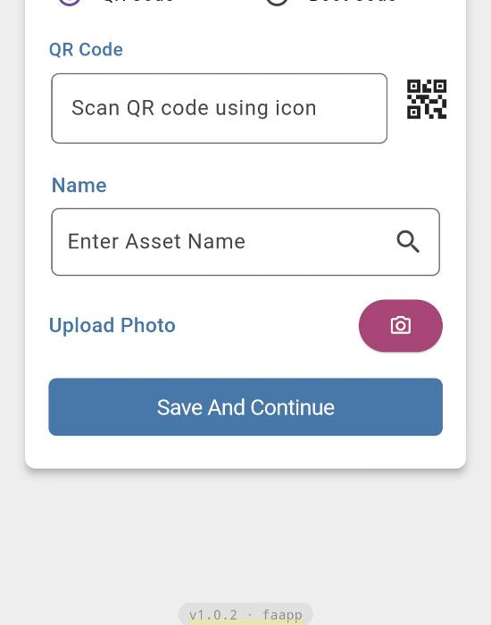 | BACK  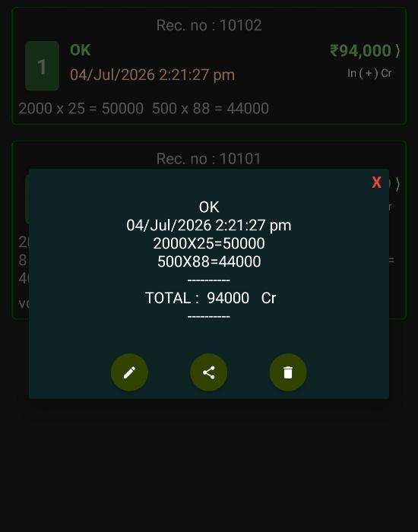
LEFT  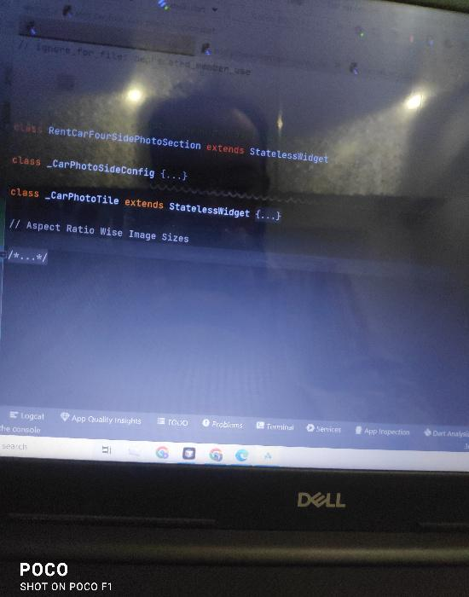 | RIGHT  

