 | F/A  Platform : Fast Agreements Application
Digital e – Leave and Relationship Agreements Details
Date |  | : | 20-March-2026 07.00 PM
First Party Name |  | : | Dipakkumar B Surati
First Party Mobile Number |  | : | 9913771173
Second Party Name |  | : | Arjunbhai Shah
Second Party Mobile Number |  | : | 12345678910
Description |  | : | Digital E- Leave and Relationship Agreement
Location |  | :

-:: Leave and relationship AGREEMENT::-

Today the said Leave and Relationship agreement implemented on ______ in English Day.

this leave and relationship Agreement is executed in favour of the party of the first PART :-
Name: _________________________
Aged about: ___, Occupation: ____,
Residing at: ___________________

(Hereinafter referred to called as a "First Part" in this agreement. Which expression includes the party of the second part himself and his heirs, guardians, successors, assignees, executors from time to time)

And
this leave and relationship Agreement is executed by the party of the second part :-
Name: _________________________
Aged about: ___, Occupation: ____,
Residing at: ___________________

(Hereinafter referred to called as a "Second Part" in this agreement. Which expression includes the party of the second part himself and his heirs, guardians, successors, assignees, executors from time to time)
WHEREAS, we the both parties hereby executed by this Leave and Relationship Agreement to binding each other that

We, the parties mentioned above, hereby state through this Mutual Understanding Agreement / Live-in Relationship Agreement that:

(1) That we both parties are adult Indian citizens and are free to live their lives according to their own will. We both parties are capable of understanding what is good or bad for themselves and are independent and competent to take all decisions related to their lives.

(2) Under this agreement, in accordance with the Supreme Court’s notification granting permission for live-in relationships issued by Hon’ble Justice Ashokbhan in Case No. 208/2004, Citation 2006 (A.S.) page 519, and the Constitution of India 1950 Article 32, and the crossing of trial under Sections 366 and 368, along with permission for inter-caste marriage under matrimonial law this agreement is made. The several final judgments of the Hon’ble Court include these acts, such as I.C.C.E-667, 2006 (90) R.J. 18, 2006 (4) Istrak-63, 2006 (5) ADJ 417, 2006 AIR (SC) 2522, 2006 AIR.
According to the directions and guidelines of these judgments, both parties, by their own free will, complete the legal procedures and agree to live together. The party No. 2 shall not claim any future maintenance or financial support from Party No. 1, and gives assurance to that effect. Once this friendship agreement comes into effect, both parties become legally permitted to live together permanently.
(3) We, the parties, have been in a loving relationship and acquainted with each other for the past two years, and as of today, we cannot live without one another. Gradually, a trustworthy relationship and friendship have developed between us. The First Party has, from time to time, supported the Second Party as a friend in times of happiness and sorrow, and a strong friendship and harmony have existed between us. The Second Party has great trust and confidence in the First Party. Therefore, the Second Party requested to live together under one roof as friends, and the First Party agreed to this request.
Accordingly, this Live-in Relationship Agreement has been made between both parties.

(4) Both the First Party and the Second Party have exchanged all kinds of family and social information with each other. Both parties have mutually obtained complete information and understanding regarding all such matters. That neither the First Party nor the Second Party has any objection or dispute regarding these matters now, nor will they have any in the future.

(5) We, the parties, have mutually decided, of our own free will, to live together under one roof as friends. Therefore, the responsibility of providing maintenance and essential necessities of life for the Second Party shall be borne by the First Party.

(6) Under this friendship agreement, both parties shall live together and maintain a friendly relationship. Both parties shall behave well with each other and fulfill each other’s needs properly.
However, the Second Party shall not receive any rights or recognition as the wife of the First Party, and therefore, the Second Party shall not claim any rights or make any demands as a wife against the First Party. Similarly, the First Party shall not receive any rights or recognition as the husband of the Second Party. But if any child is born out of the companionship of the parties, then the entire responsibility for the child’s maintenance shall lie with the First Party, and such a child shall be considered the lawful heir of the First Party, which the First Party accepts. However, the Second Party shall not have any hereditary right, interest, or share in any self-acquired or ancestral property of the First Party. Likewise, the First Party shall not have any hereditary right, interest, or share in any self-acquired or ancestral property of the Second Party.

(7) There is currently a harmonious and friendly relationship between both parties. Both parties shall continue to live together peacefully, overlook each other’s minor mistakes, and support each other with warmth, affection, and sufficient cooperation in both good and bad times. Both parties shall live together and fulfill each other’s mental, physical, and financial needs, as well as perform their respective duties and responsibilities. The parties aim to live an exemplary live-in relationship and shall not make any accusations against each other.

(8) Both parties, of their own free will and in full consciousness, choose to live together as friends. This friendship agreement has been personally prepared, presented, and executed by both parties. In the future, neither party shall raise any allegations, nor file any cases or legal proceedings against the other regarding this matter.

(9) This agreement has been made voluntarily by both parties in order to maintain a friendly relationship, and based on the Hon’ble Supreme Court’s notifications, live-in relationships are granted legal recognition for parties living together. In the judgment dated 08/05/2010 delivered by the Bench of Hon’ble Justice K.G. Balakrishnan, Justice Deepak Verma, and Justice D.S. Chauhan, eight points were addressed along with matters relating to the Right to Life. Later, on 01/02/2013, amendments were introduced under Section 2(f) of the Domestic Violence Act, making such relationships legally recognized. The several final judgments of the Hon’ble Court include these provisions. According to Article 21, this writing has been made by both parties out of their own free will and desire, intending to maintain the relationship with sincerity. Under this agreement, both parties may stay together as long as they wish. Both parties are adults, and as per Gujarat High Court’s 1998 G.L.R., page 352, it has been held that any woman who is 18 years of age is free to live her life according to her own will, and no pressure or control can be exercised over her.
Therefore, as the Second Party is an adult and wishes to live with the First Party of her own free will, there is no legal restriction regarding this arrangement.

(10) This agreement has been personally prepared, read, heard, and understood by both parties in Gujarati and their mother tongue, and has been signed voluntarily. Therefore, in the future, neither party shall claim that this writing was executed under pressure, misunderstanding, or without knowledge, and if such an allegation is made, it shall be considered void.

(11) Both parties perform their respective employment and household duties independently, and neither party has any objection, restriction, or interference regarding the other’s work, nor shall such objections be raised in the future.

(12) Any assets or items acquired from the joint earnings of both parties shall be treated as jointly owned, similar to that of a husband and wife. Accordingly, both parties shall have shared rights to use and enjoy such jointly acquired property.

(13) From now on, based on this deed, both parties shall conduct themselves similar to husband and wife. The First Party shall fulfill all noble and moral duties expected of a husband, and likewise, the Second Party shall fulfill all moral duties expected of a wife. If either party fails to do so, this agreement shall stand cancelled.

(14) If any dispute, disagreement, or misunderstanding arises between the parties, both shall resolve it mutually through understanding. Neither party shall ever entertain false suspicions or file false cases against the other, and if such actions are taken, the agreement shall stand cancelled.

(15) Both parties shall behave in such a manner that does not hurt the feelings of the other party and shall refrain from any actions that may cause distress, nuisance, or inconvenience. Both parties shall also give up any negative habits and shall, in the future, live together harmoniously, giving each other affection, warmth, and love.
This Mutual Understanding Agreement / Live-in Relationship Agreement has been read, explained, understood, and considered by both parties with full awareness, voluntarily and without any greed, pressure, inducement, or influence. It has been written and executed by both parties in a completely conscious state of mind. This agreement shall be binding upon both parties, as well as their families, guardians, heirs, and all related persons.

this leave and relationship agreement is executed in favour of the party of the first PART :-

Document Font Side Photo
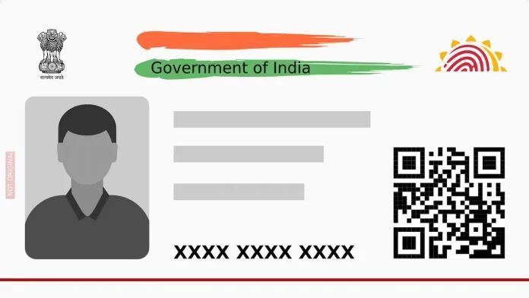
Document Back Side Photo
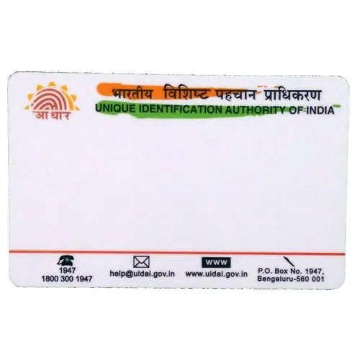

this leave and relationship agreement is executed in favour of the party of the second PART :-

Document Font Side Photo

Document Back Side Photo



this leave and relationship agreement is executed in favour of the party of the first PART :-

name and Signature photo left hand
thumb impression

SIGNATURE ----------------------------------

NAME ----------------------------------------

this leave and relationship agreement is executed in favour of the party of the second PART :-

SIGNATURE ----------------------------------

NAME ----------------------------------------

WITNESSES:-

1. Name: _________________ Mobile Number: ……………………………

2. Name: _________________ Mobile Number: ……………………………

