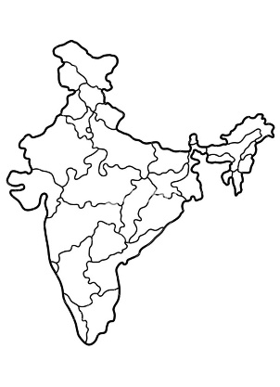 | F/A  Platform : Fast Agreements Application
Digital e – Torrent Power Agreements Details
Date |  | : | 25-07-2026
Party Name (New Owner) |  | : | Abdullah Arshad Fazal
Party Mobile Number |  | : | 8780805047
Description |  | : | Digital E- Torrent power Agreement
Location |  | : | 43, Vesu, Surat, Gujarat, India, 395007
Torrent Power Service no |  | : | 1234546789

To,
Torrent Power Limited
Torrent House, Station Road,
Surat – 395003
Subject: Consent Letter for Joint Ownership
Reference:-
- Change of name in Service No. 1234546789.
- Allotted of a new electricity connection.

- We hereby state that the property bearing House No./Plot No./Bungalow No. 63, Survey No. , is jointly owned by us. We have no objection if the electricity bill is issued in the name of Suraj Chavhna. We give our full and unconditional consent for the same and undertake that we shall not raise any objection in this regard in the future. We also have no objection if a new electricity connection for our jointly owned property is granted in the name of Suraj Chavhna.
- If any dispute arises in the future regarding this matter and any claim, litigation, or legal proceedings are initiated against the Company as a result, we, the joint owners, shall be solely and fully responsible for the same.
- We hereby declare that we have signed this letter as joint owners voluntarily, that the signatures herein are our true and genuine signatures, and that they have been made without any pressure, coercion, or undue influence from any person. We hereby affirm and certify the above statements to be true.

Name of Joint Owner Signature
Abdullah Arshad Fazal 